

Emerging Network Technologies

Riverbed Modeler
Exercise 2

Faculty of Architecture, Computing and Engineering
School of Applied Computing
Mount Pleasant Campus
Swansea
SA1 6ED

INTRODUCTION and OBJECTIVES OF THE Exercises
The previous Riverbed exercise (4b) provide you with step by step instructions to build a network, collect statistics and analyse the statics.

Following from the previous exercise, with the use of Riverbed Modeler You will build and test a "what-if" scenario to ensure that the load added by the second network will not cause the network to fail.

You are ask to expand a small company's intranet. Currently, the company has a star topology network on the first floor of its office building and plans to add an additional star topology network on another floor.

- Creating the small Internetworks

Use step by step instruction from exercise 4b:
- Initial Topology: Create empty scenario
- Choose Network Scale: Office & Use metric units
- Specify Size: 100 m x 100 m
- Select Technologies: Sm_Int_Model_List

From the menu go to Topology Rapid Configuration
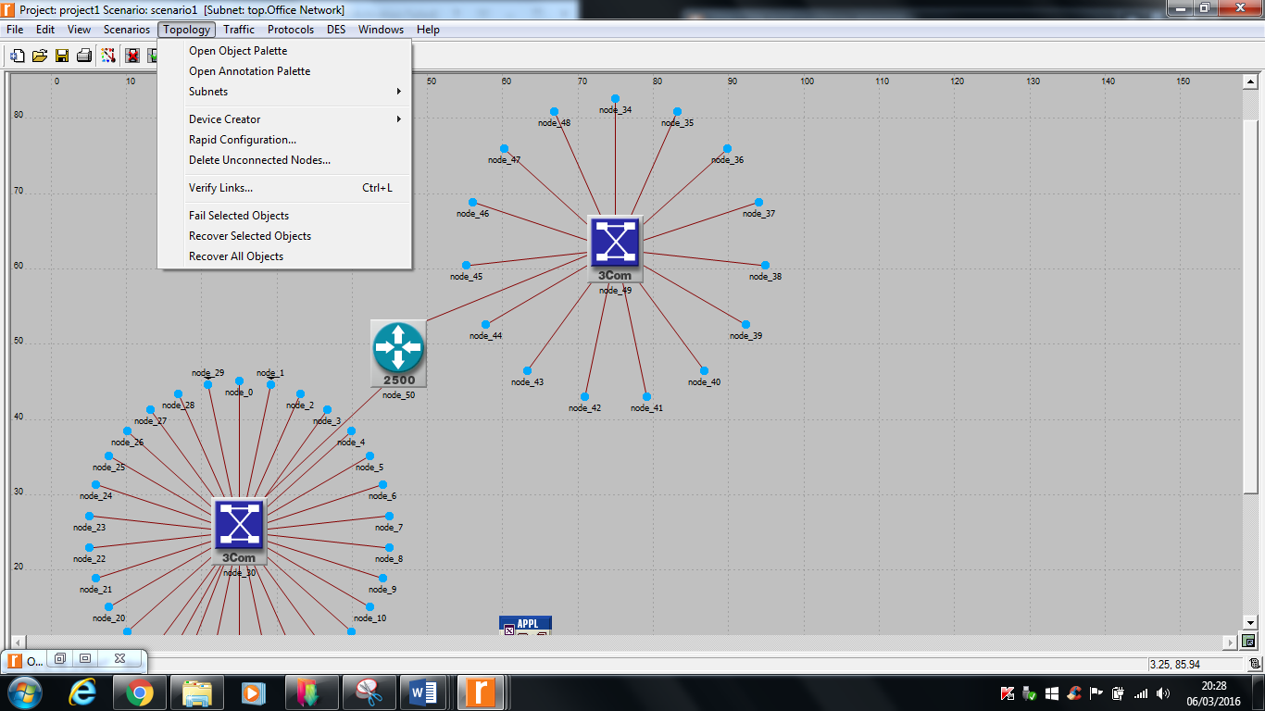

- Rapid Configuration: Star
- Center Node Model: 3C SSII 1100 3300 4s ae52 e48 ge3 (or any switch of your choice example Cisco)
- Periphery Node Model: Sm_Int_wkstn
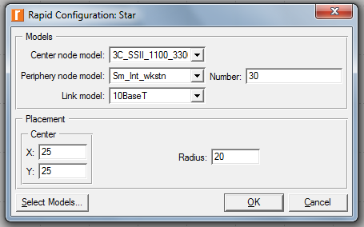
- Number (of periphery nodes): 30
- Link Model: 10BaseT
- Center X x Y: 25 x 25
- Radius: 20

Go to the object palette to add:
- Sm_Int_server use 10BaseT to connect server to the backbone switch.
- Sm_Application_Config,
- Sm_Profile_Config.
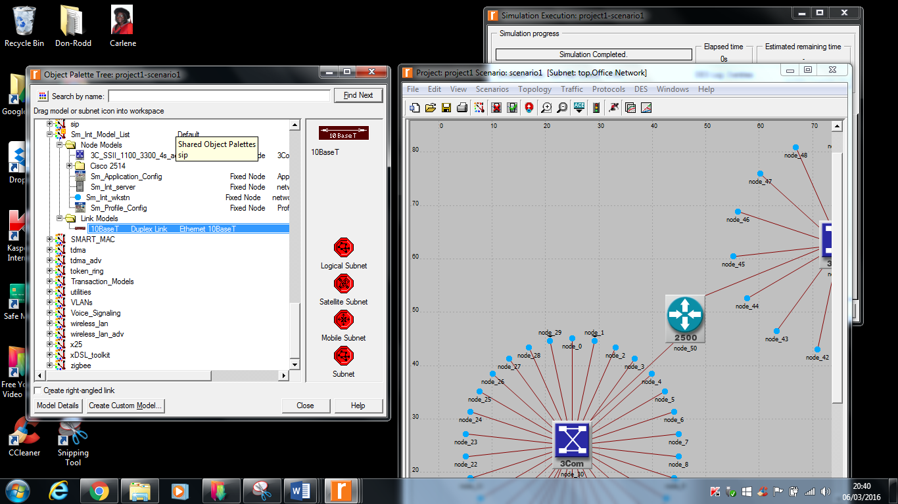

To view description of any node:
- Right-click on a node View Node Description
  - Viewing the backbone switch description, 3C SSII 1100 3300 4s ae52 e48 ge3 represents a stack of 4 (or the switch of your chosen choice)
  - 3Com switches (4s):
    - 2 SuperStack II 1100 switches
    - 2 SuperStack II 3300 switches
  - 52 auto-sensing Ethernet ports (ae52)
  - 48 Ethernet ports (e48)
  - 3 Gigabit Ethernet ports (ge3)

The original network

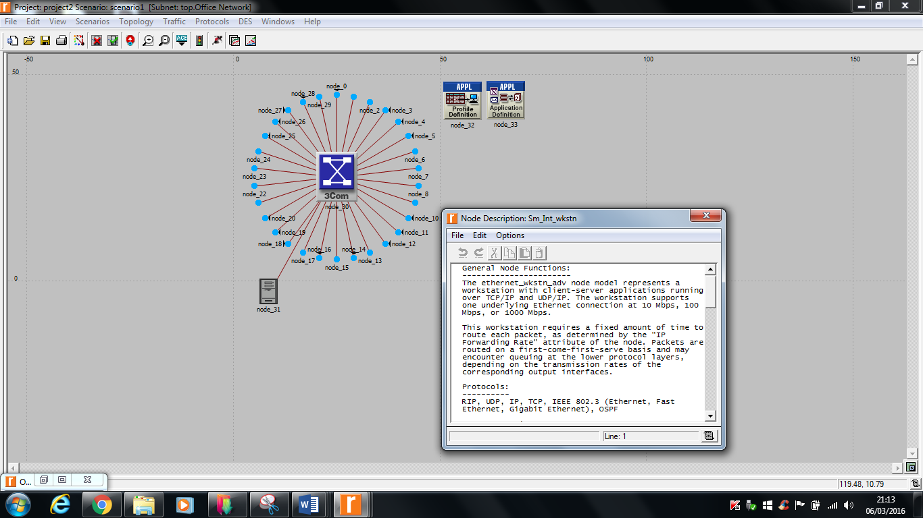

Will the server be able to handle the additional load of the second network?
- Right-click on the server node Individual DES Statistics Node Statistics Ethernet Load (bits/sec)

Will the total delay across the network be acceptable once the second network is installed?
- Right-click in the workspace (but not on an object) Individual DES Statistics Global Statistics Ethernet Delay (sec)

- Run the simulation for 30 minutes
Roman

- Expanding the network

From the menu go to Topology Rapid Configuration (follow similar step as (1.) above
- Rapid Configuration: Star
- Center Node Model: 3C SSII 1100 3300 4s ae52 e48 ge3 (or any switch of your choice example Cisco)
- Periphery Node Model: Sm_Int_wkstn
- Number (of periphery nodes): 15
- Link Model: 10BaseT
- Center X x Y: 75 x 62.5
- Radius: 20
- CS 2514 1s e2 sl2 (Cisco 2514 router), 10BaseT

The expanded network

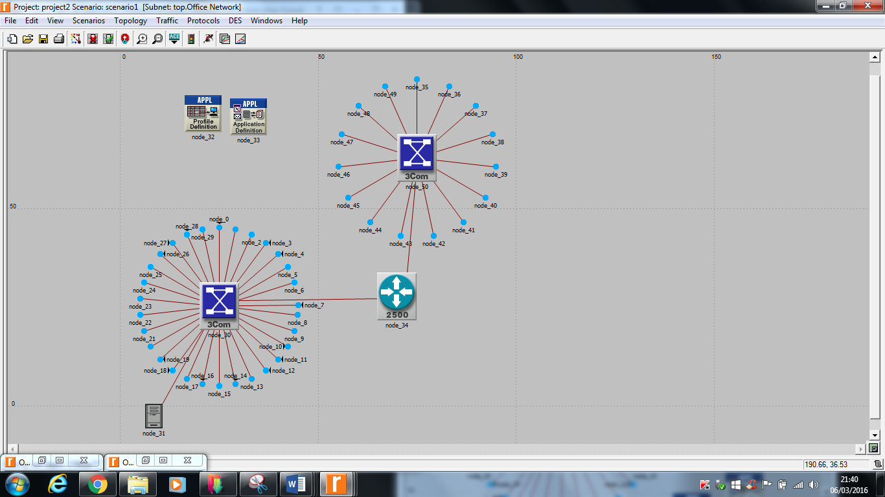

- Comparing results

- Menu Bar DES Results Compare Results...

The average load for the expansion scenario is higher (as expected)
But there is no significant change in Ethernet delay on the network

