Student ID Number/ Name | 2008582  Cristina Miloiu
Programme Title | BA Business Management
Module Title | Data Handling & Business Intelligence
Module Code | LCBB5000
Lecture`s name | Joy Botu
Coursework Title | Assessment 2
Academic Declaration:
In submitting this work, I affirm that my work adheres to the scholarly and intellectual standards of honesty and integrity. I affirm that this work is my work only and that in the preparation of this work I have not consulted any person. I affirm that I have not plagiarised or misrepresented the ideas or language of someone else as my own and that I have fully and accurately attributed any ideas or text of others to the sources and documented each source”.
Word Count | 3995 | Date Submitted | 13.05.2022

Table of Contents
Part 1 2
Excel for pre-processing 2
Excel for analyzing 2
Visualizing of data using Excel 2
Pivot Tables 3
VLOOKUP Function 8
Attribute Table 12
Part 2 14
Data Mining 19
Classification 19
Regression 19
Text Mining Methods 20
Categorization 20
Summarization 20
Advantages and disadvantages of the SPSS and Excel 21
References 22

Part 1

Excel for pre-processing
Preprocessing of data is a technique in which raw data is transformed into an efficient and useful format (GeeksforGeeks, 2021). There are different steps involved in data preprocessing like data cleaning, transformation of data, reducing of data by compressing it without losing the actual raw data. Data cleaning includes deleting or sorting the data, excluding the missing data, clustering of data, deleting the meaningless data, etc. Data transformation includes scaling of data, setting up different attributes, replacing the values in the raw data. Data reduction includes discarding the unwanted data which will not be useful in the analysis portion, selecting the subsets attributes.

Excel for analyzing
It is the process of transforming the raw data which can be usable and get relevant information which helps the organizations in taking data-driven decisions. Different Excel functions are made on the raw data to extract useful information from the data which can be beneficial for the organizations and they may have a competitive edge over its competitors. A deeper analysis of the data is done here like using of different and important functions in the Excel like descriptive statistics, range of the data is calculated, mean, median, mode, regression, correlation, etc. (Crowder, 2022) important analyzing tools like Pivot tables, VLOOKUP functions, auto sum function, etc. there are hundreds of formula which can be used in data analysis to extract useful information.

Visualizing of data using Excel
There are different data visualization tools in the excel (Qin, et al. 2018, p. 1) which helps the user in designing charts, graphs, etc. to analyze data in a better and easy manner. The different tools in excel are pie charts, bar charts, scatter diagrams, histograms, line graphs, Gantt charts, time lines, etc. It is very easy for the users to insert these graphs and charts in excel. Highlight the data which the user like to insert the visual on and the go on the insert tab and select the chart the user like to insert in the data and the chart is created.

Pivot Tables
Pivot tables are used in Excel to summarise data, analyzing and exploring of the data, and lastly present the data in the summary format. Pivot charts assists the pivot tables to easily compare the data, set trends in the data, and also add patterns in the data. The main function of pivot table is that is summarizes the large set of data with minimal use of functions (Jansen and Hermans, 2018, p. 3). Using Pivot table users are able to identify the unanticipated questions in the data.
Use of Pivot Table
- Large set of data is made user-friendly.
- Subtotaling and aggregating the numeric data by summarizing them in different categories and sub categories, and then calculating the formulas.
- The detail summary data is extracted according to the parameters set by the user on the data
- Filtering, sorting, and grouping of data made it easy for the users to gather necessary information on the area of focus.
There were 3 pivot tables added to the data provided.
Crime Rate | Sum of Education
45.5 | 12.4
52.3 | 10.9
56.6 | 11.2
60.3 | 11.9
64.2 | 12.2
67.6 | 13.5
70.5 | 14.1
73.2 | 12.9
75 | 12.9
78.1 | 11.4
79.8 | 12.9
82.3 | 12.5
83.1 | 13.6
84.9 | 13.2
85.6 | 11.4
88 | 12.9
92.3 | 12.7
94.3 | 13.3
95.3 | 12
96.8 | 10
97.4 | 10.8
98.7 | 12.1
99.9 | 10.7
103 | 11
104.3 | 12.5
105.9 | 13.4
106.6 | 11.1
107.2 | 13.7
108.3 | 13.8
109.4 | 11.4
112.1 | 10.9
114.3 | 12.8
115.1 | 13.7
117.2 | 12.9
119.7 | 11.9
121.6 | 13.9
123.4 | 11.7
127.2 | 10.4
132.4 | 12
135.5 | 12.5
137.8 | 14.2
140.8 | 12
145.4 | 12.2
149.3 | 12.3
154.3 | 12.3
157.7 | 15.1
161.8 | 13.2
Grand Total | 582.4

The grand total of the education column is 582.4 which means that the crime rate is less among the educated people in both the regions. The highest value in the education data set is 15.1 and lowest is 10. While the highest value in crime rate is 161.8 and the lowest value is 45.5. Visualization of this data is done through the bar chart in Excel (Mahajan and Gokhale, 2019, p. 199).

Column Labels
Northern |  | Southern |  | Total Sum of Labour Force | Total Sum of Males
Sum of Labour Force | Sum of Males | Sum of Labour Force | Sum of Males
17847 | 30678 | 8529 | 15524 | 26376 | 46202

The above column chart (Mahajan and Gokhale, 2019, p. 199) shows the relationship between the three variables namely, region, labour forces and males. The blue column shows the sum of labour forces in the northern region, the orange bar shows the sum of males in the Northern region, the grey column shows the sum of labour forces in Southern region and lastly the yellow bar shows the sum of males in the Southern region. As seen in the chart the total of labour forces in the Northern region is 17847 and in Southern region it is 8529. The total of labour forces in both the region is 26376. While the total sum of males in both the regions together is 46202. The total number of males in the Northern region is 30678 while in southern region it is 15524.
Males | Sum of Mature Unemployment | Sum of Below Wage
934 | 34 | 135
938 | 36 | 154
948 | 50 | 158
950 | 41 | 261
953 | 67 | 478
955 | 28 | 239
956 | 47 | 247
962 | 34 | 276
964 | 110 | 442
965 | 22 | 139
966 | 35 | 170
968 | 90 | 419
969 | 68 | 456
972 | 80 | 611
973 | 26 | 237
974 | 28 | 254
977 | 35 | 166
978 | 34 | 165
981 | 31 | 228
982 | 38 | 168
984 | 54 | 391
985 | 78 | 340
986 | 70 | 454
989 | 25 | 171
990 | 35 | 166
994 | 39 | 167
996 | 27 | 224
998 | 20 | 144
1012 | 73 | 356
1018 | 28 | 215
1024 | 27 | 225
1029 | 24 | 174
1038 | 42 | 176
1045 | 40 | 200
1049 | 40 | 160
1071 | 41 | 152
Grand Total | 1597 | 9118

The above column charts (Mahajan and Gokhale, 2019, p. 199), the mature unemployment among the males according and also the males which earn below wages. The sum of total of mature unemployed are 1597 and the total of below wages are 9118. In the column chart the blue columns are for mature unemployment while the orange column is for below wages.

VLOOKUP Function
It is the vertical lookup function which is considered to the most powerful and useful function in the Excel. It is used to find things in a table or rows (Support.microsoft, 2022). The syntax of this function includes four parameters namely lookup_value, table_array, col_index_num, and range_lookup. Based on these parameters the excel is able to compute the lookup value for the dataset.
Education | Youth Unemployment
12.4 | 80
10.9 | 135
11.2 | 97
11.9 | 135
12.2 | 78
13.5 | 77
14.1 | 70
12.9 | 114
12.9 | 114
11.4 | 99
12.9 | 114
12.5 | 124
13.6 | 77
13.2 | 84
11.4 | 99
12.9 | 114
12.7 | 102
13.3 | 78
12 | 105
10 | 108
10.8 | 92
12.1 | 73
10.7 | 86
11 | 76
12.5 | 124
13.4 | 113
11.1 | 81
13.7 | 84
13.8 | 102
11.4 | 99
10.9 | 135
12.8 | 97
13.7 | 84
12.9 | 114
11.9 | 135
13.9 | 76
11.7 | 88
10.4 | 83
12 | 105
12.5 | 124
14.2 | 91
12 | 105
12.2 | 78
12.3 | 96
12.3 | 96
15.1 | 102
13.2 | 84

 | Minimum | Maximum | Average | Range | Median | Mode
Education | 10 | 15.1 | 12.39 | 5.1 | 12.40 | 12.90
Youth Unemployment | 70 | 135 | 98.45 | 65 | 97 | 114
In the above table, VLOOKUP function was used to compute the education and youth unemployment. The highest value in the education is 15.1 while in youth unemployment it is 135. The mode of education was computed as 12.90 and of youth unemployment it is 114. This shows these values in the dataset are repeating. The range (Mishra, et al. 2019, p. 67) of the youth unemployment data is 65 and of education is 5.1.
Labour Force | Wage
540 | 564
535 | 453
512 | 288
480 | 457
599 | 593
624 | 507
641 | 486
537 | 487
523 | 489
599 | 593
533 | 318
526 | 572
595 | 529
547 | 689
521 | 396
632 | 526
602 | 557
536 | 627
586 | 617
510 | 394
530 | 405
522 | 496
515 | 395
638 | 382
595 | 529
623 | 588
553 | 421
601 | 590
542 | 589
537 | 487
497 | 427
519 | 620
574 | 540
574 | 540
521 | 396
560 | 462
560 | 462
564 | 513
571 | 537
567 | 626
591 | 578
531 | 559
542 | 589
583 | 557
580 | 657
577 | 673
631 | 674

 | Minimum | Maximum | Average | Range | Median | Mode
Labour Force | 480 | 641 | 561.19 | 161 | 560 | 599
Wage | 288 | 689 | 519.87 | 401 | 529 | 593
The above table shows the relationship between the labour force and wages. The mode (Mishra, et al. 2019, p. 67) of the data of labour force is 599 and of wage is 593. The range of the both the dataset i.e. labour force and wage are 161 and 401 respectively. The maximum value of labour force is 641 and minimum value is 480. While the maximum value of wage is 480 and minimum value is 288.
Males | Below Wage
965 | 139
1045 | 200
962 | 276
968 | 249
989 | 171
972 | 206
984 | 196
977 | 166
968 | 249
1024 | 225
969 | 250
948 | 158
986 | 190
964 | 126
973 | 237
1029 | 174
984 | 196
934 | 135
964 | 126
950 | 261
986 | 190
996 | 224
953 | 251
974 | 254
972 | 206
1049 | 160
955 | 239
998 | 144
990 | 166
978 | 165
956 | 247
982 | 168
1038 | 176
1012 | 162
938 | 154
972 | 206
981 | 228
953 | 251
1018 | 215
985 | 166
985 | 166
964 | 126
969 | 250
1012 | 162
966 | 170
994 | 167
1071 | 152

 | Minimum | Maximum | Average | Range | Median | Mode
Males | 934 | 1071 | 983.02 | 137 | 977 | 972
Below Wage | 126 | 276 | 193.51 | 150 | 190 | 166
The above table shows the relationship between the males and below wages as the two variables. The average (Mishra, et al. 2019, p. 67) of the male’s dataset is 983.02 while of below wage is 193.51. The maximum value of male and below wage are 1071 and 276 respectively. The median shows the mid value of the dataset which was computed as 977 for male dataset and 190 for below wage dataset.

Attribute Table
Atribute
Region
0 | Northern
1 | Southern
 | Northern (0) |  | Southern (1)
 | In figures | In % | in figures | In % | Total
Youth | 4134 | 63.47 | 2379 | 36.53 | 6513
Education | 396.4 | 6.09 | 186 | 31.94 | 582.4
ExpenditureYear0 | 2879 | 72.07 | 1116 | 27.93 | 3995
Labour Force | 17847 | 67.66 | 8529 | 32.34 | 26376
Males | 30678 | 66.40 | 15524 | 33.60 | 46202
More Males | 31 | 65.96 | 16 | 34.04 | 47
State Size | 1177 | 68.39 | 544 | 31.61 | 1721
Youth Unemployment | 3028 | 67.48 | 1459 | 32.52 | 4487
Mature Unemployment | 1040 | 65.12 | 557 | 34.88 | 1597
High Youth Unemploy | 31 | 65.96 | 16 | 34.04 | 47
Wage | 17641 | 71.44 | 7052 | 28.56 | 24693
Below Wage | 5366 | 58.85 | 3752 | 41.15 | 9118
The region was divided into two categories one is northern region and other one is southern region. The raw data consist the values in the region as 0 and 1. 0 was allocated to the northern region and 1 was allocated to the southern region. The total number of youth in northern region are 4134 which is 63.47% of the total youth while in the Southern region the youth were 2379 which is 36.53% of the total youth. The total number of high youth unemployed was 31 and 16 in northern and southern region respectively. The wages paid were high in northern region as compared to the southern region. There are more number of males in the northern region than southern region according to the data. The total youth unemployed in both the regions are 4487.

Part 2
Ice cream
Frequency Table

Statistics
 |  | id | ice_cream
N | Valid | 200 | 200
N | Missing | 0 | 0

ice_cream
 |  | Frequency | Percent | Valid Percent | Cumulative Percent
Valid | Vanilla | 95 | 47.5 | 47.5 | 47.5
Valid | Chocolate | 47 | 23.5 | 23.5 | 71.0
Valid | Strawberry | 58 | 29.0 | 29.0 | 100.0
Valid | Total | 200 | 100.0 | 100.0

Pie chart
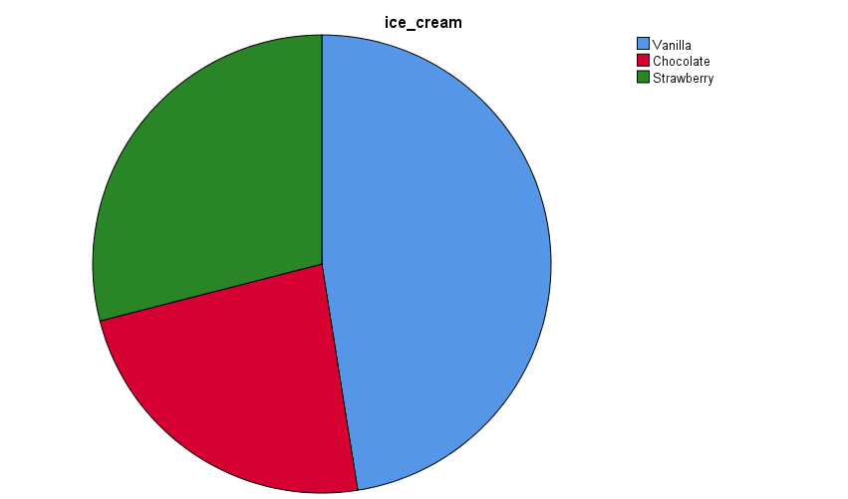

After analysing pir chart it can be said that out of 200 students 95 students like vanilla ice- cream, 29% likes choclate and remaining 23.5 % likes choclate falvour ice-cream. Presnetation is made in tabular and chart format so that it becomes possible to analyse the data.
Males and Females

female
 |  | Frequency | Percent | Valid Percent | Cumulative Percent
Valid | Male | 91 | 45.5 | 45.5 | 45.5
Valid | Female | 109 | 54.5 | 54.5 | 100.0
Valid | Total | 200 | 100.0 | 100.0

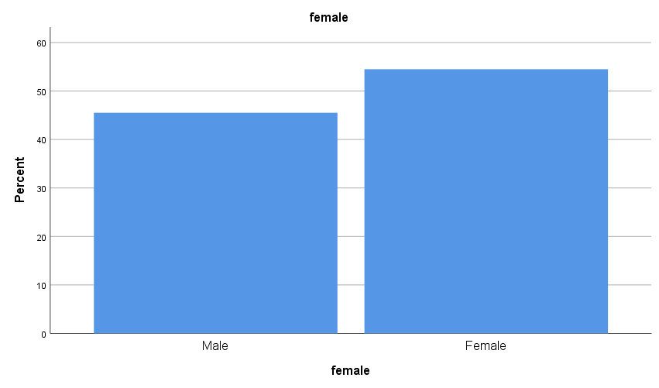
Above bar graph divides reposndents into two categories i.e., males and females.Out of 200 respondents 109 are females and 91 are males. Here it can be said that ratio of females are higher then ratio of males.

Mean and median

Statistics
 |  | id | ice_cream
N | Valid | 200 | 200
N | Missing | 0 | 0
Mean |  | 100.50 | 1.82
Median |  | 100.50 | 2.00
Mode |  | 1ª | 1
Std. Deviation |  | 57.879 | .857
Variance |  | 3350.000 | .734
Minimum |  | 1 | 1
Maximum |  | 200 | 3
a. Multiple modes exist. The smallest value is shown

ice_cream
 |  | Frequency | Percent | Valid Percent | Cumulative Percent
Valid | Vanilla | 95 | 47.5 | 47.5 | 47.5
Valid | Chocolate | 47 | 23.5 | 23.5 | 71.0
Valid | Strawberry | 58 | 29.0 | 29.0 | 100.0
Valid | Total | 200 | 100.0 | 100.0

Mean, median and mode are condidered as useful tool in ststistics. These are covered in the category of descriotive statistics tools. Here mean and median value of dataset is computed as 100. On the other hand minimum value is 1 and maximum value is 100. Std deviation of dataset is computed as 57.87.

Clustering

Quick Cluster

Initial Cluster Centers
 | Cluster
 | 1 | 2
id | 1 | 200
ice_cream | 2 | 1
female | 1 | 0

Iteration Historyª
Iteration | Change in Cluster Centers
Iteration | 1 | 2
1 | 49.502 | 49.508
2 | .000 | .000
a. Convergence achieved due to no or small change in cluster centers. The maximum absolute coordinate change for any center is .000. The current iteration is 2. The minimum distance between initial centers is 199.005.

Final Cluster Centers
 | Cluster
 | 1 | 2
id | 51 | 151
ice_cream | 2 | 2
female | 1 | 0

Number of Cases in each Cluster
Cluster | 1 | 100.000
Cluster | 2 | 100.000
Valid |  | 200.000
Missing |  | .000

Clustering analysis is defined as kind of technique which aims at grouping similar objects in same group. Clustering is of various types. K -means clustering is considered as one of the commonly applied clustering techniaue in statiatics. Main motive of applying clustering technique is to identify clusters or distinct grouos within a dataset. Here clustering value is comuted as 49.50 which can be considered as good. Two distinct groups can be ormulated with variables.

Data Mining

Classification
It is the process that extracts the valuable data to get the long set of any type of raw data. It includes analyzing the data patterns uses in the large batch to classify the data using one or more software. It defines the data which is used in providing an application with multiple fields. It defines the method which is used in exploring the large database and also helps in improving the skills it uses to improve the market scenario. It is used to analyze the relationship between parameters such as customer age along with the taste and gender (Hussain et al. 2018).
It defines the common technique that is very useful for the separation of points of data. It also allows the data to organize the data set. It includes rigid and vast data sets with a set of algorithms that can be easily sorted by the data mining classification quality. It always aims to provide the category of the data for the new entrants along with the set of different categories based on the labeled set of training. It also depends on the task for the structure that is anatomical, the Preparation of tissues, and the way to classify accuracy varies.

Regression
It defines the data mining techniques that are used in analyzing the range for the numeric values which includes the data set. Data mining can be implemented in a variety of factors including marketing including database, management of credit risk, detection of fraud, filtering the spam email, and discerning or even the sentiment or opinion of users. It defines the process of sorting through large data sets to identify patterns along with solving business problems through analysis. The techniques and tools enable enterprises to make business decisions with the capability to predict the future. It also helps in fetching the correct data from the database It also depicts meaningful patterns for the dependencies of the data. It is responsible for fetching the data and extracting the structure within the data.
It is the technique that is used in getting the mathematical and the numeric values. It is the technique that is used to classify the model and also helps in analyzing the relationship between various types of variables and often uses the contribution in getting the particular outcome together. In this, linear regression refers to the model of the data that is completely made of linear variables.

Text Mining Methods

Categorization
It is the firm of text mining that is used in sorting documents within various groups. It allows automates the combination of Natural processing language. It uses machine learning for categorization to provide a review to the customer, it also helps in supporting the tickets and any other activity that is used in the document based on the content. Text categorization is used for tagging text in helping to get organized groups. By using NLPs, the classifiers use text automatically. It helps in analyzing the text and then assigning the pre-defined tags for the categories based on its content (Jin and ko 2019).
The text will be classified by the use of words for giving the bag representation. The program of words uses each document for providing the work with words in every very helpful document. It should also represent every document as the vector in the metric space. It would also use the clustering techniques that define the group that is used in getting similar content within the terms of the document. It always helps in defining the standardization of the platforms, that use in making the search easier and relevant and also helps in improving the user experience by using the navigation and the experience of the user.

Summarization
It is the technique that is used to shorten the long piece of the text. The intention was to create a coherent and fluent summary with two of the main points that help to outline the document. Automating the text summarization that is commonly used for defining the machine learning with the bits of help of NLP. It defines text summarization as the process of exploring the short along with coherent and uses the fluent summary for explaining a very big text document. It involves providing the major outlining of the text's major points (Tandel et al. 2019).
It defines the restating the innovative ideas of the text in the short words as possible. It helps in doing the writing part along with the oral. It uses various types of techniques some of them are drama, listening to music, and taking part in any type of cultural activities it can be individual or in a group. It helps the student to learn as well as determine the essential ideas and consolidate important details that help in supporting them.

Advantages and disadvantages of the SPSS and Excel
SPSS | SPSS | EXCEL | EXCEL
Advantage | Disadvantage | Advantage | Disadvantage
It is the friendly operating software by which the user can interact with the software | It is one of the very heavy software that is not been purchased by everyone. | In Microsoft Excel, information can be easily stored that uses the software for calculation. | The issue in excel relates to the security in which there the data is not secure t can be accessed by everyone who sits on the computer.
The output is going to be very easy; it uses the steps for calculation of the data which is entered in the SPSS | While involve in the training session the user or the trainee has access to all the features | It uses the visualization option that helps in maintaining the chart. | It is very difficult to use advanced excel with all the features and formulas. It is quite expensive compared to normal excel
It is statistical software that is very easy to access. It can be utilized by everyone. | By using the SPSS tool, it is very difficult for the new user to insert the graph easily. | It has a various number of templates available online, that are free to use, and to learn more benefits of excel | In excel it has not got any of the trackers in which if any mistake has happened while entering the data in the excel sheet it would be difficult.

References
- Crowder, J. (2022) How to Use Microsoft Excel’s Data Analysis ToolPak for Descriptive Statistics. [online] TurboFuture. Available at: https://turbofuture.com/computers/How-to-Use-Microsoft-Excels-Data-Analysis-ToolPak-For-Descriptive-Statistics. [Accessed: 25 April 2022].
- GeeksforGeeks (2021) Data Preprocessing in Data Mining - GeeksforGeeks. [online] Available at: https://www.geeksforgeeks.org/data-preprocessing-in-data-mining/. [Accessed: 25 April 2022].
- Hussain, S., Dahan, N.A., Ba-Alwib, F.M. and Ribata, N., (2018). Educational data mining and analysis of students’ academic performance using WEKA. Indonesian Journal of Electrical Engineering and Computer Science, 9(2), pp.447-459. DOI: 10.11591/ijeecs.v9.i2.pp447-459
- Jansen, B. and Hermans, F. (2018) The use of charts, pivot tables, and array formulas in two popular spreadsheet corpora. arXiv preprint arXiv:1808.10642. DOI:
https://doi.org/10.48550/arXiv.1808.10642.
- Jin, M. and Ko, H.K., (2019). A Text Mining Analysis for Research Trend about the Mathematics Education. East Asian mathematical journal, 35(4), pp.489-508. http://dx.doi.org/10.7858/eamj.2019.039
- Luo, Y., Qin, X., Tang, N. and Li, G., (2018), April. Deepeye: Towards automatic data visualization. In 2018 IEEE 34th international conference on data engineering (ICDE) (pp. 101-112). IEEE.
- Mahajan, K. and Gokhale, L.A. (2019) Advanced Charting Techniques of Microsoft Excel 2016 Aiming Visualization. International Journal of Computer Sciences and Engineering (IJCSE), 7. https://www.researchgate.net/profile/Kirti-Mahajan/publication/332115080_Advanced_Charting_Techniques_of_Microsoft_Excel_2016_Aiming_Visualization/links/5fe46a0c45851553a0e75a6c/Advanced-Charting-Techniques-of-Microsoft-Excel-2016-Aiming-Visualization.pdf.
- Mendes, R. and Vilela, J.P. (2017) Privacy-preserving data mining: methods, metrics, and applications. IEEE Access, 5, pp.10562-10582. DOI: 10.1109/ACCESS.2017.2706947
- Mishra, P., Pandey, C.M., Singh, U., Gupta, A., Sahu, C. and Keshri, A. (2019) Descriptive statistics and normality tests for statistical data. Annals of cardiac anaesthesia, 22(1), p.67. DOI: 10.4103/aca.ACA_157_18.
- Qin, X., Luo, Y., Tang, N. and Li, G. (2018) DeepEye: Visualizing Your Data by Keyword Search. In EDBT (pp. 441-444). http://da.qcri.org/ntang/pubs/edbt2018.pdf.
- Sereno, M., Besançon, L. and Isenberg, T., (2019), June. Supporting volumetric data visualization and analysis by combining augmented reality visuals with multi-touch input. In EuroVis Posters (pp. 21-23).
- Support.microsoft (2022) VLOOKUP function. [online] Available at: https://support.microsoft.com/en-us/office/vlookup-function-0bbc8083-26fe-4963-8ab8-93a18ad188a1. [Accessed: 25 April 2022].
- Tandel, S.S., Jamadar, A. and Dudugu, S., (2019), March. A survey on text mining techniques. In 2019 5th International Conference on Advanced Computing & Communication Systems (ICACCS) (pp. 1022-1026). IEEE. DOI: 10.1109/ICACCS.2019.8728547
- Utami, M.C., Sabarkhah, D.R., Fetrina, E. and Huda, M.Q., (2018), August. The use of FIFO method for analysing and designing the inventory information system. In 2018 6th International Conference on Cyber and IT Service Management (CITSM) (pp. 1-4). IEEE.
- Wang, Y.Q., (2014). MeteoInfo: GIS software for meteorological data visualization and analysis. Meteorological Applications, 21(2), pp.360-368.
- Yuan, C. and Yang, H. (2019) Research on K-value selection method of K-means clustering algorithm. J, 2(2), pp.226-235. DOI: https://doi.org/10.3390/j2020016.

