Data Analysis

Chapter Four

4.1 Introduction
4.2 Data Analysis
4.3 Demographics and Descriptive Statistics
4.4 Statistic Findings
4.5 Questionnaire Findings
4.5.1 Participants
4.5.2 Response
4.5.3 Should all Police officers carry taser?
4.5.4 Taser officers
4.5.5 non-Taser officers
4.5.6 Safety
4.5.7 Public Perception
4.6 Conclusion

4.1 Introduction

This paper started life to answer questions regarding police use of Taser. The literature review demonstrated that many aspects of Taser use, such has health implications, had been heavily investigated throughout the world albeit the consensus is, that more research is required. A clear gap was identified with a lack of literature covering the police officers’ point of view. To answer the question, should all police officers carry Taser, a selection of surveys was sent to Taser officers and non-Taser officers in Gwent and South Wales police with the goal to capture their thoughts and experiences. This information, along with governments statistics will be analysed throughout this chapter to answer the question.

4.2 Data Analysis

Data analysis is defined as “A process of systematically applying statistical and/or logical techniques to describe and illustrate, condense and recap, and evaluate data” (ORI, 2025). This involves, defining the objective, collecting the data, cleaning unnecessary data, analysing the patterns and numbers in the data before explaining the results (datacamp, 2024).

4.3 Demographics and Descriptive Statistics

This study was directed at police officers within Gwent and South Wales police with any serving officer permitted to complete the survey anonymously.

4.4 Statistic Findings

Since 2017, all Police forces in the United Kingdom have been required to record data on Police use of force including Taser use (Home office, 2024)
The data demonstrates a sharp rise in Taser use between 2017 and 2020 followed by a steady decrease to 2024. Although Taser has been used, only a small percentage has been discharged with the numbers dropping steadily since 2020, at the highest level in 2020, 10% of Taser use ended in discharge. This suggests that Taser is effective at deescalating a situation without the need to be fired. There is a small amount of use that is not documented clearly as to whether the Taser has been drawn or discharged, this figure has dropped in recent years suggesting that Police forces are becoming more efficient at documenting use of Force, see figure 4.1.
These statistics were collected through the home office and documented in Police use of force statistics, England and Wales April 2017 to year ending 2024.
Year ending 2018 (Home Office, 2018).
Year ending 2019 (Home Office, 2019).
Year ending 2020 (Home Office, 2021).
Year ending 2021 (Home Office, 2021).
Year ending 2022 (Home Office, 2022)
Year ending 2023 (Home Office, 2023)
Year ending 2024 (Home Office, 2024)

Figure 4.1

4.5 Questionnaire Findings

A total of two surveys were made available through links posted on Police internal systems. One survey was directed at Police officers equipped with Taser and one directed at Police officers without Taser.

4.5.1 Participants

The survey’s found that 41% of officers taking part were taser trained compared to 59% not currently carrying taser. Of the officers currently taser trained, only 44% are assigned to response policing compared to 73% of officers not carrying taser, see figure 4.2.

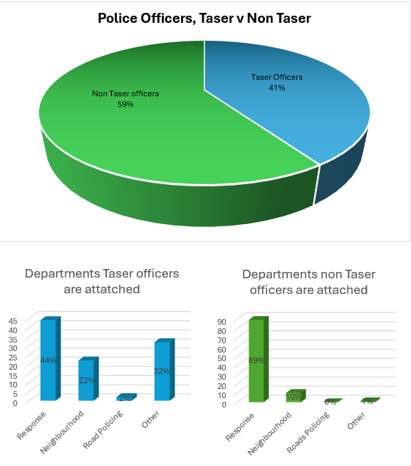
Figure 4.2

4.5.2 Response

Of all the police officers taking part in both surveys, 61% are assigned to response policing, of these officers only 29.5% are Taser trained, see figure 4.3

Figure 4.3
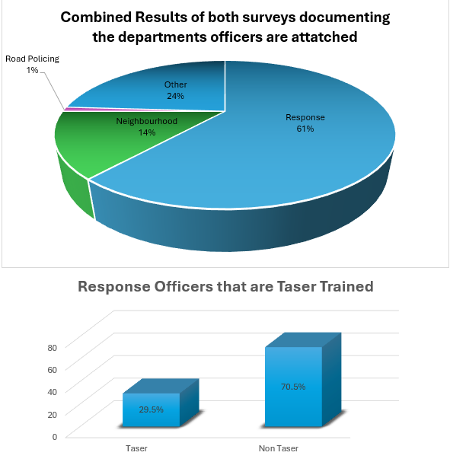

4.5.3 Should all Police officers carry taser?

When asked if all response officers should carry taser, 59% of taser officers agreed and 66% of non taser officers’ which equivalents to 63% of total officers taking part in the surveys, 17% answered maybe with 20% answering no, see figure 4.4.

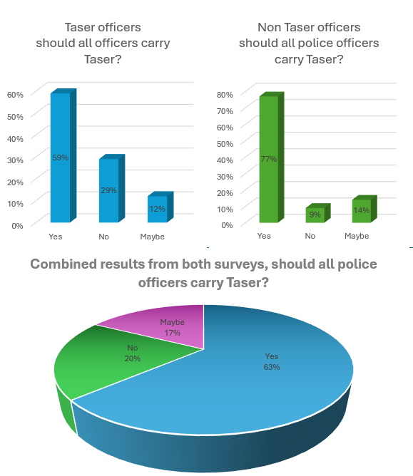Figure 4.4

4.5.4 Taser officers

From the survey, it was determined that all Taser trained officers have been in service for at least 2 years with 66% of officers being in service for more than 5 years.
These officers received their Taser training at various times with 39% being trained between 12 and 24 Months and 37% being trained between 2 and 5 years, see figure 4.5.

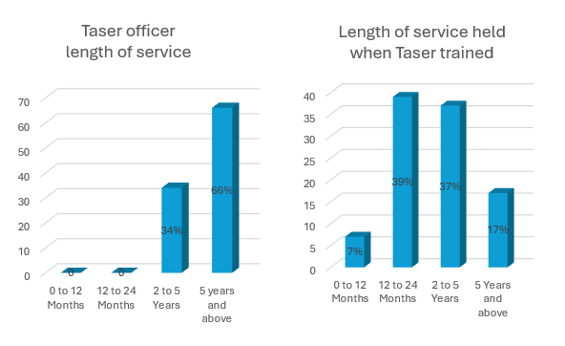Figure 4.5

The survey has shown that 80% of officers have utilised the red dot aiming system however, only 32% have discharged the device suggesting that the threat of Taser has been effective at de-escalating the situation, see figure 4.6.

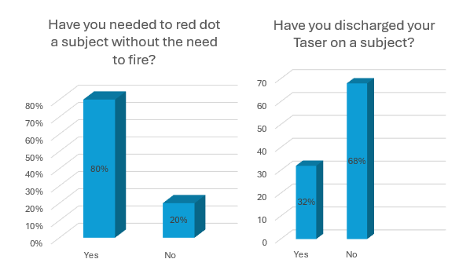Figure 4.6

Officers that have discharged their Taser gave mixed descriptions of how the event affected their feelings, some showed confidence in their actions however some showed worry and shock, below are a selection of comments provided anonymously.

“It didn’t affect my feelings; it was a means to safely detain them”.

“I was fine as I was confident my actions were proportionate”.

“I have discharged taser a number of times. I have been confident in my use and application of conflict management and the training given”.

“There was an amount of adrenaline that I felt the physical effects of. Emotionally I was relieved it worked due to the nature of the incident”.

“Shocked - Wasn't expecting it to escalate”.

“Nervous, immediately questioning myself”.

Of all the Taser officers taking part in the survey, 88% agreed that Taser is an effective device with no persons answering “No” to this question. Likewise, 93% of officers would recommend Taser with no persons answering “No”.
Reassuringly, 87% of officers believe that verbal communication is the most effective means of gaining compliance with only 4% believing that Taser is the most effective option, see figure 4.7.

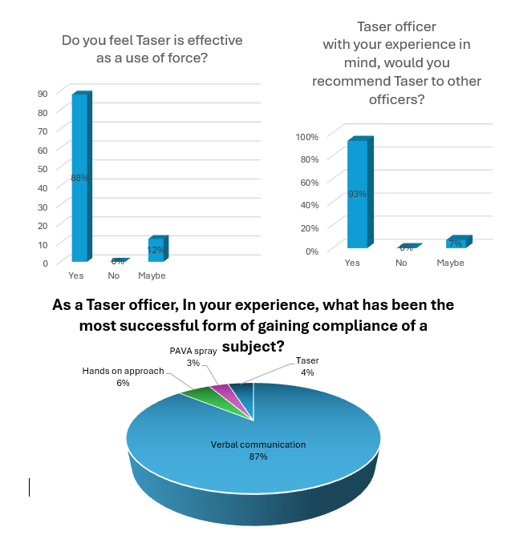Figure 4.7

4.5.5 non-Taser officers

Almost half of non-Taser officers have been in service for 2 to 5 Years with an additional 25% being in service for more than 5 Years. 80% of non-Taser officers have stated that they wish to carry Taser however only 32% have applied at the time of taking the survey. 47% of these officers believe the optimum time to receive Taser training would be between 12 and 24 Months, see figure 4.8.
13% of these officers sated that they do not wish to carry Taser due to the pressure, health concerns and responsibility, below are a selection of comments provided anonymously.

“Current models are not reliable enough”.

“Do not wish to complete the course due to high pressure”.

“I do not want to be held responsible if the person loses his life due to an undiagnosed health condition”.

“Lots of responsibility and constant backlash from media”.

“I think if all Officers had taser, it would send out a certain message to the public”.

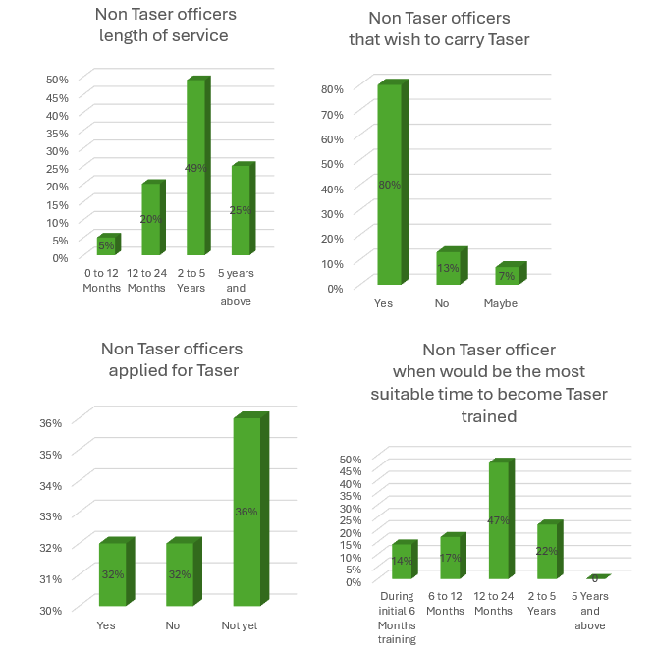Figure 4.8

Non-Taser officers provided mixed feelings on their desire to carry Taser following attending a call where a Taser has been utilised, below are a selection of comments provided anonymously.

Yes - More, not only can it be used in the defence of officers facing immediate threat, but also in the prevention of the subject from harming himself.

“Yes - made me want to carry taser more”.

“Yes - yes, there would have been no better way to resolve the situation than through immediate force”.

“Red dotted but not deployed. And it has probably made me want a taser less”.

“Yes, it hasn't changed my opinion on it, I just don’t want to carry taser”.

4.5.6 Safety

Only 27% of non-Taser officers feel sufficiently equipped to carry out their role with 75% stating that they would feel safer carrying a Taser, however 93% of Taser officers stated that they feel that they attend calls with a higher risk factor due to their skill set.
81% of non-Taser officers stated that they felt safer attending a call with an officer equipped with Taser, see figure 4.9.

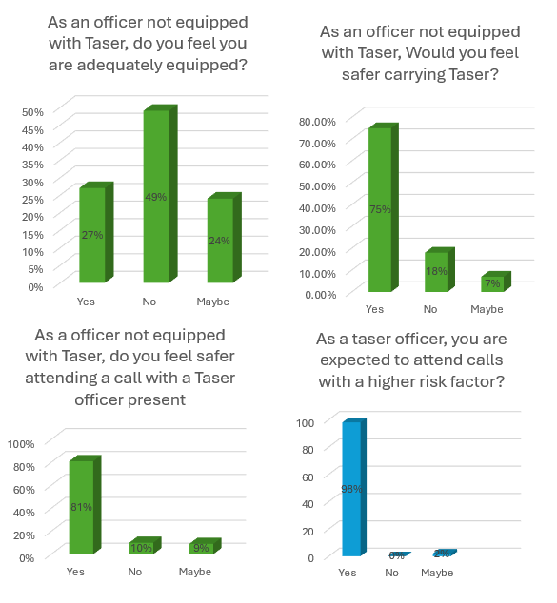
Figure 4.9

4.5.7 Public Perception

60% of officers not equipped with Taser felt that Taser led colleagues are treated differently by subjects and members of the public, see figure 4.10.
The vast majority believe this is due to the visual deterrent, below are a selection of comments provided anonymously.
“Yes, works as an effective deterrent for subjects while on show attached to kit”.

“Yes, very visual deterrent”

Yes, treated much more seriously and feel they are respected higher.

“Yes - taser officers are treated differently by subjects as they see the taser as a higher form of force”.

“Presence of taser in holster alone can be sufficient to de-escalate situations and can change a subject’s behaviour dramatically”.

“Yes, I feel like the taser is a deterrent and the public have a perception on taser. I have been present when a member of the public has said to my colleague the only reason, I have not hit you is because I can see you're carrying a taser”.

However, some said

“Possibly treated with more authority”

“No, I find it’s all about communication”.
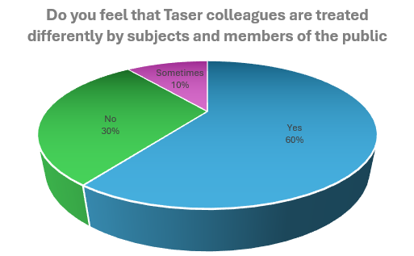
Figure 4.10

4.6 Conclusion

Statistics show a sharp increase then a steady drop, this suggests that use is lowering.
Although Taser has been drawn, discharge has occurred only 10% of the time at the maximum which has lowered to 6% in recent years, this demonstrates that Taser is effective at deescalating a situation.

Currently, only 29.5% of Response officers are Taser trained showing a shortage on the department that possibly needs Taser the most.

80% of officers who are not currently Taser trained wish to carry Taser however only 36% have applied at the time of conducting the survey for reasons unknown, this is a possible future study to determine why these officers have not yet applied.

Only 27% of officers not equipped with Taser, feel they are sufficiently equipped to carry out their role with 75% of officers stating they would feel safer with Taser.

Of the officers Taser trained, 80% have drawn Taser and utilised the red dot aiming system however only 36% have discharged which demonstrates that Taser is effective at deescalating a situation prior to discharge.

88% of Taser officers believe that Taser is an effective use of force however 87% believe that verbal communication is the most effective way of deescalating a situation, this would suggest that the officers first point of call would be using verbal communication of Taser.

63% of officers feel that all police officers should carry Taser with 17% being undecided. 81% of officers feel safer attending a call with a Taser officer however the current percentage of 29.5% means that officers would need to attend calls in groups of three and four to feel safe and sufficiently equipped.

The data suggests that most officers wish to carry Taser, and that Taser is an effective means of deescalating a situation however not all wish to carry due to the pressure and risks associated. The data suggests that there is a shortage of Taser officers on Response and an uplift is needed however this should be down to the officer to decide if they carry or not and not compulsory for all.

Bibliography
datacamp, 2024. What is Data Analysis? An Expert Guide With Examples. [Online]
Available at: https://www.datacamp.com/blog/what-is-data-analysis-expert-guide
[Accessed 01 02 2025].
Home Office, 2018. Police use of force statistics, England and Wales: April 2017 to March 2018. [Online]
Available at: https://assets.publishing.service.gov.uk/media/5c139f1c40f0b60bbee0d7de/police-use-of-force-apr2017-mar2018-hosb3018.pdf
[Accessed 2025 02 01].
Home Office, 2019. Police use of force statistics, England and Wales April 2018 to March 2019. [Online]
Available at: https://assets.publishing.service.gov.uk/media/5dfa126440f0b60941fff023/police-use-of-force-apr2018-mar2019-hosb3319.pdf
[Accessed 01 02 2025].
Home Office, 2021. Police use of force statistics, England and Wales: April 2019 to March 2020. [Online]
Available at: https://www.gov.uk/government/statistics/police-use-of-force-statistics-england-and-wales-april-2019-to-march-2020/police-use-of-force-statistics-england-and-wales-april-2019-to-march-2020
[Accessed 01 02 2025].
Home Office, 2021. Police use of force statistics, England and Wales: April 2020 to March 2021. [Online]
Available at: https://www.gov.uk/government/statistics/police-use-of-force-statistics-england-and-wales-april-2020-to-march-2021/police-use-of-force-statistics-england-and-wales-april-2020-to-march-2021#ced-conducted-energy-device-use
[Accessed 01 02 2025].
Home Office, 2022. Police use of force statistics, England and Wales: April 2021 to March 202. [Online]
Available at: https://www.gov.uk/government/statistics/police-use-of-force-statistics-england-and-wales-april-2021-to-march-2022/police-use-of-force-statistics-england-and-wales-april-2021-to-march-2022
[Accessed 01 02 2025].
Home Office, 2023. Police use of force statistics, England and Wales: April 2022 to March 2023. [Online]
Available at: https://www.gov.uk/government/statistics/police-use-of-force-statistics-april-2022-to-march-2023/police-use-of-force-statistics-england-and-wales-april-2022-to-march-2023#ced-conducted-energy-device-use
[Accessed 01 02 2025].
Home office, 2024. Police use of force statistics. [Online]
Available at: https://www.gov.uk/government/collections/police-use-of-force-statistics
[Accessed 01 02 2025].
Home Office, 2024. Police use of force statistics, England and Wales: April 2023 to March 2024. [Online]
Available at: https://www.gov.uk/government/statistics/police-use-of-force-statistics-april-2023-to-march-2024/police-use-of-force-statistics-england-and-wales-april-2023-to-march-2024#ced-conducted-energy-device
[Accessed 01 02 2025].
ORI, 2025. Data Analysis. [Online]
Available at: https://ori.hhs.gov/education/products/n_illinois_u/datamanagement/datopic.html#:~:text=Data%20Analysis%20is%20the%20process,and%20recap%2C%20and%20evaluate%20data.
[Accessed 01 02 2025].

Appendix

Research Proposal
Research Proposal Sheet.docx

Ethics Form
PG2_Application_for_Ethical_Approval_10-2022.docx

Taser officer survey result in spreadsheet format
Taser officers.xlsx

Non-Taser officer survey result in spreadsheet format
Non-Taser officers.xlsx

Figure 3.1 - The research onion
https://poweredtemplate.com/the-research-process-onion-diagram-76401/

Figure 4.1 - Police use of force statistics created from information available on Gov.co.uk.
figure 4.1 Taser Statistics.PNG

Figure 4.2 - A selection of graphs highlighting the survey participants.
Figure 4.2 Participants.PNG

Figure 4.3 – The combined results of both surveys highlighting the participants attached to response policing and Taser carriers in this department.
Figure 4.3 Response.PNG

Figure 4.4 – A graph highlighting the combined results of the question, should all police officers carry Taser?
Figure 4.4 Should all officers carry Taser.PNG

Figure 4.5 – A graph highlighting the length of service held by Taser officers.
Figure 4.5 Taser 1.PNG

Figure 4.6 – A graph highlighting Taser usage through red dotting a subject and discharge.
Figure 4.6 Taser 2.PNG

Figure 4.7 – A graph highlighting officers’ thoughts on Taser effectiveness, whether officers would recommend Taser and the most successful form of gaining compliance.
Figure 4.7 Taser 3.PNG

Figure 4.8 - A selection of graphs highlighting non-Taser officers’ length of service, those that wish to carry Taser and those who have applied.
Figure 4.8 Non Taser.PNG
Figure 4.9 – A selection of graphs that look to answer whether officers feel adequately equipped without Taser, if officers would feel safer with a Taser and if officers feel safer attending a call with a Taser led officer. A graph also highlights Taser officers attending calls considered to be a higher risk.
Figure 4.9 Safety.PNG

Figure 4.10 – A graph highlighting how officers feel the public treat a Taser officer in comparison to a non-Taser officer.
Figure 4.10 Public perception.PNG

Survey Questions

Non-Taser officers

A selection of questions directed at police officers that do not currently carry taser

1 - What Police force do you work for?
Gwent
South Wales
Other

2 - Which department are you assigned?
Response
Neighbourhood
RPSO
Other

3 - How much service do you have?
0 to 12 months
12 to 24 Months
2 to 5 years
5 years and above

4 - Do you think all police officers should carry taser?
Yes
No
Maybe

5 - Would you like to carry taser?
Yes
No
Maybe

6 - If you do not wish to carry taser, why not?

7 - Do you feel you are adequately equipped as a police officer without taser?
Yes
No
Maybe

8 - Have you applied to carry taser?
Yes
No
Not yet

9 - Would you feel safer carrying taser?
Yes
No
Maybe

10 - Do you feel safer attending a call with a taser officer present?
Yes
No
Maybe

11 - Do you feel that taser led colleagues are treated differently by subjects and members of the public, if yes, in what way?

12 - Have you attended any calls where taser has been used, if yes, has this made you want to carry taser more or less?

13 - In your opinion, when would the most suitable time for officers to receive taser training be?
During initial 6 months training
6 to 12 months
12 to 24 Months
2 to 5 years
5 years and above

14 - Do you think taser trained officers should be exposed to taser discharge during training?
Yes
No
Maybe

Taser officers

A selection of questions directed at police officers carrying Taser

1 - What Police force do you work for
Gwent
South Wales
Other

2 - Which department to which are you assigned?
Response
Neighbourhood
RPSO
Other

3 - How much service do you have?
0 to 12 Months
12 to 24 Months
2 to 5 years
5 years and above

4 - How long have you carried Taser?
0 to 12 Months
12 to 24 Months
2 to 5 years
5 years and above

5 - How much service did you have when taking your taser course?
0 to 12 Months
12 to 24 Months
2 to 5 years
5 years and above

6 - Do you feel, as a taser officer, you are expected to attend calls with a higher risk factor?
Yes
No
Maybe

7 - Do you feel a subject is more compliant when an officer is carrying taser?
Yes
No
Maybe

8 - Do you feel taser is effective as a use of force?
Yes
No
Maybe

9 - How confident are you in using taser?
Extremely confident
Somewhat confident
Neutral
Somewhat not confident
Extremely not confident

10 - Have you discharged your taser on a subject?
Yes
No

11 - How did discharging your taser make you feel?

12 - How many times have you used your taser?

13 - Have you needed to red dot a subject without the need to fire?

14 - With your experience in mind, would you recommend taser to other officers?
Yes
No
Maybe

15 - Do you feel all response officers should carry taser?
Yes
No
Maybe

16 - As a taser officer, how much experience do you feel officers should have before carrying taser?
During initial 6 months training
6 to 12 months
12 to 24 Months
2 to 5 years
5 years and above

17 - In your experience, what has been the most successful form of gaining compliance of a subject?
Verbal communication
Hands on approach
PAVA spray
Taser

18 - Do you think taser trained officers should be exposed to taser discharge during training?
Yes
No
Maybe

