

Student name: Yocasta Isabel Rodriguez Pineda.

Student ID: 2514330
Module name: Introduction to Health and Social Care.

Module code: LCHS4003-LON
Lecturer name: Shepherd Ziko.



CONTENTS =================== PAGE

Element --- 1 ------- COMMUNITY MENTAL HEALTH SERVICE =========== 1
Brief History of Community and mental Health Services: ==================== 1
Current functioning of the service: ================================= 1
Tow Challenges Faced by the Service ======================================== 2
Stigma and inequality in Access =================================== 3
Poster about Community and mental health services=================== 4

Element 2: ============Community Antenatal Midwifery. ================== 5
SHORTLY INTRODUCTION: ======================================== 5
Origins And History==============================================5
Key drivers: ==================================================== 5
Current Functions
Impact on Quality of Life: ==========================================6
Challenges and Critiques ======================================================6
Enhancing in the service=========================================== 6
References ===================================================== 7

INTRODUCTION

Element --- 1 ------- COMMUNITY MENTAL HEALTH SERVICE

I chose community and mental health services because mental health is a fundamental part of overall health wellbeing. In this year awareness of mental health issues such as anxiety, depression, has increased significantly the root cause are by la situation and tension of the society is very important early intervention to reduce future illness mental in younger, children and older peoples. Community and health services play a crucial role in supporting individuals within mental health conditions within their own environments. These services focus on promoting wellbeing, independence, and recovery while reducing the need for hospital admissions.

Brief History of Community and mental Health Service:

In UK the introduction of police such as the Care in the Community initiative in the 1980 marked a significant transition aimed to provide treatment and support within the community rather than hospitals. Over time, services expanded to include multidisciplinary teams, crisis intervention, and specialised support for different populations.

Current functioning of the service:

Provide support at:
1- Community mental Health Teams (nurse, social workers, psychiatrists, psychologists and occupational therapist).
2- Primary Care Support: General practitioners (GPs) are often the first point of contact. They provide initial assessment, prescribe medication, and refer patients to specialised service when needed.
3-Crisis intervention Services: Provide support to individuals experiencing severe mental health episodes. Their aim is to prevent hospital admission by offering intensive care home.
4-Psychological Therapies: These therapies help individuals manage their symptoms and improve coping strategies.
5-Social Support Service: also address social factors such housing, employment, and education. Is influenced by social and environmental conditions.
6- Child and Adolescent Mental Health Service: Provide specialised support for young people with behavioural problems and developmental difficulties and disorders.
7- Recovery and Rehabilitation Programs: Offer special focus on helping individuals regain independence, build life skills, and reintegrate into society. ￼
Overall, the current system emphasises collaboration between healthcare providers, patients, and family members, service such as online therapy and helps, improving accessibility.

Tow Challenges Faced by the Service

Increasing Demand and Limited Resources.

One of the biggest challenges is the growing demand for mental health services. Factors such as population growth, social pressure, and increased awareness have led to more people seeking and wetting to helps mental care professional, funding staff with over workload and not always kept pace to offer an appointment revision.
As a result, long list wetting can delay treatment and worsen conditions, affecting the quality of care provided.

Stigma and inequality in Access

Despite progress, stigma around mental health still exists. Some individuals may feel ashamed or afraid to seek help, leading to delayed diagnosis and treatment.
Additionally, there are inequalities in access to services. People from minority ethnic backgrounds, rural areas, or lower socioeconomic groups may face barriers such as language differences, lack of awareness, or limited availability of local services. This can result in unequal health outcomes and reduced effectiveness of care.

Community and mental health services are essential in promoting wellbeing and supporting individuals in living fulfilling lives. The shift from institutional care to community-based support represents a significant advancement in healthcare, focusing on dignity, independence, and holistic care.

Person-centred, accessible, and designed to all differents age groups and backgrounds.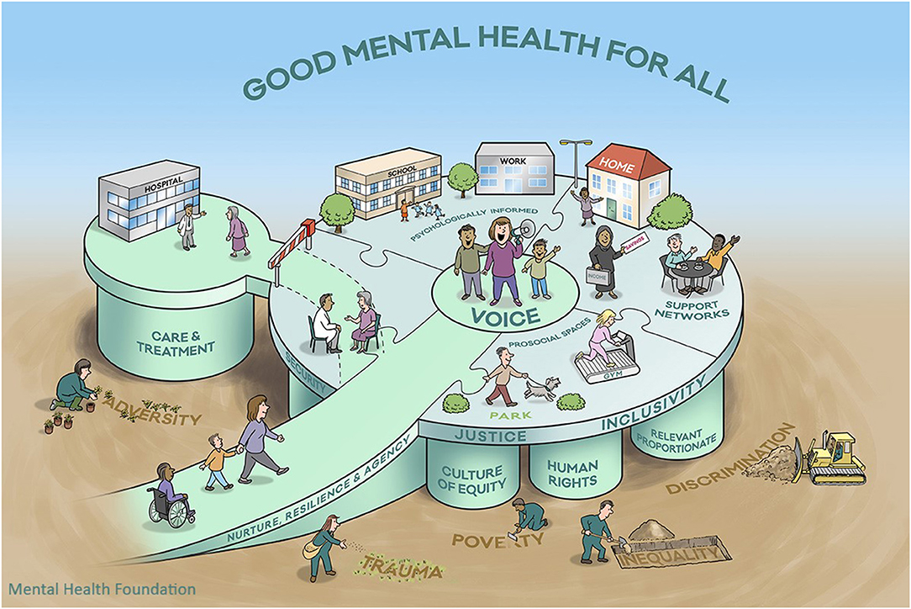
Community Mental Health.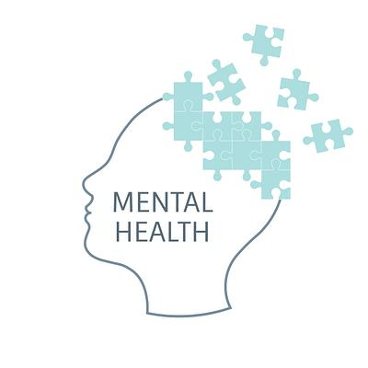Historically, care was primarily provided During the 19th and early 29th centuries, individuals with mental conditions were receiving inhumane care.
Choice mental health service because es fundamental part of overall health wellbeing.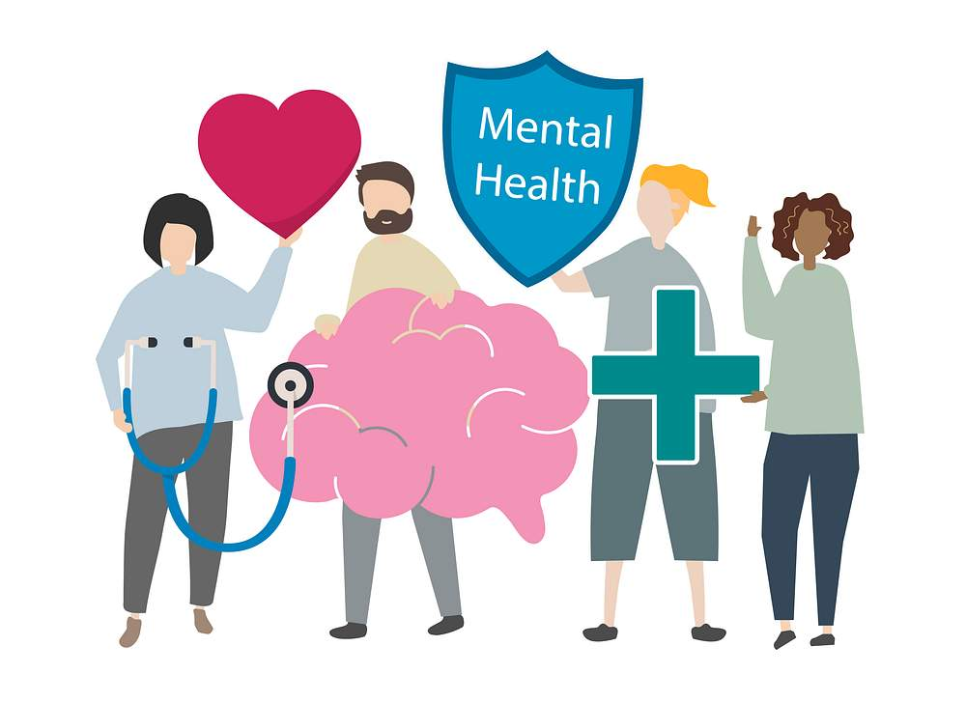
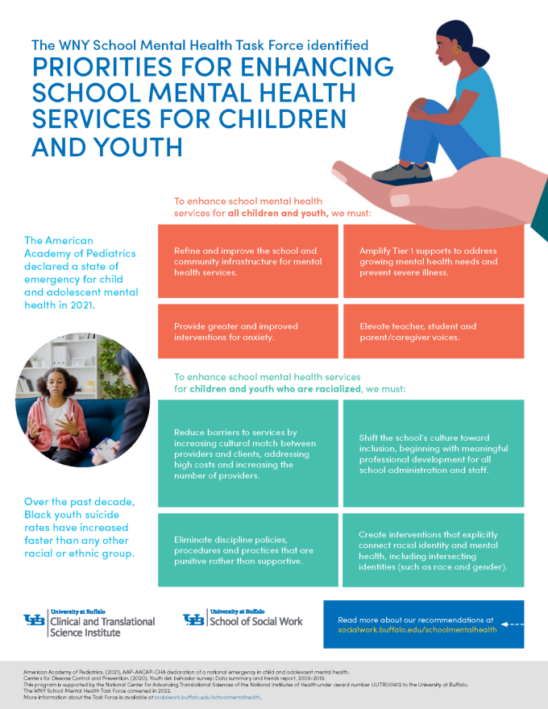Provide early intervention and enhance care.

1. Increasing Demand and Limited Resources.
2. Stigma and Inequality in Access.
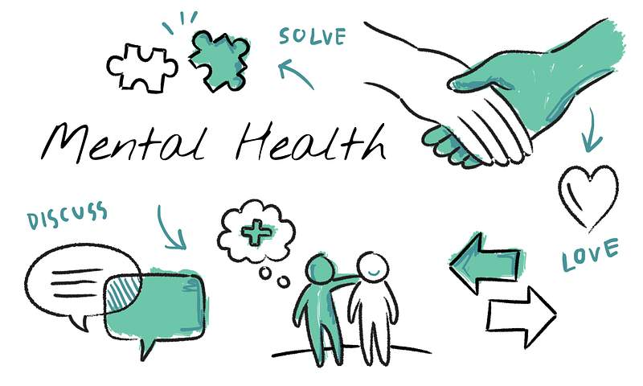Operate through a wide range of integrated care systems.

Yocasta Rodriguez: Introducction to Health and Social Care 2514330@student.uwtsd.ac.uk
Community mental Health Service / Community antenatal midwifery service
Element 2: ============Community Antenatal Midwifery.
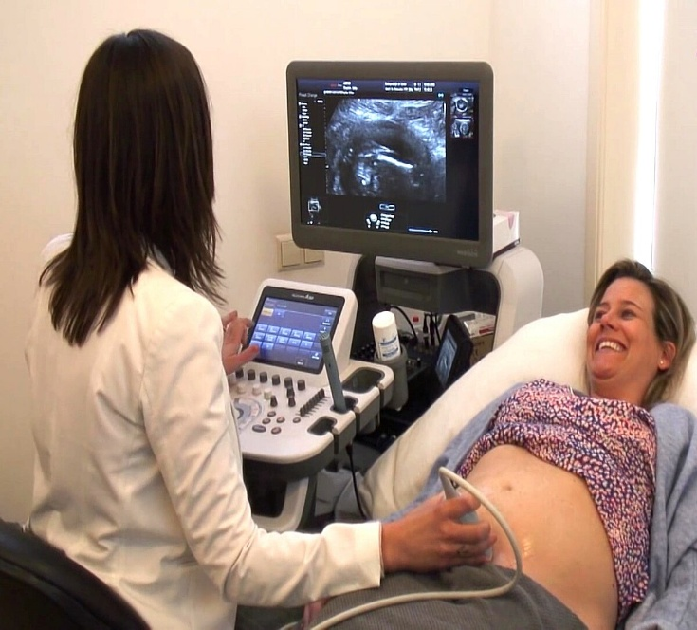

SHORTLY INTRODUCTION:
Community antenatal midwifery services in the UK, provided mainly through the National Health Service, support women and families throughout pregnancy. These services focus on delivering personalised, holistic care within the community, promoting health, early intervention, and positive outcomes for both mother and baby.

Origins And History
Emerged in late 19th – early 20th century due to high maternal and infant mortality.
Early midwives provide home visits, prenatal care, and education.
Professionalized with public health systems like the NHS (UK).

Key drivers:
Accessible, preventive prenatal care
Reducing pregnancy and birth complication

Maternal education and family support
Collaboration between healthcare professionals

Current Functions
Comprehensive prenatal care:
Monitoring maternal and baby health
Early detection of complications
Emotional and educational support
In overall Encouraging Women’s active participation for safety and wellbeing
Impact on Quality of Life:
Reduce anxiety and promotes Healthy habits (Green & Baston. 2003)
Provide social support for women and families (Renfrew et al., 2014)
Prevent Short-and long-term health issues (Homer et al., 2014)
Builds trust between community and health services (NHS England, 2023)
Challenges and Critiques
Limited access in rural or disadvantaged areas (Sandall et., 2016)
Increasing demand pressures resources due to increasing demand (Renfrew et al., 2014)
Ongoing need for culturally sensitive training (Homer et al., 2014)
Enhancing in the service
These Improvements can make antenatal services more accessible, personalised, and effective for mothers and babies. Provide early access to care, Continuity of care, Reduce inequalities, Digital support, Mental health care workforce support.
With the development of public health systems, such as the NHS in the UK, the service becomes professionalized and integrated into primary care.
Overall, the service has significantly improved maternal and neonatal outcomes by promoting early access to cares, continuity of care, and strong relationships between midwives and service users. Models such as continuity of carer have been encouraged following recommendations from the Better Bitrh report, aiming to ensure women are supported by a known midwife through their pregnancy journey. This approach enhance trust, improve communication, and contributes for safer, more personalised care.
Community midwives also play a key role in health promotion, including education on nutrition, breastfeeding, mental health, and safeguarding. Their work helps reduce health inequalities by reaching vulnerable populations and offering care home, clinics, and community settings

References

Green, J., & Baston, H. (2003) Reducing maternal anxiety in pregnancy: a community midwifery approach, Midwifery, 19 (1), pp. 44-52.

Renfrew, M.J., McFadden, A., Bastos, M.H., Campbell, J., Channon, A.A., Cheung, N.F., et al. 92014) “Midwifery and quality care: finding from a new evidence-informed framework for maternal and newborn care, The Lancet, 384(9948), pp 1129-1145. https://doi.org/10.1016/S0140-6736(14)60789-3
Sandall, J., Soltani, H., Gates, S., Shennan, A. and Devane, D. (2016) Midwife-led continuity models versus other models of care for childbearing women. Cochrane Database of Systematic Reviews, Issue 4. Art. No.: CD 004667.
http://doi.org/10.1002/14651858.CD004667.pub5
NHS England (2023) Antenatal and postnatal care: guidance for community midwifery services. Available at:
http://www.england.nhs.uk/midwifery-guidance (Accessed: 21 March 2026)
Homer, C.S.E., Friberg, IK., Dias, M.A.B., Ten Hooper-Bender, P., Sandall, J., Speciale, A.M., Bartle, L. (2014) The projected effect of scaling up midwifery, The Lacet, 384(9948). Pp. 1146-1157.

