Charnai clarke
Student number 2007510
Module code: BMHP4003_BIRM
Lecturer’s name: Rebecca Kavanagh
Assignment title: case study report

Content’s page: page numbers:

Introduction 3
Social learning theory 3
Attuites 4
Theory of planned behaviour 5
Unhealthy eating 6
Effects of obesity 6
Ways to reduce obesity 7
Conclusion 7
Reference page 8

Introduction
In this report I will be writing about three different theories, I had to explain what each theory was, how they work and why they are important. I also added in some professional and personal examples and evidence to support me throughout this assignment. In this assignment I would then go onto explain about the local clinical commissioning group and how they work with paints with obesity and ways they can decrease the rise in obesity, I will do this by creating a plan with steps explain what my plan is and why it would be of help to the group, for them to then use it in their commissioning group.
Psychologist- this is an expert or specialist in psychology. (www.dictionary.com)

Social learning theory:
This is the theory of learning process and social behaviour which proposes that new behaviour can be acquired by observation and imitation. This can be both positive and negative as we tend to observe others around us and follow the example given, starting from as an infant, when we are at a young age, children are still finding their way in life and are building their P.I.E.S (psychical, intellectual, emotional and social) skills and start by following people most close to them, this could be at both home and schools. But where this theory start? it started with Albert bandura, who is a well-known influential social cognitive psychologist, who studied at university of British Columbia where he got his bachelor’s degree for phycology. (R.L..Akers,2015)
Bandura is known for a lot of his theories, but the social learning theory also known as the observational theory Is most popular as if is used still to this day and if very much affective. He showed through this theory how behaviour is influenced through what we see as young children, mainly from what we see growing up watching tv.
This is because of the common use it has in social work and the solid understanding. This theory has also shown to have increased the engagement across developing self-organising skills.
The social learning theory was broken down into four stages, stage one the attention stage this is having the motivation to pay attention in order to learn you need to be able to focus and use your observation skills to help individuals build confidence and behaviour. The second stage is retention, this is remembering what you have paid attention to this can include mental Image, symbolic rehearsal and cognitive organisation. Third stage is the reproduction, this is performing the model of what you have paid attention to and remembered in order to carry out what you have learning in your behaviour. Then then last stage, which is motivation, this is the most important stage as for observation learning to work individuals must be inspired to copy the behaviour that has been modelled.
The social learning theory is a great help with the case study as by using this method the clinical commissioning group can put in place a routine or action plan, follow it themselves to see how well it works which is good when setting an example as most people are visualist meaning they like to see results before actual trying something them self’s, having regular updates on how the plan is working on the staff with encourage patients to try it out themselves being up the confidence and positive behaviour will motivate them, which will be a big help with lowing the amount of people that are obese, this is a great way to help the young generation and prevent them from developing more serious conditions when older.

Attitudes:
this theory is a branch of social psychology that studies how individuals evaluate an attitude and how it can define a person. Attitude is also a set of emotions, behaviour or beliefs towards objects, people and situations which is often started from the surrounding of an induvial from a young age as they tend to follow in the footsteps of the people, they are most influenced by this do not always have to be people in their home it could be friends, educators or celebrities.
There are four different types of attitudes that people express, the first one is positive attitudes, which is being optimistic about people, yourself, interactions and situations. People who are positive also tend to be uplifting, hopeful and good company as they also think of ways to be grateful, for example waking up late for work, missed your bus and now you have to wait 30 minutes for the second one to arrive, instead of making that effect your day someone with a positive mindset would thing of ways they could resolve the situation by analysing what happening and finding ways in which they can go about the rest of the day.
The second one is negative attitudes, this is people who possess bad conduct and attract to everything in a bad way, this could simply be by how they handle situations and the way to react to induvial by their behaviour towards them.
The third one is neutral attitudes which is when a person does not care about the outcome of something this could be the behaviours of others towards them or a situation they have come across. They tend to look at everything from both aspects and understand that most situations can go one of two ways. But do not care of what the outcome maybe they would rather leave the situation for someone else to figure out or have no emotions towards anything.
Finally, the last one sikken attitude this is the calibre to destroy every positive image or situation that happens, this type of attitude relates to negative and is very destructive. Individuals who have this type of attitude can be from how a person was raised or traumatic events that have led a person to turn this way. (G. Maio,2009)
Attitude’s theory links in with the case study for helping decrease obesity as it allows the CCG to understand the different types of attitudes people have, having this kind of understanding may make it easier for them to communicate with patients and also gain that trust to help form the bonds between them, as a young adult myself I do find it easier to talk to someone I feel that I can relate to and isn’t judging me. Using the attuite theory we can see how patients and staff can work affectively together and see the rates of obesity overall do down.

Theory of planned behaviour:
This is a psychological theory that is linked to behaviour by suggesting that there are a few different factors that influence weather our attitudes is reflected in our behaviour. The Theory of planned behaviour also known as theory of reasoned action started in 1985 by a gentleman named Icek Ajzen, who was a social psychologist and professor. Ajzen stated ‘’ this theory was built off what was assumed of human behaviour in the theory reasoned action’’ and can explained the theory in three stages to help others understand how this theory works and why it was so effective. (P. M. Bentler,1979)
The first one, attitude demonstrate how we feel about doing something. It can be spoken verbally, or it can be through body language and face expression. The second one subjective norm means the beliefs of individuals that matter most, this could be both family and friends or people which a big influence in our life, which can have an impact on our behaviour and the way we look at certain situations. Finally, perceived control this is whether a person believes they have the right to control or direct a situation.

Unhealthy eating
This is when you have an unbalanced diet and tend to eat more fatty foods and snacks which can lead to many becoming overweight, foods like pizza, burgers, fries etc can lead to this, although most foods people like tend to contain high amounts of sugar and salt, people still eat it, this could be for a few reasons. Some eat unhealthy food because they do not know how to cook with healthy ingrediencies that taste nice or could be that they comfort eat, this is when you eat foods like chocolate, ice cream etc because you are sad and it may uplift your mood, but for more people they eat unhealthy food because it is more affordable. But what many do not know are the long term affects unhealthy food can have. Which as acne, bloating and weight gain. Which can then progress onto bad breath, bad skin, low energy, tiredness and hair loss.
Eating unhealthy can also affect the personality as some start to feel lazy, sad and lonely. The CCG could help prevent the number of people eating unhealthy through, advertising trips to farms, encoring people to cut down on sugar and fatty food, create meal plans or leaflets with higher fibre food and giving out fruits and water gift bags to help push individuals to want to eat and drink healthier without feeling pressured. (www.sciencedirect.com)

Effects of Obesity
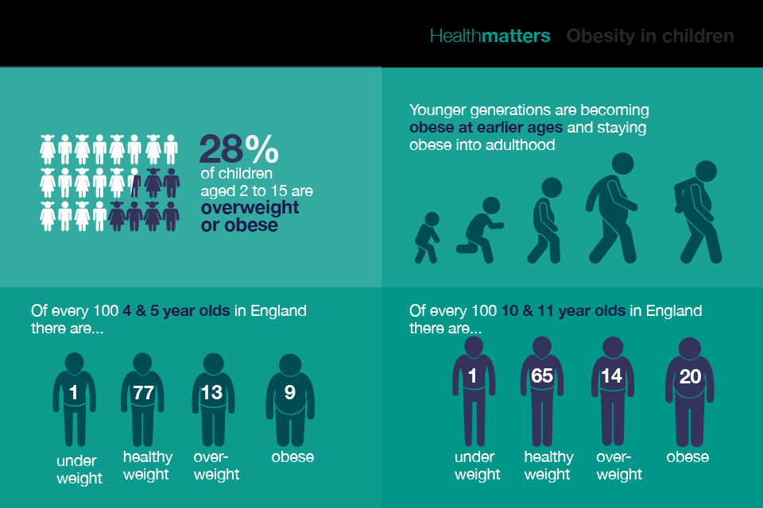
What is obesity? a person who has a high excess of body fat which can affect their health. Health workers can detect this by using BMI (body mass index) this is when they measure your height and weight and calculated together. A person who has a body mass index over 30kg/m2 are classes as obese. (www.bitesize.com) obesity is a very serious thing as there are many risks it can lead too such as strokes, diabetes, heart disease and some types of cancer. Which can have a negative impact life as some of these risks can lead to death. (www.gov.com)
Ways to help recuse obesity
The local clinical commissioning group could help stop the uprising of obesity by:
- Creating plans for healthy food diets
- Introduce walks
- Sport activity clubs
- Sponsors for the gym
- Cooking classes that promote healthy eating
up above I have listed a few ways this group could help prevent the youth to become obese but instead help increase healthy diets and lifestyle. They could do this by starting programmes that they can sign up too, which they could get older volunteers to join in on as this will influence the youth to follow seeing the example set by the older adults.
Conclusion
In this report I was able to explain what social learning theory, attitude and theory of planned behaviour was, I was able to include two psychologist Icek Ajzen and Albert Bandura, where I briefly spoken about them and the thought process of why they came up with the theories they had created.
This was helpful as I was able to link each one to the case study and how it related to obesity and this report. I then went onto explain more about the CCG group and ways in which obesity could be recued not only within the group but worldwide once people see the results and effect of this report it is way be of great use to help influence other groups within the area or city to speared awareness. By writing this report it also gave me a better understanding on how much obesity can really affect someone’s life and made me think more about my own lifestyle choices as a young adult who does not look after their health as much as they should this helped me to see the more serious side and risk.

Reference page

Website: https://www.bbc.co.uk/bitesize/topics/ztnnb9q/articles/zdx8jty
F. Gino (2015) organizational behaviour and human decision processes pg. 179-211
https://www.sciencedirect.com/science/article/abs/pii/074959789190020T
G. Maio (2009) the psychology of attitude and attitude changes. Pg. 24-54
https://books.google.co.uk/books?hl=en&lr=&id=tk1tDwAAQBAJ&oi=fnd&pg=PP1&dq=the+psychology+of+attitude+and+attitude+change&ots=W82z_pCZvd&sig=ct4QDjfEDnOIKPD_iCV2MME45W0#v=onepage&q=the%20psychology%20of%20attitude%20and%20attitude%20change&f=false
website- Health matters: obesity and the food environment published 31st 2017
https://www.gov.uk/government/publications/health-matters-obesity-and-the-food-environment/health-matters-obesity-and-the-food-environment--2
website- https://www.nhs.uk/conditions/obesity/
P. M. Bentler and G, Speckart, (1979) models of attitude and behaviour relations, Pg. 452-464
R, L. Akers., (2015). The handbook of criminological theory. pg. 230-231 Alex R Piquero
https://books.google.co.uk/books?hl=en&lr=&id=U6V1CgAAQBAJ&oi=fnd&pg=PA230&dq=social+learning+theory&ots=gHQy-NyRmU&sig=ZoBNky5jK7Y-A3KPfdbUUzuxxVI#v=onepage&q=social%20learning%20theory&f=false
S, L, Gable, and J. Haidt, (2005) what (and why) is positive psychology. pg. 103-110
https://journals.sagepub.com/doi/abs/10.1037/1089-2680.9.2.103
https://psychologenie.com/types-of-attitudes
https://www.sciencedirect.com/topics/medicine-and-dentistry/unhealthy-diet

