Is VR an emerging technology and how does it compare to current technology?

Introduction

VR has seen a rise in the industry with the Oculus Rift and PlayStation VR Headsets and is getting a lot of demand (follow up). As an emerging technology, games need to adapt and work with VR to make sure the game experiences work with the technology. This means that if a game doesn’t look like a VR game but uses VR it can potentially cause issues with the players experience. This includes control peripherals, if the controls also feel wrong. Keeping VR up to date with regular games is a challenge that each VR game faces when competing with the console market.

What is VR?

VR stands for Virtual Reality and is used to immerse players in a ‘virtual’ world by creating a virtual world on a computer or console.This is just a computer generated world that the player sees through the use of a VR Headset, this headset covers the face and shows the user the game world, it then uses motion tracking to move the camera to match the players head movements, simulating them looking around the world. Virtual Reality has started to rise in popularity and various headsets have been made to host the platform, like the Oculus Rift, Vive, Playstation VR, and Samsung Gear VR. Virtual Reality uses 6DoF (6 degrees of Freedom) tracking to track the players movement in the real world and translate it into the virtual world accurately. This tracking is essential to make the game as immersive as possible. (O'Boyle and Willings, 2018) Oculus Rift and other VR devices also can support compatible controllers, these controllers will be used to simulate the players hands. This means if the player is using a sword in the game, the player will be able to wave the motion controller around, and see the sword matching the swinging movements, additionally the buttons can be used to pick up in game items or weapons, or even pull a trigger. The combination of controllers and the headset allow for a completely immersive experience in the virtual world. On the other hand, VR can be used to watch 180 - 360 degrees videos or images, these are videos and images that the user can look around, for example VR house tours, this will allow the user to look around a real house based on another person recording a video of the house in 360 degrees.

Differences between VR games and Standard Games.

The game industry is filled with various genre of video games, like Strategy, RPG, Shooter and Platformers. These are just a few of the popular game genres. The variety of games in the industry bring fans from all over, and with the rise of Virtual Reality, players have a variety of peripherals to play the games on. However, each peripheral plays differently from each other, for example PC uses keyboard and mouse, whereas Xbox uses a standard gamepad, additionally the Nintendo Switch can be used in a handheld mode, or with a standard gamepad or even the JoyCons a small controller that has motion control too, however they all function the same in its own way. However, VR also is capable of using the same control schemes in its own unique way, with the analogue sticks and mouse controls, being the same as the head tracking of the VR, as they both usually move the camera, like the player does when looking around.

VR does however have a wide range of differences to standard games. One of the first differences comes from the playable character. In standard games the player needs a character to play, even in most first person games, some games allow character customisation or they have pre made characters. These characters need to be modeled and put into the game so the player has someone to identify as in the game. Without these characters, the player wouldn’t feel invested in the game, however in VR this isn’t needed in most cases, as the player is ‘in’ the virtual world and playing as themselves, as the game moves with their head movement, their hands movement is tracked with the controllers, this allows the game developers to skip over making full character models, for the player, but still need to model NPC’s so they player can see characters in the virtual world. This is called Virtual Body Ownership Illusion, “This is the illusion of owning either a part of a body or an entire body other than one’s own” (Lewis, 2016). This is needed to make the player immersed in the game, because if the games camera is moving left or staying static as the player moves their head, they won’t get immersed and feel like they are in the world, the will be reminded that they are just in a game. On the flip side, regular games don’t need to do this, as the player has a character they will be using to enjoy the game.

User Experience in VR

User Experience or UX for short, is the design process that game developers use to make their games as user friendly as possible by utilizing design based around human psychology of the player and their behaviours, thinking processes and their personal capabilities. If a game developer doesn’t make use of UX the game will either be too hard, not enjoyable or could end up failing heavily. “UX provides constant guidance, going back-and-forth between aiding design and then testing it on real players. As a whole, this process reduces key risks inherent to making things for people to use, such as ‘complexity-creep’, games being difficult-to-understand, or having to re-do work over and over if players ‘don’t get it’.” (Medium, 2017)

The most important part of any game or media platform is user experience, if a game doesn’t take their users into consideration when creating a game, the game will most likely fail, as the user will not want to come back to the game and bad reviews will be written, ruining sales. User Experience also applies to VR, and getting it wrong can cause multiple issues to the user. According to the 2016 Augmented and Virtual Reality Survey Report by Perkins Coie, “user experience is one of the biggest obstacles to the mass adoption of VR technology.” (Coie, cited in Lewis, 2016) User experience has multiple factors to it and each one must be carefully considered to make sure the user gets the best experience possible. In VR it is very important to make sure the user doesn’t get motion sickness playing a game, lack of attention to the negative effects of VR, can increase the chances of the players getting motion sickness or headaches. “VR can confuse your brain because your body is stationary but you’re viewing an environment that is moving. Providing a fixed reference point, such as a horizon line or a dashboard that stays with you as you move, helps ease nausea.” (Hudelson, 2018). One of the earliest Virtual Reality headsets was the Virtual Boy released in 1995, this console was Nintendo’s worst selling console, and for good reasons. Nintendo tried their hand at Virtual Technology too early, before the technology was ready, this lead to many negative reviews of the Virtual Boy, resulting in it being discontinued, one of the reasons was the various migraines and headaches people experienced. In an article, the author stated that he only could “remember only migraines, eye strain and disappointing games.” and also pointed out that Nintendo put in their own warnings saying “extended play sessions could cause headaches and even seizures” (Langshaw, 2014).

To make Virtual Reality as immersive as possible, the experience needs to feel immersive, the Virtual world needs to feel real. Allowing the player to look around, interact with the world and even perceive sound, shadow and light so they feel like they’re in three dimensional space. However, there are problems to making this work, “If you’re walking around, and can only see the virtual world, you’re liable to trip and fall or walk into traffic.” (Virtual Reality User Experience and Design, 2018). This shows how hard it can be to make a perfect user experience in VR, however there are many ways to work with the user experience and make VR games good.

Differences in UI Design Processes

When designing games for VR, the designer needs to make sure they are taking the VR aspects into account. This means that during the design processes, they will need to make sure the design elements work in the VR world. UI in VR can be tricky as it needs to look good and not out of place in the game by using perception. Placement of the UI is also very important, as stated by a designer from Unity “it’s best to position your UI at a comfortable reading distance, and scale it accordingly.” (Unity, 2018) Furthermore, you need to make sure that the UI isn’t too far away, too close, or too small for the user, doing this incorrectly could end up straining the eyes of he user. Due to this proper design techniques need to be put in place to ensure the UI doesn’t harm the gamer or ruin their experience if it is clipping through models or is unreadable. However, when making UI for non-VR games the process is different as the player needs a HUD to see and understand what's happening in the game, in VR this isn’t needed as the player is more focused on what they see, and not the corner of their eyes. However, this only applies to Non-Diegetic UI. There are 2 main kinds of UI, Diegetic and Non-Diegetic , Diegetic is UI that the character can see and interact with, for example the Pip Boy from Fallout, whereas Non-Diegetic is UI that the player sees but the character can’t, like amount of bullets, or a pause screen. (Olotu, 2016)

UI is a major part of any game, without it, the game becomes more like a interactive video than a game, UI needs to be implemented correctly for each platform as it lets players know what to do, for example if a door is closed in a console game, players may think it's just an environment asset and can't be opened, but if small text with a button pops up when close to the door, the player can experience the game easier and more fluently. As stated by Ernest Adams “All on screen UI features will be oriented around the main view of the game world.” (Adams, E, 2006, p235). Virtual Reality requires much different design to that of traditional games. This is because standard UI uses 2D menus placed in front of the entire game so the player can see the menus at the same time as the game they’re playing. In VR, it is generally better to avoid using UI as the experience is supposed to be that of the player actually in the world, and in the real world you wouldn’t see floating messages like bullet count or pressing buttons to interact. Due to this the designer needs to endure the game is immersive and has enough things for the player to interact with by choice, like a light switch doesn’t need a message on it telling the player to press it, the player should be able to see a light switch and flip it without prompts. Additionally, Audio can be used as a means of UI, for example if a player has been shot in a shooter, their character could make grunts of pain to let the player know they’re in pain, instead of a message on screen saying ‘low health’, audio cues can also be good for horror VR games, like a creaking door behind the player to make them turn around and lead them in the right direction. However, it should be known that being too subtle could cause issues, one article stated “Don’t be careful not to be too subtle. The danger of losing big UI elements is that players don’t notice them anymore. You need to user test your UI carefully to make sure it isn’t too inconspicuous.”. (MCV, 2016)

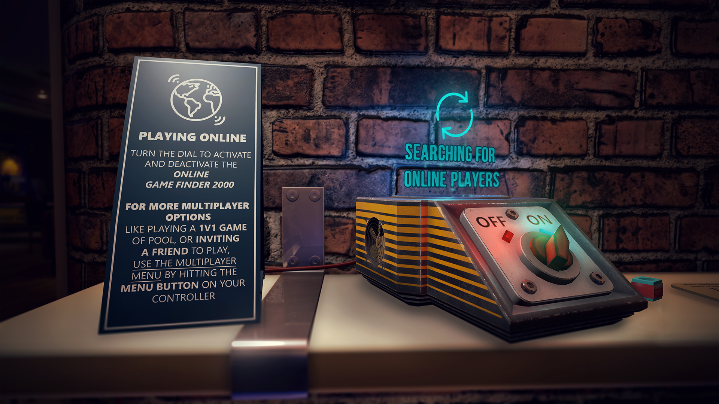
(PERILOUSMATT, 2017)

The menu image above comes from a forum on Steam, this forum talks about UI upgrades and Multiplayer upgrades for the game Sports Bar. The developer has decided to use a retro machine to simulate the player search feature, instead of a menu that just says search for players or something similar. The reason this UI works better for VR is because the player can walk over to the bar and turn the dial if they would like to search for multiplayer games. This type of UI doesn’t work as well in standard games as the player may not think to interact with a box on the table, but in VR the player can see the dial closer and also interact with it with hand movements. This is why VR and Standard UI need to act the same but also be designed better to fit the style of game and the platform it is on.

Overall, VR UI requires a lot of testing and needs to be handled very differently from a standard game. Each platform has its own use for UI, and each one requires different methods to be effective. However, these methods can be used universally. Audio cues can still be a great source of information in standard games, just as much as VR games, additionally pause menus or standard menus can also work in VR, like in Skyrim VR.

Case Study

Skyrim vs Skyrim VR

Bethesda have made a variety of large open world games, one being Elder Scrolls: Skyrim. Skyrim is a very popular game that has been ported and remade various times. It is an open world rpg game that allows the player to kill dragons, do quests, steal from npcs, or play as a model citizen. There are various ways to play Skyrim and more recently a Virtual Reality port. The virtual reality port plays the same as the standard version but of course needs changes to make it work in VR. Porting a standard game to VR requires a good amount of work, and won’t always work out. Below will be a comparison of each major part of the game

UI

Skyrim has a very large UI, that consists of a list in a black menu, that opens sub menus and covers the entire screen. This is one of the biggest complaints about Skyrim, one person stated that “the back end UI of Skyrim is a horrible clunky mess.” (Rossignol, 2011) The menu, is access by pressing ‘Tab’ or ‘Start’ on a gamepad, this allows the player to access their items, the map, weapons, scrolls and more.

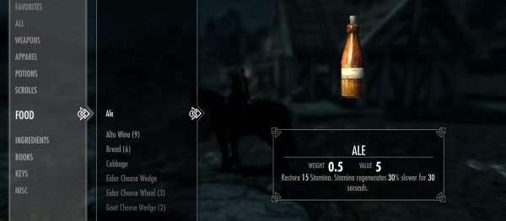
(Rossignol, 2011)

The HUD of Skyrim has an objective tracker in the top middle part of the screen, it is a black bar that tracks the direction the player faces by scrolling through the compass points. There are also a variety of bars that track magic, health, enemy health and more that appear when needed. This means that the screen isn't cluttered with bars the player doesn't need at the time of play. Furthermore, there is a lock pick UI that appears when the player is picking a lock, this UI makes the player play a mini game to unlock the door or chest that they’re trying to pick using the pop up menu.

Skyrim VR needs to play as close to the original as possible, if the gameplay and UI are completely different, returning players may struggle to adapt to the VR style. However, this is hard to do in a menu based game. As previously stated, having pop up menus and floating text can pull players out of the immersion of the virtual world. Skyrim VR struggled with this and got a variety of reviews, with most reviews complaining about the UI. One critic stated that “Menus are just floating, flat boxes that you navigate as if you aren’t in VR at all.” (Jagneaux, 2018) This is facing problems with players because it makes them feel like they're in a game not in the world when the player wants to change weapon. A big black menu will pop up covering the players field of view, the health bars are at their feet floating and the pick locking mini game still pops up on screen. UI in Skyrim VR is the same as the standard version and doesn't attempt to change the UI and HUD to fit VR.

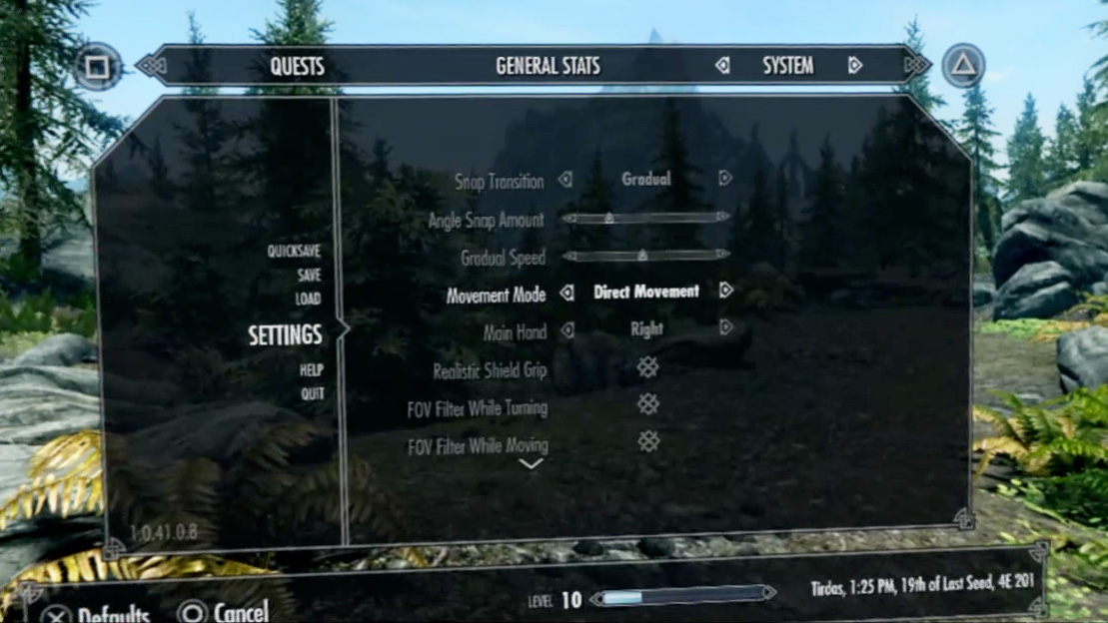
(Skyrim VR UI, 2017)

Gameplay

Skyrim is an Action RPG that allows the player to roam freely in an open world and play through a large story through quests and hunting. However, the player is also allowed to play at their own pace by doing sub quests, pick pocketing npc’s, buying upgrades, learning spells, hunting and killing dragons. A review on Skyrim states that nothing is random and useless in the enormous world, even chewing on a butterfly wing can unlock alchemy recipes for upgrades in the game. (Onyett, 2011), This is the type of gameplay that makes the fans enjoy it so much, the open world and mechanics of the game is the driving point of the good reviews, and Bethesda remaking Skyrim multiple times, even with the VR port. A huge ‘wow’ factor of the game is the dragons, dragons make the game exciting when the appear. Having dragons appear randomly changes the dynamic of the game because the player and the NPC’s will team up to take down the Dragons.

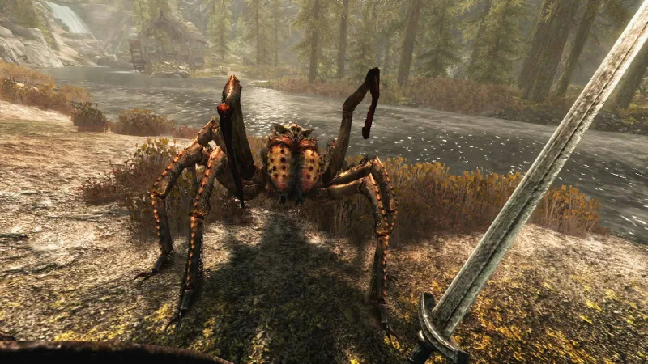
(Alexandra, 2017)

In the VR version of Skyrim. The core gameplay also remains the same, however, a stronger sense of excitement is gained from the VR version as you have the world mounted to your head with a VR headset and can see the vast mountains, environment and towns. Furthermore, IGN stated in a review about the gameplay in vr that “Creatures looking big on screen because is one thing; towering over you is another. I don’t have a particular hangup about spiders, but seeing the huge Frost Spiders in the early dungeons come at me sent chills down my spine.” (Stapleton, 2017) VR has allowed the gameplay to become more immersive, because the player can walk around and explore the world they remember, in full 360 degrees, and can look around at the characters, interact with them, feel tiny compared to a dragon and so much more as the gameplay is converted into VR.

Controls

The controls in skyrim contains sword fighting, lock picking, bow and arrow shooting, magic and ‘shouting’. This combat system allows the player to slash enemies, shoot them, burn them, freeze them and more. A lot of players have experienced mixed reviews with the combat controls. One user on a forum stated “Combat is a huge part of TES and am surprised that Bethesda still can't make combat decent. A sophisticated hit detection system would make combat so much more enjoyable, if I shoot an arrow to someone's leg I want to see them limping and acknowledging that they are injured.” (Birch, 2012) The lack of hit detection can kill immersion for some players and a lot of them have complained about this on forums and also created Mod packs to improve the combat system. However, not everyone has access to mods and have to play with the combat system Bethesda provided. On the other hand, some people are ok with the combat and enjoy it when using the magic and Shouts. These attacks are enjoyed by users because it allows the player to shoot fire or ice for example out of their hands, which is less clunky than a sword. This is one of the other major issues people complain about however, as combat has always been a problem with Elder Scrolls games in the past.
The non combat controls however are easy to carry out as most interactions are carried out with one button, when moving around the world with the analogues the player can open doors, pick locks, search enemies, and walk through doors with a single interact button, this makes exploring the world and progressing through the story, collecting items and stealing from npc’s. A basic overworld control system helps make the players enjoy the game if they are disliking the combat system.

Skyrim VR has two ways to control the game on PlayStation VR, the game can be played with the Dualshock controller, or the Playstation Move controllers. For a more immersive experience it is recommended to play with the move controllers because it allows the player to move their real hands, and see the characters hands move in the same motion, this helps make the player think they are in the game. The Move controllers can be used to move your character by using the analogue stick on the move controller or the player can aim at a position and press a button to teleport. Additionally “The teleportation method is there to prevent motion sickness, but really breaks the immersion and forces awareness of the fact that you are indeed playing a video game.” (Quinn, 2017) The ability to move around the world and see everything move with you with the VR goggles is the best form of immersion VR can offer, and the PS Move can also be used to swing the swords in game to attack enemies, draw the bow and let an arrow fly, or use it to shoot magic out of your hands. This is the most well reviewed method of controlling the game, as the DualShock controller feels the same as playing the standard version of the game. The primary difference in controls comes from the Move’s motion controls allows the player to feel like they’re actually swinging a sword as the sword moves with the players swing and they can experience an in game fight with an NPC instead of just pressing the attack button on a controller. However, the controls aren’t without flaw and users have made sure to right reviews about the controls, Quinn stated later in their review that, the combat in Skyrim VR is both its strength and its weakness, as with the standard version, the melee combat feels imprecise and due to the Move controllers inaccuracy, the gameplay boils down to the player flailing their arms around to actually hit someone with their sword. However, this is still more fun than just pressing a button especially when you simulate holding a giant axe, chopping enemies up.

Comparison

Overall, Skyrim has gone through many ports, remakes and versions since its initial release in 2011. Skyrim being ported to VR was a big change for the Bethesda title, as it allowed the players to experience the game they enjoyed in a new viewpoint. The VR version has a good set of changes to the standard and is overall a good experience according to most reviews. However, it isn’t without its flaws, and still has the same bugs and gameplay issues the original has. However, the port was still a success for the popularity of VR in the gaming industry, the demand for VR games was high enough the Bethesda also ported their game Fallout 4 to VR as well. The standard version of the game had a vast open world that the VR version was able to adopt nicely and make Skyrim look even better than it usually does, in a 3D Stereoscopic view.

The UI was a poor example of VR porting and was one of the biggest issue for immersion in Skyrim VR, the lack of VR friendly UI and HUD prevented Skyrim VR to be as immersive as possible, making the player get reminded about the fact that they are playing a video game, and not in the world of Skyrim. However, some immersion breaking features are indeed needed to avoid the player getting headaches, nausea or seizures with the teleporting feature. It may ruing the immersion but according to reviewers it does help the player avoid getting headaches from exploring the world as they are standing or sitting still whilst simulating motion.

The overall experience based on reviews, mentions that the games play almost identically even when ported from Console/PC to Virtual Reality, bar the obvious motion controls, and teleporting that wasn’t present in the original game, this proves that as a whole it was a successful port to VR and still was able to capture the charm of the original game. This shows that games can be ported to VR successfully, but care is needed to be put into the ports for the game to work in VR, additionally, not every game can be ported to VR as they don’t all fit the same playstyle a VR game offers, for example, a side scrolling platformer like mario wouldn’t work in VR as VR currently doesn’t track leg movements like jumps, and the viewpoint of the player would be awkward as they wouldn’t necessarily be the moving character.

Conclusion

Overall, VR is an emerging technology because it still isn’t developed completely and is still working out any kinks to the games it offers. The VR community is still working towards making good games for the systems that offer a new immersive experience to their gaming. Console games and VR games are able to co-exist as they are able to make their own unique genres and in some cases, make ports of current console games into VR, or have VR modes in the standard edition of the game, like Gran Turismo Sport. Developers still face controversy from consumers and the press as some players have received headaches or gotten sick whilst playing the games. The technology is still being developed and worked on to make the technology a better experience for all users of Virtual Reality.

Bibliography

Books

Adams, A., 2006. Fundamentals of game design. Upper Saddle River, N.J. : Pearson Prentice Hall, c2007..

Websites

Unity. (2018). User Interfaces for VR - Unity. [online] Available at: https://unity3d.com/learn/tutorials/topics/virtual-reality/user-interfaces-vr [Accessed 6 Nov. 2018].

Olotu, T. (2016). A brief guide to UX and UI design in videogames | UserZoom blog. [online] UserZoom. Available at: https://www.userzoom.com/blog/a-brief-guide-to-ux-and-ui-design-in-video-games/ [Accessed 6 Nov. 2018].

O'Boyle, B. and Willings, A. (2018). What is VR? Virtual reality explained. [online] Pocket-lint.com. Available at: https://www.pocket-lint.com/ar-vr/news/136540-what-is-vr-virtual-reality-explained [Accessed 30 Dec. 2018].

Lewis, P. (2016). 5 Virtual Reality Design Considerations - Creating the VR Killer App Part 2. [online] VR Fitness Insider. Available at: https://www.vrfitnessinsider.com/5-virtual-reality-design-considerations-creating-vr-killer-app-part-2/ [Accessed 31 Dec. 2018].

Lewis, P. (2016). 5 Virtual Reality Design Considerations - Creating the VR Killer App Part 1. [online] VR Fitness Insider. Available at: https://www.vrfitnessinsider.com/5-virtual-reality-design-considerations-part1/ [Accessed 4 Jan. 2019].

Hudelson, B. (2018). Designing for VR: A Beginners Guide. [online] Marvel Blog. Available at: https://blog.marvelapp.com/designing-vr-beginners-guide/ [Accessed 7 Jan. 2019].

Langshaw, M. (2014). A look back at Nintendo's Virtual Boy. [online] Digital Spy. Available at: https://www.digitalspy.com/gaming/retro-gaming/a562419/virtual-boy-retrospective-nintendos-disastrous-foray-into-vr/ [Accessed 7 Jan. 2019].

Virtual Reality User Experience and Design. (2018). [Blog] Proto.io. Available at: https://blog.proto.io/virtual-reality-user-experience-design/ [Accessed 8 Jan. 2019].

MCV. (2016). Creating the perfect user interface for VR. [online] Available at: https://www.mcvuk.com/development/creating-the-perfect-user-interface-for-vr [Accessed 10 Jan. 2019].

Rossignol, J. (2011). User Interface: Skyrim’s Silly Choices. [online] Rock Paper Shotgun. Available at: https://www.rockpapershotgun.com/2011/11/14/user-interfarce-skyrims-silly-choices/ [Accessed 11 Jan. 2019].

Jagneaux, D. (2018). The Elder Scrolls V: Skyrim VR (PC) Review – Become the Dragonborn. [online] UploadVR. Available at: https://uploadvr.com/skyrim-vr-rift-vive-pc-review/ [Accessed 11 Jan. 2019].

Onyett, C. (2011). The Elder Scrolls V: Skyrim Review - IGN. [online] IGN. Available at: https://m.uk.ign.com/articles/2011/11/10/the-elder-scrolls-v-skyrim-review [Accessed 11 Jan. 2019].

Stapleton, D. (2017). The Elder Scrolls V: Skyrim VR Review - IGN. [online] IGN. Available at: https://m.uk.ign.com/articles/2017/11/22/the-elder-scrolls-v-skyrim-vr-review [Accessed 11 Jan. 2019].

Birch, J. (2012). No hit detection makes Skyrim combat terrible : V - Skyrim. [online] Gamesas.com. Available at: http://www.gamesas.com/hit-detection-makes-skyrim-combat-terrible-t249248.html [Accessed 11 Jan. 2019].

Quinn, B. (2017). The Elder Scrolls V: Skyrim VR Review: Fresh Ideas, Bad Controls. [online] CGMagazine. Available at: https://www.cgmagonline.com/reviews/elder-scrolls-v-skyrim-vr-review-fresh-ideas-bad-controls/ [Accessed 11 Jan. 2019].

Images

Rossignol, J. (2011). Skyrim UI. [image] Available at: https://www.rockpapershotgun.com/2011/11/14/user-interfarce-skyrims-silly-choices/ [Accessed 12 Jan. 2019].

Skyrim VR UI. (2017). [image] Available at: https://www.resetera.com/threads/skyrim-vr-ot-take-a-coffee-table-to-the-knee.6238/ [Accessed 12 Jan. 2019].

PERILOUSMATT (2017). SportsBar VR Menu. [image] Available at: https://steamcommunity.com/games/269170/announcements/detail/562228356566120178 [Accessed 12 Jan. 2019].

Alexandra, H. (2017). Skyrim VR Spider.. [image] Available at: https://kotaku.com/skyrim-vr-actually-made-me-throw-up-yet-i-want-to-play-1820559231 [Accessed 12 Jan. 2019].

