Use the words from each list to label the parts of the digestive system. What is number one?
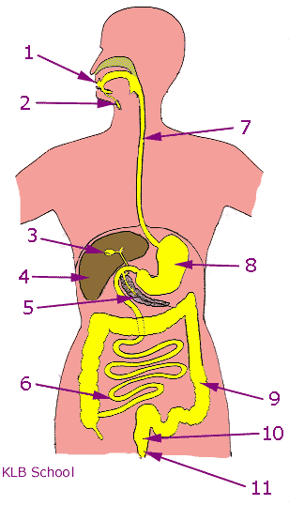
Gall bladder
Rectum
Mouth
Oesophagus/gullet
Large intestine
Liver

2
What is number two?
(1 Point)
Gall bladder
Rectum
Mouth
Small intestine (Ileum)
Oesophagus/gullet
Large intestine
Anus
Liver
Pancreas
Stomach
Salivary glands

3
What is number three?
(1 Point)
Gall bladder
Rectum
Mouth
Small intestine (Ileum)
Oesophagus/gullet
Large intestine
Anus
Liver
Pancreas
Stomach
Salivary glands

4
What is number four?
(1 Point)
Gall bladder
Rectum
Mouth
Small intestine (Ileum)
Oesophagus/gullet
Large intestine
Anus
Liver
Pancreas
Stomach
Salivary glands

5
What is number five?
(1 Point)
Gall bladder
Rectum
Mouth
Small intestine (Ileum)
Oesophagus/gullet
Large intestine
Anus
Liver
Pancreas
Stomach
Salivary glands

6
What is number six?
(1 Point)
Gall bladder
Rectum
Mouth
Small intestine (Ileum)
Oesophagus/gullet
Large intestine
Anus
Liver
Pancreas
Stomach
Salivary glands

7
What is number seven?
(1 Point)
Gall bladder
Rectum
Mouth
Small intestine (Ileum)
Oesophagus/gullet
Large intestine
Anus
Liver
Pancreas
Stomach
Salivary glands

8
What is number eight?
(1 Point)
Gall bladder
Rectum
Mouth
Small intestine (Ileum)
Oesophagus/gullet
Large intestine
Anus
Liver
Pancreas
Stomach
Salivary glands

9
What is number nine?
(1 Point)
Gall bladder
Rectum
Mouth
Small intestine (Ileum)
Oesophagus/gullet
Large intestine
Anus
Liver
Pancreas
Stomach
Salivary glands

10
What is number ten?
(1 Point)
Gall bladder
Rectum
Mouth
Small intestine (Ileum)
Oesophagus/gullet
Large intestine
Anus
Liver
Pancreas
Stomach
Salivary glands

11
What is number 11?
(1 Point)
Gall bladder
Rectum
Mouth
Small intestine (Ileum)
Oesophagus/gullet
Large intestine
Anus
Liver
Pancreas
Stomach
Salivary glands

12
Where is made the carbohydrase enzyme ?
(3 Points)
Salivary glands
Stomach
Pancreas
Small intestine
13
Where is made the protease enzyme ?
(3 Points)
Salivary glands
Stomach
Pancreas
Small intestine
14
Where is made the lipase enzyme ?
(2 Points)
Salivary glands
Stomach
Pancreas
Small intestine

15
The two main tissues in the the digestive system are:
(2 Points)
Muscular
Glandular
16
What tissue made the enzymes to digest the food?
(2 Points)
Glandular
Muscular

