Alexander Apps (1806320)
1806320@student.UWTSD.ac.uk

BA Business and Management -BMSP4004 Generating Business Data and Analysis

Lecturer Dr Roisin Mullins – Assignment 2 –

Due date May 3rd
Essential Concepts and Principles of Modelling and Analysing data

Contents

Executive Summary - Page 2

Introduction to Spreadsheets and Data – Page 3

Spreadsheet Considerations – Page 3 - 5

Spreadsheet Analysis - Page 6 - 7

Stages of Modelling for Spreadsheets – Page 8 - 9

Spreadsheet Analytics - Page 9 - 11

Data visualisation – Page 11 - 14

Conclusion - Strengths of using a spreadsheet for decision making purposes – Page 14

Bibliography – Page 15

Appendices (Analysis of the four Databases showing full Practical Application and Data Modelling)
Page 16 - 29

Executive Summary
The following report discusses the development and benefits of modelling data within a spreadsheet. What we need for its development.
In conclusion, how well can a spreadsheet help a business. But since the spreadsheet’s development no business could really survive without them.
Introduction to Spreadsheets and Data

What is data? The Merriam Webster Dictionary states data as “[the] factual information (such as measurements or statistics) used as a basis for reasoning, discussion, or calculation” (Merriam-Webster, 2019).
Why should we analysis data? When a piece of data is analysed, we begin the process of pattern detection. Hypothetically we ask questions like, how well is a new line of products selling. Data may be different, but the analysis of developing patterns won’t change.
The gathering and understanding of data have become a new language for business. No business could survive without a rigorous understanding of its economic anatomy, data is essential to the sustainable business world.
Simply put without an accurate conceptual modelling and analysis of data, failure would become an inevitability. Data is essential for growth, understanding, predictions and directions, thanks to its usage managers have a sense for action.
Analysing data allows the many questions of business’s to be answered. But what goes into data analysis and visualisation, what categories can we use? Are there stages to modelling data, and what are the essential strengths of spreadsheet usage.

Spreadsheet Considerations

When creating a spreadsheet for the understanding of data patterns, some of the first considerations are the management and collection of relevant data. A spreadsheet is an ideal tool for this, great amounts of data can be accurately stored and collated correctly within one.
Cragg et al states that "A recent study of a sample of organisations that used spreadsheet modelling reported some alarming statistics relating to the poor quality of the models developed “(Cragg et al 1993).
Mather (Mather, 1999) acknowledges that “there is an increasing trend in the current business environment to use a spread-sheet platform to build decision models. The main benefits of developing spreadsheet-based business models are their transparency and portability characteristics.” Mather also suggests that "most spreadsheet users do not follow a framework for model development” (Mather, 1999), this could result in chaotic production and can be easily avoided with developmental processes.
When building a spreadsheet a few concepts will be used in the developmental phase. Firstly, Mather suggests that the creator identify the Input and Outputs. Linking the Input and Outputs should come next this is done through “user-defined intermediate or calculation variables” (IBID). The Carbon database required significant alterations so the requisite calculations could be performed.

Variable Inputs and Logic Flow:
This is data that changes during the required time scale, such as buying patterns during holiday seasons. Swansea business school database has varying times of power consumption shown in appendix.
Deterministic inputs:
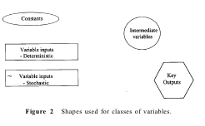
Are where “the material properties are well known to the creator (Joumaa, 2013)”. “A deterministic input, for example, if given the same input information will always produce the same output information.” (Businessdictionary, 2019). Within the Carbon and Weather databases they are shown as the grass tab and the power usage, price and cost effectiveness tab.
“Four different shapes of `bubbles' are used in order to differentiate between constants, variable inputs, intermediate variables and key outputs. A `D' is used to identify a decision input, a tilda or `~' to identify stochastic inputs and an asterisk `*' to indicate a link to a previous or future time period. The shapes are shown in Figure2.” (Mather, 1999)

Stochastic inputs:
Are logic inputs that will be random Biller at al cites that "the selection of a probability distribution to capture the uncertainty in the input environment of a stochastic system. These include the representation of the randomness in the time to failure for a machining process, the time between arrivals, and the demand received for a product of an inventory system” (B. Biller, 2013). This an essential but sometimes a difficult variable to analyse. Shown within the wind data in the Weather database within the appendix.
Constant Inputs:
These are variables that will never change during the duration of proposed project. Shown in the Weather Data base within the appendix.
Intermediate Variables:
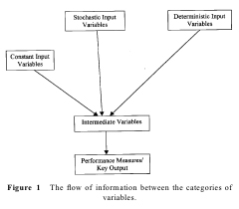
Intermediate variables are used to link input and output data. Mather specifies that “The choice of intermediate variables is subjective, but, as long as the processing is accurate, the actual number of the sevariables is not critical, and it is always better practice to use more rather than less” (Mather, 1999). This allows the creator to further dissect the process into small steps in turn reducing complex formulae’s and reducing erroneous conclusions.
Represented above is a flow of the company’s logic/data between information categories (Mather, 1999)

Performance Measures or Key Outputs:
Specific outputs that are integral to the project, e.g. certain sales.

Test and Audit the Model:
Breaking down the errors in a spreadsheet is onerous. Some tests that are used upon a developed spreadsheet to reduce programming errors are.
Zero Tests:
Set the inputs to zero which will ensure that the output values will be they should be.
Logic Tests:
Increase and decrease input values. This shows what direction the outputs data will be in as well as what errors can be anticipated.
Manual Tests:
“Substitute a series of small, easy to manipulate, values for the inputs and compare a manual calculation of the outputs to those generated by the spreadsheet.” (Mather, 1999)
By auditing a spreadsheet, the creator identifies precedential and dependent equations allowing discovering problems within the formulae.
Mather makes clear that "the framework assumes that the underlying model is a good enough representation of the situation" (Mather, 1999). If the data provided and formulae are accurate then the required task can be completed!

Spreadsheet Analysis

O’Beirne states that “The quality of the data in spreadsheets is less discussed than the structural integrity of the formulas.” (O'Beirne, 2008). This is a concerning factor for a manager and designer how accurate are we and are we becoming obsolescent.
Inaccurate data can cost a company a great amount of resources through inaccurate data sampling. O'Beirne discusses that “In one case $125,000,000: the price of a Mars Climate Orbiter lost in space in September 1999. One team used English units (e.g., inches, feet and pounds) while the other used metric units for a key spacecraft operation. Dr. Edward Weiler, NASA's Associate Administrator for Space Science said "The problem here was not the error, it was the failure of NASA's systems engineering, and the checks and balances in our processes to detect the error. That's why we lost the spacecraft."” (O'Beirne, 2008).
A spreadsheet requires parameters, usually the first task they complete is the preparation or pre-processing of the information for use. It ensures that the data is:
Correct:
Is it highly accurate and up to date? The Swansea database needed cleaning before proceeding.
Countable:
That it will be presented in a format for mathematical analysis. These calculations like SUM, AVERAGE, VLOOKUP and percentage were all used in the 4 databases shown within the appendix
Standardised:
That it has a consistent format, that will eventually be easily applied to said spreadsheet. Shown in the Carbon database appendix.
Non-redundant:
Non redundant data refers to duplicated data. There were many duplicate entries within the prosumer file that needed elimination.
Many companies and situations have large data thresholds which can possess an erroneous character and can be full of contradictions.
By cleaning before the implementation and design process we eliminate many mistakes. Contemporary information (Real Life Data), can easily become riddled with missing values. Differing formats creates havoc at the evaluation step and may contain extreme values having large amounts of redundant data. Cleaning considers the need for consistency in formatting.
Phillip Bewig understands that “You can’t eliminate errors from the spreadsheets you develop, but you can reduce their number.” (Bewig, 2005) and to “Expect errors. As a reader, never pick up a spreadsheet and use it without first assuring yourself it is correct; even following all the principles and techniques suggested here won’t reduce an average 90% error rate to zero, at least not all the time.” (IBID.

So, in what way can we pre-process data:
Manually:
This is a taxing process when the data volume is large, and it may produce additional errors.
Automation:
A faster form of processing; it requires the use of a computer programme. Meaning staff will need programming experience in the use of C/C++ or Java.
Once our data has been refined it may be presented in a consistent format. Many programmes can now be used. Excel is good for statistical analysis along with R SPSS, SciPy, if it is simple Data Classification or Clustering then Weka. Topic or Document Modelling can be explored through Mallet and Wordle and if just organising data then Hadoop, MapReduce or OpenRefine. These are but a few tools for analysis there are plenty more.
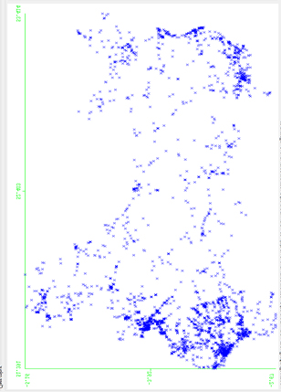
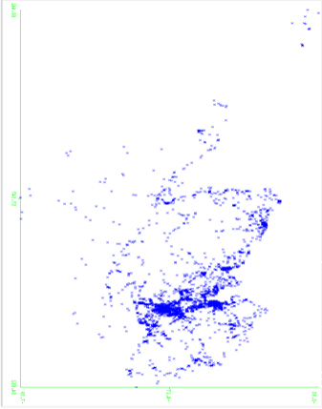
Lastly will need a visualisation expression to show our findings quickly to a larger audience with ease. Weka, Excel and R can create graphs and tables easily. This is essential for greater observance.
Pictured above a visual depiction of crashes within Scotland Wales easy to see which country is shown due to the visual aid of the pictures (data.gov.uk, 2018)

Stages of Modelling for Spreadsheets

“Classically spreadsheets are considered modelling tools and much of the literature deals with questions of forecasting based on historical data or projections based on the expectations of marketing people.” (O'Beirne, 2008)
A manager’s vision starts with a scenario which they wish to break. Incorporating many managerial variables into the breakdown as needed.
Simply a business scenario, say orders, occupy a very generic outlook of what a spreadsheet does.
There are three main stages to a spreadsheet (Edwards 1997)
The Logic Model:
“Is a visual presentation of how your plans, ideas or efforts are supposed to be executed. It would contain an explanation of why your ideas, strategies, and processes are excellent solutions to issues at hand.” (templatelab, 2019) Shown for all databases in the appendix.
The Data Model:
“Is a representation of the data structures in a table for a company’s database and is a very powerful expression of the company's business requirements. This model is the guide used by functional and technical analysts in the design and implementation of a database.” (techopedia, 2019). Data Model this is where data is defined through analysis.
The Presentation model:
Where a visual demonstration of the data is developed showing different types of information against each other and the effect they have on one another. Presentation Models are visual tools, used for conveying complex results quickly. But with its simplification it essentially supresses data but conveys a stronger sense of understanding. But they greatly showcase the modelled data for the human eye easily. Graphs and Pivot tables are all shown in the appendix.

All spreadsheet logic models consist of usually four main components: Variables, Constants, Parameters and Co-efficients.
Variables are protean values within the data that change freely (sales). A Constant is a value within the logical information that will always remain the same, time for example. Parameters are settings for analysis that will surround the data with a relevant delineation, essentially an element whose value is held constant, namely production levels of a work line. Coefficients are areas within the data where there are overlaps between information; staff using the same equipment across two similar departments.
Conceptualise, Verbalise and Formalise any logic model for a spreadsheet. Otherwise nothing will be achieved. The conceptual stage determining the goals and issues that we wish to explore. What modelling techniques will we use is this going to be a complex or simple sheet for the data how much do we need to analyse here and what should we assume about our techniques here are they working, or they need to be changed.
Verbalise where we strictly fix our proposed models for analysis giving for competent completion. Written understandings about the differing types of sales will be shown, what sense of relationship do factors have between each other.
Formalisation, where symbols will be assigned to factors like wind direction. A full showing of the type of units used will be shown and all conventions, will be illuminated.

Spreadsheet Analytics

There are 6 main considerations for spreadsheet analytics,
1) Recognising a problem: (adapted from Adapted from James R Evans (2014))
Problems occur between the sense of observable harnessment and the expectations of what we think we should be observing. Temperatures may be too hot to warrant distribution of certain items within seasons.
2. Defining the problem:
The complexity of this definition increases with: there are many things to be considered, the consideration is tied to a group, problems within the completion of the objectives, groups outside the encompassment could be affected, persons fixing the problem and the person owning the problem are not the same and time is always a factor narrowing all criteria.
3. Structuring the problem:
Once the goals have been agreed upon, the directions for tackling the problems can be chosen and with any extra parameters and constraints being considered.
4. Analyzing the problem:
This is the trial and error part of analytics “such as evaluating different scenarios, analyzing risks associated with various decision alternatives, finding a solution that meets certain goals, or determining an optimal solution.” (IBID)
5. Interpreting results and making a decision:
Modelling data will divulge all the details of the problems at hand, the business must remember that this part of the decision process and the spreadsheet is a tool.
6. Implementing the solution:
Now we have a reflection of the real situation within the model, to implement changes it may require changes like motivation, creating trust, gaining new resources and modifying the structure of the business
The use of analytics in business must meet a few criteriums:
- “data,
- information technology,
- statistical analysis,
- quantitative methods
- mathematical/computer-based models” (IBID)
A manger gains a new vista as to operations and can allowing better fact-based directions.
Spreadsheets now have many applications:
From helping to set price, learning customer demographics, merchandising, locating areas for businesses; who can find the best footfall and social media shows a manager social trends in buying habits and help marketing.
Benefits and Challenges of Business Analytics and its scope within Business:
Benefits, reduced cost, management has a sense of risk, quicker and more precise decisions and morale, efficiency and profitability can increase easily. It comes with challenges “lack of understanding of how to use analytics, competing business priorities, insufficient analytical skills, difficulty in getting good data and sharing information, and not understanding the benefits versus perceived costs of analytics studies.” (IBID)
Scope is a triumvirate.
Descriptive analytics:
This understands the past and present state of the business to make decisions for sustainability.
Predictive analytics:
This is predictive it relies upon relationships within data; determining the best course for future business decisions.
Prescriptive analytics:
The greatest alternative practices needed to increase or decrease objectives.

Data Classes and metrics for Business Analytics:
Data uses Metrics for its class. Metrics are simply a unit that can measure a quantity of performance, measurements the act of obtaining a metrics data and measures the number value of a metric. Discrete metrics are obtained through counts. Continuous metrics based on a continuous sense of measurement “length, time, volume, or weight” (IBID)
Data has 4 main classes:
- “Categorical (nominal) data - sorted into categories according to characteristics. (Different suppliers)
- Ordinal data - ranked according to some relationship to one another. (Order numbers)
- Interval data - ordinal but have constant differences between observations. (Order date or Arrival date)
- Ratio data - continuous and have a natural zero. (Order quantity, order cost)” (IBID)

All data must be accurate and not obsolete and have correct measurements, things like correct orders or asking service desks for the number and time of customer calls will measure the number but not the complaints as many queries may be trivial.

Data visualisation:
Is needed for expedient and immediate clarity. Data visualisation presents the patterned data in a concise manner.
It can provide supervisors and managers with sensibilities that won’t rely so much on programmers and creates a better sense of collaboration and data sharing. (IBID)
Tabular data against visual data (below). Tabulating data allows the determination of sales (how many units sold), in one time period compared to another.
“For example, we see that sales of product A dropped in February, specifically by 6.7% (computed as 1 – B3/B2). Beyond such calculations, however, it is difficult to draw big picture conclusions.” (IBID)
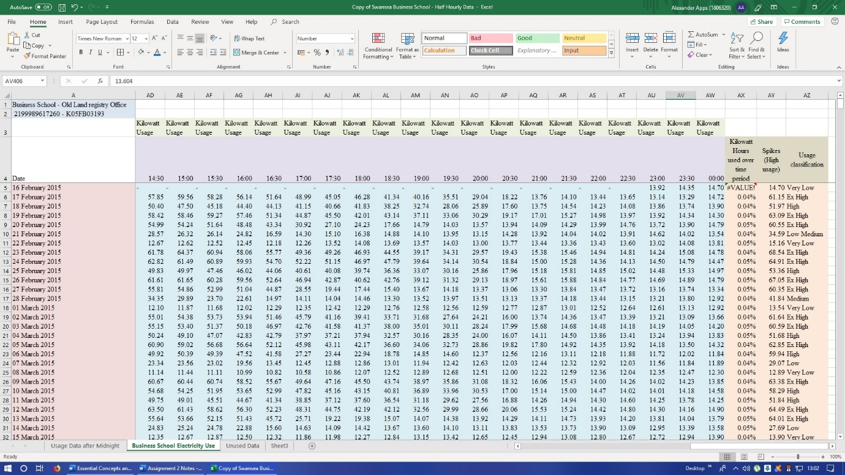
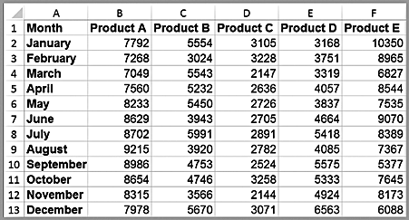

Above a Tabular representation of Data from the Swansea Business School Database Showing Electricity usage and being coloured for easier attention (Examined in greater depth in the Appendix 1).

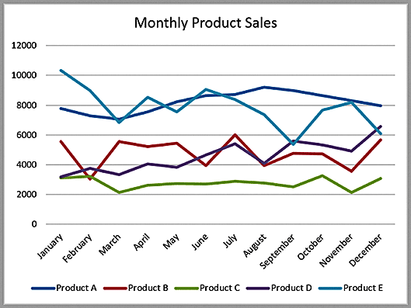
Above the table easily shows to the viewer completed sales and to identify seasonal trends for certain items. Consumer trends can easily be charted here and quickly understood. (IBID)

Dashboards
A great tool for modellers is visually represents a business’s measurements, it gains it designation from a car’s dashboard. This provides a manager with great summaries of business data helping to further manage business functions.
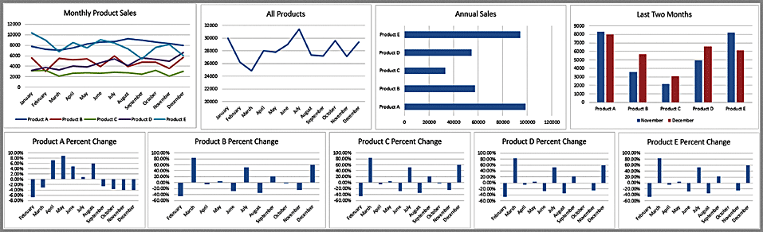
(Evans, 2014)
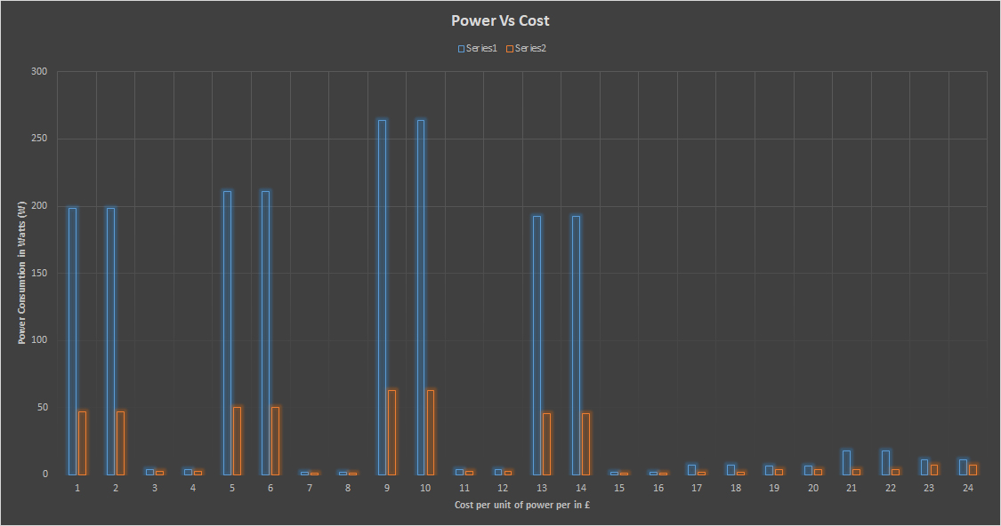
About Column and Bar Charts Evans says, “Column and bar charts are useful for comparing categorical or ordinal data, for illustrating differences between sets of values, and for showing proportions or percentages of a whole.” (IBID)

Example of a line chart from the carbon database shown in greater detail in the appendix

Area charts:
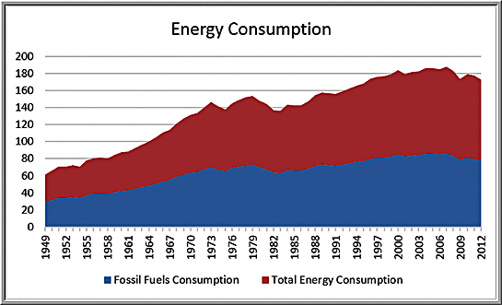
- “An area chart combines the features of a pie chart with those of line charts. Area charts may clutter the observer’s mind with too many details if too many data series are used.” (IBID)
Scatter charts:
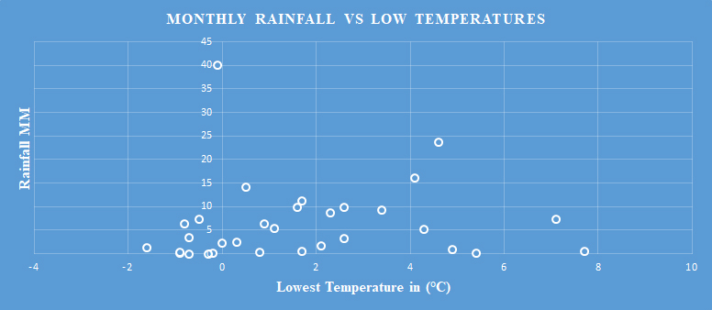
“Scatter charts show the relationship between two variables. Construction requires observations that consist of pairs of variables.” (IBID)
Above a scatter chart from the Weather Data 2018 data base (shown in greater detail in Appendix 2)

Shown above are just a few ways to visualize the patterns that data can. They show manager where their company is headed. But the final decision lies with the person in charge.

Conclusion - Strengths of using a spreadsheet for decision making purposes
In any business strategy and planning are crucial and they required accurate data to thrive sustainably. Choosing the correct tools for the job helps managers make the correct decision, through the analysis and storing of pertinent data patterns over time. (Natter, 2019)
Spreadsheets have the power to collect and visualize data information, even with their limitations. They can correctly categorise data, calculate very quickly and for an entire company they offer multiple groups the same information. They have problems there can be biases from creators, learning the calculation syntax takes a long time and some report a lack of security with the reports, the anatomy of an entire businesses mercantile history is entombed within. (IBID)
However, the pros greatly outnumber the cons. Since its development in 1978 by Dan Bricklin it’s provided great advantages for business. Capable of analysing numbers, monies and statistical patterns, it stores and manages a business central data. Interpreting it and visualizing (Smith, n.d.) . No business could function effectively without them, they have become integral to the decision process, simply put in an accurate spreadsheet we can trust.

Bibliography

B. Biller, A. A. (2013). Encyclopedia of Operations Research and Management Science. In A. A. B. Biller, Stochastic Input Model Selection (pp. 1476-1486). Berlin: Springer.
Bewig, P. L. (2005). How do you know your spreadsheet is right? Principles, Techniques and Practice of Spreadsheet Style. Cornell University.
Businessdictionary. (2019). Deterministic. Retrieved from Businessdictionary.com: http://www.businessdictionary.com/definition/deterministic.html
data.gov.uk. (2018, November 08). Road Safety Data . Retrieved from data.gov.uk: http://data.gov.uk/dataset/road-accidents-safety-data
Edwards John S., F. P. (1997). Decision Making with Computers: The Spreadsheet and Beyond . London: Pitman Publishing.
Evans, J. R. (2014). Business Analytics. Pearson.
Joumaa, H. (2013, October 10th). What is the difference among Deterministic model, Stochastic model and Hybrid model? Retrieved from Researchgate.net: https://www.researchgate.net/post/What_is_the_difference_among_Deterministic_model_Stochastic_model_and_Hybrid_model
King, C. P. (1993). Spreadsheet Modelling Abuse: An Opportunity for OR? The Journal of the Operational Research Society, 743-752.
Mather, D. (1999). A framework for building spreadsheet based decisionmodels. Journal of the Operational Research Society , 70-74.
Merriam-Webster. (2019). Data. Retrieved from Merriam-Webster: https://www.merriam-webster.com/dictionary/data
Natter, E. (2019, January 25). The Advantages & Disadvantages of Spreadsheets. Retrieved from smallbusiness.chron.com: https://smallbusiness.chron.com/advantages-disadvantages-spreadsheets-26551.html
O'Beirne, P. (2008). Information and Data Quality in Spreadsheets . European Spreadsheet Risks Interest Group.
Smith, S. (n.d.). The Advantages of Using Spreadsheets. Retrieved from yourbusiness.azcentral.com: https://yourbusiness.azcentral.com/advantages-using-spreadsheets-3647.html
techopedia. (2019). Data Modeling. Retrieved from techopedia: https://www.techopedia.com/definition/14/data-modeling
templatelab. (2019). More than 40 Logic Model Templates & Examples. Retrieved from templatelab: http://templatelab.com/logic-model/#Logic_Models_Examples

Appendix
Appendix 1: Swansea Business School Database stages of Data Modelling
Pictured above is the Swansea Business School Database maximum and minimum usage of the day has been calculated in a percentage using the formula =(B900/$AB$919) to establish these factors. Sperate data has been given its own colours that are not too harsh upon the eye. The recorded data was then tidied or cleaned to 2 decimal places. Kilowatt per half hour were recorded at the top and Spikes were recorded using the =MAX(B914:AW914) formula. In cell AX5 a comment was placed due to not enough data being available for a full day.
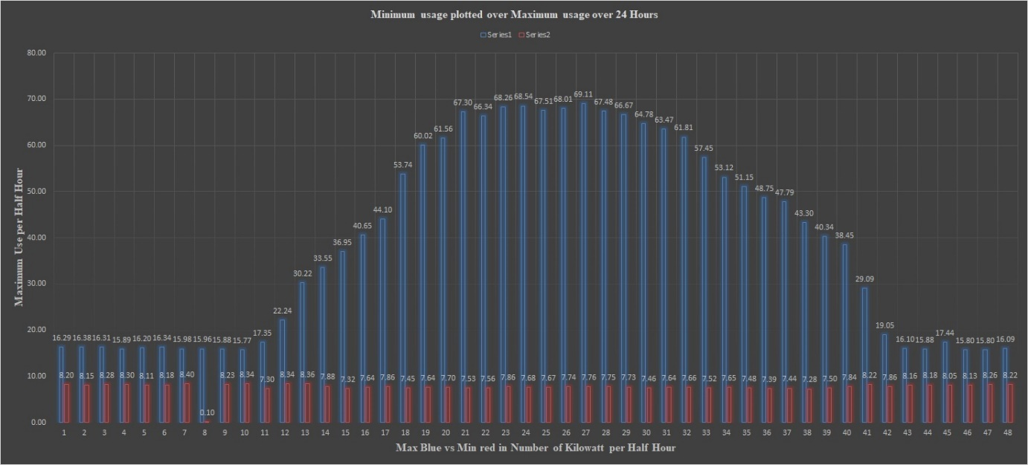
Shown here is an easy visual representation created through Microsoft Excel It shows Electrical consumption in Kilowatts per half hour for Max consumption Vs Min consumption. It could help a manager see where the greatest need is.
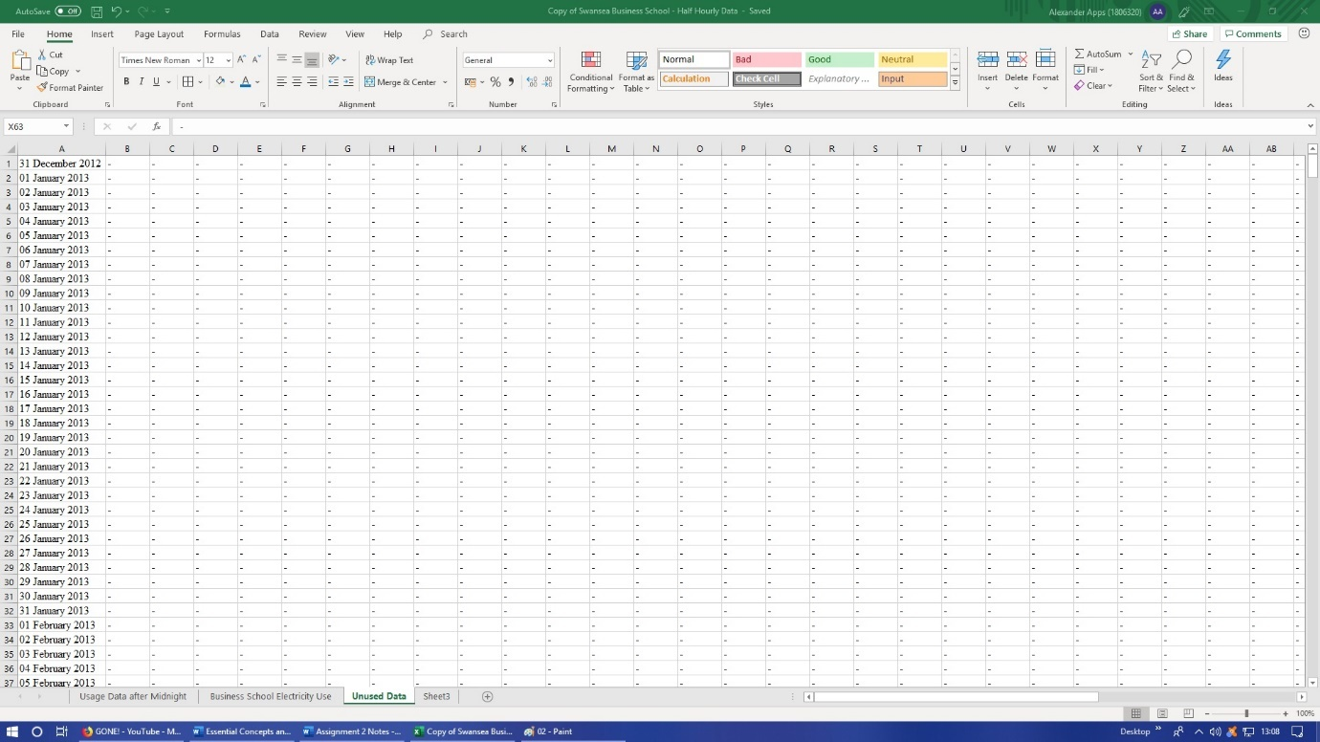
All Redundant data was captured and presented within a separate tab
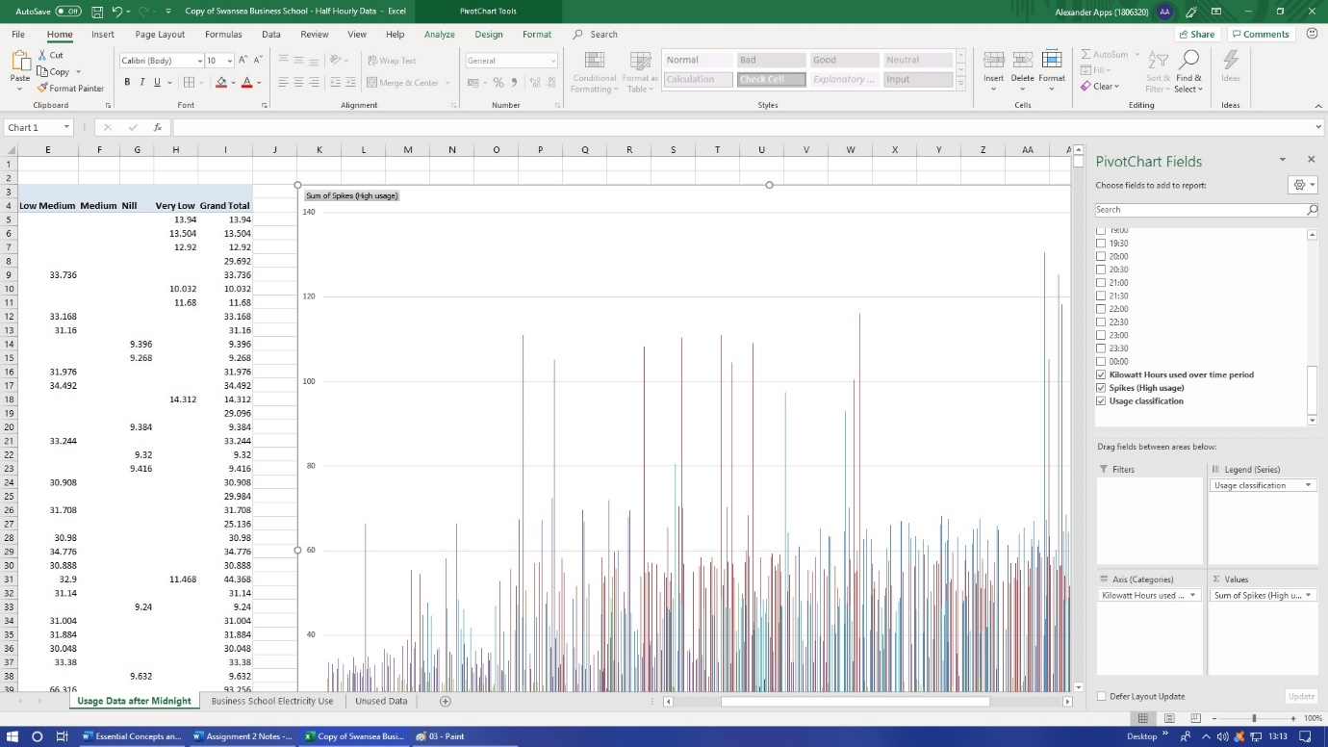
A Pivot table was created to show relevant information of electrical consumption after midnight against kilowatt use overtime on a separate tab
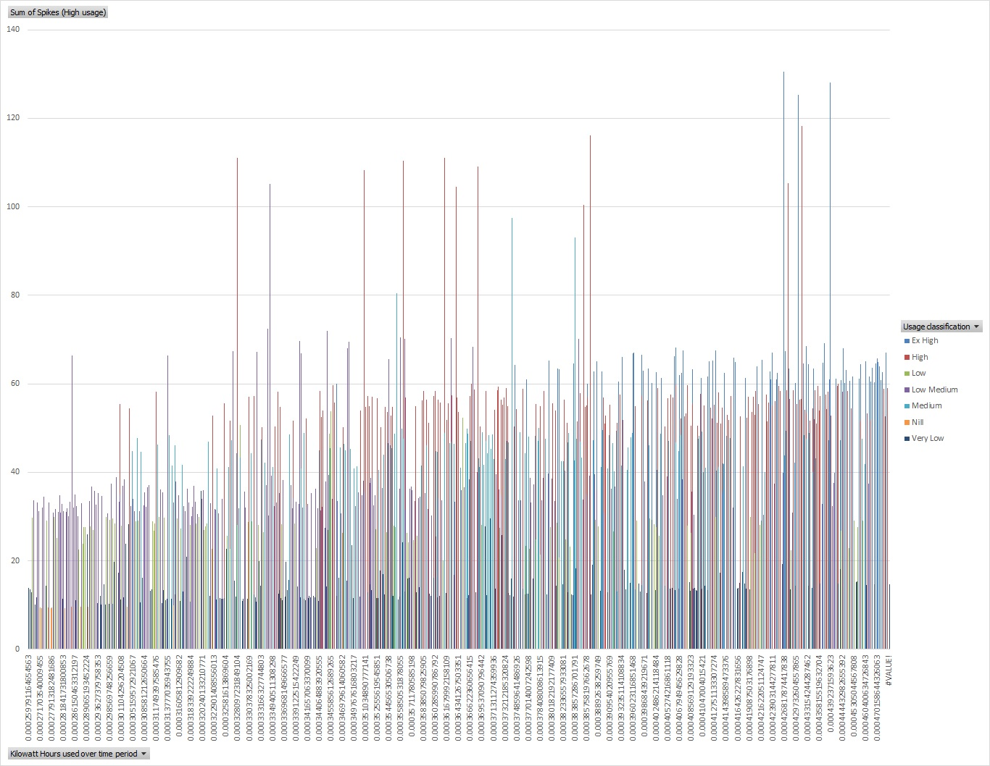
A better showcase of the Pivot Table shown directly above

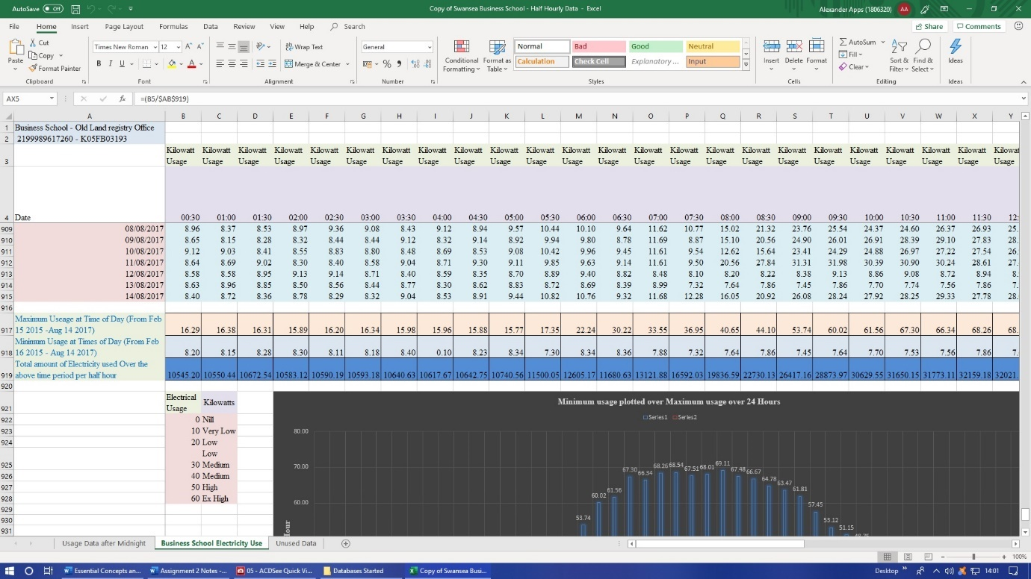
Above. easy calculations reveal Max, Min and Total using the respective formulas of =MAX(B5:B915), =MIN(B5:B915) and =SUM(B5:B915) to calculate relevant numbers, with the B numbers representing recorded range.
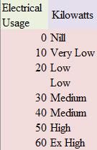
Lastly the VLOOKUP formula was used to determine the level of electrical use =VLOOKUP(AY908,$B$922:$B$928:$C$922:$C$928,2) starting with the requisite initial cell followed by the table (shown above), while using the F4 function for clarity then specifying the number of columns 2 for the formula to work
Appendix 2: Weather Data 2018 stages of Data Modelling
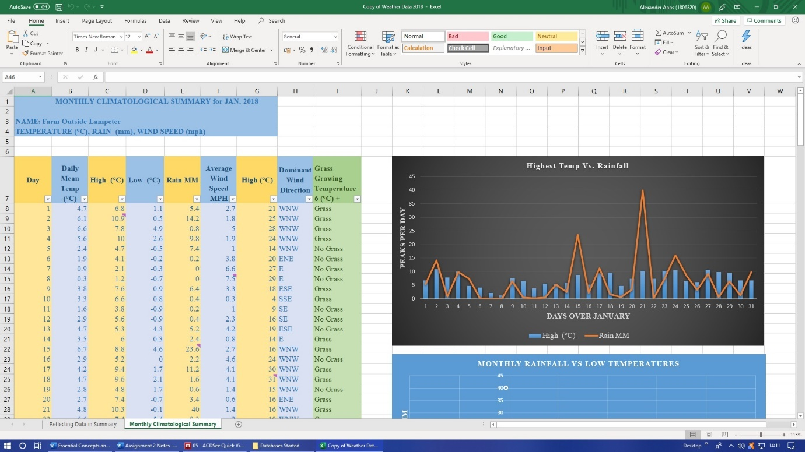
Data was given MM and (°C) to define the data, Minimum’s and Maximum’s were shown for the month through relevant comments data was coloured for easier direction and a grass table was added, for the temperature of 6 (°C) (The temperature that grass begins to grow at)

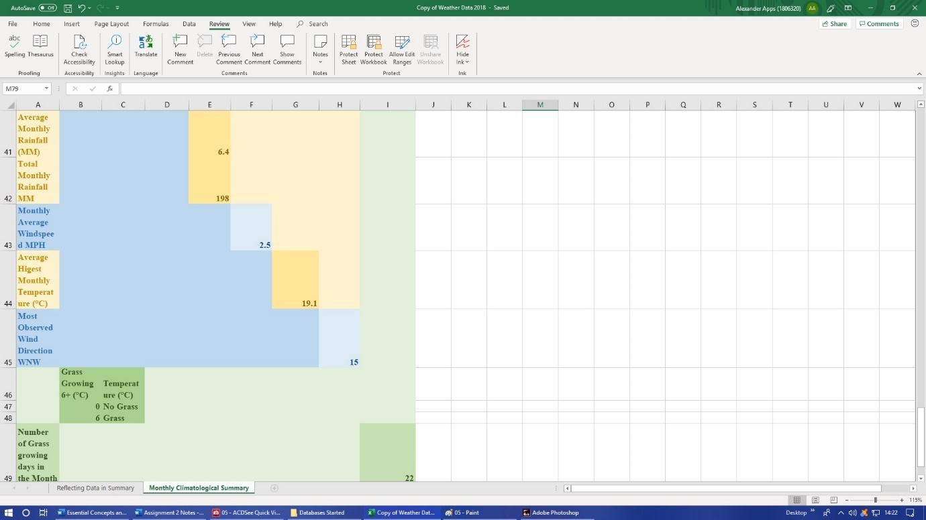

The AVERAGE =AVERAGE(B8:B38) calculation was used to determine average daily temperature, average monthly temperature, average monthly rainfall and average windspeed.
The SUM =SUM(E8:E38) formula was used to determine total monthly rainfall the highest observed temperature within the month.
Also, the VLOOKUP formula was used to determine if grass would grow if the temperature was above 6 (°C) on a specific day. Incorporating the table below for the formula to work.
Comments were also placed on Max and Min designations.
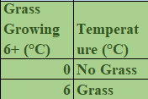

This table was essential to the VLOOKUP formula to work

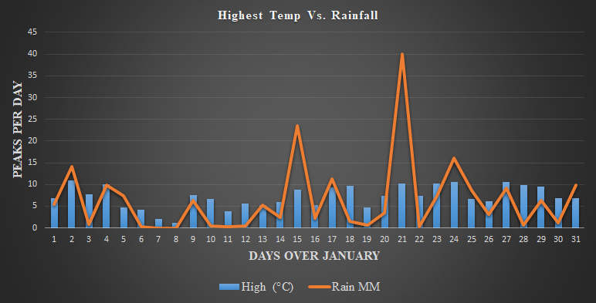
Above Excel was able to create a graph of rainfall vs high temperatures over a monthly period that is visually appealing and visually vocal for the manager or whomever needs this relevant information.

Another graph here a scatter diagram quickly shows where the highest concentration of rainfall is when the temperature is at its lowest is leading the eye quickly to it.

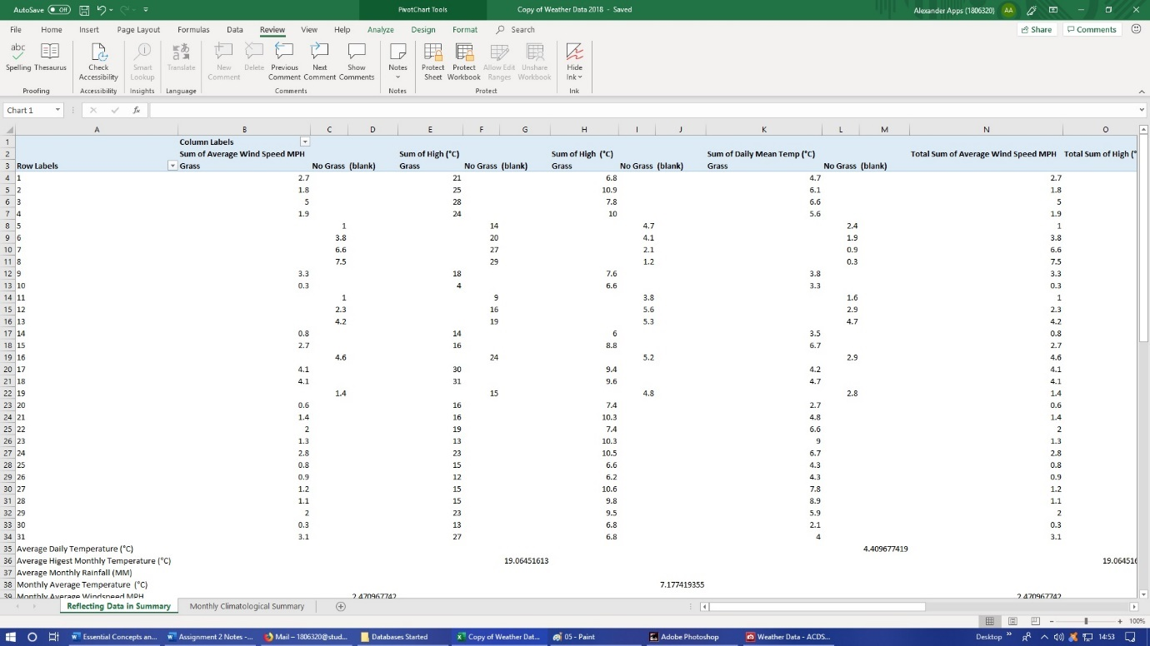
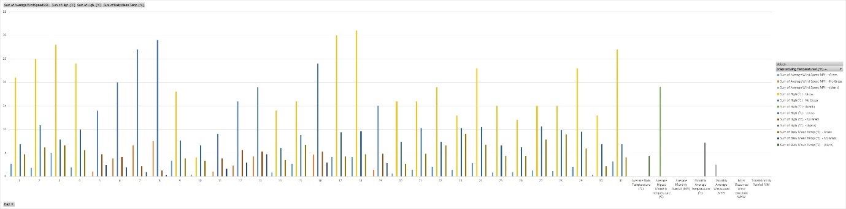
A Pivot table was created showing the best days for grass plus highest temperatures within the month and its graphical equivalent.

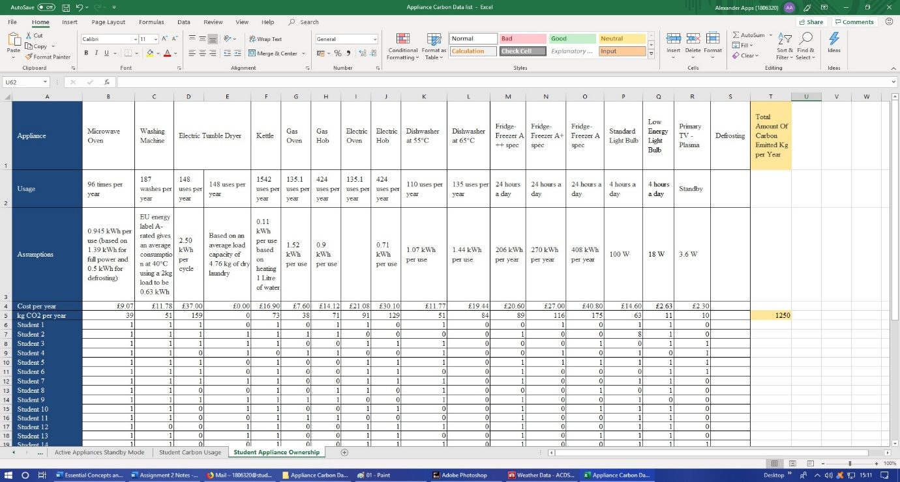
Appendix 3: Appliance Carbon Data list stages of Data Modelling
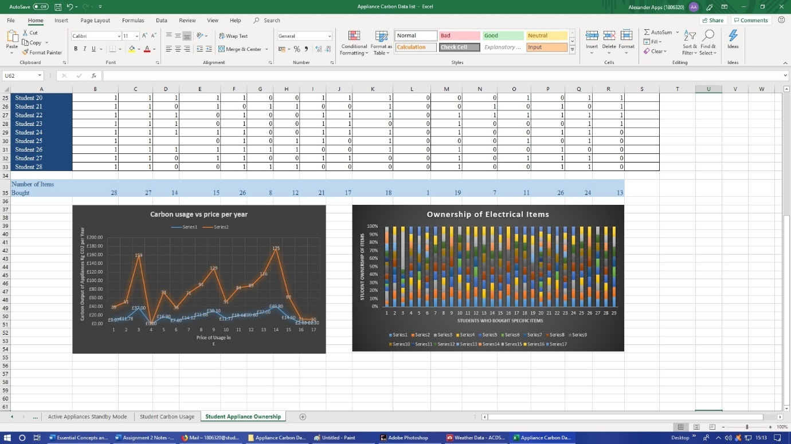

For the third database the data was first cleaned by separating cells and including zeros and occasionally ones to keep the info correct. The number of kettles bought, and carbon emitted was calculated using the SUM function.
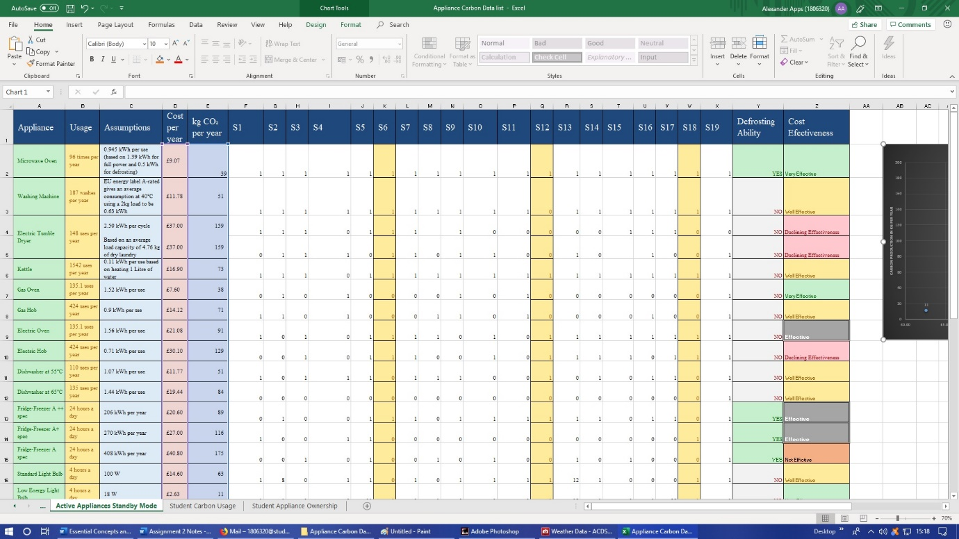
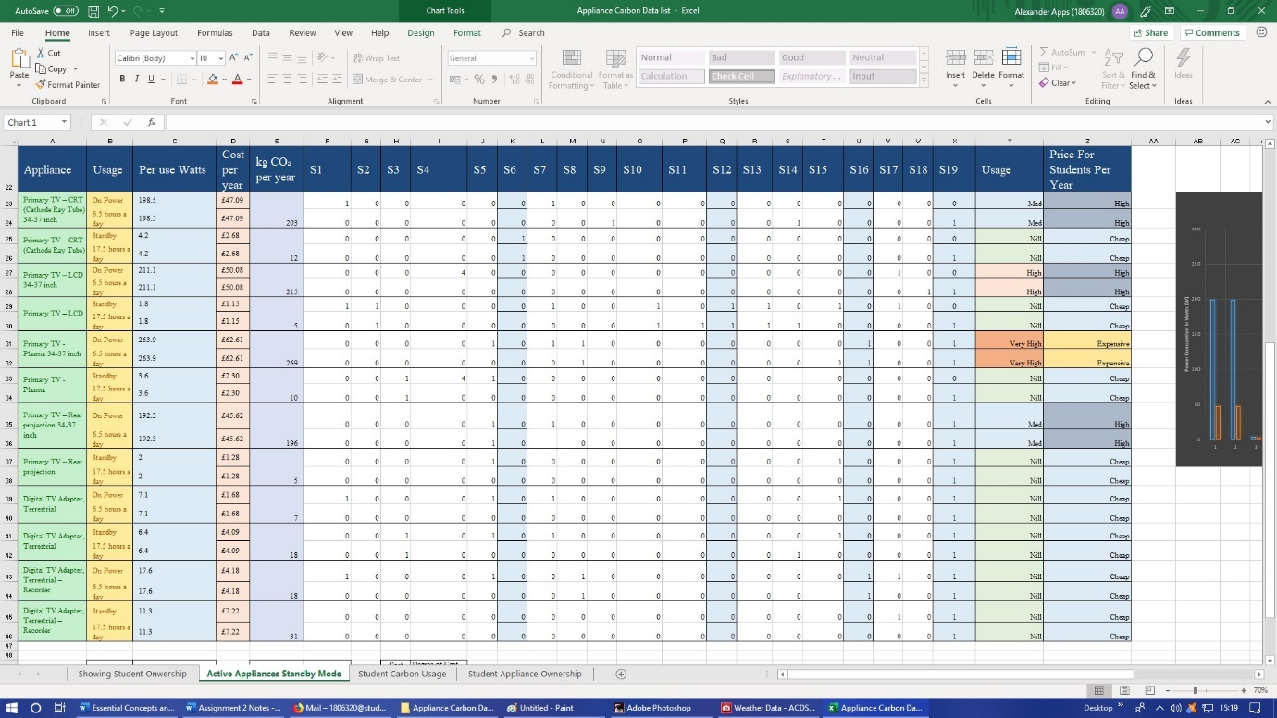
Show respectively in the above 2 pictures. The information upon this spreadsheet has been cleaned and coloured for easier scrutiny. 2 new lines of analysis have been added to the spreadsheet: Defrosting Ability, Cost Effectiveness, Power Usage and Price for Students per Year.
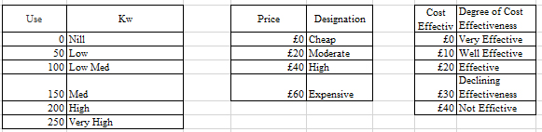
These tables were used in VLOOKUP function to create the lines of analysis

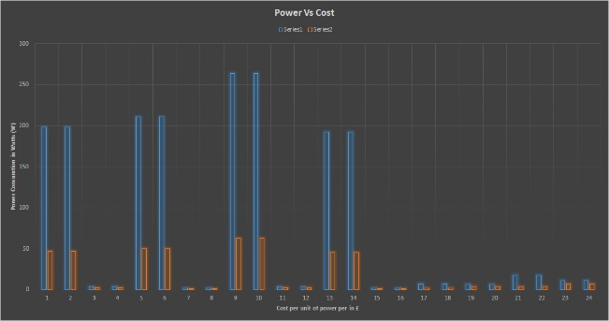
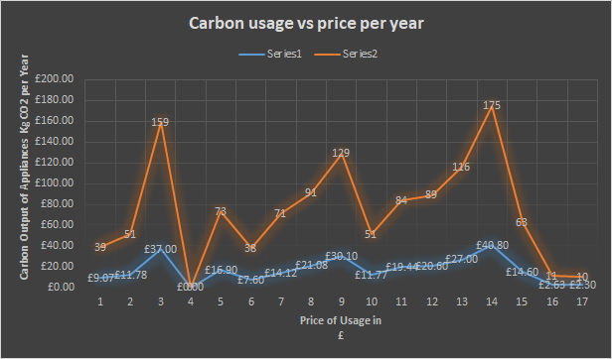
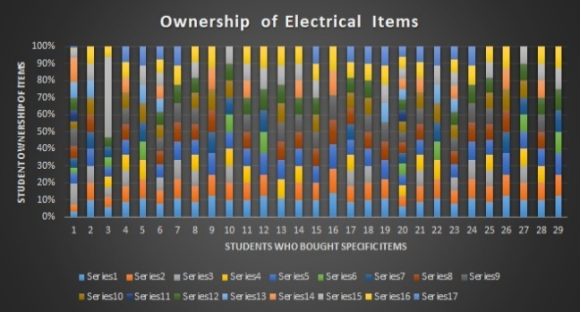
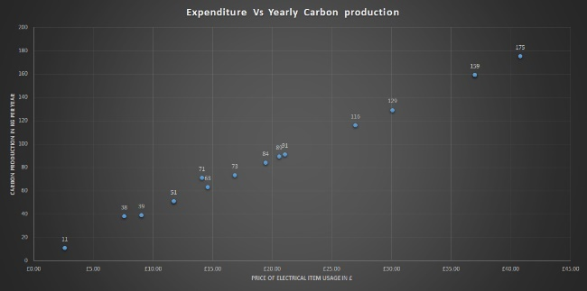

Four graphs were created through Excel. Respectively, measuring carbon usage against price power vs cost, student ownership of electrical items and expenditure vs yearly carbon production. All of these will give a manager a greater understanding of where buying habits and student consumption are.

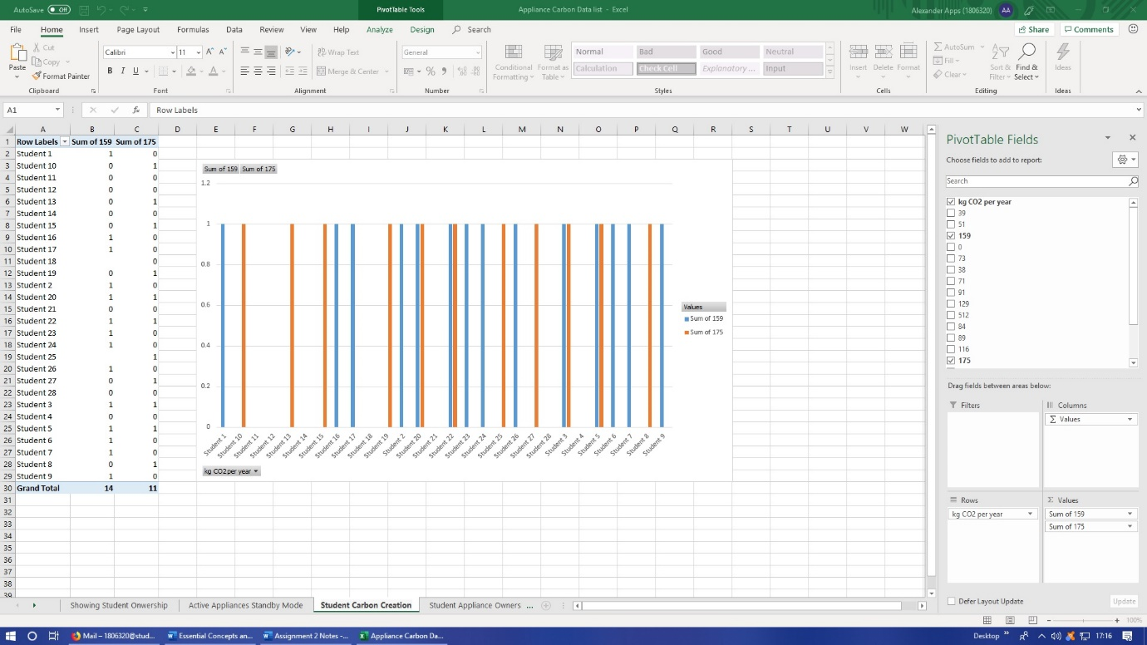
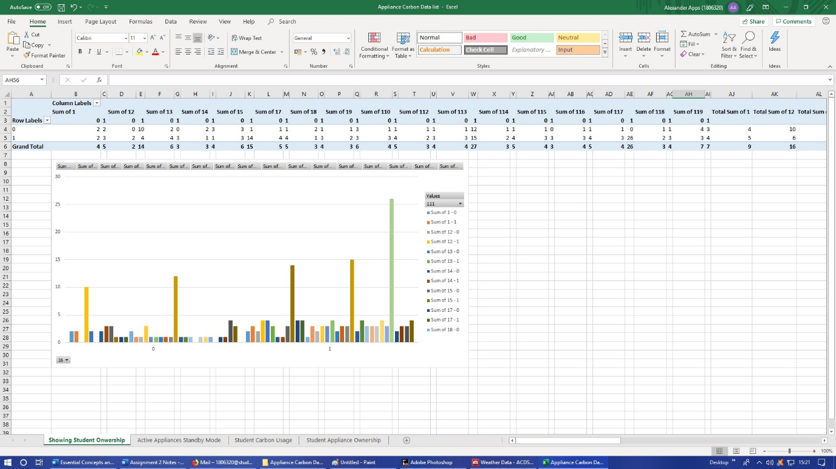

Lastly two Pivot tables were created showing Student Carbon Creation, and Student Ownership of certain electrical appliances

Appendix 4: Prosumer Database stages of Data Modelling

Duplicate information was removed from the Prosumer database and added to an additional tab. Comments were place upon the company that employs the most people. The Max and MIN formula was used within the database COUNTIF filter was used to determine the differing size of companies on the ICT tab to determine if they used Facebook all relevant data as shown in the pictures below.
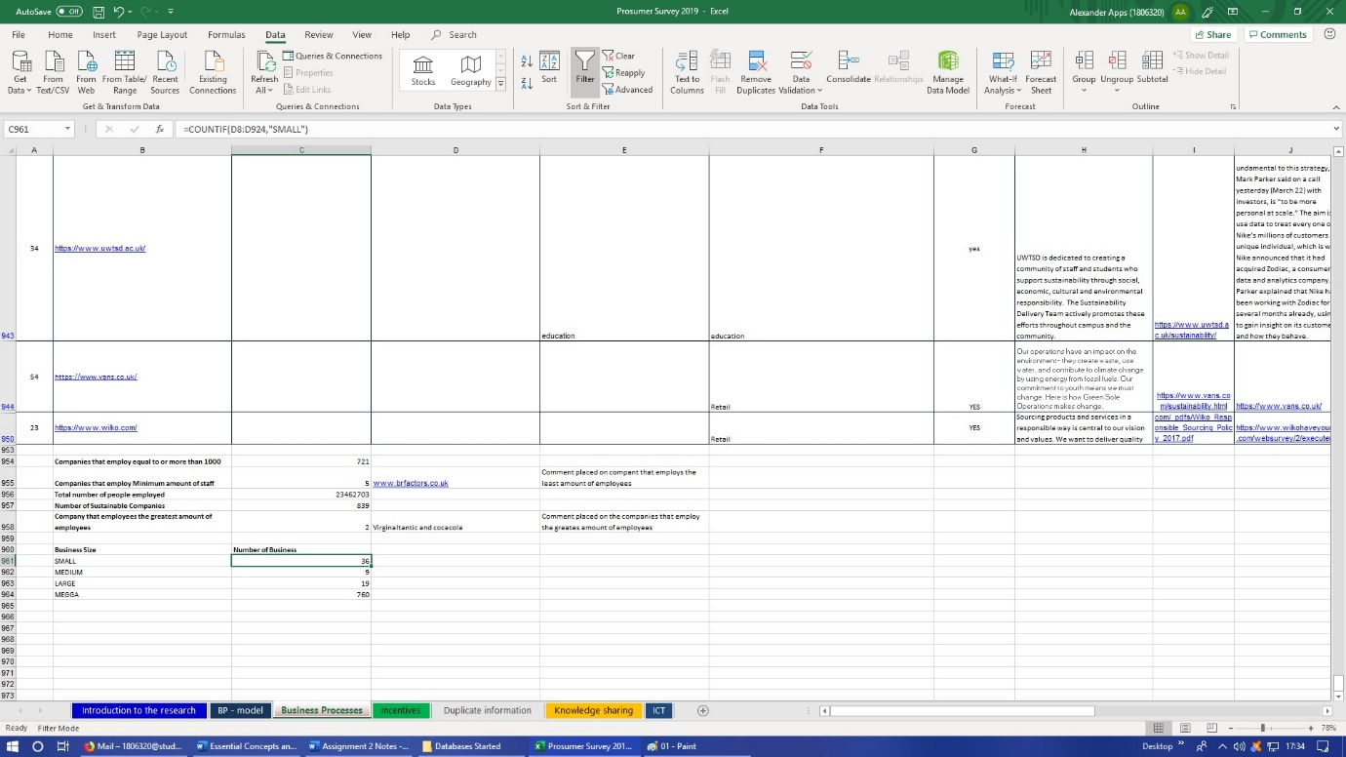
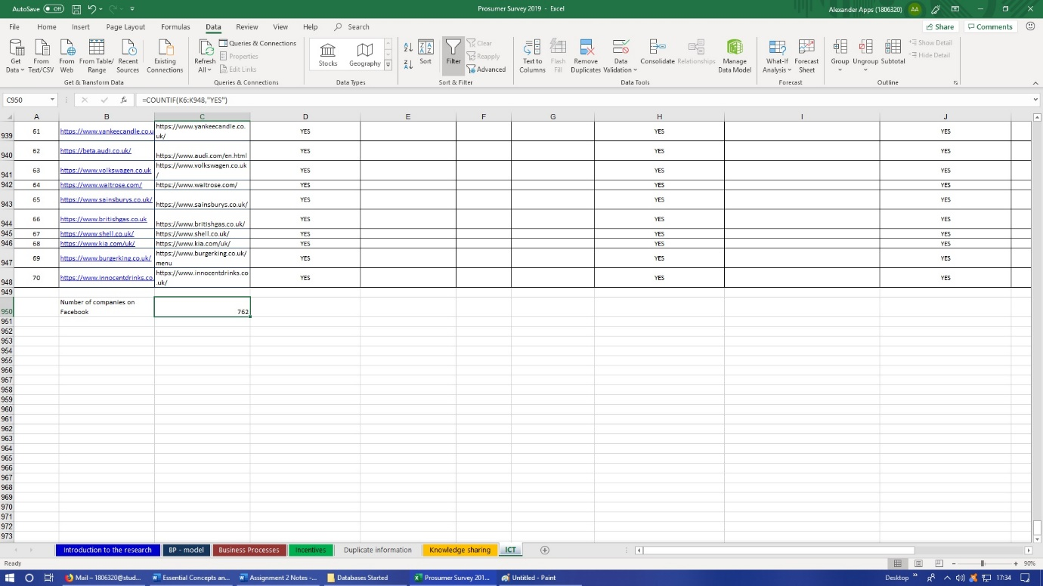

Below some of the tabs filled with duplicate information bottom picture shows gathered information using the COUNTIF filter.


