Master of Business Administration

Human Capital Management
(LCMB7023)

Lecturer: Dr Eno Maycock

Student Name : Patel Jeel Vipulbhai

Student Id No. : 2534779
Word Count : 2545

Contents

1. Introduction ............................................................................................................ 02
2. Task A: Socialisation, Identity & Business Activism ......................................... 02
- 2.1 ……………………………………………………………………..…………....... 02
- 2.2 ……………………………………………………………………....................... 05
- 2.3 …………………………………………………………………........................... 06
3. Task B: Job Design ............................................................................................... 07
- 3.1 …………………………………………………………………........................... 07
- 3.2 ……………………………………………………………………....................... 08
4. Task C: Reflective Report ..................................................................................... 10
- 4.1 ………………………………………………………………............................... 10
- 4.2 …………………………………………............................................................ 10
5. Conclusion …………………………..........................................................................11
6. References ..............................................................................................................12

Helios Urban Mobility (HUM)
Business Nature and Complexity: As we mentioned, Helios is not a typical app development company. It works on high-tech things like AI, electric vehicles, and smart-city analytics, which is a very responsible job.

Geographical Challenges: The company’s culture is not consistent due to the distance and cultural differences between London, Berlin, and Singapore, which we called ‘Cultural Fragmentation’.

Severity of Problems:

8 months: The company’s money is wasted and government contracts are not completed on time.

54% Engagement: Half of the employees work just for the salary, not interested in the company’s growth.

Graduates leaving the job: The company is losing its future leaders.

TASK A: Socialisation, Identity & Business Activism (≈1,000 words)
Traditional onboarding and strategic socialization are two diametrically opposed approaches to human capital management (Klein & Heuser, 2008). Traditional onboarding is an administrative and short-term process that focuses only on paperwork—such as setting up laptops and signing rules. In contrast, strategic socialization is a long-term and multi-dimensional transformation that uses systematic mentoring and specific goals to transform an unknown employee into a loyal company citizen (Bauer, 2010). Helios Urban Mobility must abandon its outdated onboarding method, as leaving graduate employees stranded in separate regional offices has resulted in 8 months of operational learning delay (waste time) in the company and employee engagement has dropped to 54%.

- Critically evaluate traditional onboarding versus strategic organisational socialisation (Relevant theories: Van Maanen & Schein; psychological contract theory; identity construction).
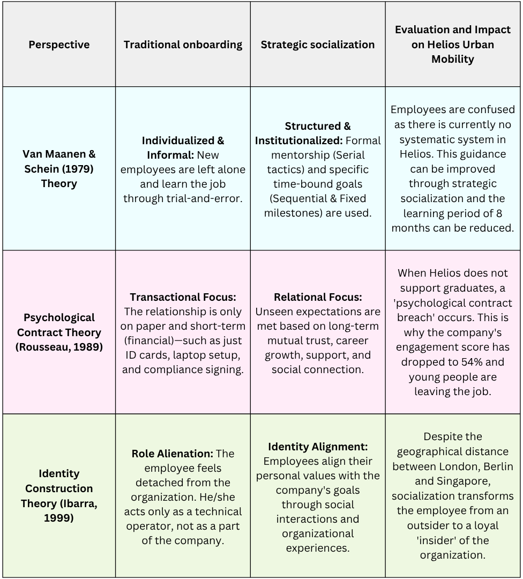

This one-year plan directly addresses Helios' key issues—such as 8 months of wasted time, distance between offices, and 54% employee attrition—by replacing the old system with a streamlined process.

1st-Year Strategic Socialization Framework

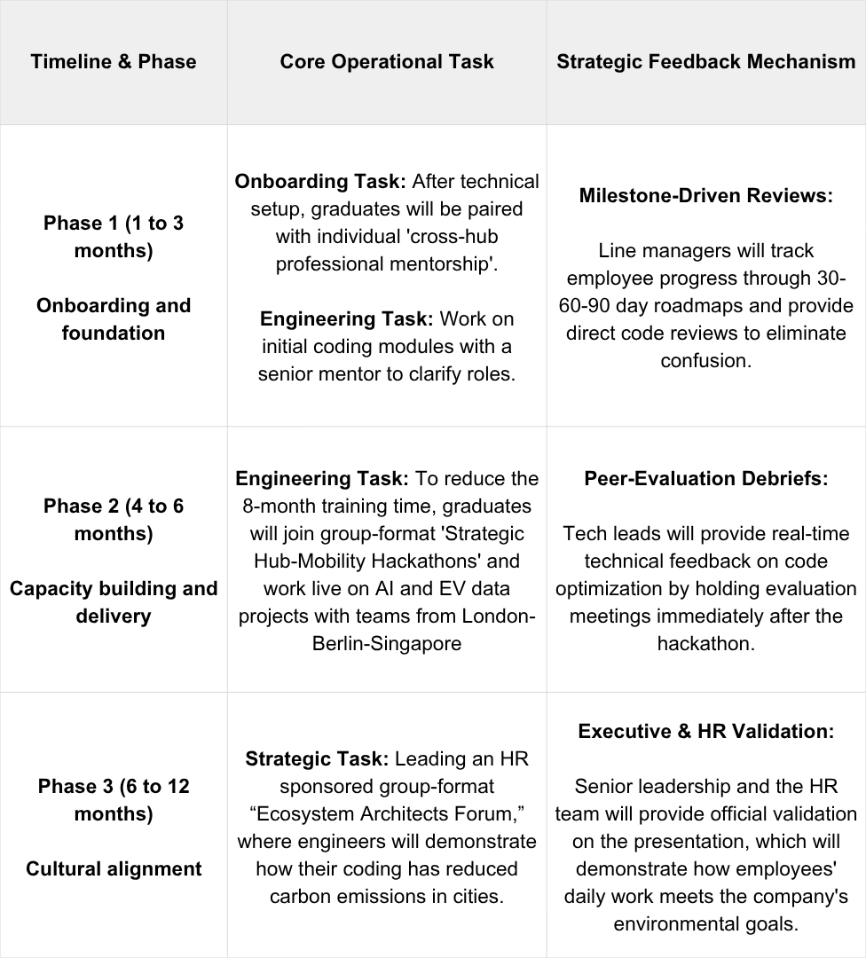

Strategic Justification - Commercial and strategic reason:

The main reason for incorporating this goal-based roadmap into the assignment is to make the socialization process data-informed rather than trial-and-error. By clarifying the specific activities, group or individual formats, and the roles of their owners (i.e. HR, mentors, and graduates), Helios will be able to create a strong environment that will restore employee trust, bridge the gap between offices, and successfully reduce the long 8-month training period in London, Berlin, and Singapore.

- Design a structured socialisation framework for Helios (pre-boarding → first 90 days → year one). Justify your decision.
Introduction:
Helios is currently facing serious issues like poor onboarding practices, a long 8-month learning curve for employees, low engagement scores (54%), and attrition among new graduates. Therefore, it is imperative to create this structured socialization framework across all offices of the company to ensure engagement, loyalty, and long-term retention of new employees.
Framework Design

Stage 1: Pre-boarding (before the day of starting the job)
Helios will launch a digital portal that will showcase the company’s culture, mission and values. This will include a welcome video from the CEO, early job expectations and basic AI-mobility modules. Assigning a Peer Buddy/Mentor before starting the job reduces employee anxiety. According to Rousseau’s Psychological Contract Theory (1989), this early communication builds a strong sense of trust and positive expectations towards the company from day one.

Stage 2: First 30 Days (Orientation and Cultural Engagement)
This phase will include a structured induction program, culture workshops and introduction to the teams in London, Berlin and Singapore offices. Along with this, meetings with senior leaders and shadowing with experienced employees will be held. This not only teaches the employee technical work, but also integrates into the company culture and removes his confusion. This entire process is part of the formal and serial strategy of Van Manen and Schein (1979) which makes the employee feel like a member of the company.

Stage 3: 31 to 90 days (Capability Building)
In this stage, graduates will be directly placed on live projects instead of giving fake work. Feedback sessions, continuous mentorship and projects to work with different teams will be given every week. This will help the new employee to directly do productive work instead of just learning, which will increase his confidence. With this active learning method, the 8 months of learning time (Ramp-up time) that the company wastes can be reduced to a great extent.

Stage 4: 1 year (Employee retention and identity building)
For long-term engagement, graduates will be provided with smart-mobility innovation projects, leadership development programs, opportunities to work with international offices, and career planning and an award system. With this ongoing support, talented young people will not run away from the job. According to Ibarra's Identity Construction Theory (1999), all these experiences help the employee connect his or her own personal goals with the larger goals of the company, so that he or she begins to consider himself or herself a loyal part of the company.
This systematic framework transforms Helios’ onboarding from a paper-based process in the first week to a long-term development journey. By providing pre-employment engagement, early days mentoring, and ongoing development opportunities, the framework reduces employee anxiety, strengthens the psychological contract, and helps employees align with the company. As a result, the framework directly addresses Helios’ key issues—long learning curve, low engagement (54%), and high graduate attrition rates.

- Propose mechanisms to cultivate:
A. Organizational Identification
To foster a deep organizational identity across all international hubs, Helios should launch ongoing story-sharing forums and cross-border innovation labs. According to identity construction theory (Ibarra, 1999), professional identity is shaped by social experiences. By involving software developers in eco-friendly smart-mobility projects rather than just giving them a daily job, their personal engineering values ​​are directly linked to the company’s environmental mission, making employees loyal members of the company.

B. Ethical Professionalism
Helios should provide psychological safety in the workplace by creating anonymous compliance channels and a peer-review system. According to the Psychological Contract Theory (Rousseau, 1989), ethical behavior is sustained only when employees are confident that the organization will deliver on its invisible social promises. Providing such a systematic feedback system makes it clear that coding rules, ethical values, and security are being strictly followed without any fear.

C. “Business Activist” Mindset
To instill a “business activist” mindset in employees, Helios should create a collective task force across departments and the criteria of stakeholder capitalism. This reflects the evolutionary model of Dave Ulrich (2013), an HR business partner, where employees actively challenge company strategies and protect social and environmental interests rather than just doing administrative work. By training engineers to analyze the environmental impacts of projects rather than just coding, they become long-term corporate citizens.

TASK B: Job Design (≈1,000 words)

- Propose an innovative job design strategy using Job Characteristics Model, Job crafting theory, and Skills-based architecture or internal talent marketplaces.

To address Helios’ operational weaknesses—particularly its long 8-month ramp-up period and low engagement score (54%)—the company will need to move away from old, rigid methods and embrace a modern, flexible job design. The strategy includes Hackman and Oldham’s Job Characteristics Model (JCM), Wrześniewski and Dutton’s Job Crafting Theory, and an AI-powered Internal Talent Marketplace (ITM). The plan bridges geographical boundaries and connects offices in London, Berlin, and Singapore with a digital network.

- Structural change through the Job Characteristics Model (JCM)
Using the JCM model (Hackman & Oldham, 1976; Parker et al., 2019), Helios should make the following changes to the way its software engineers work to increase their motivation:

Skill Variety & Task Identity: Instead of giving new graduates only boring tasks like debugging, they should be given entire smart-mobility modules (like route optimization systems). Engineers will use different skills (AI modeling, cloud, data visualization) and will take on the entire responsibility from the beginning of the project to going live (task identity).

Task Significance: Helios should link the engineers’ coding to the benefits of the environment. Developers should be shown live statistics showing how much carbon emissions have been reduced in the city by their algorithms, so that they understand the social significance of their work.

Autonomy & Feedback: Engineers should be given the freedom to find their own path and solve problems by removing the strict rules of managers. Along with this, instant and accurate feedback should be given by having automated code-testing and weekly review meetings with seniors.

- Freedom to work through job crafting theory
JCM defines job structure, while job crafting theory (Wrzesniewski & Dutton, 2001) empowers software engineers to change their jobs from the bottom-up:

Task Crafting: Graduates should be given the autonomy to spend 20% of their working time on micro-projects of their choice or solving technical challenges for Helios.

Relational Crafting: Engineers should be allowed to form their own teams between the London, Berlin and Singapore hubs to exchange knowledge and strengthen relationships.

Cognitive Crafting: Employees need to change their identity. They see themselves as "ecosystem architects" who protect the environment, rather than just ordinary coders.

- Implementation of Internal Talent Marketplace (ITM)
To bring all these theories together, Helios will create a digital Internal Talent Marketplace (ITM) platform (Boudreau & Jesuthasan, 2021). The old positions like ‘Junior Developer’ will be removed from the company.

Project managers from all three global offices will divide their big projects into small gigs (short-term work) and post them on this platform and write the required skills (like Python, Machine Learning). Graduate engineers will be able to view these international projects as per their choice and career goals and apply (Bid) to work in them.

This digital system will bridge the gap between offices, new employees will get global exposure from day one, and this same process will reduce their 8-month long learning period (ramp-up time) and make the job an exciting journey.

- Explain how your design will stimulate intrinsic motivation and support innovation.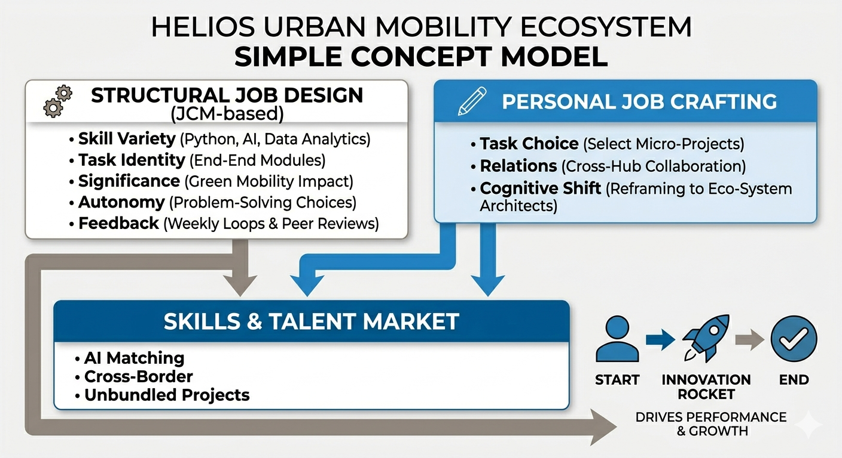
(Integrated Job Design For Helios. Generated using Gemini AI, June 2026 Google. (2026).)

This new job design plan meets the psychological needs of employees working in Helios, inspiring them to work from within and helping them come up with innovative ideas.

Increase Intrinsic Motivation
According to Self-Determination Theory (SDT - Deci & Ryan, 2000), an employee’s intrinsic motivation to work arises only when their three core psychological needs are met: Autonomy, Competence, and Relatedness. This plan directly addresses all three of these:

Autonomy: Thanks to the Internal Talent Marketplace (ITM) and job crafting, software graduates are no longer under the strict command of managers. By giving them the freedom to choose their own projects and set their own daily work schedules, they feel more responsible for their work.

Competence: Thanks to the skills-based architecture, employees can choose projects that match their skills and give them the opportunity to learn something new. This continuous learning process accelerates employee development and transforms the 8-month long learning period into active learning.

Relatedness: Despite the geographical distance between the London, Berlin and Singapore offices, when employees work together on the same platform towards global goals, a strong team spirit is created among them. New employees do not feel alone or isolated, but feel part of a global team.
Supporting Internal Innovation
Innovation is always born from the fusion of conceptual freedom and different ideas (Zhou & Hoever, 2023). Our new job design supports this ecosystem in the following ways:

Cognitive crafting and a larger purpose: When engineers start to see themselves as “smart-mobility architects” who save the environment rather than just a typical typing or coding employee, their minds become more creative. This larger purpose inspires them to think out-of-the-box and create new software solutions.

Bridging the knowledge gap between offices: In the old ways, knowledge was limited to the same office. The ITM framework breaks down these walls, so that an engineer in London can join a machine learning (ML) project in Singapore online and share their ideas.

Mixing different perspectives: When young engineers from different cultures in Europe and Asia work together, there is a great exchange of knowledge and experiences. Working with an understanding of the traffic and environmental problems of different cities greatly strengthens the company's research capacity (R&D), which gives rise to new innovations in the smart mobility market.

TASK C: Reflective report (≈500 words)

- Discuss how you will use AI as a decision-support tool without eroding critical human judgement.
As a future HR professional, I don’t see artificial intelligence (AI) as a replacement for humans, but as an important tool to help with decision-making in HR. In a complex company like Helios, AI algorithms can process large amounts of employee data very quickly—such as finding the right candidate skills in an internal talent marketplace or early warning of which employees are about to leave. However, over-reliance on machines can introduce algorithmic bias into the system and weaken a person’s own critical judgment.

AI heavily depend on historical data. It doesn’t have the emotional intelligence, empathy, or moral values ​​that humans have to understand in different situations. For example, if an employee’s coding performance suddenly drops, AI will simply flag them as a poor employee; but AI cannot understand the employee’s personal difficulties, burnout, or internal conflicts going on in the office.

Therefore, I will adopt a “Human-in-the-Loop” approach. I will use AI for everyday tasks like data analysis, but I will use my own human intelligence and discretion to make final decisions, understand employee situations, and make ethical decisions. This will make HR management data-informed rather than just data-driven.

- Outline a personal capability development plan to enhance your future employability capabilities, including but not limited to data literacy, AI augmentation in HR, strategic influencing skills, and global mobility awareness.
To enhance my employability in the future and manage employees internationally, I have prepared a step-by-step plan as follows:

Data Literacy (Timeline: Next 6 months):

Goal: Understand HR data and create strategies for the company’s benefit.

Step: Take a professional course in HR Analytics to understand HR metrics and dashboards.

AI Augmentation in HR (Timeline: Next 9 months):

Goal: Use AI tools safely in recruitment and onboarding.

Step: Attend a seminar on AI-driven Talent Acquisition to conduct the recruitment process ethically without bias.

Strategic Influencing Skills (Timeline: Continuous - 1 year):

Goal: Strongly present HR strategies to the company’s CEO and senior leaders.

Step: Attend a workshop on Advanced Negotiation and Persuasion to align HR goals with the business.

Global Professional Awareness (Timeline: Next 12 months):

Objective: Learn international law, visa policy and the art of working across cultures.

Step: Study the Cross-Cultural Management module and understand visa regulations in tech hubs in the UK, Europe and Asia.

By following this development plan, I will be able to transform from a typical HR officer into a modern, technology-enabled “business activist”. This preparation will enable me to innovate and lead sustainable growth in the large global companies of the future.

In conclusion, a change in strategic HR management is necessary to solve the main problems of Helios company (8 months of wasted time, 54% engagement and distance between offices). Replacing the old onboarding methods with a 1-year socialization framework will close the gap between London, Berlin and Singapore. At the same time, the new work arrangement through the JCM model and the Talent Marketplace (ITM) will increase the intrinsic motivation of employees. Looking ahead, this plan will make new graduates capable “ecosystem architects”, who will connect their daily work with the company’s environmental goals. This will prevent employees from leaving the job and prepare Helios company’s future leaders in the smart-mobility market.

References:
- Bauer, T. N. (2010). Onboarding new employees: Maximizing success. SHRM Foundation Executive Briefing.
- Boudreau, J. W., & Jesuthasan, R. (2021). Work without jobs: How to reboot your organization's work operating system. MIT Press.
- Deci, E. L., & Ryan, R. M. (2000). The "what" and "why" of goal pursuits: Human needs and the self-determination of behavior. Psychological Inquiry, 11(4), 227-268.
- Hackman, J. R., & Oldham, G. R. (1976). Motivation through the design of work: Test of a theory. Organizational Behavior and Human Performance, 16(2), 250-279.
- Ibarra, H. (1999). Provisional selves: Experimenting with image and identity in professional adaptation. Administrative Science Quarterly, 44(4), 764-791.
- Klein, H. J., & Heuser, A. E. (2008). The onboarding of new employees. The Handbook of Personnel Selection and Recruitment, 277-296.
- Parker, S. K., Knight, C., & Ohly, S. (2019). The future of work: Changing job designs and internal motivation. Annual Review of Organizational Psychology and Organizational Behavior, 6(1), 403-433.
- Rousseau, D. M. (1989). Psychological and implied contracts in organizations. Employee Responsibilities and Rights Journal, 2(2), 121-139.
- Ryan, R. M., & Deci, E. L. (2000). Self-determination theory and the facilitation of intrinsic motivation, social development, and well-being. American Psychologist, 55(1), 68-78.
- Ulrich, D. (2013). Human resource champions: The next agenda for adding value and delivering results. Harvard Business Press.
- Van Maanen, J., & Schein, E. H. (1979). Toward a theory of organizational socialization. Research in Organizational Behavior, 1, 209-264.
- Wrzesniewski, A., & Dutton, J. E. (2001). Crafting a job: Revisioning employees as active interpreters of their work. Academy of Management Review, 26(2), 179-201.
- Zhou, J., & Hoever, I. J. (2023). Research on workplace creativity: A review and redirection. Journal of Management, 49(1), 333-368.
- Google. (2026). Gemini AI-Generated Diagram for Job Design Ecosystem. Generated on June 2026. Retrieved from Gemini platform.

