

Program | BsC Cloud Computing
Module | Cloud Computing Architecture
Student | Petko Baremov
Lecturer | Suneth Fernando
Assessment Title | Report
Word Count | 2500 words

TABLE OF CONTENTS |  | Page
Introduction |  | 2
VM Associated Resources |  | 2
Virtual Networks |  | 4
Azure Images |  | 10
Virtual Machines in Microsoft Azure |  | 11
Conclusion |  | 15
References |  | 16

Introduction
This research provides an overview on some of the technology utilized in cloud computing. Data was collected over the internet, using free and available sources.

Virtual Machines Associated Resources

Virtual Machines need resources to function in the same way a physical one does. Since VMs are a software representation they do not own any physical resources, rather they share the ones provided by the physical host they reside on. Virtualized resources, associated with functioning of a VM are as follows:
  - Virtual CPU. VMs are allowed to use to the hosts physical CPUs resources not directly but through the virtualization software. VMs should not have a direct access to the host’s CPU because this is likely to interfere with the scheduling process managed by the host won operating system. VMs can be configured with a different number of virtual CPUs (vCPU). This depends on the host own resources and different vendors specifications. For example, VMWare owned Enterprise Plus tier of vSphere (VM management software) allows for 64 vCPUs per VM [1]. When CPUs works under high workload and/or multiple VMs are competing for its resources, hypervisor software manages scheduling requests to ensure that all VMs have access to CPU resources.
Thanks to virtualization, a single VM can have access to multiple CPUs. In this case, the vCPU is made of different CPU operations executed timely across all available cores. Thus, a smaller number of CPUs can handle multiple VMs [2]. Also, this contributes to the vCPU’s power. Logically, 1 vCPU is equal to 1 physical CPU core. However, a vCPU can be more powerful than a physical one, when it is made up of time slots available across multiple hosts’ cores.
Hypervisor software include CPU scheduling algorithms to allow for each VM to use a certain time of its resources. In cloud environment, in case of insufficient CPU resources available, VMs can be migrated between servers depending on resource availability. This process can be automated and contributes to elasticity and high-availability of the cloud-based VMs [2].

  - Virtual memory. VMs need Random Access Memory (RAM) to run their OS and applications. VMs use host’s memory depending on their size plus additional overhead needed for the virtualization. VMs are allocated certain size of memory during their creation and configuration process. The VMs OS will see this space as a contiguous addressing block, while the underlying host’s memory may not be contiguous [3].
Memory address management is shared between the VM OS and the hypervisor. The host manages its hardware memory without telling the VMs OS and interfering with their own memory management subsystems. VMs OS manages its virtual to physical memory addressing and the hypervisor translate this to actual machine addresses on the host [3].

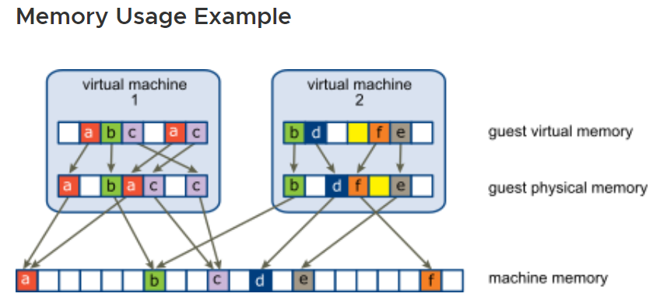
Source: https://docs.vmware.com/en/VMware-vSphere/7.0/com.vmware.vsphere.resmgmt.doc/GUID-6E85F6DE-7365-4C28-B902-725D3C76C2E6.html

VMs may not use the entire dedicated memory all the time, rather what is needed for the OS and applications at the moment and should not exceed their allocated size.
Memory overcommitment may occur when many virtual machines are running on a host and their combined workload exceeds the available hardware resources. However, different vendors provide their own proprietary techniques to deal with memory overcommitment. For example, VMWare’s virtualization software suite provides options for transferring memory from idle virtual machine to another. Another memory optimization technique, proprietary to VMWare is memory sharing. When same operating system is run on multiple virtual machines there will be replication of applications and data. VMware provides its proprietary Transparent File Sharing (TPS) procedure to share blocks with memory between VMs. Redundant copies of memory will be eliminated, and it will free up space from the allocated size. This should be factored in when designing the virtual architecture.

  - Virtual Hard Disk (VHD). Virtual machines behave equal to a real machine and as such, expect to have access to their own dedicated storage. Since they do not have their own resources, but ‘borrow’ from their hosts a solution for their storage is needed. A VHD is a software representation of a disk drive that is installed and accessed on a VM. Essentially, it is image of a hard disk, stored on the server and given to the VM. it logically is part of the VM but physically is a part of the hosts own storage. It can be configured to provide same functionalities as a physical one – partitioning, use of different types of file systems [4].
Thanks to the virtualization, multiple VHDs can be created on a single physical drive. And VHDs size can be either fixed or flexible – expanding and shrinking, based on the current requirements.
Shared storage is widely used in virtualized environment. Logically, it works as somewhat Network Attached Storage (NAS), allowing for data to be accessed and shared between physical and virtual machines. This reduces storage complexity and allows for greater data availability.
VMs are stored on the physical server as a set of files (disk images, OS iso files, snapshots, etc.), and can be accessed to anyone connected to the shared storage. In this way, VMs can be easily cloned and/or moved from a server to another, in a case of, for example, planned or unplanned server downtime [1].
  - Virtual network.
Physical machines are connected in a network using physical cables and devices – switches and routers. Virtualization separates software from hardware aspects of the network. All relevant physical components are replaced with their software representation. They behave same as physical devices because they follow same protocols and procedures. This allows for greater flexibility, ease of management and not least reducing of hardware when implementing virtualized network topologies [5].
When VM is created, it is configured with own virtual network adapter. It is a software application part of the VM set of files. It provides functionalities of a Network Interface Card including own and unique MAC address. It serves as its Ethernet adapter to connect to a network. VMs can be configured with different number of network adapters, depending on their size and vendor-specific requirements. Each adapter serves to connect to a different network with unique MAC address – same as a physical one.
When VMs are configured on a same host, they create virtual network and can communicate using their own NICs and their assigned private IP addresses. to connect to internet or other network they need to communicate through an intermediary device – physical or virtual witches and routers.

Virtual Networks

Virtual Networks are a way of communication between physical and virtual machines and devices physically and logically located on in different locations. Nods are connected through cables in a physical network. In a Virtual Network, nods are connected by virtualized versions of switches, routers, and network adapters.
Virtual networks can be configured logically, regardless of the actual physical locations of the underlined hardware. This has multiple advantages. For example, data centres can be situated in several physical locations and logically grouped together and create more flexible and efficient options for network administration. For example, network can be expanded if needed, but without the need to buy additional hardware, workload balancing options throughout a greater network infrastructure, thus achieving higher availability and better service and security [5].
Virtual networks operate on layers 2 and 3 of the OSI model, same as physical networks. The difference is that the functions of switches and routers may be executed not only by physical devices but by software applications also.
Examples of virtual networks are VPN, VLAN and VXLAN.
VPN – Virtual Private Network
VPN is internet-based networking technology. It links users over existing networks. VPN is created by attaching predefined routing information to the network packets which takes them through a defined routing path. Essentially VPN crates an addressing tunnel between the users and allows for secure login onto remote networks. VPN is widely used nowadays because it allows for masking the actual location, thus enhancing security, allows for remote connection onto corporate networks and secure encrypted communication [6].
VLAN – Virtual Local Area Network
VLAN is used for network segmentation regardless of the physical locations of the connected nods. Unlike LANs (Local Area Network), VLANs are not bound to a physical area. VLANs can stretch across multiple locations in a switched environment [7]. VLANs are created by configuring ports on Layer 2 devices. Once a port is configured as either access or a trunk port it forwards traffic bound for the respective VLAN through them. VLANs happen at the Layer 2 of the OSI model and nods on the VLAN do not even know that they are part of one.
VLAN allows for network segmentation, thus enhancing security and network capabilities. By default, hosts on a VLAN can not communicate outside of it, unless inter-VLAN routing has been configured. Inter-VLAN routing technique include router-on-a-stick and layer3 enabled switches but they are outside the scope of this report.
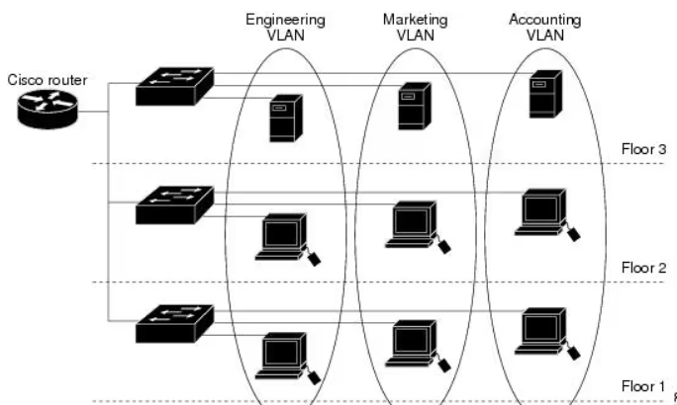
Source:https://www.cisco.com/c/en/us/td/docs/switches/datacenter/sw/5_x/nx-os/layer2/configuration/guide/Cisco_Nexus_7000_Series_NX-OS_Layer_2_Switching_Configuration_Guide_Release_5-x_chapter4.html

VXLAN – Virtual Extensible Local Area Network
VXLANs is a network virtualization technology and is widely used in contemporary data centres. VXLAN creates a tunnel between the source and the destination hosts. Layer 2 frames are encapsulated into UDP (User Datagram Protocol) packets, with attached 24-bit Virtual Network Identifier (VNI) and transmitted over a Layer 3 network. Receiving host decapsulate them int layer 2 frames. The two encapsulating and decapsulating nodes are called VXLAN Tunnel Endpoint (VTEP) [8].

When VTEP resides on a hardware device it is called hardware VTEP

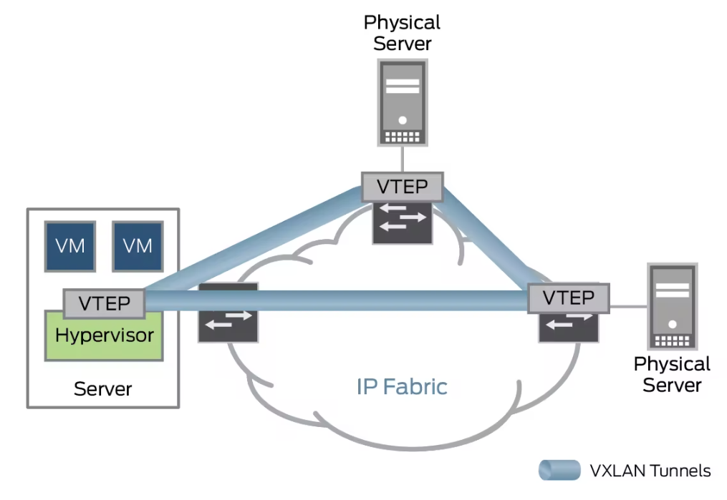
Source:https://www.juniper.net/gb/en/research-topics/what-is-vxlan.html#:~:text=VXLAN%20is%20an%20encapsulation%20protocol,the%20use%20of%20virtual%20networks.

When VTEP resides on a virtual machine it is called software VTEP.
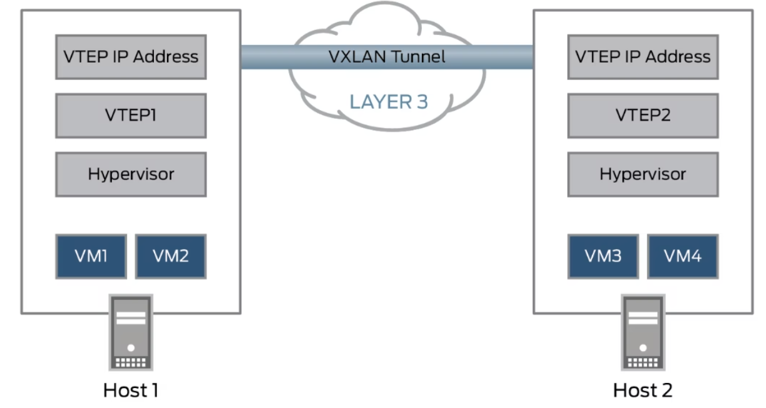
Source:https://www.juniper.net/gb/en/research-topics/what-is-vxlan.html#:~:text=VXLAN%20is%20an%20encapsulation%20protocol,the%20use%20of%20virtual%20networks.

Virtual networks consist of 5 integral parts – virtual switches and routers, virtual network adapters, underlying physical network infrastructure, servers, virtual machines, and physical nodes.

Virtual switches

Virtual Switches are software applications that provides switching capabilities in virtual networks just like a physical switch would between wired nods. They operate on layer 2 (Data Link) of the OSI model using the network adapters and MAC addresses of the connected virtual machines. Virtual switches work by checking the network packets headers’ Layer 2 information and forwarding them through their logical ports (same as a physical one) accordingly. They are used to provide connection between virtual machines and virtual and physical networks [9].
Virtual switches reduce the number of physical switches in a virtualized network topology. They are managed through software which in turns ease out the network administration. Virtual switches can ensure the integrity of a virtual machine when it is migrated throughout the network – by checking its network and security settings against a preconfigured profile [9].
Benefits of virtual switches:
- They are easily created, replicated, and deleted, if not needed or compromised.
- They are managed remotely and through software, which eases administration.
- They can be used to enforce security policies.
- They can provide an isolated environment for testing and experimentation purposes.

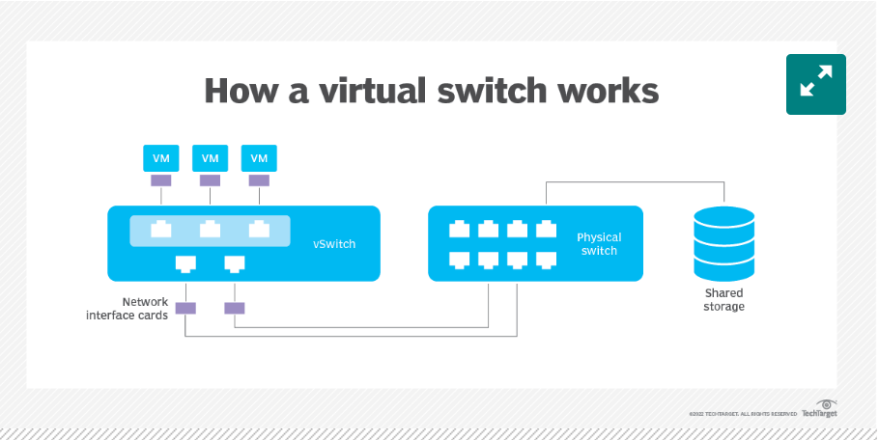
Source:https://www.techtarget.com/searchitoperations/definition/virtual-switch#:~:text=A%20virtual%20switch%20(vSwitch)%20is,VMs%20or%20a%20physical%20network.

Types of virtual switches:
- External. This type provides connectivity between VMs and existing physical networks including internet. It is bound to an existing physical network adapter and forwards the traffic through it, in order to reach other networks or network segments [9].
- Internal. Entirely software based. It provides connectivity to hosts in an internal network but not to other segments or internet. Connected hosts can communicate with one another but cannot access any resource from outside the network.
- Private. Used create an isolated virtual machine network. All hosts are in entirely isolated environment and cannot access resources from beyond the private switch [9].
The above-mentioned virtual switches work from inside a host and do not extend outside a host own based virtual machines.
- Distributed. Works outside a single host. Usually used in data canter environment. Allows multiple virtual machines to communicate across multiple physical hosts.
Virtual switching software is a standard part of hypervisor software package of the biggest vendors on the market. Most commonly used types of such software are – open vSwitch by Linux foundation, Hyper-V Virtual Switch by Microsoft and VMware vSwitch.

Comparison between different types of virtual switches
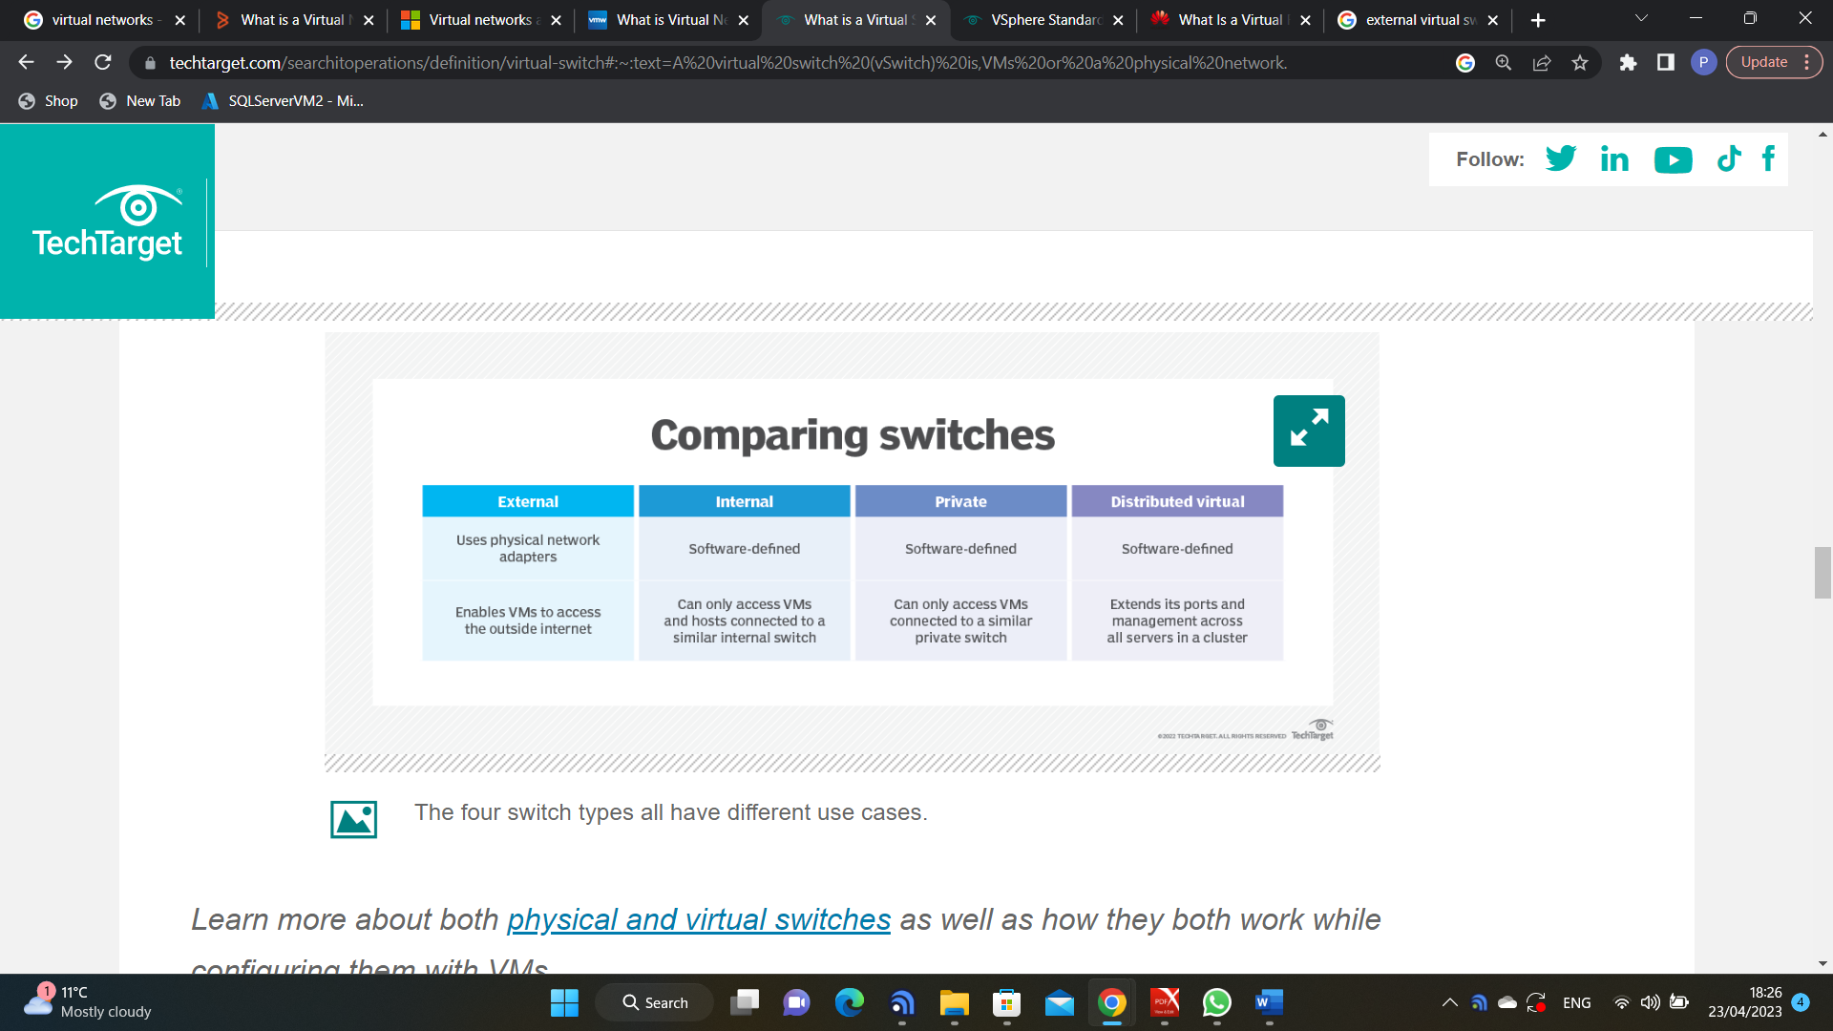
Network Security Groups
Network Security Groups are used to filter inbound and outbound network traffic between resources in a virtual network. They maintain a list of security rules that apply to hosts put together in a security group. NSGs act as a sort of software firewall for all the hosts in the group. They work by checking the network traffic against their list of assigned restrictions and preventing restricted traffic.

Azure Images
VM image is a single, executable file, that contains the configuration and data (including Operating System and data disk) of an instance of a virtual machine. Images are used to deploy preconfigured VMs instead of building them from anew. This saves time, eases management and enhance scalability and security [10]. Similar to VM image is the VM Snapshot. It is a copy of the VM disk file at the moment it is taken. It is used to deploy that virtual machine instance with that known configuration. Snapshots can be taken before a major upgrade and to restore VMs in case of failures.
Virtual machine images in Microsoft Azure refer to pre-configured templates of virtual machines that can be used to quickly deploy new instances of a virtual machine with the desired operating system, software, and settings. These images can be either provided by Microsoft or created by users and uploaded to Azure. The images are stored as VHD (Virtual Hard Disk) files and can be used to create new virtual machines in a matter of minutes, without the need to manually install and configure the operating system and applications. Azure offers a variety of images, including Windows and Linux, and users can also create custom images based on their specific needs. Images come from a number of publishers and not Microsoft alone. All images are characterized by their publisher, version, and pricing.

Below is a print screen of Azure Marketplace with VM Image options.
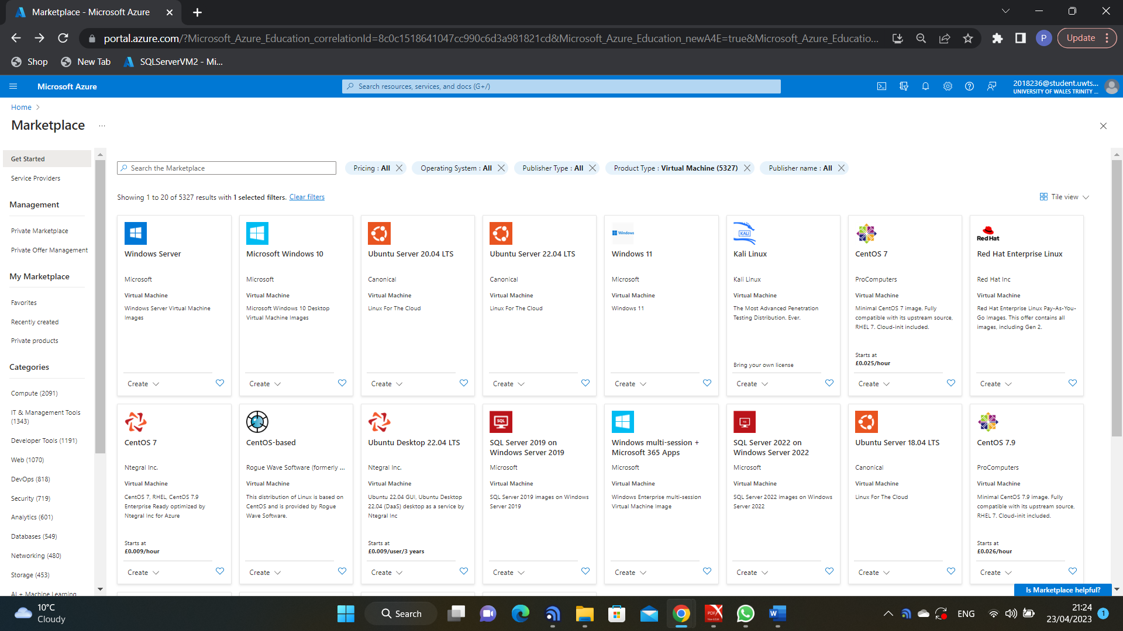

Virtual Machines in Microsoft Azure
Subscription to Microsoft Azure portal is needed in order to use and create its resources. Virtual machines are created from ‘Create a Machin’ button and following steps. The user can choose from a list of preconfigured options.
This particular virtual machine is created using ‘Azure for students’ subscription – an option given by Microsoft for students. They can access it, using their student email. Afterwards, they have a free credit worth 100$ of Azure resources [11].
Azure resources can be grouped together for management purposes in resource groups. The user needs to choose an Azure region where the virtual machine to be deployed. Azure regions are geographical areas where groups of clustered data centres deployed. Choosing the proper Azure region where a resource to be deployed helps solving some of the latency issues.

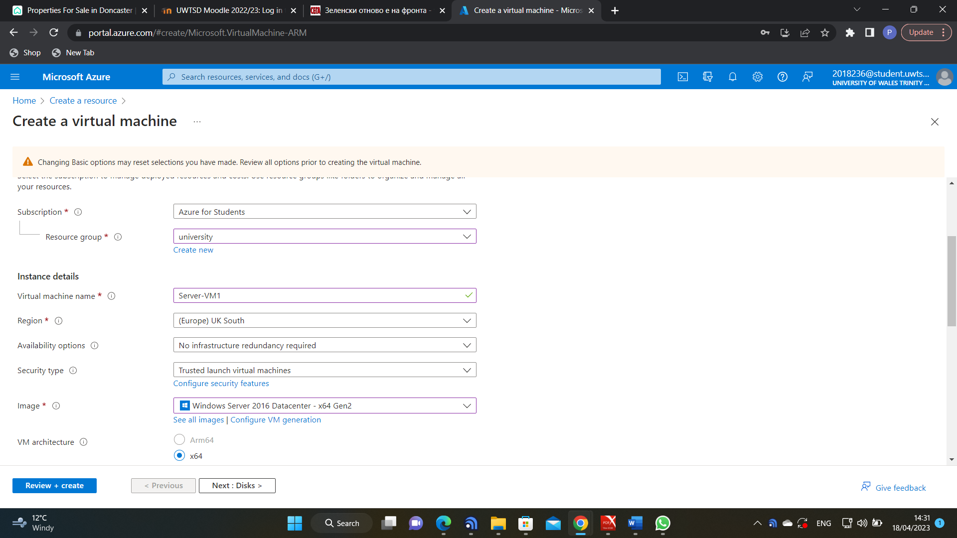

Next step is configuring the virtual hard disk. Azure allows for choosing between multiple options providing different performance. However, they come with different pricing.
NB. Even if a virtual machine is not running, Azure still charges for the storage.
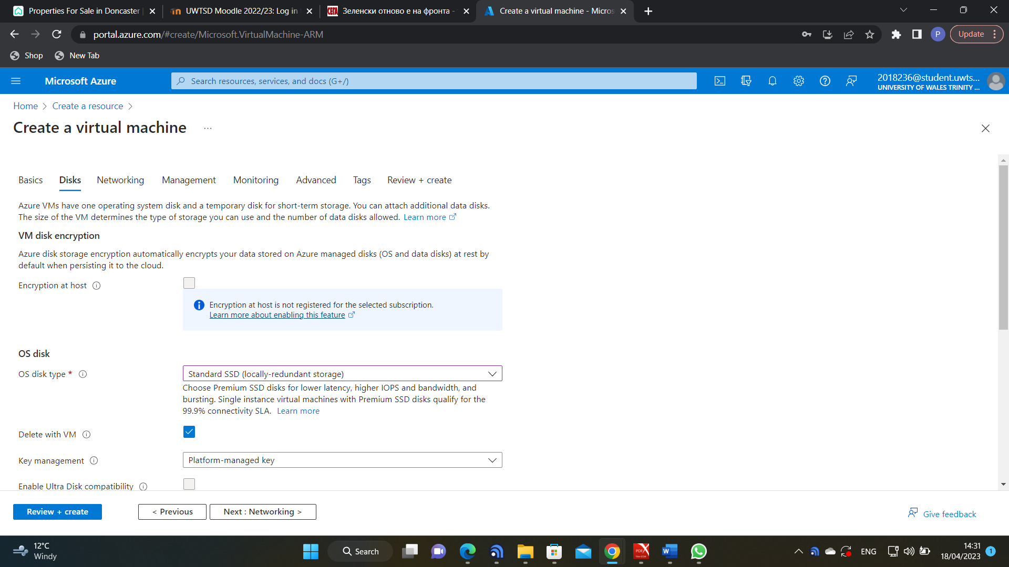

Next step is configuring the network options. Azure allows for creation of networks and subnets during creation of VMs.

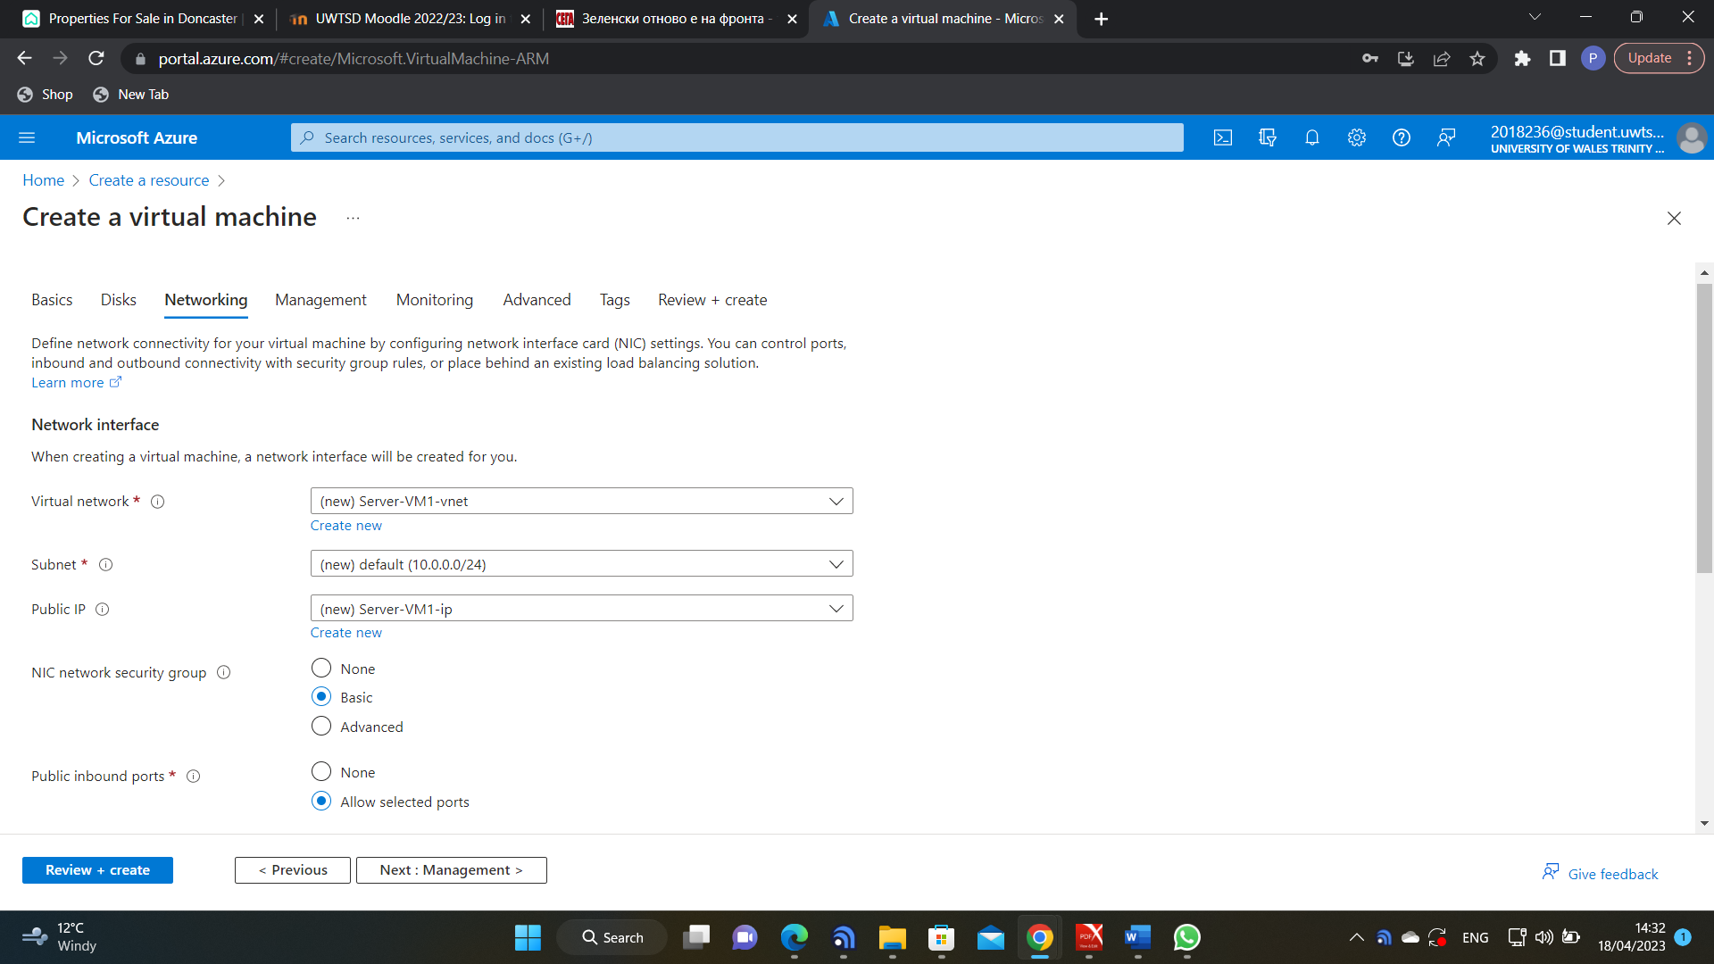

Once the initial configuration is complete, it is reviewed, and Azure initialize creation of the virtual machine.
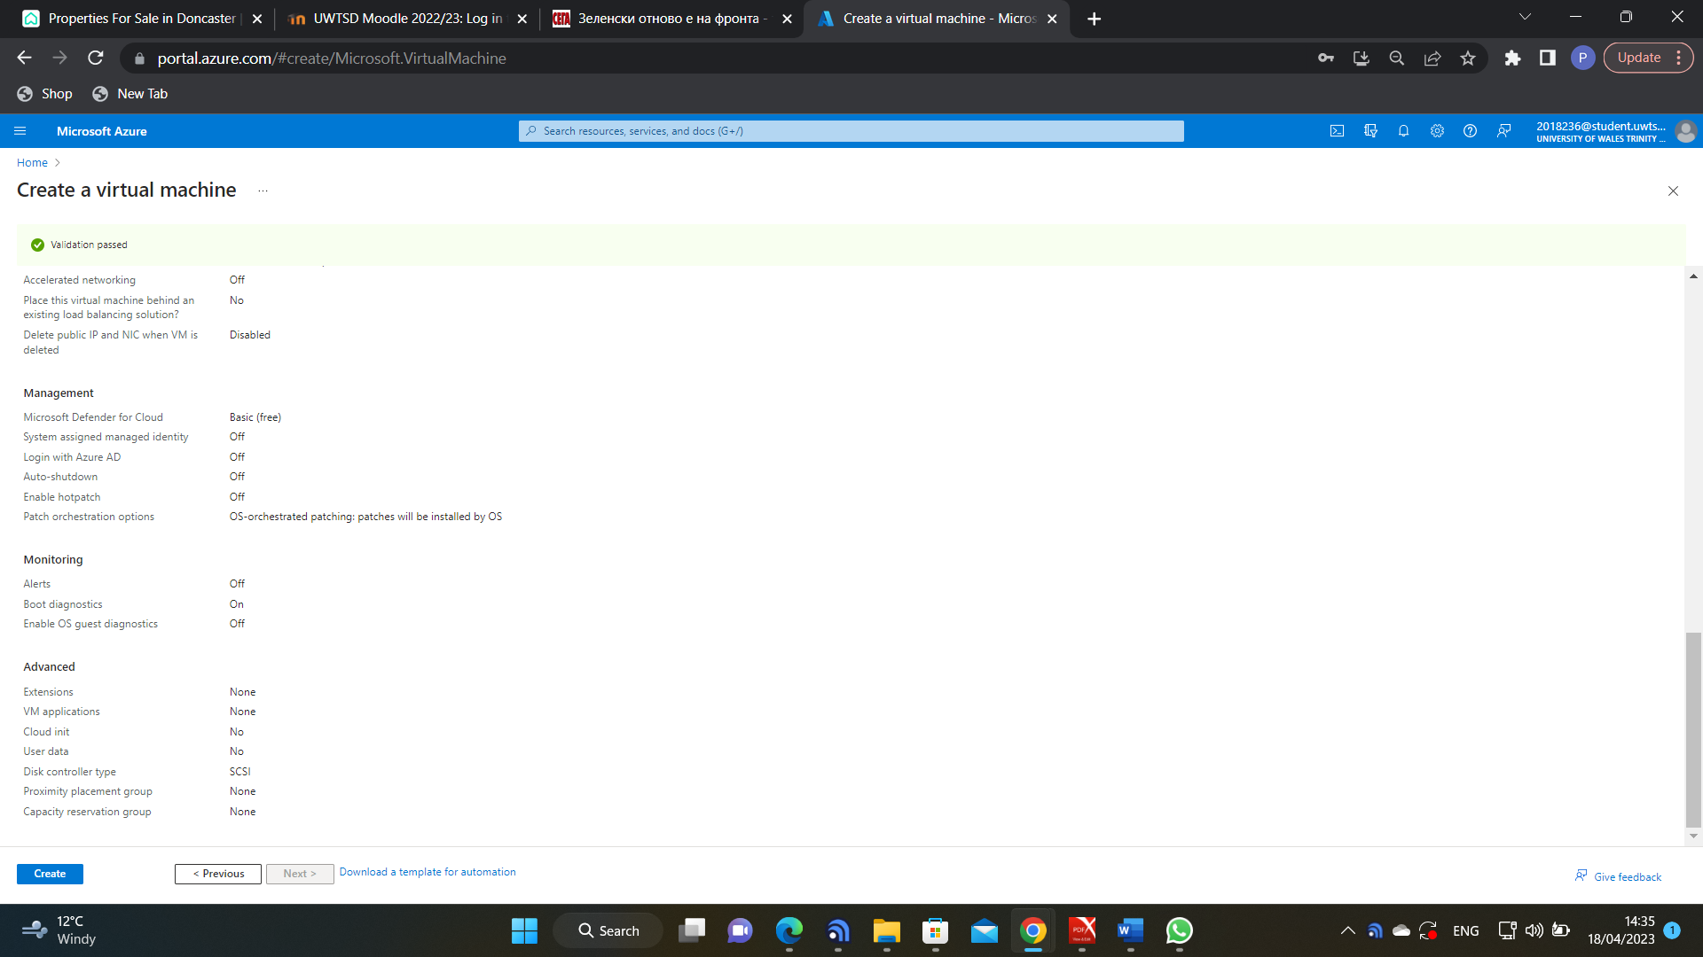

Once the virtual machine is created, it is put in a resource group, together with other allocated resources. This particular resource group consists of two virtual machines – a data base server and a Windows server.
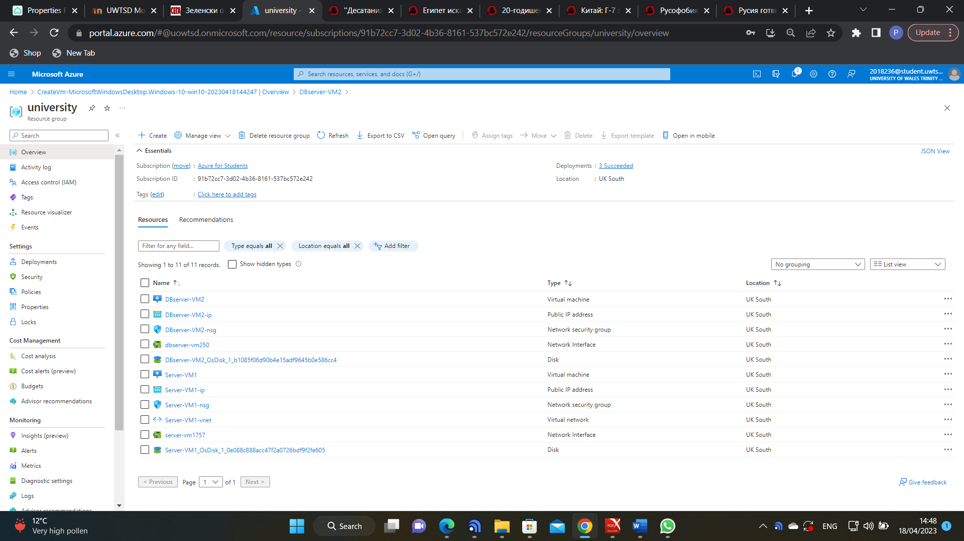

Remote connection to the two VMs has been established using Remote Desktop Protocol (RDP). The two machines can ping each other, after disabling their firewalls.
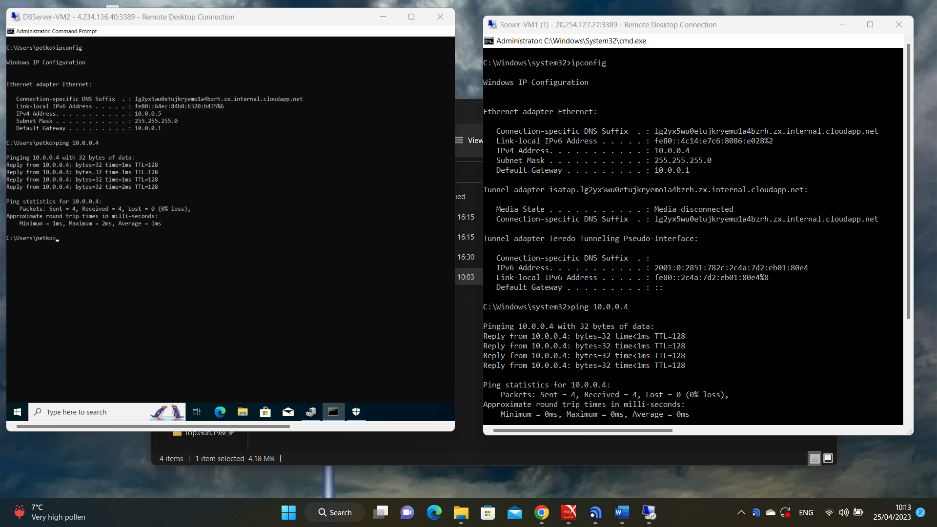

Conclusion
Virtual machines provide flexible and efficient solutions for running multiple operating systems on a single physical machine. While they come with some drawbacks, their importance will continue to grow as organizations adopt cloud computing and virtualization technologies.

References

[1] | Packtpub, "https://subscription.packtpub.com/book/virtualization-and-cloud," [Online]. Available: https://subscription.packtpub.com/book/virtualization-and-cloud/9781782172185/1/ch01lvl1sec11/the-primary-virtual-machine-resources. [Accessed 10 April 2023].
[2] | Hyve Managed Hosting, "https://www.hyve.com/what-is-a-vmware-vcpu/," [Online]. Available: https://www.hyve.com/what-is-a-vmware-vcpu/. [Accessed 10 April 2023].
[3] | VMWare, "https://docs.vmware.com/en/," [Online]. Available: https://docs.vmware.com/en/VMware-vSphere/7.0/com.vmware.vsphere.resmgmt.doc/GUID-C25A8823-F595-4322-BD0D-4FD5B081F877.html. [Accessed 16 April 2023].
[4] | M. Rouse, 11 January 2017. [Online]. Available: https://www.techopedia.com/definition/26811/virtual-hard-disk-vhd. [Accessed 10 April 2023].
[5] | VMWare, "https://www.vmware.com/tvirtual-networking.html," [Online]. Available: https://www.vmware.com/topics/glossary/content/virtual-networking.html. [Accessed 20 April 2023].
[6] | S. Watts, "bmc.com," 16 June 2020. [Online]. Available: https://www.bmc.com/blogs/virtual-network/. [Accessed 20 April 2023].
[7] | Cisco, "https://www.cisco.com," [Online]. Available: https://www.cisco.com/c/en/us/td/docs/switches/datacenter/sw/5_x/nx-os/layer2/configuration/guide/Cisco_Nexus_7000_Series_NX-OS_Layer_2_Switching_Configuration_Guide_Release_5-x_chapter4.html#:~:text=A%20VLAN%20is%20a%20group,on%20the%20same%20LAN%20segme. [Accessed 20 April 2023].
[8] | Juniper, "https://www.juniper.net/gb/en/research-topics/what-is-vxlan," [Online]. Available: https://www.juniper.net/gb/en/research-topics/what-is-vxlan.html#:~:text=VXLAN%20is%20an%20encapsulation%20protocol,the%20use%20of%20virtual%20networks.. [Accessed 21 April 2023].
[9] | A. S. Gillis, "https://www.techtarget.com/definition/virtual-switch," [Online]. Available: https://www.techtarget.com/searchitoperations/definition/virtual-switch#:~:text=A%20virtual%20switch%20(vSwitch)%20is,VMs%20or%20a%20physical%20network.. [Accessed 20 April 2023].
[10] | Microsoft, "https://learn.microsoft.com," [Online]. Available: https://learn.microsoft.com/en-us/azure/virtual-machines/windows/cli-ps-findimage. [Accessed 23 April 2023].
[11] | Microsoft Corporation, "https://azure.microsoft.com," [Online]. Available: https://azure.microsoft.com/en-gb/free/students/. [Accessed 20 April 2023].

