

COMPONENT 1: PORTFOLIO: INDEPENDENT
DISSERTATION: THE IMPACT OF ARTIFICIAL INTELLIGENCE ON CUSTOMER EXPERIENCE IN THE UK RETAIL SECTOR: A CASE STUDY OF IKEA

Module code: LCLM6005
Module: Independent Project

Student Name: Cristinel Dascalu
Student ID:2233978

Abstract
Chapter 1: The chapter has highlighted the core background of the UK retailers using and heavily investing in the AI tools to facilitate long-term relationships with their client base. Though they are predominantly utilised, the major problem has arisen in the segment of proper implementation and a lack of effective management strategies. Therefore, the study has the major aim to focus on the interrelationship of findings based on the results.

Table of Contents
Chapter 1: Introduction 4
1.1 Background 7
1.2 Problem Statement 8
1.3 Aims 10
1.4 Objectives of the study 10
1.5 Research Questions 10
1.6 Study significance 10
1.7 Rationale of this research 10
1.8 Dissertation structure 11

List of Figures
Figure 1.1: Current AI adoption roadmap by the UK retail industry 7
Figure 1.2: Problems that can arise in the evaluation of the subject paradigms 8

List of Tables
Table 1.1: Dissertation structural layout 11

List of Abbreviations
UK- United Kingdom
CX - Customer Experience
AI - Artificial Intelligence

Chapter 1: Introduction

1.1 Background
In the modern era of technological disruptions, the integration of Artificial Intelligence (AI) is fundamentally reshaping customer experience (CX) in the retail sector. The United Kingdom (UK)-based retail companies are emerging players in leveraging these technological advancements. This helps in individualising services, streamlining retail operations, and improving satisfaction (Rashid and Kausik, 2024). Following the period of the pandemic, several UK retailers expanded their AI adoption strategies to include post-purchase experience evaluation by 2025. Recent implementations involved chatbots, algorithms of intelligent searching procedure, product data analytics, insights regarding the predictive post-purchase, marketing automation, as well as inventory replenishment systems (Briggs, 2024) (Refer to Figure 1).
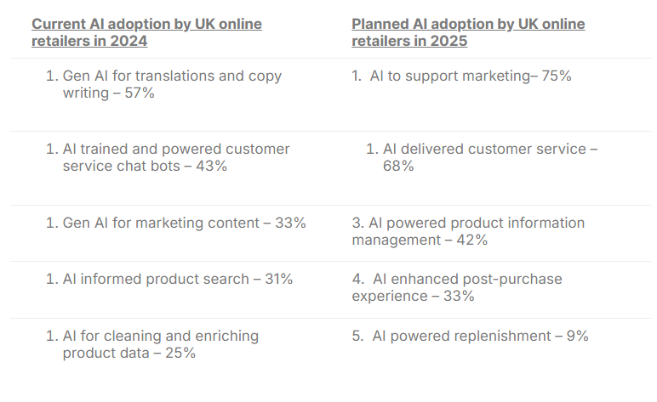

Figure 1.1: Current AI adoption roadmap by the UK retail industry
(Source: Briggs, 2024)
Following this recent AI-facilitated integration trend in the retail operations, IKEA of the UK has incorporated AI across manifold touchpoints to improve CX (IKEA, 2022). This can be highlighted by several distinct areas of AI deployment, such as predictive analytics, personalised shopping, and voice-assisted amenities, which tend to focus on long-term client retention (IKEA, 2022). This inclined urge to involve AI in the client handling can be further explored to showcase how IKEA can tailor CX by modernising its retail services through AI.

1.2 Problem Statement
Despite the increasing involvement of AI within the retail segment, a notable challenge persists concerning customer trust and the perceived value of the services in the retail companies. Although 87% of retailers in the UK have employed AI and 63% are increasing investment in 2025, merely 19% of customers believe they obtain satisfactory value for the usage of their personal insights (Overall, 2025). For IKEA, supplementary issues such as inexact colour rendering, insubstantial spatial visualisation, and restricted interaction quality can additionally hinder client satisfaction (Ozturkcan, 2021). These inadequacies not only reduce user satisfaction but also underline a persistent gap between client prospects and the capabilities of AI-driven retail systems (Refer to Figure 1.2).

Figure 1.2: Problems that can arise in the evaluation of the subject paradigms
(Source: Self-Developed)
For IKEA specifically, this tension may manifest in the type of downgraded engagement and long-term friction in handling several digital touchpoints, despite developing its tactical speculation about AI. The problem is henceforth twofold, and this is required to be addressed by the critical evaluation of the interrelationship between AI implication and CX improvement by IKEA itself.
Thus, the problem statement has become twofold. Apparently, IKEA’s strategic investment in AI can be challenged by permanent customer scepticism. On the other hand, the insufficiencies of AI-driven user interfaces intimidate long-term engagement of customers of the company and their loyalty. This tension henceforth underscores the crucial need for a detailed evaluation of how AI implementation interconnects with client experience improvement. Lacking the assessment of this disconnect IKEA’s strategy of AI involvement may unintentionally erode. This can threaten the enhancement of its client relationships, turning technological determination into an obligation as compared to a sustained competitive advantage, which indicates the rationale of the study.

1.3 Aims
This research looks deeper into the assessment of how AI involvement can help the enhancement of Customer experiences in the retail segment, by taking IKEA as the key focus analysis of the detailed evaluation. It seeks the core outline of the key concerns and suggests some of the practical notions so that the issues can be resolved and client experiences can be enhanced by the company.

1.4 Study Objectives
- To review in what way IKEA can use AI systems to facilitate shopper interactions within the UK-based retail scene.
- To study which AI tools can be employed to determine the improvement in involvement, customer happiness, and buying journey-based experience analysis.
- To pinpoint significant obstacles IKEA can encounter when putting AI-driven personalisation into CX practices.
- To recommend practical steps for determining AI-powered client experiences at IKEA more efficiently.

1.5 Research Questions
- In what way can IKEA use AI systems to facilitate shopper interactions within the UK-based retail scene?
- Which AI tools can be employed to determine the improvement in involvement, customer happiness, and buying journey-based experience analysis?
- What obstacles can IKEA encounter when putting AI-driven personalisation into CX practices?
- What practical steps can be taken to make AI-powered client experiences at IKEA more efficient?

1.6 Study significance
The major analysis is about to enrich the expanding assessment based on the previous scholarship concentrated on human‑focused AI within the UK-based retail by assessing how AI solutions can harmonise, or diverge from altering buyer expectations (Patil, 2024). This study can be helpful in addressing the continuing necessity for both academic and industry-based individuals to deepen the basic understanding of the major influence of AI on customer experience. It can be determined, especially in such contexts where automation issues tend to weaken human-related connections.

1.7 Rationale of this research
The key rationale of the study lies in forward-moving strategic and academic perspectives on the connection between AI and CX within the UK retail industry. As retailers progressively deploy AI to customise services and streamline processes, it becomes an essential tool to comprehend client perceptions and responses to these innovations (Petrescu et al., 2024). As the current retailers are increasingly adopting AI skills to customise services, streamline procedures, and encounter increasing client expectations, understanding the way they perceive and interrelate with the key AI-based innovations has now become essential.

1.8 Dissertation structure
Chapters | Description
CHAPTER 1: Introduction | This chapter focuses on the background analysis, followed by the problem evaluation, detection of aim, questions, and objective formation for further progress.
CHAPTER 2: Literature Review | This chapter focuses on the empirical literature evaluation based on subject aspects, and this guides the overall findings by showcasing the conceptual framework, theoretical assessment, and identifying the literature gap.
CHAPTER 3: Methodology | This chapter apprises the choice of methodology by first identifying the method and then justifying the choices.
CHAPTER 4: Results and Discussion | This chapter focuses on all the core results which have been found by analysing the subject aspect.
CHAPTER 5: Recommendations, Conclusion and limitations of the research | The recommendation for the completion of the summary is going to be given in this chapter. The limitations would also be involved so that future studies can find the scope to do similar research.
Table 1.1: Dissertation structural layout
(Source: Self-Developed)

References
Briggs, F. (2024) UK retailers widen AI adoption roadmap to include post-purchase in 2025, IMRG data reveals, UK retailers widen AI adoption roadmap to include post-purchase in 2025, IMRG data reveals. Available at: https://retailtimes.co.uk/uk-retailers-widen-ai-adoption-roadmap-to-include-post-purchase-in-2025-imrg-data-reveals/ (Accessed: November 1, 2025).
IKEA (2022) IKEA launches new AI-powered, digital experience. Available at: https://www.ikea.com/us/en/newsroom/corporate-news/ikea-launches-new-ai-powered-digital-experience-empowering-customers-to-create-lifelike-room-designs-pub58c94890/ (Accessed: November 1, 2025).
Overall, P. (2025) The AI disconnect in UK retail: Retailers push ahead but shoppers push back | Retail Bulletin. Available at: https://www.theretailbulletin.com/retail-solutions/the-ai-disconnect-in-uk-retail-retailers-push-ahead-but-shoppers-push-back-30-07-2025/ (Accessed: November 1, 2025).
Ozturkcan, S. (2021) “Service innovation: Using augmented reality in the IKEA Place app,” Journal of Information Technology Teaching Cases, 11(1), pp. 8–13. Available at: https://doi.org/10.1177/2043886920947110.
Patil, D. (2024) “Artificial intelligence in retail and e-commerce: Enhancing customer experience through personalization, predictive analytics, and real-time engagement.” Available at: https://www.researchgate.net/publication/385890528_Artificial_intelligence_in_retail_and_e-commerce_Enhancing_customer_experience_through_personalization_predictive_analytics_and_real-time_engagement (Accessed: November 1, 2025).
Petrescu, M., Krishen, A.S., Gironda, J.T. and Fergurson, J.R. (2024) “Exploring AI technology and consumer behaviour in retail interactions,” Journal of Consumer Behaviour, 23(6), pp. 3132–3151. Available at: https://doi.org/10.1002/cb.2386.
Rashid, A.B. and Kausik, M.A.K. (2024) “AI revolutionizing industries worldwide: A comprehensive overview of its diverse applications,” Hybrid Advances, 7, p. 100277. Available at: https://doi.org/10.1016/j.hybadv.2024.100277.

COMPONENT 1: PORTFOLIO: INDEPENDENT
DISSERTATION: THE IMPACT OF ARTIFICIAL INTELLIGENCE ON CUSTOMER EXPERIENCE IN THE UK RETAIL SECTOR: A CASE STUDY OF IKEA

Module code: LCLM6005
Module: Independent Project

Student Name: Cristinel Dascalu
Student ID: 2233978

Table of Contents
Chapter 2: Literature Review 3
2.1 Purpose of the Literature Review 3
2.2 Contextual Literature Review 3
2.2.1 Concept of AI within the Retail Sector 3
2.2.2 AI in Shaping Customer Interaction in Retail 4
2.2.3 Significance of AI in Improving Customers’ Happiness and Smoothing Buying Experiences 5
2.2.4 Challenges in Using AI-driven Personalisation in Retail Brands 6
2.2.5 Suggestions for Improving AI-driven Customer Experiences in Retail 7
2.3 Theoretical Principles 7
2.3.1 TAM 7
2.3.2 SERVQUAL (Service Quality) Framework 8
2.3.3 ECT (Expectation-Confirmation Theory) 9
2.4 Conceptual Framework 10
2.5 Recognised Research Gap 11
2.6 Summary 11
References 12

Chapter 2: Literature Review

2.1 Purpose of the Literature Review
A synthesis of scholarly articles and journals on AI’s significance in the retail industry in shaping customer experiences is included in this literature review. This chapter includes an evaluation of theoretical concepts and all empirical perceptions for developing a comprehensive idea about current insights. This section also targets to point out the under-explored areas and limitations in existing literature that can lead to the identification of a research gap in meeting the research questions of the entire study.

2.2 Contextual Literature Review

2.2.1 Concept of AI within the Retail Sector
In retail, AI refers to the applications that include the usage of machine learning, automation, suggestion engines and predictive analysis for evaluating consumer data, predicting demands and offering personalised experiences. AI adoption within retail has accelerated from simple suggestion systems to practical personalisation (Moodley and Sookhdeo, 2025). In the UK retail markets, AI adoption is expanding rapidly and changing retail operations into digitalised functions.
In the strategic context, AI helps in estimating market demand and optimising inventory systems of retail brands. On the other hand, AI offers suggestion engines, personalisation and customer chatbots to successfully streamline the buying journeys of customers (Moodley and Sookhdeo, 2025). IKEA is a multinational furniture brand that has adopted AI within its CX and supply chains. The demand sensing AI tool of the company includes multiple points, including consumer insights, sales, weather, economic indicators and others. It significantly helps the company in improving its forecast accuracy (Khan and Sarkar, 2024). The forecasting accuracy of IKEA has helped the company to increase its sales rate making alignment with consumer insights.
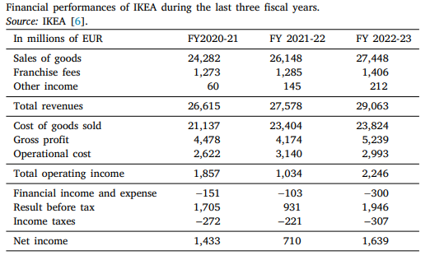

Figure 2.1: Sales Growth of IKEA
(Source: Khan and Sarkar, 2024)
The digitalised retail functions with the support of AI have helped IKEA to increase its overall sales rate to 27,578 euros in 2022-2023 (Khan and Sarkar, 2024). The integration of AI tools for the optimisation of inventory has successfully managed IKEA’s business operations across its global stores. Besides these, the AR-driven Place app, using intelligent visualisation, has supported the brand to improve customer decision-making.

2.2.2 AI in Shaping Customer Interaction in Retail
Every touchpoint of customer journey is shaped through an AI application, before and after sales. AI tools help in personalising emails and ads, empower suggestion engines on official websites and boost service speed with the support of virtual agents and chatbots. For instance, the online tools and AR app of IKEA allow customers to visualise furniture in their own homes and offer customised recommendations with the improvement of product discovery (Ozturkcan, 2021). AI-supported channels include Virtual assistance and chatbots that help in answering questions 24/7 and customise ads matching past buying behaviours of customers. AI-powered CRM (Customer Relationship Management) systems also help in tracking consumer preferences and provide offers on time. IKEA utilises chatbots for handling regular queries and frees employees to solve complex problems.
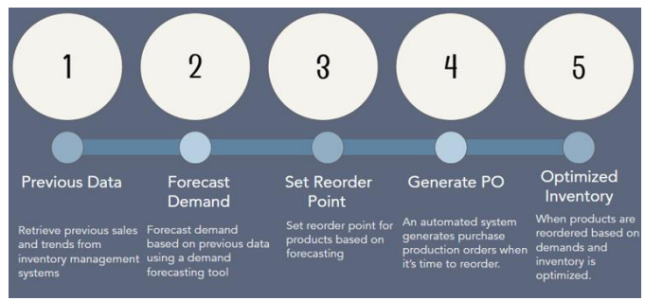

Figure 2.2: Stages of Improving CE with the help of AI
(Source: Viswanathan, 2025)
Conversational AI is useful for customers to easily find products, place orders, and get product delivery without having less friction. Recommendation engines utilise behavioural analytics and highlight the products that are more likely to be purchased, increasing clicks and expanding sessions (Viswanathan, 2024). AI tools are helpful in improving interaction speed, perceived service standards and convenience at the same time. However, the absence of human empathy, misinterpreted requests and impersonal qualities sometimes create miscommunication. Retail brands, like IKEA, use AI in support of human intervention to keep their services both caring and fast.

2.2.3 Significance of AI in Improving Customers’ Happiness and Smoothing Buying Experiences
In the retail market, customer happiness refers to the pleasure that shoppers feel after purchasing products. Customer happiness includes ease in product findings, emotional satisfaction and the entire memory of their buying journeys. Experiential satisfaction is dependent on how enjoyable, smooth and helpful customers feel in every stage from product discovery to checkout (Yin, Qiu and Wang, 2025). AI supports in increasing customer happiness with the maintenance of transparent buying journeys. It significantly makes shopping journeys frictionless by quickly highlighting relevant products and supporting customers with practical help.
AI offers personalised product recommendations depending on their purchasing context and previous behaviour. AI-driven personalised suggestions help customers to find products according to their interests, instead of showing irrelevant endless product lists (Yin, Qiu and Wang, 2025). The relevant product showing feature through AI support potentially helps in developing product relevance with increased purchase loyalty and intention. AI also helps in increasing the speed of the checkout process and provides practical assistance to reduce customer frustration. For instance, IKEA has placed its AR app and current AI-driven designing tools to explore 3D showrooms, leading to easier product selection and lower uncertainties (Viswanathan, 2024).
Retailers connect with AI across store, online and mobile touchpoints to offer smoother and consistent buying experiences to consumers. The predictive personalisation helps in analysing consumer needs and helps in reducing irrelevant product lists by offering relevant choices to customers (GhorbanTanhaei et al. 2024). Well-informed recommendation engines help in lowering stress and speed up decision-making, contributing to higher customer happiness. In short, enhances product relevance, removing purchasing frictions and speeding up the checkout process. It has significantly helped retail companies, like IKEA, to develop customer happiness and loyalty at the same time.

2.2.4 Challenges in Using AI-driven Personalisation in Retail Brands
AI personalisation allows better shopping experiences but creates real-life challenges. Firstly, GDPR and data privacy risks are observed as key challenges linked with AI personalisation in retail. Collection and combination of purchasing, browsing and location data can cross legal limitations unless retail brands follow strict regulations (Morić et al. 2024). Big retailers, like IKEA, publish privacy policies with details and offer data control policies to successfully comply with existing regulations. Several customers are observed to distrust algorithmic decisions powered by AI. People feel worried about how their personal data is utilised and whether the offered suggestions are fair or a hidden manipulation.
Ethical concerns are also closely linked with AI personalisation systems. Personalisation can be felt as surveillance if it monitors too closely, and algorithms can produce bias if training is not sufficient. Companies should analyse biases and monitor the decisions made by AI personalisation. Over-personalisation can create creepiness by suggesting products, revealing private inferences (Rezk et al. 2024). The reveal of private inferences can make shoppers feel uncomfortable, and that can create negative influences directly on retail brands.
Service failure is another significant risk that is related to AI usage within the retail landscape. Wrong room-fit recommendations or inaccurate suggestions usually frustrate consumers and trigger complaints among them, harming retail companies (Rezk et al. 2024). Practical challenges in AI usage include complicated tech integration, a workforce skill gap in AI control and high incorporation costs. Retailers should invest more in strong testing, employee training and data governance before rollout. These risks are demanding more responsible AI governance, focusing on consumer controls, policies and audits, important for trusted and safe personalisation. IKEA has promoted data-control features and public data protection in its official app to offer more choices and transparency (Ali et al. 2023). It has potentially helped the brand to keep consumers’ privacy, creepiness concerns and trust.

2.2.5 Suggestions for Improving AI-driven Customer Experiences in Retail
Retail brands must incorporate AI models with more transparency, following transparent ethical regulations to increase customer trust. XAI (Explainable AI) offers explanations about recommendation engines’ suggested products, consumers’ buying interests and buyers' safe feelings. The bots and digital tools of IKEA have significantly improved the query-solving process and make customers feel safe with AI-driven product suggestions. Strict data handling protection is highly important in supporting AI personalisation. Business firms should store only required information, encrypt the required data and maintain strict accessibility control for making personalised offers out of privacy issues (Abdulsalam and Hedabou, 2021). Customer consent mechanisms, including easy opt-ins, opt-outs and transparent choices, offer people power to control personalised marketing and maintain goodwill.
A blend of service models with human empathy and AI speed can help in routing high-stakes, complicated and emotional cases to employees. This blend of AI speed and human empathy can create a more empathetic and responsive dimension within retail organisations and lead to higher consumer satisfaction.

2.3 Theoretical Principles

2.3.1 TAM
PU (Perceived usefulness) and PEOU (Perceived ease of use) are two main elements included in TAM (Technology Acceptance Model). Perceived usefulness focuses on customers’ beliefs on AI adoption’s significance to enhance their buying experiences. On the other hand, PEOU highlights the effortless and simple feelings about technological usage (Arachchi and Samarasinghe, 2023). In the retail market, customers are more interested in proactive interaction with AI when it helps in saving time, creating easier navigation and providing accurate recommendations.
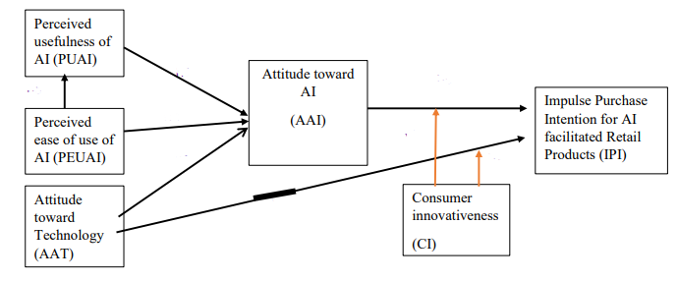

Figure 2.3: TAM in AI-Powered Retail Operations
(Source: Arachchi and Samarasinghe, 2023)
TAM in AI retail applications constantly shows that higher PEOU and PU help in increasing consumer acceptance of product searching tools, digital assistance and virtual try-ons. It is observed that perceived risks and trust both extend TAM within the AI application context, as consumers can hesitate to accept biased or intrusive algorithms (Arachchi and Samarasinghe, 2023). Therefore, it can be stated that efficient AI within retail operations should blend transparent data handling with usefulness and simplicity to encourage its adoption rate.

2.3.2 SERVQUAL (Service Quality) Framework
The SERVQUAL framework stresses service quality, maintaining five different dimensions, including empathy, responsiveness, reliability, tangibles and assurance. In the case of AI-powered retail interactions, the dimensions of the SERVQUAL model help in assessing the sufficiency of automated systems to meet customer expectations (Singh and Singh, 2024). For example, chatbots shape responsiveness through accuracy and speed while offering replies. Personalised suggestions meet reliability dimensions by matching recommendations with consumer preferences. Clear privacy policies and protected data management within retail help in keeping assurance and reducing perceived risks while consumers share their personal data (Singh and Singh, 2024). On the other hand, tangibles are linked to user interface designing, visual quality of AI platforms and clarity.
However, it is noted that AI models often struggle with empathy as they are not enough to fully identify emotional cues and deal with proper understanding as human employees can. AI-supported shopping supports strong responsiveness and reliability, but empathy has remained as the primary limitation (Singh and Singh, 2024). It significantly suggests that matching human support with AI assistance can improve the overall SERVQUAL outcomes.

2.3.3 ECT (Expectation-Confirmation Theory)
ECT illustrates customer satisfaction by connecting their basic interactions with the actual performance of an individual system. Customers within the retail landscape expect AI to offer personalised support, convenience and speed (Moodley and Sookhdeo, 2025). After the use of AI models, customers assess their perceived performance. If the performance of AI models exceeds or meets then confirmation occurs and leads to satisfaction. On the other hand, if the perceived performance falls short in meeting consumer expectations, then disconfirmation occurs and results in dissatisfaction (Ramasamy et al. 2024. In the AI-driven retail, efficient problem resolution, recommendation accuracy and smooth chatbot interactions strongly influence perceived performance. ECT highlights that satisfaction with AI models develops customer loyalty, increases willingness to share information for personalisation and repeat usage. Thus, retailers should ensure that AI models offer efficiency and convenience, fulfilling consumer expectations to build long-term engagement and trust.

2.4 Conceptual Framework
Concept of AI within the Retail Sector
Challenges in Using AI-driven Personalisation in Retail Brands
AI in Shaping Customer Interaction in Retail
Significance of AI in Improving Customers’ Happiness and Smoothing Buying Experiences

THE IMPACT OF ARTIFICIAL INTELLIGENCE ON CUSTOMER EXPERIENCE IN THE UK RETAIL SECTOR: A CASE STUDY OF IKEA

Suggestions for Improving AI-driven Customer Experiences in Retail

Theoretical Foundation
TAM, ECT and SEVQUAL Model

Figure 2.4: Conceptual Framework

2.5 Recognised Research Gap
All the existing literature points out the increasing importance of AI for improving retail experiences among customers through predictive analytics, chatbots, personalisation and AR tools. However, limited insights are observed in the current studies about balancing ethical concerns, trust, customers' comfort and efficiency while using AI technologies. The existing studies heavily concentrate on operational advantages, yet under exploration is observed in the evaluation of AI-driven interactions in service quality maintenance. All these underexplored areas are to be concentrated in this particular study to enhance its reliability for future researchers.

2.6 Summary
This individual chapter of this study includes key literature on the growing significance of AI to transform retail consumer experiences. It also significantly analyses the role of AI applications in improving decision-making, personalisation and service speed with practical examples of IKEA. The challenges linked with AI applications, like service failures, privacy risks and ethical concerns, are also highlighted in this section.

References
Abdulsalam, Y.S. and Hedabou, M. (2021) ‘Security and privacy in cloud computing: technical review’. Future Internet, 14(1), p.11. Available at: https://doi.org/10.3390/fi14010011
Ali, M., Naeem, F., Kaddoum, G. and Hossain, E. (2023) ‘Metaverse communications, networking, security, and applications: Research issues, state-of-the-art, and future directions’. IEEE Communications Surveys & Tutorials, 26(2), pp.1238-1278. Available at: Available at: https://arxiv.org/pdf/2212.13993
Arachchi, H.D.M. and Samarasinghe, G.D. (2023) ‘Impulse purchase intention in an AI-mediated retail environment: Extending the TAM with attitudes towards technology and innovativeness’. Global Business Review, p.09721509231197721. Available at: https://doi.org/10.1177/0972150923119772
GhorbanTanhaei, H., Boozary, P., Sheykhan, S., Rabiee, M., Rahmani, F. and Hosseini, I. (2024) ‘Predictive analytics in customer behavior: Anticipating trends and preferences’. Results in Control and Optimization, 17, p.100462. Available at: https://doi.org/10.1016/j.rico.2024.100462
Khan, M.R. and Sarkar, U. (2024) ‘Business leadership in the digital age: IKEA’s story in the retail and consumer sector’. Green Technologies and Sustainability, 2(2), p.100081. Available at: https://doi.org/10.1016/j.grets.2024.100081
Moodley, K. and Sookhdeo, L. (2025) ‘The role of artificial intelligence personalisation in e-commerce: Customer purchase decisions in the retail sector’. South African Journal of Information Management, 27(1), pp.1-16. Available at: https://doi.org/10.4102/sajim.v27i1.1926
Morić, Z., Dakic, V., Djekic, D. and Regvart, D. (2024) ‘Protection of personal data in the context of e-commerce’. Journal of cybersecurity and privacy, 4(3), pp.731-761. Available at: https://doi.org/10.3390/jcp4030034
Ozturkcan, S. (2021) ‘Service innovation: Using augmented reality in the IKEA Place app’. Journal of Information Technology Teaching Cases, 11(1), pp.8-13. Available at: https://doi.org/10.1177/20438869209471

Ramasamy, G., Ramasamy, G.D. and Ramasamy, P. (2024) ‘Conceptual review of consumer satisfaction theories with expectation-confirmation and disconfirmation paradigm for business sustainable growth and decision making’. F1000Research, 13, p.1399. Available at: https://doi.org/10.12688/f1000research.158612.1
Rezk, A.M., Simkute, A., Luger, E., Vines, J., Elsden, C., Evans, M. and Jones, R. (2024, May) Agency Aspirations: Understanding Users' Preferences And Perceptions Of Their Role In Personalised News Curation. In Proceedings of the 2024 CHI Conference on Human Factors in Computing Systems (pp. 1-16). Available at: https://doi.org/10.1145/3613904.3642634
Singh, P. and Singh, V. (2024) ‘The power of AI: enhancing customer loyalty through satisfaction and efficiency’. Cogent Business & Management, 11(1), p.2326107. Available at: https://doi.org/10.1080/23311975.2024.2326107
Viswanathan, J. (2024) ‘Artificial Intelligence: Transforming the Future of Retail’. International Journal of Science and Research (IJSR), 13(9). Available at: https://dx.doi.org/10.21275/SR24901234506
Yin, J., Qiu, X. and Wang, Y. (2025) ‘The Impact of AI-Personalized Recommendations on Clicking Intentions: Evidence from Chinese E-Commerce’. Journal of Theoretical and Applied Electronic Commerce Research, 20(1), p.21. Available at: https://doi.org/10.3390/jtaer20010021

ASSIGNMENT TITLE: COMPONENT 3: PRACTICAL ACADEMIC DISCUSSION: PRESENTATION ON PROPOSAL ON "THE IMPACT OF ARTIFICIAL INTELLIGENCE ON CUSTOMER EXPERIENCE IN THE UK RETAIL SECTOR: A CASE STUDY OF IKEA"  Student Name: Cristinel Dascalu  Student ID : 2233978 | Introduction  ● The subject notion is how AI impacts the CE in the United Kingdom (UK) retail enterprise in recent times (Adam, Wessel, and Benlian, 2021).
 | - ● It will discuss further methodological choice, literature analysis, and implications in future business settings.
- 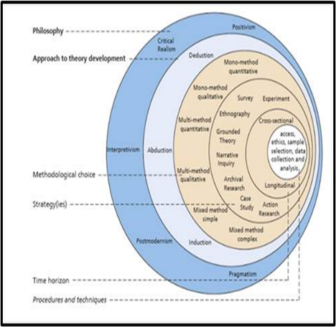 | 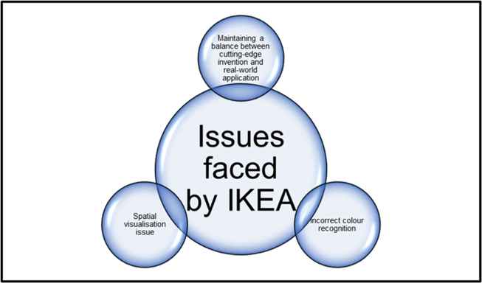● IKEA has faced business challenges. ●These include adopting effective AI technologies, inaccurate product recommendations, and visualisation ineffectiveness (Adam, Wessel, and Benlian, 2021).
CE works as a crucial factor, and thus, this research is crucial to determine based on the AI impact evaluation. | SMART objectives are addressed based on different aspects of the construction of the proposal. The questions and objectives are well aligned and focused on direct stances of CE inclination based on AI in IKEA. This will pinpoint the real issues faced by the organisation (Adam, Wessel, and Benlian, 2021).
Literature Review Systems Theory has been involved (Thimm, 2022). | ● It has core elements such as technology, functions, and human resources.
● AI improves operational effectiveness. | ● This furthermore inclines customer satisfaction, and thus CE.
Methodology A secondary-data-based qualitative study will be adopted (Adams, Khan, and Raeside, 2007, p 5). It will ensure validity through inclusion and exclusion determination (Saunders, Lewis and Thornhill, 2019, p 15). The study relies solely on qualitative data (Walliman, 2004). | ● This will determine the limitation, as there will only be secondary sources.
● The sources can be limited in scope and extent (Cooper and Schindler, 2014). | ● The risk of unconscious bias will arise.
Practical Implications The limitations will involve the lack of recent instances. | Conclusion The subject aspects will thoroughly follow methodological choices.
●The gap will be further addressed through recent findings.



COMPONENT 1: PORTFOLIO: INDEPENDENT
DISSERTATION: THE IMPACT OF ARTIFICIAL INTELLIGENCE ON CUSTOMER EXPERIENCE IN THE UK RETAIL SECTOR: A CASE STUDY OF IKEA

Student Name: Cristinel Dascalu
Student ID: 2233978

Table of Contents
Chapter 3: Research Methodology 3
3.1 Chapter Introduction 3
3.2 Research Assumptions and Philosophy 3
3.3 Research Design 4
3.3.1 Theoretical Interpretation Developing Approach 4
3.3.2 Methodological Choice 4
3.3.3 Research Strategy 4
3.4 Data Collection 4
3.4.1 Search Strategy 4
3.4.2 Inclusion and Exclusion Criteria 5
3.5 Sampling of Collected Data 5
3.6 Datasets and Analysis 5
3.7 Reliability and Validity 5
3.8 Limitations in the Research 6
3.9 Ethical Concern 6
3.10 Time Horizon 6
3.11 Summary 6
References 7
Appendix: Time Horizon 8

Chapter 3: Research Methodology

3.1 Chapter Introduction
The study on the influences of AI application within the UK retail market seeks an exploratory examination. In the context of exploratory examination, a well-structured secondary qualitative study is included for justifying and achieving the research objectives and aim. Methodology is the key section for providing detailed information about the entire research procedure and justifying it with legal findings (Saunders et al. 2023).
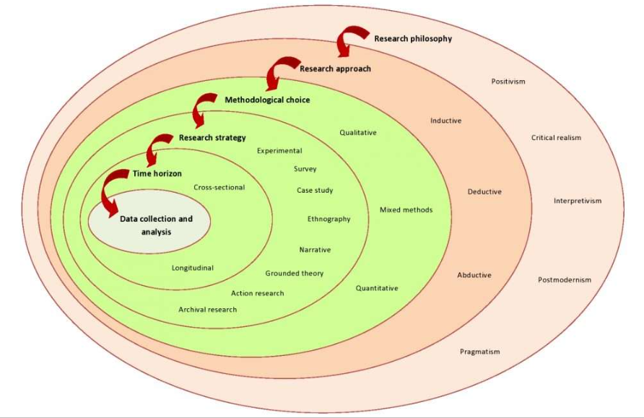
Figure 3.1: Research Onion
(Source: Saunders et al. 2023)
A roadmap is offered through the research onion for describing methodological designs and choices.

3.2 Research Assumptions and Philosophy
In this particular study, an interpretivist philosophy seems to be accurate for assessing the connected qualitative data with the human-centric exploration study. The consideration of secondary qualitative choice highly supports the application of interpretivism philosophy (Thorne, 2025). Additionally, this particular philosophy is helpful for the evaluation of main contexts for the AI-assisted practices in the retail sector of the UK and assessing their overall impacts.

3.3 Research Design

3.3.1 Theoretical Interpretation Developing Approach
This research maintains the application of journal paper reviewing and theory-based literature methods. The theory-based and paper reviewing method perfectly aligns with the deductive approach.
The application of the deductive approach usually begins from the analysis of the current theories, data collection, assessment and finally concludes with testing (Fife and Gossner, 2024). It significantly helps in deciding whether the research is appropriate or not. Therefore, the use of a deductive approach is justified for use in the secondary study. The deductive approach also supports the shaping of the major issues related to AI incorporation within retail brands, like IKEA, through datasets’ analysis.

3.3.2 Methodological Choice
A mono-method choice is used in this qualitative research work. In this particular secondary research, secondary qualitative information is derived through the analysis of the current academic studies and papers on AI integration in the retail landscape. Mono-method is a well-suited choice for justifying exploratory and interpretivism research (Saunders et al. 2023). It has potentially supported the understanding of the AI impacts on retail brands with the guidance of secondary data. Furthermore, the AI-impacted reports at IKEA help justify the practical evidence of AI integration within the retail sector.

3.3.3 Research Strategy
This individual research includes an exploratory strategy for the evaluation of available and accessible secondary datasets. Exploratory investigations significantly support the reinforcement of a more comprehensive investigation (Garg et al. 2023).

3.4 Data Collection

3.4.1 Search Strategy
Multiple authentic datasets support the integration of the secondary information collection for gathering all essential data. IEEE, ScienceDirect, Google Scholar, Elsevier and IEEE databases are included for inserting accurate literature about AI’s effects in retail operations (Sohail et al. 2022). Besides the use of databases, some IKEA-specific information is used in this research to explore the unexplored areas of AI influences on retail business operations.
Different keywords depending on the objectives and aims are included in this investigation. Besides these, the application of some Boolean operators (and, not, or) is used with keywords to find all suitable and relevant research papers existing in the databases.

3.4.2 Inclusion and Exclusion Criteria
Inclusion Criteria | Exclusion Criteria
- All peer-reviewed research papers that are properly suited to AI application practices in retail.  - Relevance with keywords, such as ‘AI influences in retail operations’, ‘AI incorporation’, and ‘retail operations’, etc.  - Publication year of research papers and company reports within the previous five years, from 2020 to 2025.  - Practical evidence availability in the English language. | - Research studies that do not include proper data about AI influences on customer experiences of retail companies.  - Papers with a concentration on other retail organisations besides IKEA.  - Paper publication year before 2020.  - Absence of credible
Table 3.1: Criteria for Inclusion and Exclusion

3.5 Sampling of Collected Data
All datasets are purposely sampled after the collection of secondary data. Here, all research papers and company reports are examined depending on the exclusion and inclusion elements and research objectives and aims. The random method in sampling improves the scope of including biased data due to the absence of objective and precise data sampling (Saunders et al. 2023). In this case, the purposive method in sampling improves the data collection process to drive an objective-centric data stimulation, leading to thematic evaluation.

3.6 Datasets and Analysis
This study maintains a thematic analysis process that allows the evaluation of all included data and the findings in synthesised groups for developing themes. A group of keywords, like AI impacts on customer experiences, AI influences in retail experiences and others, is utilised for building themes. The entire thematic assessment has followed a keyword-centric theme development method (Braun and Clarke, 2024). These themes are potentially evaluated with different supporting documents for establishing a fruitful research outcome.

3.7 Reliability and Validity
The application of the present datasets is included in improving the study's credibility and minimising biased information (Hort et al. 2024). Additionally, company information about IKEA is included to support the qualitative knowledge from the current literature. Furthermore, authentically cited research findings are essential to increase research reliability. Besides these, the ethically and transparently structured research outcomes have supported this study’s reliability.

3.8 Limitations in the Research
This study is limited to mono-method practices, which minimises the effectiveness due to the non-existence of primary data. Despite primary data gathering seeking a strong research framework and ethical practices, the absence of primary methods, like interviews within retail organisations and AI developers, can minimise the real-life implications of this research.

3.9 Ethical Concern
The secondary qualitative collection demands limited ethical concerns as the entire method does not handle any confidential or personal data (Taquette and Borges da Matta Souza, 2022). A good alignment with the ethical standards of the university is maintained in this research. Besides these, the authentic citation of the utilised resources is a key ethical practice, which is maintained within this study.

3.10 Time Horizon
A cross-sectional time horizon is maintained in this research [Refer to Appendix].

3.11 Summary
The methodology section points out the strategic progression of this research and its completion. The use of secondary qualitative examination supports the research in strengthening its strategy and minimises the challenge of biased research outcomes. Besides these, the thematic evaluation method leads to the evaluation of the major findings extracted from secondary literature.

References
Braun, V. and Clarke, V. (2024) ‘Supporting best practice in reflexive thematic analysis reporting in Palliative Medicine: A review of published research and introduction to the Reflexive Thematic Analysis Reporting Guidelines (RTARG)’. Palliative medicine, 38(6), pp.608-616. Available at: https://doi.org/10.1177/02692163241234800
Fife, S.T. and Gossner, J.D. (2024) ‘Deductive qualitative analysis: Evaluating, expanding, and refining theory’. International Journal of Qualitative Methods, 23, p.16094069241244856. Available at: https://doi.org/10.1177/16094069241244856
Garg, S., Mitra, S., Yu, T., Gadhia, Y. and Kashettiwar, A. (2023, June) ‘Reinforced approximate exploratory data analysis’. In Proceedings of the AAAI Conference on Artificial Intelligence (Vol. 37, No. 6, pp. 7660-7669). Available at: https://doi.org/10.1609/aaai.v37i6.25929
Hort, M., Chen, Z., Zhang, J.M., Harman, M. and Sarro, F. (2024) ‘Bias mitigation for machine learning classifiers: A comprehensive survey’. ACM Journal on Responsible Computing, 1(2), pp.1-52. Available at: https://doi.org/10.1145/3631326
Saunders, M., Lewis, P., and Thornhill, A. (2023). Research Methods for Business Students (9th ed.). Pearson.
Sohail, A., Nawaz, N.A., Shah, A.A., Rasheed, S., Ilyas, S. and Ehsan, M.K. (2022) ‘A systematic literature review on machine learning and deep learning methods for semantic segmentation’. IEEE Access, 10, pp.134557-134570. Available at: https://doi.org/10.1109/ACCESS.2022.3230983
Taquette, S.R. and Borges da Matta Souza, L.M. (2022) ‘Ethical dilemmas in qualitative research: A critical literature review’. International Journal of Qualitative Methods, 21, p.16094069221078731. Available at: https://doi.org/10.1177/16094069221078731
Thorne, S. (2025) Interpretive description: Qualitative research for applied practice (p. 354). Taylor & Francis.

Appendix: Time Horizon
Activities | Week 1 | Week 2-3 | Week 4-5 | Week 6 | Week 7-8 | Week 9 | Week 10-11 | Week 12
Choosing the research topic and developing the research question
Literature Review
Choice of Methodology
Inclusion and exclusion criteria
Development of keywords and Boolean Operators for data search
Data Collection and Data Scrutinisation
Data evaluation and Theme development
Discussion on the derived findings
Conclusion and Recommendations
(Gantt Chart)

COMPONENT 1: PORTFOLIO: INDEPENDENT
DISSERTATION: THE IMPACT OF ARTIFICIAL INTELLIGENCE ON CUSTOMER EXPERIENCE IN THE UK RETAIL SECTOR: A CASE STUDY OF IKEA

Module code: LCLM6005
Module: Independent Project

Student Name: Cristinel Dascalu
Student ID: 2233978
Abstract
The concept of AI has come into existence due to the broader technological adoptions that have changed the buying decisions of consumers. Thus, retail companies like IKEA focus on implementing AI-powered personalisation tools through visualisation that allows consumers to choose their products visually. However, it results in cybersecurity threats that tend to harm the image of the brand in terms of stealing away the personal information of consumers. Thus, it is crucial to deploy GDPR policies that can implement data protection laws within the company to prevent issues. Furthermore, focusing on employee training activities can help in developing knowledge about AI personalisation tools that can enhance customer experiences.

Table of Contents
Chapter 4: Results and Discussion 7
4.1 Chapter Introduction 7
4.2 Results 7
4.2.1 Theme observations 7
4.2.2 Overall findings 16
4.3 Discussion 17
4.4 Summary 19
References 20
Appendices 23
Appendix 1: Theme table 24

List of Figures
Figure 4.1: IKEA launched AI assistance 8
Figure 4.2: IKEA chatbot Billie 9
Figure 4.3: IKEA facilitated AI-based home design 10
Figure 4.4: Statement of the Social Media Director of IKEA 11
Figure 4.5: Adobe Experience Cloud solutions adopted by IKEA as the AI-driven tool 12
Figure 4.6: Significant reasons for cybersecurity attacks 13
Figure 4.7: Technological skills required for boosting performance 14
Figure 4.8: Functions of GDPR rules 15
Figure 4.9: Encryption process 16

List of Tables
Appendix Table 1: Thematic findings 24

List of Abbreviations
CXM – Customer Experience Management
AR – Augmented Reality
GDPR- General Data Protection Regulation

Chapter 4: Results and Discussion

4.1 Chapter Introduction
Chapter four is focused on the core results determination as well as the discussion of the gained aspects based on the thematic analysis. The findings are intended to be aligned with the offering of critical discussion related to how AI can influence the client experiences in the UK retail sector. The analysis is focused on the core emphasis on the IKEA operations within the UK retail landscape to attend to the study aim and answer all the study outcomes. The chapter has been structured based on the thematic evaluation and identification, and the overall findings assessment. This has been followed by the discussion of the chapter based on comparing and contrasting with previous analysis to understand the core relationship analysis of AI and the customer experience. Then the chapter summary would be provided so that the key malaise can get the logical flow and the overall determination can get the integrated perspective.

4.2 Results

4.2.1 Theme observations
Implementation of AI systems by IKEA to facilitate shopper interactions within the UK retail sector
In the recent landscape of the digital transformation in retail operations, the implementation of AI is very impactful in driving customer behaviour and gaining more informed insights regarding their choices. The worldwide recognised furniture-selling company recently introduced AI-powered home design, a shopping tool, and an inspiration called the IKEA AI assistant (Ingka Group, 2024). This is only available on the GPT store of OpenAI. By providing the tool that can offer users customised furniture as well as decor suggestions focused on several variables such as room dimensions, style of individuals, functional requirements, budgets, and others, this motive has represented a significant aspect.

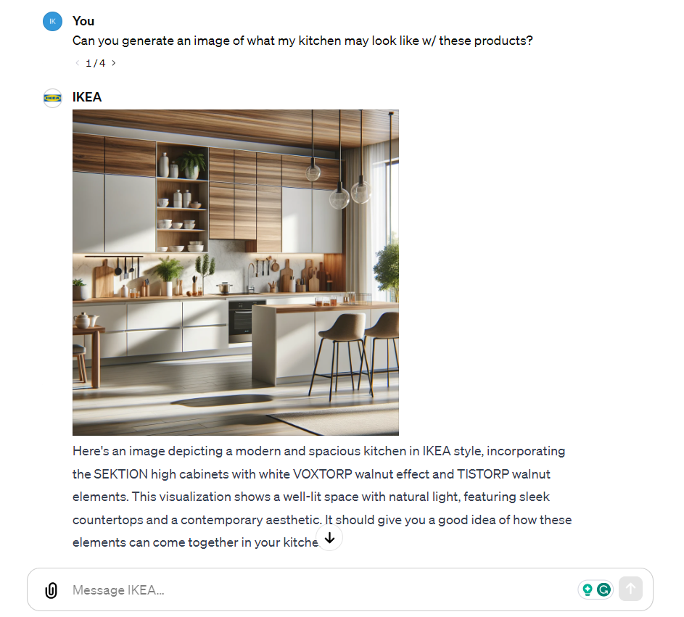

Figure 4.1: IKEA launched AI assistance
(Source: Ingka Group, 2024)
This can also be applied to handling the order as well as status processing techniques around the time, which can be determined as transactional automation. Moreover, this AI assistant can determine routine query triage, which can also allow the employees of IKE to work on more difficult job aspects, such as escalation or deflection. The company has effectively developed Bille, the IKER-specified AI chatbot (Ingka Group, 2023). This is used on all country sites of the company, including the UK operations. This is helpful in managing the status of the orders, rescheduling deliveries, shop hour assessments, and simple inquiry determination, similar to the OpenAI involvement. This is also Dter indeed, as the main conversational bot of the company that can interact with the customers (IKEA, 2025). The company has an assistance page, which specifically states that Billie has been available throughout the website and has become the best at rescheduling several customer deliveries and fulfilling their major demands.

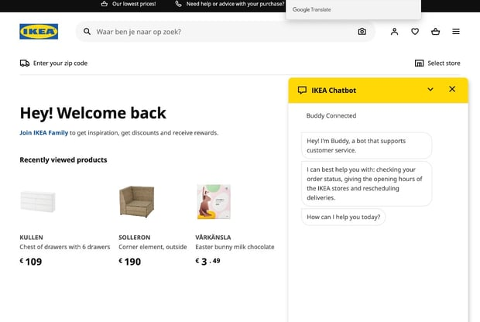

Figure 4.2: IKEA chatbot Billie
(Source: Ingka Group, 2023)
Based on these two significant AI assistances by IKEA, the key role of more sophisticated intelligence bots can be addressed, which is more prominent in handling the business operations as well as facilitating the customer experiences (IKEA, 2025). They can understand the customer's questions, can provide information on the available products at the store or in inventories, offer suggestions, and even assist with the design of the customer's interior spaces. This helps the company to be one of the leading digital transformational leaders who are going beyond the transactional utilisation of AI applications into advisory roles that can satisfy the customers to gain their positive feedback and increase their conversion rates and reported visits, driving the sales of furniture in return. Therefore, this can determine that this analysis of theme can answer the first research question by determining that the automation is implied by IKEA to be for customer convenience by being the customer-first personal approach (IKEA, 2022). The chatbots, such as Billie and others, can therefore incline perceived responsiveness from the customer based on decreasing client effort to determine their furniture choices alone. This can thus reduce the friction also surrounding the transactional touchpoints, such as the order tracking and returns. IKEA, in this case, has utilised a hybrid approach where the human staff offer higher value-driven design guidance while the chatbots and other AI applications handle the triage as well as the escalation of the employee choices and guidance (Ingka Group, 2023). Thus, the company has created human-machine synergies. This can be consistent with the larger retailing strategy of repurposing the human labour evaluation for experiencing jobs and employing AI to impose more nuanced customer-targeted analysis, which cannot be performed only by the workforce with manual labour.


Figure 4.3: IKEA facilitated AI-based home design
(Source: IKEA, 2022)
AI tools to determine the improvement in involvement, customer happiness, and buying journey in IKEA
In this globalised era, AI plays a crucial role in the business environment for achieving comparative advantages. The concept of AI not only helps in shaping the consumer journey but also provides companies with the scope to come up with more innovative digital ideas for boosting sales. AI tools like personalised emails and ads help in boosting the service speeds, which satisfy the consumers (Gkikas and Theodoridis, 2021). The findings stated that AI tools implemented by IKEA help the customers visualise the furniture in terms of making personalised choices that provide the company with customer loyalty. Furthermore, it can be observed that the 24/7 chatbots help the customers answer their questions, through which they receive the solution they are looking for, which influences the buying decisions of the consumers. Thus, it can be understood that the implementation of AI tools helps in shaping the journey of the consumers in this globalised era, which helps the company boost its sales.
Based on the particular emphasis on analytics and data monitoring, IKEA has collaborated with Sprinklr. This has given IKEA AI-driven organisational risk detection tools, etc. This crisis evolution is connected to the unified customer experience management platform (Unified CXM). As per the recent requirement to be aligned with the customer investment evaluation, their happiness assessment, and being connected with their long-term buying journey, this specific AI tool can help IKEA to simply implement this instrument that can suit the client demand assessments. IKEA can now have precise and up-to-date information regarding the current journey of the customer, their products, and other brand insights based on this AI tool application that can help IKEA to determine its brand leadership and position in the UK retail sector. The long-term collaboration, therefore, helped IKEA to monitor the incoming enquiries, the social media-related customer feedback, the real-time client sentiments, and the conversational client journeys (Sprinklr, 2025). These have become easier for the company with the UCXM, which has provided the company with a competitive positioning in the market based on its recent digitalisation-focused decision-making.


Figure 4.4: Statement of the Social Media Director of IKEA
(Source: Sprinklr, 2025)
Moreover, IKEA, apart from data analytics and the digital platform, has been collaborating with Adobe. In order to comprehend and improve customer interactions, IKEA espouses a customer journey and design-referred methodological transformation with the help of AI (Adobe, 2024). Thus, in this aspect of fulfilment, Adobe Experience Cloud can be helpful, which is also utilised by the parent company of IKEA, Ingka Group. In 2018, the parent business located the involvement of this AI-driven solution. With respect to enhancing the core scalability and modernising the CRM operations (Adobe for Business, 2025). Adobe Analytics and the recent customer journey analytics solution have become part of the company's operations. Customer journeys, according to the company, are the sequences of contacts with the brand across several customer journey-based touchpoints; these interactions can thus usually fall into the AI-based analytical approach application, which can help the customer go through a non-sequential manner to more accurately assess their satisfaction level (Nicastro, 2022). In order to comprehend the client's needs and make their level of happiness higher, include their involvement for the long term, IKEA and Ingka Group have collaboratively involved the design thinking methodology based on this customer journey solution. Therefore, it can be determined that these core findings have answered the second research question, which required the information regarding the specific AI tools applied by the company for enhanced customer experience.
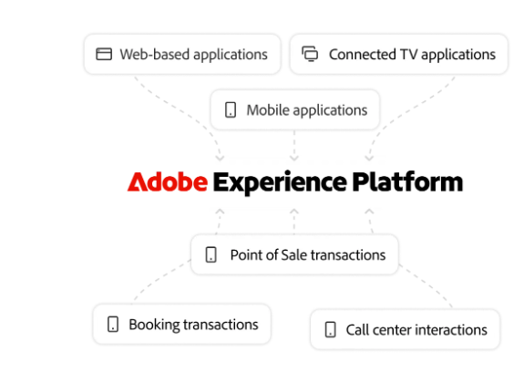

Figure 4.5: Adobe Experience Cloud solutions adopted by IKEA as the AI-driven tool
(Source: Adobe for Business, 2025)
Obstacles IKEA encounters when putting AI-driven personalisation
AI helps companies massively to earn sales that not only boost customer loyalty rates but also establish the image of the brand. However, implementation of AI often comes with several challenges that make it difficult for companies to implement it successfully within their business culture. It can be observed that the cybersecurity issue can be considered as the most significant kind of challenge IKEA faces, which acts as a major obstacle for the company to deploy AI-driven personalisation (Viswanathan, 2024). Despite knowing the benefits of AI personalisation in terms of shaping the consumer experiences, the company fails to launch it successfully. It can be considered that GDPR and privacy laws are the crucial issue that revolves around AI-personalisation, especially in the retail sector. This happens because the retail sector is prone to cybersecurity issues where the consumer data, browsing history and location data are easily accessed by hackers (Aslan et al. 2023). This results in massive issues in terms of stealing away the private information from the customers, which hampers their financial status. These issues are highly punishable under the GDPR laws, which can result in huge penalties (Amoo et al. 2024). Therefore, companies like IKEA implemented privacy policies for controlling the data that focus on existing compliance and privacy laws.
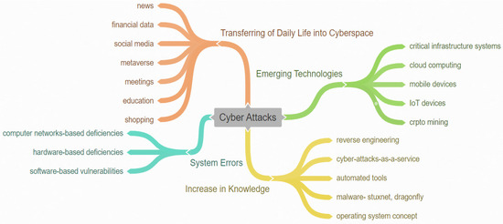

Figure 4.6: Significant reasons for cybersecurity attacks
(Source: Aslan et al. 2023)
Another significant obstacle which the company faces in maintaining the ethical concerns related to the personalisation system. The company finds it difficult to maintain the AI-personalisation as the employees lack training in monitoring and handling the personalisation systems. This results in revealing the private interests of the public in terms of suggesting to them products beyond their expectations. Therefore, IKEA is required to implement strict training for the employees or hire experts who have greater knowledge about technological tools, which can teach the employees about the required technological skills (Saniuk, Caganova and Saniuk, 2023). This can help the company to mitigate the obstacle of ethical concerns that erode the company's image. On the other hand, another major obstacle which the company encounters is service failure. This happens as the company fails to suggest the wrong visualisation to the consumers, which results in a misfit for the consumers. This issue massively harms the image of the company, which not only compromises the quality of the furniture but also the consumer trust in designer products.
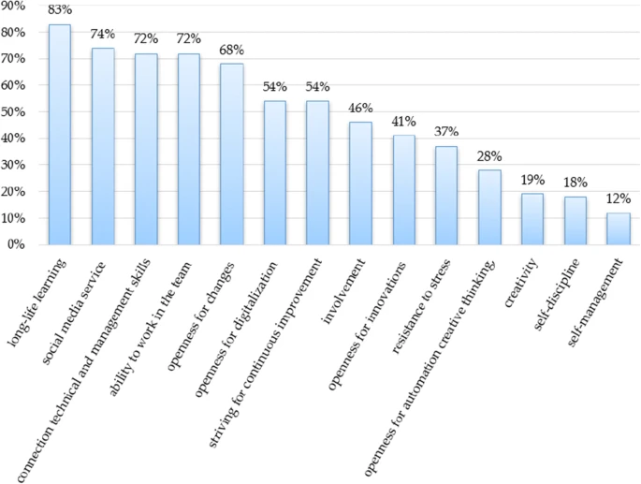

Figure 4.7: Technological skills required for boosting performance
(Source: Saniuk, Caganova and Saniuk, 2023)
The service failures can be considered a significant issue in deploying AI-personalisation that occurs due to a lack of knowledge and complicated technological integration. Thus, it can be understood that the analysis of the theme determines the exact obstacle which the company faces in implementing AI-personalisation in terms of finding the exact solution that can help the company boost its image (Gkikas and Theodoridis, 2021). Additionally, for mitigating these obstacles, the company can deploy stronger AI governance policies that can help ensure safe and transparent communication through the personalisation strategy of chatbots. Hence, deployment of data-control protection and public data protection features helps in making more appropriate choices through the official application of the company (Khurana, 2021). Therefore, it can be understood that the implementation of AI-personalisation comes with massive challenges due to cybersecurity concerns. However, with proper deployment of laws and employee training, companies can come out of this issue in terms of mitigating the obstacles which erode the image of the company. This process will help in making the customer journey smooth in terms of providing the organisation with long-term customer loyalty.
Recommendation of practical steps for determining AI-powered client experiences at IKEA
AI-powered client experiences help in shaping the experience of consumers in this contemporary world massively. It can be observed that consumers in today's world prefer companies which implement technological aspects. The main reason behind doing this is that technology aspects like AI-powered experience make it easier for consumers to choose a product without wasting much time (Gkikas and Theodoridis, 2021). However, it comes with massive challenges that often erode the trust of the company in terms of leaking private information from browsing histories. This act hampers the financial status of the consumers as well as the image of the brand massively. Therefore, the implementation of mitigation strategies has become crucial to prevent such vulnerable acts from happening in the future. It can be observed that the government has implemented several acts to put a stop to these issues. These laws revolve around the GDPR rules that are imposed by the government to prevent cybersecurity issues (Amoo et al. 2024). It can be observed that IKEA focuses on the strict handling of data that prevents any kind of data from being misused. Furthermore, focusing on consumer consent mechanisms helps in enhancing transparency in terms of increasing customer loyalty for the company. For example, the XAI offer suggests the customers various products which develop interests among them (Saniuk, Caganova and Saniuk, 2023). Furthermore, the company also implements bots and digital tools that provide customer support 24/7 in terms of obtaining feedback for mitigating any kind of future issues.
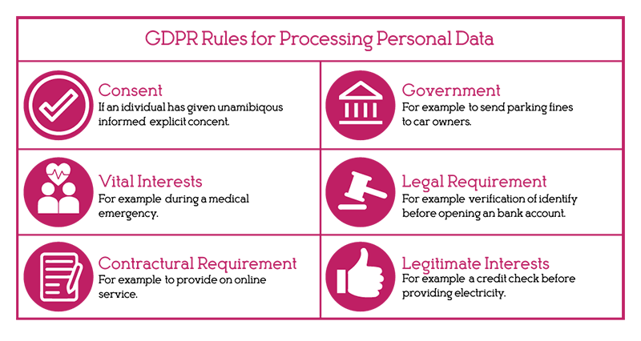

Figure 4.8: Functions of GDPR rules
(source: HIPAA Guide, 2023)
Thus, the findings determined that to solve the cybersecurity issues, the company has to abide by the governmental rules of ethical policy in terms of preventing phishing activities. However, it can be observed that an encrypted system plays a major role in ensuring an effective personalisation system. IKEA is known to provide a virtual experience to consumers through which they can choose the furniture design they want. However, in the meantime of choosing the products, consumers often face the issue of hacking or phishing. Therefore, implementing an encrypted system that prevents third parties from entering into the process in terms of securing the tool can enhance the experience of the customers (Khurana, 2021). Another significant kind of suggestion revolves around the implementation of human-centric strategies that can help in understanding the complicated and emotional situation of the employees. This is because employees play a central role in enhancing customer experience, especially in the retail sector. Thus, when employees are continuously motivated in terms of providing them with training to handle the AI speed, they can deliver better performances in terms of enhancing customer satisfaction (Nguyen and Malik, 2022). Thus, the mixture of human-centric strategy and AI speed can help in enhancing a more responsive and healthy organisational environment, which will increase the highly personalised experience of the customers massively.
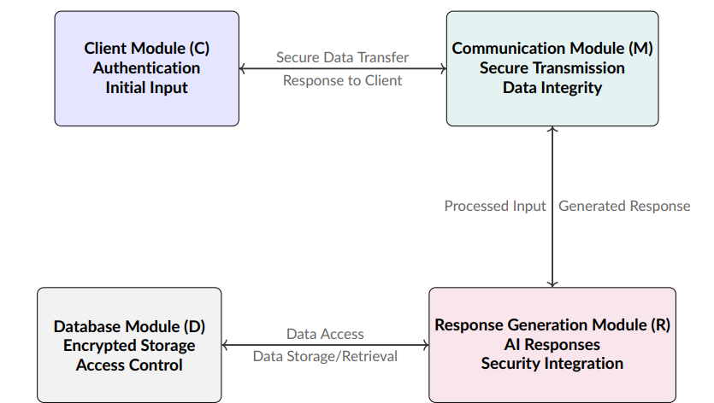

Figure 4.9: Encryption process
(Source: Khurana, 2021)
Altogether, the recommendations of implementing ethical policies, human-centric approaches and employee training help in enhancing AI personalisation customer experience within the retail sector. Furthermore, it results in providing the company with massive comparative advantages in terms of deploying innovative AI personalisation strategies, which separate it from other companies (Farayola et al. 2023). This will not only mitigate the issue but will create opportunities for the organisations in terms of providing them with long-term sustainability performances through a mixture of human-centric and AI personalisation strategies for enhancing customer experiences.

4.2.2 Overall findings
The key results analysis has shown that IKEA has made a significant move towards the digital transformation and customer-centric innovation. The company has deliberately implemented AI solutions to improve customer interaction in the UK retail landscape. The retail AI is a subject of the company and is accessible to the customer based on GPT access. These have been utilised by the global customer base. This can help in tracking the orders and inventory enquiries and assisting customers regarding deliveries. IKEA is currently using advanced analytics and a customer-experience-based system. These are implied in maximising the customer contacts. IKEA has also implemented unified CXM and the Experience Cloud of Adobe so that the customer journey analytics can be effectively addressed. Through inclined, individualised, and frictionless customer experiences, these AI-focused technologies have helped IKEA to maximise its customer-attracting capability. The parent company, Ingka Group, also takes help from these tools to comprehend the behavioural appetite of the clients.
Despite these core developments, the study has pointed out some of the challenges IKEA has when putting AI-focused customisation into key practices; the most difficult issue is the cybersecurity threat. This is connected to the GDPR-related privacy issues. The clients can suffer financial losses as a result of the violation. Moreover, inadequate training in AIU supervision may also raise ethical concerns. This resulted in the poor management of the customisation of AI, leading to the operational failure of IKEA. Practical suggestions have highlighted the significance of strong AI governance. This can help to overcome the issues, including stringent data handling guidelines and an encrypted system that can address the issues. Such as phishing of data, yet improved consumer consent-taking procedures can also help to increase transparency.

4.3 Discussion
Based on the first thematic evaluation, it can be determined that the findings of the first theme show that IKEA uses a variety of AI tools to influence the customer experience at every point of the purchasing procedure. Both are done before and after purchases, and the thesis involved tailored emails, targeted advertisements, and an AI-focused visualisation application installation for furniture suggestions. This can be determined as similar to the findings of literature, as Ozturkcan (2021) stated that augmented reality applications and online visualisation aspects can greatly improve the product discovery. These also support the involvement of customisation. The resellers therefore support this by demonstrating how the client base of the company can imagine the furniture inclusion in their rooms using the company-focused AI-powered design tools. This tool can lower ambiguity and enhance operational decision-making (Marr, 2024). The convergence has shown that the industrial move towards immersive digital purchasing can improve shopping experiences by shaping the customer journey. As the literature analysis of Viswanathan (2025) highlighted, AI can enhance the service speed and optimise the touchpoints of the customer journey. The findings also supported the literature evaluation based on determining the role of conversational AI and chatbots in building seamless and streamlined customer journey experiences for IKEA. This is also in alignment with the chatbot of IKEA, Billie, that declines the employee stress based on automating the order tracking (Rogerson, 2023). This responds to the customer queries around the clock, which results in increased customer satisfaction.
The second thematic evaluation can also determine that various AI tools are currently operating at the company. As per the literature evaluation of Yin, Qiu and Wang (2025), customer satisfaction in the retail industry is fuelled by seamless, satisfactory, and emotionally uplifting purchasing experiences. When customers can locate the product with ease and can receive a clear supply throughout the whole purchasing and customer journey touchpoints, these ideas are in alignment with the implementation of several AI techniques, such as customer journey analytics, experience cloud, emails, and other services. These have shown that the company effectively employed these technologies of AI to lower the friction and also align the interactions between the customer and the company employees. Examples which are given in the context are the AR apps, AI-focused home and ground assistance, and unified CXM tools (Wilkinson, 2025). Therefore, based on the overall evaluation, the study as well as the literature have concurred that a seamless customer journey can be tailored using the suggestions given by AI for the personalised services. The personalised recommendation and full-time guidance and support can boost customer satisfaction and fortify their loyalty for the long term. The study has also highlighted that AI has sped up the checkout and eliminated the necessary product display based on the AI ecosystem created by IKEA. Thus, the company has gained an improved customer experience by implementing the AI application effectively, and this has met the second study question.
In this contemporary world, the concept of AI personalisation places a central role for organisations to develop customer satisfaction. In the retail sector, companies like IKEA focus on implementing personalisation to enhance customer experiences. However, implementing the strategy of inbound marketing comes with both challenges and opportunities that highly influence the buying decision of the consumers. It can be understood that IKEA focuses on implementing GDPR rules for mitigating any kind of cybersecurity issues (HIPAA Guide, 2023). Thus, both the literature review as well as the findings highlighted the importance of ethical governance Strategies for enhancing the readiness of the organisation. However, it can be observed that their strategic orientation differs from each other due to the various buyers that exist within the organisation. Hence, the recommended solution focuses on implementing future-oriented strategies that revolve around both Innovation and personalisation Strategies for enhancing AI-driven customer Experiences through personalisation (Fasnacht and Schlosser, 2025). The major point of comparison lies in understanding the issue of cybersecurity and the implementation of GDPR policies within the organisation. The findings focus on understanding the data privacy regulations and cybersecurity issues, which are some of the significant issues IKEA faces in enhancing customer satisfaction. This results in enhancing fear and loss of company trust as the consumer faces the threat of financial losses through virtualisation of selecting furniture. Conversely, the recommendations for implementing strategies to prevent these issues focus on improving the solutions by deploying encrypted systems and strong data handling strategies (Amoo et al. 2024). It can be observed that the findings of GDPR rules pose a major opportunity for organisations in terms of deploying AI-powered personalisation, which can be aligned with the long-term transparency of the organisation.
The significant point of contrast is understanding the ethical concern and algorithm fairness within the company. It can be observed that the findings focused on understanding the ethical strategies implemented by the company, which they find difficult to implement. This happens due to the lack of training among the employees in terms of handling the digital tools, which results in these issues. Conversely, the recommendations of deploying XAI and human-centric approaches help in solving these ethical issues massively in terms of increasing fairness and transparency among consumers (Zahid et al. 2025). Furthermore, the comparison of understanding service failure and technology on the implementation of AI tools, like virtual fitting rooms, where customers can choose their design accordingly through virtual tools. However, the findings suggested that during this process, the chances of cybersecurity are massively affected by the interruptions of the third party that harms the company's image. Hence, the recommendation of deploying employee training activities in terms of handling the digital tools helps in solving the issue massively (Saniuk, Caganova and Saniuk, 2023). Thus, it can be understood that this segment significantly focuses on improving the customer experience through AI-powered personalisation that not only helps in enhancing the image of the company but also fosters consumer trust. The research objectives have been therefore met by analysing the impact of the digitalisation and AI application by IKEA on the attainment of customer experience journey.

4.4 Summary
The concept of AI-powered personalisation plays a massive role in the retail sector in terms of earning consumer satisfaction. Retail companies like IKEA focus heavily on implementing AI personalisations to enhance the experience of the consumers (Viswanathan, 2024). Thus, the implementation of virtual tours allows consumers to select the designs of the furniture and customise it as per their own choices. However, in between this process, the customer faces cybersecurity issues as well as network issues, which hampers the trust in terms of losing the image of the brand. Thus, it is extremely important to deploy strategies that can prevent the company from going through these cybersecurity issues in terms of increasing competitive advantages. Thus, the findings focus on understanding the importance of deploying GDPR rules that revolve around the ethical policy of preventing any kind of cybersecurity issues (Khurana, 2021). However, providing employee training can also help the company massively in terms of understanding the correct way of monitoring and using the digital tools.

References
Adobe (2024). Adobe Customer Journey Analytics | Holistic Insights Across Every Touchpoint. Available at: https://business.adobe.com/products/adobe-analytics/customer-journey-analytics.html (Accessed: 9 December 2025).
Adobe for Business (2025) Adobe Experience Platform | Adobe for Business. Available at: https://business.adobe.com/products/experience-platform/adobe-experience-platform.html (Accessed: 9 December 2025).
Amoo, O.O., Atadoga, A., Osasona, F., Abrahams, T.O., Ayinla, B.S. and Farayola, O.A. (2024) ‘GDPR's impact on cybersecurity: A review focusing on USA and European practices’, International Journal of Science and Research Archive, 11(1), pp.1338-1347. Available at: https://www.researchgate.net/profile/Olukunle-Amoo/publication/378106122_GDPR's_impact_on_cybersecurity_A_review_focusing_on_USA_and_European_practices/links/65c6ecb579007454976c2b2d/GDPRs-impact-on-cybersecurity-A-review-focusing-on-USA-and-European-practices.pdf
Aslan, Ö., Aktuğ, S.S., Ozkan-Okay, M., Yilmaz, A.A. and Akin, E. (2023) ‘A comprehensive review of cyber security vulnerabilities, threats, attacks, and solutions’, Electronics, 12(6), p.1333. Available at: https://www.mdpi.com/2079-9292/12/6/1333
Farayola, O.A., Abdul, A.A., Irabor, B.O. and Okeleke, E.C. (2023) ‘Innovative business models driven by AI technologies: A review’, Computer Science & IT Research Journal, 4(2), pp.85-110. Available at: https://www.academia.edu/download/109333870/774.pdf
Fasnacht, D. and Schlosser, J. (2025) ‘The role of foresight in bridging the gap between trends and customer experiences’, European Journal of Futures Research, 13(1), p.11. Available at: https://link.springer.com/article/10.1186/s40309-025-00256-6
Gkikas, D.C. and Theodoridis, P.K. (2021) ‘AI in consumer behavior’, In Advances in Artificial Intelligence-based Technologies: Selected Papers in Honour of Professor Nikolaos G. Bourbakis—Vol. 1 (pp. 147-176). Cham: Springer International Publishing. Available at: https://link.springer.com/chapter/10.1007/978-3-030-80571-5_10
HIPAA Guide (2023) GDPR for dummies. Available at: https://www.hipaaguide.net/gdpr-for-dummies/ (Accessed: 9 December 2025).
IKEA (2022) IKEA launches new AI-powered, digital experience. Available at: https://www.ikea.com/us/en/newsroom/corporate-news/ikea-launches-new-ai-powered-digital-experience-empowering-customers-to-create-lifelike-room-designs-pub58c94890/ (Accessed: December 9, 2025).
IKEA (2025) Chat with IKEA’s chatbot “Billie” . Available at: https://www.ikea.com/no/en/customer-service/knowledge/articles/df6c7g64-3863-4314-9113-5965665839fc.html (Accessed: December 9, 2025).
Ingka Group (2023) AI and Remote Selling bring IKEA design expertise to the many. Available at: https://www.ingka.com/newsroom/ai-and-remote-selling-bring-ikea-design-expertise-to-the-many/ (Accessed: December 9, 2025).
Ingka Group (2024) IKEA launches a new AI-powered assistant in OpenAI GPT Store. Available at: https://www.ingka.com/newsroom/ikea-launches-new-ai-powered-assistant-in-openai-gpt-store/ (Accessed: December 9, 2025).
Khurana, R. (2021) ‘Implementing Encryption and Cybersecurity Strategies across Client, Communication, Response Generation, and Database Modules in E-Commerce Conversational AI Systems’, International Journal of information and cybersecurity. Available at: https://www.researchgate.net/profile/Rahul-Khurana-10/publication/386576217_Implementing_Encryption_and_Cybersecurity_strategies_across_client_communication_response_generation_and_database_modules_in_e-Commerce_conversational_AI_systems/links/675797a210214e7cc4a8477f/Implementing-Encryption-and-Cybersecurity-strategies-across-client-communication-response-generation-and-database-modules-in-e-Commerce-conversational-AI-systems.pdf
Marr, B. (2024) The Amazing Ways IKEA Is Using Generative AI. Available at: https://www.forbes.com/sites/bernardmarr/2024/04/05/the-amazing-ways-ikea-is-using-generative-ai/ (Accessed: 9 December 2025).
Nguyen, T.M. and Malik, A. (2022) ‘Impact of knowledge sharing on employees' service quality: the moderating role of artificial intelligence’, International Marketing Review, 39(3), pp.482-508. Available at: https://www.emerald.com/insight/content/doi/10.1108/IMR-02-2021-0078/full/html
Nicastro, D. (2022) Adobe Sees Growth in Digital Experience Segment, Pathlight Adds Quality Assurance, More CX News. Available at: https://www.cmswire.com/customer-experience/adobe-sees-growth-in-digital-experience-segment-pathlight-adds-quality-assurance-more-cx-news/ (Accessed: 9 December 2025).
Rogerson, S. (2023) Ikea uses AI chatbot to support shoppers - IoT M2M Council. Available at: https://www.iotm2mcouncil.org/iot-library/news/smart-retail-news/ikea-uses-ai-chatbot-to-support-shoppers/ (Accessed: 9 December 2025).
Saniuk, S., Caganova, D. and Saniuk, A. (2023) ‘Knowledge and skills of industrial employees and managerial staff for the industry 4.0 implementation’, Mobile Networks and Applications, 28(1), pp.220-230. Available at: https://link.springer.com/article/10.1007/s11036-021-01788-4
Sprinklr (2025) How IKEA stays ahead of the game: inside the retail giant’s global media and brand health monitoring strategy. Available at: https://www.sprinklr.com/stories/ikea/ (Accessed: December 9, 2025).
Viswanathan, J. (2024) ‘Artificial Intelligence: Transforming the Future of Retail’, International Journal of Science and Research (IJSR), 13(9). Available at: https://www.researchgate.net/profile/Jeyaganesh-Viswanathan/publication/383756320_Artificial_Intelligence_Transforming_the_Future_of_Retail/links/66d94a7264f7bf7b197b5c01/Artificial-Intelligence-Transforming-the-Future-of-Retail.pdf
Wilkinson, L. (2025) How Ikea approaches AI governance. Available at: https://www.ciodive.com/news/Ikea-AI-governance-approach-EU-Act-Pact-compliance/740696/ (Accessed: 9 December 2025).
Zahid, I.A., Garfan, S., Chyad, M.A., Albahri, A.S., Albahri, O.S., Alamoodi, A.H., Deveci, M., Homod, R.Z. and Alzubaidi, L. (2025) ‘Explainability, Robustness, and Fairness in User-Centric Intelligent Systems: A Systematic Review’. IEEE Transactions on Emerging Topics in Computational Intelligence. Available at: https://ieeexplore.ieee.org/abstract/document/11012706/

Appendices

Appendix 1: Theme table
Themes | Codes | Findings
Implementation of AI systems by IKEA to facilitate shopper interactions within the UK retail | AI assistant and bot | IKEA uses advanced AI tools to drive sales.
AI tools to determine the improvement in involvement, customer happiness, and buying journey in IKEA | CXM, AR app, Billie | IKEA implements several types of diversified AI tools.
Obstacles IKEA encounters when putting AI-driven personalisation | GDPR, skill gap. | The company faced GDPR constraints and skill gaps.
Recommendation of practical steps for determining AI-powered client experiences at IKEA | Advanced encryption and data governance. | Advanced encryption and data governance are required to comply with the customer service.

Appendix Table 1: Thematic findings
(Source: self-created)

COMPONENT 1: PORTFOLIO: INDEPENDENT
DISSERTATION: THE IMPACT OF ARTIFICIAL INTELLIGENCE ON CUSTOMER EXPERIENCE IN THE UK RETAIL SECTOR: A CASE STUDY OF IKEA

Module code: LCLM6005
Module: Independent Project

Student Name: Cristinel Dascalu
Student ID:2233978
Abstract
In order to overcome the challenges, the company has to focus on certain policies that can help it boost the image of the brand in the competitive retail market. Recommendation strategies like deploying a robust and secure digital culture within the organisation, employee training and maintaining ethical policies focus on overcoming the challenges. These strategies help the organisation enhance the customer experience in terms of providing solutions to mitigate issues within personalisation.

Table of Contents
Chapter 5: Recommendations, Conclusion and limitations of the research 5
5.1. Limitations of the research 5
5.2. Recommendations 5
5.2.1. Enhancing ethical rules within the company to prevent privacy issues 5
5.2.2. Deploying employee training activities 6
5.2.3. Focusing on the aspects of building a more secure and robust digital environment 7
5.3. Conclusion 8
References 9

List of Figures
Figure 5.1: Implementation of responsible AI tools 6
Figure 5.2: Demand for employees with technological knowledge 7
Figure 5.3: Process of deploying a secured and robust digital environment 8

List of Abbreviations

GDPR- General Data Protection Regulation

Chapter 5: Recommendations, Conclusion and limitations of the research

5.1. Limitations of the research
It can be observed that the research provides various useful information about the implementation of AI-powered personalisation within the organisational culture of IKEA. It also focused on the aspects of how, in this contemporary world, the concept of AI has helped the company to earn consumer trust in terms of increasing organisational productivity, as stated by Gkikas and Theodoridis (2021). The study also focused on secondary data in terms of collecting information from various Governmental reports, company websites, articles and journals to understand the knowledge of AI in the retail sector. Despite this, it can be understood that these reports can provide certain biases or outdated information, which may not be relevant or applicable to the selected topic for the research.
Additionally, the research focuses on the company of IKEA, which revolves around selling furniture and home products to consumers. It can be understood that the only focus is on the implementation of digital tools in the retail sector, which possesses massive challenges and opportunities, as stated by Viswanathan (2024). However, it failed to explain the various kinds of training or strategies required to be implemented by the company to mitigate the technological conditions. Another significant limitation with the research posed was the lack of primary data that normally revolves around surveys, interviews or collecting opinions from the experts. Thus, the analysis of the perspective of the study could have been improved in terms of collecting information from the consumers regarding their experiences of using AI-powered personalisation tools.

5.2. Recommendations

5.2.1. Enhancing ethical rules within the company to prevent privacy issues
IKEA is required to focus on implementing ethical rules besides GDPR policies in terms of preventing cybersecurity issues from happening within the company premises. It can be observed that the customer faces cybersecurity issues, especially during the virtual tool process of selecting designs for the furniture. Hence, the company is required to implement responsible AI tools that can help in enhancing the personalisation experience (Aldoseri, Al-Khalifa and Hamouda, 2023). Furthermore, IKEA can focus on strengthening its encryption process in terms of implementing applications that can prevent third-party entry. Furthermore, providing recommendation systems to the customers can help in allowing a more fulfilling experience in terms of implementing structural protection activities.
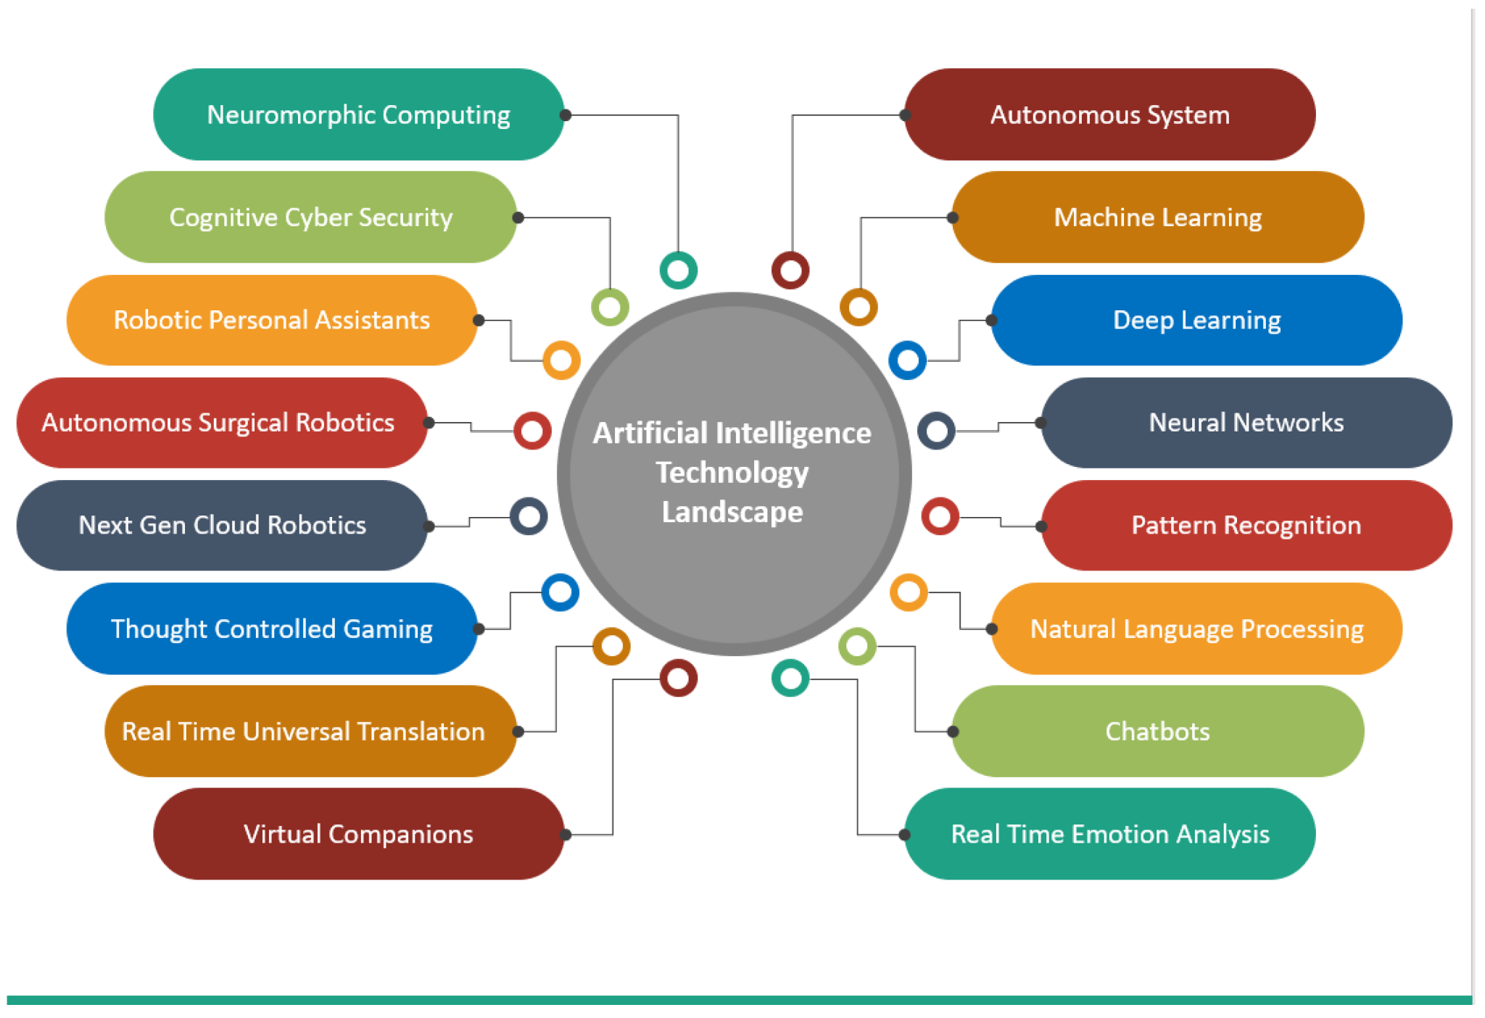

Figure 5.1: Implementation of responsible AI tools
(Source: Aldoseri, Al-Khalifa and Hamouda, 2023)

5.2.2. Deploying employee training activities
The employees of IKEA often find it difficult to handle the digital tools, which result in massive cybersecurity issues. Companies focus on hiring employees who have greater technological skills. Thus, to increase competitive advantages, IKEA can focus on implementing training activities through mentorship programs and knowledge sharing that can help the employees understand the importance of data literacy (Saniuk, Caganovaan and Saniuk, 2023). Furthermore, hiring an expert from the university can also help in teaching the employees about the correct use of visualisation tools. This can help the employees to prevent the entry of third parties during the visualisation tour provided to the customers for selecting the furniture. Additionally, the company can also focus on implementing a hybrid Service model for the employees in terms of preventing job burnout. This can help the employees react more proactively in terms of handling the digital tools, which will avoid any kind of complications in the future.
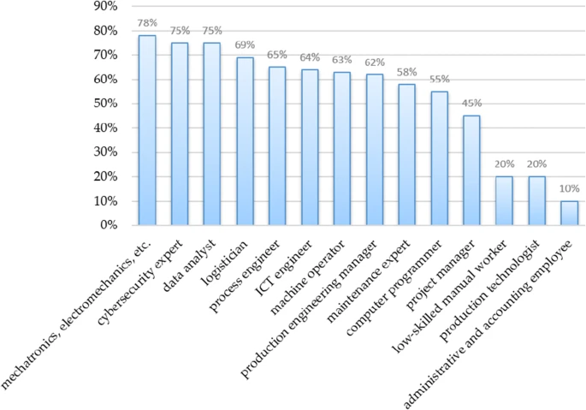

Figure 5.2: Demand for employees with technological knowledge
(Source: Saniuk, Caganovaan and Saniuk, 2023)

5.2.3. Focusing on the aspects of building a more secure and robust digital environment
In this contemporary world, organisations are continuously focusing on implementing digital strategies as a core part of the organisational culture. Thus, IKEA can focus on deploying a secure and robust digital environment in terms of implementing behaviour strategies that continuously revolve around digital aspects. For example, the company can focus on designing virtual tools for the employees where they can play games during their leisure time. This can help the employees to understand the importance of virtual tools, which will prevent any kind of cybersecurity activities from happening in the future. Furthermore, continuous digital innovations can help in creating a secure and robust digital environment within the company (Asatiani et al. 2021). This can be done by collecting feedback from the employees regarding the digital, which can mitigate errors and ensure valuable suggestions from the employees to prevent it from happening in the future.
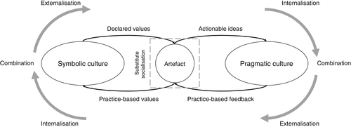

Figure 5.3: Process of deploying a secured and robust digital environment
(Source: Asatiani et al. 2021)

5.3. Conclusion
The concept of AI is massively implemented by IKEA in terms of enhancing customer satisfaction. Hence, it can be observed that AI-powered personalisation is implemented by the company massively in the form of virtualisation tools so that the customers can select their designs accurately. Thus, the research focuses on the analysis of developing product recommendations by the company to enhance the service delivery and shopping experience among consumers. However, it can be observed that deploying the strategies often comes with massive risks like cybersecurity vulnerability, which erodes the image of the company in terms of losing consumer trust. The research also focuses on the effective use of personalisation in the implementation of GDPR rules that revolve around the ethical strategies of practising human-centred and data protection practices.
The study also focused on understanding the importance of applying effective personalisation through robust data protection strategies that can help in enhancing customer satisfaction. Hence, recommendations like implementing a secure and robust digital environment, employee training activities and strengthening the help policy are explained in terms of achieving comparative advantages. Through these, the company can help in improving a stronger foundation in terms of minimising any kind of biasness and avoiding service failure in terms of securities and a healthy digital environment within the organisation. Altogether, the study revolves around the implications of Technology on its traditional strategies due to the demand of consumers. Therefore, through secondary data analysis, the study collected information about the concept in terms of increasing transparency that has enhanced the credibility and reliability of the research.

References
Aldoseri, A., Al-Khalifa, K.N. and Hamouda, A.M. (2023) ‘Re-thinking data strategy and integration for artificial intelligence: concepts, opportunities, and challenges’, Applied Sciences, 13(12), p.7082. Available at: https://www.mdpi.com/2076-3417/13/12/7082?ref=blog.on-demand.io
Asatiani, A., Hämäläinen, J., Penttinen, E. and Rossi, M. (2021) ‘Constructing continuity across the organisational culture boundary in a highly virtual work environment’, Information systems journal, 31(1), pp.62-93.Available at: https://onlinelibrary.wiley.com/doi/abs/10.1111/isj.12293
Gkikas, D.C. and Theodoridis, P.K. (2021) 'AI in consumer behaviour', In Advances in Artificial Intelligence-based Technologies: Selected Papers in Honour of Professor Nikolaos G. Bourbakis—Vol. 1 (pp. 147-176). Cham: Springer International Publishing. Available at: https://link.springer.com/chapter/10.1007/978-3-030-80571-5_10
Saniuk, S., Caganova, D. and Saniuk, A. (2023) 'Knowledge and skills of industrial employees and managerial staff for the Industry 4.0 implementation', Mobile Networks and Applications, 28(1), pp.220-230. Available at: https://link.springer.com/article/10.1007/s11036-021-01788-4
Viswanathan, J. (2024) ‘Artificial Intelligence: Transforming the Future of Retail’, International Journal of Science and Research (IJSR), 13(9). Available at: https://www.researchgate.net/profile/Jeyaganesh-Viswanathan/publication/383756320_Artificial_Intelligence_Transforming_the_Future_of_Retail/links/66d94a7264f7bf7b197b5c01/Artificial-Intelligence-Transforming-the-Future-of-Retail.pdf

