

Assessment 2: Report

General anxiety disorder, schizophrenia and autism

Student name: Ginka Borisova
Student ID:1915313

Module name: Mental Disorders and Psychopathology
Module code: (BMHP6006_LON)
Lecturer name: Bianca Sanfilippo
Word count: 2833

Table of Contents

Introduction 3
General Anxiety Disorder (GAD) 3
Schizophrenia 6
Autism 9
Conclusion 12
References 13
Appendix 16

Introduction
Mental health complications can be identified as a common problem in human lives due to several external and internal reasons. The mental state of ordinary people is being affected due to daily stress and pressure from complications in their lives and physical environmental factors. The concerned report has critically examined the classification, treatment, diagnosis and measurements of rehabilitation among three mental disorders chosen from ICD-10 (WHO, 2010). The disorders presented in this report will be GAD (General Anxiety Disorder), Schizophrenia, and Autism, which directly impact people's lives.

General Anxiety Disorder (GAD)
Definition
GAD includes panic disorder which can also be stated as a post-traumatic disorder, obsessive-compulsive disorder and social phobia. In this mental disorder, a person does excessive worry about several different events, which provides high tension and anxiety. GAD mainly begins in the twenties, and 30% of GAD referrals can occur in this period (Bahceci et al., 2021).
Percentage of people
It has been identified that 1780 people face work-related stress, anxiety and depression among 100,000 workers in Great Britain (Hse, 2021). Generally, 4% of the population is affected by GAD at some point in their lives. It has been noticed that GAD is found twice as much in women than men as they are more likely to be exposed to physical and sexual abuse, discrimination and poverty.
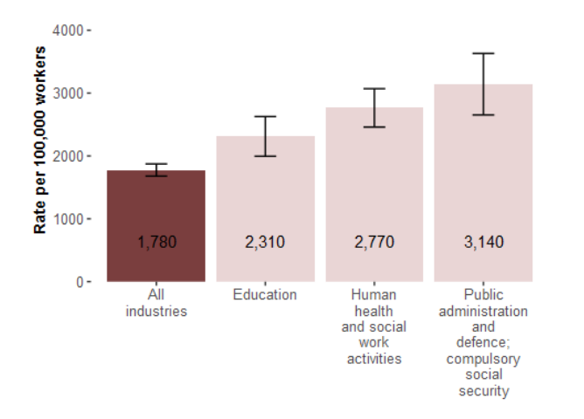
Figure 1: Rate of people facing GAD according to different industries
(Source: Hse, 2021)
The above figure helps to identify the rate of people who are diagnosed and facing anxiety. The people in public administration and defence face many anxiety issues in their regular lives.
Classification
GAD is classified under ICD-10 under ‘Neurotic, stress-related and somatoform disorders’ F40-F48, more precisely under F41.1, considered a type of anxiety disorder.
Causes
GAD can be developed due to different reasons such as any traumatic life experience, brain structure, complications in genetics and maintenance of social factors. Furthermore, the food habits about taking caffeine and trouble in relationships can also introduce panic disorder or GAD. The inflammation could be introduced due to biological mechanisms in the aetiology of GAD (Costello et al., 2019). The aetiology of GAD is not clear; researchers suggest a combination of several factors can cause it: chemical imbalance or overactivity in areas of the brain responsible for emotions, genetic and family history of traumatic experiences, misuse of drugs and alcohol and other health conditions.
Signs/Symptoms
The concerning mental disorder mainly has two kinds of significant symptoms: extreme worry about different events and cannot control the level of stress. Furthermore, patients with GAD can face considerable amounts of depression and anxiety while doing their daily activities (Slee et al., 2021). They can also have difficulty concentrating. Furthermore, they can also face massive headaches, stomach aches and problems controlling feelings of worry (NHS UK, 2021).
Diagnosis
GAD needs to be diagnosed as having the stated symptoms for six months or more, and patients can find difficulty managing feelings of anxiety. The professional or GP may carry out a physical examination to diagnose GAD through a blood test to identify any other causes of these symptoms. The GP introduces some questionnaires to determine the patient's mental health and understand whether the patient is facing complications due to the severe effect of GAD or not. The questions will be answered about patients’ experiences over the last two weeks.
Treatments
According to the severity, the GP or psychological therapist suggests some guides for self-help courses to understand that the patient can cope with anxiety. Currently, CBT (“Cognitive behavioural therapy”) is one of the effective treatments for GAD. It helps to question patients’ negative or anxious thoughts and gives them the courage to do things that have been avoided for fear and worry. If the severity is minor, then CBT and relaxation are the treatments provided by the GPs of NHS (NHS UK, 2021). However, healthcare professionals usually prescribe Sertraline, Paroxetine, and Escitalopram if there is significant severity.
Measurements of rehabilitation
GAD-7 is a tool that helps understand the severity of a patient's disorder and anxiety symptoms. It has been identified through a set of questionnaires as depicted in Appendix. The GAD-7 can be developed in pre and post-treatment. It helps measure depression, anxiety, and well-being (Johnson et al., 2019). Therefore, it helps to understand the rate of treatment for GAD patients about giving back their typical lifestyle. The UK health professionals try to provide suitable therapies to patients free at NHS and continuously monitor the patients appropriately.
Guidance and Principle of care NICE
It is essential to build a relationship with the patients diagnosed with GAD and engage in a non-judgemental manner. Furthermore, exploring the treatment options collaboratively with the person (NICE, 2019). The guidance for families and carers is that they need to make a friendly relationship so that patients can share their feelings. Furthermore, the GPs need to provide written and verbal information about the GAD patient and how it can be managed effectively. It is essential to inform the local and national self-help organisations to support the families.
Recommendations
The intervention for GAD patients needs to be more developed to live their lives appropriately. In addition, the friends and families need to be more corporative about the mental state of the patients and understand their complications in dealing with aby critical events. Moral support and understanding of internal feelings are necessary to deal with these patients. Hence, it is the responsibility of the GP to provide all kinds of benefits in improving the mental state of patients. Therefore, the concerned recommendations can help improve patients’ health and mental state with GAD complications.

Schizophrenia
Definition
Schizophrenia is a severe mental disorder where people interpret reality as abnormal. It introduces hallucinations, disordered thinking and behaviour, and delusions in their daily functions. It can be categorised with risk genes which can promote inflammation and are taught by environmental stress factors in the alteration of the immune system (Müller, 2018). This mental issue can be identified as a significant psychosis disorder where the person cannot significantly relate mood, behaviour, or thoughts. It also includes the complications of bipolar disorder and personality disorder. It is a rare type of mental disorder identified among people.

Percentage of people
Schizophrenia can be identified in 1 person among 100 in the UK, which is relatively fewer than other mental disorders (Walsh, 2022). Therefore, it is difficult to get appropriate treatment for the concerned mental illness about maintaining a good life with daily habits. Furthermore, 20 million people worldwide face complications from Schizophrenia (Mind, 2022). Therefore, it can be identified among young and older adults to understand the reality.
Classification
Schizophrenia is categorised in ICD-10 under ‘Schizophrenia, schizotypal and delusional disorders’ F20 – F29. The schizotypal disease includes the condition which impacts behaviour and anomalies of thinking and resembles what has been seen by the person with Schizophrenia (WHO, 2011). Furthermore, the concerned disorder can introduce odd or eccentric behaviour and a tendency to social withdrawal through paranoid and bizarre ideas. Different delusional characteristics can be developed in a person with delusional disorder, including apparent and auditory hallucinations with evidence of severe brain disease. It also provides personality disorders, psychogenic and psychosis, which impact a person's life's internal and external environment.
Causes
The exact cause of schizophrenia is still unknown, and very researchers and professionals have analysed the state of mind of patients with Schizophrenia. However, it can be stated that a combination of physical, psychological, environmental, and genetic factors can make a person develop the conditions of Schizophrenia. Furthermore, massive stress and mental pressure can also trigger the symptoms of Schizophrenia and introduce psychotic episodes (NHS UK, 2022). Stress and drug abuse can be identified as the main trigger for which the complications regarding Schizophrenia can be initiated, and different difficulties can be identified. Studies have also stated that the brain structure of a person with Schizophrenia is slightly different from others, and it can also be a cause of Schizophrenia.

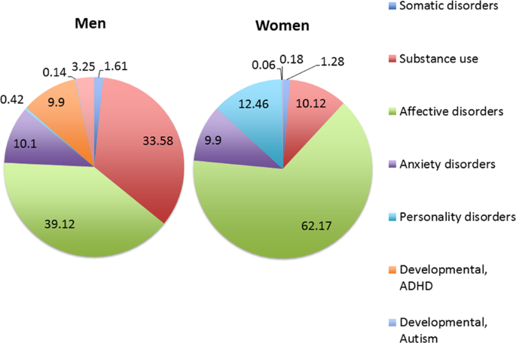

Figure 2: Preceding diagnosis before developing schizophrenia
(Source: Sommer et al., 2020)
Individuals hospitalised at least once before being diagnosed with schizophrenia have been given different non-psychotic diagnoses, as shown in Figure 2, which might have been a cause for developing this mental health disorder (Sommer et al., 2020).
Signs/Symptoms
Schizophrenia can change the thinking and behaviour of a person entirely, and this mental disorder can be developed slowly among a person. The positive symptoms of Schizophrenia are delusions and hallucinations. On the other hand, the negative symptoms of Schizophrenia are they do not take any interest in social interactions and often appear flat or emotionless (NHS UK, 2022). A person with Schizophrenia also can become suicidal in this mental state for a lack of support and adaptable behaviour from others. Sometimes, the individual feels that someone else has taken his body, and they control all his thoughts. It can be identified as a personality disorder.
Diagnosis
As the causes of Schizophrenia are also unknown, there is no reliable diagnosis and monitoring therapy for the concerned disorder. The CMHTs (“community mental health teams”) can assess an individual presenting symptoms such as hallucinations, hearing voices, delusions, and incoherent speech and diagnose a patient with Schizophrenia if all other causes for their signs are ruled out (NHS UK, 2022). BDNF (“Brain-derived neurotrophic factor”) can help in the diagnosis and maintaining the treatment of Schizophrenia (Peng et al., 2018). The BDNF factors are mainly included to understand the brain's functions in managing appropriate psychological operations. Therefore, it is essential to maintain a proper diagnosis about understand the severity of Schizophrenia. The psychological professionals mainly do counselling and ask different questions to identify the problems regarding Schizophrenia.
Treatments
After an appropriate diagnosis, it is essential to maintain effective treatment to get back to regular life with daily habits. Schizophrenia can be cured through an individually tailored combination of medicine and talking therapy. Furthermore, many people have also been treated with CMHTs (NHS UK, 2022). The concerned team provides day to day support and treatment to the patients with Schizophrenia until they ensure that the patient can be cured by themselves. CPA (Care Programme Approach) can also identify as an effective treatment or practice about mitigate the complications of Schizophrenia.
Measurements of rehabilitation
It is essential to measure the quality of treatment of Schizophrenia in the UK to understand the condition of patients. The “Quality Indicator for Rehabilitative Care (QuIRC-SA)” can be used as a tool to measure the rehabilitation of Schizophrenia (UCL, 2022). The living environment of patients with Schizophrenia is suitable and adaptable in the UK, and the therapeutic setting is also appropriate for GP and professionals. Furthermore, treatments and interventions are also effective, and the medical professionals have provided self-management suggestions. The human rights of the UK with the “Human Rights Act 1998” have also been maintained appropriately, encouraging people with Schizophrenia to live everyday life.
Guidance and Principle of care NICE
According to guidelines, social and health care professionals need to be trained to handle young people and children with Schizophrenia disorder. The health and social care professionals also need to know about the implication of the Children Act 1989, the Mental health Act 1983 and the Code of practice related to the Mental Health Act (NICE, 2016). Furthermore, it helps to maintain effective local safeguarding procedures through the safeguarding system. The patients need to take care of routinely by the community team. The patient should not be passed from one group to another in any condition or unnecessarily.
Recommendations
The recommendations need to be provided to the family and carers about improving their support and acceptance of Schizophrenia patients. Furthermore, the patients must be calm while receiving the treatments. Daily check-ups and monitoring are needed to provide appropriate interventions to improve health and maintain behavioural sustainability. In addition, the family members also need to understand the mental condition of patients and always make a comfortable atmosphere for them to mitigate stress, which can trigger Schizophrenia disorder. Therefore, the concerned recommendations can be helpful about improve treatments and diagnosis of Schizophrenia.

Autism
Definition
Autism or ASD is a mental disorder that introduces complications in maintaining appropriate communication and behavioural problems. Autism can also identify as a minor problem or disability which needs full-time care in a particular facility. Autistic people may find it hard to communicate and interact with other people, and they also find difficulty understanding, thinking and feeling any situation. Autism is a commonly diagnosed mental disorder among males and females (Hull et al., 2020).

Percentage of people
It is identified that around 700,000 people in the UK are diagnosed with autism. Furthermore, one in 100 children is born with autism symptoms.
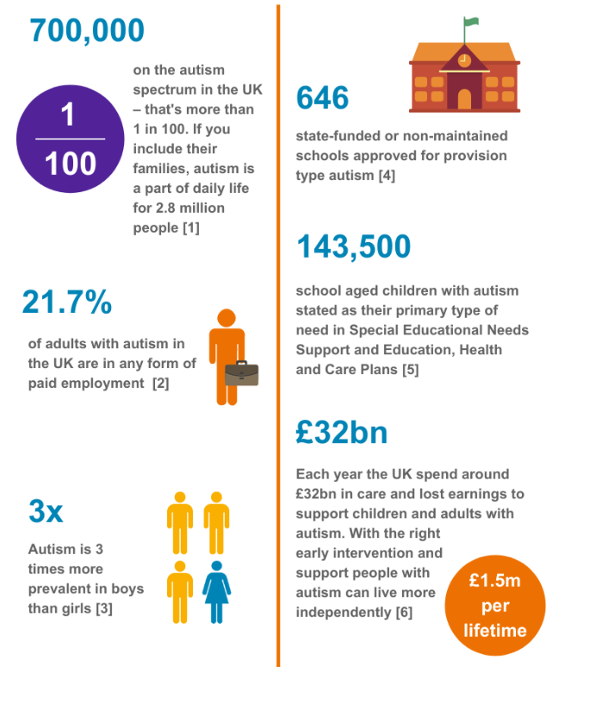
Figure 3: Statistics regarding Autism in the UK
(Source: Beyond Autism, 2022)
The above figure helps to understand the percentage of autistic people in the UK, and 21.7% of people with autism are getting paid employment (Beyond Autism, 2022). Furthermore, 32 billion euros have been spent on the treatment of Autism. Therefore, it can be stated that the concerned mental disorder is quite popular among people in the UK, and many people are facing complications due to the concerned issue.
Classification
Autism is classified in ICD-10 under ‘Disorders of psychological development’ F80-F89 and forms together with Asperger syndrome, pervasive developmental disorder not otherwise specified (PDD-NOS), Childhood disintegrative disorder (CDD), and Rett syndrome, a group of five disorders classified as Pervasive developmental disorder F84. The first four diseases are usually named Autistic Spectrum Disorders (ASD).
Causes
There is no cause for which a person can face complications with autism. Furthermore, it can be developed regarding combinations of genetic and nongenetic environmental influences. Again, the concerned factors can introduce risks for children who develop autism after birth. Autism can also be raised due to brain differences (Autism Speaks, 2020). In addition, complications in genetic conditions can also present risks regarding autism and introduce complications in interacting with others who are normal. ASD is mainly taught in a person before three years of age.
Signs/Symptoms
Autism is mainly diagnosed among children at an early age. It can be identified through symptoms such as delay in language skills, movement skills, and complications in understanding the learning and cognitive skills - autism impacts individual development trajectorially. Furthermore, the children with Autism can also introduce Epilepsy and Seizure disorder which can affect their future development for developing the skills. Moreover, the children mainly incorporate issues regarding making eye contact with people or others about managing appropriate interactions (Dahiya et al., 2020). Children with ASD also face complications in learning and moving or paying attention to something, so there is a delay in understanding and identifying some situations appropriately.
Diagnosis
The diagnosis process of Autism is mandatory to manage the mental health growth of a child or adult. Therefore, getting appropriate advice from GP or health visitors is essential for under five-year-old children and getting treatments. Furthermore, autistic children need to have a suitable special education needs (SENCO) staff which helps to understand the child’s thoughts (NHS UK, 2022). The health professional introduces appropriate autism assessment through some questions that help identify autism and ASD disorder complications. The diagnosis helps both parents and children identify the children’s needs and improve their mental health.

Treatments
Currently, there are no standard treatments for Autism or ASD related children. Still, there are many ways to minimise the symptoms and maximise the children’s abilities with Autism. Behavioural management therapy, cognitive behaviour therapy and early interventions are helpful for Autism children to maximise their abilities.
Measurements of rehabilitation
The measurement of rehabilitation can be developed with Childhood Autism Rating Scale (CARS) as 15 items to accurately identify the children with Autism (Moon et al., 2019). The concerned tool has been incorporated with a child’s age and identifies the mental growth with their age or development. The scores have been provided about a child’s mental growth with Autism complications. Therefore, the measurement of rehabilitation needs to be incorporated appropriately about understand the quality of treatment.
Guidance and Principle of care NICE
As per the guidelines by NICE, it is essential for autistic children and young people to have full access to health services and social care. In addition, it is necessary to manage appropriate coordination of care with autistic children and young people through the local specialist community. Local autism teams also need to ensure that every autistic child can manage and coordinate the treatment.
Recommendations
It can be recommended that appropriate support be provided to autistic children, and proper behaviour needs to be provided. It helps them improve engagement with the society and influence to do different creative and innovative operations. Furthermore, practical training and skill development programs can be provided to autistic children to improve their daily habits.

Conclusion
A critical examination of the presented three mental health disorders classified in the ICD-10 is necessary to understand the nature of the illness and its aetiology and symptoms. Furthermore, it helps determine treatments and measures of rehabilitation using the latest guidance and recommendations offered by medical professionals through policies and NICE guidelines.

References
Autism Speaks. (2020). What Causes Autism? | Autism Speaks. [online] Available at: <https://www.autismspeaks.org/what-causes-autism#:~:text=A%20common%20question%20after%20an,a%20child%20will%20develop%20autism.> [Accessed 20 April 2022].
Bahceci, I., SÖZTANACI, U.S., PUŞUROĞLU, M., Arslan, N., DURAN, Ö.F., Bahceci, B. and Yazici, Z.A., (2021). Evaluation of The Relationship Between Apelin 36 and Oxidative Stress In Patients With General Anxiety Disorder. Middle Black Sea Journal of Health Science, 7(3), pp.397-403.
Beyond Autism. (2022). Statistics - BeyondAutism. [online] Available at: <https://www.beyondautism.org.uk/about-autism/understanding-autism/statistics/> [Accessed 20 April 2022].
Costello, H., Gould, R.L., Abrol, E. and Howard, R., (2019). Systematic review and meta-analysis of the association between peripheral inflammatory cytokines and generalised anxiety disorder. BMJ Open, 9(7), p.e027925.
Dahiya, A.V., McDonnell, C., DeLucia, E. and Scarpa, A., (2020). A systematic review of remote telehealth assessments for early signs of autism spectrum disorder: Video and mobile applications. Practice Innovations, 5(2), p.150.
Hull, L., Petrides, K.V. and Mandy, W., (2020). The female autism phenotype and camouflaging: A narrative review. Review Journal of Autism and Developmental Disorders, 7(4), pp.306-317.
Hse.gov.uk. (2021). Work-related stress, anxiety or depression statistics in Great Britain, 2021. [online] Available at: <https://www.hse.gov.uk/statistics/causdis/stress.pdf> [Accessed 20 April 2022].
Johnson, S.U., Ulvenes, P.G., Øktedalen, T. and Hoffart, A., (2019). Psychometric properties of the general anxiety disorder 7-item (GAD-7) scale in a heterogeneous psychiatric sample. Frontiers in psychology, 10, p.1713.

Mind. (2020). Mental health facts and statistics. [online] Available at: <https://www.mind.org.uk/information-support/types-of-mental-health-problems/statistics-and-facts-about-mental-health/how-common-are-mental-health-problems/> [Accessed 20 April 2022].
Moon, S.J., Hwang, J.S., Shin, A.L., Kim, J.Y., Bae, S.M., Sheehy‐Knight, J. and Kim, J.W., (2019). Accuracy of the Childhood Autism Rating Scale: A systematic review and meta‐analysis. Developmental medicine & child neurology, 61(9), pp.1030-1038.
Müller, N., (2018). Inflammation in schizophrenia: pathogenetic aspects and therapeutic considerations. Schizophrenia bulletin, 44(5), pp.973-982.
NICE – National Institute for Health and Care Excellence (2016) Psychosis and schizophrenia in adults: prevention and management. (Online). Available at: https://www.nice.org.uk/guidance/cg178/chapter/1-Recommendations (date accessed: 19 April 2022).
NICE – National Institute for Health and Care Excellence (2016) Psychosis and schizophrenia in children and young people: recognition and management. (Online). Available at: https://www.nice.org.uk/guidance/cg155/chapter/recommendations (date accessed: 19 April 2022).
NICE – National Institute for Health and Care Excellence (2021) Autism spectrum disorder in under 19s: support and management. (Online). Available at: https://www.nice.org.uk/guidance/cg170/chapter/recommendations (date accessed: 19 April 2022).
NICE – National Institute for Health and Care Excellence (2019) Generalised anxiety disorder and panic disorder in adults: management. (Online). Available at: https://www.nice.org.uk/guidance/cg113/chapter/1-Guidance#principles-of-care-for-people-with-generalised-anxiety-disorder-gad (date accessed: 19 April 2022).
NHS UK. (2021). Diagnosis - Generalised anxiety disorder in adults. [online] Available at: <https://www.nhs.uk/mental-health/conditions/generalised-anxiety-disorder/diagnosis/?msclkid=5661d0a9a54011ec880a278cfce57bff> [Accessed 20 April 2022].
NHS UK. (2021). Treatment - Generalised anxiety disorder in adults. [online] Available at: <https://www.nhs.uk/mental-health/conditions/generalised-anxiety-disorder/treatment/#:~:text=Cognitive%20behavioural%20therapy%20(CBT)%20is,single%20treatment%20works%20for%20everyone.> [Accessed 20 April 2022].
NHS UK. (2022). Causes - Schizophrenia. [online] Available at: <https://www.nhs.uk/mental-health/conditions/schizophrenia/causes/#:~:text=The%20exact%20causes%20of%20schizophrenia,might%20trigger%20a%20psychotic%20episode.> [Accessed 20 April 2022].
NHS UK. (2022). Symptoms - Schizophrenia. [online] Available at: <https://www.nhs.uk/mental-health/conditions/schizophrenia/symptoms/> [Accessed 20 April 2022].
NHS UK. (2022). Treatment - Schizophrenia. [online] Available at: <https://www.nhs.uk/mental-health/conditions/schizophrenia/treatment/> [Accessed 20 April 2022].
NHS UK. (2022). How to get diagnosed with autism. [online] Available at: <https://www.nhs.uk/conditions/autism/getting-diagnosed/how-to-get-diagnosed/> [Accessed 20 April 2022].
Peng, S., Li, W., Lv, L., Zhang, Z. and Zhan, X., (2018). BDNF as a biomarker in diagnosis and evaluation of treatment for schizophrenia and depression. Discovery medicine, 26(143), pp.127-136.
Sommer, I.E., Tiihonen, J., van Mourik, A., Tanskanen, A. and Taipale, H. (2020). The clinical course of schizophrenia in women and men—a nation-wide cohort study. npj Schizophrenia, [online] 6(1), pp.1–7. Available at: https://www.nature.com/articles/s41537-020-0102-z.
Slee, A., Nazareth, I., Freemantle, N. and Horsfall, L., (2021). Trends in generalised anxiety disorders and symptoms in primary care: UK population-based cohort study. The British Journal of Psychiatry, 218(3), pp.158-164.
UCL (2022) Quality Indicator for Rehabilitative Care. (Online). Available at: https://quirc.eu/quirc-sa/ (date accessed: 19 April 2022).
Walsh, M., (2022). Schizophrenia statistics: Symptoms and treatment. [online] The Checkup. Available at: <https://www.singlecare.com/blog/news/schizophrenia-statistics/> [Accessed 20 April 2022].
World Health Organisation, WHO (2010) ICD-10 VERSION (Online). Available at: https://icd.who.int/browse10/2010/en#/F30-F39 (Accessed: 16 December 2021).

Appendix

Generalised Anxiety Disorder Questionnaire – GAD-7

