BA (Hons) Leadership and Management Skills for the Workplace

LCLM 5001 Understanding and Engaging Stakeholders module

Component 2- Individual Report

Lecturer Dr Aso Abdullah

Ayan Tifow 2420687


Table of Content
Title Page……………………………………………………………………..……....Pg 1

Table of content ………………………………………………………………..……Pg 2

Executive Summary and Introduction…………………………………………....Pg 3

An appraisal of the company to include SWOT and PESTLE analysis……..Pg 4

Identifying Stakeholders (Internal and External)……………………………….Pg 6

Roles, Responsibilities, Benefits, and Challenges of Stakeholders………..Pg 8

Critical Stakeholder Engagement Process and Conflict Management Using the 4C’s Model……………………………………………………………………………..Pg 12

Evaluate the impact of stakeholders’ engagement on your business performance and provide recommendations for future……………………….Pg 14

Recommendations for Future Stakeholder Engagement……………………Pg 16

Conclusion……………………………………………………………………………Pg 18

References…………………………………………………………………………….Pg 19

Executive Summary and Introduction

This report evaluates stakeholder identification, analysis, and engagement strategies for the introduction of StaySmart+, a premium AI-enabled customer experience service developed by Marriott International. As one of the largest hospitality organisations globally, Marriott operates more than 8,700 hotels across over 130 countries and territories, serving millions of guests each year through a wide portfolio of brands. In the United Kingdom, the company has an established presence in key cities such as London and Birmingham, catering to both business and leisure travellers. With a workforce of approximately 400,000 employees worldwide, the organisation has the operational capacity, resources, and expertise required to implement large-scale service innovations.
The StaySmart+ programme introduces artificial intelligence, based guest interaction tools, personalised travel planning, and sustainability-focused amenities designed to enhance service quality while improving operational performance. The initiative aims to increase guest satisfaction, strengthen brand differentiation, and support long-term competitiveness in global hospitality markets.
This report applies key academic concepts, including stakeholder theory, relationship marketing, and project management frameworks, to identify and evaluate the internal and external stakeholders involved in the project. Structured engagement tools are used to support this analysis, including stakeholder mapping, stakeholder and resource dependency theories, RACI matrices, communication planning, and the 4C’s engagement model: communication, consultation, collaboration, and commitment.
The discussion also considers the practical challenges and ethical considerations associated with stakeholder engagement in a multinational hospitality environment. Particular attention is given to issues such as data privacy, cultural diversity, and the adoption of emerging technologies. The findings highlight that effective stakeholder engagement plays a critical role in ensuring successful project implementation and sustainable organisational performance. The report therefore concludes with recommendations aimed at strengthening long-term stakeholder relationships and supporting responsible innovation.

An appraisal of the company to include SWOT and PESTLE analysis

A situational analysis highlights the strong strategic position of Marriott International for launching the StaySmart+ initiative. The organisation benefits from a globally recognised brand, an extensive international footprint and an established digital infrastructure that supports innovation across its portfolio. Strong brand equity and internal capabilities are recognised as key strengths within strategic analysis frameworks (Johnson, Scholes and Whittington, 2020). Marriott’s Bonvoy loyalty program also strengthens customer retention and enables data-driven personalisation, supporting relationship marketing strategies that prioritise long-term stakeholder value (Christopher, Payne and Ballantyne, 2013). Furthermore, the company’s experience in implementing global initiatives demonstrates strong organisational capabilities for managing large-scale change and innovation.
However, organisational size and structural complexity may reduce agility and slow decision-making processes (Johnson, Scholes and Whittington, 2020). Differences in digital skills across international properties and potential resistance to technological change may also affect implementation success, reflecting common barriers identified in digital transformation research (Project Management Institute, 2021).
Externally, growing demand for personalised and technology-enabled hospitality services creates significant opportunities. Modern travelers increasingly expect seamless digital engagement and tailored guest experiences (Christopher, Payne and Ballantyne, 2013). At the same time, environmental awareness is influencing consumer purchasing behavior, making sustainability an important strategic priority for global hospitality brands.
Nevertheless, organisations operating internationally face several external threats. Cybersecurity risks and data privacy concerns continue to increase as hotels collect and manage large volumes of customer data. In addition, varying regulatory environments across countries create compliance challenges. Institutional theory highlights that organisations must operate within socially accepted legal and ethical frameworks in order to maintain legitimacy (Suchman, 1995). Competitive pressure is also intensifying as global competitors such as Hilton and Accor continue to invest heavily in digital innovation and smart hospitality technologies (Johnson, Scholes and Whittington, 2020).

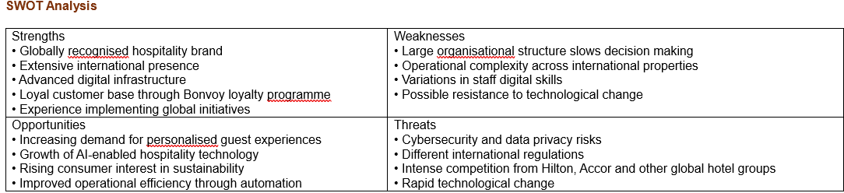

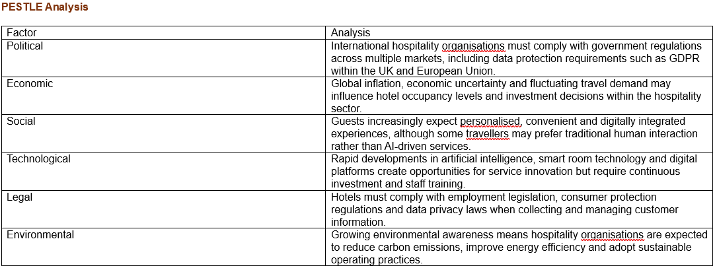

Identifying Stakeholders (Internal and External)

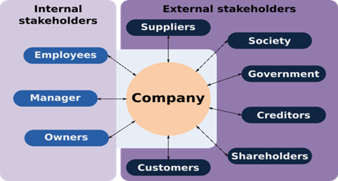

Stakeholders are individuals or groups who can influence or are influenced by the outcomes of a project (Freeman, 1984). Identifying these stakeholders is essential for the successful implementation of the StaySmart+ service within Marriott International, as the project involves multiple departments and external partners operating across different markets. Stakeholders are generally categorised as internal or external depending on their relationship with the organisation. Understanding their interests, expectations, and level of influence enables the project manager to design effective engagement strategies and ensure that the project objectives are achieved (Ashcroft, 2017).
Internal stakeholders consist of individuals and teams within the organisation who contribute directly to the planning, development, and delivery of the StaySmart+ initiative. At the strategic level, the Board of Directors and senior management provide overall direction, approve funding, and ensure that the project aligns with the company’s long-term digital and sustainability strategies. The Project Manager and Project Management Office (PMO) are responsible for coordinating the project, managing resources, monitoring progress, and ensuring communication across departments (PMI, 2021).
The IT and digital transformation teams play a crucial role in developing and integrating the AI-based technologies that support the StaySmart+ service. Similarly, product development and innovation teams design the service features to ensure they meet customer expectations and enhance the overall guest experience. The marketing and sales departments are responsible for promoting the service and communicating its benefits to customers, thereby strengthening the brand’s competitive advantage. At the operational level, hotel general managers oversee the implementation of the service within individual hotels, while frontline staff, including receptionists, housekeepers, and concierge teams, are responsible for delivering the service directly to guests and supporting them in using the new technology.
External stakeholders also play a significant role in the project’s success. Guests and loyalty programme members are the primary users of StaySmart+, and their feedback will determine the effectiveness and acceptance of the service. Technology vendors and AI solution providers supply the systems and technical expertise required to develop and maintain the platform. In addition, sustainability partners help ensure that the environmental elements of the service align with global sustainability standards. The organisation must also work closely with regulatory bodies and data protection authorities to ensure compliance with legal and ethical requirements. Furthermore, local communities and shareholders have a broader interest in the organisation’s reputation, ethical conduct, and long-term financial performance.
To manage these diverse stakeholders effectively, organisations often apply Mendelow’s Power–Interest Matrix, which categorises stakeholders according to their level of influence and interest (Mendelow, 1991). Stakeholders such as senior management, IT teams, and guests hold high levels of both power and interest and therefore require close management. Vendors and regulatory authorities also possess significant influence due to their control over resources and compliance requirements. Meanwhile, frontline staff and local communities require active engagement to ensure cooperation and successful service delivery (Johnson, Scholes and Whittington, 2020).

Roles, Responsibilities, Benefits, and Challenges of Stakeholders

The successful implementation of the StaySmart+ service requires the coordinated involvement of multiple stakeholders, each contributing specific expertise, resources, and influence. Understanding the roles and responsibilities of these stakeholders is essential for ensuring that the project is delivered effectively and that potential challenges are managed appropriately. Stakeholder theory emphasises that organisations must balance the interests of different groups to achieve long-term value and project success (Freeman, 1984).

At the strategic level, senior management and the board of directors play a critical role in providing overall direction, approving funding, and ensuring that the StaySmart+ initiative aligns with the organisation’s strategic objectives, particularly in relation to digital innovation and sustainability. Their endorsement gives legitimacy to the project and ensures that adequate resources are allocated. However, senior leaders often manage multiple organisational priorities, which may limit the time and attention they can devote to the project. Ensuring continued leadership support is therefore essential for maintaining momentum and organisational commitment (Johnson, Scholes and Whittington, 2020).

The Project Manager is responsible for coordinating all project activities and ensuring that stakeholders remain aligned with the project’s objectives. This role includes planning timelines, managing budgets, identifying and mitigating risks, and facilitating communication between departments. According to project management frameworks, effective coordination and stakeholder communication are key responsibilities of the project manager in complex initiatives (PMI, 2021). Nevertheless, the role can be challenging, particularly when managing stakeholders from different cultural and organisational backgrounds or when addressing resistance to change associated with new technologies.

Technical implementation of StaySmart+ relies heavily on the IT and digital transformation teams, who are responsible for developing, integrating, and maintaining the AI-driven systems that support guest interaction and data analysis. These teams provide essential technical expertise and ensure that systems are secure and compliant with cybersecurity standards. However, they may face pressure from tight implementation deadlines, system compatibility issues, and strict data protection regulations.

The marketing and sales departments contribute by designing the value proposition of the StaySmart+ service and communicating its benefits to target markets. Their role includes creating promotional campaigns, strengthening brand differentiation, and encouraging customer adoption. While the introduction of innovative services can enhance the brand’s competitive position, marketing teams must ensure that promotional messages accurately reflect service capabilities to avoid unrealistic customer expectations (Christopher, Payne and Ballantyne, 2013).

Operational stakeholders such as hotel general managers and frontline staff are equally important to the success of the project. Hotel managers oversee the implementation of the service at property level and ensure that operational processes are adapted accordingly. Frontline employees, including receptionists and concierge staff, interact directly with guests and play a key role in facilitating the use of AI-enabled services. Their operational insight and experience contribute significantly to service improvement. However, the introduction of advanced technologies may create concerns among employees about increased workload or potential job displacement, which can lead to resistance if not properly managed.

External stakeholders are effective because they also bring both benefits and challenges. Guests benefit from more personalised, efficient, and convenient services, but they may express concerns about data privacy and reduced human interaction. Technology vendors and solution providers contribute innovation and specialised knowledge, although strong governance and contractual agreements are necessary to manage dependency risks. Additionally, regulatory authorities ensure that the organisation complies with legal and ethical requirements, particularly in areas such as data protection and AI governance. While compliance strengthens organisational legitimacy and reputation, regulatory constraints may limit operational flexibility (Suchman, 1995).

A range of appropriate frameworks, model, and theories to engage them such as stakeholder's matrix, engagement plan, communication plan and RACI matrix
Stakeholder engagement is essential for effective project management, particularly for complex global initiatives such as the StaySmart+ service developed by Marriott International. When projects involve multiple stakeholder groups with different interests and expectations, structured theories and frameworks are required to guide communication, responsibilities, and decision-making. One of the most influential concepts in this area is stakeholder theory, which argues that organisations should consider the interests of all parties affected by their activities rather than focusing solely on shareholders (Freeman, 1984). Stakeholders include employees, customers, suppliers, regulators, investors, and local communities. Projects are more likely to succeed when managers recognise the influence of these groups and actively involve them throughout the project lifecycle.
Another relevant concept is the relational lens, which emphasises the importance of building long-term relationships with stakeholders through trust, cooperation, and shared value (Ashcroft, 2017). This perspective suggests that stakeholder engagement should be viewed as an ongoing process rather than a one-time consultation. For the StaySmart+ initiative, maintaining transparent communication with employees, technology partners, guests, and regulators is essential. When stakeholders feel informed and included, they are more likely to support organisational change and contribute to successful implementation.
In practice, organisations use several tools to apply these theories. One widely used method is stakeholder mapping, particularly through the power–interest matrix developed by Mendelow (1991). This framework categorises stakeholders based on their level of influence and interest in the project. Individuals or groups with high power and high interest—such as senior executives, IT specialists, and key customers—require close engagement and frequent consultation. Stakeholders with lower influence may only need periodic updates. Using this approach helps project managers prioritise engagement efforts and allocate resources effectively (Johnson, Scholes and Whittington, 2020).
Another important framework is the RACI matrix, which clarifies roles and responsibilities within a project. RACI represents Responsible, Accountable, Consulted, and Informed, and it helps define who performs tasks, who has final decision authority, whose expertise must be consulted, and who should receive updates. Clearly defining these responsibilities reduces confusion, strengthens coordination between teams, and supports efficient project implementation (Project Management Institute, 2021). Within the StaySmart+ project, the RACI model can be used to allocate responsibilities among senior leadership, project managers, IT departments, hotel managers, and external partners.
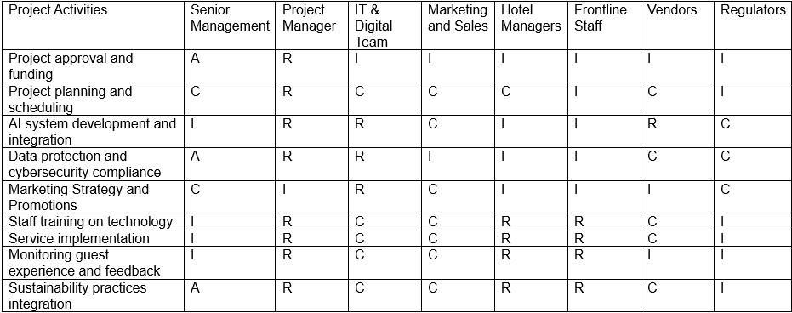
Organisations also rely on stakeholder engagement plans and communication strategies to maintain regular interaction with stakeholders throughout the project lifecycle. These plans specify communication channels, the frequency of engagement, and responsibility for delivering key messages. Effective communication helps manage expectations, address concerns early, and minimise potential conflict (Project Management Institute, 2021).
The concept of relationship marketing further strengthens stakeholder engagement by emphasising long-term collaboration with customers and partners. This approach focuses on trust, communication, and value creation rather than short-term transactions (Christopher, Payne and Ballantyne, 2013). In the hospitality sector, maintaining strong relationships with guests is particularly important because customer satisfaction and loyalty directly influence business performance.
Two key theories are particularly relevant to the StaySmart+ initiative:
First, Stakeholder Theory highlights the importance of recognising and addressing the interests of all groups affected by organisational decisions (Freeman, 1984). By identifying stakeholders and understanding their expectations, project managers can improve cooperation, build trust, and create long-term value for both the organisation and its partners.
Second, Resource Dependency Theory explains that organisations often rely on external partners to access essential resources such as technology, expertise, and distribution channels (Pfeffer and Salancik, 1978). In the case of Marriott International, the company may depend on technology providers for artificial intelligence systems used in StaySmart+, food suppliers for hotel operations, and online travel agencies that bring customers to its properties. However, heavy reliance on external partners can create risks if suppliers increase prices, change terms, or fail to deliver services.
To reduce these risks, organisations can adopt several strategies. One approach is supplier diversification, where the organisation works with multiple partners instead of relying on a single provider. Marriott could also strengthen its internal technological capabilities by investing in digital teams capable of managing AI systems internally. In addition, the company can encourage customers to make direct bookings through its loyalty platform rather than relying heavily on third-party booking platforms. These strategies help the organisation maintain greater control over resources and reduce operational risks.
Overall, combining stakeholder theory, practical engagement tools, and resource management strategies enables organisations to build stronger stakeholder relationships, improve transparency, and enhance coordination during large projects such as StaySmart+.

Critical Stakeholder Engagement Process and Conflict Management Using the 4C’s Model
Managing stakeholders is a crucial aspect of delivering successful projects, particularly when initiatives are large and complex, such as the StaySmart+ service introduced by Marriott International. As a global hospitality organisation operating thousands of hotels across more than 130 countries, Marriott must coordinate with a wide range of stakeholders, including employees, hotel managers, technology partners, regulators, and guests. Each of these groups has different expectations, interests, and levels of influence over the project. Effective stakeholder management therefore requires a structured approach throughout the entire project lifecycle, from planning and design to implementation and evaluation. One practical framework that supports this process is the 4C’s model, which focuses on Communication, Consultation, Collaboration, and Commitment. This model helps project managers maintain clear relationships with stakeholders while minimising misunderstandings and potential resistance to change.
The first component, communication, involves providing clear, consistent, and transparent information to all stakeholders. In large organisations such as Marriott International, communication is essential to ensure that employees, partners, and guests understand the purpose and benefits of the StaySmart+ system. Regular updates through meetings, internal platforms, and training sessions can help employees understand how AI-powered tools will improve guest experiences rather than replace human roles. Effective communication reduces uncertainty and supports smoother organisational change (Project Management Institute, 2021).
The second element, consultation, focuses on actively seeking stakeholder input during decision-making. This can involve surveys, feedback sessions, or pilot testing with employees and selected hotel locations. Consulting stakeholders allows project managers to identify concerns early and adjust implementation strategies accordingly. For example, staff members may provide valuable insights into how AI systems could integrate with existing hotel operations. Engaging stakeholders in this way also increases their sense of involvement and ownership, which is a key principle in stakeholder theory (Freeman, 1984).
The third component, collaboration, encourages different departments and stakeholders to work together to achieve shared objectives. In the StaySmart+ project, collaboration may involve close cooperation between IT teams, hotel managers, marketing departments, and external technology providers. By working jointly on problem-solving and service design, stakeholders can combine their expertise to improve the effectiveness of the new system. Collaborative working environments are often associated with higher levels of innovation and stronger organisational performance (Johnson, Scholes and Whittington, 2020).
The final element, commitment, focuses on securing long-term stakeholder support for the project. Commitment can be achieved by demonstrating the value of the initiative, recognising stakeholder contributions, and providing adequate training and resources. When employees and partners feel confident in the project’s benefits, they are more likely to support its implementation and sustain its outcomes.
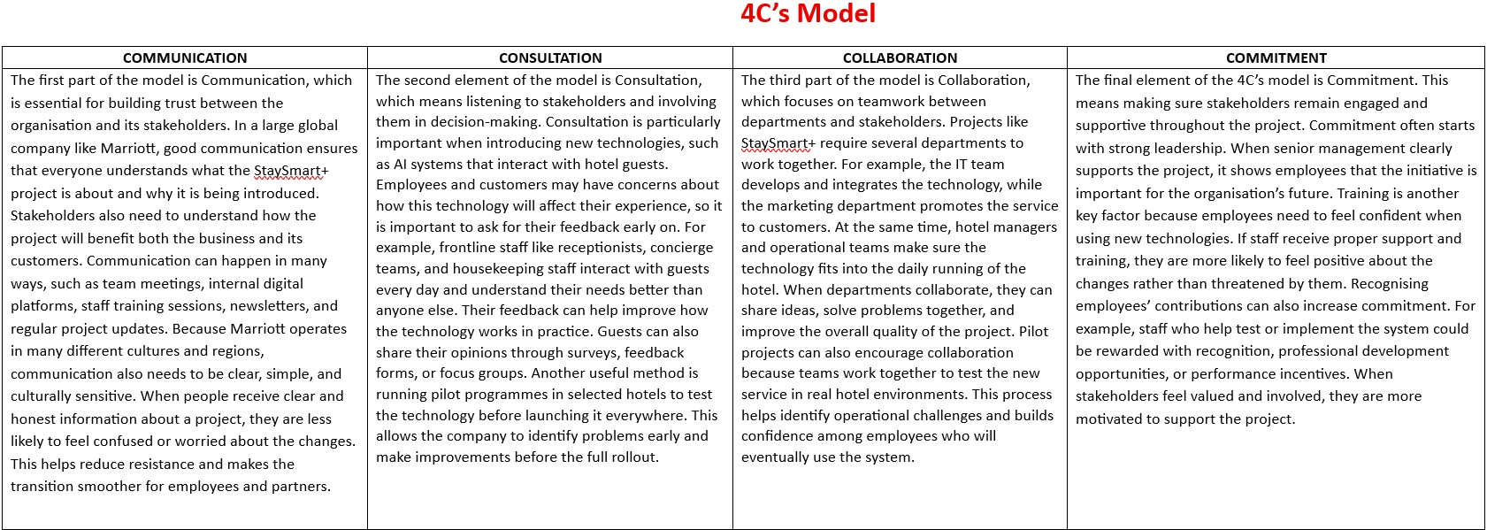

Despite these strategies, conflicts may still arise in complex projects. Employees might fear that AI technologies could increase workloads or threaten job security, while guests may express concerns about how their personal data is collected and used. To address such challenges, project managers must apply conflict management techniques such as negotiation, mediation, and open dialogue. These approaches encourage stakeholders to share their concerns while working collaboratively toward mutually beneficial solutions (Project Management Institute, 2021).
Ethical considerations are also important when implementing advanced technologies. Artificial intelligence systems can raise issues related to privacy, transparency, and algorithmic fairness. Therefore, organisations must ensure that customer data is managed responsibly and that digital systems comply with relevant data protection regulations. Maintaining ethical standards strengthens trust between the organisation and its stakeholders (Christopher, Payne and Ballantyne, 2013).
Overall, the 4C’s model offers a structured and practical approach to stakeholder engagement in complex international projects. By emphasising communication, consultation, collaboration, and commitment, project managers can build strong relationships with stakeholders, minimise resistance to change, and support the successful implementation of innovations such as StaySmart+ across Marriott’s global operations.

Evaluate the impact of stakeholders’ engagement on your business performance and provide recommendations for future

Stakeholder engagement is a key factor in improving business performance, particularly for global hospitality companies such as Marriott International. Stakeholders include employees, guests, suppliers, investors, and local communities who are affected by the organisation’s activities. When companies actively involve these groups in decision-making, communication, and service development, they are more likely to achieve better outcomes. The Balanced Scorecard framework helps organisations understand how engagement in areas such as learning and growth, internal processes, and customer satisfaction ultimately contributes to financial success. Key Performance Indicators (KPIs) are also used to measure and track improvements in different areas of performance.

One of the most visible impacts of stakeholder engagement is improved guest satisfaction and loyalty. In the hospitality industry, customer experience is extremely important. When hotels actively listen to guest feedback through surveys, loyalty programmes, and online reviews, they gain valuable insights into what customers expect. This information can then be used to improve services, personalise guest experiences, and address any issues quickly. For example, if guests highlight long check-in times or poor communication, the hotel can adjust its processes to improve service. KPIs such as guest satisfaction scores, Net Promoter Score (NPS), repeat booking rates, and customer feedback ratings can measure the success of these improvements. The cause–effect relationship is clear: when guests feel that their opinions matter and see improvements in service quality, they are more likely to remain loyal to the brand.

Stakeholder engagement also has a significant influence on employee engagement. Employees are one of the most important internal stakeholders because they directly deliver the services that customers experience. When employees are involved in decision-making, training programmes, and innovation processes, they are more likely to feel valued and motivated. For example, involving frontline staff in discussions about new technologies or operational changes allows them to share their experience and suggest improvements. This can increase job satisfaction and create a more positive workplace environment. KPIs such as employee satisfaction surveys, productivity levels, staff turnover rates, and absenteeism levels can help measure employee engagement. According to the Balanced Scorecard logic, when employees feel engaged and supported, they provide better service, which leads to improved customer satisfaction and stronger financial results.

Another important area affected by stakeholder engagement is brand reputation. Hospitality companies depend heavily on their reputation because customers often choose hotels based on trust, reviews, and brand perception. When organisations communicate openly with stakeholders and respond positively to feedback, they build credibility and trust. Engaging with communities, supporting social initiatives, and demonstrating responsible business practices can also strengthen the organisation’s image. Brand reputation can be evaluated using KPIs such as online ratings, social media sentiment, customer reviews, and brand perception surveys. A positive reputation attracts new customers, strengthens partnerships, and provides a competitive advantage in the hospitality market.

Stakeholder engagement can also improve operational efficiency within the organisation. When employees, managers, and external partners collaborate effectively, business processes become more efficient. For example, frontline staff may identify operational issues such as delays in service delivery or inefficient booking systems. By listening to these insights, management can make improvements that reduce costs and improve performance. KPIs such as average check-in time, service delivery speed, occupancy rates, and operational cost efficiency can help measure improvements in internal processes. This demonstrates the cause–effect link between stakeholder collaboration and improved operational performance.
In addition, strong stakeholder engagement supports better sustainability performance. Many hotels now work with environmental organisations, suppliers, and local communities to reduce their environmental impact. This may include initiatives such as energy conservation, waste reduction, and responsible sourcing. Engaging stakeholders in sustainability initiatives helps ensure that these programmes are realistic, effective, and widely supported. KPIs such as energy consumption per guest, water usage, recycling rates, and carbon emission reductions can be used to measure sustainability performance.

By building strong relationships with stakeholders, companies like Marriott can achieve long-term success and sustainable growth.



Recommendations for Future Stakeholder Engagement



Effective stakeholder engagement has a significant influence on organisational performance, particularly for global service initiatives such as the StaySmart+ project implemented by Marriott International. When stakeholders are actively involved in planning, decision-making, and implementation processes, organisations can improve service quality, operational efficiency, and long-term sustainability. Evaluating stakeholder engagement through key performance indicators (KPIs) and the Balanced Scorecard approach helps organisations understand how engagement contributes to both financial and non-financial outcomes (Kaplan and Norton, 1996).
One major area affected by stakeholder engagement is guest satisfaction and loyalty. In the hospitality industry, positive customer experiences directly influence repeat bookings, brand loyalty, and online reviews. When guests are involved through feedback surveys, digital engagement platforms, or loyalty programmes, organisations gain valuable insights into their expectations. For example, the integration of AI-based services in the StaySmart+ initiative can personalise guest experiences by analysing customer preferences and travel behaviour. High guest satisfaction levels can be measured through KPIs such as customer satisfaction scores, repeat bookings, and loyalty programme participation (Christopher, Payne and Ballantyne, 2013).
Stakeholder engagement also has a strong impact on employee engagement and productivity. Employees are key stakeholders because they deliver the service directly to customers. When staff members are consulted and trained during technological changes, they are more likely to support innovation and adapt to new systems. Engaged employees often demonstrate higher motivation, improved service quality, and better problem-solving capabilities. Performance indicators such as staff retention rates, training participation, and employee satisfaction surveys can be used to measure this impact (Project Management Institute, 2021).
Furthermore, important outcome is brand reputation. Organisations that maintain transparent relationships with stakeholders, including customers, communities, and regulators, are more likely to build trust and credibility. Strong stakeholder relationships can enhance the organisation’s public image and strengthen its competitive position in the market. For a global brand like Marriott International, maintaining a positive reputation is particularly important because customers often choose hotels based on trust, quality, and ethical standards.
Stakeholder engagement can also improve operational efficiency. Collaboration between departments, suppliers, and technology partners allows organisations to streamline processes and solve problems more effectively. For example, close cooperation between IT teams and hotel management during the StaySmart+ rollout can help ensure that AI tools are integrated smoothly into daily operations. Efficiency improvements may be measured through KPIs such as reduced service delivery time, improved system performance, and cost savings.
Also an important dimension is sustainability performance. Engaging stakeholders such as local communities, environmental organisations, and suppliers can support more responsible business practices. Hospitality organisations increasingly focus on reducing energy consumption, minimising waste, and adopting environmentally friendly technologies. Stakeholder collaboration helps ensure that sustainability initiatives are both practical and widely supported.
Finally, effective stakeholder engagement contributes to risk reduction. Early consultation with employees, regulators, and technology partners allows organisations to identify potential issues before they escalate. For instance, discussions about data protection or technological implementation can help prevent legal challenges, operational disruptions, or reputational damage.
Based on this evaluation, several recommendations can strengthen future stakeholder engagement. First, organisations should establish continuous feedback mechanisms such as digital surveys, guest experience platforms, and employee forums to capture stakeholder perspectives regularly. Second, investing in advanced staff training, particularly in areas such as artificial intelligence, digital systems, and ethical data use, will help employees adapt to technological innovation. Third, organisations should adopt localised engagement strategies, recognising that stakeholder expectations may vary across different regions and cultural contexts. Finally, building long-term sustainability partnerships with suppliers, communities, and environmental organisations can enhance corporate responsibility and support sustainable growth.

Conclusion
Identifying and engaging stakeholders is essential for the successful implementation of the StaySmart+ initiative at Marriott International. Using tools such as stakeholder mapping, RACI matrices, engagement plans, and communication strategies enables project managers to coordinate responsibilities, manage expectations, and strengthen collaboration. By applying stakeholder theory and resource dependency theory, organisations can better understand stakeholder influence and address potential risks, ultimately supporting effective project delivery and long-term organisational performance.


