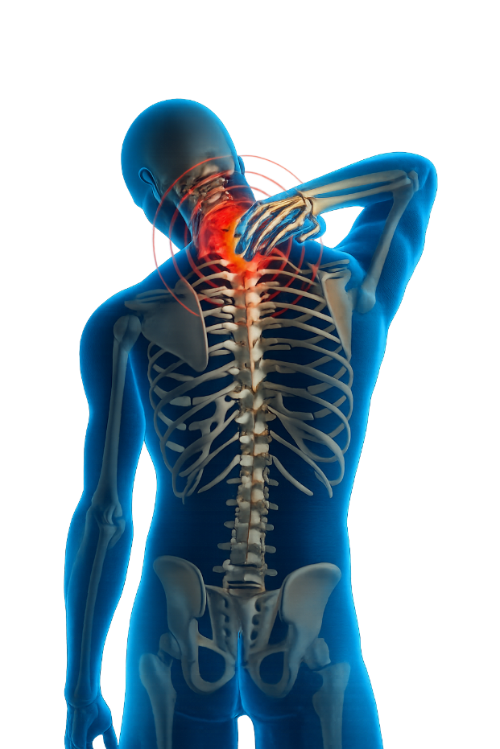
Past and Present Approaches to Spinal Cord Injury Rehabilitation and the Evolving Role of the Therapy Assistant Practitioner

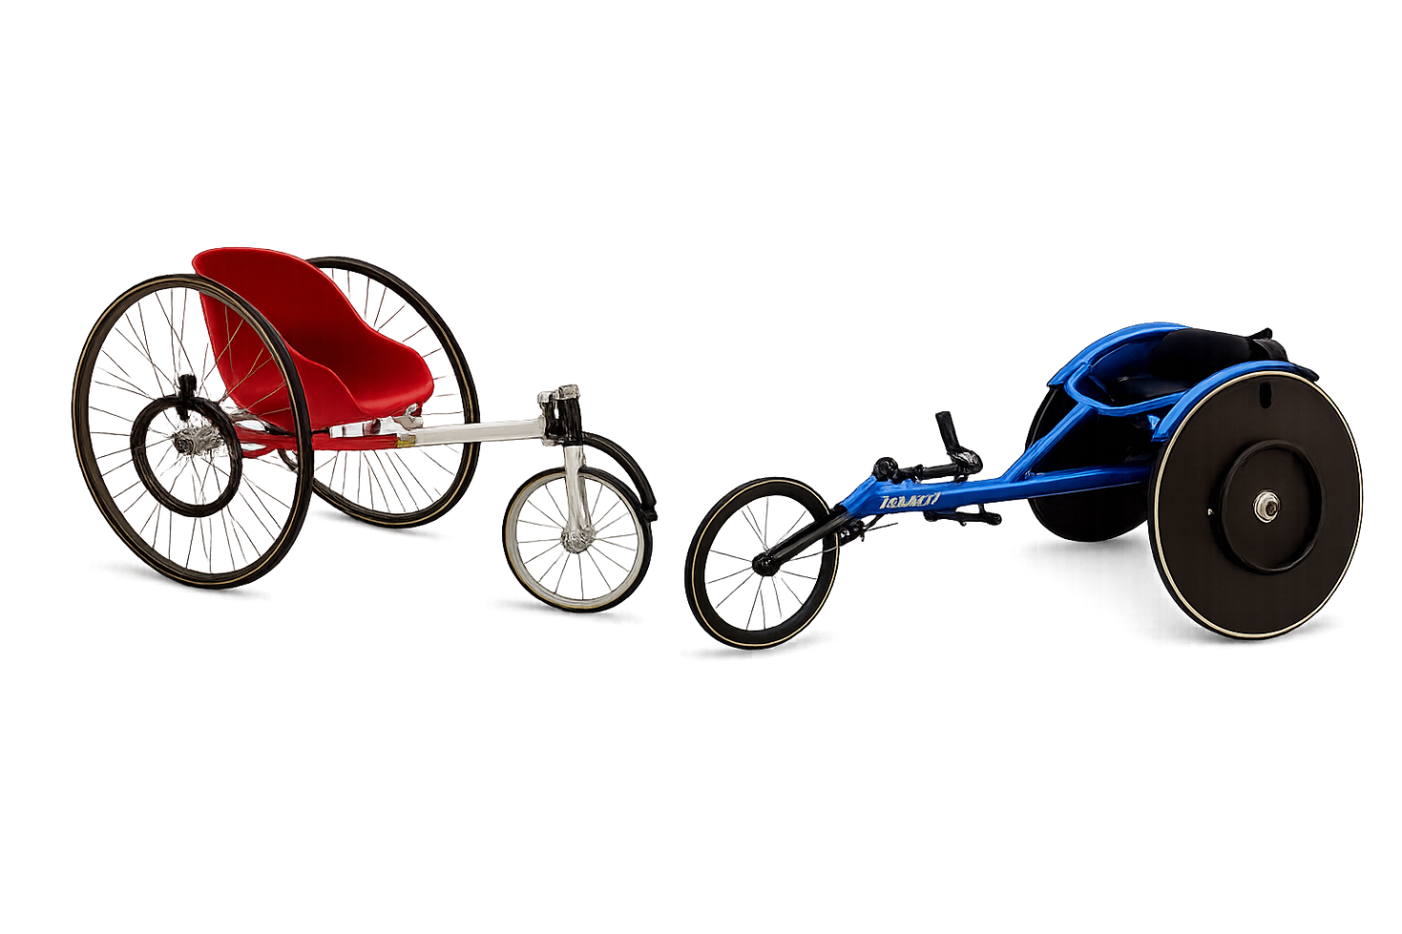

Name: Darren Evans
Student number: 2517855

Contents
Introduction 3
Case study 3
Overview of condition 5
Previous approaches 6
Current approaches 7
Co production 9
Clinical governance and supervision framework 10
Conclusion and recommendations 11
References 13
Appendix 17

Introduction
This research explores the rehabilitation journey of a 23-year-old patient with a T12 incomplete spinal cord injury (SCI) and considers how past and present approaches to SCI rehabilitation could have affected the patient’s outcomes and overall recovery. The report focuses on how the patient’s rehabilitation and well-being are supported within the Welsh SCI Rehabilitation Centre (WSCIRC), while exploring the role the Therapy Assistant Practitioner (TAP) has within the multidisciplinary team and on the overall patient’s rehabilitation journey.
It will discuss how SCI rehabilitation has changed over time, from earlier approaches involving prolonged bed rest and little rehabilitation, to modern rehabilitation that is more active and focused on promoting independence and quality of life. It explores the importance of involving patients in goal setting and decision-making throughout rehabilitation. Recognising the wide impact SCI can have on both the individual and their family.
The research also explores the importance of clinical governance and supervision frameworks in supporting safe and effective practice. Throughout, the focus is placed on how these approaches influence rehabilitation outcomes and the patient’s long-term goal of returning to sport, now through competitive wheelchair sport.

Case study
The Welsh SCI Rehabilitation Centre (WSCIRC), based at University Hospital Llandough, is the only specialist SCI rehabilitation centre in Wales, providing multidisciplinary rehabilitation to support independence and self-management (Cardiff and Vale University Health Board, 2026).
Within this setting, the Therapy Assistant Practitioner (TAP) plays a key role in supporting a range of therapy-led interventions, with physiotherapy being one of the main disciplines involved in the patient’s rehabilitation journey. These interventions include strengthening exercises, postural control, mobility and the promotion of independence in activities of daily living (ADLs).
Spilsbury et al. (2010) describe TAPs as higher-level support workers who complement the role of registered professionals, contributing to the delivery of care and supporting the implementation of therapeutic interventions within multidisciplinary teams.
This case study explores the rehabilitation journey of a 23-year-old male who sustained a T12 incomplete SCI following a road traffic collision. The patient is currently an inpatient in WSCIRC and is having intense therapy where a multidisciplinary team approach is utilised.
The patient presents with reduced motor function in the lower limbs, resulting in impaired mobility and reliance on a wheelchair for independence. This may lead to secondary complications such as joint stiffness and contractures. A typical referral allocated to the TAP may involve supporting the patient with a structured stretching programme to maintain joint range of movement and prevent contractures, which are recognised as a common and disabling complication in individuals with SCI. While stretching remains a commonly used intervention (Billington et al., 2022), other evidence suggests that contracture management is complex and may not always result in significant improvements in joint mobility (Harvey et al., 2011).
Another complication affecting the patient is pressure ulcers, prolonged wheelchair use places the patient at a higher risk (NICE, 2024). The TAP plays an important role in supporting wheelchair techniques like pressure relief and safe positioning to promote independence and reduce this risk.
Psychologically, the patient experienced low mood and uncertainty following the injury, however, engagement in rehabilitation has supported improvements in confidence and motivation. The patient has expressed a desire to return to sport, which has become a focus in all rehabilitation goals, reflecting a person-centred approach that places the patient’s individual goals at the centre of care planning (NICE, 2021).
The patient was previously active, and sport formed a significant part of their daily routine prior to injury. This SCI has resulted in a loss of independence and the need for full time wheelchair use, impacting previous activities and overall lifestyle. Strong family support has positively influenced engagement in rehabilitation. However, the inability to return to previous forms of physical activity has highlighted the need for alternative ways to maintain fitness and a sense of purpose.
The introduction of sport-related therapy has supported both physical and psychological recovery by improving fitness and increasing the patient’s engagement in sessions. Participation in events like the Stoke Mandeville Games has also played an important role in boosting motivation and reducing feelings of low mood, giving the patient something positive to work towards and helping them develop meaningful goals such as progressing in competitive wheelchair sport. This case study shows the impact SCI can have on the patient, affecting not only physical ability but also psychological wellbeing. Understanding the condition is important in guiding rehabilitation and supporting person-centred care.

Overview of condition
A spinal cord injury refers to damage to the spinal cord resulting in loss or impairment of motor, sensory, and autonomic function below the level of injury. The World Health Organization (WHO, 2024) states that spinal cord injuries can result from traumatic causes, such as road traffic collisions, or non-traumatic causes like tumours, infections and degenerative conditions.
Injuries can occur at different levels of the spine, including the cervical, thoracic and lumbar regions. The level of injury determines functional outcomes, with higher injuries causing more widespread impairment. Cervical injuries may affect all four limbs, whereas thoracic and lumbar injuries typically affect the trunk and lower limbs (NHS, 2026). A T12 injury, as seen in the case study, primarily affects lower limb function while preserving upper limb ability.
A spinal cord injury has a significant impact not only on the patient, but also on their family and healthcare services. The patient may require long-term rehabilitation, which can place emotional and financial strain on family members. Spinal cord injury is also linked to a range of secondary complications, including chronic pain, spasticity, pressure injuries, respiratory issues, and bladder or bowel dysfunction. These complications can have a major impact on long-term health and quality of life, often requiring ongoing monitoring and management (NSCISC, 2024).

Previous approaches
Historically, SCI was associated with extremely poor prognosis and was often considered a death sentence. Prior to the development of specialist spinal injury care, many patients died within weeks or months of injury due to secondary complications such as pressure ulcers, respiratory infections, and urinary tract infections (Silver, 2005). Silver also highlights that early management of SCIs was limited, with very little understanding of the complications that occurred.
Earlier approaches focused on prolonged bed rest and medical stabilisation. During this time, there was limited involvement of structured therapy support, and nothing like the modern TAP with care focusing mainly on basic nursing management rather than active rehabilitation. Despite this, periods of bed rest were sometimes considered necessary to allow for fusion and bone healing, also to help with maintaining blood pressure, which plays an important role in improving cord perfusion in acute phase of injury (Afshari et al., 2020). Patients with higher-level spinal cord injuries may also experience autonomic complications, like autonomic dysreflexia. AD is a potentially life-threatening condition characterised by a sudden increase in blood pressure in response to stimuli below the level of injury (RNOH, 2026). Increased understanding of this complication developed over time, with Guttmann and Whitteridge first describing AD in 1947 (Silver, 2000). This increasing understanding of complications contributed a major turning point in SCI management.
In England in 1944, Sir Ludwig Guttmann created a spinal unit at Stoke Mandeville, he introduced the multidisciplinary approach for treatment and rehabilitation for SCI patients, this became a world-renowned unit for research and clinical care. From that time, the SCI service in the UK started to improve and increased the number of these units throughout the country (Kumar et al., 2017). Kumar et al. (2017) also state that Guttmann believed many of the complications previously thought to be inevitable following SCI were in fact preventable and were largely the result of poor management rather than the neurological impairment itself.
Guttmann, often referred to as the “father of spinal cord injury” challenged traditional approaches. He focused on early mobilisation and improving overall patient care and wellbeing. He then introduced a more active approach to rehabilitation, encouraging patients to move away from prolonged bed rest and into physical activity. As part of this, he incorporated sport into rehabilitation, recognising its benefits for physical strength and mental health. This led to the development of the Stoke Mandeville Games in 1948, which later became the foundation of the Paralympic Games (The National Archives, 2026). This gave individuals the opportunity to participate in organised sport and regain purpose. The impact of Guttmann’s work on SCI rehabilitation and the introduction of sport is also portrayed in The Best of Men (2012), which highlights the development of the Stoke Mandeville Games and the shift towards active rehabilitation. The film portrays his revolutionary approach to spinal injury treatment and Dr. Guttmann was later knighted in 1966 for his contributions to medicine and the Paralympic movement. This approach continues to influence modern rehabilitation and is reflected within the case study, where the patient has attended Stoke Mandeville events and is using wheelchair sport as a key part of recovery and long-term goals.

Current approaches
Current approaches to SCI rehabilitation focus on maximising functional independence, preventing secondary complications, and improving overall quality of life (Danney, 2025). Advances in SCI and rehabilitation have improved patient outcomes considerably, SCI is no longer viewed as a death sentence. Modern rehabilitation is now delivered through a meaningful, person-centred approach and requires the use of multidisciplinary health interventions including, physical, occupational, and psychosocial in addition to medical and nursing management (Craig et al., 2022)
As SCI rehabilitation became more active and multidisciplinary, rehabilitation support roles similar to the modern TAP developed, working closely with registered professionals to provide ongoing support with rehabilitation programmes. TAPs are now recognised as important members of the multidisciplinary team and The introduction of these roles has massively improved patient outcomes and reinforced therapeutic goals (Spilsbury et al., 2010).
Advancements in technology have also significantly improved SCI rehabilitation. Digital tools, hoists and modern technologies like exoskeletons have enhanced rehabilitation. These aids not only support better patient rehabilitation and independence but reduce the risk of injury to staff, as earlier approaches relied on manual handling techniques that increased the likelihood of musculoskeletal injuries, it wasn’t until the mid to late 20th century that hoists and other aids were invented (Wessex Healthcare, 2026). Even with new technology Staff injuries remain an issue today. In 2023–2024, out of 1.9 million people with work-related illnesses or injuries in Great Britain, 511,000 were musculoskeletal normally caused by manual handling (HSE, 2025), so safe handling is still at the upmost importance, the TAP plays an important role in supporting the safe use of these technologies and interventions.
Modern SCI rehabilitation is strongly based on a person-centred approach; patients are actively involved in goal setting and decision-making. The All-Wales Rehabilitation Framework highlights the importance of supporting individuals to “live the life they want to” through value-based rehabilitation approaches (Welsh Government, 2022). Within the case study, returning to sport was a key focus of rehabilitation, reflecting the patient’s personal interests and making all sessions person centred was paramount.
The TAP plays an important role in supporting person-centred rehabilitation by adjusting sessions to include patient’s goals and abilities. Decisions are influenced by a range of factors, including the patient’s mobility, fatigue levels and motivation under MDT guidance. This ensures that rehabilitation remains safe and meaningful to the patient (Skills England, 2025).
Even though there are improvements in SCI rehabilitation, challenges remain. Access to specialist services can be limited and increasing demand puts pressure on resources, affecting therapy intensity and availability (Tallqvist et al., 2023). Recent data suggests around 4,400 new SCIs occur each year in the UK, higher than previous estimates of 2,500, increasing pressure on services (WheelPower, 2024). This rise affects access to specialist rehabilitation and may delay treatment and outcomes.

Co production
Co-production is an important part of modern SCI rehabilitation and involves working together with patients and carers when planning and delivering care. NHS England describes co-production as people with lived experience and healthcare professionals working in equal partnership throughout the development and delivery of services (NHS England, 2026). In practice, this involves a multidisciplinary team including physiotherapists, occupational therapists, nurses, psychologists, and the Therapy Assistant Practitioner, as well as the patient and their family.
An example of co-production within SCI rehabilitation is the development of the SCI Health Maintenance Tool (SCI-HMT), a self-management tool designed to support individuals with spinal cord injury in managing secondary complications and well-being. The tool was developed through a co-design process involving people with lived experience of SCI together with healthcare professionals, allowing patient experiences to directly influence the development of the resource. During the design process, participants highlighted that mental health needed to be a priority, demonstrating the importance of involving patients in the design of rehabilitation interventions (Bourke et al., 2026).
A very important use of the SCI-HMT is supporting the prevention and management of pressure injuries, which remain a common complication following SCI. This focus on skin care reflects the co-design process of the tool, where individuals with lived experience identified pressure injuries as a key concern that needed to be addressed. As a result, the tool includes guidance on monitoring skin integrity and recognising early signs of pressure damage, reducing the risk of complications (McInnes et al., 2020).
Co-production also involves collaboration with a range of external agencies to support ongoing rehabilitation and help continuing to meet long-term goals. These may include community rehabilitation teams, social services, and charities that will help support individuals. In addition, organisations linked to wheelchair sport, such as WheelPower, and events such as the Stoke Mandeville Games can provide opportunities for continued participation and engagement in sport (WheelPower, 2026). Within the case study, these services may support the patient in accessing appropriate equipment, continuing rehabilitation following discharge, and progressing towards their goal of attending the Paralympics.
However, there are still challenges within co-production. Gibson et al. (2024) highlight that patients and carers are not always fully involved in decision-making, and in some cases may not attend MDT meetings at all, meaning they are not always part of the decision-making process, which goes against the idea of co-production. Gibson et al. (2024) also highlight communication gaps between professionals, patients, and services, which affects continuity of care and makes rehabilitation planning difficult. These challenges can affect the multidisciplinary team, including the TAP, when supporting rehabilitation and long-term patient goals.

Clinical governance and supervision framework
Clinical governance is a framework used within healthcare organisations to ensure that the quality of care is maintained and improved. It also relates to the responsibility organisations have for monitoring and evaluating how well these systems are working. This includes processes such as reporting concerns, identifying poor practice, sharing information across services, and responding to patient complaints. These systems aim to improve standards of care and ensure patient safety across healthcare settings (Freeman and Walshe, 2004).
Clinical governance is commonly linked to seven key areas, referred to as the seven pillars of clinical governance. These help structure how this is done in practice. They include clinical effectiveness, risk management, clinical audit, education and training, patient and public involvement, information management, and staff management (Flint, 2024).
A supervision framework is an important part of clinical governance and focuses on supporting healthcare staff to work safely and effectively. It involves regular guidance and monitoring to ensure that care is delivered to a high standard. For a TAP, both clinical governance and supervision are directly relevant. Clinical governance sets the expectations around safe practice, communication, record keeping, and managing risk, while supervision helps the TAP to meet these expectations in day-to-day work.
The TAP works under the supervision of registered professionals such as physiotherapists and occupational therapists, making sure that any interventions match the patient’s ability and stage of rehabilitation. This is especially important when supporting goals like returning to wheelchair sport, where poor decisions could increase the risk of injury.
The HCPC (2024) stresses that when tasks are delegated, registered professionals must make sure the person is trained and properly supervised. The Francis Report (2013) showed what can happen when systems like clinical governance and supervision do not work properly. It highlighted serious issues including poor communication and a lack of oversight, which led to patients being harmed. This has reinforced the importance of strong governance, open reporting cultures, and effective supervision. For TAPs, this means they should not be left to manage risks alone but should be supported and given clear guidance so they can work safely and confidently within their role.

Conclusion and recommendations
This case study shows just how much a SCI can affect someone’s life, not only physically but also emotionally. The patient in this example has had to adjust to major changes, but with the right support, they have made good progress. Modern SCI rehabilitation, like the approach used at the WSCIRC, focuses on helping people rebuild independence and confidence. The TAP plays a big part in this by supporting daily therapy and helping them work towards goals that matter to them, such as returning to wheelchair sport. This is very different from older approaches, where patients spent long periods in bed and had limited therapy, which often led to poor outcomes (Silver, 2005). The development of specialist spinal units and Guttmann’s work has shaped the active, goal-focused rehabilitation used today (Kumar et al., 2017).
The research also highlights how important co-production is. When patients and families are involved in planning care, rehabilitation becomes more meaningful and motivating. But research shows that this doesn’t always happen, and communication can sometimes break down (Gibson et al., 2024). This is where strong clinical governance and good supervision matter. The Francis Report (2013) showed what can go wrong when communication and support are missing. For TAPs, this means working safely and having the right supervision to make sure the patient receives safe and effective care.
Based on the research, there are a few recommendations that could help improve the patient’s rehabilitation and support safe practice. One important step would be keeping supervision regular and structured for the TAP. This would make sure the TAP always has clear guidance and feels confident with the tasks they are supporting, especially when working on things like wheelchair skills or sport-related goals (Skills for Health, 2023).
Another recommendation is to make sure the patient, and their families are more involved in MDT meetings. When patients are included in discussions about their own care, they are usually more motivated, and the goals become more meaningful to them (Bate & Robert, 2023).
It would also be helpful to make psychological support more available throughout the rehabilitation process. Adjusting to a SCI can be emotionally challenging, with a lot of patients reporting depression once realising that life wouldn’t be what they used to know and NICE (2022) highlights that mental health support should be part of rehabilitation from the start.
Supporting the patient to stay involved in wheelchair sport is also important. Research shows that adaptive sport can improve fitness and overall wellbeing for people with spinal cord injuries (Blauwet & Willick, 2022). Building stronger links with community sport organisations could help the patient continue progressing after discharge. Charities such as Back Up, and SPUR which are linked to the spinal injury unit in Wales, play an important role in helping people access opportunities and stay active after injury. However, funding is a major challenge for these organisations, and more needs to be done to raise money so they can continue providing these essential services (Back Up Trust, 2024).
Finally, continuing to strengthen clinical governance is essential. Encouraging staff to report concerns and share learning helps keep care safe and improves the overall quality of the service, as it creates a culture where issues are picked up early and acted on rather than being missed (NHS England, 2023)

References
Afshari, F.T., Choi, D. and Russo, A. (2020) “Controversies regarding mobilisation and rehabilitation following acute spinal cord injury,” British Journal of Neurosurgery, 34(2), pp. 123–126. Available at: https://doi.org/10.1080/02688697.2019.1708268.
Back Up Trust (2024) About Us. Available at: https://www.backuptrust.org.uk/ (Accessed: 14 May 2026).
Bate, P. and Robert, G. (2007) Bringing user experience to healthcare improvement: the concepts, methods and practices of experience-based design. Oxford: Radcliffe Publishing.
Billington, Z.J., Henke, A.M. and Gater, D.R. (2022) Spasticity management after spinal cord injury: The here and now’, Journal of Personalized Medicine, 12(5), p. 808. Available at: https://doi.org/10.3390/jpm12050808 (Accessed: 1 May 2026).
Blauwet, C. and Willick, S. (2022) ‘The role of adaptive sports in rehabilitation for individuals with spinal cord injury’, PM&R, 14(5), pp. 657–665.
Bourke, J.A., Middleton, J.W., Tran, Y., Craig, A., McDonald, R., Gough, K. and Hearn, T. (2026) ‘Development of the Spinal Cord Injury–Health Maintenance Tool (SCI-HMT): a co-design approach involving people with lived experience and healthcare professionals’, Spinal Cord. Available at: https://doi.org/10.1038/s41393-026-01171-8
Cardiff and Vale University Health Board (2026) The Welsh Spinal Cord Injury Rehabilitation Centre. Available at: https://cavuhb.nhs.wales/our-services/the-llandough-centre-for-specialist-spinal-and-neurological-rehabilitation-tlcssnr/the-welsh-spinal-cord-injury-rehabilitation-centre/ (Accessed: 1 May 2026)
Craig, A., Guest, R., Tran, Y., Middleton, J., Costa, R., Taplin, J. and Wijesuriya, N. (2022) ‘Investigating dynamics of the spinal cord injury adjustment model: mediation model analysis’, Journal of Clinical Medicine, 11(15), p. 4557. Available at: https://doi.org/10.3390/jcm11154557.
Flint, J. (2024) ‘The seven pillars of clinical governance’, Salford Professional Development. Available at: https://www.salford.ac.uk/spd/seven-pillars-clinical-governance (Accessed: 12 May 2026).
Francis, R. (2013) Report of the Mid Staffordshire NHS Foundation Trust Public Inquiry. Available at: https://www.gov.uk/government/publications/report-of-the-mid-staffordshire-nhs-foundation-trust-public-inquiry (Accessed: 13 May 2026).
Freeman, T. and Walshe, K. (2004) “Achieving progress through clinical governance? A national study of health care managers’ perceptions in the NHS in England,” Quality & safety in health care, 13(5), pp. 335–343. Available at: https://doi.org/10.1136/qshc.2002.005108.
Gibson, C., Landry, M.D. and Tuntland, H. (2024) ‘Conceptualizing the facilitators and barriers of successful multidisciplinary teamwork within the reablement process: A scoping review’, Patient Preference and Adherence, 18, pp. 2621–2635. Available at: https://doi.org/10.2147/PPA.S504007.
Harvey, L.A., Glinsky, J.V., Bowden, J.L. and Arumugam, N. (2011) ‘Contracture management for people with spinal cord injuries’, NeuroRehabilitation, 28(1), pp. 17–20. Available at: https://doi.org/10.3233/NRE-2011-0627.
Health and Care Professions Council (HCPC) (2024) Standards of conduct, performance and ethics. Available at: https://www.hcpc-uk.org/standards/standards-of-conduct-performance-and-ethics/ (Accessed: 13 May 2026).
Health and Safety Executive (HSE) (2025) Key figures for Great Britain 2024 to 2025. Available at: https://www.hse.gov.uk/statistics/overview.htm (Accessed: 12 May 2026).
McInnes, E., Jammali-Blasi, A., Bell-Syer, S.E.M., Dumville, J.C., Middleton, V. and Cullum, N. (2020) ‘Prevention and management of pressure injuries in people with spinal cord injury: systematic review and evidence summary’, Journal of Tissue Viability. Available at: https://pmc.ncbi.nlm.nih.gov/articles/PMC7380902/ (Accessed: 12 May 2026).
National Spinal Cord Injury Statistical Center (2026) National Spinal Cord Injury Statistical Center. Available at: https://sites.uab.edu/nscisc/ (Accessed: 14 May 2026).
Naveen Kumar, Aheed Osman and J.R. Chowdhury (2017) “Traumatic spinal cord injuries,” Journal of Clinical Orthopaedics and Trauma, 8, pp. 116–124. Available at: https://doi.org/10.1016/j.jcot.2017.06.022.
NHS (2026) Understanding spinal cord injury. Available at: https://swspinalcordinjury.nhs.uk/patient-area/understanding-sci-2/ (Accessed: 1 May 2026).
NHS England (2023) The NHS Patient Safety Strategy: Safer Culture, Safer Systems, Safer Patients. Available at: https://www.england.nhs.uk/patient-safety/the-nhs-patient-safety-strategy/ (Accessed: 14 May 2026).
NHS England (2026) Co-production. Available at: https://www.england.nhs.uk/always-events/co-production/ (Accessed: 12 May 2026).
NICE (2021) Shared decision making. Available at: https://www.nice.org.uk/guidance/ng197 (Accessed: 1 May 2026).
NICE (2022) Rehabilitation for Adults with Complex Needs: Psychological Support. Available at: https://www.nice.org.uk (Accessed: 14 May 2026).
NICE (2024) Pressure ulcers: risk factors. Available at: https://cks.nice.org.uk/topics/pressure-ulcers/background-information/risk-factors/ (Accessed: 1 May 2026)
Royal National Orthopaedic Hospital (RNOH) (n.d.) Autonomic dysreflexia. Available at: https://www.rnoh.nhs.uk/services/spinal-cord-injury-centre/clinical-resources-advice/autonomic-dysreflexia (Accessed: 8 May 2026).
Silver, J. (2000) “The history of Guttmann’s and Whitteridge’s discovery of autonomic dysreflexia,” Spinal cord, 38(10), pp. 581–596. Available at: https://doi.org/10.1038/sj.sc.3101077.
Silver, J.R. (2005) “History of the treatment of spinal injuries,” Postgraduate medical journal, 81(952), pp. 108–114. Available at: https://doi.org/10.1136/pgmj.2004.019992.
Skills England (2025) Assistant practitioner (health). Available at: https://skillsengland.education.gov.uk/occupations/OCC0215 (Accessed: 12 May 2026).
Skills for Health (2023) Supervision in Healthcare: Best Practice Framework for Support Workers. Available at: https://www.skillsforhealth.org.uk (Accessed: 14 May 2026).
Spilsbury, K., Bloor, K., Bartlett, C. and Carr-Hill, R., 2010. Assistant practitioners: identity, responsibilities and development. British Journal of Healthcare Assistants, 4(12), pp.599-602.
Tallqvist, S., Kallinen, M., Koskinen, E.A., Hämäläinen, P. and Häkkinen, A. (2023) ‘Facilitators and barriers in the rehabilitation process described by persons with spinal cord injury: a deductive-inductive analysis from the Finnish spinal cord injury study’, Annals of Medicine, 55(2), p. 2303398. Available at: https://doi.org/10.1080/07853890.2024.2303398.
The Best of Men (2012) Directed by Tim Whitby. BBC Television. available at: prime video (Accessed: 02 May 2026).
The National Archives (2026) Sir Ludwig Guttmann and the birth of the Paralympic Games. Available at: https://www.nationalarchives.gov.uk/explore-the-collection/stories/sir-ludwig-guttmann-and-the-birth-of-the-paralympic-games/ (Accessed: 8 May 2026).
Welsh Government (2022) All Wales Rehabilitation Framework: Principles to achieve a person-centred value-based approach. Available at: https://www.gov.wales/sites/default/files/publications/2022-10/all-wales-rehabilitation-framework.pdf (Accessed: 12 May 2026).
Wessex Healthcare (2026) The history and evolution of patient handling equipment. Available at: https://wessexhealthcare.co.uk/the-history-and-evolution-of-patient-handling-equipment/ (Accessed: 12 May 2026).
WheelPower (2024) Every two hours, someone is paralysed by spinal cord injury in the UK. Available at: https://www.wheelpower.org.uk/news/new-spinal-injury-data/ (Accessed: 1 May 2026).
WheelPower (2026) WheelPower: National charity for wheelchair sport. Available at: https://www.wheelpower.org.uk/ (Accessed: 12 May 2026).
World Health Organization (WHO) (2024) Spinal cord injury. Available at: https://www.who.int/news-room/fact-sheets/detail/spinal-cord-injury (Accessed: 1 May 2026).

Appendix


