Emily Brown (1900471)

Level 4 Assignment
Module - Cycle 1 Core Studies: The Learner: who am I teaching?
Module Code - ECAD4007

Submission Date - 13/12/19

Assignment Title - Using the profile given, identify how specific aspects of the child’s holistic development could be met within an educational setting. Underpin this with references to relevant theories, research and examples of excellent practice.

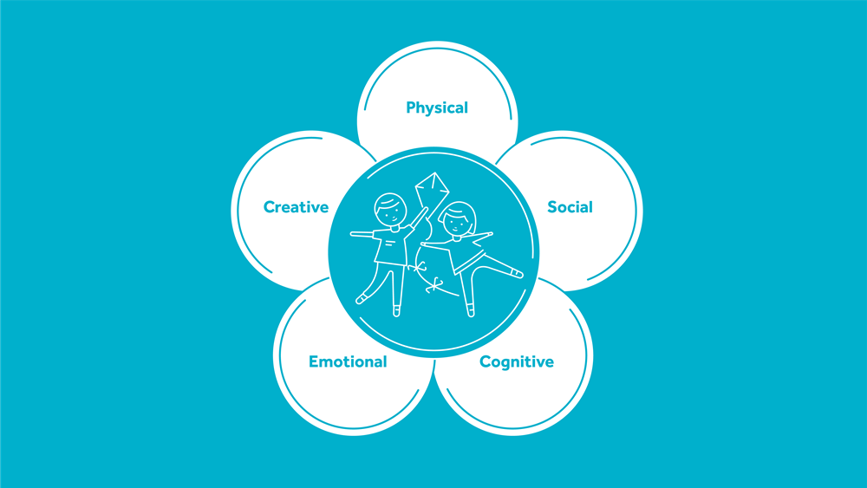

Module Lead - Tom Cox

Table of Contents
Introduction 4
Cognitive 5
Emotional 6
Social 8
To conclude 10
Reference List: 11

It is important that teachers understand child development to develop strategies to evolve children’s skills. An understanding of how to support children with different academic and emotional needs will help them to create appropriate strategies. A holistic approach to education emphasises how to learn rather than to memorise information for testing. Holistic development encompasses mental, psychological, social development and emotional growth. Theorist Maria Montessori supports holistic approaches to development. Montessori’s method focusses on independence learning. Curriculum 2022 proposes children are taught to be independent learners. This is something Montessori believed and is subsequently taught in her schools. The “EPIC Board” (Everyone Plans In Class), allows children to decide what they would like to learn about a topic – I have seen this approach on recent bridging days. This is then incorporated into lessons plans with key subject areas included.
(Montessori, 2019)

Teachers are required to protect the health, safety and welfare of pupils. “The Common Law Duty of Care” outlines a teacher’s duty of care towards a pupil should be similar to that of a parent/guardian. Teachers must however remain professional at all times, for example; when a child is hurt, a parent/guardian would “kiss it better”, a teacher should use a verbal comforting approach to avoid crossing professional boundaries. “The Statutory Duty of Care” demonstrates teachers’ responsibility under the Children Act. This law “places statutory duties upon those who care for children”. When safeguarding and welfare issues arise, teachers should consider the wishes of the children involved. Article 12 “Right to be Heard” should be implemented throughout education. Depending on a child’s age, they may need an advocate. Younger children may not understand danger to their welfare and safeguarding concerns therefore a teacher should advocate for them. Every school will have their own safeguarding policy with similar basic principles.
(NUT, 2013-14)

Ella is a four-year-old girl in the “Preoperational Stage” of her development who has been in Reception class for six months. At this stage, Ella should begin to think symbolically and use words and pictures to represent objects. Ella can name “some simple” objects such as “doggy”. Despite having supportive parents and having attended playgroup, Ella’s progress is limited. Consequently, her teacher has concerns. Ella’s Pupil Profile indicated her strengths and teacher concerns. Having studied her profile, theorists and participated in bridging days I have compiled strategies to help Ella progress.

Cognitive
Cognitive development involves the building of skills needed for learning such as attention, memory, thinking and problem solving. (Gilles, 2019) Theorists Bruner, and Vygotsky have produced extensive research into this stage of development.

Ella’s speech in unclear, she uses many one-word responses, rarely initiates talk but will respond. Shyness is apparent therefore I suggest speaking to Ella on a one-to-one basis or as part of a group to encourage her to communicate. Ella is dependent on gestures to communicate her needs but can be reluctant to do so. Increasing Ella’s confidence and self-esteem will encourage her to communicate linguistically more.

Ella’s teacher should allow independent learning. Multisensory learning allows children the opportunity to receive and process new information before compartmentalising it and making connections between new information and prior knowledge. Bruner’s Spiral Approach to Education shows that learning is achieved overtime rather than in short periods. (McLeod, 2019) This approach allows Ella to discover learning independently. Similarly, to enhance Ella’s self-esteem, her teacher should observe her playing and interacting in order to identify when she interacts and when she becomes withdrawn. “Never help a child with a task at which he feels he can exceed” (Montessori, 2019). Additionally, Braden (1969) states that “self-esteem occurs in conjunction with a person’s thoughts, behaviour, feelings and actions”.

Following observation, lessons can be adapted to suit Ella’s needs and encourage development. As Ella is “beginning” to communicate her feelings, she should be presented with more opportunities like giving her responsibility in the classroom. For example; passing out resources to her peers meaning more interaction all round. This method of distraction will also help her to overcome her separation anxiety.

In classrooms Montessori’s theories are being utilised by allowing the children choices. “EPIC – Everyone Plans In Class”, is a constructivist approach that allows learners to construct their learning, this encourages the children to suggest what they would like to learn about a topic. For Ella this approach encourages her to communicate her feelings towards the topic. (Appendix 1). During these activities, children are free to learn about a topic by using ICT, mathematics, creativity, and discovery in and outdoors.

To establish Ella’s routine I would suggest a timetable with each lesson depicted by an image and words to help Ella make links between them. This will help Ella’s reading, communication and decrease her anxiety towards being separated from her Mum in the morning. A routine will decrease Ella’s separation anxiety as she will have a clear understanding of what her day looks like before her mum picks her up. In addition, when introducing a lesson, Ella’s teacher should repeat the aim of the activity to measure her understanding. This will allow the children time to process and the teacher time to reiterate anything that was misunderstood. Constructivist believe when a child remembers, they process and restructure their existing knowledge to link it to new information. The brain only remembers information/knowledge that is used regularly therefore it is key that topics are revisited often.

Emotional
Ella is unhappy to separate from her Mum each morning. This is referred to as separation anxiety. To decrease Ella’s anxiety, I would suggest giving Ella responsibilities in the morning to distract her from her Mum leaving and give her a sense of independence. Incorporating this into Ella’s morning routine will make her feel special and excited to go into school and do her job.

Ella seems to be detached from the other children as she often plays on her own and appears unaware of her peers. To increase Ella’s social interaction, her parents and teacher should encourage playdates. This will enable Ella to make friends in her home environment and allow her Mum to interact with other Mums. This will develop Ella’s reluctance to share resources with her peers. Vygotsky’s theory shows that Ella needs to interact with other children, this will enable her to be more independent in school as she currently enjoys other children “taking care” of her. Additionally, teaching Ella on a one-to-one level by encouraging her to walk up/downstairs independently, an adult should be there to support and increase her confidence. Alternatively, working in a small group will encourage speaking to her peers. This setting will develop her fine motor skills as she currently holds a pencil with a “splayed”, four-finger grip. Activities such as using tweezers to count sweets will help with this. This will also help Ella establish a preferred writing hand as soon she will learn to form letters.

Ella might be an only child so may be mollycoddled at home. At her age, Ella should be able to walk up and down stairs using one foot per step, but she needs an adult’s help. At home she may be carried up/downstairs by her parents however, this decreases her independence. I would suggest meeting with her parents regarding her lack of independence and unwillingness to interact. This will allow her teachers to gain an understand of her home life. Strategies can be developed to help Ella develop cognitively, emotionally, socially and physically.

Ella often appears confused by instructions and has difficulty following them therefore class instructions should be broken down into step-by-step instructions and she should have access to a visual, colour-coordinated timetable to refer back to independently. This will increase Ella’s confidence and perhaps make her happier when coming to school.

Following these interventions, an ALNCO (Additional Learning Needs Coordinator) should be consulted. Some of Ella’s characteristics both academically and emotionally are similar to those of a child on the Autistic Spectrum. For example; unwillingness to interact and slow physical development. An ALNCO may use “Thrive” to establish strategies’ to help Ella in all areas of her life not just academically and will observe progress. Ella will need to be medically diagnosed by a child/education phycologist. Both of these professionals will her Ella and her parents understand her condition. Ella can then be properly supported at home and school.

Social
A child’s interactions with other children and adults is equally as important as their academic development. “Social development refers to the process by which a child learns to interact with others”. As children develop, they acquire the skills to communicate and process their actions. Social development refers to the relationships a child has and how a child deals with conflict, this can impact many forms of a child’s development. From the sensorimotor stage through to the formal operational stage, social development can help a child`s language and communication, build self-esteem, and strengthen learning both emotionally and academically. (Social Development in Children (SCAN of Northern Virginia, 2019). Personal and Social Education (PSE) aims to help children develop self-esteem and language skills to allow the opportunity to solve differences with peers. (Welsh Assembly Government, 2019) At four-years-old, children tend to be egocentric. In Ella’s case, she is unable to negotiate solutions to conflicts without adult intervention. This is normal for a child of her age however a restorative approach for example; What happened? What were you thinking? How do you feel? Who has been hurt/upset by what happened? What do you think needs to happen now? Both/all of the children involved should be asked these questions to reach a fair conclusion and help the children to understand each other’s feelings. This will help Ella establish her own feelings and resolve conflict independently.

Studies show that everyday experiences with parents/guardians are fundamental to a child’s developing social skillset. A child’s relationship with their parents/guardian is the first relationship they establish. Parents/guardians model positive interactions and relationships with people, similar to a teacher’s role. By Ella’s age, she should “express affection openly, though not always accurately”. At this age children have difficulty in expressing their emotions and do not yet understand them all. In schools, approaches such as “checking in” allows children to express their feelings by putting their name on a face that depicts their emotion. This approach helps the children to display their emotions and the teacher to help the child comprehend this. Another attribute includes awareness of other’s emotions. In Ella’s case, she does not consistently show care and respect for others. PSE encourages to be more aware of others’ emotions. As a teacher, cooperative play should be modelled by playing alongside children in a ‘peer-like’ manner.

Currently, Ella displays signs of solitary play as she is reluctant to share resources and mainly plays alone whilst being seemingly unaware of her peers. At Ella’s age, she should be playing with/alongside others demonstrating interactions. From a parental point of view, Ella should attend play dates, this will decrease Ella’s separation anxiety and put her mother’s mind at ease as well as increasing Ella’s confidence with communication. (SCAN of Northern Virginia, 2019)

“Bronfenbrenner’s Ecological Systems Theory” (Appendix 2) states the “Microsystem” is the immediate environment in which a child lives – home and school. This refers to the permanent community and relationships in the child’s life. These interactions involve relationships with family members, classmates, and teachers. A child’s interactions with the children and adults in their lives affects how they develop socially. Similarly, how children interact with the people in their microsystem affects how they treat children. The second stage, “Mesosystem encompasses the interaction of the different microsystems which children find themselves in”. This refers to the interaction between home and school. According to Bronfenbrenner’s theory, if parents/guardians have an active involvement in their child’s friendships by encouraging playdates, the child’s development is affected through communication and interaction. On the other hand, if the child’s parents/guardians discourage friendships this could cause conflict in the child’s emotions, leading to negative development. (What is Bronfenbrenner’s Ecological Systems Theory? The Psychology Notes HQ) Children should be allowed to form their own friendships and discover these independently. This is similar to Montessori’s theory of discovery in education.

Albert Bandura’s cyclical “Social Learning Theory” conveys that behaviour is learnt from one another via observation, imitation and modelling. Environmental factors; the opportunities and experiences the child receives also impacts a child’s social development. This is ongoing through a child’s development and education. (Social Learning Theory (Bandura), 2019). (Appendix 3)
Vygotsky’s “Learning Theory” concurs with Bandura’s theory and says that young children use language to plan, monitor and guide behaviour. A Knowledgeable Other (MKO) models correct behaviour for the child. (Social Development Theory (Vygotsky) Learning Theories, 2019).

To effectively help Ella, she should progress at her own pace with some assistance from more knowledgeable sources. As Montessori believed, independence is key to a child’s development. I believe that a visual timetable in addition to a steady routine including responsibilities will help Ella progress. Teachers should closely observe her development and re-evaluate her progress at the end of term. If Ella does not progress in the highlighted areas, consulting her parents and a child psychologist would be the next step. Slow progression could indicate a condition such as Autism.

Reference List:

Daily Montessori. (2019) Montessori Theory
Available at: http://www.dailymontessori.com/montessori-theory/
(Accessed on 2nd November 2019)

Gilles, G. (2019) What Are Cognitive Skills in Children? – Development, Definition & Training
Available at: https://study.com/academy/lesson/what-are-cognitive-skills-in-children-development-definition-training.html
(Accessed on 2th December 2019)

Learning Theories. (2019) Social Learning theory (Bandura)
Available at: https://www.learning-theories.com/social-learning-theory-bandura.html
(Accessed on 26th November 2019)

Learning Theories. (2019) Social Development Theory (Vygotsky)
Available at: https://www.learning-theories.com/vygotskys-social-learning-theory.html
(Accessed on 26th November 2019)

McLeod, S. (2019) Bruner – Learning Theory in Education
Available at: https://www.simplypsychology.org/bruner.html
(Accessed on 2nd November 2019)

National Teachers Union. (2012-14) Education, The Law and You
Available at: https://www.teachers.org.uk/files/the-law-and-you--8857-.pdf
(Accessed on 5th December 2019)

Psychology Notes HQ. (2019) What is Bronfenbrenner’s Ecological Systems Theory?
Available at: https://www.psychologynoteshq.com/bronfenbrenner-ecological-theory/
(Accessed on 25th November 2019)

SCAN of Northern Virginia. (2019) Social Development in Children
Available at: https://www.scanva.org/support-for-parents/parent-resource-center-2/social-development-in-children/
(Accessed on 18th November 2019)

Very Well Mind (2019) Signs of Low Self-Esteem
Available at: https://www.verywellmind.com/what-is-self-esteem-2795868
(Accessed on 8th November 2019)

Welsh Assembly Government. (2019) Personal and social education framework for 7 to 19-year-olds in Wales
Available at: https://hwb.gov.wales/storage/35fae761-054b-4e9b-928c-03e86b3e207f/personal-and-social-education-framework.pdf
(Accessed on 2nd November 2019)

Welsh Government. (2019) A guide to Curriculum for Wales 2022
Available at: https://hwb.gov.wales/draft-curriculum-for-wales-2022/a-guide-to-curriculum-for-wales-2022
(Accessed on 2nd November 2019)

Appendix

Appendix 1
Enhanced Provision - Focus: Space
Date/Dyddiad: _ Weeks beginning 5/11/19 and 12/11/19

Sand  Tywod | Problem Solving  Datrys Problemau | Paint  Paent | Creative Area  Ardal Creadigol | Computers  Cyfrifiadur
 | MDJ  Resources: whiteboard pens and whiteboards  A Trip into Space | MDJ  Can you create your own space rocket?  Resources: chalks, pastels, and coloured paper  Space Rocket handprint craft  WALT:  Reflect on their own work and the work of others  MDJ  Can you create your own Remembrance Day art using pastels and chalks? | Can you make your own Alien?  Resources: glue, different materials  WALT:  Combine materials to create their own images  Can you create your own monster cupcake?  Can you create your own constellation card?  Resources:  Strats, silver/gold pens, black paper | Log into J2E and create an Alien  iPad – use the “wordfoto” app to thinkof amazing adjectives to describe the Alien  Attack of the Robots! Animation – Use the Animation App to create and build your own robot  WALT:  Select appropriate software to complete given tasks in order to use animation  ONGOING  Abacus – online maths games
Construction  Adeiladu | Role Play  Chwarae Rôl | Cwtch Cymraeg | Writing Table  Ardal Ysgrifennu | Funky Fingers  Bys Ffynci
Can you design and build your own symmetrical Alien?  Resources:  Building blocks, cardboard boxes and cellotape  WALT:  Develop their understanding of designing and modelling  Can you make your own straw rocket that flies? |  | Ask the Alien questions eg: Pwy wyt ti? Ble wyt ti’n byw? Pryd mae dy benlwydd di?  Skills:  Make themselves understood, speak clearly, listen to familiar voices  Resources:  Welsh books, key words, tedi twt books, papers, iPad etc | ONGOING  Secret diaries  MDJ  WALT:  Write for a variety of reasons  Resources:  Coloured pencils, paper RWI sound words  Forming words | Can you make moon rocks?  Which moon rock goes the furthest?
Reading Corner  Cornel Ddarllen | Discovery Table  Darganfod (Outdoors) | Number  Rhif | Music  Cerdd  (Outdoors) | Outdoor Activities
Create a fact file for your favourite Rainforest Animal  Resources:  Fiction books, non-fiction books, clipboards, pencils, book review sheets, key words, fact files for other animals | Can you build a boat that floats?  Key questions – Did any of your findings surprise you?  Resources:  Different materials, scissors | MDJ  Can you make a numicorn Aliens? What is the value of your Alien?  Resources:  Numicorn, whiteboards, and pens  Can you make an Alien that is worth 20, 50, 100 when each material is worth a different value?  Resources:  Pipe cleaners, googly eyes  Can you make a 2D shape Alien?  Resources:  2D shapes, googly eyes, scissors and glue | Compose a song and use the natural resources to write your musical piece.  Eg: rock = clap, shell = click  Resources:  Stones, sticks and shells  Skills:  Create their own musical ideas and contribute to simple compositions | Use the natural materials to make a rocket or space theme  Ordinal numbers – use the fans to race the cars.  Which cars came first/second etc?

Appendix 2
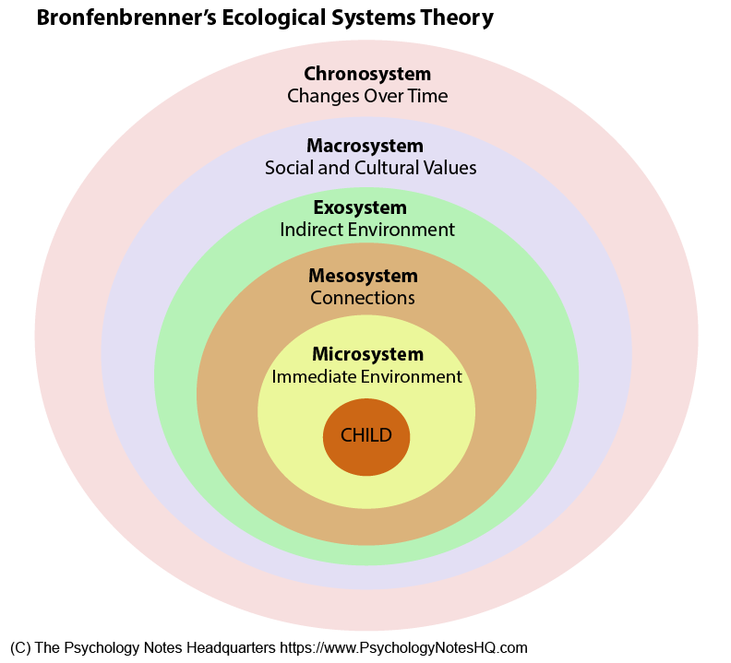

Appendix 3


