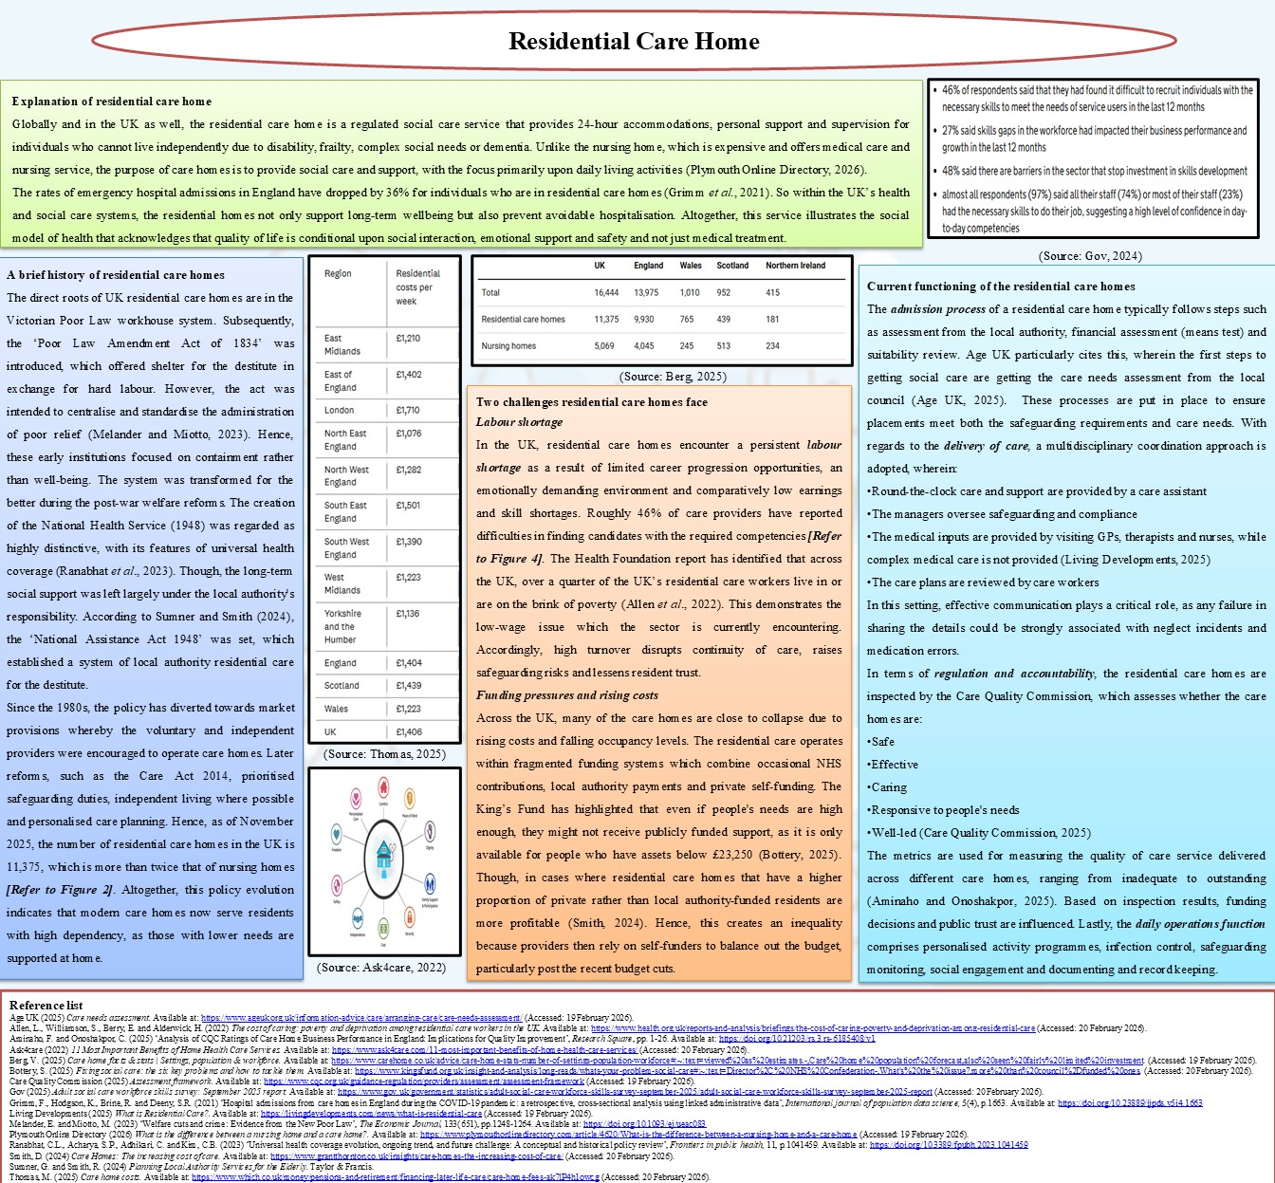



Name:Ioana Madalina Priboi
Student ID:2511525
Module Code: LCHS4003_BIRM
Module: Introduction to Health an Social Care
Lecturer: Azida Zainol

Submitted on: 23.02.2026
Table of Contents
Task 1: Poster 3
Explanation of residential care home 3
A brief history of residential care homes 4
Current functioning of the residential care homes 5
Two challenges residential care homes face 6
Task 2: Essay 7
Reference list 9

Task 1: Poster

Explanation of residential care home
Globally and in the UK as well, the residential care home is a regulated social care service that provides 24-hour accommodations, personal support and supervision for individuals who cannot live independently due to disability, frailty, complex social needs or dementia. Unlike the nursing home, which is expensive and offers medical care and nursing service, the purpose of care homes is to provide social care and support, with the focus primarily upon daily living activities (Plymouth Online Directory, 2026).
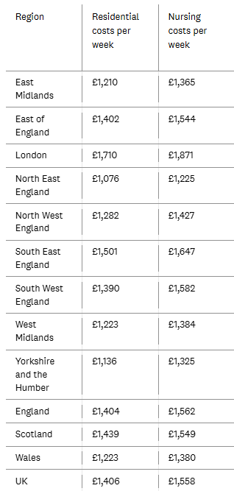
Figure 1: Average care home cost
(Source: Thomas, 2025)
The rates of emergency hospital admissions in England have dropped by 36% for individuals who are in residential care homes (Grimm et al., 2021). So within the UK’s health and social care systems, the residential homes not only support long-term wellbeing but also prevent avoidable hospitalisation. Altogether, this service illustrates the social model of health that acknowledges that quality of life is conditional upon social interaction, emotional support and safety and not just medical treatment.

A brief history of residential care homes
The direct roots of UK residential care homes are in the Victorian Poor Law workhouse system. Subsequently, the ‘Poor Law Amendment Act of 1834’ was introduced, which offered shelter for the destitute in exchange for hard labour. However, the act was intended to centralise and standardise the administration of poor relief (Melander and Miotto, 2023). Hence, these early institutions focused on containment rather than well-being. The system was transformed for the better during the post-war welfare reforms. The creation of the National Health Service (1948) was regarded as highly distinctive, with its features of universal health coverage (Ranabhat et al., 2023). Though, the long-term social support was left largely under the local authority's responsibility. According to Sumner and Smith (2024), the ‘National Assistance Act 1948’ was set, which established a system of local authority residential care for the destitute.
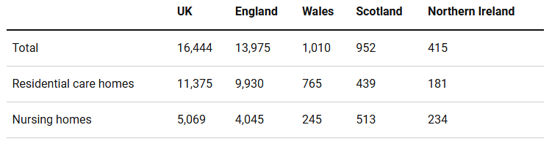
Figure 2: Residential care homes in the UK
(Source: Berg, 2025)
Since the 1980s, the policy has diverted towards market provisions whereby the voluntary and independent providers were encouraged to operate care homes. Later reforms, such as the Care Act 2014, prioritised safeguarding duties, independent living where possible and personalised care planning. Hence, as of November 2025, the number of residential care homes in the UK is 11,375, which is more than twice that of nursing homes [Refer to Figure 2]. Altogether, this policy evolution indicates that modern care homes now serve residents with high dependency, as those with lower needs are supported at home.

Current functioning of the residential care homes
The admission process of a residential care home typically follows steps such as assessment from the local authority, financial assessment (means test) and suitability review. Age UK particularly cites this, wherein the first steps to getting social care are getting the care needs assessment from the local council (Age UK, 2025). These processes are put in place to ensure placements meet both the safeguarding requirements and care needs. With regards to the delivery of care, a multidisciplinary coordination approach is adopted, wherein:
- Round-the-clock care and support are provided by a care assistant
- The managers oversee safeguarding and compliance
- The medical inputs are provided by visiting GPs, therapists and nurses, while complex medical care is not provided (Living Developments, 2025)
- The care plans are reviewed by care workers
In this setting, effective communication plays a critical role, as any failure in sharing the details could be strongly associated with neglect incidents and medication errors.
In terms of regulation and accountability, the residential care homes are inspected by the Care Quality Commission, which assesses whether the care homes are:
- Safe
- Effective
- Caring
- Responsive to people's needs
- Well-led (Care Quality Commission, 2025)
The metrics are used for measuring the quality of care service delivered across different care homes, ranging from inadequate to outstanding (Aminaho and Onoshakpor, 2025). Based on inspection results, funding decisions and public trust are influenced. Lastly, the daily operations function comprises personalised activity programmes, infection control, safeguarding monitoring, social engagement and documenting and record keeping.
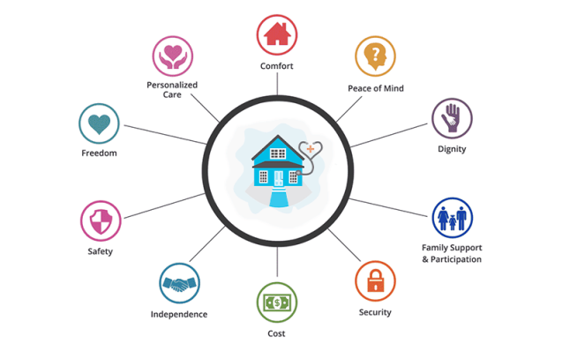
Figure 3: Functions of residential care homes
(Source: Ask4care, 2022)

Two challenges residential care homes face
Labour shortage
In the UK, residential care homes encounter a persistent labour shortage as a result of limited career progression opportunities, an emotionally demanding environment and comparatively low earnings and skill shortages. Roughly 46% of care providers have reported difficulties in finding candidates with the required competencies [Refer to Figure 4].
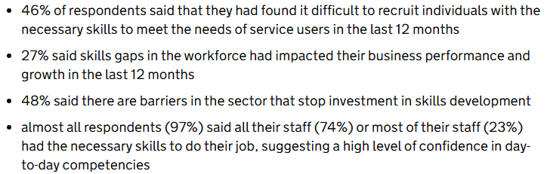
Figure 4: Skill shortage issue
(Source: Gov, 2025)
The Health Foundation report has identified that across the UK, over a quarter of the UK’s residential care workers live in or are on the brink of poverty (Allen et al., 2022). This demonstrates the low-wage issue which the sector is currently encountering. Accordingly, high turnover disrupts continuity of care, raises safeguarding risks and lessens resident trust.
Funding pressures and rising costs
Across the UK, many of the care homes are close to collapse due to rising costs and falling occupancy levels. The residential care operates within fragmented funding systems which combine occasional NHS contributions, local authority payments and private self-funding. The King’s Fund has highlighted that even if people's needs are high enough, they might not receive publicly funded support, as it is only available for people who have assets below £23,250 (Bottery, 2025). Though, in cases where residential care homes that have a higher proportion of private rather than local authority-funded residents are more profitable (Smith, 2024). Hence, this creates an inequality because providers then rely on self-funders to balance out the budget, particularly post the recent budget cuts.

Task 2: Essay
The ambulance service originated from the battlefield evacuation system, specifically during Napoleonic and later European battles. Napoleon’s surgeon-in-chief invented this service for transporting the wounded soldiers to the field hospital (Larrey, 2025). The service was later adopted in a civil setting in the late 19th century, and it was managed by the charities or local authorities. Before the enactment of the national ambulance service, the police and firefighters were responsible for transporting patients to the hospital (Siriwardena et al., 2024). With the NHS’s establishment, the ambulance provisions were incorporated within the UK’s national healthcare framework. The ambulance service’s primary role was to transport the injured, not to treat them. In the late 19th century, the ambulance services were transformed into mobile emergency hospitals. This shift widened the healthcare metamorphoses toward pre-hospital interventions alongside rapid response systems.
The ambulance service in current times has extended its clinical responsibilities. Cimino and Braun (2023) particularly has pointed out that the paramedics administer intravenous medications, perform advanced airway management and ultrasonography for conditions which could be life-threatening. Medicine and technological advancements around prehospital procedures have transformed and improved patient care outcomes. This lowers unnecessary hospital admissions while improving support system efficiency. However, increasing responsibility without proportional staffing growth has contributed towards workforce burnout and delayed response times. 2018 data on a single UK ambulance service has revealed that more than 50% of the ambulance crew have reported experiencing signs of burnout and a high level of depersonalisation (Beldon and Garside, 2022). While a recent study by Powell et al. (2023) has pointed out that the major contributing factors to burnout among emergency personnel in hospital settings are excessive workload, lack of emotional support and interpersonal conflicts.
Across the UK, the demand for ambulance services is rising continuously. In 2023, the UK ambulance service market size was valued at USD 1,470.1 million, which is projected to grow at a CAGR of 8.23 to reach USD 2.995.54 million (Introspective Market Research, 2025). The factors that have been identified to cause this demand rise due to ageing population, difficulty in accessing primary care and the prevalence of chronic illness. This indicates that across the UK, the ambulance services increasingly handle emergencies surrounding mental health and social care concerns. This altogether implies that the ambulance service operates as a safety net for wider system gaps. Care Quality Commission (CQC) is the primary regulatory body of the private ambulance providers in the UK (Met-Medical, 2026).
Hence, in enhancing the quality of care, the ambulance services have demonstrated their significance. Through early interventions in situations of stroke, trauma or cardiac arrests, the ambulance service has yielded significant benefits. As emphasised by Almutair et al. (2024), timely paramedic interventions have been attributed towards improved survival rates in cases where cardiac arrests, pain and time-sensitive conditions have been observed. The ambulance services across the UK are also free at the point of use and available regardless of income or mobility. This ensures that healthcare access is equitable. Modern paramedics are ready to treat patients at their homes and refer them to community groups. This altogether reduces hospital admissions and supports independence. Overall, apart from being an emergency responder, the ambulance services are a key component of an integrated healthcare system.

Reference list
Age UK (2025) Care needs assessment. Available at: https://www.ageuk.org.uk/information-advice/care/arranging-care/care-needs-assessment/ (Accessed: 19 February 2026).
Allen, L., Williamson, S., Berry, E. and Alderwick, H. (2022) The cost of caring: poverty and deprivation among residential care workers in the UK. Available at: https://www.health.org.uk/reports-and-analysis/briefings/the-cost-of-caring-poverty-and-deprivation-among-residential-care (Accessed: 20 February 2026).
Almutair, M.K., Alharbi, S.E., Aljuhani, M.A., Alqahtani, M.A.A. and Alenezi, E.M.G. (2024) ‘Effectiveness of paramedic interventions in pre-hospital emergency care: a systematic review’, Cuestiones de Fisioterapia, 53(03), pp.3091-3098. Available at: https://doi.org/10.48047/ga9kkf15
Aminaho, F. and Onoshakpor, C. (2025) ‘Analysis of CQC Ratings of Care Home Business Performance in England: Implications for Quality Improvement’, Research Square, pp. 1-26. Available at: https://doi.org/10.21203/rs.3.rs-6185408/v1
Ask4care (2022) 11 Most Important Benefits of Home Health Care Services. Available at: https://www.ask4care.com/11-most-important-benefits-of-home-health-care-services/ (Accessed: 20 February 2026).
Beldon, R. and Garside, J. (2022) ‘Burnout in frontline ambulance staff’, Journal of Paramedic Practice, 14(1), pp. 6–14. Available at: https://doi.org/10.12968/jpar.2022.14.1.6.
Berg, V. (2025) Care home facts & stats | Settings, population & workforce. Available at: https://www.carehome.co.uk/advice/care-home-stats-number-of-settings-population-workforce#:~:text=viewed%20as%20estimates.-,Care%20home%20population%20forecast,also%20seen%20fairly%20limited%20investment. (Accessed: 19 February 2026).
Bottery, S. (2025) Fixing social care: the six key problems and how to tackle them. Available at: https://www.kingsfund.org.uk/insight-and-analysis/long-reads/whats-your-problem-social-care#:~:text=Director%2C%20NHS%20Confederation-,What's%20the%20issue?,more%20than%20council%2Dfunded%20ones. (Accessed: 20 February 2026).
Care Quality Commission (2025) Assessment framework. Available at: https://www.cqc.org.uk/guidance-regulation/providers/assessment/assessment-framework (Accessed: 19 February 2026).
Cimino, J. and Braun, C. (2023) ‘Clinical research in prehospital care: current and future challenges’, Clinics and Practice, 13(5), pp.1266-1285. Available at: https://doi.org/10.3390/clinpract13050114
Gov (2025) Adult social care workforce skills survey: September 2025 report. Available at: https://www.gov.uk/government/statistics/adult-social-care-workforce-skills-survey-september-2025/adult-social-care-workforce-skills-survey-september-2025-report (Accessed: 20 February 2026).
Grimm, F., Hodgson, K., Brine, R. and Deeny, S.R. (2021) ‘Hospital admissions from care homes in England during the COVID-19 pandemic: a retrospective, cross-sectional analysis using linked administrative data’, International journal of population data science, 5(4), p.1663. Available at: https://doi.org/10.23889/ijpds.v5i4.1663
Introspective Market Research (2025) UK Ambulance Services Market - Insights for Business Growth Report 2024-2032. Available at: https://introspectivemarketresearch.com/reports/uk-ambulance-services-market/ (Accessed: 21 February 2026).
Larrey, D.J. (2025) Memoir Of Baron Larrey: Surgeon-In-Chief Of The Grande Army. Bonhopai Books.
Living Developments (2025) What is Residential Care?. Available at: https://livingdevelopments.com/news/what-is-residential-care (Accessed: 19 February 2026).
Melander, E. and Miotto, M. (2023) ‘Welfare cuts and crime: Evidence from the New Poor Law’, The Economic Journal, 133(651), pp.1248-1264. Available at: https://doi.org/10.1093/ej/ueac083
Met-Medical (2026) How Private Ambulance Services Are Regulated in the UK: A Complete Guide. Available at: https://www.met-medical.co.uk/met-medical-news/how-private-ambulance-services-are-regulated-in-the-uk-a-complete-guide (Accessed: 21 February 2026).
Plymouth Online Directory (2026) What is the difference between a nursing home and a care home?. Available at: https://www.plymouthonlinedirectory.com/article/4620/What-is-the-difference-between-a-nursing-home-and-a-care-home (Accessed: 19 February 2026).
Powell, C., Fylan, B., Lord, K., Bell, F. and Breen, L. (2023) ‘A qualitative analysis of stressors affecting 999 ambulance call handlers' mental health and well-being’, International Journal of Emergency Services, 12(2), pp.231-242. Available at: https://doi.org/10.1108/ijes-12-2021-0080
Ranabhat, C.L., Acharya, S.P., Adhikari, C. and Kim, C.B. (2023) ‘Universal health coverage evolution, ongoing trend, and future challenge: A conceptual and historical policy review’, Frontiers in public health, 11, p.1041459. Available at: https://doi.org/10.3389/fpubh.2023.1041459
Siriwardena, A.N., Siriwardena, A., Patel, G., Botan, V., Smith, M.D., Smith, M., Phung, V.H., Pattinson, J., Trueman, I., Ridyard, C. and Hosseini, M.P. (2024) ‘Community First Responders' role in the current and future rural health and care workforce: a mixed-methods study’, Health and Social Care Delivery Research, 12(18), pp.1-101. Available at: https://doi.org/10.3310/JYRT8674
Smith, D. (2024) Care Homes: The increasing cost of care. Available at: https://www.grantthornton.co.uk/insights/care-homes-the-increasing-cost-of-care/ (Accessed: 20 February 2026).
Sumner, G. and Smith, R. (2024) Planning Local Authority Services for the Elderly. Taylor & Francis.
Thomas, M. (2025) Care home costs. Available at: https://www.which.co.uk/money/pensions-and-retirement/financing-later-life-care/care-home-fees-ak7lP4h1owcg (Accessed: 20 February 2026).

