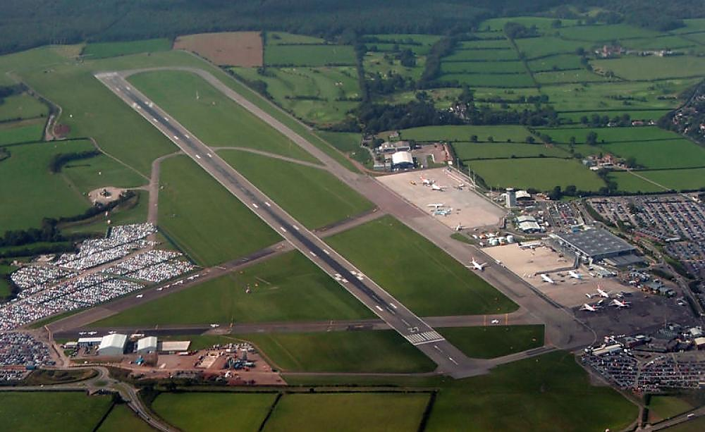
Assess Environmental Impact and Design out Impacts.
Revision of EIA Bristol Airport 2005 by Entec and BIA Master Plan 2006
MATEUSZ MORGA (1705592) | 5/8/20 | Environmental Impact Assessment

Contents
1.0 Introduction 2
1.0.1 Bristol International Airport (BIA) Location 2
1.2 What is EIA? 0
1.3 Proposed expansion 0
1.3.1 Full list of proposed BIA upgrades (Fig.3) (Johns and Pratt, 2005). 0
2.0 Impact Assessment and mitigation (EIA Entec and Master Plan Cross-analysis) 0
3.0 Conclusion 0
4.0 REFERENCES 1

Figure 1 Bristol Airport Location (Map Sourced form BIA Entec EIA 2005). 4
Figure 2 Bristol Airport Inventory Map Including Proposed Expansion Zones (Ordnance Survey Map, ENTEC BIA EIA 2005). 0
Figure 3 BIA Master Plan Development to 2015 (Bristol International Airport, 2006). 0

Table 1 (A) BIA Air Quality Analysis. 1
Table 2 Summary of Airport Emission Sources (tonnes per annum) 0
Table 3 (B) BIA Noise Impact Analysis. 0
Table 4 (C) BIA Transport Impact Analysis. 3
Table 5 (D) BIA Community Impacts Analysis. 6
Table 6 (E) BIA Biodiversity Impact Analysis. 8
Table 7 (F) BIA Geology and Land Quality Impact Analysis. 0
Table 8 (G, H) BIA Cultural Heritage and Landscape Visual Impacts Analysis. 1
Table 9 Singapore Changi Airport (Terminal 4) (Airport Technology, 2018). 2

SOMETHING WENT WRONG WITH MY TABLE AND FIGURE CONTENT?

1.0 Introduction

1.0.1 Bristol International Airport (BIA) Location

BIA is placed in South-West England (North Somerset), seven miles south from Bristol City (Fig. 1) (National Grid Ref: NGR ST 506654). It occupies a section of the beautiful rural region (a 176ha of total area with an option of immediate 10ha land acquirement to the south). BIA lies within the boundary of Forest of Avon (a section of Lusgate Plateau is the potential expansion zone). BIA is located within a Grin Belt designation and is surrounded with AONB local planning, SSSI Felton Commons, Somerset and Mendips Special Area of Conservation (SAC).
There are no current rail link connections with region’s largest city (Bristol), so bus services (running form two stations) and private cars (or taxis) are dominating forms of transport) utilizing A38 (primary road access).
The airport facilities include passenger terminal building and main aircraft parking apron, runway with taxi service bays, short/long term traffic car parks, air traffic control tower, offices (administration and operations) located in the old terminal building and ancillary facilities: fuel station, catering, general aviation facilities including aircraft hangars and car hire (Fig.2) (Johns and Pratt, 2005).
2.650 people were working in BIA (52 separate businesses in 2005), and the total regional employment linked with the airport operations were 3,327 jobs (2005) and are predicted to expand by the additional 5.000 at 2030.

1.1. Brief History and Ownership

The Airport was officially opened in 1930 (31 May) by HRH Prince George, and it was the only third civil Airport in the UK. First extensions to the terminal building were made in 1965. Today BIA is owned by Ontario Teachers’ Pension Plan (Teachers’) (an independent organization headquartered in Toronto) which invests and administers the pensions of the province of Ontario’s 323,000 active and retired teachers (Bristol Airport, 2020). The plans are to increase the passenger throughput from the current 5 million passengers a year (ppa) to 12 million ppa by the mid-2020s.

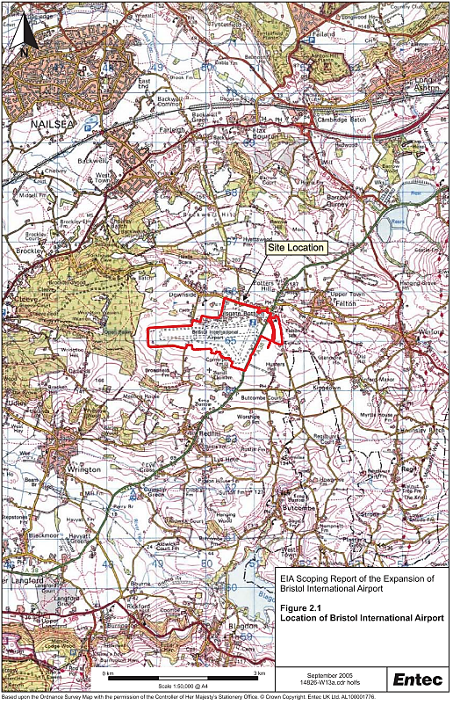
Figure 1 Bristol Airport Location (Map Sourced form BIA Entec EIA 2005).

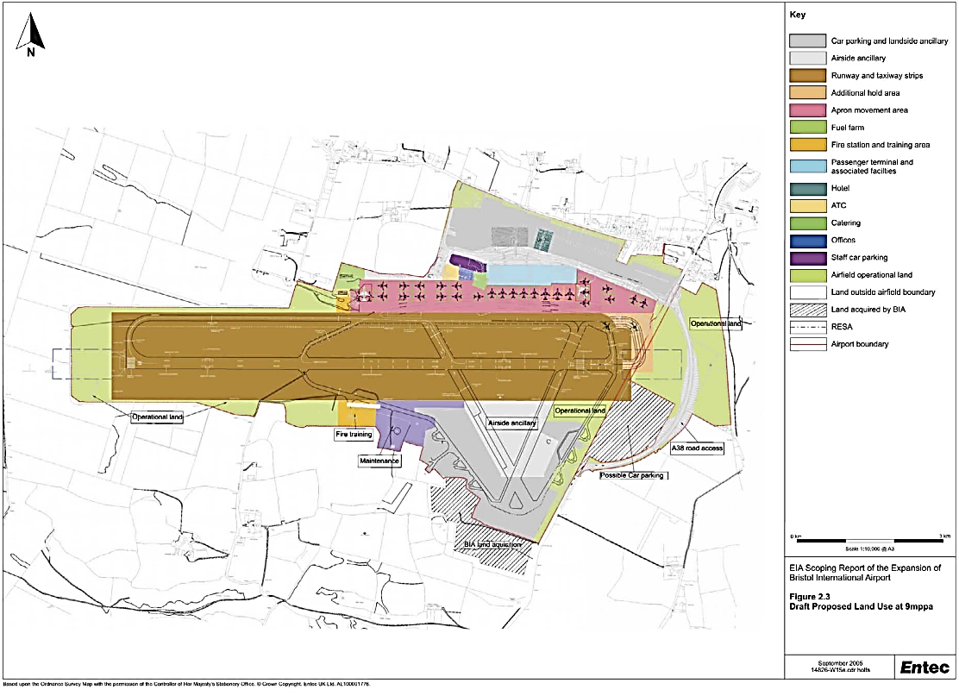
Figure 2 Bristol Airport Inventory Map Including Proposed Expansion Zones (Ordnance Survey Map, ENTEC BIA EIA 2005).

1.2 What is EIA?

EIA is a systematic process to identify, predict and evaluate the short/long-term environmental effects (including social, economic, and cultural) of proposed actions or development projects. Also, the correct EIA must include preventing, mitigating, or offsetting of the adverse consequences of intended undertakings.
One of the main tasks for the EIA is to inform the process of decision making by highlighting the environmental threats (or risks) that the project may cause.

The EIA is always implemented within an initial phase of the project (usually after the Proposal Indication) and is consisting of the three main phases (Scoping that is assessing the impact/risk, Impact Analysis that numbers the severity of assessed impact/risk and finally a Mitigation Process that finds solutions to lessen the impact or offset if mitigation is not possible). Next, the EIA report is implemented in the Reviewing Process (a decision is made if the project is granted permission). If yes, the EIA is assisting along with the entire project development, including additional monitoring (or support) after the projects initial construction phase was completed.

1.3 Proposed expansion

Aviation White Papers is the UK’s strategic framework that sets out the development of the airport industry in the country and has the power to control the capacity (or throughout) of the individual airports across the country. It also refers to any policy that can be related to aviation development projects in the UK. In 2003 the BIA airport operator was ‘invited’ to ‘bring forward as soon as possible a long-term master plan setting out the proposals’ of the airport expansion including terminal expansion and runway extension (Secretary of State for Transport, 2003, p:102)

1.3.1 Full list of proposed BIA upgrades (Fig.3) (Johns and Pratt, 2005).
1. Expansion of the passenger terminal.
BIA need to be at least 60% to 80% larger to handle a 9 mppa.

2. Insertion of new mezzanine floor and aircraft access piers in existing terminal building.
New access was proposed to improve existing insufficient infrastructure.

3. Apron extensions including extra 12 stands.

4. Provision of new multi storey car parking facilities.
Current proposals are for a single multi storey car park, 4 storeys in height, with 1000 spaces, to cater for short term parking requirements. Land will be safeguarded for a second, similar car park, in the future if required (it must be very close to the terminal).

5. Long Stay car park to south of airport as an extension to the existing silver zone.

6. Demolition of former terminal building and existing fire station (a replacement facility is proposed on the southern side of the runway).

7. Hotel accommodation, 100-120 bed size will, potential to expand to 200 beds, business/conference facilities and limited provision of leisure.

8 New fuel-farm (an underground storage) is also proposed. The chosen location is the north western corner of the north side long stay car park). To make room for the westerly expansion of the aircraft apron the existing fuel farm will be removed.

9. New road infrastructure to optimise the traffic through-flow and safety (potential for highway improvements at the entrance to BIA).

10. Runway and taxiway adjustments to the taxiway system at the eastern end of the runway to prevent aircraft waiting to get onto the runway restricting access to the aircraft stands in this area. One option under consideration is the provision of an additional taxiway hold area at the runway threshold.

Map presented below (Fig. 3) presents the BIA Master Plan including all proposed upgrades and changes until 2015.

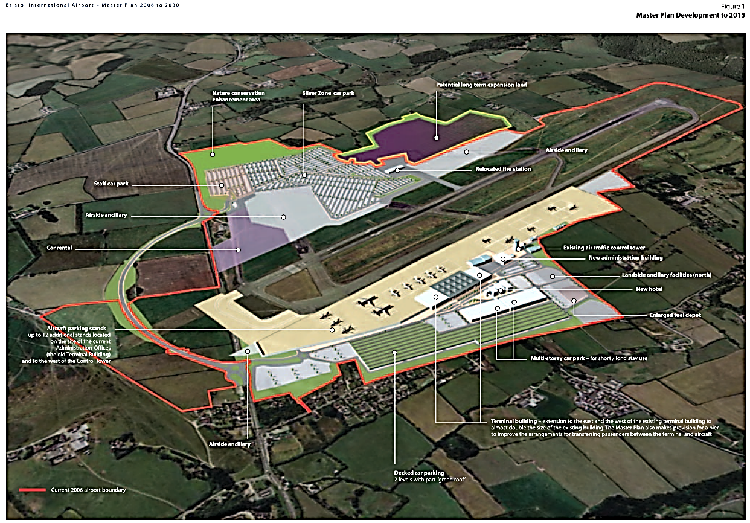
Figure 3 BIA Master Plan Development to 2015 (Bristol International Airport, 2006).

2.0 Impact Assessment and mitigation (EIA Entec and Master Plan Cross-analysis)

The environmental topics considered by the environmental appraisal of the Master Plan, are Air quality, Noise Impact, Transport, Biodiversity, Community, Cultural Heritage, Geology, Landscape and Visual Impact and land quality.
Table 1 (A) BIA Air Quality Analysis.
EIA Areas of Interest | Used Regulations (Applicable) | Impacts suggested by EIA (ENTEC 2005) | 2005 EIA Mitigation Suggestions (ENTEC 2005) | Master Plan: Proposed Mitigations  (BIA 2006) | Expert, Public Comments
A. Air Quality | Air Quality Regulations (AQS) (2000) derived from EPAQS, EU and WHO  Dispersion modelling and emission inventories (2005-2020) | 1. An assessment of the road traffic emissions (concerning NO2 and PM10) is required, alongside roadways, junctions, also deposition of airborne pollutants on designed sites (SSSI and SAC) should be predicted by modelling techniques. An increase in Nitrogen deposition may cause changes to vegetation composition but should not affect bats  2. EIA stated that air traffic emission will be increased and may need further investigation (NO2 and PM10) however they are already exceeding background threshold levels set by DEFRA no AQS authorities are not required to do further checks, also C02 was omitted due to being an international issue | 1. Locating junctions and intersections away from sensitive receptors  2.Traffic management schemes resulting in free-flowing traffic, including priority schemes, speed limits and road design, will minimise emissions (free flow conditions where vehicle speeds are 60-80 kph are optimum).  3.Using dense vegetation screens or barriers (there is some evidence that pollutant concentrations are slightly reduced in a small area to the lee side of a large screen or barrier).  4.Improvements to public transport connections and use, to reduce private vehicle use, and the configuration of roads and car parks to minimise congestion. | According to the BIA Master Plan air quality at BIA will continue to meet the standards laid down by Government in the National Air Quality Objectives.  Proposed mitigation was:  1. Designing traffic management schemes and improve infrastructure to achieve free flow traffic conditions  2. Achieving improvements to public transport connections and use, to reduce private car use.  3. Designing roads and car parks to minimise congestion  4. Reducing emissions from ground support equipment, including the use of alternative fuels and technology (the airport vehicle fleet has recently been converted to biodiesel) |  | 1. Air quality was raised as one of the main concerns by the public consultation within the (Bristol International Airport, 2006) no detail provided?  2. Archive materials(Stop Bristol Airport Expansion, 2006)  highlight issues of misguided expansion: ‘BIA try to compare local emissions with those that happen only during take-off and landing – and ignore the huge amount emitted during flight’  And accused of using outdated calculation figures for the South West region not including the passengers that live far away and travel long distances (their carbon footprint is increased by 51% increasing airport footprint by 27%).  3.According to the local community findings protesting against the BIA expansion (including Tom Leimdorfer-Green Party councillor and

 |  | according to Aviation White Paper  Studied pollutants:  - oxides of nitrogen  - carbon monoxide  - hydrocarbons  - sulphur dioxide  - particulate matter  3.Dust emissions during construction phase where also considered. Short duration of the dusty activities is not considered as health risk (maximum 250 m of the range for dust impact). | 5. To minimise emissions of CO and hydrocarbons from aircraft, the modifications to the airfield layout/scheduling/operating protocols should be designed and operated in such a way as to minimise idling and taxiing times. | Also, mission inventories for Bristol International Airport have been constructed for the years 2004 and 2020 and it was suggested that higher concentrations of pollutants are in expected locations and there are no expected exceedances for air quality standards within the local area at present and even for 2020 they are predicted to be well below the annual average standard outside the Airport perimeter. | Stopbia.com) the CO2 emissions emitted by the airport by 2015 ‘will emit six times more CO2 than all the cars in Bristol’ and the expansion proposal is not compatible with the Climate Change aims e.g. (Ambroziak, 2010).  4. Recent article in Greenwood, (2019, p:2) presented some comments regarding latest expansion proposal of the BIA to 12 million passengers annually by 2025 (an increase of 97.373 aircraft movements in a year and 9.500 extra vehicle movements): Aberdeen University studies have shown that increased air pollution leads to the stunting of babies’ growth during pregnancy. Also, a local pregnant woman said: ‘I don’t want a massive expansion at Bristol Airport that is going to impact on my child’s health. My brother hasn’t flown for the last seven years because he believes it is unsustainable’.

Strangely enough, EIA stated that data for CO and PM10 had not been collected near to the BIA. Therefore, the highly fragmented and outdated data form NETCEN (Appendix 1) will be used as the benchmark for any test (ENTEC).
According to the BIA Master Plant emission models have shown that BIA will continue to meet the standards for air quality laid down by Government in the National Air Quality Objectives which when confronted with the using of outdated calculation methods and neglecting the pollution produced up in the air (apart of landing and take-off) sounds vague and imprecise.
One of the major air pollutants associated with airport and aircraft operations is CO2 (carbon dioxide) which was not included in the list (both parties accordingly avoided presenting CO2 data) of tested air pollutants (Table 2). 1992 Rio Earth Summit has led to 166 countries signing the United Nations Framework Convention on Climate Change (UNFCCC) acknowledging a need of tackling a Climate Change issue and agreeing on a need of reducing greenhouse gas emission (GHG).
The Guardian informed that a flight analysis showed that ‘short-haul return flight from London to Edinburgh, contributing more CO2 than the mean annual emissions of a person in Uganda or Somalia’ (Komenda, 2019, p:1). The same with a carbon footprint that is produced not only by the extra passengers travelling to the Airport but the one embedded in the construction phase of the expansion, the manufacturing of the extra aircraft and extra crew that serves the flights? The EIA report also neglects those carbon emissions as the mitigation process seems to be only focusing on the local impacts (Bristol International Airport, 2006).
Additionally, water vapour is also emitted by aircraft at high altitude that is also contributing to the aircraft emission causing warming impact (the concentrated condensation clouds cause increased warming of the Earth’s surface Also ‘Aircrafts’ high-altitude emissions have a greater global warming impact than they would if the emissions were released at ground level’ (Katherine Hoff, 2000, p:1)
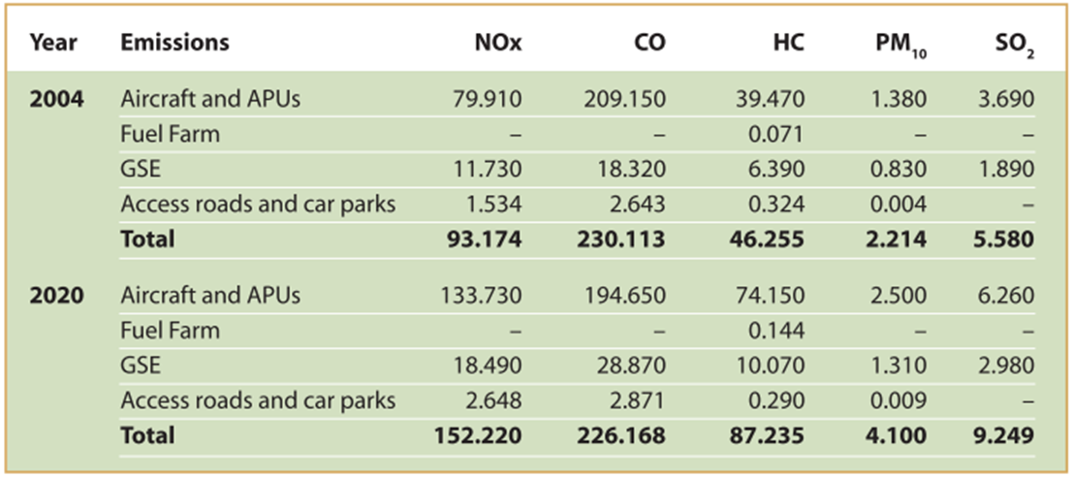
Table 2 Summary of Airport Emission Sources (tonnes per annum)
In terms of the toxic emission, there is nothing in EIA that would specify the human health concerns (although many researchers have confirmed the negative health impacts on children and humans’ brain (s. A.4.).
Traffic management schemes, e.g. ‘Designing roads and car parks to minimize congestion’ proposed in (s. A.1.) lacks essential details and is a very generic statement (not proper mitigation proposal).
One of the positive aspects of the mitigation process was that the airport vehicle fleet has recently been converted to biodiesel.

To combat air pollution, the Airport Carbon Accreditation programme, run by Airports Council International (ACI) was introduced. It is helping more than 200 airports to manage their emissions, with the ultimate goal of carbon neutrality.
Offsetting of the carbon emissions is another proposal: Zurich airport has reduced its emissions since 1991 by 30% (Airport Technology, 2018).

Table 3 (B) BIA Noise Impact Analysis.
EIA Areas of Interest | Used Regulations (Applicable) | Impacts suggested by EIA (ENTEC 2005) | 2005 EIA Mitigation Suggestions (ENTEC 2005) | Master Plan: Proposed Mitigations  (BIA 2006) | Expert, Public Comments, Opinions
B. Noise | Planning Policy Guidance Notes (PPG’s): PPG24: Planning and Noise, 2001.  Aerodromes (Noise Restrictions) (Rules and Procedures) Regulations 2003.  DEFRA (2002) regulations say that above the 57dB levels is set as ‘the onset of community annoyance’.  European Noise Directive (Directive  2002/49/EC of the European Parliament). | Four noise sources:  • construction noise: potentially affecting local school (Felton Primary) and surrounding residential properties  • airborne noise: noise model outputs used to measure sensitive areas suggest a potential increase due to the increase in day air traffic movement, also no nigh tine quotas will be retained to 2010 however tendency to increase morning flights form easyJet  • ground operations noise; increased aircraft stands, and relocation will increase aircraft taxiing noise close to the airport terminals, especially western end of the runway | 1.Future traffic data is not available at the time of EIA so Transport Assessment will be required in future (will be done by private company).  2. Modelling of the future noise levels will utilise US Federal Aviation Authority’s Integrated Noise Model (INM)  (summer weekly schedule).  2. No night-time additional mitigation required as the night-time is controlled by nigh-time quota up to 2010.  3.Construction noise will be minimised through construction traffic management strategy (BIA)- no significant mitigation required | 1. Detailed noise modelling was undertaken for airborne noise (typical 16-hour summer day). It was scheduled to represent 6 and 9 million passengers (annum increase) (in compliance with DEFRA Environmental Noise Directive) which showed only small increase (9million ppm) in ends of runway but decreased in north and south areas (‘no greater noise footprint compared with 2004 levels’).  2. The school fall outside of 63dB noise threshold (Suggested by White Paper mitigation benchmark measures) so no relocation funds are offered, however additional insulation | Complaints relating to noise originating from BIA or overflying aircraft have been received by North Somerset Council ('from time to time'), Bath and North East Somerset Council (eight complaints since 2001), and Bristol City Council, (7 complaints since 2001) (Johns and Pratt, 2005).  According to The Guardian article (Carvel, 2005, p:1)  the Queen Mary's School of Medicine (London) research discovered that  ‘children in schools under airport flightpaths have more difficulty learning to read and score less well in memory tests’  BIA neighbour residents have complained about the horrible noise not just coming from the aircrafts but also increased road traffic (the needed to install expensive silence

 |  | • road traffic noise: a proposal of an increased passenger  throughput will increase generation or the road traffic noise and around new parking areas (sensitive receptors like local properties could get affected) | 4. Cumulative noise levels including road  traffic, ground operations, airborne noise should also be calculated and estimated (LiMA models) including an assessment carried out the local school.  5. a Noise Insulation Grant Scheme that used since 1997 (noise insulation grants for properties experiencing noise levels above 82dB (A) are good.  6.ENTEC report suggests that newer and quieter aircraft will replace the noisier ones with time therefore the 82dB(A) zone will reduce with time (regardless the increasing aircraft air traffic). | was provided.  3. According to the European Directive Noise Directive (2002) noise maps will be prepared (for every 5 years) however, an intention here is to collect historical noise.  4. An introduction of a continuous decent approach to reduce engine noise will significantly minimise effects of aircraft noise (less engine power used). The aim is to achieve 95% of continuous decent approaches within 2 years.  5. Noise Insulation Grant is in operation, however only for properties regularly experiencing noise levels above 90 dBA.  6. The night noise quota system was | glass in bedrooms) and paid for it themselves as not being in the airport noise footpath allowing for grants (Ambroziak, 2010).  A research carried out near London Heathrow Airport has showed that  high levels of aircraft noise were associated with increased risks of  stroke, coronary heart  disease, and cardiovascular disease in communities leaving near the London’s airport (Anna et al., 2013).  A 15 years later, director of noise mapping company (an engineering expert) have largely criticised BIA by omitting the noise regulations (57dB) saying that he is regularly recording peaks over 75dB and

 |  |  |  | implemented at BIA (unused carried over to the next season).  7. Provision of acoustic barrier (northern edge of the apron), to the east of the Terminal Building was implemented in order to mitigate against the increased ground noise. | that most up-to-date WHO regs are set even less (below 40dB). WHO states that constant noise exposure (to above 40 dB) leads to adverse health effects (Melanie Greenwood, 2019).

Noise is one of the major issues reported by stakeholders. An analysis of the Noise issue regarding the BIA expansion (Johns and Pratt, 2005, p:79) begins with the sentence: ‘in some cases, even without such quantified information, it is reasonable to assume that the changes will not result in a significant effect’ which shows the ENTEC’s (which is a private company employed to do EIA for BIA) approach and may suggest bias.

Implementation of continuous decent approach while reducing the overall noise coming from aircraft engines, in fact, was a part of the process aiming to expand airports-controlled airspace (it was actually stated in the report’s noise mitigations section ) (Bristol International Airport, 2006).

Also using of Noise Insulation Grants is an excellent approach; however, the noise qualification zones introduced by the BIA (90 dB) against the recommended 82dB (Johns and Pratt, 2005) looking unfair. Also, the 57dB (the onset of community annoyance’) recommend by DEFRA is 33dB lower than BIA grant qualification limit.

Regarding the acoustic barriers provided on the north edge of the apron, some modelling was implemented, which is widely used as a recommended solution. However, according to Master Plan 2006, the chosen mitigation measures ‘the resultant noise (to the north of the airport) is predicted to decrease slightly’ (Bristol International Airport, 2006, p:97). No data nor approximate numbers were provided, which makes the use of the word ‘slightly’ very ambiguous.

Noise is a difficult factor to have full control off as aircraft and cars combustion engines are noisy by their nature. However, it is possible to set stricter noise regulations that can force aircraft carrier companies to invest in most-modern technology. An attractive solution was implemented in London’s City Airport, where the noisiest airlines -breaking that employ obsolete and noisy aircraft will be fined 600£ per each rule=flight. Tessa Simpson (City Airport environmental manager) said that the money collected through the scheme would be put back into a community fund helping people to protect their houses from the excessive noise (Sleigh, 2018).

Table 4 (C) BIA Transport Impact Analysis.
EIA Areas of Interest | Used Regulations (Applicable) | Impacts suggested by EIA ENTEC 2005 (Johns and Pratt, 2005) | 2005 EIA Mitigation Suggestions (ENTEC 2005) | Master Plan: Proposed Mitigations  (BIA 2006) | Expert, Public Comments, Opinions
C. Transport | Local Transport Plans 2002  Greater Bristol Joint Local Transport Plan (GBJLTP),  Greater Bristol Strategic Transport Study (GBSTS). | 1. Background traffic flows are predicted to increase (A38) even if the export expansion does not go ahead according to ENTEC (although ‘no current traffic flow data available’) ((Johns and Pratt, 2005, p:92).  2. No evaluation of potential environmental impact due to increased traffic was possible (lack of traffic flow data), however some increase is expected.  3. Increased road activity will have consequences on road safety (risk of accidents) especially in the rural areas (e.g. country-side roads are used due to the poor access and rural location of the BIA).  4. Capacity of highways links and junctions will be affected (traffic speed slowed) by increased passengers’ numbers and staff associated car journeys. | 1. Promotion of public transport use to reduce private car use (mitigation of road congestion) however no reliable, fast rail direct links is connected with the airport (nearest one is 4 miles away in Nailsea& Backwell) so reliance on pore bus and coach services is the only alternative.  2. Routing Strategy assessment (prepared by Ove Arup) to assess sensitive receptors of HGV’s operations  3. Analysis of Personal Injury Accident Data Records for highway links to assess road safety during the construction process.  4. Assessment of the local amenity status to identify key affected stakeholders: businesses, schools, and local residents. | 1. RASCO study suggested a heavy rail as the only way for expanding airports to handle increased passenger numbers (15ppa) which is a possible future project (although very expensive due to the nature of Bristol terrain).  2.A bus-based public transport was recommended for the BIA. Therefore, seamless interchanges between coaches and reginal rail links are priority.  3. Improvement of wider public transport system (to allow for integration and interchanges between wider public transport system).  4. A13% target of passengers using public transport at 9 million ppa is set in BIA transport strategy (Master Plan 2006). | 1. The Master Plan itself seems to be recognising the issues of the traffic increase caused by the airport expansion, however it blames the Bristol City region as being one of the highest private car users in the UK.  2. In Whitelegg (2005) economic report RASCO study showed that airport traffic would account for 30% of total traffic on the A38 by 2015 and congestion levels to increase 40% by the year 2030.  3. Residents of BIA area complain about the lack of pavements, street lighting and roads being very dangerous to local users. They also talk  about not being able  to even join the traffic

 |  | 5.Construction activity associated with traffic baseline changes (HGV’s). | 5. No Environmental enhancement measures (due to the increased traffic) have been proposed by ENTEC 2005 EIA report. | 5. A formal Staff Travel Plan is being implemented to promote and encourage alternative means of travel to and from the Airport and reduce single occupancy car journeys by staff.  6. Calming of the traffic issues on the B3130 village road is to be solved by BIA (a suitable scheme is to be delivered through collaboration with Parish Council). | during the pick hours due to over-congested roads and asking for the infrastructure development prior to being delivered first prior to the BIA expansion (Ambroziak, 2010).  4. Somerset Live (online local news) have interviewed BIA neighbouring villagers and was told that cars trying to get to the Airport are an even bigger issue that plains are coming in over their heads (Tristan Cork, 2019).  5. In 2020 politicians are still debating about another airport expansion (up to 12milion ppa) and Cabinet Member for the Climate Emergency has stated that ‘. Bristol is the largest UK airport without rail or light rail. Its mode share of public transport is a measly 13% and falling, the lowest of all UK airports of similar or larger size. Most employees travel by car, as there are few towns nearby. Most passengers travel by car or taxi (Cllr Sarah Warren, 2020).

The information concerning the traffic issues around BIA (Table) highlights the fact that since the BIA ENTEC EIA in 2005 the traffic issue has only increased and EIA’s implemented along the BIA expansion form 6 to targeted 12 million ppa has not influenced much on the decision making process. Bristol airport is the largest Airport in the UK without the light/heavy direct rail link, and road congestion has not been resolved either. The promises made by the Master Plans mitigation projects make promises that EIA is not responsible for the monitoring of the delivery progression. The main concern of the ENTEC in their EIA (2005) is the construction phase (avoiding of accidents caused by the heavy machinery) while the Master Plan (2006) is only able to make empty promises while the main concern is the continuous BIA throughput expansion.

A proposed solution for the Bristol Airport road congestion especially in peak times (including kerbside traffic congestion) could be an innovative solution implemented in Tampa International Airport (USA) Master Plan in 2018 when the airport capacity has reached record-breaking 21 million ppa causing huge vehicle traffic issues. To solve the issue, passengers who travel without checking their bags can by-pass the baggage claim procedures and queuing up in the lobby and go directly into security screening and departure gate (or to receive expedited pick-up). It has alleviated much of the congestion within the airport facility and adjacent road network. Advanced computer modelling systems were also utilized in the process (International Airport Review, 2020).

Table 5 (D) BIA Community Impacts Analysis.
EIA Areas of Interest | 1.Used Regulations (Applicable) | 2.Impacts suggested by EIA ENTEC 2005 (Johns and Pratt, 2005) | 3.2005 EIA Mitigation Suggestions (ENTEC 2005) | 4.Master Plan: Proposed Mitigations  (BIA 2006) | 5.Expert and Public Comments, Opinions
D. Community Impacts | Government White Paper required a full public consultation  The Town and Country Planning Act (1990) | 1. In this section EIA focus are potential impacts on employment, tourism, and investment and trade (air, noise and traffic causing potential health issues were investigated earlier). A separate assessment was undertaken.  2. Direct/Indirect and induced employment from construction activity.  3. Direct/Indirect and induced employment from increased airport activity.  4. Changes in provision of open land could affect the availability of areas for informal recreation.  5. Effects from increased tourism and inward investment or trade. | 1. In line with the Government’s expectation for public participation in the planning process EIA has suggested undertaking a full public consultation during preparing the Master Plan.  2. According to EIA no Public Rights of Way (PRoW) occur within or immediately adjacent to the airport boundary so no mitigation required here.  3. Also EIA has suggested that: ‘BIA contributes to the regional economy through attracting inward investment, supporting productivity and growth of indigenous industries’ (Johns and Pratt, 2005, p:55).  4. No additional mitigation has been confirmed to be necessary at the time of writing EIA report. | 1. A Statement of Community Involvement (SCI) informing about involvement of the community and stakeholders was prepared in 2004 and circulated to 58 consultees (published in 2005).  2. Also public consultation carried out in two phases: fist phase (March-May 2005 which generated comments regarding the issues and concerns about the BIA expansion used to inform preparation of Master Plan).  Second phase was a consultation of the draft detailed Master Plan inviting comment on the development options which was available online, in the local library and distributed door-to-door. | 1. Key issues from the public consultation:  - Public transport and surface access- the most significant issues arising in the consultation process.  - Landscape and visual impacts, loss of Green Belt (due to carpark expansion)  - Noise and night flights issues (but no changes to Night flight quota is planned).  - Air pollution (airport responded: ‘air pollution concentrations in residential areas around the airport are predicted to remain within national and EU air quality limits’ (Bristol International Airport, 2006, p:8)  - Economy issues: concerns over

 |  |  |  | 3. The Bristol International Airport Consultative Committee forum was established to allow for consultation with the local authority and interest groups.  4. Additionally, a two-day exhibition in Bristol city centre, Chew Magna, Cleeve, Winford and Wrington were run including a key stakeholder workshop. | the security of future demand for air travel, expenditure by tourists being exported and the quality of employment created.  2. Whitelegg (2005, p:5) suggested that although BIA promises the economic boost and bringing jobs for the local community he added: ‘creating significant levels of traffic congestion through an expansion of BIA will inevitably damage the regional and sub-regional economy as car drivers gaining access to the airport for cheap holidays abroad delay time sensitive business trips and logistic services’  3. Stop Bristol Airport Expansion (2006) faults the EIA and local authorities for lack of in depth independent analysis of the economic benefits to the region of expanding the airport that would adding that their own analysis performed by Ecologica has indicated many areas being affected by the expansion

The overall impression is that the community impacts regarding the more economical side of the BIA expansion were carried out very extensively and sufficiently. The BIA Master Plan has promised a significant economic boost to the North Somerset region (I line with the Entec’s EIA statement (D.3.3) However when taking into consideration the full spectrum of impacts together (e.g. increased road traffic) (D.5.1, 2) and a lack of in-depth professional economic Analysis carried out by the authorities, the very positive vision proposed by the EIA and BIA authorities does not look so promising any more.

The independent, professional, economic Analysis ((e.g. Whitelegg (2005)‘Economic Impact of Bristol International Airport’) is proposed to be included in the EIA investigation process as a compulsory phase that is fully transparent and available for public scrutiny. Such an analysis should consider all the areas being affected, including air pollution, traffic, noise and loss of Green Belt, which is valuable to the North Somerset tourism sector.
Table 6 (E) BIA Biodiversity Impact Analysis.
EIA Areas of Interest | 1.Used Regulations (Applicable) | 2.Impacts suggested by EIA ENTEC 2005 (Johns and Pratt, 2005) | 3.2005 EIA Mitigation Suggestions (ENTEC 2005) | 4.Master Plan: Proposed Mitigations  (BIA 2006) | 5.Expert and Public Comments, Opinions
E. Biodiversity | Institute of Ecology and Environmental Management (guidelines and assistance for Ecological Impact assessment)  English Nature and protected species (Department DEFRA)  Baseline data source: BIA Nature Conservation Management Plan (Cresswell Associates 1999) | 1. Five SSSI located near airport – disturbance through noise and dust.  2. Two SAC’s: North Somerset and Mendip Bats Area of Conservation (G. and Lesser Horseshoe).  3. Nineteen non statutory sites (Wildlife Sites) lie within 2 kilometres- Newt, Slow worm, Dormouse.  4. Two badger sets (Meles meles) sets on S airport boundary – increased mortality with traffic. | 1. Work affecting nesting birds will be carried out outside of the breeding season (mid-February to mid-August (No  significant effects are likely).  2. Roosting Bats habitats will be surveyed English Nature (200430). The information will used as the design evolves and will be used as the basis of appropriate mitigation.  3. Survey to confirm the presence of badger sets: | 1. Master Plan 2006 acknowledges the loss of some Green Belt land to be an issue, however it justified by the boosting of the regional economy.  2. Further wildlife surveys are recommended by BIA Nature Conservation Plan  3. The Silver Zone Car Park will have number of nature conservation initiatives to enhance the biodiversity of the airport estate. | 1. Surprisingly, no biodiversity loss was picked up by the second phase public consultation carried out by BIA (October-December 2005).  2. An article in The Guardian (2010) has informed that BIA expansion to 10 million ppa and carpark extension to the south a 12.3 hectares of Green Belt land will be affected and will cause a habitat loss for badgers, bats, dormice and many bird species.

 | Regional Spatial strategy for South-West 2004 (The South West Regional Assembly). | Damage or disturbance to nesting birds, nests, or their young by construction activities.  Loss of areas of the grassland through construction activities and pollution transmitted through polluted groundwater.  Also, the EIA points toward the south of the airport suspecting the gradual habitat deterioration due to the lack of conservation interest (due to the agricultural practices) | ‘This information will be used as the design evolves as the basis of appropriate mitigation’ (Johns and Pratt, 2005, p:51).  4. Creation of new and enhancement of old/existing habitats (parts of Cornerpool Farm, and/or other discrete parcels of land to the east of the A38).  5.Provision of additional opportunities for known local ecological resources (e.g. bats, badgers, and reptiles), and where possible, seek to contribute to LBAP targets.  6. Mature trees and hedgerows will be retained (when possible). All new planting will use native species of a local provenance where appropriate, particularly where this planting is in proximity to natural stands of vegetation or existing hedgerows/trees/scrub. | (e.g. bats foraging to the south to be improved).  4. introduction of Green Roofs is mentioned to the north of the airport to provide biodiversity benefits (not clear when and where exactly).  5. Badger proof fencing and underpasses will be installed along the new road development if necessary.  6. Decker carpark (South of the airport) will provide a green roof that will ensure minimum disturbance to the local residents.  7. Use of lighting designed to minimise spillage of light off-site. | Also, SSSI woodland (close to Felton Common is going to be affected.  3. A ten years later an article in North Somerset Times that further expansion (from 10 to 12 million ppa capacity) of BIA was recommended for approval. Tarisha Finnegan-Clarke (BAAN) has said that loss of greenbelt habitats, increased traffic and air pollution including traffic congestion are detrimental to the local communities and’ outweigh the benefits put forward by the airport’ (Gareth Newnham, 2020, p:2).

It must be stated that a very detailed local biodiversity survey was carried out. However, hen reading the EIA proposed mitigation in regard to the biodiversity loss (e.g. increased mortality due to the loss of habitat, noise and pollution) the favourite suggested action to be implemented by BIA is as follows: ‘This information will be used as the design evolves as the basis of appropriate mitigation’ (Johns and Pratt, 2005, p:51) (E.3.2, 3). It is not clear how the EIA is going to be involved throughout the construction phase and monitoring of the habitat conservation after the construction phase is finished.
Also, BIA Master Plan (2006) reminds in his Regional Planning Guidance review that: ‘Policy SS4 deals with Green Belt and the need to critically review Green Belt boundaries and remove land from the Green Belt if it represents the most sustainable option for accommodating development’ (Bristol International Airport, 2006), p:22. The proposing ‘appropriate mitigation’ by Entec’s EIA (2005) does not sound very convincing. BIA economics is the clear favourite here.
When discussing ‘Carpark Issues’ (Bristol International Airport, 2006) the expansion of the car parking was recognized as not just affecting the visual and landscape aesthetics but also increasing its footprint within a Green Belt land.

The proposed BIA Master Plan (2006) proposed the installation of a green roof for the decked car park (south area) only mentioned the visual aspects of the development to be the primary concern of the BIA constructors. An author’s recommendation is to extend the green roof onto the proposed adjacent multi-storey car park facility and design the roof to add to the local Biodiversity and to mitigate the loss of Green Belt habitat in this section. An interesting survey on functionality of commercial green roofs discovered that adverse weather, continuous exposure to UV and irregular water availability cause lack of nutrients and create monocultures (limiting most plants growth) which can significantly affect the environmental benefits of green roofs. However according to the researcher’s addition of specific living soil organisms (fungi Trichoderma, mycorrhizal fungi and soil bacteria) can form a base-food chain and make a more resistant and biodiverse green-roof solution (University of Portsmouth, 2017). Using of such techniques could help to achieve the maintenance-free green roof, cost-effective solutions to biodiversity loss mitigation.

Due to the time and word count constrains the remaining EIA areas of potential impact will be presented together in one table.

Table 7 (F) BIA Geology and Land Quality Impact Analysis.
EIA Areas of Interest | 1.Used Regulations (Applicable) | 2.Impacts suggested by EIA ENTEC 2005 (Johns and Pratt, 2005) | 3.2005 EIA Mitigation Suggestions (ENTEC 2005) | 4.Master Plan: Proposed Mitigations  (BIA 2006) | 5.Expert and Public Comments, Opinions
F. Geology and Land Quality | Soil survey by Findlay et al (1984)  Waterman Environmental (2003)  Terradat (1998) and AEA Technology (2000) hydro-geological survey | - Fuel tanks  - Airport Operations  - Car parking and Roadways  - historical mining and quarrying (subsidence, metals)  - potential contamination associated with former WWII RAF operations at the site – metals, inorganic contaminants, polycyclic aromatic hydrocarbons; | 1. Suitable personal protective equipment and working practices employed during development works within these areas would minimise potential risks to construction workers. The hardstanding associated with the proposed car parking would act to remove the main pathway  2. Further work might be required in regard to the potential land contamination.  3.Improvments of drainage to reduce potential contaminants impacting land quality | 1. A qualitative assessment was carried out regarding potential human health and environmental risk which concluded no significant environmental changes and risks is expected in result of the BIA expansion. | No comments found.

Table 8 (G, H) BIA Cultural Heritage and Landscape Visual Impacts Analysis.
G. Cultural Heritage Impact | The Ancient Monuments and Archaeological Areas Act 1979  Planning (Listed Buildings and Conservation Areas) Act 1990  World Heritage Sites | - ENTEC archaeologists visited site in January 2005 to investigate the 600 records (some relating to WWII) received from SMR research. However, ‘recorded points of interest have not been accurately plotted (as no grid references have been received at this time) and therefore effective interpretation of these data has not been possible’ (Johns and Pratt, 2005, p:33). | 1.‘No measures have been identified at this stage’ (Johns and Pratt, 2005, p:38). | 1.‘The development is unlikely to pose any threat to features identified within the airport’ (Bristol International Airport, 2006, p:85)  2. Further desk-based work is proposed in regard to the WWII possible remains (to be agreed with North Somerset Council). | No additional comments.
H. Landscape and Visual Impact | Guidelines for Landscape and Visual Impact Assessment produced by the Landscape Institute and Institute of Environmental Management and Assessment (2002)  The North Somerset Landscape Character Assessment (October 2004) | - Views of the Cornerpool Farm to the south will be slightly affected by the southern carpark.  ‘No field studies have been undertaken at night nor have potential views from the Mendip Hills been investigated’ (Johns and Pratt, 2005)  - North Somerset Council Suggest declining landscape condition attributed not only to | 1. Effective landscaping that is respecting mature vegetation is recommended.  2. Careful consideration will be given to building design, choice of materials and lighting.  3.Proposed multi-storey carpark to be green-roofed. | 1. The north side of the airport to be enhanced with planting.  2. Green roofs installed on the proposed multi-storey carpark.  3. North side acoustic barrier to be covered with planting.  4. A planting scheme | 1. A comment received  During the public consultation (Master Plan 2018) said that BIA is opposing construction of a multi-storey carpark that would take so much more space and protected further landscape and Grin Belt destruction however: ‘Bristol Airport want the  (Bristol International Airport, 2018, p:3)

 |  | The airport development but is also blaming the management of field boundaries. |  | to create a new southern boundary to the airport.  5. Replacement of existing lights with dark skies compliant lighting where possible.  4 Opportunities for the environmental enhancement should be constantly reviewed. | cheap option of low-cost car parking and they adjust the argument to their own benefit regardless of further detrimental impacts to the environment’ (Bristol International Airport, 2018, p: 3)

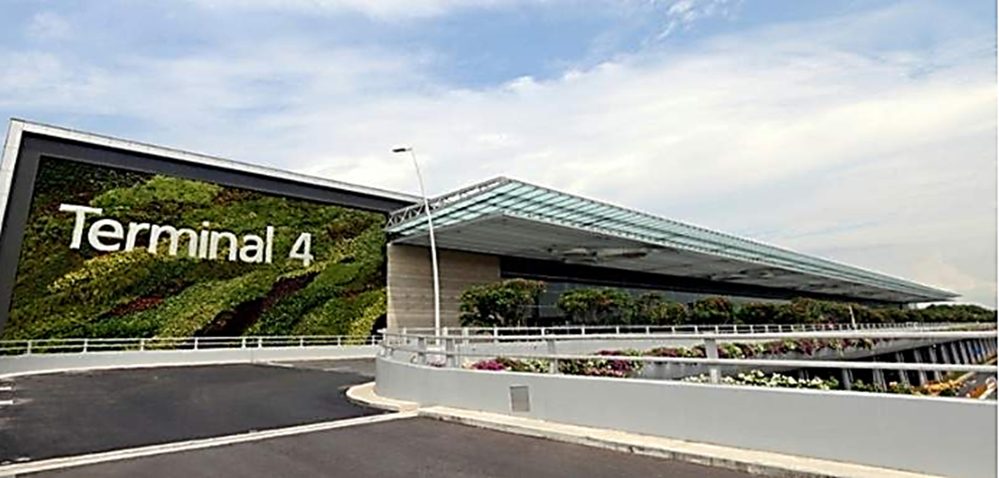
Table 9 Singapore Changi Airport (Terminal 4) (Airport Technology, 2018).

There are many landscapes and visual propositions included in the BIA EIA (2005) and Master Plan (2006) mitigation projects; however, none of the proposed greenings involves the main passenger terminals. It is proposed to introduce a greening of the entire front wall, like Singapore Changi Airport (Terminal 4) (Fig. 7) which could potentially help to blend in of the BIA gigantic terminal structure with the surrounding green/rural landscape. The Singapore airport front wall has been planted with 20.000 plant species and was found to reduce the temperature of the whole structure in summer (Airport Technology, 2018).

Overall, Entec’s EIA states that regarding Geology and Land Quality, the very little ground investigation has been undertaken at the site, and only qualitative data were used for assessment of the potential effects. BIA does not rule out potential issues that may arise in the future.
The nature of the airport buildings/structure is complicated to be mitigated against affecting the visual aspect (especially when surrounded by beautiful green rural surroundings, however, the proposed EIA (2005) visual mitigations seems to be rather cosmetic, and the green-roofing of the proposed multi-storey car park are very good. However, BIA is not looking to be building one in the near future (expansion into green fields is unfortunately much cheaper).

3.0 Conclusion

The EIA areas of potential impact are investigated individually, where, in fact, they all are strongly interlinked, and it is challenging to introduce the appropriate mitigating measures for this scale structures when trying to isolate the problematic areas. The EIA report should perhaps try tackling all the issues in a more holistic way running cross-correlating, multivariate models of Analysis and be able to predict more accurately by seeing the full picture and having more chances to find room for the improvements.
Using of private companies for airports EIA’s as well as White Paper (Department of Transport) setting benchmark regulations and even suggesting mitigation approach (when in fact it is a governing body that has a mission to grow UK’s airport economy) can lead to bias and ambiguity. Often, EIA results suggest inadequate (soft) measures, especially when dealing with projects of the Bristol Airport size.
Human health (especially long term effects) were not much considered by the EIA 92005). Similarly with the Climate Change, transboundary pollution and impact (due to being an international issue it is left in governments competence which makes the subject a matter of national and international efforts) (EIA seams to be excluding airports from the global responsibility).
The EIA monitoring after development construction was finished should be defined more precisely (regular updates are necessary to be able to monitor the progression of the implemented mitigations).
Lastly, the recent Corona Virus events should make EIA and Aviation industry (in the UK and globally) to rethink the expansion drive and perhaps incorporate such anomalies into their project expansion models.

4.0 REFERENCES

Airport Technology (2018) The world’s most environmentally friendly airports, Verdict Technica Limited. Available at: https://www.airport-technology.com/features/worlds-environmentally-friendly-airports/ (Accessed: 7 May 2020).
Ambroziak, Z. (2010) ‘Plane Crazy’. YouTube. Available at: https://www.youtube.com/watch?v=uH9ZR70LCH8.
Anna, L. et al. (2013) ‘Aircraft noise and cardiovascular disease near Heathrow airport in London: Small area study’, BMJ (Online), 347(7928). doi: 10.1136/bmj.f5432.
Bristol Airport (2020) Bristol Airport Ownership. Available at: https://www.bristolairport.co.uk/about-us/who-we-are/bristol-airport-ownership (Accessed: 8 May 2020).
Bristol International Airport (2006) Bristol International Airport Master Plan 2006-2030. Bristol.
Bristol International Airport (2018) Draft PCAA response to Master Plan Consultation – Stage II Development Proposals and Options May 2018. Bristol. Available at: https://www.theccc.org.uk/publication/ccc-writes- (Accessed: 8 May 2020).
Carvel, J. (2005) Aircraft noise may impair learning, The Guardian. Available at: https://www.theguardian.com/uk/2005/jun/03/health.schools (Accessed: 7 May 2020).
Cllr Sarah Warren (2020) B&NES Cabinet Member Speaks Out Against Bristol Airport Expansion, BathNES Lib Dems. Available at: https://www.bathneslibdems.org.uk/bristol_airport_north_somerset (Accessed: 7 May 2020).
Greenwood, Melaine (2019) ‘Dangerous pollution’ at Bristol Airport, Ecologist The Journal for the Post-Industrial Age. Available at: https://theecologist.org/2019/may/28/dangerous-pollution-bristol-airport (Accessed: 7 May 2020).
Greenwood, Melanie (2019) Noise pollution from Bristol airport, Ecologist. Available at: https://theecologist.org/2019/oct/23/noise-pollution-bristol-airport (Accessed: 7 May 2020).
International Airport Review (2020) Solving kerbside traffic congestion to increase passenger experience, Rusell Publishing Limited. Available at: https://www.internationalairportreview.com/article/94337/kerbside-management-passenger/ (Accessed: 8 May 2020).
Johns, M. and Pratt, M. (2005) Environmental Impact Assessment of the Expansion of Bristol International Airport. Bristol.
Katherine Hoff (2000) Airplane Emissions, Center for Biological Diversity. Available at: https://www.biologicaldiversity.org/programs/climate_law_institute/transportation_and_global_warming/airplane_emissions/ (Accessed: 8 May 2020).
Komenda, N. (2019) How your flight emits as much CO2 as many people do in a year, The Guardian. Available at: https://www.theguardian.com/environment/ng-interactive/2019/jul/19/carbon-calculator-how-taking-one-flight-emits-as-much-as-many-people-do-in-a-year (Accessed: 7 May 2020).
Secretary of State for Transport (2003) The Future of Air Transport. London.
Sleigh, S. (2018) Tough new noise fines to hit flights at City Airport after surge in resident complaints, London Evening Standard. Available at: https://www.standard.co.uk/news/london/tough-new-noise-fines-to-hit-flights-at-city-airport-after-surge-in-resident-complaints-a3985591.html (Accessed: 7 May 2020).
Stop Bristol Airport Expansion (2006) stop bristol airport expansion, SBEA Alliance. Available at: http://sbae.bristolfoe.org.uk/questions.php (Accessed: 7 May 2020).
The Guardian (2010) Bristol Airport expansion: green belt and SSSI under threat, Environment. Available at: https://www.theguardian.com/environment/2010/aug/09/3 (Accessed: 8 May 2020).
Tristan Cork (2019) Bristol Airport: Residents reveal what it’s really like living beneath flight path and in neighbouring villages - , Somerset Live. Available at: https://www.somersetlive.co.uk/news/living-near-airport-residents-opinions-3549850 (Accessed: 7 May 2020).
University of Portsmouth (2017) Improving the biodiversity of green roofs , ScienceDaily. Available at: https://www.sciencedaily.com/releases/2017/03/170301085255.htm (Accessed: 8 May 2020).
Whitelegg, J. (2005) The Economic Impact of Bristol International Airport. Lancaster.

