The development of my voice type over a period of 100 years
The types of roles women sang, in category were “soprano, mezzo-soprano, and contralto” [André, N. A. (2006).]. Also, the gender of the roles were picked out by the “primo otto cento tradition” [André, N. A. (2006).], The “primo otto cento tradition” is the definition of “masculine and feminine sounds” [Johnson, V., Fulcher, J. F., & Ertman, T. (Eds.). (2007). However, my assessment will however outline the development of the soprano voice type over a period of a 100 years, of the ‘Classical Era’ from (1750-1820).]I will also be looking closely into the opera buffa genre, to talk about the progression and the key operas that portray their soprano roles, and the technicality needed to perfect the role, for the soprano voice type.
The Classical Era took over mid 1700’s (1750-1820) and the Baroque Era was coming to an end. The name Classical is applied to the period because of its art and literature. There was a sense of admiration of the classical artistic of literary heritage of Greece and Rome. In Comparison to the Baroque Era the Classical Era used simplicity in their music but enlightened them. The “Enlightenment” period dominated the 18th centry which was also named as “The Age of Reason” [ Roberson, Rusty 2016, p 246-274].
In the classical Era there was “Opera Buffa” also known as, “Comic Opera” and “Opera seria” meaning “serious opera”. The rise of Opera Buffa arose reactions in some Opera Seria composers such as Zeno and Metastasio [Smith, 1970, p.103]. The comical genre of opera was made to relate to common people compared to the serious opera, which was acquainted to the more, higher class, and noble royalists. Opera Buffa was a 1720’s new style of opera that first developed in Naples in the first part of the 18th century, which was and still till this day an important aspect of the 18thcentury. When it became popular in Rome and Northern Italy, it was characterized by everyday settings and librettos about everyday characters (not heroes, rulers, or Gods) in a contemporary setting, which varied from having two acts. However, in Opera Seria, they used mythical settings and used high voices both (sopranos and Castrati) from principle characters often even used for monarchs. Unlike Opera Buffa, it contained three to four acts and used inspiration from ancient history or mythology [(spring, 2006) Ellen T. Harris.]. for example, a comical opera (The Barber of Seville), based on two acts which was written by Gioacchino Rossini, and the libretto by Cesare Sterbini. Although the opera was based on a French comedy written by Pierre Beaumarchais, Le Barbier de Séville 1775, Rossini’s opera was fist performed under the name of ‘o sia L'inutile precauzione’ at the Teatro Argentina, Rome February 20,1816 [Rossini, 2018, Alma Books]. In act 1 of this opera the character “Rosina” opens with ‘Una voce poco fa’ a ‘Cavatina’ which derives from the Italian word ‘cavata’ meaning an ‘extraction’ resulting in short song or aria. Many of which require good Technique due to the lyrical long phrases for example in this aria during the requires the singer more use of breath and stretching the vowels especially on the double dotted note on the ‘una’ and double dotted on the ‘poco’.

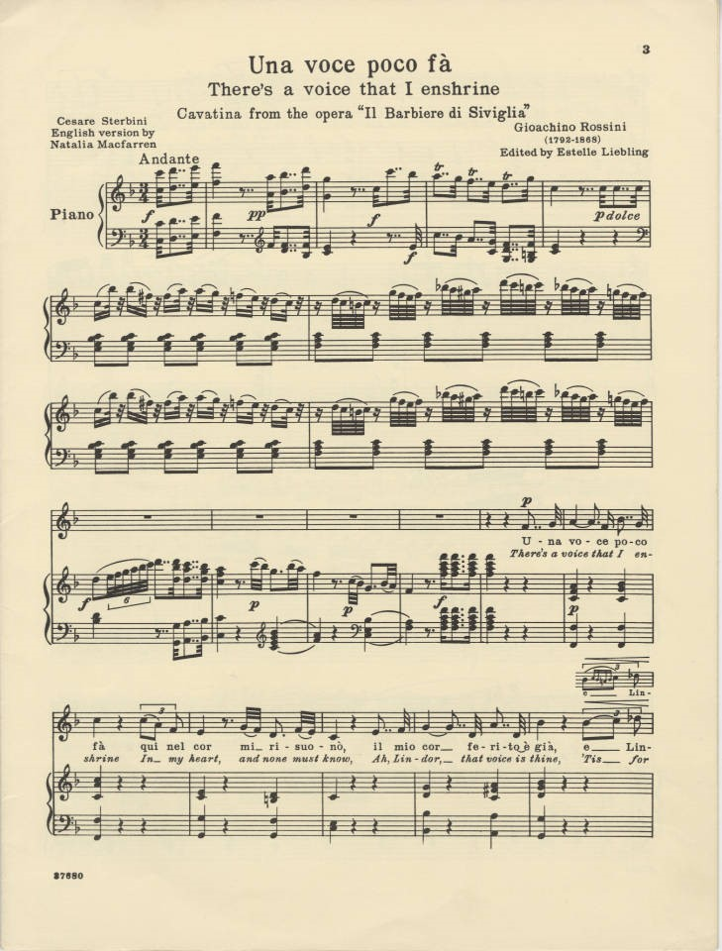

Further on, the key is to keep the continuous sound of the vowel coming up to the short notes, for most singers and evidently in this aria, the precise breath control needed, foreshadows the technique that is used by the singer. Moreover, most ‘cavatinas’ are followed by a ‘cabelleta’, which involves a fast-paced section and pushes the singer's technical skills. [Burton, 2006, p.15]. Here in the fast-paced section of the aria is where the soprano/Coloratura can to display their technicality, especially with the

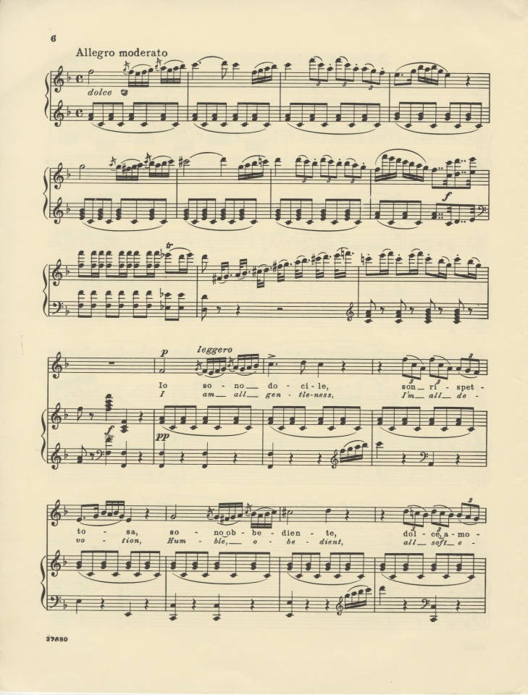

Although the character “Rosina” was originally implied for mezzo-sopranos originally written in the key E major, however, it was transposed up a semitone up into F Major for sopranos and especially for coloratura soprano’s which enabled many sopranos of the specific ability to excel in their opera careers. For example, ‘Roberta Peters’ who was an American coloratura soprano played the role of Rosina, who beautifully sings the famous ‘Una voce poco fa’ aria displays such colour and depth to the aria whilst exhibiting her top range and coloratura coal capabilities.
Also, the composer Wolfgang Amadeus Mozart, who composed the comical four act opera “The Marriage of Figaro" in 1786, with the Italian libretto ‘Lorenzo De Ponte’ which premiered in Vienna may,1786. Was also a libretto based on Pierre Beaumarchais La folle journée, ou le Mariage de Figaro, first performed in 1786 [Thomas, 2006]. The “Marriage of Figaro’ continues the plot of The Barber of Seville, several years later and there is also a transition in the way Mozart writes in comparison to Rossini. For example, for the soprano voice, in this opera has the choice of five roles, (Susanna, countess, Marcelina, Barbarina), in this opera however the main characters are Susanna and the countess. One of the arias sung by Susanna “Deh Vieni non tar dar” contains a recitative and an aria. For a soprano this is perfect to display control and convey emotion. The aria is based on Susanna trying to lure in the count and seduce him. Tricking him so she and the countess can catch him out on his adultery acts. The vocal control to keep the legato is crucial. For example, in the recitative

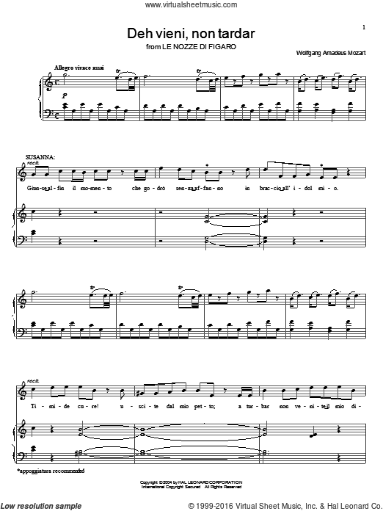

It is important to convey the prerogative of the situation and characters motive, and to tell the story of what is to come, since a recit is normally written in “blank verse” and usually has a lot of text involved, advancing the plot [Wright, 2013]. It could be differentiated from the aria, due to its spoken like tone. Although, the soprano would have to have engaged support especially for some of the lower notes such as “dol” on a G and “mio” on an E. In comparison to Rossini’s “The barber of Seville” the recit differs from the cavatina in ‘una foce poco fa’. The cavatina allows the soprano to show the quality in speed and control of the high notes, and in the recit of ‘deh veini non tar dar’ this allows the sopranos voice to be free from any added orchestral accompaniment although it takes a while to learn, due to the minimal use of accompanist due to the more “leisurely pace” [Wright, 2013].
Next in ‘deh vieni non tar dar’ is the aria. The aria also meaning in Italian “song or ayre” tends to be more “passionate and more “tuneful” [Wright, 2013]

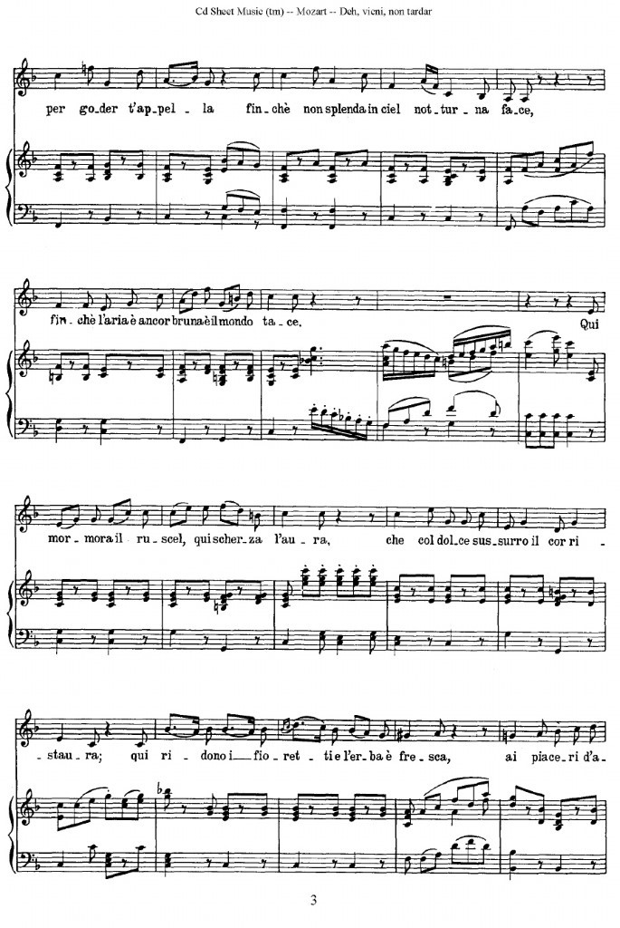

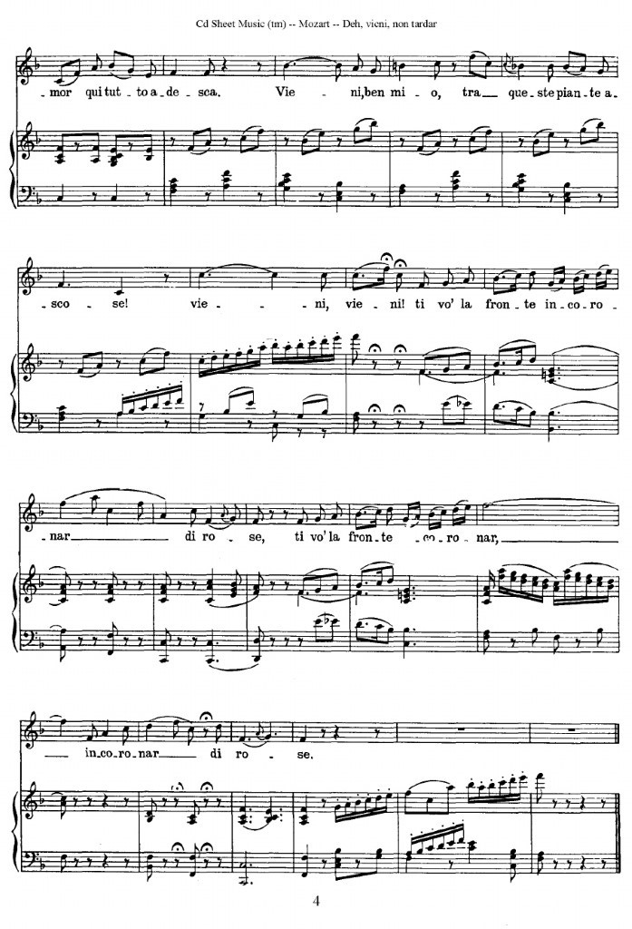

The tempo changes from common time in the recit to 6/8 in the aria, and indeed there is much needed use of legato and stretching of the vowels. In this song, the soprano especially needs to be seductive and sweet. The idea that Susanna is perpetrating as the countess, to seduce the count, although she is really thinking about Figaro, whom he doesn’t know this which causes envy and jealousy on his part. Typically, the soprano used for Susanna would be a lyric soprano, the lyric soprano range is usually from B below middle C to two octaves higher to top C6 and usually an “ideal feminine” type of voice [Richard,2000]. Also, another name used for the role of Susanna would be “soubrette” which refers to the most common type of “comedic” and “charming” young woman, depicting them as flirtatious or “frivolous” [Richard,2000]. Most commonly with a “soubrette soprano” are essential to have “youthful” qualities and a wide spread vocal range, although lyric sopranos are less “dependent” on their top range, for example, compared to coloratura sopranos [Richard,2000] Although as the soprano voices progress, the lyric soprano/soubrette does need a “bridge” between light lyric and coloratura categories, especially in Mozart's music with a lot of technicality, the soprano is expected to manage the number of “technical tasks” [Richard,2000]. Mozart created a versatile repertoire of music which was suited to many types of singers, especially lyric sopranos. Another of Mozart's opera buffa work, is “The magic flute” written in two acts, and the libretto written by a German librettist “Emanuel Schikaneder” whom helped Mozart on his work for this German comical opera [M. F. M. Van Den Berk 2004], even though it is a comical opera, its use of mythical imagery and magic has been said to have dug deep into the “mystical core” of a” human's soul” [Van Den Berk, M. F. M. (2004)]. One of the main characters, which is a soprano, which is a lyric soprano, is “Pamina” which in this opera has a number of “light high notes” and “low notes”, suited to the liking of a lyric soprano [Robinson, P. A. (1986)]. In the famous soprano's aria “Ach Ich Fulhs”, it is said to be one of the most challenging arias of Mozart's creations, the background of this aria is that “Pamina” feels in utter “despair” [Robinson, P. A. (1986)], who is singing to her love interest “Tamino” who is “bound to silence” [Robinson, P. A. (1986)]. Pamina’s G minor aria in act 2 “embodies her response” in the “minor mode” [Harris, R. (2002)]. Her character could be said to be the classical heroin, whom Is in despair and longing for her lover. Certain elements in this aria allows the lyric soprano to have a light and bright sound to their voice, with the aria starting off on a down beat on the phrase “Ach” onto an upbeat onto “fulhs”, is to allow the singer to feel the flow of the aria. Moving onto the “es ist” which on the “ist” is a G, which needs to be light and bright especially on the “i” vowel, which luckily is a natural brightening vowel, allowing the singer to create space on the top. Even though the singer must keep the tempo steady and to not rush the wide intervals. However, the singer has more freedom with the rhythm with the staccato notes, when it gets to the phrase “Herzen mehr zu ruck”,

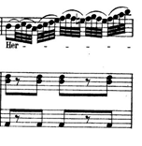

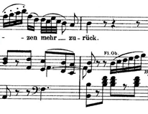
Between the stacacti it can allow the singer to take deeper breath without causing disruption during the phrase. In this German opera, the soprano is expected to sing this song with great German diction and ability to sing the German constants throughout even with the wide intervals and high tessitura. This is surprisingly, Mozart’s last piece of opera. It is evident that he poured all his “love and fantasy” and his “profound” thoughts on life and music in the world into his last opera [Harris, R. (2002)]. Although the history of this opera created a lot of “divergent” and resulted in “contradictory” interpretations of the German opera [Heartz, D. (1990)]. For example, during the 1790’s “masons” in northern Germany saw an “allegory” of the “brotherhoods secrets” in the opera [Heartz, D. (1990)], and so the director of the national theatre in Berlin, “Johann Jakob Engel” who was a German author, whom did not approve of the opera, wanted it off the royal stage in 1792,despite the interest of the king “Friedrich Wilhelm II” [Heartz, D. (1990)].

Another major genre, which was the third main opera genre of the early 19th century, after (opera buffa and opera seria) was a genre called “Semi-seria”[Castelvecchi, S. (2013]. It was said that “semi-seria opera” was ‘the presence to a greater or lesser extent of comic elements” [Castelvecchi, S. (2013]. Also the genre has been described by its Italian “contemporaries” as a “genius mixtum” which is referring the genre contrasts “high and low extremes of styels”[ Castelvecchi, S. (2013]. A popular well-known semi seria opera La Gazza ladra, written by the composer “Gioachino Rossini” which translated into English is “The thieving magpie”. The semi-seria opera is written in two acts, and the libretto written by, Giovanni Gherardini, which was based on “La pie voleuse by Théodore Baudouin d'Aubigny and Louis-Charles Caigniez.” [Gallo, D. (2012]. In 1817, Rossini was leaving Rome, heading to Milan and in during “early march” of that year, he began writing the La Gazza ladra for “La scala” [Gallo, D. (2012]. Which then, the opera was set to premiere on the 31st of May 1817. The soprano role, which the character names is “Ninetta, Fabrizio’s servant”, the soprano whom sang this when it premiered was “Teresa Belloc-Giorgi", a “soprano contralto”, a “contralto” type of soprano, many roles that were “written for castrati” are suitable for “contralto” [Miller, R. (2000)]. The “melodrame historique” of the “libretto” in Rossini’s La Gazza ladra, also has a lot of importance of understanding “19th century” opera [Sala, E. (1997)]. The sopranos' aria in act 1 of the opera, ‘Di piacer mi blaza il cor’ which Is also a cavatina, takes a lot of

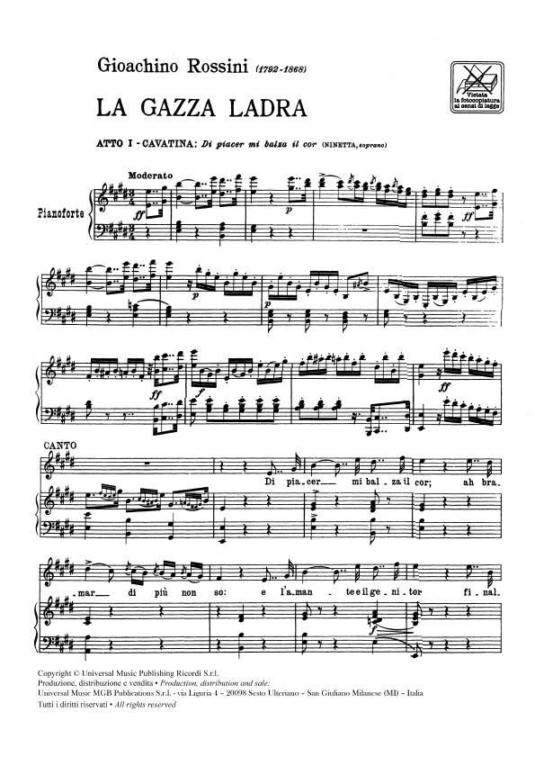
Technical work. With this aria, and most opera’s, the use of the “Bel canto and the English literal translation is “Beautiful singing” [Stark, J. (2003)]. A guy named “Giovanni Battista Lamperti”, studied the “technics of bel canto” singing, he mentioned that “breathing” should be “diaphragmatic”, so “that the singer can gain enough “air tranquilly” with a minimum of “exertion” from the “lungs” to the “vocal organs”[Coffin, B. (1989).]. Also, the reason why singers find themselves out breath or cracking in their voices, is because they could be placing “strain” on their “vocal organs” in “clavicular” breathing. For a benefitting performance, the singer must be “free and loose”, their shoulder joints “down” so that they can let their “chest” be free without “raising it” [Coffin, B. (1989)]. The “Bel canto” way of singing, has said to have several “golden ages”, and “idioms” [Stark, J. (2003).] Also, it has been said that it is a way of practicing “fluid vocal ornamentation”, and the “critical muscular balances” of the “Italian method”, which are suited to a highly “trained voice” [Stark, J. (2003).] This style of technique is used mostly in many operatic singers and teachings, because it does help the singer to engage their full support and breath control. The “Bel canto” technique can also help with the “vibrato” and “cantabile” style of singing [Stark, J. (2003).] With the “Bel canto” style of singing, the singer would then sing, through the song using more legato, which is a crucial aspect, especially in Italian opera. Legato can be said to be a “continued vibration", and there can be a “play of resonance” until “vibrato is established” [Coffin, B. (1989)]. This is important, especially when singing through the vowels. This aria could be said to be sung by a “coloratura”, due to the certain rhythmic features. The aria contains a lot of high fast paced notes, much like Rossini's other opera (Buffa) “The Barbra of seville” aria, which also had a cavatina in the aria ‘Una voce poco fa’. Both arias, contain challenging rhythmic features, however, both sopranos would have to keep legato. Even with a top range, sopranos especially need to have a strong low part of their voice, with “Bel canto” training; this should help balance out their voice and range.

In conclusion, the high soprano voices have always typically sung the “female heroin's” compared to the lower female voices such as “mezzo soprano’s” whom sang the “male heroic” roles. Even with the rise of the “tenor” during the first half of the 19th century, and the evolving practice of “travesti” (French word, for disguising yourself as the opposite sex) which the female singer singing the “travesti” role would be heard singing as either a “man or women” [Johnson, V., Fulcher, J. F., & Ertman, T. (Eds.). (2007)], for the” full duration of the opera” compared to the soprano voice type, typically “mezzo-sopranos” would portray the cross-dressed character, because of the “lower tessitura” [Johnson, V., Fulcher, J. F., & Ertman, T. (Eds.). (2007)]. For example, in Le Nozze Di figaro, the character “Cherubino” is a male character written for a women's voice, but shortly after the tenor voice emerged in the 1830’s [Johnson, V., Fulcher, J. F., & Ertman, T. (Eds.). (2007)] It only then left women's voices to be the heroine and then leaving the “travesti” roles to the “tenor” voice type, [Johnson, V., Fulcher, J. F., & Ertman, T. (Eds.). (2007)]. Although, through all this the representation of women's voices continued to “straddle the aural” and “visual” representation of female and male character's [André, N. A. (2006)]. However, what I will be referring to is the soprano voice, which has the popular role of playing the “prima donna” roles. So, the women portraying the “prima donna roles" would be have the “highest soprano range” [André, N. A. (2006)].

References
André, N. A. (2006). Voicing gender: castrati, travesti, and the second woman in early-nineteenth-century Italian opera. Indiana University Press.
Burton, D, Fisher.2006, Opera Journeys Publishing
Castelvecchi, S. (2013). Sentimental Opera: Questions of Genre in the Age of Bourgeois Drama. Cambridge University Press.
Coffin, B. (1989). Historical vocal pedagogy classics. Scarecrow Press.
Gallo, D. (2012). Gioachino Rossini: a research and information guide. Routledge.
Harris, R. (2002). What to Listen for in Mozart. Simon and Schuster.
Heartz, D. (1990). Mozart's Operas:(A Centennial Book). Univ of California Press.
Johnson, V., Fulcher, J. F., & Ertman, T. (Eds.). (2007). Opera and society in Italy and France from Monteverdi to Bourdieu. Cambridge University Press.
Miller, R. (2000). Training soprano voices. Oxford University Press, USA.
Roberson, R. (2016). Enlightened Piety during the Age of Benevolence: The Christian Knowledge Movement in the British Atlantic World. Church History, 85(2)
Robinson, P. A. (1986). Opera & ideas: from Mozart to Strauss. Cornell University Press.
Rossini, G, 2018, Alma Books,
Sala, E. (1997). On the Track of La pie voleuse. The Opera Quarterly, 13(3), 19-40.
Smith, P.J. (1970).The Tenth Muse .New York: Schirmer.
Stark, J. (2003). Bel canto: a history of vocal pedagogy. University of Toronto Press.
Thomas, H. (2006). Beaumarchais in Seville: an intermezzo. Yale University Press.
Van Den Berk, M. F. M. (2004). The Magic Flute. Brill.
Warrack, J & West, E. (1992), The Oxford Dictionary of Opera,
Wright, C. (2013). Listening to music. Nelson Education.

