Student Name: Nassaba Maomed Guiba-Fernandes

Student Number: 1605896

Module Title: Pathway Project 2

Module number: EMPL4010

Assignment Title: Individual Reflective submission

Module Lecturer’s Name: Mushfiqur Rahman

Page of Contents

Introduction

Contents

Conclusion

References

Introduction
Reflection is a formal of mental processing based on the further processing of knowledge and understanding that we already possess according to Moon, 2004. Reflection is a crucial learning tool for individuals and that part of a group, such as the example on this report.
This report presents a description of a focus project-Go Green UN Limited-which incorporated a degree of reflective practise, which has worked as an incentive for me, as a member of this group, to learn and utilise the information more effectively.

The Gibb’s Model of reflection will be the focus of my reflective report.

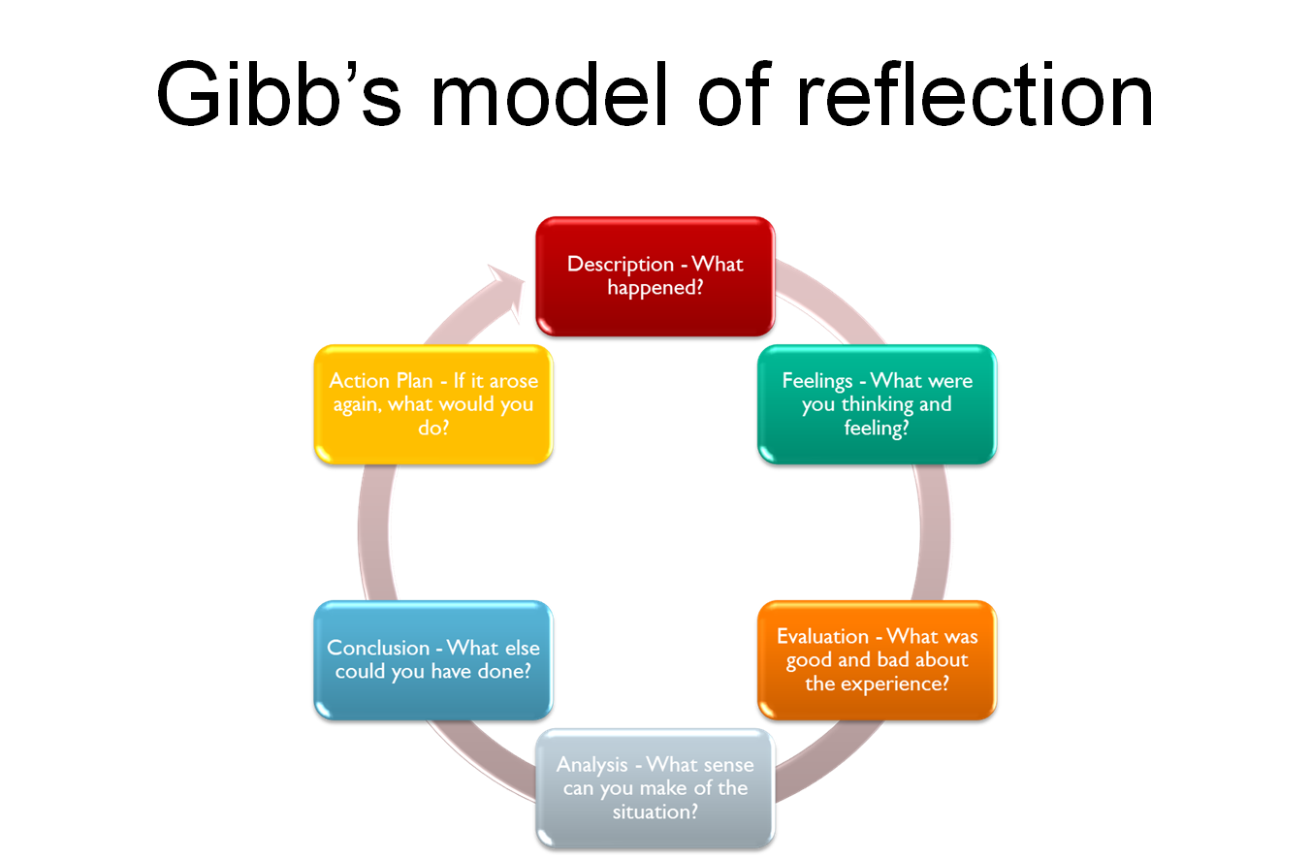

https://www.kcl.ac.uk/.../USING-GIBBS-REFLECTIVE-CYCLE-IN-COURSEWORK-D...

Description
On the first week, of the third term of this module (Pathway Project two), the entire class were given the brief of the assignment for the current term. Although we only had two modules on this particular term, the assignment consisted of three different tasks:
- A business plan, written in a power point and to be presented as group contribution on a later date, which would be revealed to us on the moddle.
- Reflective report, which is also an individual reflective account of all the actions taken, for me, as an individual.
- An individual learning, which will reflect my contribution as an active member of my group.
Later on the day, the lecturer formed groups with appointed leaders in each one. The idea, was to give us maximum chances to start working on planning, researching, writing and preparing for the final presentation, which was task one of the assignment and the one that had to be completed first. Ten weeks was the time given for us all to start organising to eventually deliver such an immense task? I was given a place on group number three which consisted of five members, including myself. The member’s names are all in the individual learning below. This task were to happen during times away from the university, so the group had to organise times when all of the members had availability to meet, at the same time and at neutral place, which became an apparent issue very earlier on the day, therefore the leader of my group came up with the genius idea to create a virtual group to enables us all to meet and communicate straight away, despite the fact that the group struggles on this particular issue. The task had began straight away for me and the other members of my group, thanks to willingness of the of our leader and of us all, including myself.
On the following week, week two, we meet inside the class thirty minutes before the class scheduled time and started to discuss a few different ideas and all members were contributing equally, also the excitement of a new project was very evident. After what seemed, a quite short space of time, Zarrah shared an idea that he had been thinking about ,but hadn’t had the chance to materialise it in terms of a business plan due to lack of knowledge and time, and this sounded to be the greatest idea so far and it became an unanimous decision and also our project. We all agree on the theme for the project, so this is how the Grow Green Farms UN Limited, concept was created and became our business plan project assignment theme.

Feelings
This project has brought amazing and unexpected feelings for me, throughout the ten weeks that my group were involved in creating this business plan. The 1st week ,due to my absency,i felt quite separated from the university ,because I was ,meant to attend ,however the last minute my mother had became unwell and instead I had to stay at home and care for her ,to make sure she had her symptoms checked and also to give her the best care possible.
The second week I started to feel more a part of my group and of the university atmosphere, just like I had experience on the previous terms, I was able to attend the class and be physically and mentally present, and that did help to set my encouragement and motivation upwards and to concentrate on doing my very best toward my group members. I also felt a little bit sad when my idea for the project was not listen to nor acknowledge ,when I was first brainstorming with all the others members , however I did also agreed to accept the other member ideas and to take on board the tasks given to me by the group leader. I also learnt that my idea, althought I truly believe it was a good concept, Zarrah ideas was the best one in the end of that day. My self esteem grown a lot of the first the period was for researching, preparing and taking actions to get the work done, on time and to the best of my ability.

Evaluation
All that I went through, throughout the entire process did enable to keep on finding the best ways to overcame my own insecurities and misconceptions, such as the thought that my idea was going to accept as the main and only one when there others members of the group as active and outspoken as me that also had ideas and were willing to share. By observing my own judgement and overconfidence I was going through the feelings of rejection and lack of acknowledgment, yet I also did that same very action, in my mind, but yes I also judged and taken for granted that my idea was to became the business plan, and that same mind set it seemed to have clouded my ability to see the circumstances occurring in that work set and to bring the best out myself. I consider myself a confident and willing to the work, whatever that may be, yet on this experience I had to re set my mind and to became humble enough to accept all circumstances has they were and become as much involved in this group as possible.
My task was to the concentrate on SWOT and PESTLE analysis. I was able to research, write, present and deliver my part with the help of my leader, who was always there and available to assist.

Analysis
This experience of working in a group and a team member has thought me a few different lessons:
- No matter what is the task ahead ,there will always be challenges and feelings will chance accordingly to the circumstances, however to be able to cope with my feelings and also express these properly to others ,such as my team members, is a challenge at the best of times ,yet and despite of the fact I have strived to become emotionally intelligent in order to be able to bring out of myself ,so I can therefore become mentally intelligent and give the best version of myself wherever I am and whatever I am doing.
- To be open-minded is an essential asset, when working within a group as team member. To accept other people ideas and to be prepared to not to have my ideas accepted is all part of the process and once this phase is mastered the student position to learn will became elevated and more receptive as well.
- To be honest about my feelings and admit to myself and to others when I am struggling and ask for help as many times as necessary.

Conclusion
It has been an amazing learning curve and experience to work as a team with my colleagues, some I was familiar with and others I never spoke. The learning opportunities that occurred whilst working as a team ,were immensely necessary in order for me grow and to understand that even when I have learn a new matter I will have something to learn that will add to my personal development and also to mental ability to remain intelligent.
Learning will be a continuous process and the more I learn the more willing I have become to continue to learn.

Action Plan
To manage my time effectively. To ask for help as soon as I find that struggles have arise. To continue to write learning for my personal development and account do any news subjects that I will be studying in the future and to stay humble.

Student name: Nassaba Maomed Guiba-Fernandes
Student number: 1605896
Module code: EMPL4010
Module number: Pathway Project 2
Lecturers name: Mushfiqul Rahman
Learning log for Project: Go Green Unlimited

• How did you work together?
The group consisted of four members: Samsul Alom (leader), Zarrar Zafar, Zarah Zafar, Clarissa Kover and I, Nassaba Fernandes. On the first week I was absent ,however the group leader contact me to find out why I didn't show up and class and to give the news that I was part of his group. He also told me to read the moodle slides relating to the week in question for me to catch with what was taught in the class. On second week of the current term ,we all work together very well having the leader already finding a way for us all to meet and to start working and brainstorming. By the end of the third week I was allocated the work I was meant to present and share with the entire group, my task was to work on the PESTLE analysis of the our project, despite the fact that it was a very young stage of the project but we all agree that it was the best way to start working on PESTLE and SWOT analysis
And that made me feel a part of the group, straight away and I was also briefed with what the group started to discuss for the business plan.
• Who did what?
Zarrar, who came up with the whole concept of the business plan, had an idea of a project he had been researching and working on for some time and he discussed with the rest of the members as business proposition and idea for us all to present as our project assignment and the entire group, me included found the idea quite fascinating and genius, so that’s when the Grow Green Unlimited was created as new business plan to be create. Samsul took on the task of starting working on the power point, with the rest the group helping him with ideas of what to put in and also with creative and positive feedback on the work he would start to create. I was given the task to research on the same types of business already in the market and find out about the competition and also to spend time with Zarrar to hear the idea and to ask questions in scrutiny way, to help the group to dig deep and get the best business plan possible. Clarissa was given the ask of reading around the idea and to make sure she understood the concept and also top feedback to Samsul with any additional information. Zarah and her marital partner Zarrar, was given the tasks to overlook any mistakes and over realistic objectives and goals of the entire business plan. We also all were made aware to start doing our individual learning logs, by Samsul.
• What went wrong?
Communication in between the group sometimes was not enough and there was also a lot of misunderstanding during the first three weeks in what exactly was the learning reflection consists of and in which style did I had to do, all of the above was in personal view and experience.
• What went well?
From day one ,the team leader was very keen to get the work done and he also made sure that he check on all the members often ,at least three or four times a week ,when he would ask if I was getting on with my learning log and for feedback on the work he had started. Zarrar was also very open and honest with his personal knowledge on the subject and he would always explain, word by word and step by step this extensive and elaborate idea together with Zarar was so compassionate and passionate about the whole project.
In all I believe the group had their strengths and weakness. Some of the strengths were an immense sense of positivity through the weeks from all of the members. There were never any arguments nor disagreements. There were a lot of discussions in the classroom at the workshop and outside the classroom. We all knew what we were meant to do and we all did to the best our ability. Zarah was also very supportive to me and willing to help anyone in the group, the same to Zarra. Clarissa was always willing to learn has she has difficulties with the English language; however she always asked if there's something she didn't understand. Samsul was very encouraging and truly kept the group going forwards and upwards with the project. For me what really worked was that I managed my time outside university well to be able to be present and to contribute to the group, in small or bigger ways.
• Did you meet often enough?
Once a week in person. So, yes I believe that was the only time we could all be present in the same place at the same time has we all have busy lives to run and to manage. There was times I felt that we were not meeting enough ,however through the exercise we , as a group managed to overcome this type of challenge and to find a way to cope bringing results in the end, with all turning out well with the time that we all had arranged previously.

• Did you use Skype or other online meeting platform?
We created a wha'tsapp group on the first week of the term to stay in direct and constant contact with each other at all times and also shared private emails as well has the university provided emails and this exchanged took place between every single member. • Did that work well?
It was the best thing that we as a group did ,because every day the leader was posting information and some other members of the group would respond and also share work done ,where we all gave each other creative feedback , so yes it work very well. • Did you have technical problems in meeting online?
None encountered by myself nor did the other members.
• Did some group members refuse to meet online? How did you overcome this?
No, apart from Clarissa who found very difficult to understand the aims and objectives of the business plan initially and she also had difficulty with filling and providing the group leader with her individual log, due to what I have mentioned above, the lack of a comprehensive understanding of the English language.
• Did someone not pull their weight? Did you discuss this with them as a group? Did you resolve this problem satisfactory?
I believe that all did our best from my point of view ,however and because of the language barrier Clarissa really struggle to understand some of the objectives and aims of the project ,but she was always keen to ask for help as she did do to me and other members if the group and even directly to the teacher . We all discuss the fact that Clarissa was struggling to get her workload done, especially with the individual learning logs and we resolved the problem amongst ourselves and we also shared it with the lecturer who helps her to understand what her task was.
• How did you divide the work between you?
The leader, Samsung had the responsibility to allocate the work and we as a group members all discuss our own individual ability to do the work he had allocated, for example my part was to research on the same business models to find out other companies leading the market in the same area and because this something that all members of the group had to do as well I felt that it more than fair how the work was allocated.
• Was it fairly shared out?
At the beginning of the task it was fairly shared out but I believe that at the some point ,some members did a bit extra work as their abilities to contribute to some parts of the subject matter was more accurate ,so in the end whoever had more to contribute were listen by others members and Samsul and Zarrar would discuss with the rest of the group if it was accurate to enter it on the project or not, nut the rest of us also always present ,supporting each other and listening to one another with respect and dignity.
• What have learned by doing this?
I have learned quite a lot, from working with a number of people that have different backgrounds, together we had become a very good and strong group with and exciting and interesting dynamics that were always brainstorming and willing to share ideas to improve as individuals and an s group. To respect other people’s opinions, qualities and limitations because none of us have ever done this particular course, placing us all in the position, which was one of learning and growing intellectually together?
• Did you enjoy the process?
Yes, I did enjoy the process of working with this amazing group of people that made my group and I, personally have developed intellectually and thoroughly the whole process.
• Why did you enjoy it?
Because despite the difficulties, the leader Samsul and Zarrar were always willing to help us to came together to go through the problems arising whilst looking to find a solution as a group.
• Did you dislike the process?
No, merely disappointed with myself the times I was not able to deliver what was required of me and the times that I didn’t attend classes or had to leave earlier due to personal circumstances.
• Why did dislike it?
I dislike the fact that I didn’t apply what I had learn on a pervious term ,on the personal development module with, Mary March ,about time management and to plan out in advantage my schedule, to be able to be present at all classes and not to let down my group. It was one of my goals when I completed my assignment on that particular su8bject, however I have learned from it, because I found myself running all the time to catch up with the rest of the group and I will not do that again in the future.
• How could it have been improved?
Good planning of resources and time. A thorough time management schedule with a backed up plan in the case the original one failed and with more extra curriculum classes to make sure that I was updated and utilising all that is available in the university to support me as a pre-graduated student.
Also we could have requested the lecturer more time to workshops on his class times when the change of meeting was higher than outside class.
To have more awareness of one and other abilities and to challenge each other’s a bit more in order for everyone to contribute as fair amount of work so the level of grading is similar as after all is a group work.

References
Gibbs, G. (1988) Learning by doing
. A guide to teaching and learning methods. FEU
Watton, P. Collings, J. And Moon, J. (2001) Reflective writing. Guidance notes for students

