SURREALISM

Surrealism often encompasses the bizarre, the hallucinatory, the irrational.
It emerged in Europe following world War and leading up to world War II it was free from the constraints of medium or visual style, it was complex and contradictory and also liberating to the individual.

In 1924 writer and poet Andre Breton published (Manifeste Du Surrealisme) a manifesto on surrealism, he described it as ”psychic atomic tourism in its pure state […] dictated by thought, in the absence of any control exercised by reason, exempt from any aesthetic or moral concern.”
Breton started the movement in 1924, was not just simply a writer, he also trained in psychiatry and medicine and we use Sigmund Freud’s psychiatric techniques, Fried served as much influence to Breton at the time and play about to roll in how the moment began.

If we really want to understand the surrealism we must first know a few things about psychology.
Our mind is divided into conscious and the subconscious, the starting point of our thoughts begin with our experiences or a conscious is what we are aware off at any given moment.

The subconscious holds a lot of information but is dormant, say for example riding a bike after you’ve learnt you no longer have to think about it this is how subconscious works it also controls functions of the body let’s we’re sleeping as well as a storehouse for symbols. It uses a powerful symbols some of which cannot be put into words a symbol can hold a lot of meaning. It lead the
eloquent and noted Swiss psychiatrist and psychologist Carl Jung who said “ The supreme goal of man is to fulfil himself as a creative unique individual according to his own innate potentialities and within the limits of reality.” To create the theory of the collective unconscious.

And because of its wealth of knowledge, surrealist will use images from their subconscious. Britain believed the subconscious should speak for itself without the limitations of rational thought. In 1913 Breton started experimenting with this pure state leading him to co-author a book called (Les Champs Magnetiques) The Magnet Fields.

Surrealist carried out experiments such as transcribing dreams and recording trans states in order to unleash the subconscious under the auspices of The Bureau Of Surrealist Research. It was Froid’s belief that as humans we are divided between our consciousness minds ( dominated by reason and held the back by social manners) and our subconscious the storehouse of desires, unprocessed experiences and instinct.

Its roots are linked to the ethos of romanticism, and it emerged out of the movement originating in Zürich and Berlin call DADA, which sought to shakeup the conventionality of modern life.
The movement was identified as anti-colonialist and ante imperialist and often drew inspiration from non-western or primitive cultures which provided an alternative set of aesthetic and social values. The movement mounted an anti-imperialist exhibition and produce pamphlets to protest against the racist and colonialist presumptions of the colonial exhibition held in Paris in 1931.

It is the surrealist interest in the uncanny which makes it almost impossible to forget their work, by making the extraordinary out of the ordinary and combining familiar items and found objects to make pieces that sometimes refer to that part of the self that lies beyond the reach of reason and liberating psychic energies. It gives us the chance to Break down the barriers between dreams and waking life, between cultures and individuals, it is an example of how reimagining ourselves could be the ultimate step to changing our world.

The following artists incorporate surrealism within their work to some extent as a medium through which to tell their stories, although subtle at times the message is still clear and even when there is no exact narrative which is often the case with the work of Kyle Thompson, surrealism challenges the mind in filling that gap by trying to derive meaning.
ARTISTS

Kirsty Mitchell
In 2008, throughout her mother’s treatment for terminal cancer Kirsty rediscovered her emotional relationship with photography, a few months later her mother passed away this is when Kirsty deeply immersed herself into the medium of photography not only for expression but more to deal with the loss of her mother.​
In 2009 Kirsty started a project entitled “Wonderland” created in her mother’s memory.​

Kyle Thompson
began taking photos when he was 19 it is then he found interest in abandoned houses and other building nearby. Locations such as vacant forests abandoned houses Lakes and rivers are frequently used by him to together with water, smoke, props and lighting effects are often use achieve a surreal atmosphere within his photos.

Alex Stoddard
He clearly draws a line between fine art photography and portraiture where he describes portraiture as capturing a person’s likeness as they are without deep thought or emotion, and fine art photography as more emotional with strong concept and meaning behind it which clarifies the meaning of its creation.
He believes the inspiration comes from personal and collective experiences and memories and he would sometime bases photographs around turbulent experiences in his childhood, or a moment that has somehow found root in his subconscious only to be awaken by a certain smell, sound or Image.

Nicole Burton
Her surroundings would often leave her feeling out of place which led to her creating her own imaginative world. Her surreal looking landscapes is a reflection of her fantasy which are brought to life with the use of textures and colours. She invokes different emotions in the viewers by the specific placement of the models.

Gergory Crewdson
Crewdson’s photography is often staged in small town America with large cinematic sets and sometimes feature surreal events, often disturbing.
His set is usually elaborately staged and lit, he has a team similar to that of Motion picture and who are also familiar with Motion picture production and lighting.

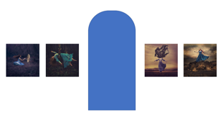
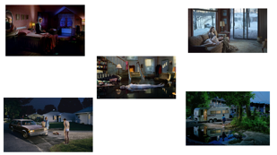
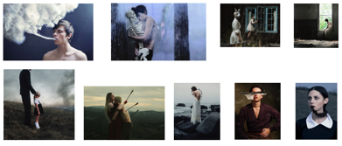
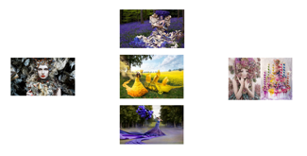
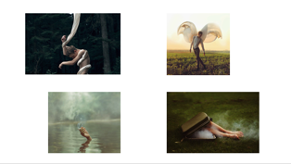
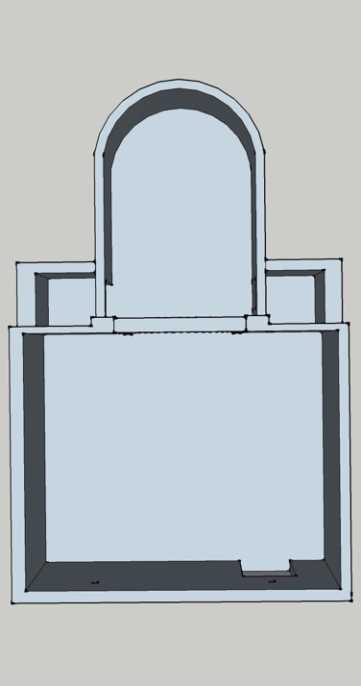
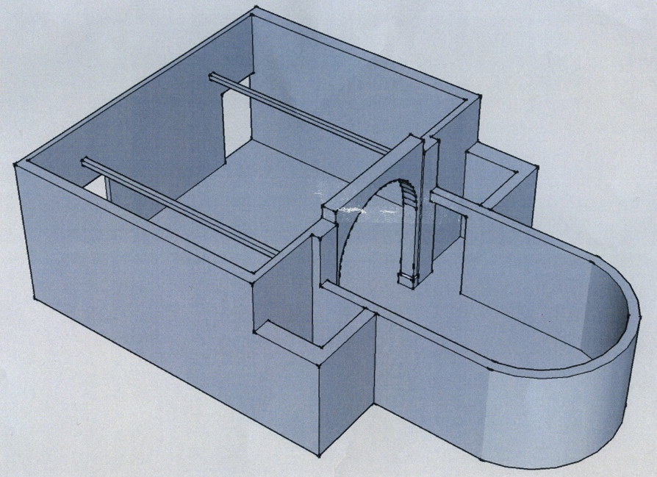
FLOOR PLAN FOR MISSION GALLERY
Kirsty Mitchell
Nicole Burton
Kyle Thompson
Gregory Crewdson
Alex Studdard
Nicole Burton
Gregory Crewdson
Kyle Thompson
Alex Studdard
Kirsty Mitchell

I have chosen to place Kirsty Mitchell’s work on the left as you enter the Mission Gallery, this seemed to be the perfect space to display her work.
On the right hand wall I have chosen to display Gregory Crewdson’s work, the reason behind this is because Gregory’s pieces are strong and often compelling in the way they tell their story.

On either side of the arched doorway is the work of Nicole Burton, my decision to place these pieces here followed careful thought and was a tight decision between Nicole Burton and Kyle Thompson however the pieces I chose to use for Kyle Thompson which I have placed on the back wall of the gallery.

Alex Studdard’s work is featured in a separate space and is comprised of more pieces than the previous artists mainly because the space is more to fill and in my opinion works better with more pieces tailored to fit the space than less but cumbersome pieces.

REFRENCES

http://www.artic.edu/reynolds/essays/hofmann.PDF
https://www.youtube.com/watch?v=y53-j_2Ad6s
https://www.youtube.com/watch?v=dt1iLYjF0RQ&t=1946s
http://www.exquisitecorpse.com/assets/manifesto_of_surrealism.pdf



