
Applied Computing
Wales Institute of Science and Art (WISA)

Cybersecurity – Sniffing Packets

Understanding Plain Text and Encrypted Traffic
Using sniffing Tool



Objectives
Understand how sniffers are used to gather user credentials.
ETHICAL STATEMENT
The tools and techniques demonstrated in this lab are intended solely for educational purposes within a controlled, virtual simulation environment (such as Cisco Packet Tracer). Their purpose is to help you understand how different network protocols function and how insecure communications can be intercepted.
Use of these or similar techniques outside of this environment — especially on live or external systems — without explicit authorization is both unethical and illegal in many jurisdictions. Unauthorized access to networks or data can result in serious legal consequences.
Always consult your instructor or institution before attempting any network experiments outside of the classroom environment. It is your responsibility as a learner to ensure your actions comply with applicable laws and institutional policies.

Resources: Packet Tracer
- Open Packet Tracer and Design the below Topology.
  - Click Windows button and search for Packet Tracer.
  - Open Cisco Packet Tracer
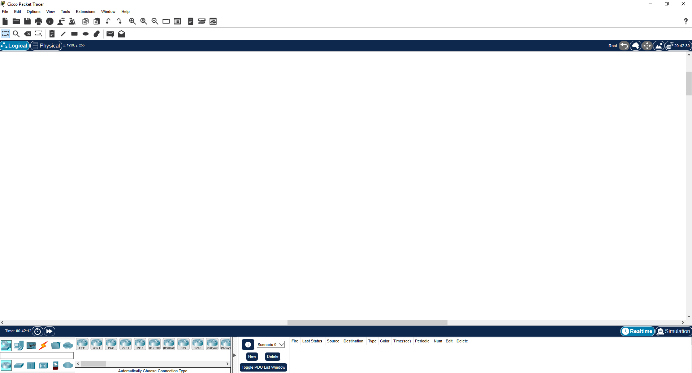
  - Bottom Left: Click on the 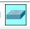 icon. You can see 2960 switch in the next tab. Drag and drop the switch.
  - Similar to the above step, search for PC icon and drag and drop a PC and a Server.
  - Click on the 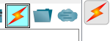 icon and select the lightening icon. Click on the pc and the switch.
  - Similarly, do the same to connect the switch to switch and Server.
  - Outcome:
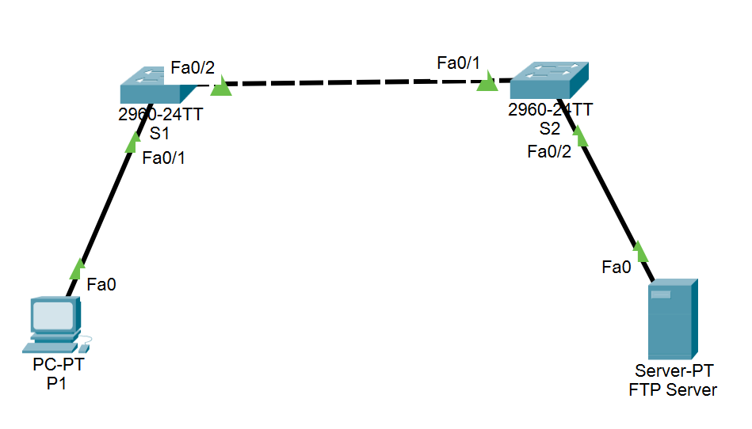
- You have now sucessfully designed a simple Network. Configure IP address to the PC and Server.
  - PC – 192.168.1.2
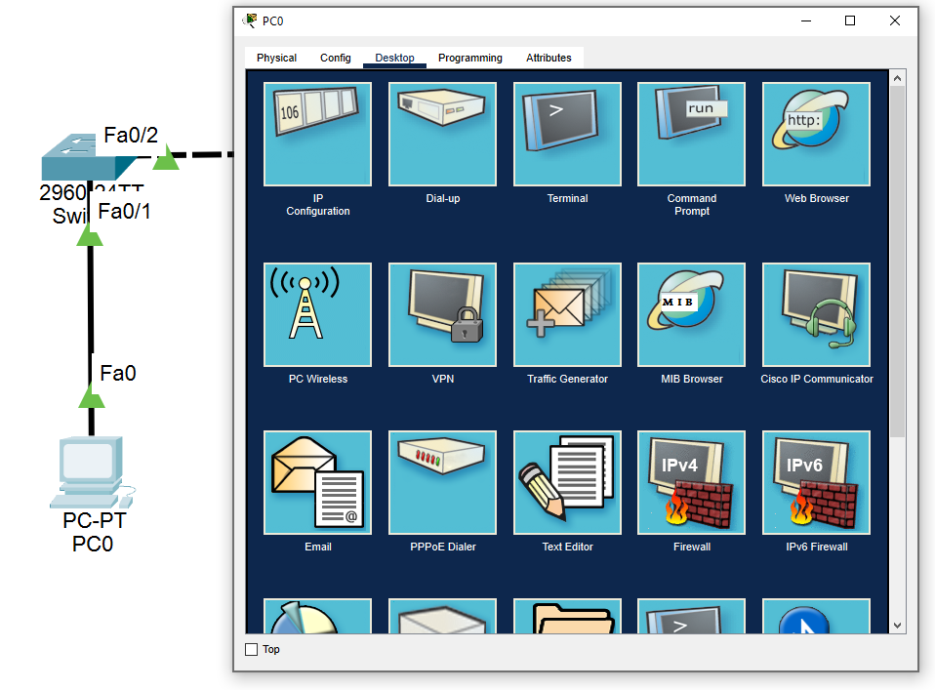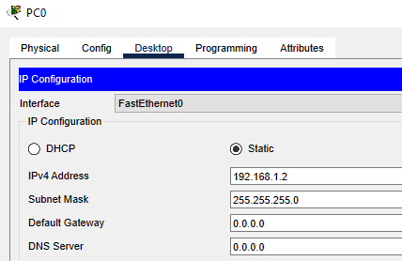
  - Server – 192.168.1.1 (Same as above, configure IP Address for the Server)
- Configure FTP Server.
  - Use internet to do research on what is FTP?
  - Write in your own words about your understanding on FTP.

  - Click on Services Tab in the Server and switch on the FTP Server
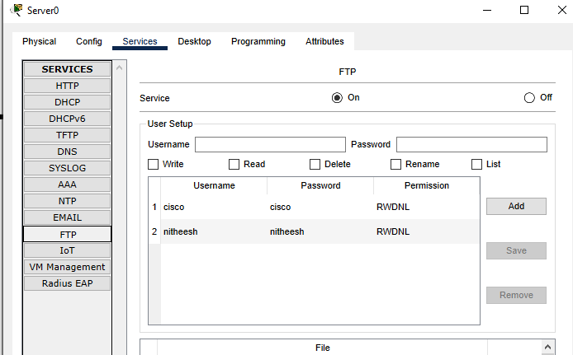
  - Add you name as username and give a password. Check Write, Read, Delete, Rename, List permissions and Add the user setup. (Similar to what you see nitheesh and cisco, now you must see your user setup)
- Test your FTP Connection
  - Click on the PC and open the command prompt.
  - Ping Server from PC
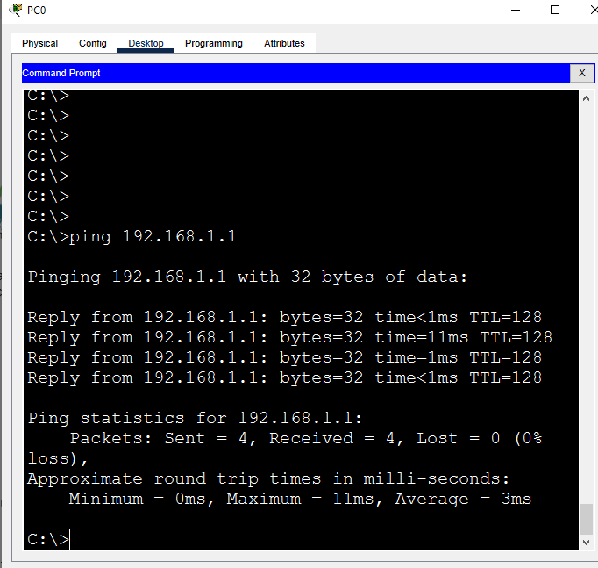
  - What is the purpose of Ping? (Use internet to search and write your understanding)

  - Was the ping sucessful? Yes/ No
  - Type the following
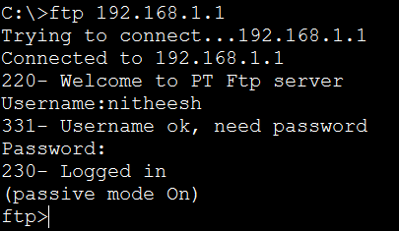
  - Did you manage to connect to the FTP Server? Yes/ No

- What happens if an attacker places a sniffing tools in the network? Let us see.
Do a research before you start.
  - What is Sniffing?

  - What are the different sniffing tools available?

  - Select the PC Icon and select the sniffer and place them in the network as shown below.
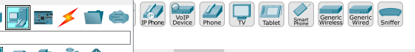
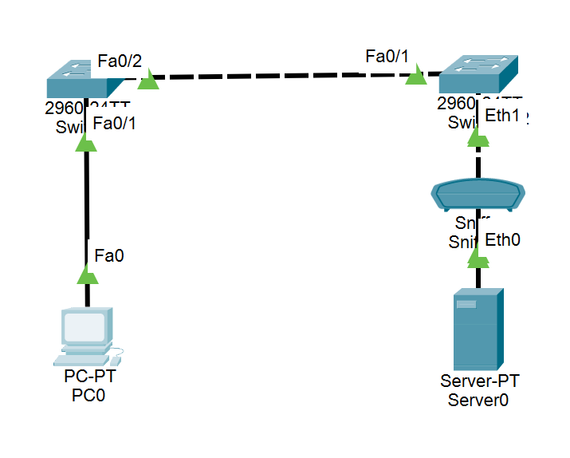
Now, you should be aware of connecting using the connection icon. Refer to 1 d step.

  - Select the sniffer and give appropriate ports as incoming and outgoing.
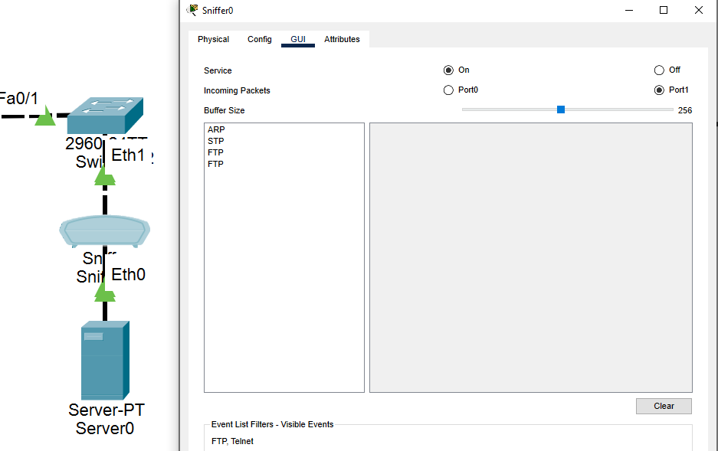
In the above case, Eth1 is Port 1 which is incoming. Because, User credentials are sent from the PC to the Server. (It may vary for you. Checkout)

  - Click on Edit Filters, MISC and select FTP. 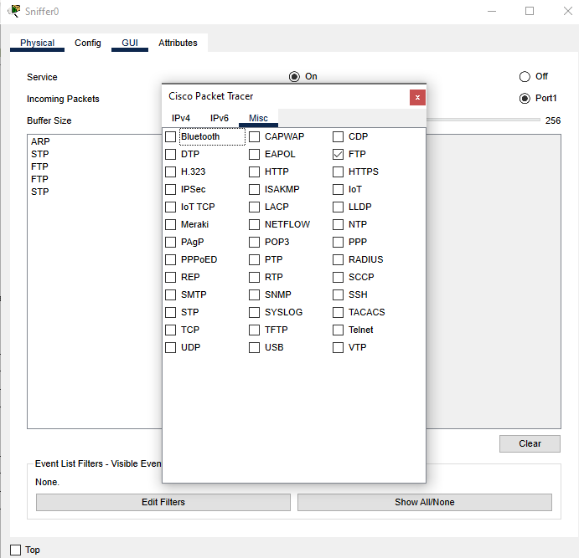
  - Go to PC1 and try to connect back to Server 1 using FTP Credentials.(Refer to step 4d)
  - After sucessful connection, click on the Sniffer and look for FTP Packets
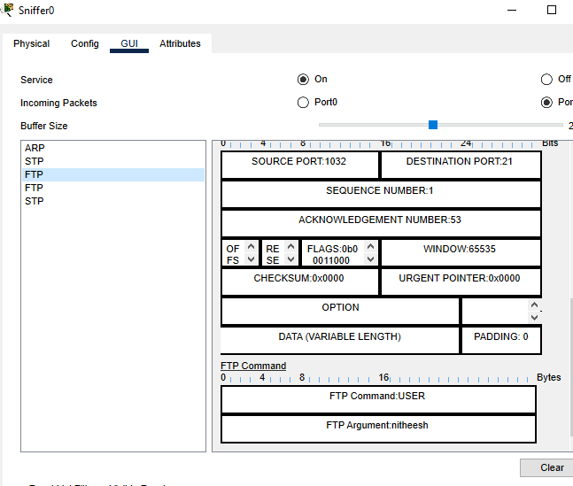

  - Did you manage to get the user credentials?


Record your Reflection:

- Write in short, your understanding on this activity.

