Student Name: Bethany Stock
Student Number: 1902668
Module: Game Design and Asset Creation 1 (M5X02043)
Word count: 2047

Introduction
In this report I will be evaluating my contributions to the group assignment where we had to design and create a game as a team. I will also be evaluating the research that I carried out, along with my process of creating the designs and how well the team worked together.

Coming up with our idea
At the beginning of the term, we were put into teams to design a video game and create a prototype of it as our project, with roles being assigned on what people felt comfortable with doing and then teams were created afterwards to ensure that there was a balance of roles on each team.
I chose to go with the role of designer and I chose this role as I am more skilled in this area compared to the other roles I could have potentially gone with so therefore I would be able to work more effectively.
After the teams and roles had been decided upon, I was grouped with Mariusz, Erin, Samantha, Josh and Ryan as my teammates with Mariusz and Ryan working with the game engine, Samantha working on animations, Josh creating the models, and Erin working on art.
As a team we came together and were quick to start proposing ideas for what our game could be about, and I suggested that we could do something like a visual novel. After further discussion, the team eventually settled on a game where you would play as a pirate and would have to run away from a sea monster while avoiding obstacles.

Research
As I was on design, my research largely revolved around gathering material that could aid in the design process by acting as references to work with and as such most of my research involved looking on the internet for images that related to the things that I was designing.
Instead of doing all my research at once, I carried out relevant research as it was needed as I could not predict what we may need a design for in the future and I would look for images that directly related to the concept that I was working on at the time, for example, I looked at pictures of octopuses and squids when I was concepting designs for the kraken and I looked at images of pirates when designing the concept for the player character.
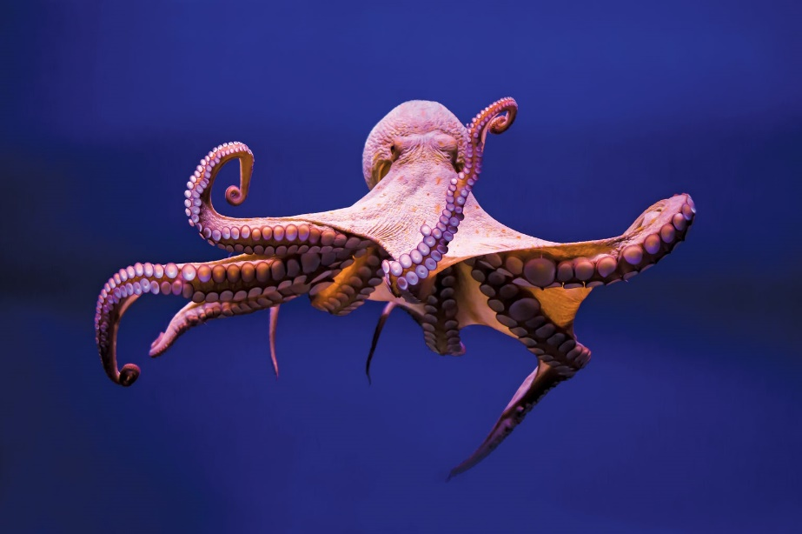
Photo of an octopus that I used as a reference. (Godfrey-Smith, 2017).

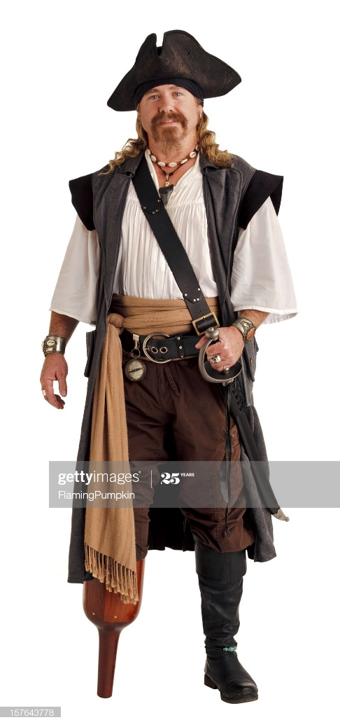
Stock photo of a pirate that I used as a reference. (GettyImages, n.d.).

I also researched video game level design theory in the form of Scott Roger’s book, Level Up!, when creating concepts for the levels in the game as I wanted to ensure that they felt good to play through.
The advice that Scott Roger gave for designing levels that I felt was relevant to what I was doing is “Start your player moving through the world with simple movement challenges: walking, jumping, and collecting goodies. Then add one mechanic. Repeat it a couple of times so the player understands how it works. Add a second mechanic, and let the player learn that one too. Then combine the first one with the second. Make things exciting with a hazard. Let players get used to doing the things they would normally do in the game (traversal, collection, interaction with mechanics) but now with the hazard being part of the equation” (Rogers, 2010). I followed this advice as the game had quite a few mechanics and obstacles that I wanted to introduce to the player in the first level but I also did not want to throw all of them at the player at once as this may overwhelm and frustrate them. To introduce the player to the mechanics over time, I spread them throughout the levels so that the player would only have to deal with one at a time until later on in the levels where mixtures would appear.
Even when I was not working on designs, I made sure to keep my eyes out for anything pirate or sea related that I saw and thought of ways that I could incorporate them into the designs as we were making a pirate game and I wanted to make sure that all designs tied into the theme in some way. An example of this was when I designed a jump pad inspired by an Orca.
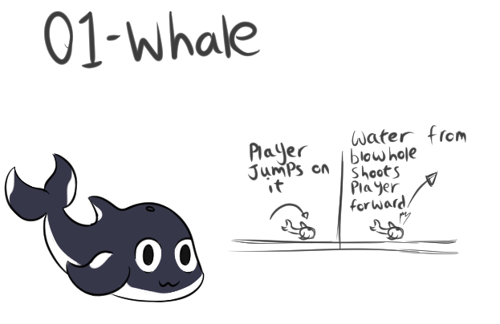
The whale jump pad concept I created.

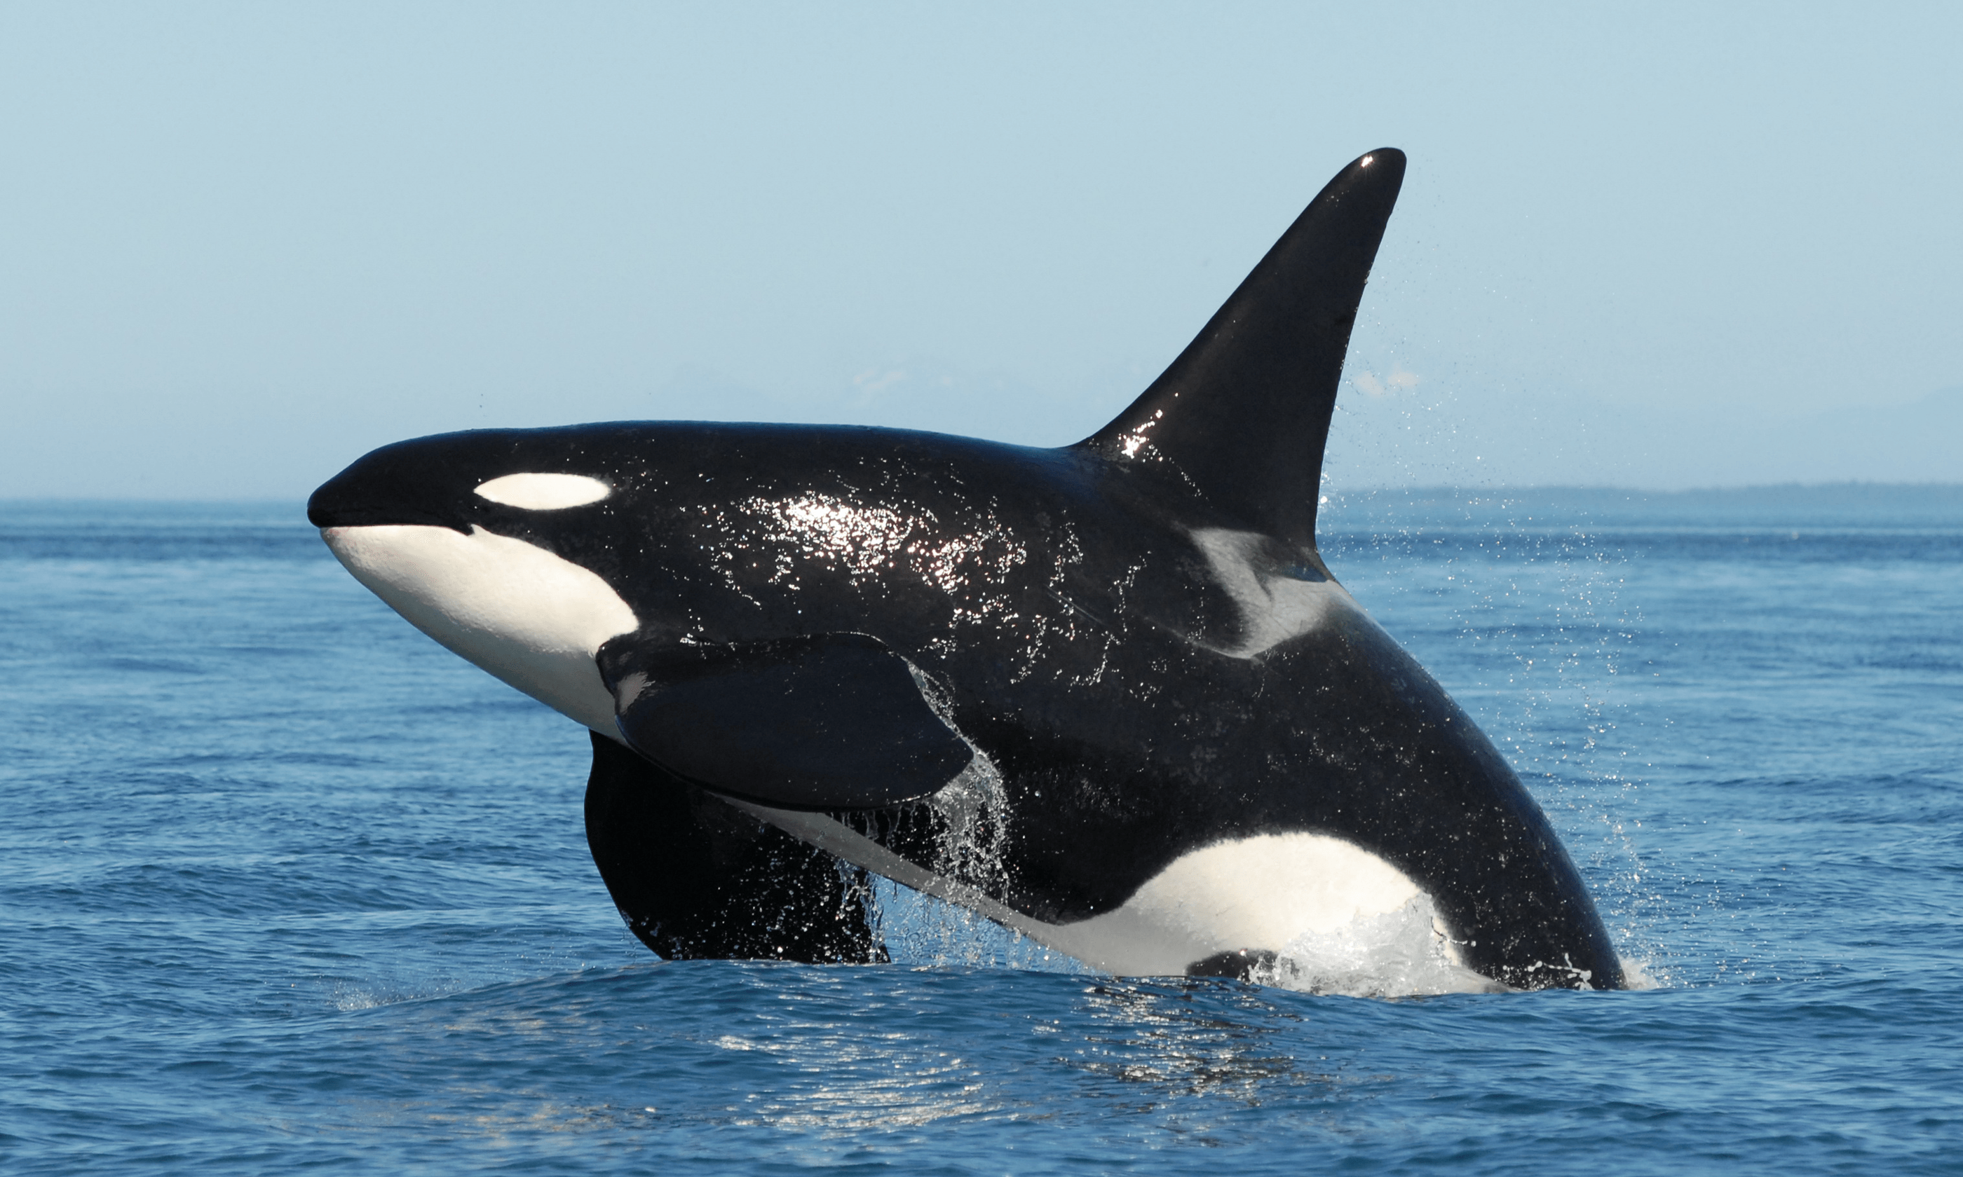
The Orca photo that I used as a reference. (Vilamoura Watersports Centre, 2020).

Overall, I think the research process went well and I had no trouble carrying it out as aquatic animals are largely documented online and pirates are popular in media so there is no shortage of images to look at for inspiration.
My contributions

As my role in the team was designer, most of my contributions were designs and concepts. An example of which being a pitch for the player character that had a colour palette inspired by the coastal towns of Santorini in Greece, that I drew when we were discussing ideas for what the player character could look like.

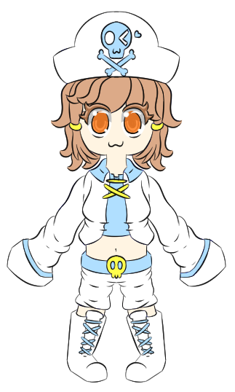
Player character concept pitch.

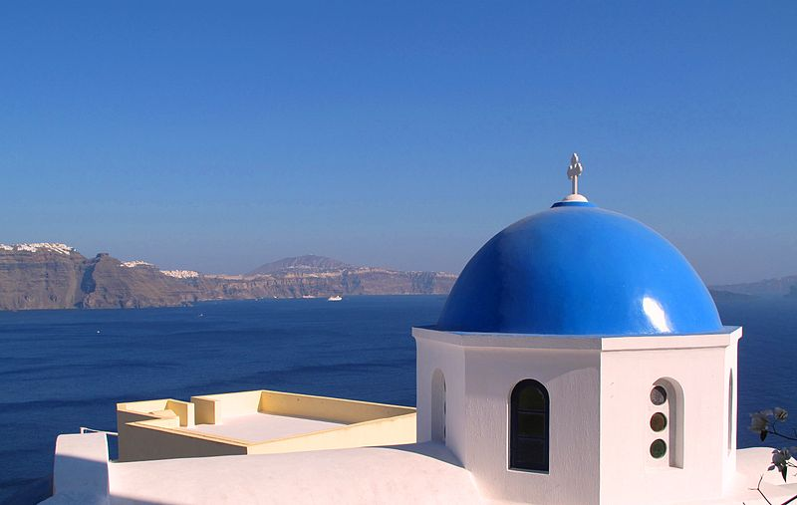
Photo of Santorini (Hhss8228, 2009).

Another example would be the shopkeeper I had created a concept design for, which was a small octopus merchant in pirate attire that would have pushed around a small raft with items that the player could buy in the game.
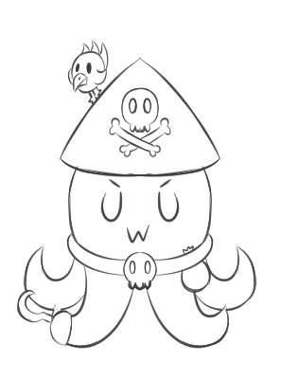
Shopkeeper concept art.

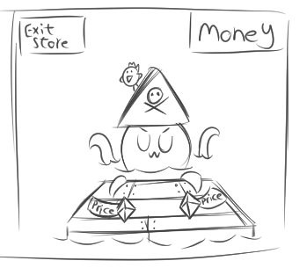
Shop concept art.

As previously mentioned, I also tried tying the designs in with the pirate and sea themes in any way possible and as such I also tried to be as creative as possible when making the designs and tried to come up with ways to incorporate these themes into the designs that I created, examples of this include the aforementioned jump pads along with the player character’s design using coastal towns as an inspiration and the shopkeeper being an octopus.
I would also occasionally come up with an idea that we could include in the game and I would create concept art for it that I could use to help convey my idea to the team when I pitched it to them. One particular example of this was an idea for an overworld hub area, with a ship there to represent each level along with each level having its own monster that would chase the player and the player would have been able to select where they wanted to go, such as one of the levels or the shop, by clicking on the corresponding ship. While this did not make it into the prototype, the idea for the kraken being a monster that would chase the player was something from the concept that was used in the prototype.

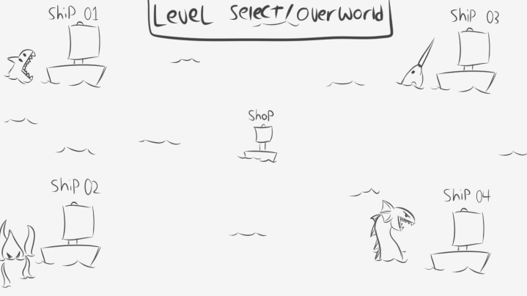
Concept sketch of the overworld hub.

When it came to drawing the concepts and designs, I chose to use Clip Studio Paint which is a digital art program that is developed by CELSYS Inc. (CELSYS Inc., n.d.).
I decided to go with this program as I am an artist and this is my drawing program of choice and as such it was the best one for me to use as I am well-versed in using it. Being a digital art program, it was also capable of doing everything that I would need it to do.
I stuck with what I knew for the most part while creating designs but I did step out of my comfort zone occasionally, such as when I was creating the level designs, any animals, and the sideview of my character as these were things I was not used to drawing.
Designs also went through changes based on self-criticism and feedback that I got from the team. One example of this would be the concept for the level design which was originally smaller and had lacked obstacles that were created after the level was designed so it was redesigned to be bigger and include these missing obstacles.
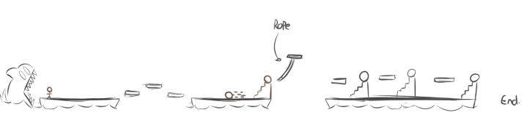First concept design for the prototype level.
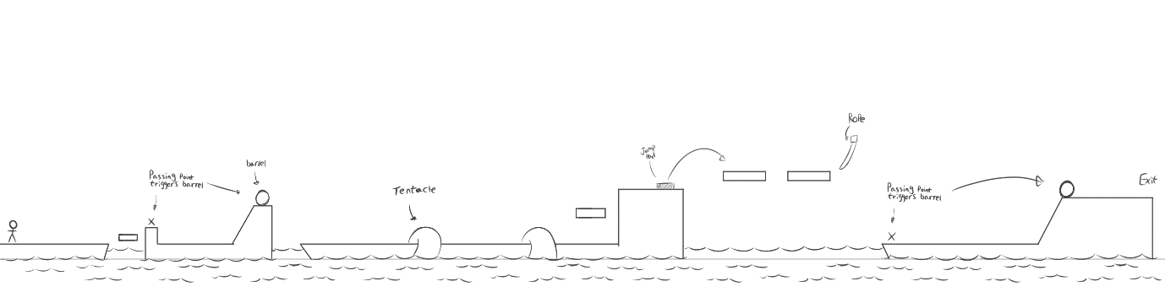The new level concept design.

Another example would be the kraken. Initially I created three different versions, with each design being vastly different from the others, when I was originally concepting it as I was not used to drawing animals and could not decided on what looked better.
The initial design would have been a skull with tentacles coming out of it and was inspired by an idea for a ghost ship that the team considered early on before scrapping it.
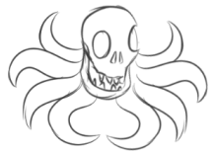
First kraken concept.

The second was designed to look sinister and tough with a scar across one of its eyes to make the kraken appear as if it had been in a previous conflict and also had mechanical scythes on the front two tentacles to mimic how pirates are typically depicted with hooks for hands.
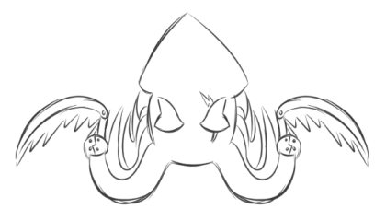
Second kraken concept.
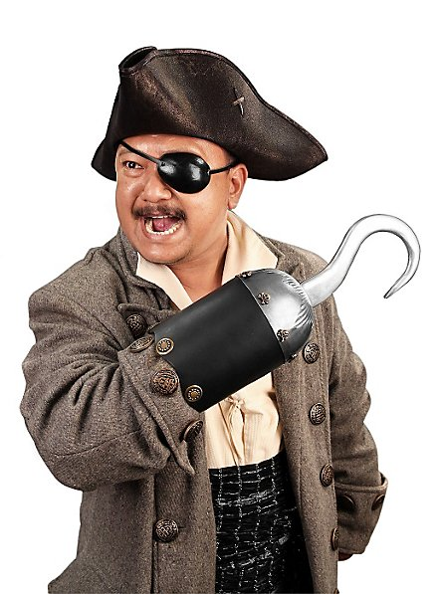
Stock photo of a pirate with a hook that acted as inspiration. (Andracor, 2020).

While I liked this concept, I thought that the mechanical scythes might be too much work for the people who would have to model and animate it and as such I tried reworking the design into something that would be easier to work with.
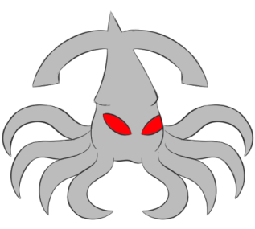
Third kraken concept.

This reworked design lacked the mechanical scythes and the scar, instead opting for glaring red eyes and having the tip of the head extended with parts that hung over to resemble an anchor.
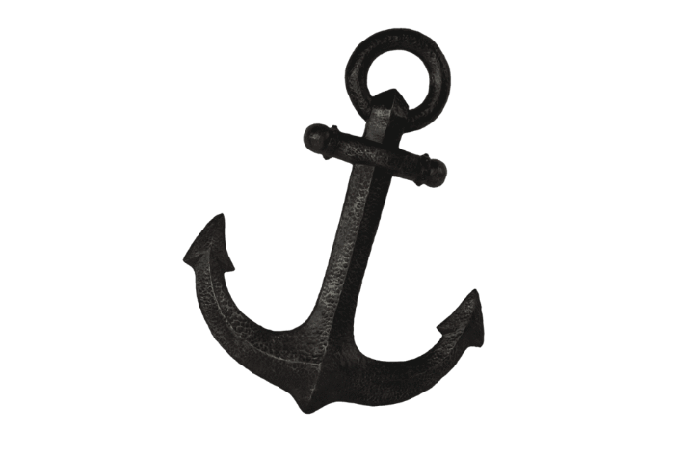
Example of an anchor that I used as a reference. (LM Treasures, n.d.).

I also contributed outside of creating designs, for example I provided some suggestions from games I had previously played when the team was throwing around ideas for the style of the game and I also suggested making the environment 3D while having a 2D player character which is an idea the team liked and which we decided to implement.
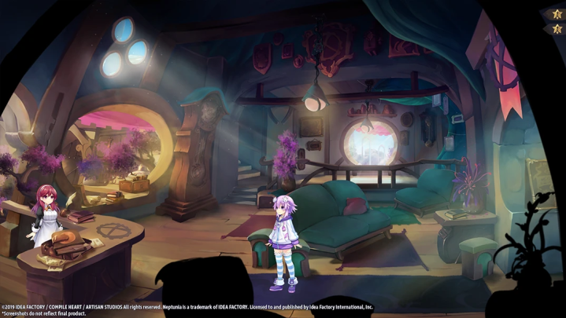
A Super Neptunia RPG screenshot I shared with the team when suggesting style ideas (Idea Factory International, 2019).
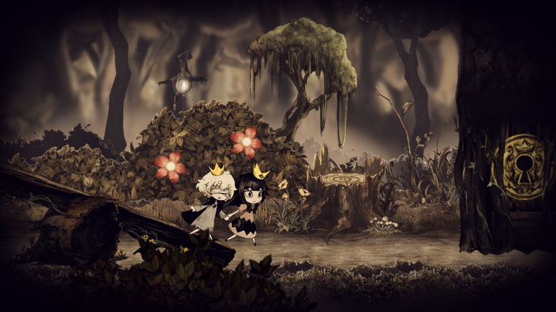
A Liar Princess and the Blind Prince screenshot I shared with the team when suggesting style ideas (Romano, 2018).

Teamwork
As a team we used a range of services to work together when creating our project. To keep an archive of the assets we had created for the prototype and to share things, we used Google Drive (Cloud Storage for Work and Home - Google Drive, n.d.) on a shared Google account.
To communicate and host meetings, we used Discord (Discord | Your Place to Talk and Hang Out, 2015). I also used discord to quickly share my designs with the rest of the team as the image file sizes were small enough to send them on Discord and teammates also used the screenshare function on Discord to livestream any progress they had made on their contributions to the rest of the team.
As teammates, we also gave feedback on each other’s work and communicated with each other so that everyone knew what they needed to do and to also discuss any new thoughts and ideas that we may have had since the last meetings.
We also utilised Google Slides (Google Slides: Free Online Presentations for Personal Use, n.d.) so that we could collaborate in real-time when we were creating our presentation to ensure that we all followed the same format.

Conclusion

Overall, I am happy with the work I have produced for the project and I think that I did sufficient research to ensure that the designs I created kept with the theme of the game. However, there are areas that I could improve on in the future, one of which being my ability to draw characters from certain angles which I am not used to as I usually draw characters from the front. I also need to improve my ability to draw animals, as I primarily draw humans, and I will work towards improving in these areas further now that I have made a start.
Another area I think I could have done better in was with my time management as, while I tried to get designs done on time, there were times when I could have created designs sooner, such as with the character design, and I will have to work towards managing my time more effectively in the future.
I also felt that the team worked well together and that communication was good, with the team making an effort to communicate during and outside of class hours and keeping each other up to date on the work we had done and giving each other feedback. I also felt that our approach to the team worked well too, with each of us having our own role to play within the team while also occasionally helping in other areas in the production of the prototype.
The prototype itself also came close to what we had envisioned for it, with most of the mechanics being implemented, however, it did not quite meet our expectations as there was issues with implementing certain mechanics and it was also lacking art assets that had yet to be implemented due to time constraints. However, as a prototype it is satisfactory as the player can still get from the start of the stage to the end of it and interact with the mechanics that have been programmed in.

References
Andracor, 2020. Stock Photo Of A Pirate With A Hook. [image] Available at: https://www.andracor.com/en/p/pirate-hook-metal--121779. Accessed 21 November 2020.

CELSYS Inc., n.d. CLIP STUDIO PAINT - The Artist's Software For Drawing And Painting. [online] Clipstudio.net. Available at: https://www.clipstudio.net/en/. Accessed 21 November 2020.

Discord. 2015. Discord | Your Place To Talk And Hang Out. [online] Available at: https://discord.com/. Accessed 21 November 2020.

GettyImages, n.d. Pirate Stock Photo. [image] Available at: https://www.gettyimages.co.uk/detail/photo/pirate-with-a-wooden-pegleg-isolated-on-white-royalty-free-image/157643778. Accessed 21 November 2020.

Godfrey-Smith, P., 2017. Image Of Octopus. [image] Available at: https://www.scientificamerican.com/article/the-mind-of-an-octopus/. Accessed 21 November 2020.

Google.co.uk. n.d. Google Slides: Free Online Presentations For Personal Use. [online] Available at: https://www.google.co.uk/slides/about/. Accessed 21 November 2020.

Google.com. n.d. Cloud Storage For Work And Home - Google Drive. [online] Available at: https://www.google.com/intl/en_in/drive/. Accessed 21 November 2020.

Hhss8228, 2009. Photo Of Santorini. [image] Available at: https://en.wikipedia.org/wiki/File:Blue-dome-Santorini.JPG. Accessed 21 November 2020.

Idea Factory International, 2019. Super Neptunia RPG. [image] Available at: http://ideafintl.com/super-nep/gallery/. Accessed 21 November 2020.

LM Treasures, n.d. Life Sized Anchor. [image] Available at: https://www.lmtreasures.com/products/pirate-prop-anchor-2-statue-resin-nautical-decor. Accessed 21 November 2020.

Rogers, S., 2010. Level Up!. 1st ed. Chichester: Wiley, p.343.

Romano, S., 2018. Liar Princess And The Blind Prince First Details, Screenshots. [image] Available at: https://www.gematsu.com/2018/02/liar-princess-blind-prince-first-details-screenshots. Accessed 21 November 2020.

Vilamoura Watersports Centre, 2020. Dolphin Watching Algarve - Orca Whale. [image] Available at: http://www.watersportsvilamoura.com/dolphin-watching-algarve-orca-whale/. Accessed 21 November 2020.

