

Programme: BSc (Hons) Health and Social Care
Module: Protecting and Supporting Families in Health and Care

Student Name: Abass Bundu Kamara
Student Number: 2416734
Module Code: BMHP5021
Lecturer Name: Amanda Jones
Friday 14 August 2026, 14:00 (2:00PM)

An Examination and Analysis of How the ‘Early Help’ System Is Signposted to UK Families by Their Local Authority Website
A comparative evaluation of Norfolk, Leeds and Tower Hamlets

Table of Contents
Introduction 3
The Early Help System 3
Multi-agency and Interdisciplinary Working 4
Local Authority Website Evaluation 5
Norfolk County Council 5
Leeds City Council 6
Tower Hamlets Council 6
Comparative Analysis 7
Conclusion and Recommendations 8
Reference List 9

Introduction
For the majority of families, a council website now acts as their first ‘front door’ to help, and this can have a significant impact on whether problems are put right before they escalate (DfE, 2026). This report looks at and assesses the communication of Early Help and wider family support on the websites of three deliberately chosen contrasting English authorities - Norfolk (a large, largely rural shire county), Leeds (a metropolitan city) and Tower Hamlets (a densely populated, highly diverse inner-London borough). The three were selected because each has a significant quantity of well-organised online content, permitting a meaningful (not arbitrary) comparison. The report first introduces the Early Help system and the significance of multi-agency working, and then critically assesses each of the websites against a set of consistent criteria, finally assessing which website as a whole is the most effective and why this is important for families.

The Early Help System
Early Help is preventative help provided to children, young people and families from conception to age 19 (or 25 for those with SEND), when the problems that might arise are starting to happen, to prevent the needs from becoming critical (NSPCC Learning, 2026). The Early Help System Guide outlines a local offer which is created from three merging service types: universal services, community support and acute and targeted services (DfE and DLUHC, 2022), as illustrated in Figure 1. Need is known across a continuum, typically represented as four levels or a ‘windscreen’ (Table 1) against locally agreed thresholds for practitioners to provide ‘the right help at the right time’. There is no mandated support; it is strengths-based and is led by a Lead Practitioner who has completed an Early Help Assessment and a Team Around the Family. Early Help sits below the statutory threshold: it is neither the ‘child in need’ support a child requires under the Children Act 1989, s.17, nor statutory child protection under s.47, but when effective it reduces the need for later, more expensive interventions (DfE, 2024). This is refined in 2026 statutory guidance, which sees targeted Early Help and section 17 support combined into a single Family Help offer that is delivered via a multi-disciplinary team and a shared offer plan (DfE, 2026). This is important for families as it should allow for a joined-up response to their story rather than them having to tell their story to multiple services, and to protection that considers every member of the household.
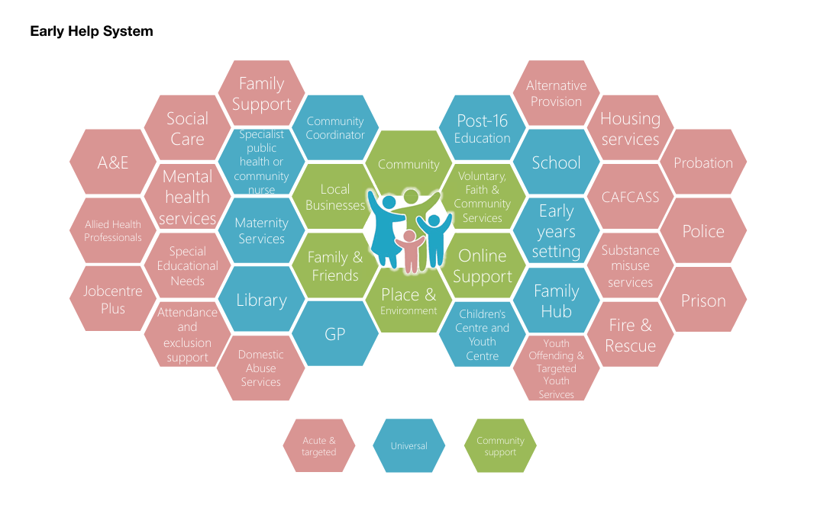
Figure: The Early Help System: universal, community, and targeted/acute services (source: DfE and DLUHC, 2022).
Level | Description of need | Typical response
1 Universal | No additional needs; thriving | Everyday services: health, education, community and online support
2 Early Help | Emerging or additional needs | Early Help Assessment, Lead Practitioner and Team Around the Family
3 Targeted | Complex, multiple needs | Coordinated multi-agency/Family Help support (Children Act 1989, s.17)
4 Specialist | Acute risk or significant harm | Statutory child protection and social care intervention
Table: The continuum of need and the Early Help / Family Help response (adapted from DfE and DLUHC, 2022; DfE, 2026).

Multi-agency and Interdisciplinary Working
Early Help is dependent on working across organisations as no practitioner would see a child's life from start to finish. This is underpinned by a statutory obligation to cooperate to further improve children's wellbeing (Children Act 2004, s.10-11), and the 2026 guidance identifies, as equal partners to safeguarding, the local authority, the police and health (integrated care boards), who have a shared responsibility and information to exchange (DfE, 2026). The guidance also reinforces that sharing information in a proportionate way to keep children safe is not prohibited by data-protection law. Multi-agency and multidisciplinary working both involve different professions working in parallel, but interdisciplinary working involves the knowledge of the various professions being combined into a single assessment and working plan, usually provided by a Lead Practitioner, working under the lead of a Team Around the Family. It is supported by evidence: a mixed-methods evaluation identified that multi-disciplinary teams supporting social care can enhance the outcomes for families on the ‘edge of care' and decrease the risk of costly care entry (Baxter, Boydell and McPherson, 2023). But joint working does not automatically work; it depends on relationships of trust, roles that are clear and good communication (Frost, Abbott and Race, 2015). Effective partnership within a family should begin with earlier identification of the family, a single coordinated plan and less duplication – just what well-designed signposting of the website should do.

Local Authority Website Evaluation
Each website is assessed against five consistent criteria: ease of finding help, plain-language clarity, referral and contact route, safeguarding signposting, and accessibility or format (see Table 2).

Norfolk County Council
The Early Help content is accessed from ‘Children and families’ and presents the reassuring ‘Early help' page with a clear, plain-language message that echoes the national position that early help is better than reacting later (Norfolk County Council, 2025). The council champions a ‘family hubs approach’, offers a 'request early help' service for families, and signposts that a Communities and Partnership team will listen and signpost. The flagship offer is the Early Childhood and Family Service, a tier 2 service within the Norfolk Threshold Guide, and the Family Information Service / the Children's Advice and Duty Service offer signposting across the breadth of services and an access point to the safeguarding front door (0344 800 8020). The key strengths of this are: a well-defined preventative message, phone route is visible, published threshold guide. Fragmentation, the main weakness, is the lack of information being easily located on the council site, a separate community directory, the Family Information Service, the Action for Children service and the safeguarding partnership, making access to help more difficult. The flagship targeted service is similarly geared towards the 0-5 age group, and the availability to older children is less apparent. This dispersion may endanger the contact that Early Help relies on for a stressed rural family, with limited connectivity.

Leeds City Council
Leeds categorises its offer through a task-based ‘Services for families’ gateway which links to the ‘family hubs' as a single place to get help (Leeds City Council, 2025a). Seven family hubs are one place for children from birth to 18 (to 25 for those with SEND) and will have hub managers, social workers and ‘senior family help practitioners' – this already has a national Family Help direction. These are supplemented by 22 school-funded ‘clusters' which coordinate schools at local level, health and social care services and adjoining services like the Money Information Centre, and substance-use support is clearly linked. The council's approach to practice is rooted in simple values, such as ‘the right conversation, with the right people, at the right time’ and ‘Think Family, Work Family’, and its extensive early help provision was recognised by Ofsted, which rated the council's children's services ‘outstanding’ for a third successive time in 2025 (Leeds City Council, 2025b). The strengths are: A single recognisable door, plain language, strong integration and external validation. The key issue is that the terminology of ‘cluster' is a professional term which may not be understood by families, and there are multiple hubs, clusters and a local offer, meaning that there is often a lack of clarity on where to begin. Despite this, one route is clearly marked, decreasing the chances of families leaving one service to go to another.

Tower Hamlets Council
The explanation of Early Help is especially clear for families within Tower Hamlets, which is available under /earlyhelp (or through ‘Health & social care’), and has dedicated sub-pages for the Early Help ‘front door', twelve Children and Family Centres, Best Start Family Hubs and an Early Help Assessment (eEHA) online (Tower Hamlets Council, 2025a). A pathway is explained in the parent leaflet, from assessment to Team Around the Family (TAF), to plan and review, and is emphasised as a voluntary process; a single telephone number (020 7364 5006) is used to route families to help, from the Multi-Agency Safeguarding Hub to urgent concerns. The recent Early Help strategy 2025-2028recent Early Help Strategy 2025–2028, based on the first 1001 days, adds welcome transparency (Tower Hamlets Council, 2025b); the borough’s children’s services were themselves rated ‘outstanding’ by Ofsted in January 2025 (Tower Hamlets Council, 2025c). Focusing on strengths, there is outstanding explanatory depth and clear signposting for safeguarding. Structural weaknesses: content on multiple deep ‘.aspx’ sub-pages, not on accessible web pages; navigation is four or more levels deep; services duplicate. If families have to wade through paperwork to find the excellent explanation, it isn't that valuable.

Comparative Analysis
All three authorities are now providing support via a family hub approach (Table 2) that is in line with the national direction of integrated Family Help (DfE, 2026). The differences are in how accessible and clear they are. The family journey is the shortest in Leeds, where the journey is on one straight and clearly marked gateway with one point of contact. Tower Hamlets has the most detailed explanation of the concept of Early Help, and the most detailed path to safeguarding (even though it is a PDF document and deep into sub-pages), but that lengthens the journey and lowers the mobile and accessibility experience for users with lower literacy and disabled users. Norfolk has the broadest range, but is most divided; there are several portals, and there is a definite 0-5 tilt. Early Help is voluntary, time-sensitive and therefore the convenience of the online journey has a direct impact on the uptake of Early Help. Overall, Leeds communicates Early Help most effectively and is most accessible; a single, clearly signposted gateway shortens the family journey and minimises the risk of a family giving up before reaching Early Help; Tower Hamlets offers the fullest explanation but compromises accessibility. This judgement is made from a desktop inspection of the sites at the time of assessment, and does not involve a full audit of accessibility or test actual end-user journeys.
Criterion | Norfolk | Leeds | Tower Hamlets
Ease of finding help | Moderate; dispersed | Strong; single gateway | Moderate; deep menus
Plain-language clarity | Good | Good; minor jargon | Excellent explanation
Referral/contact route | Phone + request form | Hub single contact | One number + eEHA
Safeguarding signposting | Via CADS | Present | Clear MASH route
Accessibility/format | Multiple portals | HTML task pages | PDF-reliant
Table: Comparative summary of Early Help web communication across three authorities (author’s analysis).

Conclusion and Recommendations
The three authorities are aiming to be a ‘hub-based Family Help’ and are making good progress in different ways – in accessibility in Leeds; in explanation in Tower Hamlets; but the authority has been hampered by fragmentation in Norfolk. There are multiple steps which can be taken that would facilitate families to receive support sooner. Norfolk needs to streamline and brand the Early Help material to provide one landing page with branding for the 0-19/25 age spectrum with one large ‘get help now' button and reduce the number of individual portals. Tower Hamlets needs to update key leaflets and strategy summaries to be accessible on the web, standardise how navigation is used, and create a one-page ‘visual pathway’. Leeds should include a brief definition of ‘clusters' and a postcode search tool to locate the nearest cluster. In all three, there must be protection and emergency contact details displayed on all pages of Early Help; content must be designed and built for use on a mobile device first, made accessible, and content must be in community languages. There are some design differences, which for families, could be a difference between asking for help early and in crisis.

Reference List
Baxter, V., Boydell, V. and McPherson, S. (2023) ‘Multi-disciplinary support for families with complex needs and children on the edge of care in the UK: a mixed methods evaluation’, Journal of Social Welfare and Family Law, 45(4), pp. 307–325.
Children Act 1989, c. 41. Available at: https://www.legislation.gov.uk/ukpga/1989/41 (Accessed: 14 August 2026).
Children Act 2004, c. 31. Available at: https://www.legislation.gov.uk/ukpga/2004/31 (Accessed: 14 August 2026).
Department for Education (2024) Supporting Families programme: annual report 2023–2024. Available at: https://www.gov.uk/government/publications/supporting-families-a-foundation-for-family-help-annual-report-of-the-supporting-families-programme-2023-2024 (Accessed: 14 August 2026).
Department for Education (2026) Working together to safeguard children 2026: a guide to multi-agency working to help, protect and promote the welfare of children. Available at: https://assets.publishing.service.gov.uk/media/69fb1c28d0e316a40f269a5b/Working_together_to_safeguard_children_2026_a_guide_to_multi_agency_working.pdf (Accessed: 14 August 2026).
Department for Education and Department for Levelling Up, Housing and Communities (2022) Early Help System Guide. Available at: https://assets.publishing.service.gov.uk/media/628de13be90e071f5f7e1bd2/Early_Help_System_Guide.pdf (Accessed: 14 August 2026).
Frost, N., Abbott, S. and Race, T. (2015) Family support: prevention, early intervention and early help. Cambridge: Polity Press.
Leeds City Council (2025a) Services for families. Available at: https://www.leeds.gov.uk/children-and-families/services-for-families (Accessed: 14 August 2026).
Leeds City Council (2025b) ‘Outstanding’ Ofsted three in a row for Leeds’ Children and Families services. Available at: https://news.leeds.gov.uk/news/outstanding-ofsted-three-in-a-row-for-leeds-children-and-families-services (Accessed: 14 August 2026).
NSPCC Learning (2026) Early help and early intervention. Available at: https://learning.nspcc.org.uk/safeguarding-child-protection/early-help-and-early-intervention (Accessed: 14 August 2026).
Norfolk County Council (2025) Early help for children and families. Available at: https://www.norfolk.gov.uk/children-and-families/early-help (Accessed: 14 August 2026).
Tower Hamlets Council (2025a) MAST Early Help and Children and Families Service. Available at: https://www.towerhamlets.gov.uk/lgnl/health__social_care/children_and_family_care/Early_Help/Early-Help-and-Children-and-Family-Service.aspx (Accessed: 14 August 2026).
Tower Hamlets Council (2025b) Early Help Strategy 2025–2028. Available at: https://www.towerhamlets.gov.uk/News_events/2025/October/Tower-Hamlets-launches-ambitious-strategy-to-support-families.aspx (Accessed: 14 August 2026).
Tower Hamlets Council (2025c) ‘Outstanding’ Ofsted rating for Tower Hamlets. Available at: https://www.towerhamlets.gov.uk/News_events/2025/January/Outstanding-Ofsted-rating-excellent-for-Tower-Hamlets.aspx (Accessed: 14 August 2026).

