Sanwar Ali Ahmed

Introduction to Computer Systems
ACCA4021

OS install and setup

Table of content:
1: Installing Oracle virtual box, virtual machine and ISO File
2: Device manager
3: Virtual hard drive partition
4: Conclusion
5: Bibliography

1: Installing Oracle virtual box, virtual machine
First process of process is installing article virtual box on a window machine,
Second part of installation is obtaining Windows operating system as ISO File
In this installation, I have chosen windows 7 64 bit.

Once you launch virtual machine, it will ask you to name your machine,
I have named my machine Sanwar Windows 2008 VM,

It will prompt you to which folder is ISO file for installation,
This will be then confirm underneath stating which folder and file name.
I’ve needed to click on skip unintended insulation, to proceed,
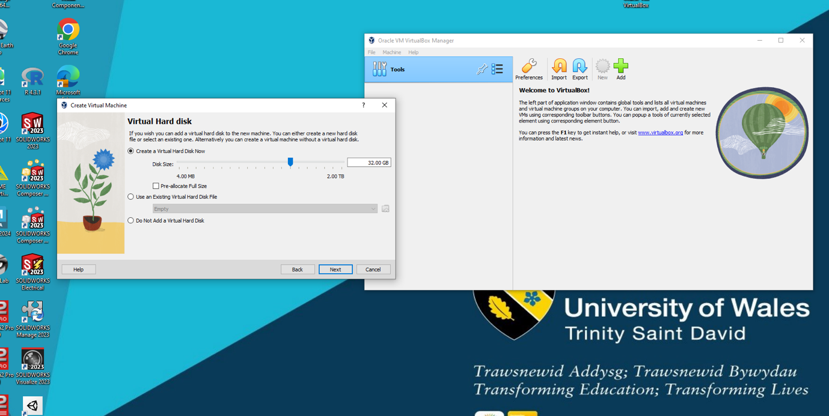
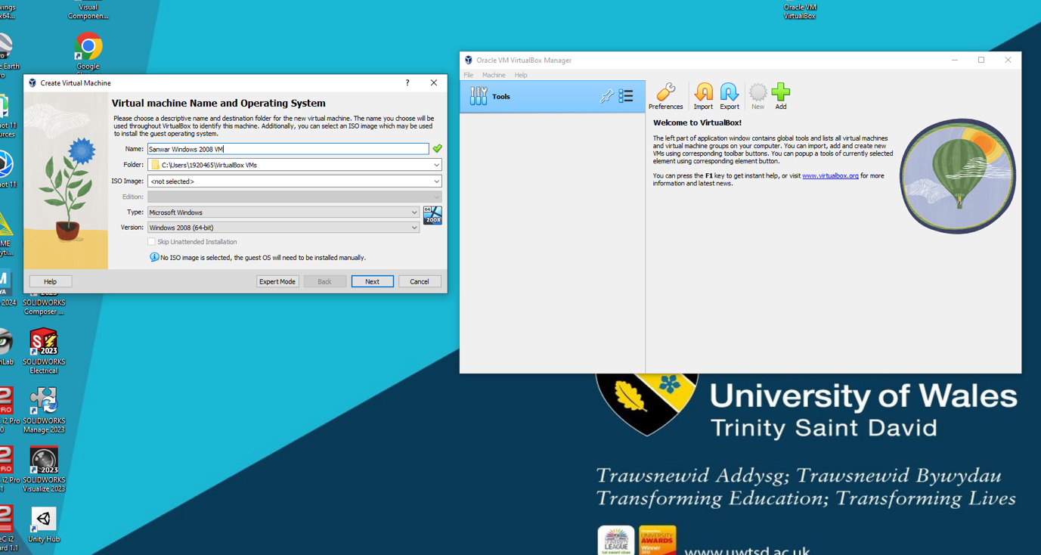
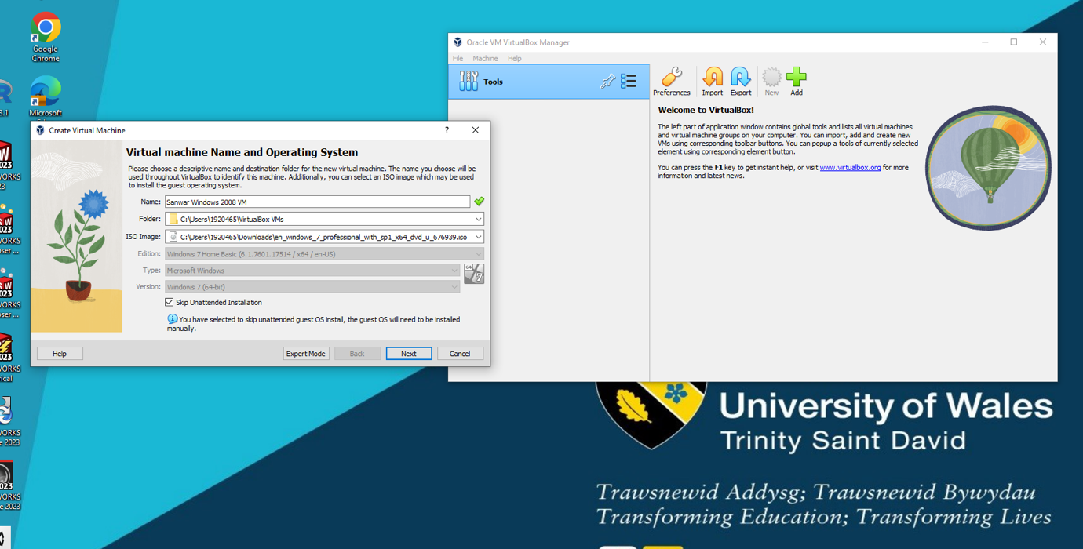

After this process I allocated 32 Gig Hard drive, Ram, and CPU Cores,
I have chosen 4G Ram and 4 CPU because this is sufficient for experimentation,
However, if this was a real case scenario, this will be determined in the real CPU Core you have on your actual machine and ram, for example if you were to allocate 4 CPU Cores you would advisable to have 8 CPU on your physical machine for headroom.
This will be a similar set up RAM allocation.

My understanding is these are virtual allocations once virtual box is closed your physical PC hardware is not allocated.

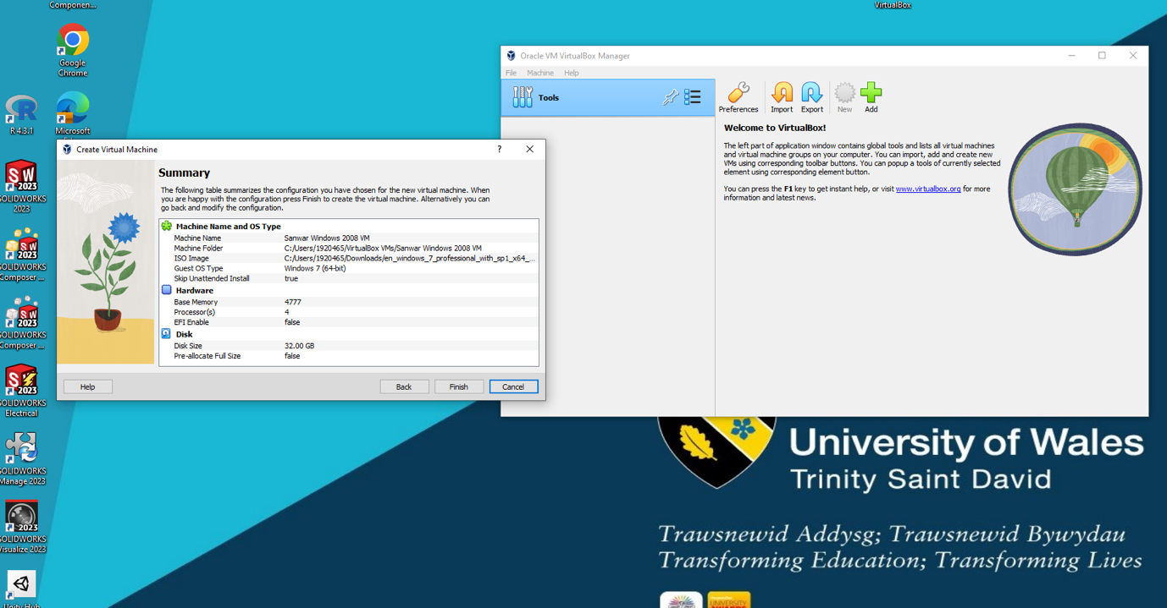

Once all allocation setting has been provided, then you are proceeded to virtual installation of windows,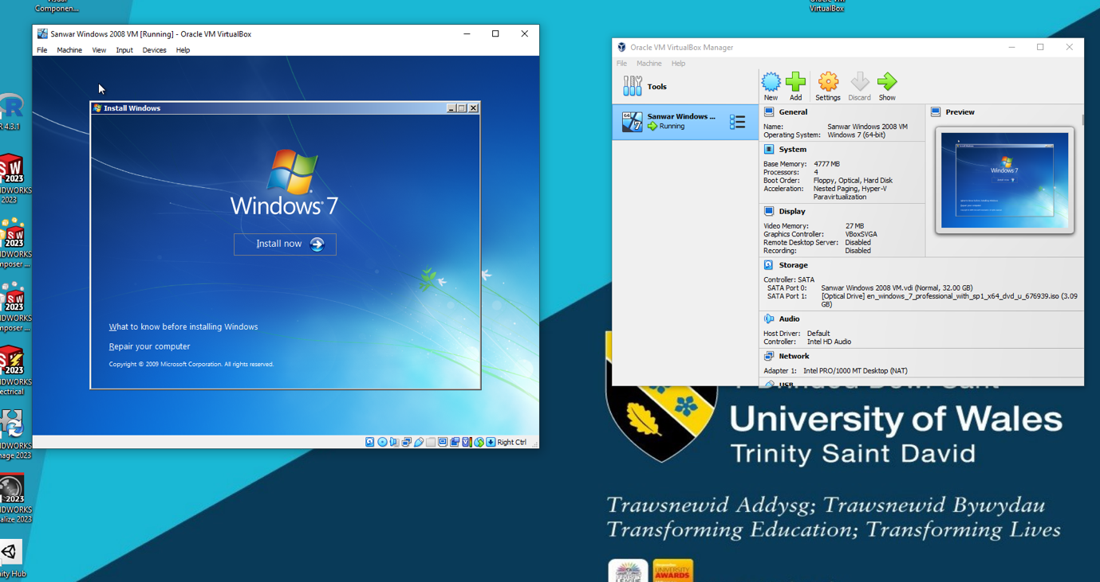

After after successful installation, I proceeded to tried to go online via window explorer,
Which I need to change some settings for this to work, didn’t work out of the box,
I’ve to switch network bridge connection, which didn’t work reverting back to NAT worked,
I was able to go online and successfully install Chrome browser,
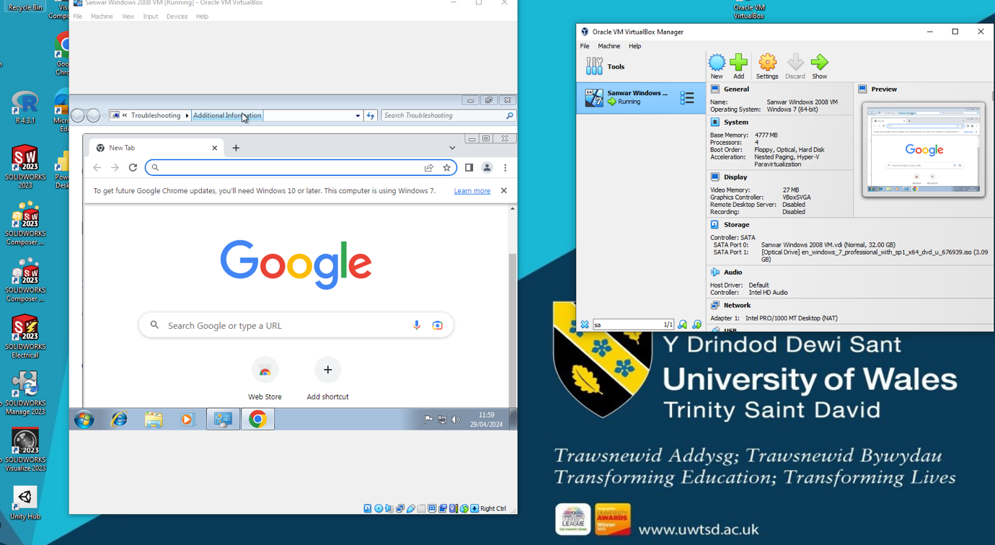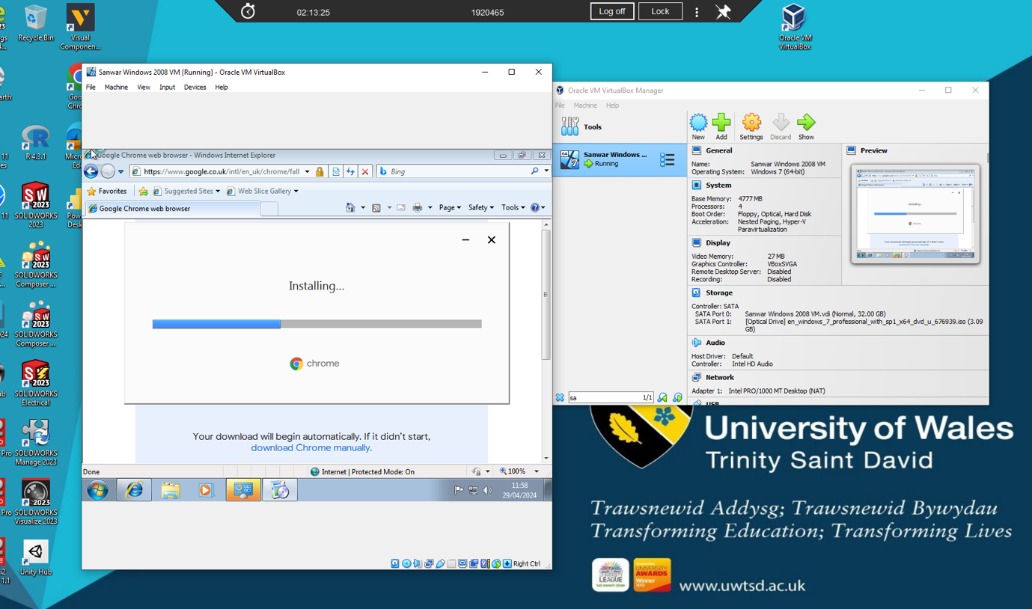

2: Device manager

Checking device manager in virtual machine, there was an outstanding issue, Driver for base system device, no software update or driver available from Windows updates, this issue remains time of testing, unable to identify which hardware it was referring to, further investigation needed.
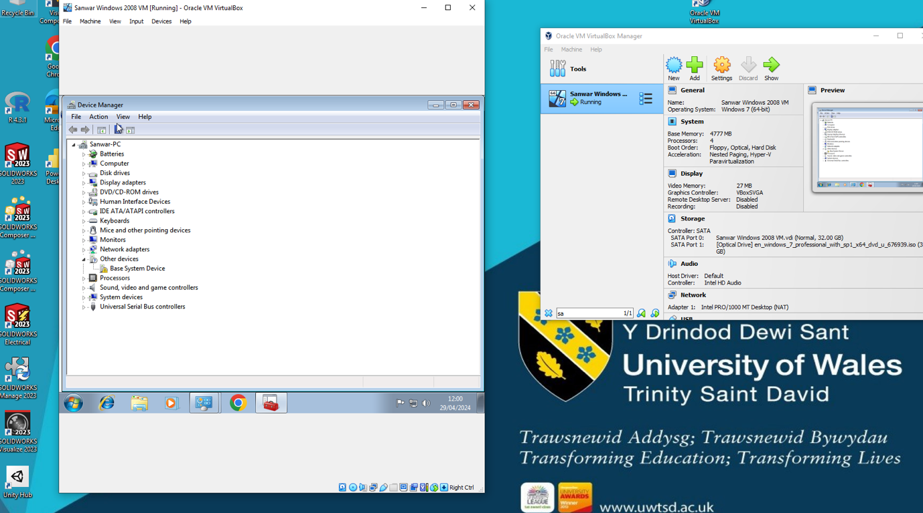

3: Virtual hard drive partition

I have successfully partitioned the virtual hard drive into two drives as instructed, this was done under control panel/ administration proceeded to shrink to drive,The new drive is identified as E,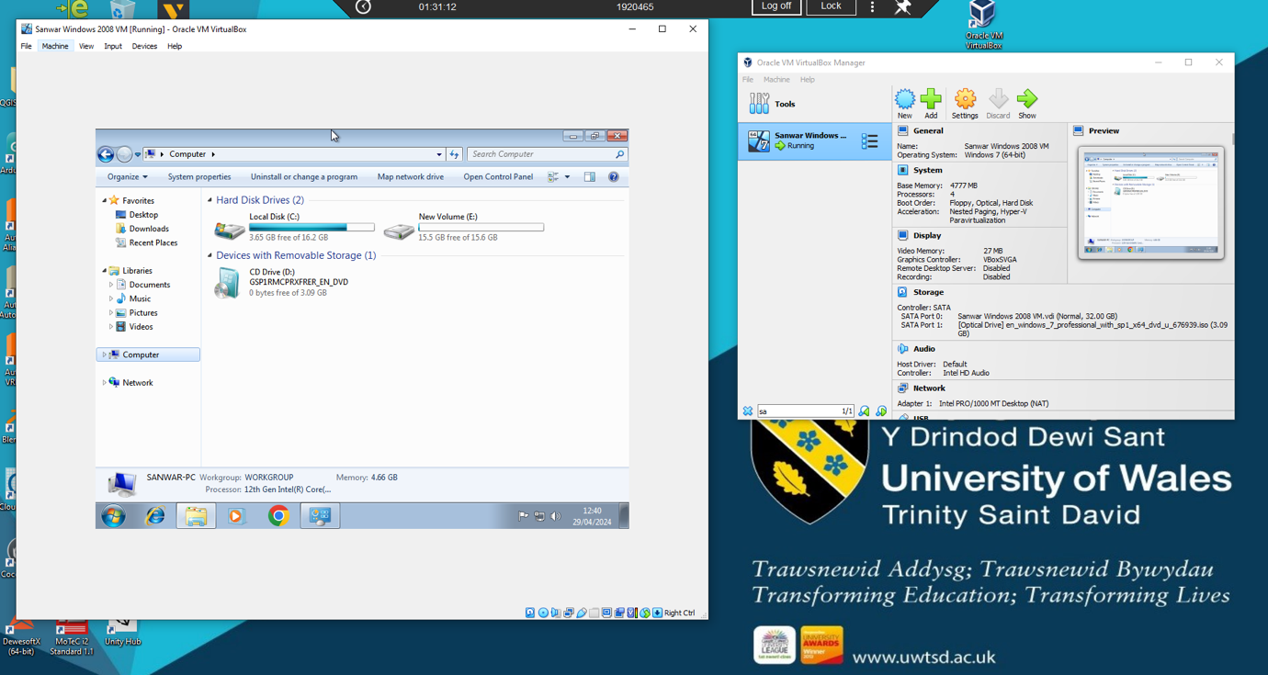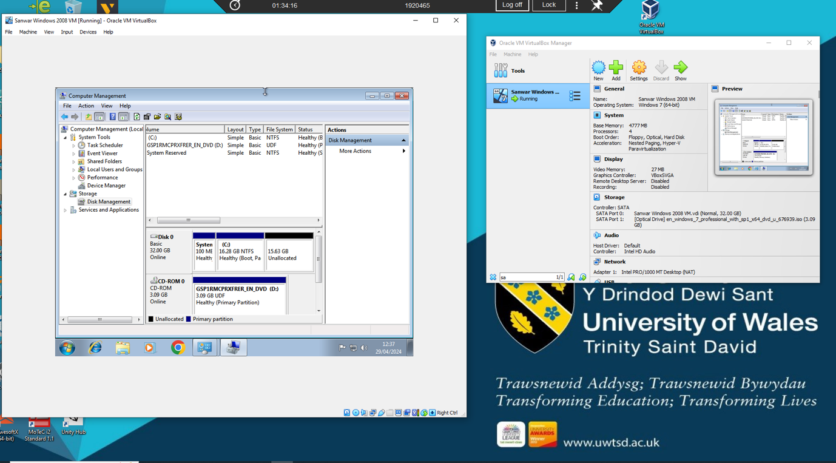

4: Conclusion

Virtual box is vital and necessary to the operation of old hardware and software in industries, this will allow for further continuous operations without needed to replace hardware and software which could be considerable sums of money, businesses put on pause due to this upgrade, the solution is virtual machines, interacting with original hardware with original software under emulation, this will give expanded life without changing the hardware or software,

Another use case for virtual machines, you can test programs without affecting the host machines such as viruses, for example you can run a virtual window 11 in virtual machine, test programs as this will be sandboxed and isolated from the host machine,
Another wide usage of virtual machine would be using partial allocation of the host machine, virtual private machine, for example, if I needed to rent a computer from the cloud,
A set up of 4 gig Ram, 2CPU, 64 Hard dive, Windows server, this will typically sell for £18 per month to the end user, this will be accessed via his PC Or tablets.
In the above example a user would need a software running 24 hours uninterrupted with electricity and Internet connection, effectively renting out virtual machines depending on requirements similar to the installation process of allocating CPU/RAM and hard drive, some cloud providers offer GPU access,

“A virtual machine in cloud computing is a software-based representation of a physical computer that can run an operating system and applications, and perform tasks just like a traditional hardwired device. This technology allows multiple independent virtual machines to coexist on a single physical host while providing innumerable benefits to organizations and users alike” [1]

Linux operating system is available which is far cheaper than windows due to licensing premium, however, with Linux operating system technical knowledge is required, which is not suitable for everyone, if we compare the same configuration as above, but with Linux operating system would be at least 60% to 70% cheaper which is open-source software.

A recently development is MacBooks running macOS, they are able to run windows operating system within macOS with a software called parallel, enabling Mac users to run windows software on their MacBook with Apple Silicon,
WEBLINK: parallels.com

Sanwar Ahmed

6: Bibliography

[1] | scalecomuting, "https://www.scalecomputing.com," 25 09 2023. [Online]. Available: https://www.scalecomputing.com/resources/exploring-uses-benefits-and-types-of-virtual-machines. [Accessed 29 04 2024].

