BLOGGING TO COMMUNICATE

Blog 1: Understanding Samsung’s Strategies
The marketing mix is a strategy of the business used by the business to increase the sales of the products of the business. In the marketing mix, there are a few of the factors present for the business which shape the promotion of the product and help to increase the sales of the products. Price is one of the major factors of the marketing mix. In the case of Samsung, for the products of Samsung, price plays a major factor. Samsung is able to provide the products to the customers at a lower price than their competitors and it helps to increase the popularity of the product.
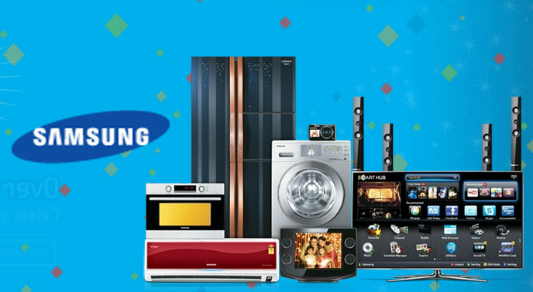
(Source: Samsung, 2021)
Product is another factor of the marketing mix, in case of Samsung; they are in the business of electronic goods, giving preferences to the mobile phone segment. The product of Samsung is very much popular, as the features provided by the company are very much useful and those products are available at less prices compared to other company’s products (Tien, 2019). Promotion is another major factor of the marketing mix. Since Samsung is in the most competitive market, hence, promotion is the only way of increasing the sales value and making a large number of customers interested in the product. Through various platforms, Samsung promotes its product to capture a large number of audiences across the globe. Along with all those, another parameter of the marketing mix is place. Place plays a major role in the growth of any company. Samsung and its products are present almost all across the globe. Apart from that, the products of Samsung are also available on the online platform as well.

Blog 2: Know the customers of Samsung!
To improve the promotional activity, segmentation of the market is crucial. Samsung, as per the market and their products, the company has segmented the whole market into a few of the segments and those market segments help Samsung to promote their products as this can be able to provide them with a better idea about the customers and the need of the products to those customers. Among many other segments, demographic segmentation and behavioural segmentation works mainly for the sales of the products for Samsung.

(Source: Samsung, 2021)
Through demographic segmentation, the customers or the market is distributed on the parameters of age, income, gender, occupation and many more (Nurwalia and Shofa, 2017). It has been discovered that the younger generation is more attracted to Samsung. Irrespective of gender the Samsung products are popular across the globe. Behavioural segmentation plays a major role in the growth of a company like Samsung. Within behavioural segmentation, purchasing habits, spending habits and customer loyalty are the factors. The customers of Samsung and the business or the promotion of the products of Samsung are mostly dependent on this segmentation. There are a large number of customers who are loyal to the brand and use only the products of Samsung. Purchasing habits also help to improve the sales number over time. There are customers who used to purchase Samsung products very frequently. Those frequent purchases of the products help to increase the sales of the products and it helps to increase the revenue for the company as well.

Blog 3: Who is Samsung targeting now?
Targeting is an activity of marketing through which the company targets a specific group of customers for selling their products. Samsung also targets their customers whom they can sell their products to. After segmentation of the product the next phase of the marketing is targeting the customers. For most of the products, all the people in the locality are not the potential customers. Hence, it is important for the business to identify the customers who want to have the products of Samsung.

(Source: Samsung, 2021)
From a survey, it is seen that the customers of different age groups are the potential customers for of Samsung products (Nurwalia and Shofa, 2017). However, in preference it can be said that the young generation people who are a little bit choosy about the technology are mainly the customers of Samsung. Samsung as a company targets the younger generation people more compared to other age groups. However, the business has their customers from all ranges of age groups. Actually targeting the customer helps to implement the promotional strategy of the business and Samsung has a huge set of potential customers, hence Samsung has to only focus on the improvement of the products so that all the customers of different age groups get satisfied and the promotions of the products can also be done combinedly.

Blog 4: Positioning
Once the targeting of the product is done, the next stage is to position the products. Samsung positions their products in such a way that the customers remember the products of Samsung as low cost and the technology provided to the product is of latest in time (Ishigai, 2020). This kind of positioning of the products help Samsung to attract a large number of customers across the globe. Hence, the positioning helps to make an image of Samsung as Samsung comes up with the latest technology at an affordable price and over the years, Samsung becomes the strongest competitor of Apple. It led the market in the first three quarters in 2019 (Business Standard, 2020).
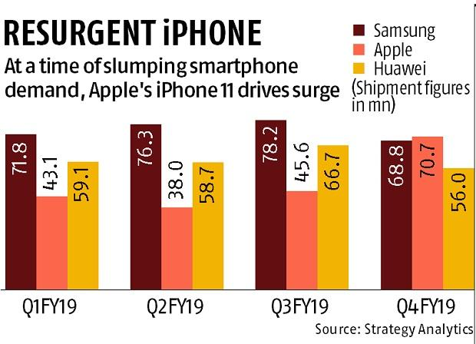
(Source: Business Standard, 2020)
Apple is also known for the implementation of latest technologies to their products. However, the price of the Apple products is not economical and it is not also affordable by the mass people. Samsung successfully finds this gap and Samsung makes an image fulfilling the gap by providing latest technological products to their customers at the economical price so that every person can get access to the products. This is the unique selling proposition of Samsung and through this unique selling proposition, Samsung become one of the major market leaders in the field of mobile manufacturer. With the help of this positioning technique, Samsung promotes its products and makes a large number of customers for their products all across the globe.

Blog 5: This is how Samsung engages with its customers
This particular company Samsung follows a very efficient marketing communication model. This particular company has conducted many workshops for its employees to improve the overall marketing communication process. This is because the marketing communication process is a very essential process for improving the overall number of target customers in a particular company (Camilleri, 2018).
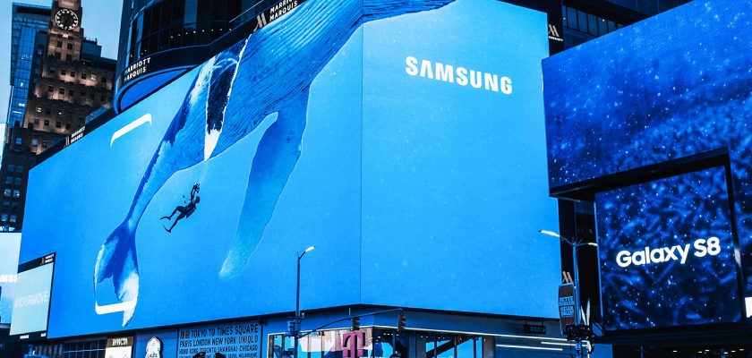
(Source: Camilleri, 2018)
Samsung always focuses on improvements in market communication so that it can gain more loyal customers in the entire global market. This is a very essential aspect that needs to be considered so the management of this particular company is taking this particular aspect very seriously. Without proper marketing communication the image of this particular company shall never improve so it is working a lot to improve the overall marketing communication aspect. There are various different aspects of marketing communication. Proper marketing communication is always done with proper levels of clarity. The client must have absolute clarity about the product and whether the product is useful to him or her. Through proper marketing communication it was very important to convey to the various clients that the products of Samsung are really efficient and also very Long lasting in nature (Villanova et al, 2021). This was a very important factor for marketing communication. Without proper levels of marketing communication proper advertisement of a particular product can never be possible. So this particular company Samsung is focusing on this aspect to a very big extent.
Blog 6: Marketing campaign
- attacking the company campaign- This particular company has always competed with the company apple for increasing their overall customer base. This was a very important strategy since Apple is a very big multinational company (Moth, 2021). So to compete with Apple Samsung they needed to be excellent in all the different approaches of marketing. This was something they proved to their customers and it was a very successful marketing campaign.
- Over to you campaign- This particular approach mainly focuses on the company’s utilisation of various types of online or social communities for launching their different products. In this particular approach they made use of the various digital platforms to promote their different products to a wide range of clients across the world. It was a very successful marketing campaign and Samsung could gather a huge number of loyal customers through this particular marketing campaign across the world.

(Source: Moth, 2021)
- Incredible art piece campaign- This particular company has promoted many new products that are not only efficient but also have an artistic look. For example the Galaxy Note pen stylus of this particular company is an electronic gadget that is not only very efficient to work with but it also looks very stylish (Moth, 2021). This type of marketing campaign was very useful for this particular company since it attracted a huge number of customers from across the world. Such products were also launched in various types of digital applications so that more and more people are attracted to these products. It was a very successful marketing campaign using which this particular company could gain a huge number of loyal customers. This was an incredible campaign using which the company could make huge profits.

References
Journal
Camilleri, M.A., 2018. Integrated marketing communications. In Travel marketing, tourism economics and the airline product (pp. 85-103). Springer, Cham. Available at:https://www.um.edu.mt/library/oar/bitstream/123456789/21432/5/Integrated%20Marketing%20Communications.pdf
Ishigai, P.A., 2020. Standardization and adaptation in multinational corporations: applied study on Samsung’s marketing mix strategy (Doctoral dissertation). Available at: https://bibliotecadigital.fgv.br/dspace;/bitstream/handle/10438/29092/Patr%c3%adcia-Ishigai-Thesis-vf.pdf
Nurwalia, A. and Shofa, F., 2017. The influence of segmenting strategy and brand positioning strategy on consumer purchasing decision (Study At Smartphone Samsung In Indonesia). Available at: https://core.ac.uk/download/pdf/188770483.pdf
Tien, N.H., 2019. International distribution policy comparative analysis between samsung and apple. International journal of research in marketing management and sales, 2020(1), p.2. Available at: https://www.researchgate.net/profile/Nguyen-Tien-32/publication/338719419_International_distribution_policy_comparative_analysis_between_samsung_and_apple/links/613c55f401846e45ef3e4a14/International-distribution-policy-comparative-analysis-between-samsung-and-apple.pdf
Villanova, D., Bodapati, A.V., Puccinelli, N.M., Tsiros, M., Goodstein, R.C., Kushwaha, T., Suri, R., Ho, H., Brandon, R. and Hatfield, C., 2021. Retailer Marketing Communications in the Digital Age: Getting the Right Message to the Right Shopper at the Right Time. Journal of Retailing, 97(1), pp.116-132. Available at: https://www.researchgate.net/profile/Ronald-Goodstein/publication/349384851_Retailer_Marketing_Communications_in_the_Digital_Age_Getting_the_Right_Message_to_the_Right_Shopper_at_the_Right_Time/links/6043114d299bf1e0785af809/Retailer-Marketing-Communications-in-the-Digital-Age-Getting-the-Right-Message-to-the-Right-Shopper-at-the-Right-Time.pdf

Website
Business Standard, 2020, Samsung position, available at: https://www.business-standard.com/article/companies/apple-samsung-in-close-competition-for-title-of-top-smartphone-seller-120013001871_1.html [Accessed: 2nd December 2021]
Moth, D., 2021, marketing campaigns, available at: https://econsultancy.com/eight-inspiring-digital-marketing-campaigns-from-samsung/ [Accessed: 2nd December 2021]
Samsung, 2021, about the com, available at: https://www.samsung.com/uk/ [Accessed: 2nd December 2021]

