DS 1 Template

My Screenshots/Photos
- Please add 4–6 screenshots or photos of your digital life.
- You can use your phone or laptop.
- For each screenshot, write one or two sentences explaining what it shows.

Screenshot/Photo 1
[Insert Photo/Screenshot below]
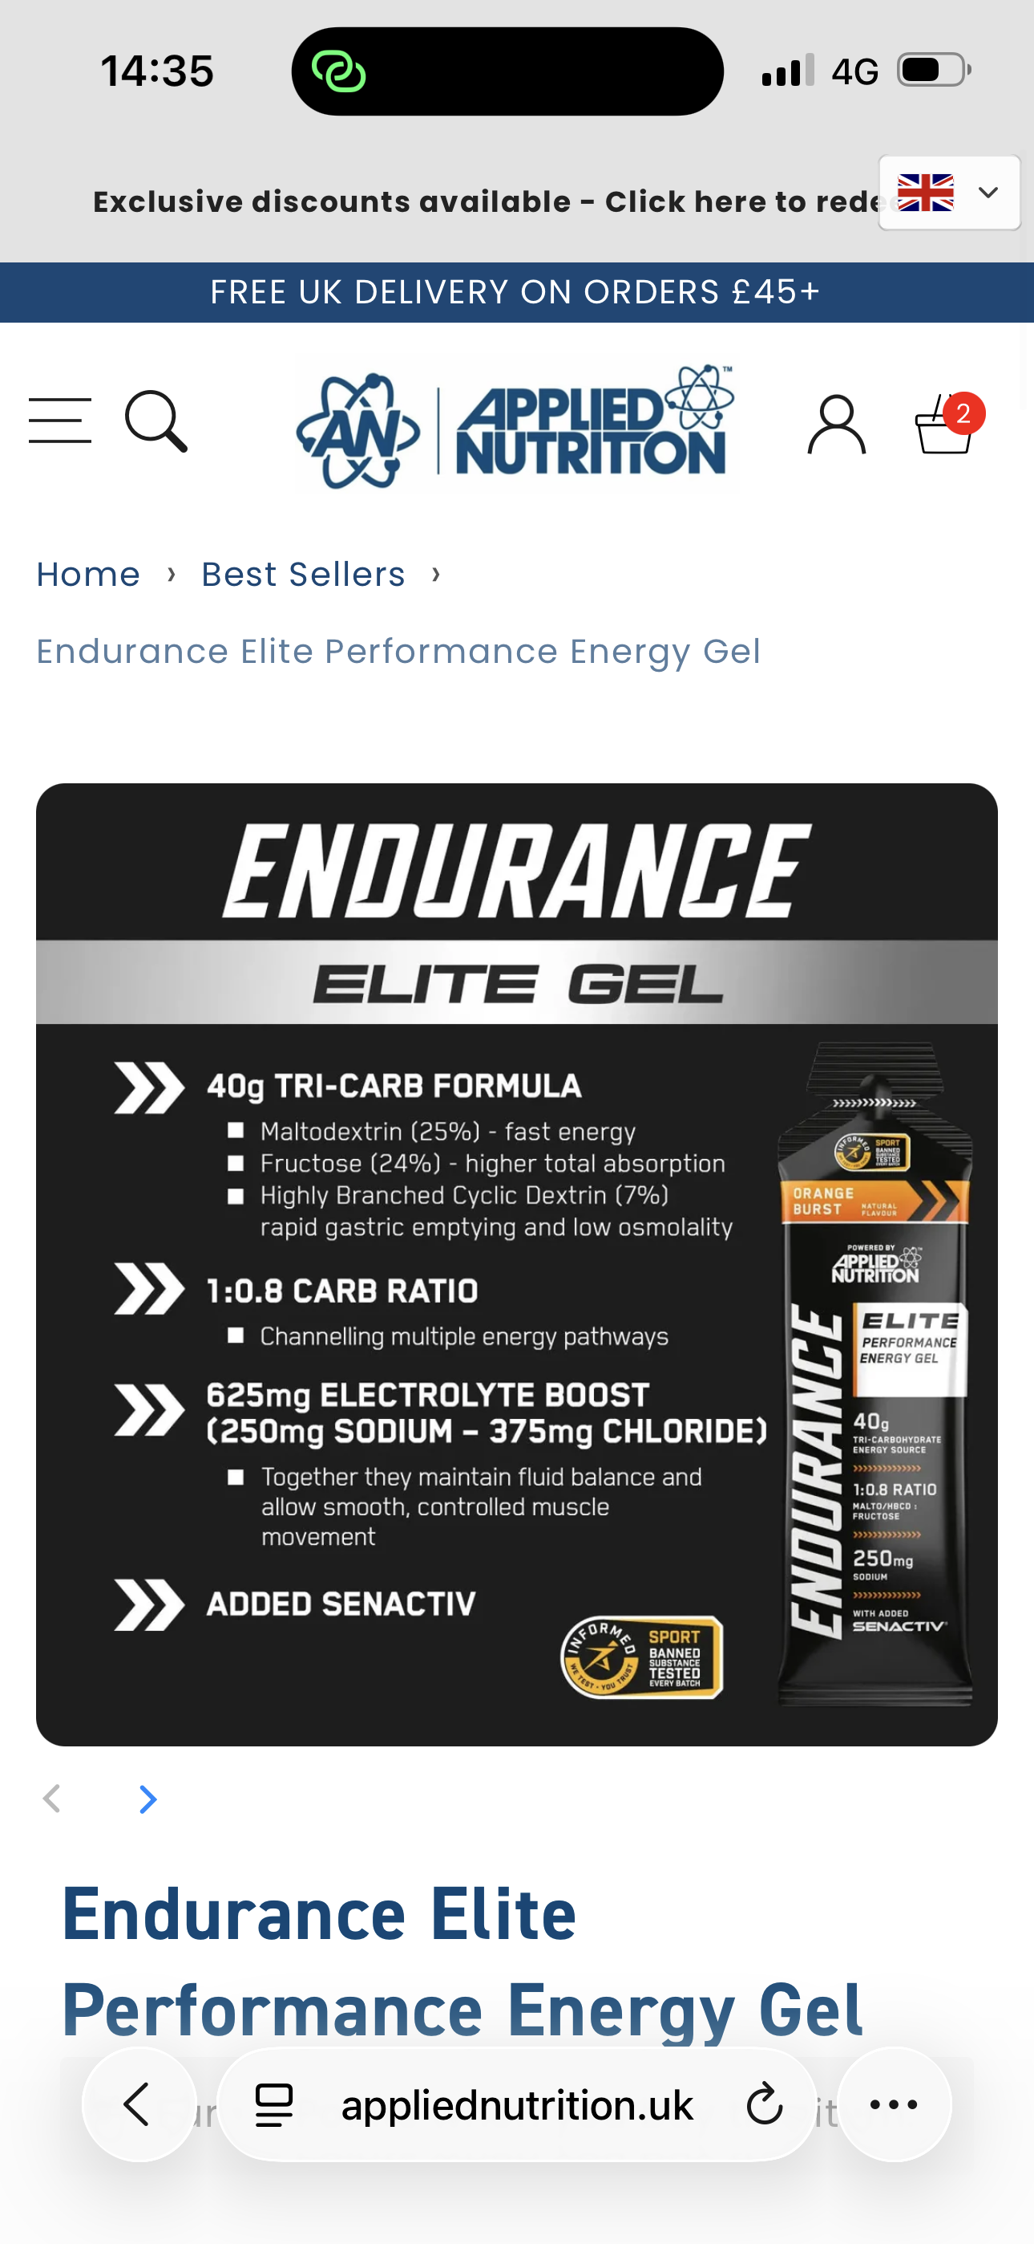
The picture shows an energy gel that you use for gym. It is made by nutrition applied and you can see the companys logo on top of the page

Screenshot/Photo 2
[Insert Photo/Screenshot below]
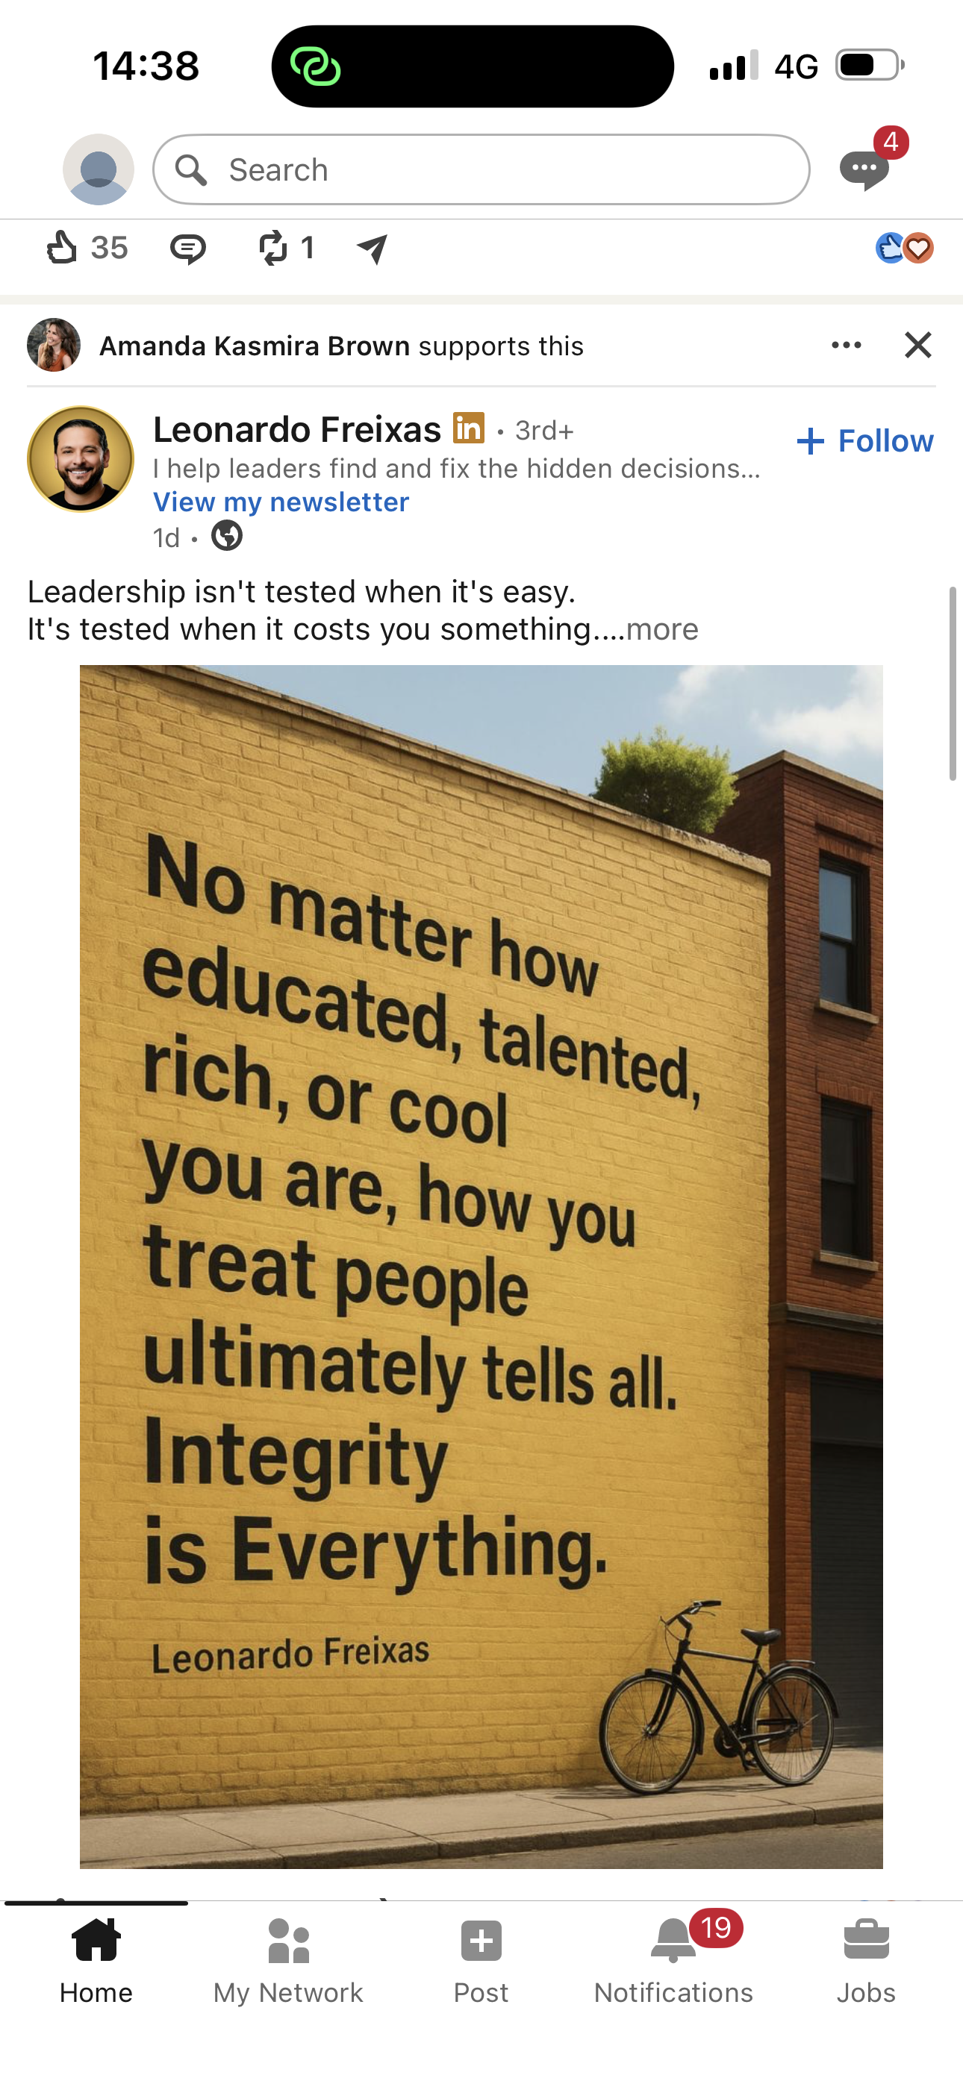
The picture It is been choice from linkedin and it says something about leadership and integrity. Basically it says that you need to be respectful for the others.

Screenshot/Photo 3
[Insert Photo/Screenshot below]
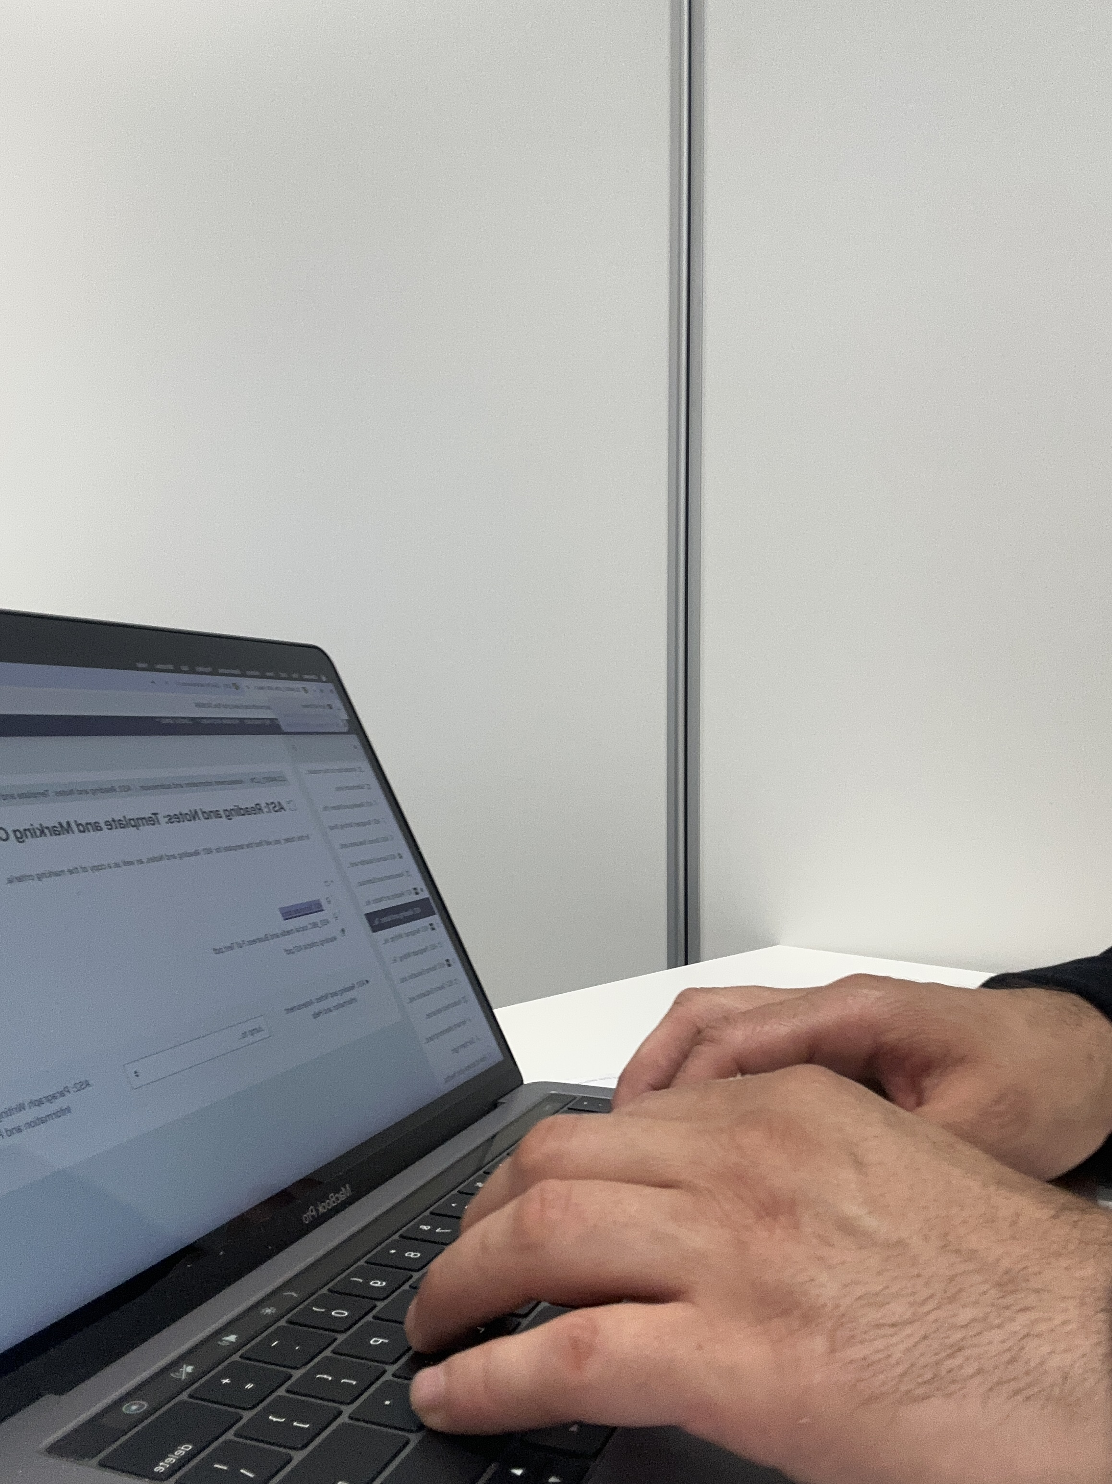
This picture shows me in the class doing some uniwork.

Screenshot/Photo 4
[Insert Photo/Screenshot below]
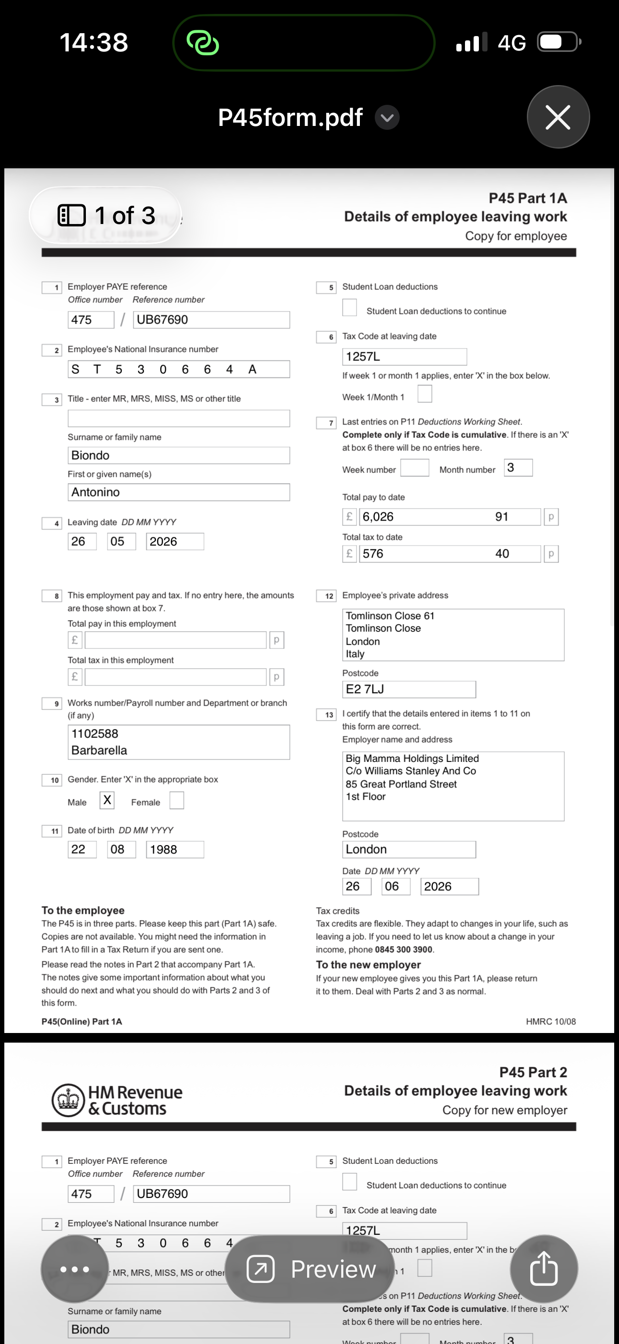
This picture shows my own p45 that it got information as tax code, national insurance numbers ecc… (please delete it once you check the asigment)

Screenshot/Photo 5
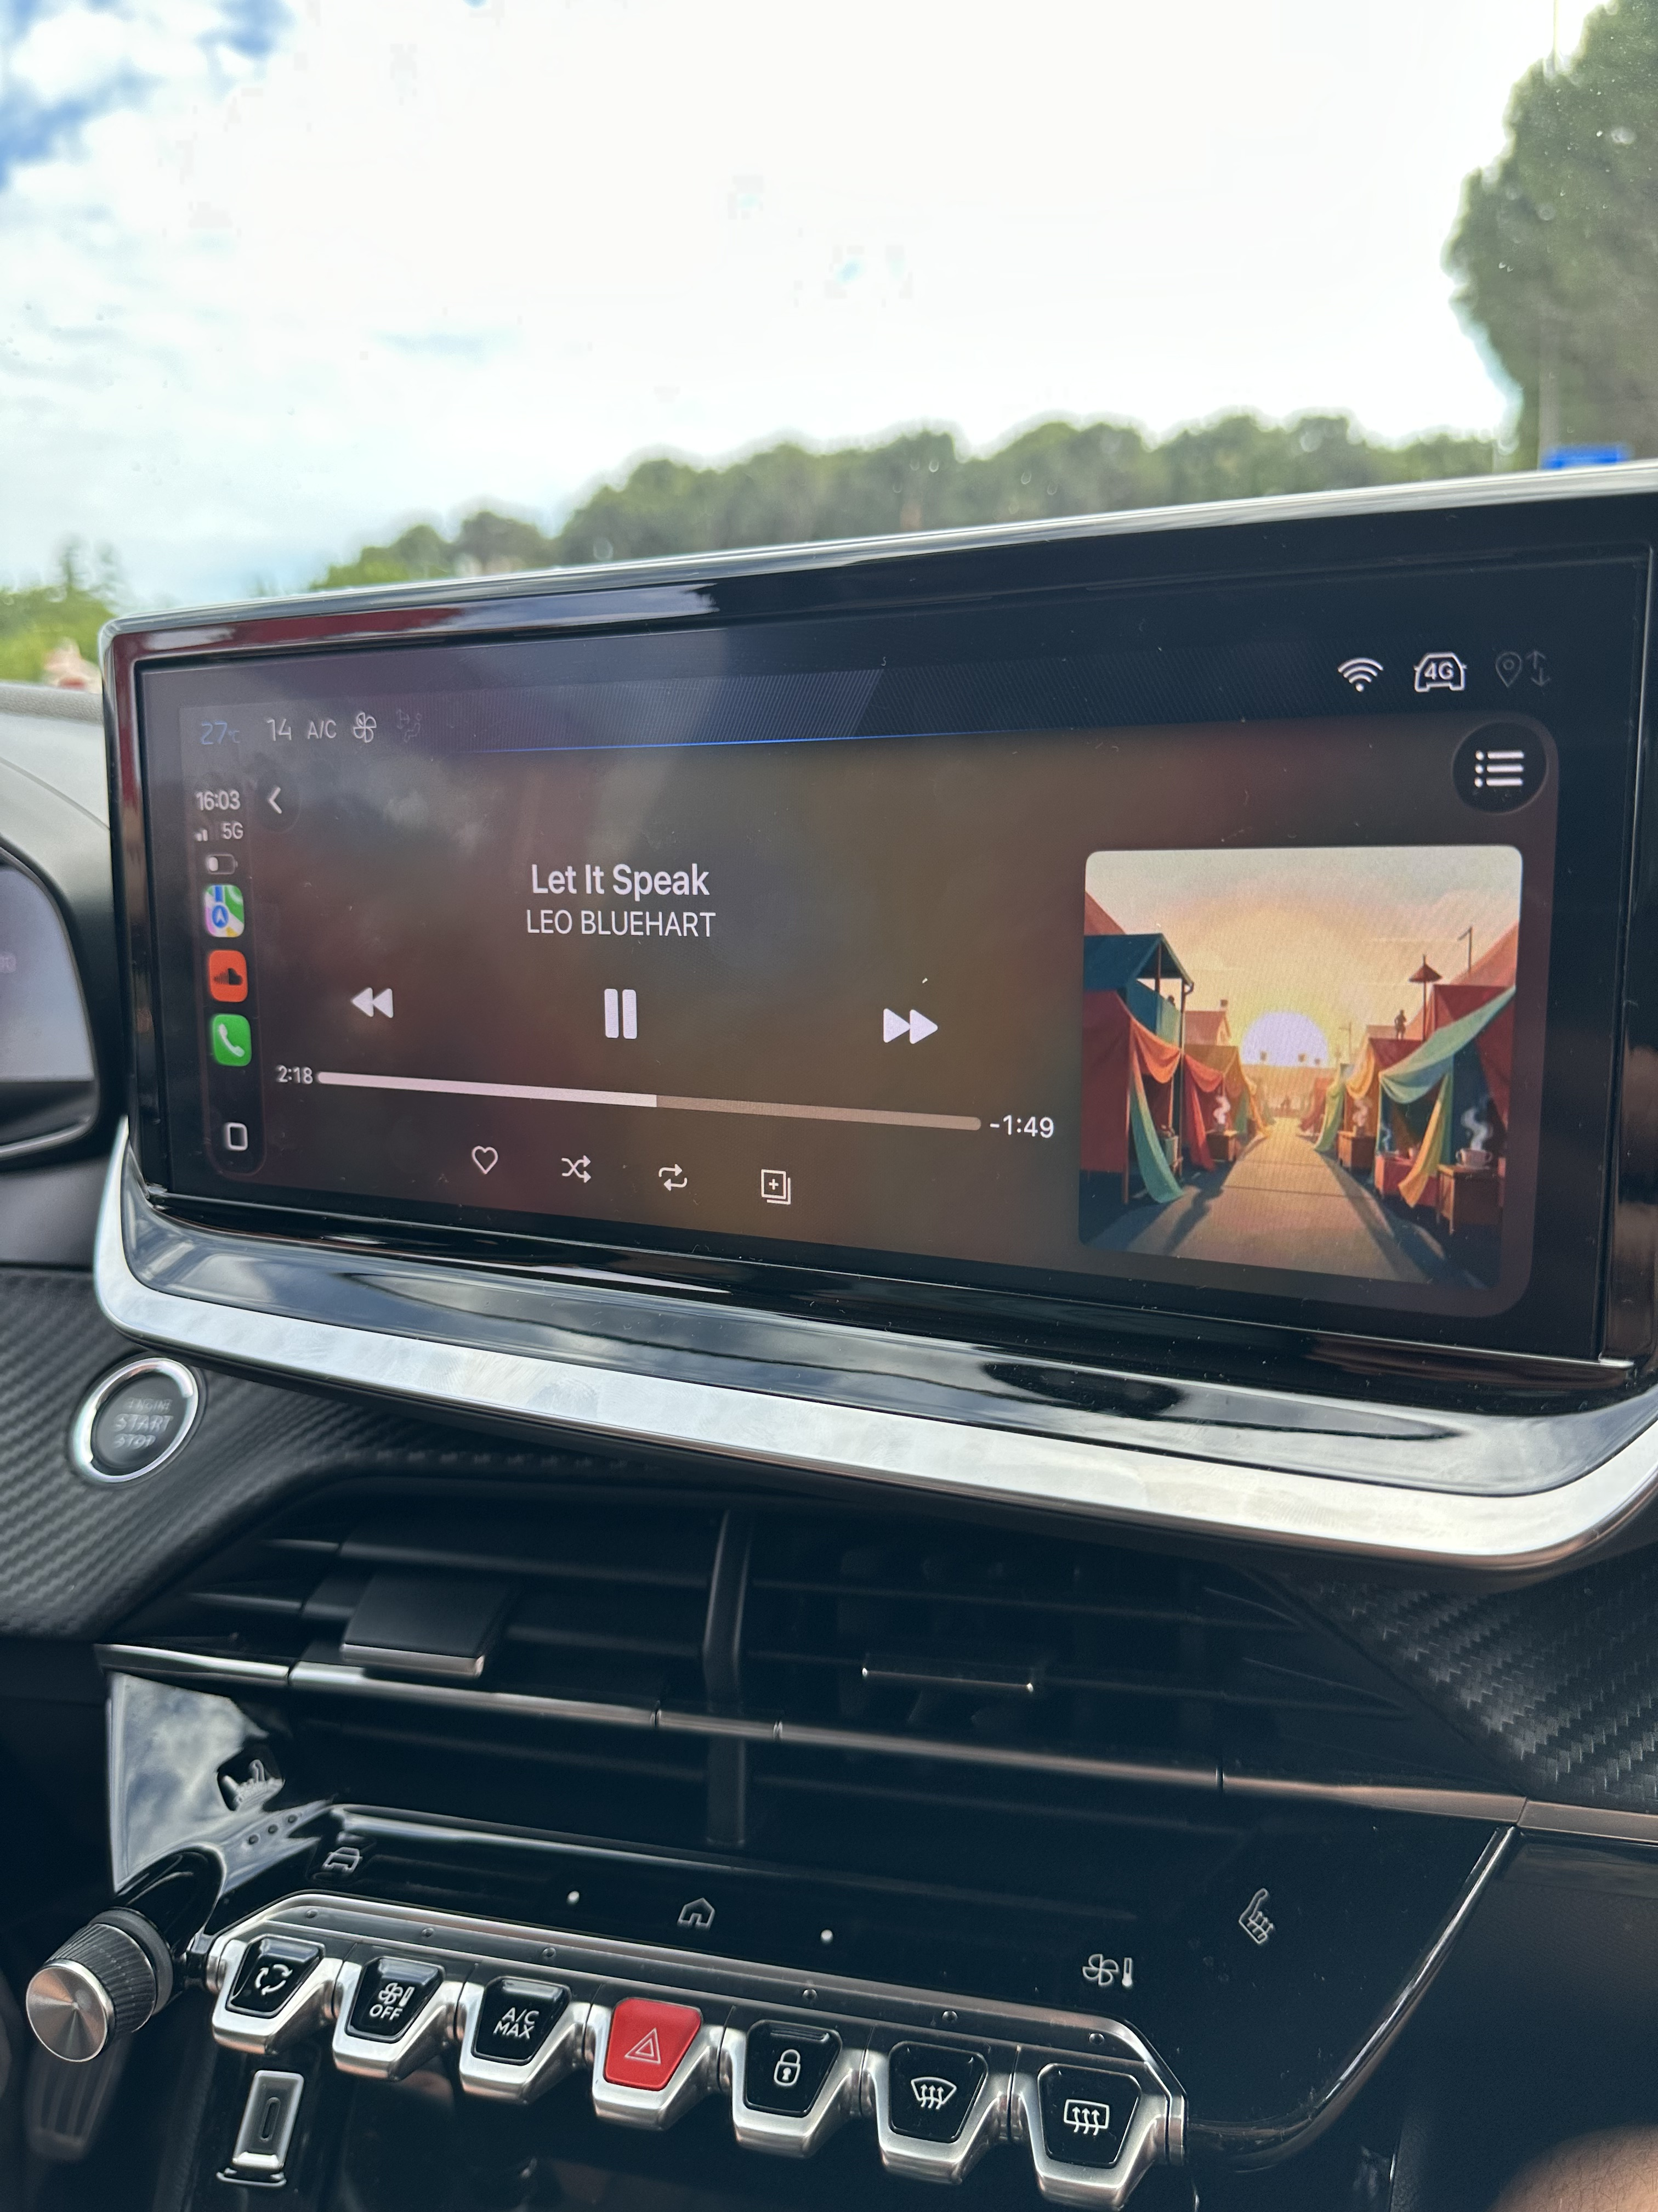
This picture shows music play on my car that I normally listen while driving every day to back home.

Screenshot/Photo 6
[Insert Photo/Screenshot below]
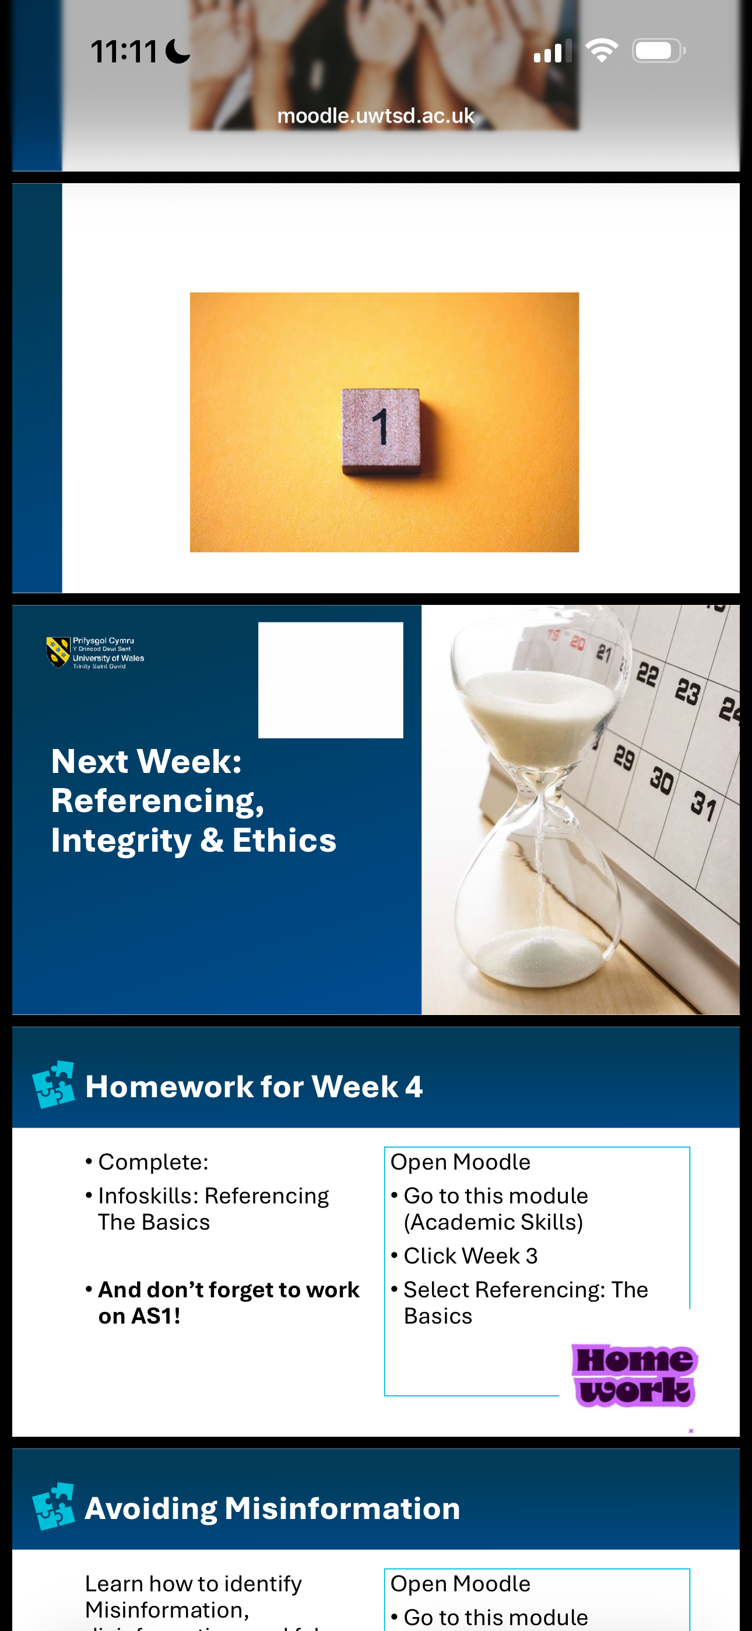
This picture shows my moodle website for university.

My Short Reflection
- Write 5–8 simple sentences about your digital life.
- You can use the sentence starters below if helpful.
Normally I use digital tools everyday, to listen my music and see news on linkdin and search general information I also use moodle to complete my home work. I also navigate in the website to check my work document ecc..

Sentence starters
- I use digital tools to …
- I feel confident when I …
- I want to improve …
- I often use these tools: …
- I sometimes feel nervous about …
- I hope this module will help me …
- Digital skills are important for me because …
You can write more if you want.

Submission Checklist
Before you submit, please check:
​​​ ☐ I added 4–6 screenshots
☐ I wrote short sentences for each screenshot
☐ I wrote my short reflection
☐ My work is my own
☐ My file opens correctly
​​☐ My file opens correctly

