
Skills for the Workplace
Module Assignment Submission
Student Name: | ABDUR ROAP
Student Number: | 1911044
Module No: | BMSK4003
Module Title: | Digital Skills and Research Methods

Statement of Confirmation of Authenticity
By the act of making this submission, the student declares that this is the work of the student named above. The work has not, in whole or in part, been knowingly presented elsewhere for assessment, or where assessment has been built on a previous assessment, this has been identified. Where materials have been used from other sources it has been properly acknowledged. If this statement is untrue, the student acknowledges that an assessment offence has been committed.
Attention is drawn to the plagiarism and unfair practice policies of both the University and of ILM.
Permission for ILM to use this script
ILM uses learners’ submissions – on an anonymous basis – for assessment standardisation. By submitting, both the centre and the learner agree that ILM may use this script on condition that identifying information is removed. However, if you are unwilling to allow ILM use this script, please refuse by ticking the box: □
Table of Contents
An Overview of the 21st Century Workplace 3
Mobile 3
Wi-fi 4
The Cloud 5
The Advantages 9
The Disadvantages 10
The Workplace 12
Social media in the workplace – An overview 17
The use of social media at LS Wholesale 21
The present 21
The future 21
The use of social media to enhance networking and career prospects 22
LinkedIn Profile 23
Final thoughts 25
References 26
Appendix 1 31
Appendix 2 34
Appendix 3 36

An Overview of the 21st Century Workplace

Throughout history, many technologies and inventions have made their way to the modern workplace environment. Be it the telephone from the early 19th century, the typewriter and the humble ballpoint pen from the 1880s.

But what has defined technology from the onset of the 21st Century in the workplace more than most has been the digital age encompassing both information and communication technologies.

The foundation of which was laid in three stages. First, enterprise computing based on mainframe computers. Second, end-user computing and finally strategic computing based on communication technology (Cascio and Montealegre 2016).
The latter led to the now ubiquitous technologies; mobile, wi-fi and the Cloud. As one has developed it has led to the other and each is interoperable in the modern world at large.

Mobile
The first commercial mobile phone was released by Motorola in 1973. However, early mobile technology was limited in scope. Hindered by the cost of ownership and the lack of network capabilities. Over time, the cost was reduced and capabilities enhanced to a point where U.K ownership jumped from 16% 1997 to 80% a decade later. But is was 2008 when mobile took off in the UK with the introduction of Apple iOS-based iPhone and Google's own Android platform that in 2018 78% of the population owned some form of a handheld device see Figure 1 (Ofcom, 2019). As of 2019, there were 5.11 unique mobile users on the planet (DataReportal, 2019).
Mobility was extended through handheld devices and allowed people to stay in touch anytime. A symbiotic relationship developed between the users and the network. More subscribers equalled more infrastructure. In the beginning, only basic call and messaging were on offer. Has capacity expanded data became prevalent through the adoption in 2003 of the 3G standard through to today's 5G. Communication between individuals and the workplace was now possible. You no longer had to be tied to your desk to access your emails. Today’s smartphones are gradually supplanting outmoded technology like Pagers that offered basic functionality has new ways were found to enhance mobile usage.

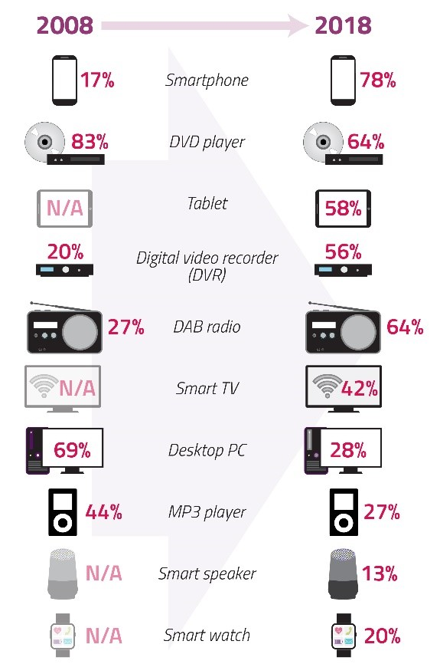
Figure 1. (Ofcom, 2019)

Prior to the development of ground-based mobile technologies, mobile was reliant on satellite services. However, has terrestrial networks spread across the globe and reducing the cost of services, satellite communication providers ran into financial difficulty. Companies such as Iridium filed for bankruptcy in 1999 as did GlobalStar in 2002.

Wi-fi
To supplement mobile technology wi-fi was developed. This led to the foundation of the Wi-fi Alliance to develop the trademarked wi-fi standard: wireless local area network. In time the standard expanded to encapsulate more frequency bands from the original 802.11a in 1999 to 802.11ac standard of today that are interoperable see Table 1 (Engineering Hub, 2017).

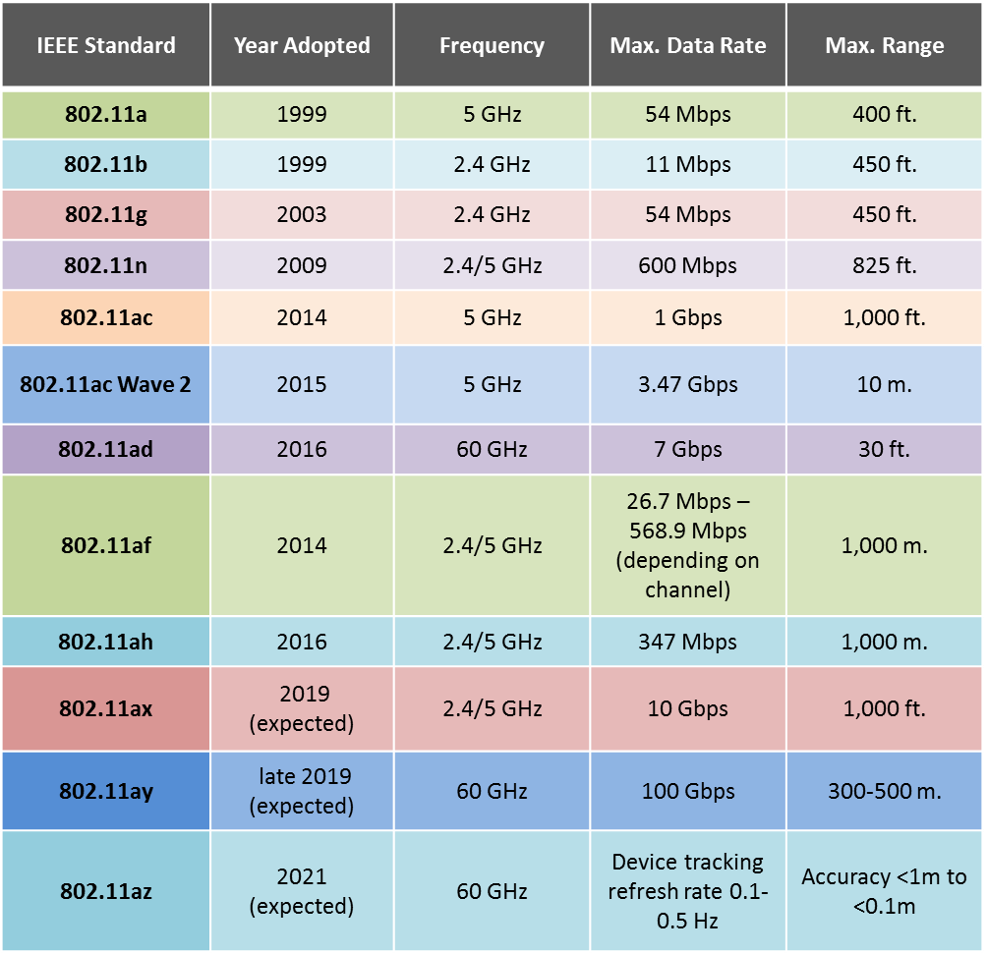
Table 1. (Engineering Hub, 2017).

This made wireless connectivity to a network that much easier and by definition internet access. Communication became available through workplace intranets rendering it faster and simpler. With Wi-fi 6 now upon us, the number of data-enabled devices that can connect to wi-fi simultaneously has been bolstered. When wi-fi isn’t available most people will revert to a mobile data connection and this is projected to be 46% by 2022 (Cisco, 2019). Wi-fi together with mobile-enabled access to the ‘Cloud’.

The Cloud
In essence, the Cloud is a new approach to data storage used by both businesses and individuals and can be seen as an evolution of server-based computing. You longer need access to physical storage of data on a local hard drive or server as information can be stored in a data facility offsite. This approach has the added advantage that companies who offer such services maintain all aspects of data storage, thus reducing costs in physical hardware. It allows for scalability as a company grows and secure remote access to data. A good Cloud service provider (CSP) would ensure integrity, availability, privacy, confidentiality, and robustness of backup facilities in case of disasters (Wu, 2016).
Cloud-based apps have increased from 545 to 1427 from 2013 and 2016 (Skyhigh, 2019) and by 2020 it is expected that 83% of companies' work will be cloud-based (LogicMonitor/Forbes, 2019).
As figure 2 (Ofcom, 2018) shows as mobile and cloud capabilities increased so did the development of apps.

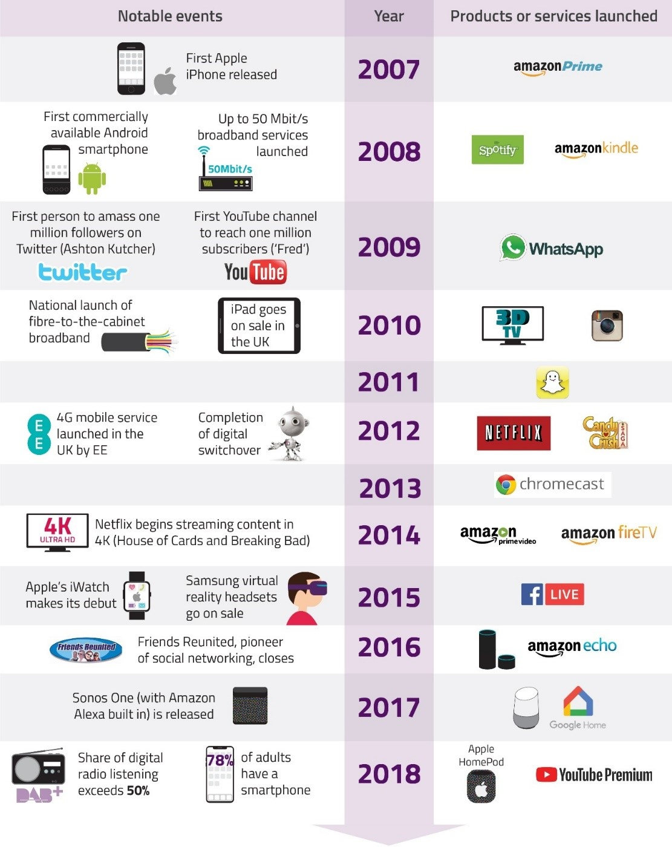
Figure 2. (Ofcom, 2018)

As an example, the predominant use of cloud services is emails and file storage 66% and 53% respectively for the EU. The latter increasing by 15% from 2014 to 2018 and among organisations that used cloud services 55% were highly dependent on such services as of 2018 figure 3 and 4 respectively (Eurostat, 2018)
Figure 3. (Eurostat, 2018)
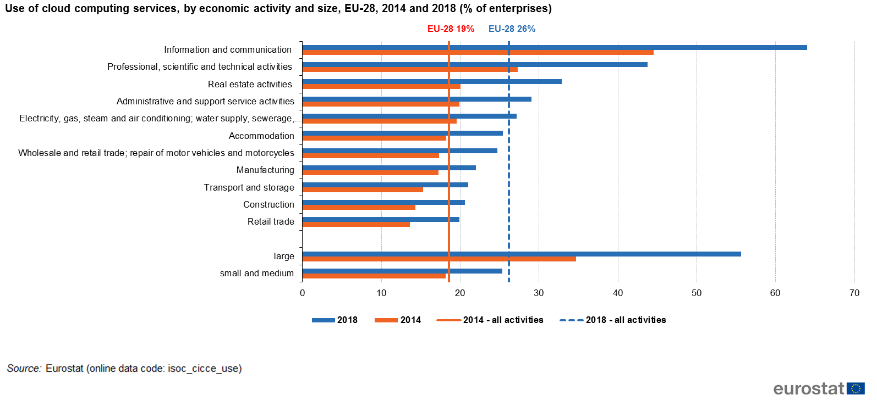Figure 4. (Eurostat, 2018)
Figure 5 shows the top commercial cloud service providers for 2019 with Amazon’s Web Services are market leaders with Microsoft’s Azure not far behind.
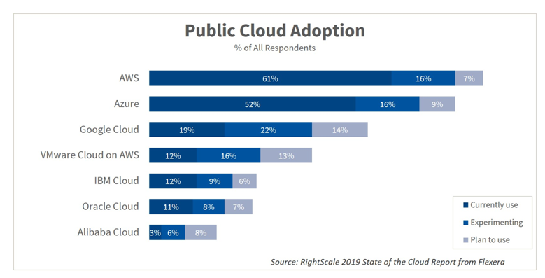
Figure 5. (Flexera, 2019)

For cloud storage providers, Dropbox is market leader with 47.3% followed by Google Drive (26.9%) and Microsoft OneDrive (15.3%) (Cloudrail, 2017).
Table 2 below shows the latest annual cost Consumer Cloud services available in the U.K.

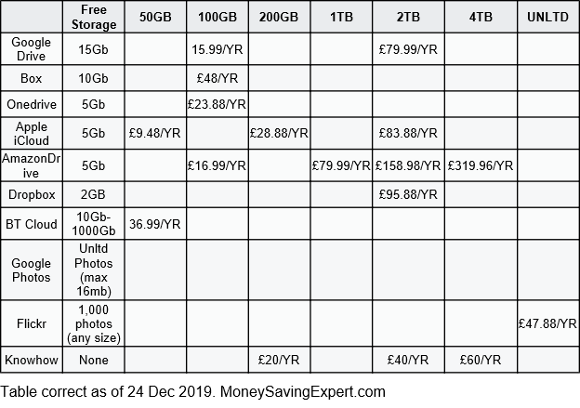
Table 2. (MoneySavingExpert, 2019)
Combined, the three technologies bought advantages and disadvantages to the workplace and life in general.

The Advantages
Mobile and wi-fi have become entwined in the workplace and in general, to such an extent, boundary between work and social life have become indiscernible. Information can be accessed in real-time; mobility has strengthened collaboration between work colleagues as communication is instantaneous (Hall, 2016). This latter point was borne out by a survey carried out the Economist Intelligence Unit as per figure 6 (Economist Intelligence Unit, 2016)

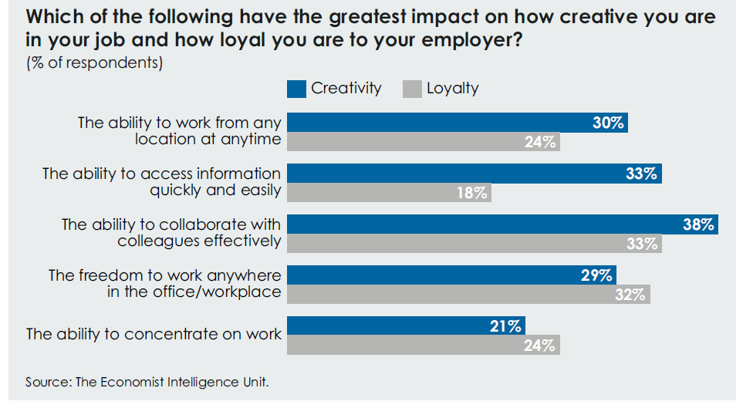
Figure 6. (Economist Intelligence Unit, 2016)

Projects can be managed remotely through the Cloud and not tied to a single location (Felstead and Henseke, 2017). Product, sales, and customer information can be monitored in real-time. Employees can integrate their use of Facebook, Twitter, Google, and other social media into their daily routines, and companies can integrate social media into their intranets, so that they can share internal information and knowledge with employees, and even with suppliers and customers. Through the use of smartphones, GPS, earphones, and microphones, employees can access online education and training materials anytime from their own companies, but also from universities in or outside their home countries. In short, the ability of mobile technology on productivity would be far less if these options did not exist. Mobile use at work is expected to increase to three hours a day by 2020 (Think with Google, 2017). This point was borne out by a survey carried out by the Economist Intelligence Unit that validates this see figures 7 & 8 below.

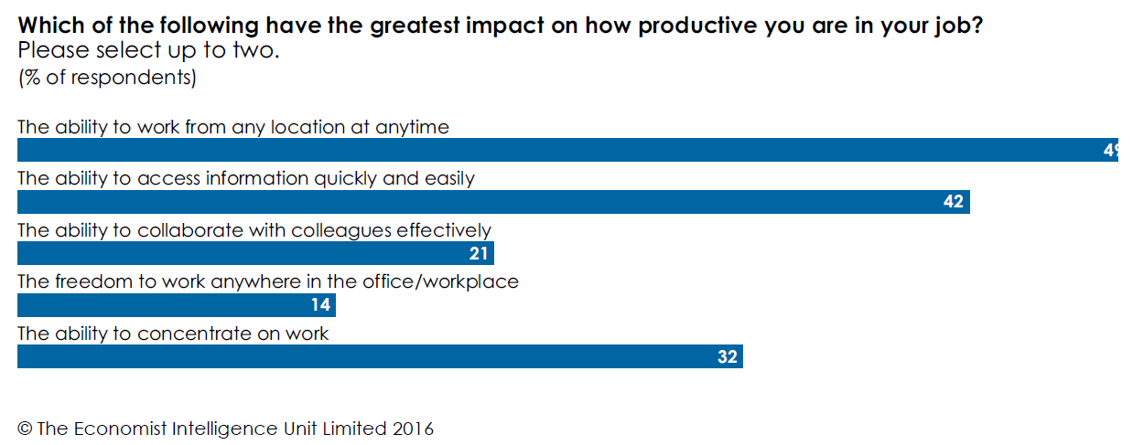
Figure 7. (Economist Intelligence Unit, 2016)

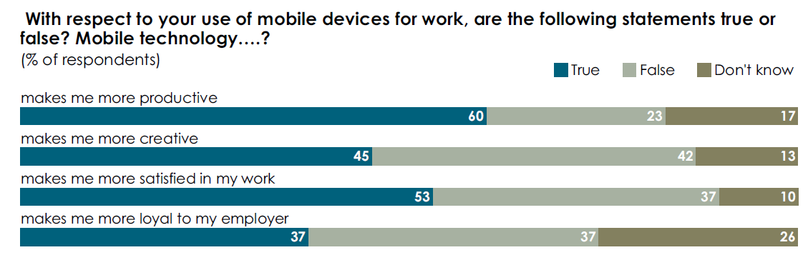

Figure 8. (Economist Intelligence Unit, 2016)

To facilitate this, applications have been developed with mobile devices in mind, thus reducing the need for large information technology infrastructure and information and communication technology staff support to be in place (Science and Technology Committee 2016, p.15)

The Disadvantages
However, always-on communications can cause workflow disruptions and by virtue decrease productivity. Multitasking suffers as a consequence. Inevitably this can lead to compromised work-life balance if the workday never finishes and communication is ongoing out of hours thereby adding to an employee work hour. This can impair there physical and mental well-being if a compromise is not found. For employers, this a ‘zero cost for inclusion’ and a ‘bottomless bowl’ for employees (Deloitte Insights 2018, p. 4). With the’ Internet of Things’ turning everyday devices into a source of data, security is becoming an issue. Many employees are taking their own devices to the workplace opening avenues for potential data leaks not to mention privacy concerns. Security is a key component of cloud computing.
Data breaches of Cloud-based service are running at record levels. The first half of 2019 we have had;
- Publicly disclosed breaches: 3,800
- Records exposed: 4.1 billion
- Increase of reported breaches vs. first six months of 2018: +54%
- List data breaches examples can be found in appendix
Symantec Corporation, (2019) (also see Appendix 1 for list of other data breaches)
The U.K Governments Cyber Security Breaches Survey (2019) shows there are costs involved when breaches occur. The average annual cost for businesses and charities is £4,180/£9,470 comprising time dealing with breaches and staff unable to carry daily work. These breaches together with the introduction of the General Data Protection Regulation 2018 have led to the beefing up security measures through technology or encryption (Davidshofer, Jeandesboz, and Ragazzi, 2016)
Furthermore, cloud computing does not provide control of stored data. The CSP has full control over data. Thought has to be given to geographic jurisdiction, regulatory laws, etc as data centres can be located anywhere in the world.
These data centres are huge consumers of energy. Today, they consume about 24% of electricity worldwide; growing annually by 7% by 2030. Figure 9 (Greenpeace 2017 p. 15) illustrates energy consumption by CSPs has increased from 15% (2012) to 21% (2017).
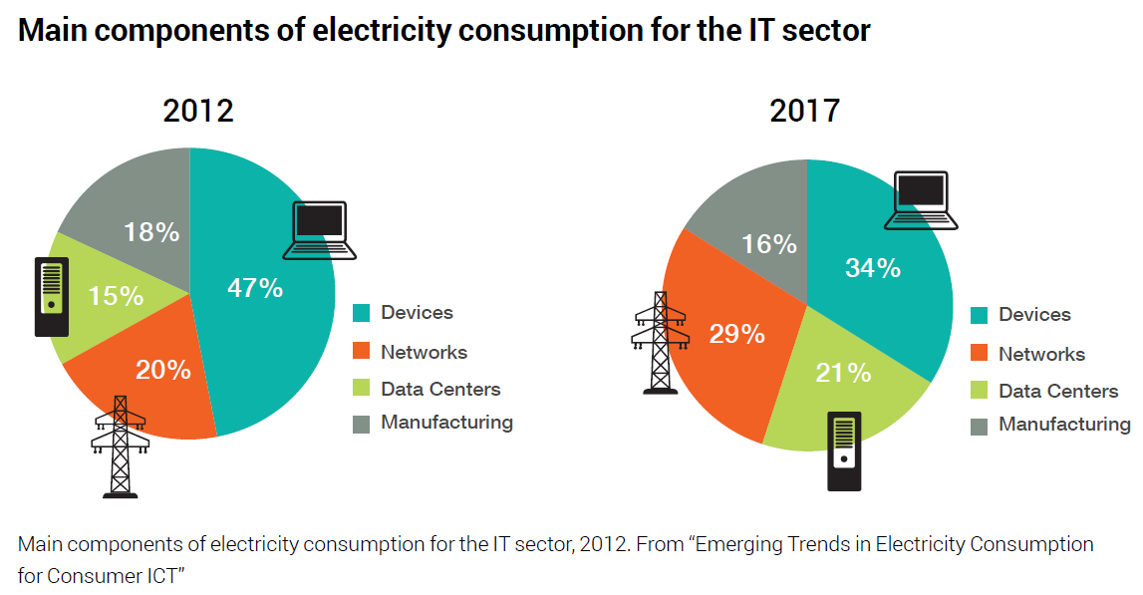
Figure 9. (Greenpeace, 2017)

Figure 10, illustrates the primary drivers are streaming video and Social media.
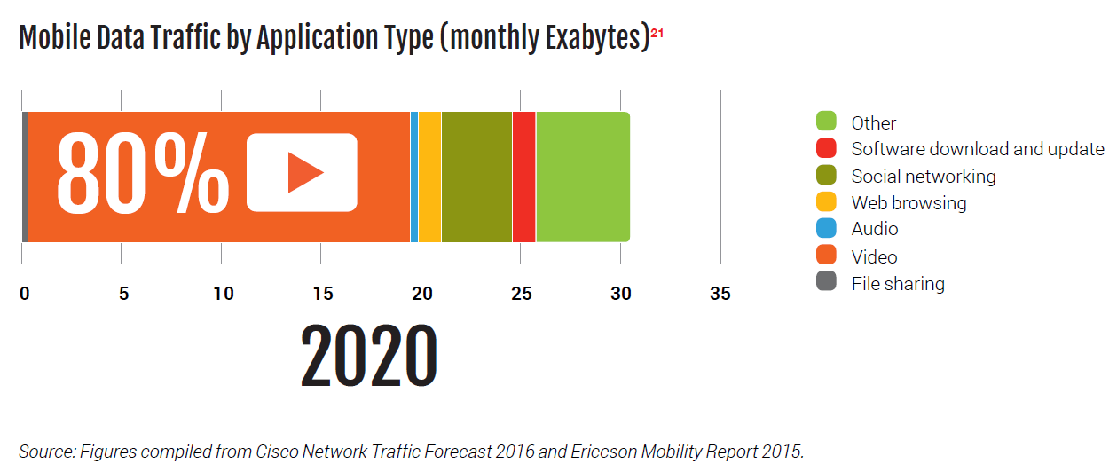
Figure 10. (Greenpeace, 2017)

The Workplace
LS Wholesale Ltd is a business that specifically caters to the Asian market. The primary technologies used are those deployed by the wholesaling and delivery side and to a lesser extent the retail side. The retail side involves the use of an electronic point of sale (EPOS) terminal. Prior to this and most of the 20th century, Electric Cash Registers were used that ran on propriety software and were limited in scope in functionality and communications. The precursor to the modern EPOS system it can be argued was the one developed by McDonald's in the 1970s.
The EPOS system records all sales and list all items that are available for sale. It has a card and cash payment facility integration. At the point of sales, items are scanned and identified through the barcode. According to Shopify a barcode is an image consisting of a series of parallel black lines and white spaces of varying widths that can be read by a scanner. It is a means for keeping track of what is being sold. It has the added advantage of increased productivity at the point of sale and as the EPOS terminal is augmented with a weighing scale, the weighing and pricing of goods are sped up.
Stock control and accounting are via the use of Sage Accounting 50 software that is a subscription-based service with a monthly cost of £180.00. This allows the business to know what is in stock and what needs reordering, place customer orders and monitor cash flow. It is HMRC compliant for tax purposes VAT, payroll and accounts can be produced from it.
As for other technologies, a new telephony system was installed that enables the communication between various parts of the site together with mobile phones to complete the system. WhatsApp is a primary source of messaging between and individuals and groups.
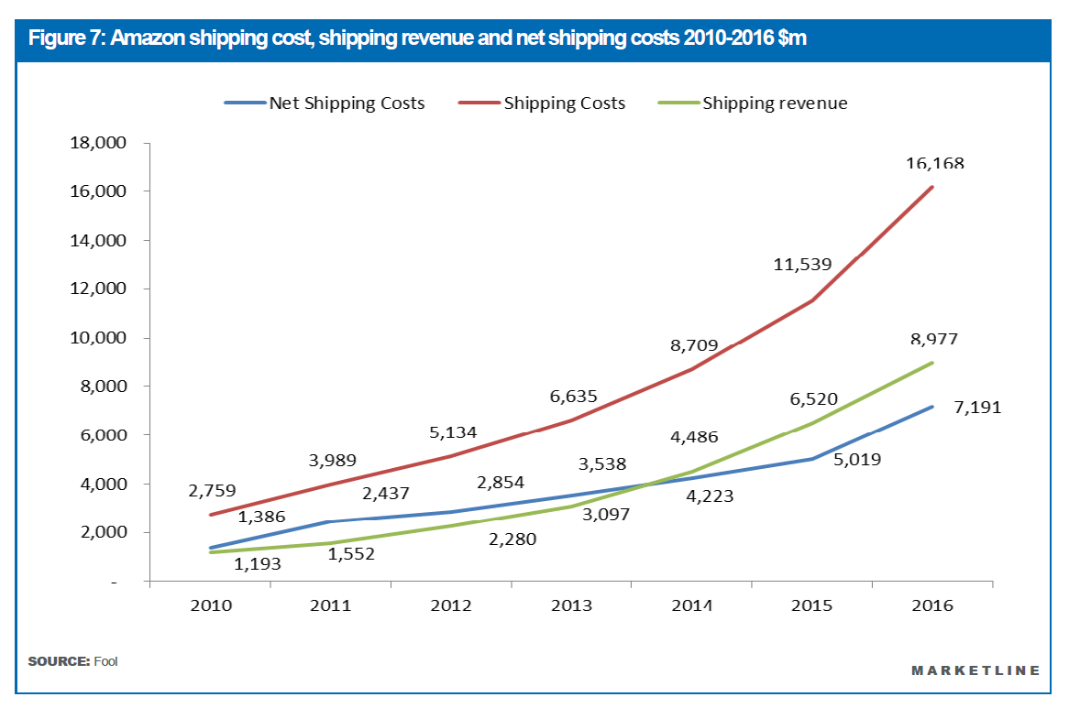

Graph 1. (Marketline, 2018)
The wholesale side has the use of fleet-wide real-time tracking of vans. This is provided by Quartix at a monthly subscription of £97.20. It is planned to integrate this ability with Geoplan’s Route Optimiser software which it is hoped will bring a 20% reduction in fuel savings. With a weekly fuel spend of £750, the annual savings will be substantial. This has the added benefit of reducing emissions and wear and tear on vehicles. This is not as advanced as say UPS the logistics business use of artificial intelligence-controlled GPS setup called Orion an acronym for On-road Integrated Optimisation and Navigation to maximise the use of its vehicles. As Graph, 1 shows Amazon's shipping costs are beginning to outpace sales (Marketline, 2018), this is a predicament that LS Wholesale will want to avoid.
The software side, Gmail is the propriety email client and Microsoft Office for general administration. The offices benefit from the use of networked printers that have the ability to order consumables as and when necessary.
One point to note is, where the business is located the broadband speeds are woefully inadequate and it imperative that a better service provider is sought out. Indeed, a fifth of Small Medium Enterprises (SME) does not have reliable broadband according to the British Chambers of Commerce (2017) survey.
As the business grows new skill sets will be required by the workforce to better adapt to the ever-changing workplace. According to Russell Ackoff (1989), a systems theorist and professor of organizational change, the content of the human mind can be classified into five categories:
- Data: symbols
- Information: data that are processed to be useful; provides answers to "who", "what", "where", and "when" questions
- Knowledge: application of data and information; answers "how" questions
- Understanding: an appreciation of "why"
- Wisdom: evaluated understanding.

The following diagram figure 11 represents the transitions from data to information, to knowledge, and finally to wisdom, and it is understanding that supports the transition from each stage to the next.

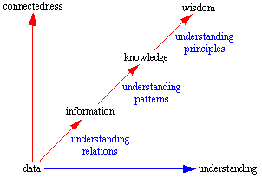
Figure 11. Adapted Ackoff, R. (1989), "From Data to Wisdom", Journal of Applied Systems Analysis, Volume 16, p 3-9.

Using this methodology, a recent survey was undertaken to ascertain the preferences of the workforce as to what type of courses or training they would prefer based on regulatory requirements regarding health and safety.
Questionnaires, samples of which can be found in Appendix 2 were provided asking employees to list their top five choices in order. The data was collected and anonymised with the consent of the workforce as per the General Data Protection Regulation 2018.
Table A (see Appendix 2) lists preferred choices in order 1 to 5 with Table B the total for each choice. The collated data shows choice 1 was clearly the most popular with choice 8 the least. This is also borne out from Graph A that shows the frequency for the various choices.

Figure 12.

Detailed analysis as per the above pie chart shows a clear tendency towards the health and safety aspect of the questionnaire. Armed with this knowledge the business can adapt its training regime. It will have to be a mix of online ‘bite-size learning and onsite training to better fit the employees' work schedule. For example, SMEs that utilises peer-to-peer learning provided by Goldman Sachs 10,000 Small Business initiative experienced a 28% increase in productivity compared to other SMEs (Goldman Sachs, 2018)
Any future training requirements will require more thought and need to encompass;
- The needs of new employees
- The existing employees training to enhance their knowledge
- Future promotion and career prospects
- Training as and when technology changes e.g. when new equipment is introduced

Training has the added benefit of improving morale as employees will require less supervision that will result in fewer accidents and compensation costs and increased productivity.
As figure 13 below shows (O’Donnell, 2000) there is a link between health and safety, productivity and profits.

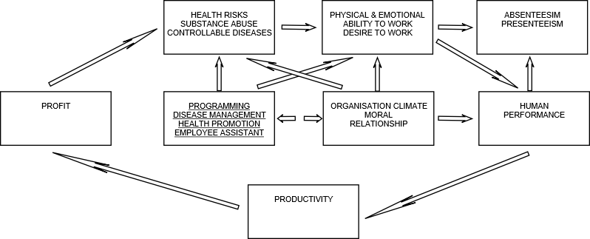

Figure 13. Adapted Mechanisms linking health, productivity, and profits (O’Donnell, 2000)

The U. K’s Health and Safety Executive estimated that 28.2 million days were lost in 2018 – 2019 alone (HSE, 2019), so any reduction is a positive outcome for productivity.
As mentioned earlier, technology will change and as the business is a wholesaler that requires warehousing and delivery vehicles, jobs will be at risk as more and more comparable businesses adopt automated systems controlled by artificial intelligence. Has Amazon’s Director of Robotics Fulfilment, Scott Anderson, recently stated that “technology is at least 10 years away from fully automating the processing of a single order picked by a worker inside a warehouse” (Bose, 2019).
The delivery aspect of the business will eventually experience some sought of automation through artificial intelligence-controlled robots or vehicles. As an example, Marble a company specialising autonomous delivery systems started off delivering food has expanded to deliver medicine, packages, groceries, etc. so you can see where the future direction of delivery automation is heading.

Social media in the workplace – An overview

What is social media? It is ‘the different forms of online communication used by people to create networks, communities, and collectives to share information, ideas, messages, and other content, such as videos’ (Keith, T 2015), that is achieved through the use of software programs and websites.
The first recognisable social media site was Six Degrees in 1997. It allowed users to upload a profile and socialise with other users. Today, there is a multitude of options available for personal and business use. Figure 14 from App Annie below shows that social media apps dominate the most downloaded apps for the past decade.

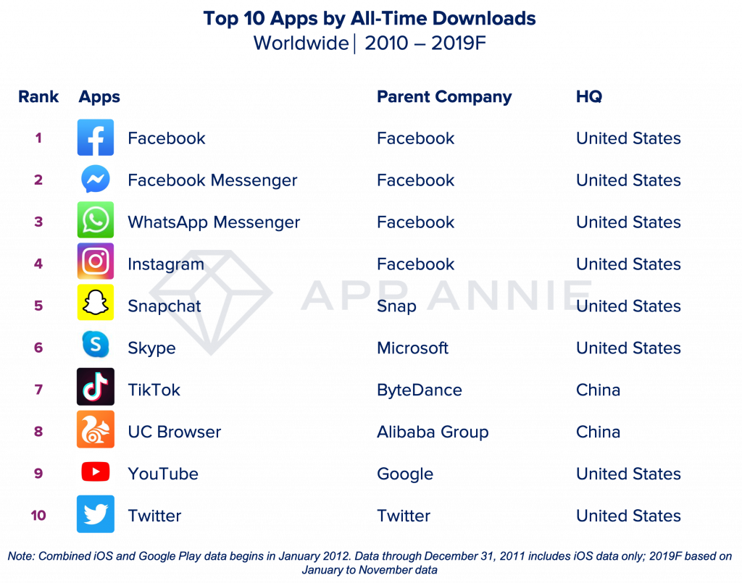
Figure 14. (App Annie, 2019)

Figure 15 illustrates the most popular social networks worldwide by active users (October 2018) prepared by Statista with Facebook having the greatest market share.
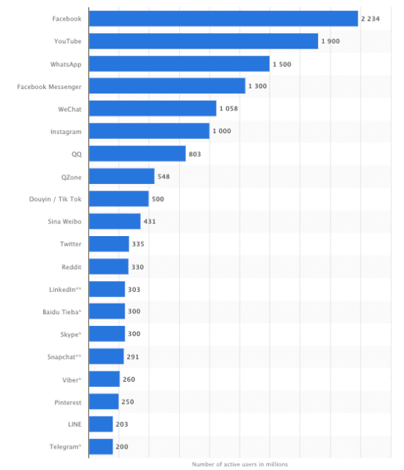
Figure 15. Popular social networks around the world as of October 2019, ranked by number of active users (Statista, 2019)

Today’s market is dominated by a handful of companies but the history of social media dictates that this will change with the emergence of new entries and the loss of old ones like MySpace.
Take for instance the explosive growth of Tik Tok. Launched 2018 its growth rate has outstripped the likes of Facebook et al. The graphic provided by Influencer Marketing Hub illustrates this perfectly with 524 million active users from inception. A feat that took Facebook over six years to reach. As of January 2019, the one billion installation mark from Google and App Store had been surpassed. From a business perspective, this is a social media platform to watch and utilise.
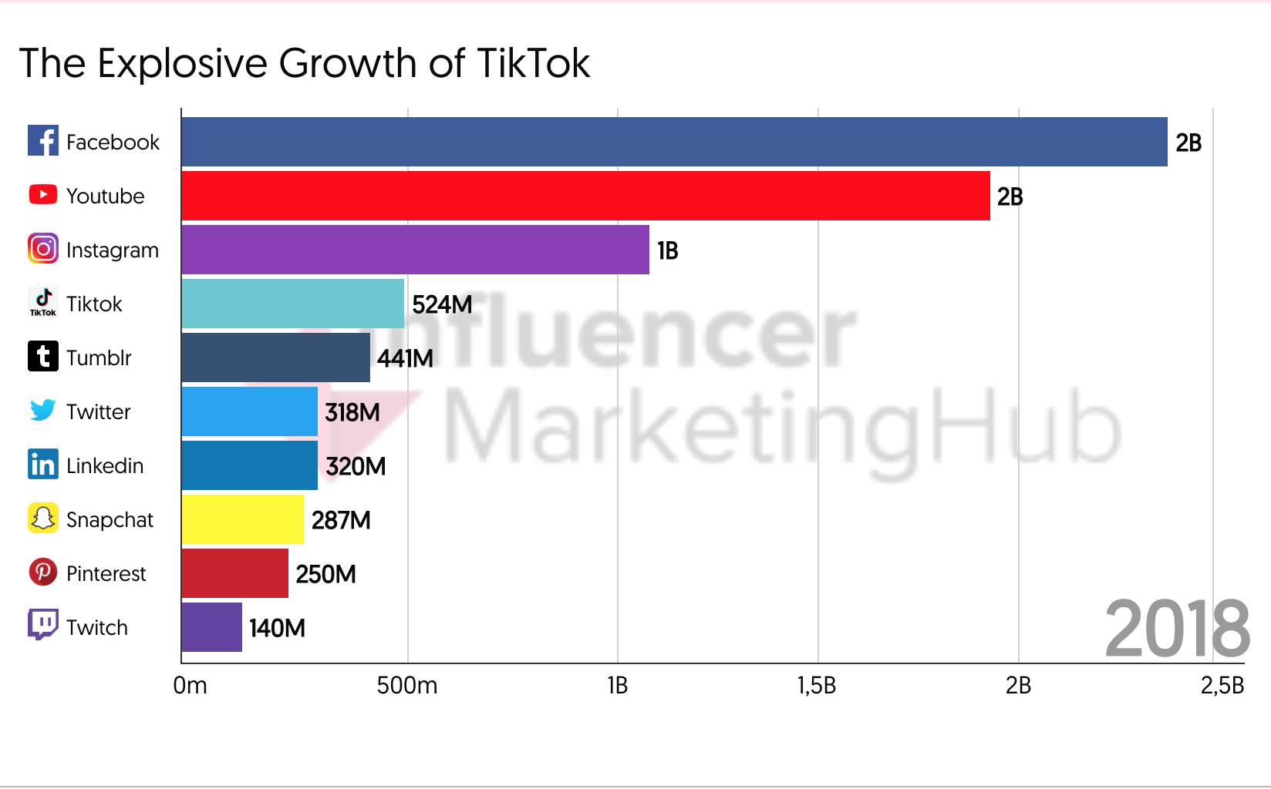
Figure 16. (Influencer Marketing Hub, (2019)

As the market leader, Facebook’s own website states that it has six million-plus active advertisers. Together with Facebook Messenger and Instagram (both Facebook-owned), its user base is nearly five billion active accounts. Other platforms used by businesses but not listed above include Yelp, Pinterest and LinkedIn.
Social media provides a cost-effective marketing tool for a business’s target audience at a scale that other avenues would find difficult to compete. Businesses should consider which platform is best suited to their needs as all will not contain their target audience.
- Facebook offers the best market tools and in-depth analytics.

- Instagram has Instagram Live to Instagram Stories, useful for business promotions.

- Twitter offers short updates and sharing links to blog posts. You can share short tweets (up to 240 characters), videos, images, links, polls and etc.

- Pinterest is a visual platform that allows users to save and display content by "pinning" digital content.

- Snapchat Stories feature will most likely be utilised by small businesses. It has its limitations, has only users who have added you can view your Stories content.

- YouTube is used by businesses that have a creative, visual or educational element. Businesses can partner with YouTubers for the brand or product placement.

- LinkedIn is more professional orientated than most social media platforms. Users create profiles that are similar to CV’s, and for companies to showcase their business. LinkedIn’s professional nature makes it the best place to post job offers and information about companies.

The utilising of social media by the business is primarily focused on advertising, marketing, and recruitment. The former can be used to sell a service or a product or even invest in the business. The latter can be used as part of the recruitment process to narrow down the best candidate for employment.
As with any business endeavour, there are drawbacks. Equally, it can be used to promote brand awareness it can also affect its reputation and credibility as negative publicity spreads quickly through social media.
Social media can benefit the workforce too. Pew Research Centre found that “34% of people use social media while at work to take a mental break from their job, 27% of people use it to connect with friends and family while at work, 24% use it to make or support professional connections, 17% use it to build or strengthen personal relationships with co-workers, 17% of people use it to learn about someone they work with, 12% of people use it to ask work-related questions to people outside of their organization, and 12% of people use it to ask such questions of people inside their organization” (Olmstead, Lampe, Ellison, 2016)
Social media can also be a distraction too. “Office workers are interrupted -- or self-interrupt -- roughly every three minutes, academic studies have found, with numerous distractions coming in both digital and human forms” (Silverman, Emma, 2012)
As discussed earlier, security and privacy concerns, as well as copyright, affect social media too.

The use of social media at LS Wholesale

The present
LS Wholesale Ltd.’s primary social media focus is Facebook. It functions as a gateway for brand awareness, product promotions, social events, and general information. In comparison to some of its competitors (see Table 3) it lacks the options that are encompassed by them. As a new and growing business, it does not have the resources as yet to commit to other platforms. However, in the short term, the intention is to create LinkedIn profiles to connect to likeminded business people in the same industry and open up networking opportunities for the business to grow. Customers will be encouraged to leave feedback on Trustpilot to build brand awareness. In the medium-term Twitter will be looked at as a means to communicate with customers.

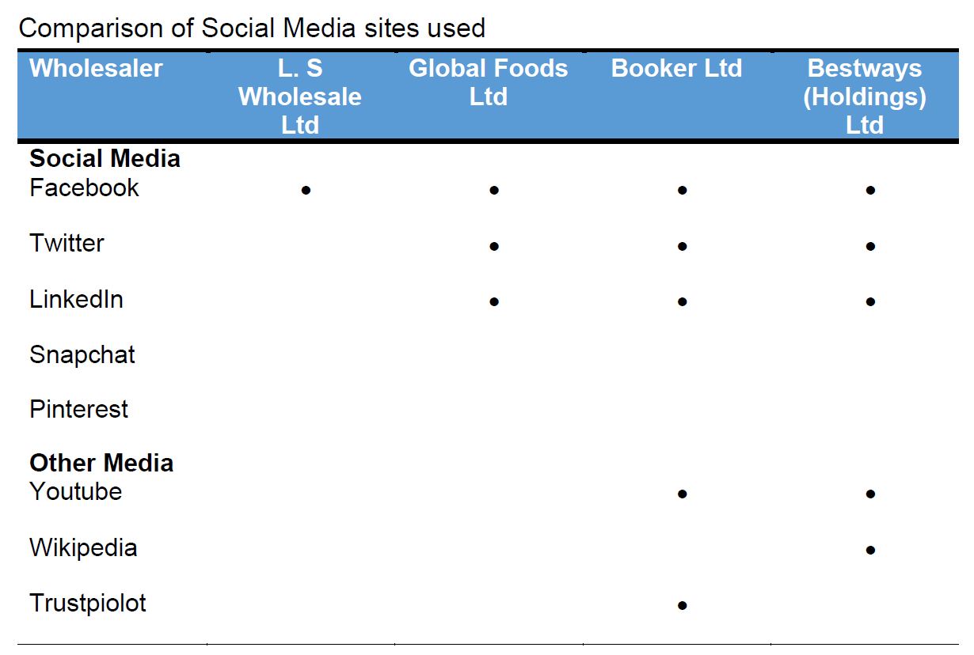
Table 3.

The future
The social media aspect is part of a two-pronged strategy combining the business website as an advertising medium. At present, it acts as a window for the wares available for sale. It does not as yet have the ability to sell. It is intended to use Shopify to build an online storefront that can be integrated into our own payment system. This is a low-cost scalable option starting from £22 per month and is used by over 800,000 businesses. To control the costs of maintaining such a service Chatbots or smart virtual assistant surrogates are an option. These are application software that takes human language as an input command and performs the allocated task by the user accordingly (Lang and Benessere, 2018). This would be better for the business need as this type of system can learn dynamically, and is constantly being updated through interactions with customers. This is a long-term goal and will be implemented as soon as practicable.

The use of social media to enhance networking and career prospects

Many of the social media sites mentioned are a duality in nature. They can be used to enhance networking and career prospects. This social networking creates and builds upon personal and business relationships that can be used to enhance career prospects. The idea is to create your own personal brand that people can relate too. This is how you promote yourself and differentiate yourself from others to potential employers or clients. Figure 17 shows the steps to building your personal brand. Careful consideration as to be given as to what information is preeminent. Detrimental social media discoveries can be used to not getting employment a list of which is given by Statista (2019). Once established being on as many social networks where your intended audience can be found is paramount. The virtues of each media network have been discussed prior. It is up to the individual to decide which is best suited to their needs based on personal circumstances.

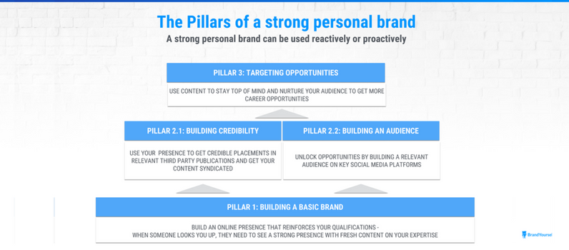
Figure 17. (Brandyourself, 2019)

For many LinkedIn with 600 million-plus current active users would be their first choice. It's tailor-made for professionals although it may be used by anyone. Here you can create networks using first, second- and third-degree connections and join professional groups It is also a place to assess job listings.

LinkedIn Profile

I have included my current LinkedIn (see Figure 18 and 19) home and profile sections as an example of the use of social media as a gateway to enhance networking and career prospects. This was achieved by creating an account and following the online setup process to create a profile. Consideration was given to privacy settings including; active broadcasts, activity feed, viewing profiles, connections, emails, members communications, and photos, etc. A good LinkedIn profile can not only help your business grow it can give individuals better employment opportunities (Song et al..2019)
Figure 18. Homepage

Figure 19. Profile page

Final thoughts
The purpose of this assignment is two-fold. To assess the impact of technology in the modern workplace and how it has evolved over time from the physical to the connected and the disconnected work environment. And, how social media has impacted the modern workplace.
Technology in a short timescale has overtaken the workforce's ability to adapt. It could be argued that these are disruptive technologies as formulated by Christensen (1997). Yes, the workforce can train, learn and acquire new skill sets but with the advent of artificial intelligence and automation becoming a disruptive force, the type of jobs available will dwindle over time has an example, 30% of finance and insurance jobs in developed economies are at risk of automation by 2029, according to PwC (Hawksworth J, et al, (2018) and the impact on wages (Frontier economics, 2018 p. 24). will be immense,
Still, training is a key component of any business it is essential to its success. The challenge is to facilitate transitions to new skills.
Social media will play its part in the sense that the public will gravitate towards it in ever larger numbers as the medium weaves its way into the fabric of everyday life.
At my age, I hope to ride out the wave of consolidation as my field of employment, bookkeeping, and place of work are vulnerable to automation and artificial intelligence onslaught, whether it’s retail, warehousing or finance as clearly illustrated by the chart in Appendix 3 from McKinsey Digital (2016). I understand technology is always changing, evolving but I’m old fashioned. I gained my current employment simply by picking up the telephone and asking for a job. No interview, no curriculum vitae, no personal statement, and no references. Not even a social media profile was needed. I simply got accepted by reputation and work experience alone built up over many years. Word and mouth: networking the old fashion way.

References

Ackoff, R. (1989), "From Data to Wisdom", Journal of Applied Systems Analysis, Volume 16, p 3-9App, [online]
Annie (2019) Top 10 Apps all-time downloads [fig] available at https://www.appannie.com/en/insights/market-data/a-look-back-at-the-top-apps-games-of-the-decade/ accessed 6 Jan 2020
Bose, N (2019) ‘Amazon dismisses idea automation will eliminate all its warehouse jobs soon’, [online] available at https://www.reuters.com/article/us-amazon-com-warehouse/amazon-dismisses-idea-automation-will-eliminate-all-its-warehouse-jobs-soon-idUSKCN1S74B9 accessed 6 Jan 2020
Brandyourself, (2019) The Definitive Guide to Personal Branding [fig.] available at (https://brandyourself.com/definitive-guide-to-personal-branding) accessed 6 Jan 2019
British Chamber of Commerce (2017) ‘Digital Economy Survey 2017’, [online] available at https://www.britishchambers.org.uk/media/get/BCC%20Digital%20Survey%202017%20Summary%20pt1.pdf accessed 6 Jan 2020
Cascio and Montealegre 2016 ‘How Technology Is Changing Work and Organizations’ pp 352, [online] available at https://libguides.ioe.ac.uk/c.php?g=482485&p=3299802 accessed 6 Jan 2020
Christensen CM. 1997. The Innovator’s Dilemma: The Revolutionary Book that will change the way you do business. New York: Harper Business
Cisco (2019) ‘Cisco Visual Networking Index: Global Mobile Data Traffic Forecast Update, 2017–2022 White Paper’, [online] available at https://www.cisco.com/c/en/us/solutions/collateral/service-provider/visual-networking-index-vni/white-paper-c11-738429.html accessed 6 Jan 2020
Cloudrail (2017) ‘Cloud Storage Report 2017’, [online] available at https://blog.cloudrail.com/cloud-storage-report-2017/ accessed 6 Jan 2020
Cyber Security Breaches Survey (2019) ‘Cyber Security Breaches Survey’, [online] available at https://assets.publishing.service.gov.uk/government/uploads/system/uploads/attachment_data/file/791942/CSBS_2019_Infographics_-_General_Findings.pdf accessed 6 Jan 2020
Davidshofer, Jeandesboz, and Ragazzi, (2016) ‘Technology and security practices: Situating the technological imperative’, [online] available at https://www.researchgate.net/publication/305751594_Technology_and_security_practices_Situating_the_technological_imperative accessed 6 Jan 2020
DataReportal (2019) ‘Digital 2019: Global Digital Overview’, [online] available at https://datareportal.com/reports/digital-2019-global-digital-overview accessed 6 Jan 2020
Deloitte Insights (2018) ‘Positive Technology’, [online] available at https://www2.deloitte.com/content/dam/insights/us/articles/4146_BEM-Positive-technology/DI-Positive-technology.pdf accessed 6 Jan 2020
Economist Intelligence Unit (2016) ‘Mobile, performance and engagement’, [online] available at https://eiuperspectives.economist.com/technology-innovation/mobility-performance-and-engagement/white-paper/mobility-performance-and-engagement?redirect=TRUE accessed 6 Jan 2020
Engineering Hub (2017) Standards showdown: 802.11 Standards side-by-side [Table]. available at http://www.l-com.com/blog/?tag=/802.11g accessed 6 Jan 2020
Eurostat (2018) ‘Cloud computing - statistics on the use by enterprises’, [online] available at https://ec.europa.eu/eurostat/statistics-explained/index.php/Cloud_computing_-_statistics_on_the_use_by_enterprises accessed 6 Jan 2020
Felstead, A. and Henseke, G., 2017. Assessing the growth of remote working and its consequences for effort, well‐being and work‐life balance. New Technology, Work and Employment, 32(3), pp.195-212 available at https://onlinelibrary.wiley.com/doi/epdf/10.1111/ntwe.12097 accessed 6 Jan 2020
Flexera. (2019) ‘Cloud Computing Trends: 2019 State of the Cloud Survey’ Flexera Blog 27 February, [online] available at https://www.flexera.com/blog/cloud/2019/02/cloud-computing-trends-2019-state-of-the-cloud-survey/ accessed 6 Jan 2020
Frontier economics, (2018) ‘The impact of Artificial Intelligence on work’, [online] available at https://www.frontier-economics.com/media/3118/ai-and-work-evidence-review-full-report.pdf accessed 6 Jan 2020
Goldman Sachs (2018) ’10,000Small Businesses’, [online] available at https://www.goldmansachs.com/citizenship/10000-small-businesses/UK/news-and-events/building-business-britain-f/report.pdf accessed 6 Jan 2020
Greenpeace (2017) ‘Clicking clean: who is winning to build a green internet’ [fig.] Available at: http://www.clickclean.org/downloads/ClickClean2016%20HiRes.pdf accessed 6 Jan 2020
Hall, A., 2016. Exploring the workplace communication preferences of millennials. Journal of Organizational Culture, Communications, and Conflict, 20, p.35.
HSE, (2019) ‘Working days lost in Great Britain’, [online] available at https://www.hse.gov.uk/statistics/dayslost.htm accessed 6 Jan 2020
Influencer Marketing Hub, (2019) 37 TikTok Statistics That Will Blow Your Mind [fig.]. available at https://influencermarketinghub.com/tiktok-statistics/ accessed 6 Jan 2020
Keith, T 2015, The Complete History of Social Media: from the First Online Network to today [online] available at https://historycooperative.org/the-history-of-social-media/ accessed 6 Jan 2020
Lang, R.D. and Benessere, L.E., 2018. Virtual Assistants in the Workplace: Real, Not Virtual Pitfalls and Privacy Concerns, [online] available at https://businesslawtoday.org/2018/02/the-rise-and-danger-of-virtual-assistants-in-the-workplace/ accessed 6 Jan 2020
LogicMonitor/Forbes (2019) 83% of Enterprise workloads will be in the Cloud by 2020, [online] available at https://www.forbes.com/sites/louiscolumbus/2018/01/07/83-of-enterprise-workloads-will-be-in-the-cloud-by-2020/ accessed 6 Jan 2020
Marketline (2018) ‘The Future of Retail: Five ways e-commerce and high street stores are evolving to suit changing consumer behaviour’, [online] available at https://www.scribd.com/document/376510311/The-Future-of-Retailing-Report accessed 6 Jan 2020
McKinsey Digital, (2016) ‘Where machines could replace humans—and where they can’t (yet)’, [online] available at https://www.mckinsey.com/business-functions/mckinsey-digital/our-insights/where-machines-could-replace-humans-and-where-they-cant-yet accessed 6 Jan 2020
MoneySavingExpert (2019) Free online storage [Table] available at https://www.moneysavingexpert.com/shopping/free-online-storage/ accessed 6 Jan 2020
O’Donnell, M. (2000) Health and Productivity Management: the concept, impact, and opportunity’, [online] available at https://journals.sagepub.com/doi/abs/10.4278/0890-1171-14.4.215 accessed 6 Jan 2020
Ofcom (2018) ‘A decade of digital dependency’, [online] available at https://www.ofcom.org.uk/about-ofcom/latest/features-and-news/decade-of-digital-dependency accessed 6 Jan 2020
Ofcom (2018) A decade of change in digital communications [fig]. available at https://www.ofcom.org.uk/about-ofcom/latest/features-and-news/decade-of-digital-dependency accessed 6 Jan 2020
Ofcom (2018) [fig.].Available at: https://www.ofcom.org.uk/about-ofcom/latest/features-and-news/decade-of-digital-dependency accessed 6 Jan 2020
Olmstead, K, et al, (2016) “Social Media and the Workplace”, [online] available at https://www.pewresearch.org/internet/wp-content/uploads/sites/9/2016/06/PI_2016.06.22_Social-Media-and-Work_FINAL.pdf accessed 6 Jan 2020
Hawksworth J, et al, (2018) ‘How automation will impact job?’ , [online] available at https://www.pwc.co.uk/economic-services/assets/international-impact-of-automation-feb-2018.pdf accessed 6 Jan 2020
Science and Technology Committee (2016) ‘Digital Skills Crisis’, [online] available at https://publications.parliament.uk/pa/cm201617/cmselect/cmsctech/270/270.pdf accessed 6 Jan 2020
Silverman, R. (2012) Managing those workplace distractions, [online] available at https://www.ics.uci.edu/community/news/articles/view_article?id=229 accessed 6 Jan 2020
Skyhigh (2019) 12 must-know statistics on Cloud usage in the Enterprise, [online] available at https://www.skyhighnetworks.com/cloud-security-blog/12-must-know-statistics-on-cloud-usage-in-the-enterprise/ accessed 6 Jan 2020
Song, Q., Wang, Y., Chen, Y., Benitez, J. and Hu, J., 2019. Impact of the usage of social media in the workplace on team and employee performance. Information & Management, [online] available at https://whel-primo.hosted.exlibrisgroup.com/primo-explore/fulldisplay?docid=TN_elsevier_sdoi_10_1016_j_im_2019_04_003&context=PC&vid=44WHELF_UWTSD_VU1&lang=en_US&search_scope=CSCOP_EVERYTHING&adaptor=primo_central_multiple_fe&tab=tab1&query=any,contains,Song%20%20Q.%20%20Wang%20%20Y.%20%20Chen%20%20Y.%20%20Benitez%20%20J.%20and%20Hu%20%20J.%20%202019.%20Impact%20of%20the%20usage%20of%20social%20media%20in%20the%20workplace%20on%20team%20and%20employee%20performance.%20Information%20&%20Management.&mode=basic accessed 6 Jan 2020
Statista, (2019) ‘Most popular social networks worldwide as of October 2019, ranked by number of active users’, [online] available at https://www.statista.com/statistics/272014/global-social-networks-ranked-by-number-of-users/ accessed 6 Jan 2020
Statista (2019) ‘Social media discoveries made by online recruiters that lead to a candidate not getting a job as of May 2018’, [online] available at https://www.statista.com/statistics/260147/damaging-social-media-discoveries-made-by-online-recruiters/ accessed 6 Jan 2020
Symantec Corporation (2019) Emerging threat, [online] available at https://us.norton.com/internetsecurity-emerging-threats-2019-data-breaches.html accessed 6 Jan 2020
Techno FAQ (2018) From Cash Registers to the Cloud – The Evolution Of POS Systems, [online] available at https://technofaq.org/posts/2018/08/from-cash-registers-to-the-cloud-the-evolution-of-pos-systems/ accessed 6 Jan 2020
Think with Google, (2017) How mobile is reshaping the B2B landscape for growth, [online] available at https://www.thinkwithgoogle.com/marketing-resources/experience-design/b2b-marketing-reshaping-growth/ accessed 6 Jan 2020
Wu, J.C., 2016. Peering Through the Cloud—Investigating the Perceptions and Behaviors of Cloud Storage Users, [online] available at https://scholarsarchive.byu.edu/etd/6175/ accessed 6 Jan 2020

Appendix 1

Financial Data Breaches
Capital One
Date: March 22 and 23, 2019
Capital One
Date: March 22 and 23, 2019
Number of records breached: 106 million
Information exposed: The largest category of information accessed during this breach was information that Capital One routinely collects when it receives credit card applications from consumers and small businesses, including names, addresses, ZIP codes, phone numbers, email addresses, birthdates, and self-reported income. Also exposed, in some cases, were customer credit scores, credit limits, balances, payment history, and contact information. The hacker behind this breach also accessed about 140,000 Social Security numbers of potential Capital One credit card customers and about 80,000 linked bank account numbers of secured credit card customers. No credit card account numbers or log-in credentials were compromised. The government has stated they believe the data has been recovered and that there is no evidence the data was used for fraud or shared by this individual.
Entertainment Data Breaches
Evite
Date: February 22, 2019
Number of records breached: 100 million
Information exposed: Names, email addresses, passwords, and IP addresses of Evite customers. Description: Evite reported that in February 2019, an unauthorized party acquired an inactive data storage file holding information about the company's users from 2013 and earlier. According to a security update from Evite, the information exposed could include names, usernames, email addresses, passwords, and, if users provided this information, dates of birth, phone numbers and mailing addresses. Users affected by this breach don't have to worry about their Social Security numbers, bank account numbers, or credit card numbers. Evite says that its customers' financial and payment data was not affected because the company does not store this information.
DoorDash Breach
Date: May 4, 2019
Number of records breached: 4.9 million people potentially affected
Information exposed: DoorDash said user information accessed included names, email addresses, delivery addresses, phone numbers, and hashed and salted passwords (which can make the passwords indecipherable to third parties). For some users, additional information was exposed. The data breach accessed the last four digits of consumer payment cards for some customers, but not the full credit card information. Drivers and merchants may have had the last four digits of their bank account numbers accessed. Also, the driver’s license numbers of about 100,000 drivers were accessed.
Healthcare Data Breaches
American Medical Collection Agency
Date: August 1, 2018, to March 30, 2019
Number of records breached: More than 20 million
Information exposed: Social Security numbers, dates of birth, payment card data, and credit card information.
(files-for-bankruptcy)
Zoll Medical
Date: From November 8 through December 28, 2018. Zoll discovered the breach on January 24, 2019.
Number of records breached: 277,319
Information exposed: Patient names, addresses, birth dates, Social Security numbers, some medical information may have been among the information exposed.
Education Data Breaches
Georgia Tech
Date: December 14, 2018, to March 22, 2019
Number of records breached: 1.3 million
Information exposed: Names, addresses, Social Security numbers, and birth dates.
Government Data Breaches
Federal Emergency Management Agency (FEMA)
Date: The Office of the Inspector General issued its findings on March 15, 2019
Number of records exposed: 2.3 million
Information exposed: Street addresses, financial institution names, electronic funds transfer numbers, and bank transit numbers of survivors of hurricanes Harvey, Irma, and Maria, and the California wildfires.
Palm Bay, Florida
Date: August 29, 2019
Number of records breached: Up to 8,500.
Information exposed: The billing information of up to 8,500 Palm Bay residents who pay their utility bills through the city's online portal.
Other Business Data Breaches
BioStar 2, a Suprema-based security platform.
Date discovered: August 5, 2019.
Number of records breached: 28 million records of over 1 million people worldwide.
Information exposed: Fingerprint data, facial recognition data, face photos of users, unencrypted usernames and passwords, logs of facility access, security levels and clearance, personal details of staff.
Information courtesy of Symantec Corporation 2019

Appendix 2

Appendix 3



