
Assessment 1 Data Handling and Business Intelligence
Module code: LCBB5000 Lecturer: Gasso Mwaluseke

SPSS and Excel report
(Individual Report)

Stefan Vasilev Zamfirov
University of Wales Trinity Saint David, London Campus,
BA Business and Management, London, United Kingdom
2024063@student.uwtsd.ac.uk

TABLE OF CONTENTS
Part 1 2
Superstore visualization analysis 2
Importance of Pre-processing and data analysis 7
Part 2 8
2.1: How many students like vanilla flavour of ice-cream? 8
2.2: How many students are Male and Female? 9
2.3: What are the Mean and Median of participants who likes chocolate and strawberry flavour ice-cream? 9
2.4: Using the dataset Ice_cream_csv provided in conjunction with SPSS, give a specific example of clustering (ex. K-Means). Show your workings with screenshots and clearly explain your results. 10
2.5: Explain the most common data mining and text mining methods that can be used in business with real world examples. 14
2.6: Discuss the advantages and disadvantages of using SPSS and Excel using relevant practical examples and present your discussions in a table. 15

Part 1

Superstore visualization analysis
Using the superstore data provided, sales and profit is calculated to evidence changes in trends over the years. MS Excel is used in this regard, which has played a significant role in the effective processing of data. (Soule, Rodrigue, & Kleen, 2020) As data available was in raw form and shipment dates according to months or years were not provided pre-processing of data was quite critical. However, excel played a significant role in preprocessing as with its use of its data was assembled on the basis of yearly data. One of the features of excel of formatting data in tables and using filters to get required data have played a significant role (Bernard, Minarti, & Hutajulu, 2018).). For instance, all the data of shipment data with sales and profit on each data is copied from a raw data set and formatting of the table is applied. After this step search filters were used on shipment dates to get all the data of a single year i.e., by typing 2009 in search results and example of this practice can be evidenced from the figure provided below.
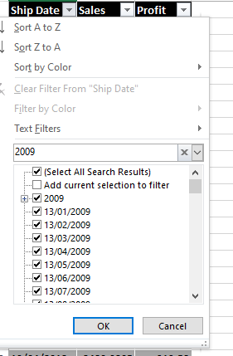
Figure 1: Superstore Analysis. (Source; Self-created).
Asfaw, Hailu, and Awol, (2022), showed that these aspects of formatting in tables and using filters as options support managers and other analysts to neat excel data. Many of the experts utilized the sort by smallest to largest option or A to Z option to format data from ascending to descending order, which can make analysis easier. For example, data could be arranged in ascending order from 2009 to 2012. However, we have not used these filters as some of the shipment dates were not written properly which is causing issues as A to Z search filters were excluding these improperly written dates. Therefore, a simple search filter was applied to compile data as per requirement. After compiling data with the use of these search results all the data on sales and profit for the year 2009 was copied and pasted as numbers to get a sum of sales and profit for this year. The data attained using these formatting and filter results for all of the years can be evidenced by the figure provided below. This graphical representation could be utilized to gauge results regarding changes in sales and profit so that increasing or decreasing trends in profit can be analysed.

Figure 2: Superstore profit and sales. (Source; Self-created).
Critically overviewing the results provided below figure. Further, an in-depth evaluation can be attained from the table provided below that is representing the percentage change in sales revenues and profit in comparison with previous years. In 2010 percentage change in sales and profit was almost -14.81% and -12.02%. In 2011, change was almost -2.71% in comparison with sales revenues attained by the company in 2010, however, profit has not shown a negative change proportion in this year as it was 3.62%. Whereas, in 2012 sales revenues showed a change of 8.18%, depicting an increase in comparison with sales of 2011, whereas, profit showed a declining proportion of -10.32% in comparison with the previous year.

Super Store | 2009 | 2010 | 2011 | 2012
Sales | 4169324.806 | 3551642.382 | 3455452.061 | 3738139.916
Percentage Change |  | -14.81% | -2.71% | 8.18%
Profit | 421,514.28 | 370,859.09 | 384,288.23 | 344,625.85
Percentage Change |  | -12.02% | 3.62% | -10.32%

Furthermore, this is considered a tool in Excel, which is a drag-and-drop analysis tool known as Pivot Table. One can find the answer to questions by slicing the data in a spreadsheet by pointing Excel to tables of data. This tool is very easy to use. Pivot tables can also be used in the analysis. Similar types of preprocessing aspects discussed previously could be undertaken with the use of Pivot Tables. For this, first, we are needed to select pivot tables and charts from the insert option in excel. By selecting it, students will get a dialogue box to enter the data set required to make a pivot table. Here, all the data of shipping dates, sales and profit were added. After going through this process, a search filter in the pivot table field of shipping date is used to extract the pivot table for the year 2010 to observe sales and profit for this year. This can be evidenced from the below section, where the search filter of 2010 was applied. These filter functions in the pivot table can also play a significant role as sorting it in the AtoZ manner can enable an analysis of different years i.e., from 2009 to 2010.

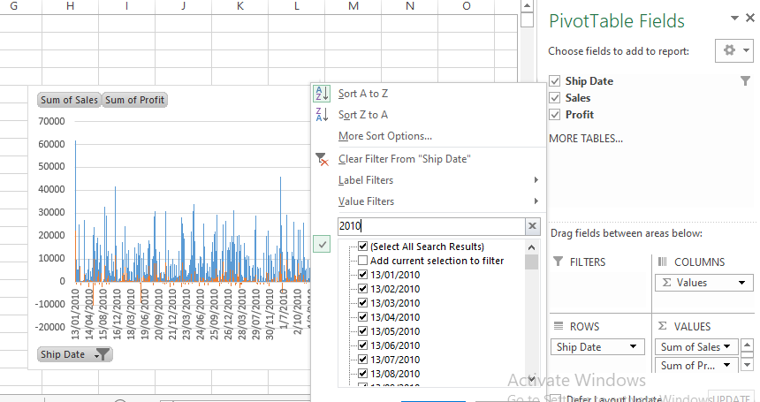
Figure 3: Pilot tables example; (Source; Self-created).
The pivot table plays a supporting role in analyzing yearly total sales and profit as at the end of the row, the pivot offers the sum of all the entries of sales revenues and profit. Using this approach pivot table of each year can be developed, which can play a significant role in the analysis. (Lee, Kerler, & Ivancevich 2018) demonstrated the fact that pivot tables support the analysis as analysts are not required to input a variety of formulas and work can be made easier with this aspect.

Figure 4: Pilot example; (Source; Self-created).
With these aspects charts and graphs can also be generated, which can play a significant role in analysis procedures and interpretation or evaluation of data. Further, chart types can be changed as per the preferences of analysts to get a better visualization of data, which can be in terms of bar, line or other charts. An example of a line pivot chart can be evidenced in the above figure.
On the other hand, the data can be fetched from other tables on the basis of the available value, which is called the lookup value (Lila, Nowneow, & Yimsiri, 2022). To understand the importance of the VLOOKUP Function, it is important to discuss it with the help of an example so that the practicality of this analysis tool can be understood (Jelen, 2019). In this instance, similar data was utilized to assess the VLOOKUP function as can be evidenced from the below figure. Here, another table Shipping date was highlighted as we need to observe its sales revenues of this date. In the next column, where sales revenue is needed to be attained, the function was applied. The formula was initiated by selecting the VLOOKUP function. After this I3 or shipping date entered is selected or the required shipping date cell is entered. In continuation, the whole table including data on shipment dates and sales was selected and the F4 function was used to make an absolute reference to this data.
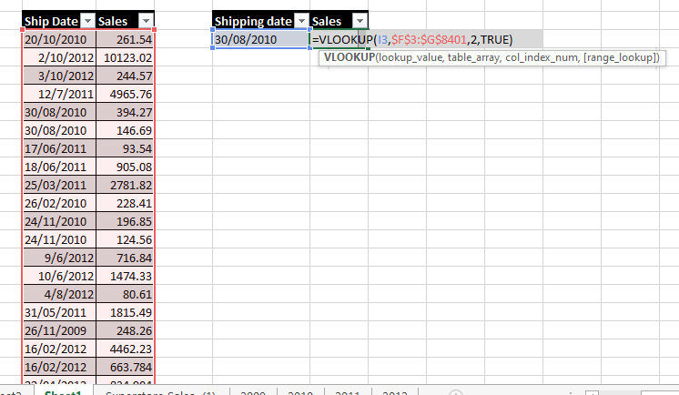
Figure 5: VLOOOKUP.(Source; Self-created).
As we have selected 2 columns and we will be needing data from 2nd column, this reference was added to the formula. At the end of the formula, the TRUE function is used so that the approximate value of all the sales on this date can be attained through the help of this function. In another case, FALSE is used so that the exact value can be attained. The reason to utilize TRUE or approximate function is that different transactions of sales occurred on this shipping date and we need total approximate sales revenue. This can be evidenced from the below figure representing the application of this function, where the TRUE function was applied in the 1st column and after this FALSE function was applied. The TRUE function is showing approximate total sales revenues generated on this date which is $1041.66. Whereas, the TRUE function total is just representing a single sales entry on this date. An exact match or an approximate match is nothing but the Range lookup. False or 0 is the argument for the same match, and True or1 is the argument for an approximate match. Therefore, the VLOOKUP function plays a significant role, when there is a huge amount of data and managers cannot manually look at all of the data set to get the total value or missing data. For instance, in large-scale superstores where at times product price tags can be missing, sales entries are often generated by using the VLOOKUP function on the product code so that product price can be identified. Therefore, VLOOKUP can play a significant role in analyzing data and gathering insight into a large data set or data mining can be performed.
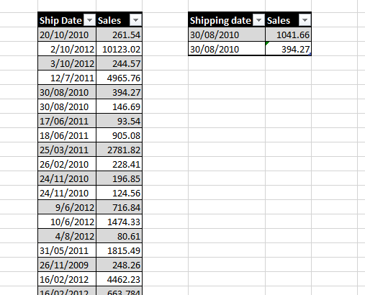
Figure 6: VLOOOKUP.(Source; Self-created).

Importance of Pre-processing and data analysis
Excel plays a significant role in different analysis procedures, data mining, data management and data visualization. However, data pre-processing in excel is important as it enables individuals to neat their data by omitting rough data entries, observing missing data, double entries of data and other issues. These issues have the potential to cause barriers to effective data management, which can hurt data analysis and visualisation analysis. However, without effective pre=processing, effective analysis cannot be performed.
Preprocessing and managing structured data is very easy through Microsoft Excel, it is a great tool for a non-programmer (Alsaadi et al., 2018). In other words, the transformation of raw data into an understandable format that the computer can analyse, through data mining and data analysis process (Anand et al., 2021). Structured data can easily be cleaned by the techniques and functions of Excel. To progress the business, companies use limitless sources like customer service interactions, internal information and the internet. To effectively “read” or understood the raw data must be preprocessed, row data cannot be run merely through machine learning and analytic programs. Another reason to use pre-processing is that raw data is messy and may contain errors, images, videos, and discrepancies it may be incomplete and without a constant design. Machines read 1s and 0s as data, it needs processed and uniform information. Data like Percentages and whole numbers are easy to calculate as structured data. Therefore, before analyzing the unstructured data like text or images, it must be formatted. On the other hand, Creek et al., (2012) showed that Garbage is the phrase used when data sets are used to train machine learning models. It means that the improperly trained model, which will not be relevant to the analysis, is what a person gets if it uses corrupt or “dirty” data to train the model. “Garbage” results are achieved by analysis of bad data used to train machine learning models, that’s why preprocessed data is more important than powerful algorithms. An out-of-range or irrelevant feature like an image of animals in a zoo or income below zero may be at your hand, which depends on the data gathering sources and techniques. Irrelevant symbols, text data or misspelt words could be in your data set. A more accurate downstream process will be at hand when preprocessed data is used. Bad decisions are followed by using bad data. “Data-driven decision-making” is very important. Preprocessing can be done based on different features. The categorical feature uses possible values and explanations from a defined set of explanations and values. These are like months of the year, the colour of the house, true/ false, negative, positive etc. Numerical features: it uses values of statistical, continuous on scale or integer-related. Values include fractions, percentages, and whole numbers. Features like word count in a document, house price, and step counts of stairs are numerical features.
After going through the pre-processing procedure, visualisation analysis and other techniques are utilized with the aid of excel, which ultimately supports businesses in the decision-making process. For instance, currently, a database of a superstar is available and analysis is needed to evidence changes in the declining trend in sales and profit. This evaluation of analysis, which can be attained with the use of pivot tables or charts can support the evaluation of issues in the performance of the organisation. On the evaluation of these issues, managers can come up with new strategies to introduce new changes so that sales revenues and profitability can be enhanced. Analysis and visualisations generated with the use of charts, pivots and other features support critical evaluation (Conant, & Chaille, 2022). For instance, changing trends in data can be analysed with these charts through the help of trend lines i.e., of different cost elements. This analysis results can be ultimately integrated into the decision-making of the company, which can play a supporting role to reduce costs where required.

Part 2

2.1: How many students like the vanilla flavour of ice cream?
47% of students have shown preferences for a vanilla flavour that is representing almost 95 students out of 200. Whereas chocolate and strawberry preferences were almost 24% and 29% respectively. Here, analysis was performed with the use of the COUNTIF function, where values in a number of specific values in cells can be observed.

Flavour | Students
Vanilla | 95
Chocolate | 47
Strawberry | 58

2.2: How many students are Male and Female?

Almost 109 students are from the female gender group representing almost 54% of the total sample. Whereas, male students are 91 in the sample showing a percentage of almost 46%.

2.3: What are the Mean and Median of participants who likes chocolate and strawberry flavour ice cream?
Mean and median of students who like chocolate and strawberry flavour are calculated, which can be seen from the table provided below. This calculation was performed using MS Excel and the descriptive statistics analysis attained shows that the mean is 2.55 which is close to 3 as it is exceeding 2.5 with few chemical points. This can be because strawberry representing a scale point of 3 was preferred more by students in comparison with chocolate having a scale value of 2. This can also be supported by the fact that mode has shown a more repetitive value of 3 representing those students like strawberries more in comparison with chocolate. The Median also shows the central value of the data set which is 3.

ICE CREAM
Mean | 2.552381
Standard Error | 0.048759
Median | 3
Mode | 3
Standard Deviation | 0.499634
Sample Variance | 0.249634
Kurtosis | -1.99264
Skewness | -0.21375
Range | 1
Minimum | 2
Maximum | 3
Sum | 268
Count | 105
Confidence Level(95.0%) | 0.096691

2.4: Clustering (ex. K-Means).
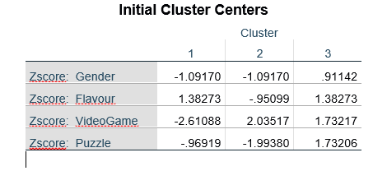
Cluster analysis histogram graph attained through histogram can be evidenced from the figure provided above. The analysis represents that in 1st cluster flavour shows a Z-score of more than +1. Whereas, other variables of gender, video game and puzzle have declined. On the other hand, 2nd cluster shows that gender, flavour and Puzzle score have remained negative while interpreting a positive score of a videogame. This is representing a score of 2.03517, which can be evidenced from the above table of initial cluster centres. In the 3rd cluster, Gender has shown a z-score of less than 1, whereas flavour, video game and puzzle scores remained more than +1. This can interpret an alignment of flavour preferences with puzzles and video games, which represents a completely different situation in contrast to other types of clusters.
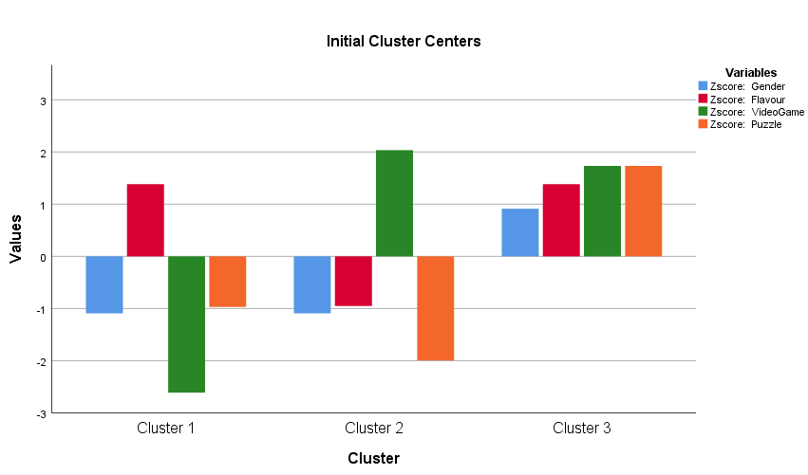

Whereas, final cluster centres can be evidenced from the below table, which shows a change in different cluster values.
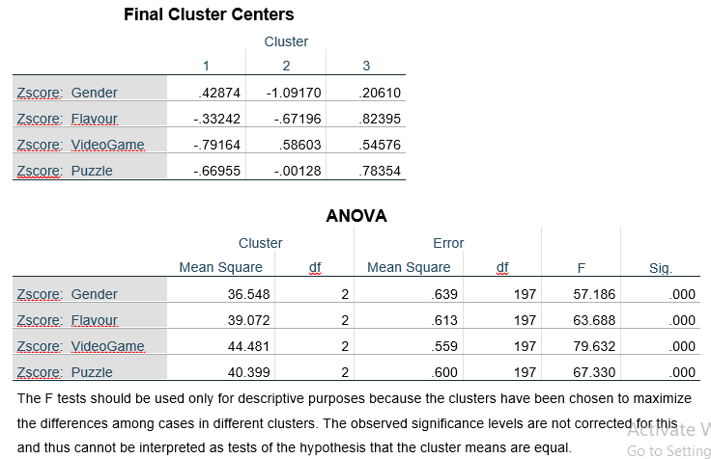

ANOVA can be observed from the above table that is including Mean square and F tests conducted on all the clusters. The mean square of video games is higher in comparison with others. The number of cases in each cluster can be evidenced from the table provided below, where cluster 1 is including 83 cases, cluster 2 has 46 cases and cluster 3 have 71 cases. Therefore, maximum cases are included in cluster 1. Here, this cluster shows analysis in the above section that gender, video games and the puzzle can have a relationship as these can move in similar directions. Whereas, the flavour has shown a completely different movement by interpreting a positive value. Thus, this cluster can be selected.

Number of Cases in each Cluster
Cluster | 1 | 83.000
Cluster | 2 | 46.000
Cluster | 3 | 71.000
Valid |  | 200.000
Missing |  | .000

The relationship among variables in this cluster is clear and gender can impact video games or puzzles. However, gender analysis conducted above shows that more female students have participated in the survey i.e., 109 out of 200. Whereas the participation of male students is almost 91 out of 200. However, differences in participation of these age groups are not quite distant. This aspect ultimately provides insight into the fact that all students either male or females like playing video games and puzzles.

2.5: Data mining and text mining methods
Some of the types of data mining methods include association (i.e., finding correlation), which is important to understand relationships among different variables. Other methods are clustering, classification, outlier analysis, sequential patterns or pattern tracking, prediction analysis, clustering classification and others. The most common type of data mining method is classification, where different characteristics are included in test data and classification rules are determined. These support analysis of data. A common example of this data mining can be evidenced in the figure provided below, where name age, income, and loan decision factors are determined. These are analysed in classification rules to interpret results. An example shows that different classification factors of income and age make it risky to offer a loan to John.
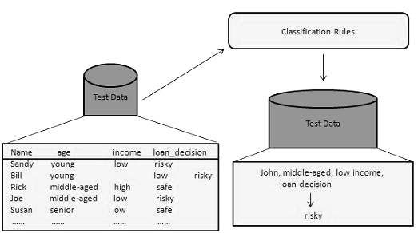
Figure 7: Classification. (Source; Piya, 2020).
Another common method used in this regard is decision tree analysis, where different decisions are analysed to select the most feasible decisions. With the classification of different, analysis can be performed effectively with the use of decision tree analysis (Hamoud, Hashim, & Awadh, 2018). The example of a decision tree can be evidenced by the figure provided below. Different E-commerce websites have used data mining methods for cross-selling and upselling their product offerings in the market. Some of these businesses are Amazon, Flipkart and others, who are utilizing “People also viewed”, and “Frequently bought together” options to the customers so that they can easily mine the company’s data. These recommendations are mainly offered by the company based on data mining as customers’ purchasing history can be gauged from the website, which can be compiled together to offer these recommendations to customers.
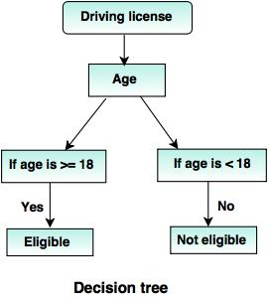
Figure 8: Decision Tree. (Source; Piya, 2020).
One of the common text mining methods is information extraction (IE), where a piece of information from unstructured or semi-structured data is extracted with the use of Natural language processing attributes. The precision and Recall process is used in this method to observe the relevance of results attained from text mining (Hamoud, Hashim, & Awadh, 2018). Another method used in this instance is Text categorization where free text documents are applied with decided categories, which can ultimately make text detection easier ( Kang, Sun, & Soares, 2019). News stories are often organized with the use of this method. Moreover, text mining plays a significant role in call center operations to improve quality. For instance, customer care teams use customer call notes in text mining so that problem resolution can be offered. The automated response could be offered to customers using text analysis which is central to chatbots. Therefore, customer service can be enhanced with the use of text mining.

2.6: Advantages and disadvantages of using SPSS and Excel
Advantages of using SPSS | Disadvantages of using SPSS
- One of the core advantages of using SPSS is that it offers accurate and reliable results with too the point analysis.  - In comparison with excel, this software has a high potential to offer good analysis of data.  - Another important aspect is that supports a wide range of analysis tools, which are usually not available in excel.  - Complex analysis can be performed. | - It can be expensive for some people as the purchase is required.  - Without good training and practice, one cannot utilize this tool effectively.  - Many of the features are quite complex in comparison with Ms Excel.

Advantages of using Excel | Disadvantages of using SPSS
- The aspect of preprocessing data options is one of the important advantages, which can invade all the others. For example, for those individuals who are utilizing SPSS, it is mandatory for them they are needed to use Ms Excel for preprocessing neat data so that it can be exported to SPSS for analysis.  - Easiness in functioning is one of the reasons that many individuals rely on it over other software.  - Purchase of software is not required. | - Complex data management can be a problem i.e., file hanging issues can arise, which can pause the completion of work.  - Many of the analysis tools available on SPSS are unavailable in Excel.

References
Alsaadi, H. I., Al-Anni, M. K., Almuttairi, R. M., Bayat, O., & Ucan, O. N. (2018, October). Text steganography in font color of MS excel sheet. In Proceedings of the First International Conference on Data Science, E-learning and Information Systems (pp. 1-7).
Anand, A., Saigal, S., Panda, R., Kodamanchili, S., Shrivastava, P., Das, A., ... & Gowthaman, T. B. (2021). Simple Mobile Application for Calculating" Ergotrauma" Made Using an Excel Sheet. Indian Journal of Critical Care Medicine: Peer-reviewed, Official Publication of Indian Society of Critical Care Medicine, 25(9), 1081-1081.
Asfaw, A., Hailu, A., & Awol, H. (2022). Improving Skill of SPSS Software For Biology 3rd Year Students of Samara University in 2021: Action Research. Indonesian Journal of Statistics and Its Applications, 6(1), 133-142.
Bernard, M., Minarti, E. D., & Hutajulu, M. (2018). Constructing Student’s Mathematical Understanding Skills and Self Confidence: Math Game with Visual Basic Application for Microsoft Excel in Learning Phytagoras at Junior High School. International Journal of Engineering & Technology, 7(3.2), 732-736.
Conant, D., & Chaille, S. (2022). Asset depreciation method comparison: An excel-based classroom exercise. Journal of Education for Business, 97(5), 351-356.
Creek, D. J., Jankevics, A., Burgess, K. E., Breitling, R., & Barrett, M. P. (2012). IDEOM: an Excel interface for analysis of LC–MS-based metabolomics data. Bioinformatics, 28(7), 1048-1049.
Hamoud, A., Hashim, A. S., & Awadh, W. A. (2018). Predicting student performance in higher education institutions using decision tree analysis. International Journal of Interactive Multimedia and Artificial Intelligence, 5, 26-31.
Jelen, B. (2019). Excel: THE NEW XLOOKUP FUNCTION. Strategic Finance, 101(4), 56-57.
Joseph, M. A. (2019, November). Getting started with SPSS, one-sample t-test, z-test for single proportion. In APHA’s 2019 Annual Meeting and Expo. American Public Health Association.
Kang, J., Sun, L., & Soares, C. G. (2019). Fault Tree Analysis of floating offshore wind turbines. Renewable energy, 133, 1455-1467.
Lee, L., Kerler, W., & Ivancevich, D. (2018). Beyond Excel: Software tools and the accounting curriculum. AIS Educator Journal, 13(1), 44-61.
Lila, B., Nowneow, A., & Yimsiri, S. (2022). Excel Based Monte Carlo Simulation for the (Q, r) Inventory Control Model. Ladkrabang Engineering Journal, 39(2), 103-112.
Piya, M., 2020). Data Mining Methods. https://www.educba.com/data-mining-methods/
Ramadhani, R., & Evans, B. (2022). Measuring students’ statistical reasoning abilities using flipped classroom model with SPSS and STATCAL. Journal of Honai Math, 5(1), 1-14.
Soule, L., Rodrigue, S., & Kleen, B. (2020). A SCAFFOLDING APPROACH TO LEARNING IMPROVES STUDENTS’CONFIDENCE IN THEIR EXCEL SKILLS. Journal of Research in Business Information Systems, 1.

