Research in practice
Saskia Bartlett
2112177
With reference: 2944
Without: 2534

Figure 1 The neuroscience of colour vision, Brocket. A (2015) 4
Figure 2 Equivalent, National gallery of art, 2024 6
Figure 3 In the Yarmouth river, 1887, P.H Emerson, Royal academy, 2024 8
Figure 4 Robert Frank Parade- Hoboken, New Jersey 1955, Artsy, 2020 9

The purpose of this essay is to explore how theory can impact a photographers practice, through in-depth evaluation of concepts and their influence on photography. This will be achieved by investigating the key words: representation, semiotics, and sociology, along with visual examples to illustrate the points addressed within the essay. As a result, the outcome will establish how the spectator viewing the photograph is both influenced by the principles outlined in semiology and sociology in obtaining meaning.
To begin, photography often is argued to be a representational tool due to the mechanical construction of cameras, preventing them from falsely capturing what is before them. This is based on the idea that the photographer would place the camera into the scene without many adjustments to location or camera settings in order to produce a photograph representing reality. Karpov. D and Kryuchkov. Y (2015, P.677) agree with this concept to some extent but claim that it is significantly more complex, needing to be broken into two types- the ‘art’ and the ‘event’. The ‘art’ type focuses on using techniques such as composition and colour to illustrate a situation, whereas the ‘event’ type takes a portion of the moment and draws upon all facts to create the photograph. Therefore, they do not dismiss that photography is a representation, but rather state there are two methods to achieve such usage.
An investigation into the ‘event type’ highlights that it is not just about positioning the camera and photographing but rather the photographer reading the information before them and trying to retell as much of it into the photograph. If the photographers aim is to accurately represent a situation, then they would need to disregard principles such as composition, angles, and lighting, as a format of display, and use them instead in a minimal sense to create a viewable factual photograph. This concept is discussed by Gunning (2017, p.43) who outlines that there are a set of rules that need to be applied to create an evidential photograph. Linking to the ‘event type’ he does not state it is unachievable but reflects that it boarders closely to the ‘art type’ and therefore there needs to be a distinguishable set of principles that ensure the photograph has captured as much of the information to represent the reality rather than stylistic choices to emphases it. Such rules might be using even lighting but not so much that it creates dramatic depth but rather make the photograph viewable, or a composition that does not alter the perspective of the situation. In essence the ‘event type’ focuses on a systematic collection of all data both of the scene and the camera to make as close to real representation.
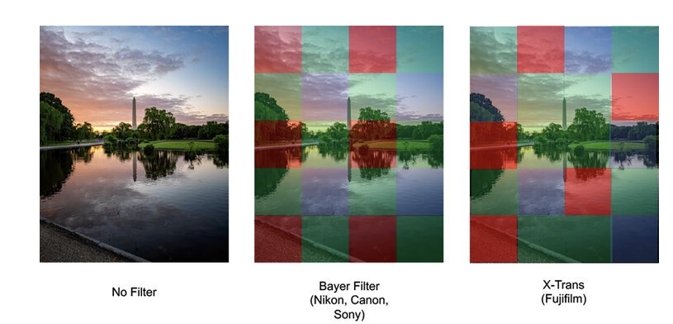
In contrast the ‘art type’ of focuses on the technical elements such as lighting, angles, and composition to represent reality, akin to the theory of neuroscience. This is an investigation into how visual stimulus such as colour, shape and texture trigger a reaction from the Hippocampus (memory) part of the brain to produce meaning (Sarinana. J, 2013). Sarinana explains how neuroscience in photography is about using certain colour and compositional techniques to produce a psychological reaction to create the representation. Extending this point Brocket. A (2015) investigated how companies applied neuroscience principles to direct the colour profiles of cameras which affect the outcome of the photographs. Fig. 1 shows how a photograph would look without the colour profiles used and how the Beyer filter causes a warmer tone while the x-trans is a cool tone. Brocket. A (2015) states that while the x-trans arrangement of pixels creates a higher quality photograph the cooler tone does not tend to draw the spectator in, hence the preferred filter is the Beyer as its warmth resonates more. This outline reflects how companies are aware of the impact that the ‘art type’ has on representation and therefore manipulate products to fit with the general trend. In both examples it has established that the ‘art type’ sits parallel to the neuroscience as it focuses on how colour, texture and composition create a representation of a situation.
Figure 1
The concept of colours having an impact on the photograph is also discussed in the semiotics theory. However, it differs slightly by arguing that it impacts the meaning taken away, rather than how the spectator will engage with the photograph. According to semiology, colour is a basic sign used to breakdown a photograph, because when one describes what they are seeing they reflect upon the coloration, which leads to the breakdown of shapes and textures. A detailed investigation into the impact of colour in semiotics was made by Caivano. J. L (1998, P.391) whereby he stated, ‘the object represented is usually arbitrary and conventional, colours work as icons, thus forming a link between the colours and objects…’. His claim is that the object is simply an entity, but that colour informs the spectator of its role and purpose preventing it beginning something in space and thus adding its value. Therefore, arguing that the purpose of colour is not to be aesthetically pleasing, but rather assists in conveying the representations that each component has within a photograph to deliver meaning.
This then leads to the proposed notion that semiotics could originate from the human need to understand and label everything they see, as a manner of making sense of anything, including photography. Mitchell (1980, pp 294-296) outlines that for one to register a photograph it must be identified within space, leading to the realisation that everything exists in a non-arbitrary manner, whereby humanity creates labels through signs and symbols to make sense of the world around them. The implication here is that semiology is a fundamental biproduct of existence because everything has meaning, resulting in signs and symbols that are then applied to the photograph. Overall, for an individual to even recognise the existence of a photograph they need to apply semiotics; and thus, a theorist like Mitchell suggests that it is impossible not to use internalised signs and symbols to read photography.
Semiotics theory also argues that comprehension of photography is not linear but rather indicates that individuals have their own unconscious and conscious influences that change the meaning, suggesting that photography is more of a communication tool. Bate. D (2009, p.42) acknowledges this implication and states ‘visual semiotics does not refute the existence of “reality”, rather it develops a way to speak about how the graphic marks on a flat piece of paper comes to signify a “reality”’. Essentially, Bate’s reflects that the semiotic theory does not imply that there is no truth to photography, but instead emphasises how different components present reality. In summation, the theory claims interpretation of a photograph is a conversation, because the reality identified by one individual is correct for them and may be transmitted like a spoken discourse
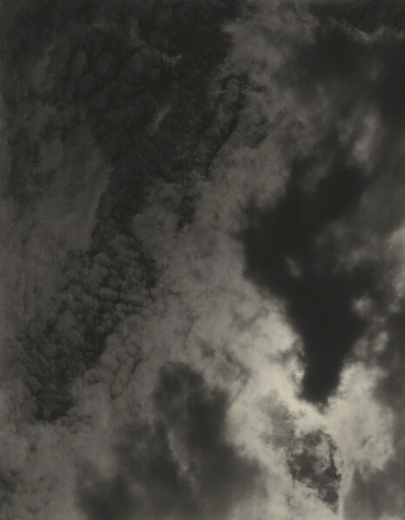
To better understand this notion presented in the semiotics theory, it is worth looking into Equivalent by Alfred Stieglitz. In fig. 2 it shows an example from the series, where the camera has been pointed up towards the sky capturing the clouds in their pattern formation at that moment. Photographs like Stieglitz which are ambiguous in nature, reflect Mitchell’s argument of semiology being born from the need to understand and Bate’s concept of discourse, as it is a human instinct to make sense of the significant of photographing clouds, and therefore they draw on the symbolisms created and apply their beliefs which will naturally differ to someone else’s beliefs. Stieglitz (1923) stated ‘I wanted to photograph clouds to find out what I had learned in 40 years of photography… to put down my philosophy of life’. This reflection summarises how the photographs were intentionally ambiguous, as a way to push himself to produce a series that reflected his technical skills and life lessons, whilst allowing for visual discourse of understanding. Therefore, it could be seen to reflect semiology because Stieglitz thought carefully about how the clouds could represent both photography and the lessons that he had acquired in a manner that encourages the spectator to think and respond.
Figure 2
Since the series of photographs were published, critics have shared what Equivalent might be discussing to them. For instance, Krauss. R (1979, P. 135) comments ‘We would not have seen what he had to expel in order to make them work, or what his source of authority was in believing that they could work…’. Here she notes upon the risk he undertook both in the practical construction, but also the personal ones of having an open meaning photographs which she believes is an important message to take from Equivalent. Her interpretation highlights how semiology of photography is about applying internalised believes to create a meaning that makes sense to them, fitting it to the spectators reality rather than what the photograph speaks to everyone in a singular representation.
Overall, Stieglitz and Krauss both focus on the technical efforts that were used to create Fig.2. However, they differ as Stieglitz tried to emphases there is a philosophy to photography too, not just construction, but Krauss was drawing on the personal costs that naturally occur. In both examples it strongly reflects how there are common signs and symbols in a photograph but are interpretated differently by each spectator from their own cultural backgrounds. This is further reinforced when Njirc and Milsoslavic (2016, P.312) as they write ‘…it is possible to reinterpret the symbols and context differently, which would lead to a different course and completion’. Therefore, they argue that semiotics is about the context that the photograph is viewed for the specific spectator rather than the context that the photograph sits in.
However, if the context in which the photograph was taken in, is important to understanding it, sociological principles should be applied. Presenting the idea that for useful meaning to be taken from the photograph as a whole there needs to be consideration to how a societies cultural values of a certain time period impacts what message is conveyed. Howard. B (2008, P.P 12-13) partially reflects upon these notions by discussing that a photograph does not automatically become a by-product of society, but rather sociology concepts are later applied to the photograph which creates the context allowing for the photographs full meaning to be drawn. By stating this he is not arguing that a photograph is not of sociological value, but rather points out that it only impacts the contextual meaning when society has moved on from that period, as in that moment it is merely about aesthetic values. In summation, the wider context of a photograph can be derived from sociology but predominately from looking back rather than in the moment.

Conducting investigations into examples will help to understand Howard’s argument. In fig.3 it depicts the river at Yarmouth, where there are boats docked ready to be unloaded or to set sail, while people play and work by the water’s edge. This figure is an example of P.H Emerson’s series of photographs that narrate the lives of the working class in the late 19th century England. The significance of looking at his work was outlined by Harper. D (1988, P.56) whereby he states, ‘His images are of specific class bound location or activity’. In this he is outlining that Emerson’s work is of sociological values because they are some of the earliest photographs that are out of the staged environment and of ‘real’ lives doing tasks assigned by class values.
Figure 3
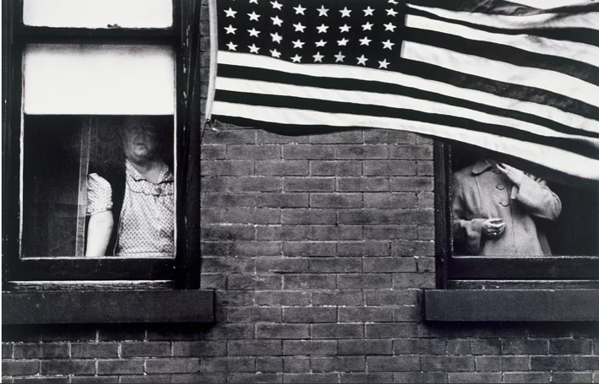
Another example would be to look at the photobook Americans by Robert Frank. Fig.4 is an example photograph from the book, featuring two figures standing in two separate windows, with the American flag obscuring the one on the right hand side. In each of Frank’s photographs he intentionally ensures there was something that resembled American culture, such as the flag in fig.4 or more subtle resemblances through cars, attire, or buildings. These motifs presented in his work, reflect back to sociology, by providing a frozen moment of the life lived in America in this period. Martausova. M (2021, P.12) supports this notion by writing ‘… provides evidence or proof with specific aesthetic value that contributes to how ‘real’ Americans are represented, hence observed’. In essence he has reflected that the choices of what Frank photographed were not arbitrary but rather carefully considered to represent American culture at that time, and therefore becoming of significant value to sociological studies.
Figure 4
Reflecting upon the work of Emerson and Frank highlight how photographs do have sociological significance at some point, due to the nature of the cameras function of recording a single moment forever. Applying Howard’s theory, the examples reflect how at that time such values would not be apparent, due to the need to research and establish the core values of each society in a time period, which could only be possible upon reflecting back and comparing.
As a result of looking at Fig.4 there is a connection between sociology and semiotics that comes apparent, in that they both rely on the signs and symbols to obtain meaning, but sociology applies them to wider societal changes rather than internalised influences. Such ideas were reflected upon by Bourdieu. P and Boltanski. L (1996, P.19) as they write ‘…demonstrate that for this practice, and more precisely, account for its instruments, its chosen objects, its rhythms, its occasions…’. In this they outline that the photograph is constructed with well-considered signs, from the subject matter to compositional techniques, that holds strong motifs to the time period that it was formed in. Thus, concluding that a photograph naturally holds sociological values since it is hard not to record a cultural moment as there are many decisions from a time period that will influence the way the photographer represents the given situation, but it might only become apparent upon reflection rather than in the moment.
Throughout this essay it has explored how both semiotics and sociology both impact the way a photograph is represent and thus understood. Both theories establish how photographs have signs and symbols that act as a representation of a time period. However, they differ in that the semiotics theory focuses on how internalised influences impact what the spectator takes away, whilst sociology emphases how the wider society context is what assists in meaning being drawn. It also discussed that photography can be used as a tool of representation, regardless of it being as a documentary or art practice, as theories argue that photography will always be a representation of a reality, whether that be from a society or an individual perspective.
Moving forward there will be further investigation into how the semiotics theory could be translated into a visual format, through the medium of art photography. This essay reflected how all types of photography can become a representation of some reality, and how at some point photographs can reflect a sociological time period in a significant manner. Therefore, to improve practice, continued research into how photography used in sociology and as a representation should be conducted, to ensure that the project is delivered in a sensitive, respectful manner. Lastly, this essay poses the question ‘Is visual response to photography equally represented by sociology as it is by semiotics?’.

Reference

Articles

Caivano. J. L (1998), P.391 Colour and semiotics: A two-way street, Colour research and application 23 (6) available at https://doi.org/10.1002/(SICI)1520-6378(199812)23:6<390::AID-COL7>3.0.CO;2-# (accessed 2nd May 2024)

Gunning, Tom (2004), P.43, What’s the Point of an Index? or, Faking Photographs, Nordicom Review

Haper. D Visual sociology: Expanding sociological vison, available at: https://doi.org/10.1007/BF02692374, (accessed 5th May 2024)

Howard. B (2008), P.P 12-13, Visual sociology, documentary photography, and photojournalism: it’s (almost) all a matter of context, available at: https://www.tandfonline.com/doi/abs/10.1080/14725869508583745, (accessed: 5th May 2024)

Karpov. D and Kryuchkov. Y (2015), P.677, Analytical photography as a new tool for the representations of reality, Procedia- Social and Behavioural sciences.

Krauss. R (1979) Stieglitz/ “Equivalents” P.135 MIT Press, available at: https://doi.org/10.2307/778239, (accessed 3rd May 2024)

Njiric and Miloslavic (2016) Semiotic effect in visual communication, P. 312

Martausova (2021) revisiting Robert frank and the status of documentary photography in the 21-ST century, Slovakia, University in Kosice

Stieglitz. A, (1923) How I came to photograph the clouds, amateur photographer and photography,

Books

Bate. D (2009) Photography the key concepts, P.42, Oxford: Berg Publishing .

Bourdieu. P and Boltanski. L (1996, P.19) Photography: a middle-brow art, Cambridge, Polity Press

Mitchell W. J. T (1980) The language of images, P.P 294-296, Chicago: University of Chicago Press

Websites

Artsy (2020), Robert Frank parade- Hoboken, New Jersey, 1955, available at https://www.artsy.net/artwork/robert-frank-parade-hoboken-new-jersey , (Accessed 5th May 2024)

Brocket. A (2023) The neuroscience behind vision, photography, and cameras, Available at: https://www.neuroscienceof.com/human-nature-blog/neuroscience-photography-cameras-vision-perception (Accessed: 26th April 2024).

Gallery of art (2016) Equivalent 1925, Available at: https://www.nga.gov/collection/art-object-page.36089.html (Accessed: 15th March 2024).

Met Museum (2016) Equivalent , Available at: https://www.metmuseum.org/art/collection/search/269404#:~:text=By%20photographing%20clouds%2C%20Stieglitz%20meant,telling%2C%20for%20the%20vagueness%20of (accessed: 20th March 2024).

Royal academy (2024), In Yarmouth river 1887 P.H Emerson, available at: https://www.royalacademy.org.uk/art-artists/work-of-art/in-the-yarmouth-river (accessed: 5th May 2024)

Sarinana. J (2013) Memories, photographs, and the human brain Available at: https://petapixel.com/2013/07/20/memories-photographs-and-the-human-brain/ (accessed: 26th April 2024).

