BIM

Assignment No 1: Construction Portfolio

Module code: ACBA 5010



Student: Max James

Student Number: 1900822

Lecturer: Gavin Traylor

Word Count on Specification: 2500 (+/- 10%)

Word Count on Document: 2,726 (Excluding Tables)
TABLE OF CONTENTS

INTRODUCTION 2

2.0 LETTER TO CLIENT 3

3.0 LEVEL OF INFORMATION REQUIRED 8
3.1 BIM Maturity Level 12
3.2 Information required within the EIR 13
3.3 Naming Conventions 14
3.4 Adherence to Welsh Governments Standards 15

4.0 EXAMPLE BIM LEVEL 2 PROJECTS & INFORMATION REQUIREMENTS 16
4.1 Haverfordwest High 17
4.2 Ysgol Caer Elen 26

4.4 Summary of BIM Examples 29
4.41 Level of Detail / Level of Information need 29

5.0 CONCLUSION 30

REFERENCE LIST 31

INTRODUCTION
This assignment will comprise of a letter which will highlight the requirements of BIM maturity for a specific project. The second part of the assignment will detail the requirements listed within the letter and explain the level of information required at each RIBA stage of the project to inform the clients EIR document.

2.0 LETTER TO CLIENT


Date: November 2022
Reference: Ysgol Glangwili
Telephone: 07774822515
Email: M.james@MTJ.ac.uk
www.MTJMulti-DiscDS.uk

MTJ Multi-Disciplinary Design Services
Unit 12 Minehead Office
Tenby
Pembrokeshire
SA67 0UR
Carmarthenshire County Council
County Hall
Castle Hill
Carmarthen
SA31 1JP

Dear Sirs/Madam,

RE: 5010 Ysgol Glangwili: BIM Requirements

I am writing to you in regards to our recent appointment to undertake multi-disciplinary design services on Ysgol Glangwili, which forms part of the 21st Century Schools programme. As part of our tender submission, we detailed an indicative BIM execution plan incorporating the request of a whole life monitoring asset through a CAFM system & this letter will detail the measures that will be taken throughout the project to achieve the required BIM maturity status. Appended to this letter, a report will detail the level of information required at each RIBA stage of the project.

As part of the tender package, it was expressed that:
- ‘The whole life monitoring of the asset needs to be through a CAFM system’

With reference to this statement & outlining the client’s requirements, the level of BIM maturity which will be worked towards is Level 2 BIM. Within the appended report, the BIM maturity level will be described in more detail, but this level of maturity allows full collaboration approach. As a Welsh Government funded project, it is vital Level 2 BIM compliance is met in accordance with Welsh Governments Mandate, referenced in the BIM Protocol document (Govermenent, 2022).

The CAFM system will adhere to BS EN ISO 5001:2014 (ISO, 2021) which is the requirements for asset management / management systems in which the CAFM system will demonstrate. With the level of BIM Maturity determined, the BIM process will be compliant by adhering to the international standard for using BIM; BS EN ISO 1950 (BSI, 2019).

To improve project controls, quality, and efficiency, as the lead consultant we will be responsible for the provision of a Common Data Environment abbreviated to CDE. Within the CDE, all project related documentation will be shared using the CDE technology. Throughout the design stage, the CDE will apply the principles outlined in BS EN ISO 19650-1:2018 (BSI, 2021) , BS EN ISO 19650-2:2018 (BSI, 2021) & BS EN ISO 19650-3:2018 (BSI, 2021) which is the standard for the organization & digitization of information; part 1 being within the concepts & principles stage, part 2 being within the delivery phase of the assets & part 3 being the operation phase of the assets. As part of the CDE, there will be numerous drawings & design information located within this environment therefore naming conventions will be used for ease of reference and to be able to locate specific information. The naming conventions will adhere to BS EN ISO 19650-1:2018 (BSI, 2021) & BS EN ISO 19650-2:2018 (BSI, 2021). The naming convention process is listed within the appended report.

Health & Safety will be paramount throughout the project and all information including the design information shared within the CDE will adhere to Health & Safety. The principles of PAS 1192-6:2018 (BSI, 2018) will be applied to the project, making sure health & safety is applied to the BIM process itself. The process of BIM itself will also mitigate risk in various ways, particularly the design stages. The detailed design will allow for co-ordination of construction activities to be determined and the sequencing of those.

From the perspective of the Carmarthenshire County Council, as the client you will hold responsibility to produce a EIR document which is the abbreviation for Exchange Information Requirements. The EIR document will be project specific in relation to this school and will format the required level of information need of the project information. The EIR document itself will allow us as the lead consultants to produce a project specific BIM Execution Plan (BEP). The EIR document itself should be informed by BS EN ISO 19650-1:2018 (BSI, 2021). As the lead consultant, it will be our duty to design the scheme in accordance with the EIR and fulfil your clients’ requirements referenced within the document. This process will be managed through BS EN ISO 19650-4:2018 (BSI, 2022), which is the updated standard of the previous BS 1192-4:2014 (BSI, 2014). These standards reference the transfer of information between parties, by adhering to this it will allow us to collaboratively work with yourselves and feed the information provided into the EIR into our BIM execution plan and utilise this throughout the process.

As data will be shared through the CDE, it is vital that the format of specific aspects of data are identified. As lead consultants, we will provide a vast amount of information through the CDE particularly throughout the design process. Below details the exchange format & the formatting of specific documents which is vital to do from the outset:

Information Type Exchange Format
- Drawings DWG, PDF
- Schedules PDF
- Asset Data / Collection Sheets XLS (Excel)
- Models RVT / REVITZO
- Reports DOC, PDF
- Manufactures Information PDF

Working towards BIM Level 2, we will be adhering to BS EN 17412-1: 2020 (BSI, 2020) which details the level of information need. This will inform the level of information required in each model produced. Prior to this standard, the level of detail for each package providing a model would be determined through the NBS BIM Toolkit, in which a LOD (Level of Detail) chart was provided, this was defined by the American Institute of Architects. As a point of reference, an assumption has been made that the level of detail in accordance with the below table will be between 200 & 400 dependent upon the model produced; this will be informed through the standard BS EN 17412-1: 2020 (BSI, 2020):

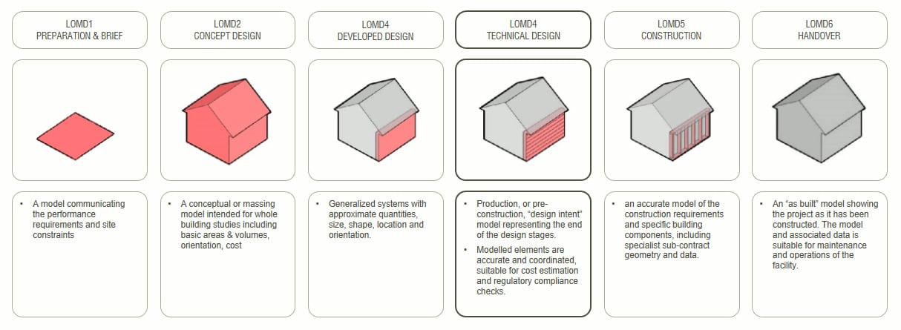

Level of Detail table (NBS, 2022)

In summary, the above details the project will be working towards Level 2 BIM maturity & details the various ways in which information will be shared. Appended to this letter is a report which the level of information need required & the information in which Carmarthenshire as the client will be required to provide to inform the EIR.

Thank you for your time & consideration, we look forward to working with you on this interesting project.

Yours Truly,

Max James ARB, RIBA
Lead Architect

MTJ Multi-Disciplinary Design Services

3.0 LEVEL OF INFORMATION REQUIRED
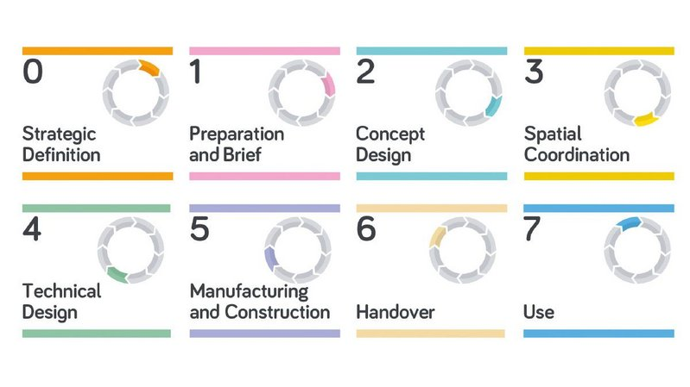
The level of information will vary at each RIBA Stage of the project, as a narrative below shows the RIBA Plan of Works:

RIBA Plan of Works (RIBA, 2020)
At each RIBA Stage of the project, there will be a different level of information required in regards to the BIM process, below details a table referencing this (design stages only):

At the end of each RIBA Stage, there will be a report issued to yourselves as the client for sign-off. These sign-off periods will be factored into a programme and give you sufficient time to review the report & any amendments required will be actioned. A revision of the report incorporating these amendments will then be issued for sign-off, without the client sign-off the RIBA stage will not be concluded.

RIBA Stage | Level of Information Required / Output of stage
The level of information required / output of the stage at RIBA 0 & 1 have various cross overs therefore have been compiled into one category. Within these two stages, this is perceived to be the project launch stage, where we as the lead consultant will consult various engagement tasks. At this stage, we will prepare very indicative general arrangement plans, with scheduled areas in accordance with the school’s curriculum.

Core Activities | Key Outcome of Activities | Method
Brief Finalisation | Within this activity, the key outcome is to finalise the educational brief. This activity will cover the BIM Level 2 strategy to achieve this brief as well as the end-users’ requirements. | This will be achieved through various design workshops taking place.
Agree schedule of areas | Upon the finalisation of the brief, the schedule of areas will be agreed. This will be done in accordance with the school’s curriculum & in accordance with Welsh Governments Building Bulletin document (Goverment, 2022) | This will be achieved through various design workshops taking place.

Within RIBA Stage 2, the design will be advanced, and the plans will become more detailed. This will also detail the non-curriculum-based areas such as the canteen & break-out areas. This will require input from yourselves as the client to determine the schools’ requirements / necessities.

Core Activities | Key Outcome of Activities | Method
Agree schedule of areas (more detail) | The key outcome of this activity is to agree the schedule of areas in more detail. This will be more in-depth plans, showing aspects such as room layouts & GIFA areas for each classroom / area. | This will be achieved through various design workshops taking place.
Design of non-curriculum-based areas | The key outcome of this activity is to agree the non-curriculum-based areas, this will be aspects such as break-out areas / canteen. | This will be achieved through liaison with yourselves as the client to determine the school’s necessities.

Within this stage, the design will be in accordance with the BIM strategy. The model itself will be designed as the initial BIM model.

Core Activities | Key Outcome of Activities | Method
Initial BIM Model | The outcome of this activity is to have initial BIM model which includes the site layout and area requirements. | This will be achieved by integrating various models such as the structural & architectural model, to attain an overall BIM model. This will be analysed with clash detection technology.

Within this stage, the design will be a detailed design incorporating all disciplines. This will require yourselves as the clients input to fully evaluate the designed solution achieved.

Core Activities | Key Outcome of Activities | Method
Detailed BIM Model | The outcome of this activity is to accomplish a fully integrated BIM model. | Technical design team meetings & client’s agreement on room layouts etc.

3.1 BIM Maturity Level
As detailed within the letter, BIM Level 2 is the level of maturity in which this project will be worked towards; The BIM Level 2 Maturity will facilitate your client needs and also adhere to the brief allowing a collaborative approach, which will require an information exchange process at different intervals of the RIBA plan of work (NBS, 2022). The information exchange element will be governed by a CDE (Common Data Environment); this will allow all relevant documentation to be uploaded to & hold all information required for the project / asset. The CDE will adhere to BS 1192-4:2014 (BSI, 2014), the standard for collaborative production of information which will fulfil the Exchange Information Requirements. Level 2 BIM is the UK Governments requirement for public sector projects, as well as the Welsh governments mandate for 21st Centaury Educational projects. The CDE will play a vital part in achieving this maturity level as the collaborative approach requires information exchange to be exceptional & coordination between us as lead consultants & you as the client will be vital. Below details a flow chart outlining BIM Maturity levels, with the level 2 approach highlighted; as can be visualised, the level 2 is a full collaboration approach, in order to achieve this requires seamless coordination:
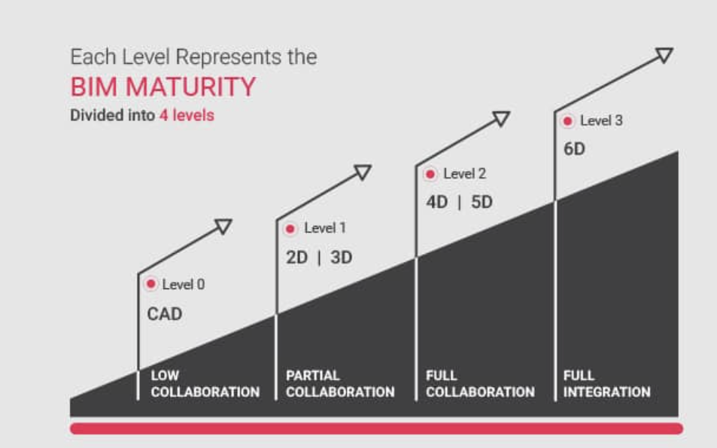

BIM Maturity Model (BIM, 2022)

Level of BIM being adhered to on this project.

3.2 Information required within the EIR
As part of the process, an EIR will be required by yourselves as the client. The EIR is Exchange Information Requirements and will be a document that specifies information in regards to the project, such as project information, relevant requirements for the AIR (Asset Information Requirements) – this has been provided within the brief which was a CAFM system. Previously, PAS 1192-2:2013 (BSI, 2014) Clause 5.3 defined the minimum content of the EIR however, this has now been inundated by BS EN ISO 19650-1 & BS EN ISO 19650-2 (BSI, 2019) in which the minimum requirements will be listed. As the client, Carmarthenshire County Council will be required to adhere to this standard in order to produce the EIR. As lead consultants, our BIM Execution Plan (BEP) will be informed by the EIR provided by yourselves.

3.3 Naming Conventions
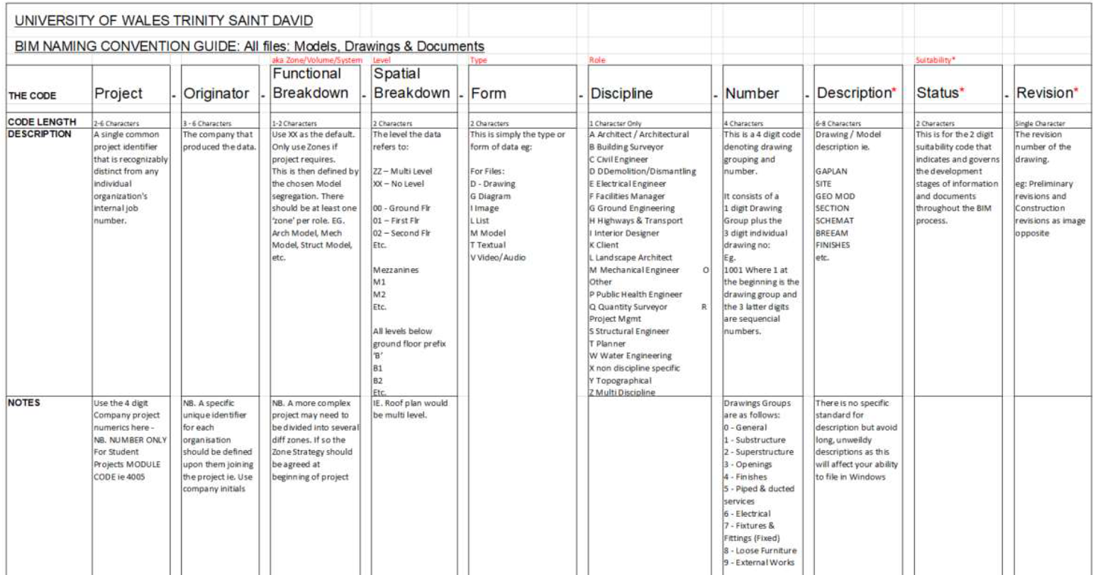
The naming conventions will adhere to BS EN ISO 19650-1:2018 (BSI, 2021) & BS EN ISO 19650-2:2018 (BSI, 2021) as listed within the letter above; the process of the naming convention is detailed within the image below:

Naming Convention process (University of Wales Trinity St David PowerPoint) (David, 2021)
By utilising the above naming convention process, an example of how the file name would look for a specific drawing within this scheme is detailed below:

Project Number: 5010
Project Title: Ysgol Glangwili
Description: 1 form entry infant school for 90 pupils, with 48 PT Nursery provisions

5010-YG-XX-ZZ-D-A-1001-GEOMOD-S1-A

By utilising this process, it allows specific documents to be located within the CDE at ease and drawings become more accessible. The example drawing naming file indicates an architectural (A) drawing (D), which is multi-level (ZZ), issued for co-ordination purposes (S1) & is at revision A (A)

3.4 Adherence to Welsh Governments Standards
As a Welsh Government funded project, BIM Level 2 will be met as referenced within the letter and throughout this report; as part of this, the building will be designed in accordance with Building Bulleting 99 which is listed within the Welsh Governments 21st Century Schools business case guidance document:

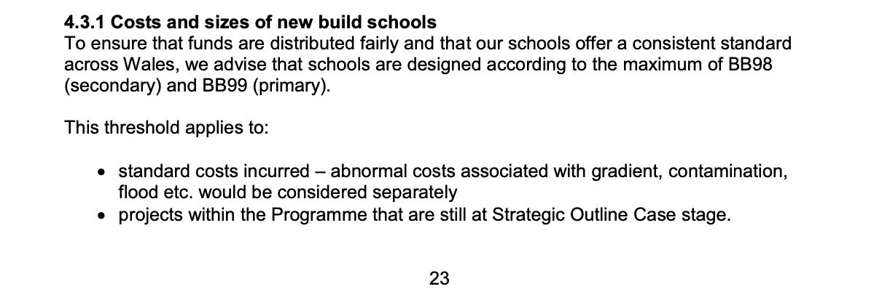
Page 23 of Welsh governments publication: 21st Century Schools and Colleges programme business case guidance (Goverment, 2020)

The example schemes listed below would have been designed in accordance with BB98 or BB99 dependent upon whether they were a primary or secondary provision.

4.0 EXAMPLE BIM LEVEL 2 PROJECTS & INFORMATION REQUIREMENTS
The level of information need & level of detail associated with that varies at each RIBA stage. The table below details an indicative overview of each RIBA stage (design stages) & the level of detail associated with that:

RIBA Stage | Requirement | Purpose
 | To provide visual aids of the general design principles. The indicative details need to be shown such as the general internal & external content to coincide with the client’s brief. | At this stage, the purpose of information is to provide a visual aid of proposals, which identifies key requirements such as primary systems – the level of detail required in drawings at this stage is low & will comprise of general arrangement plans etc.
 | To provide visual information of design to a better level of detail. This will include various designs from different disciplines & will be at a stage where the design could be given to specialist subcontractors to progress with their design element i.e., fabrication of steel frame | To attain a further understanding of the design & allow greater coordination – this is where the brief requires confirming / accepting in order to progress with the technical design stage.
 | Achieve detailed design comprising of accurate detailing such as graphical representations, primary performance & actuate dimensions. | To further the detail & accurately design the asset from the visual representation proposals at the previous stage.

Generic Level of Detail required in drawings at each RIBA Design Stage (NBS, 2022)

Below details two example projects with the level of information need associated with each:

4.1 Haverfordwest High
Haverfordwest High was a recently completed scheme (July 2022) which formed part of the 21st Century band B schemes. This project was required to meet Level 2 BIM Compliance in accordance with the Welsh Governments Mandate. The project was a two-stage design and build where the contractor novated the design element to Atkins. Below details the concept design & construction of the school:
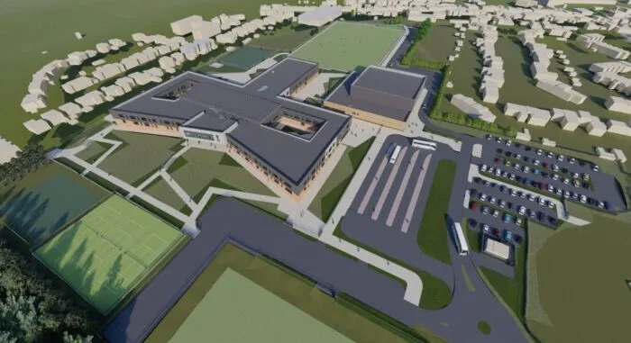

Haverfordwest High Concept Design (Online, 2020)
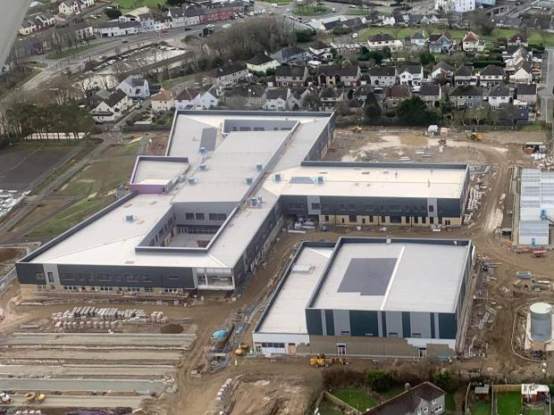

Haverfordwest High During Construction (Online, 2020)
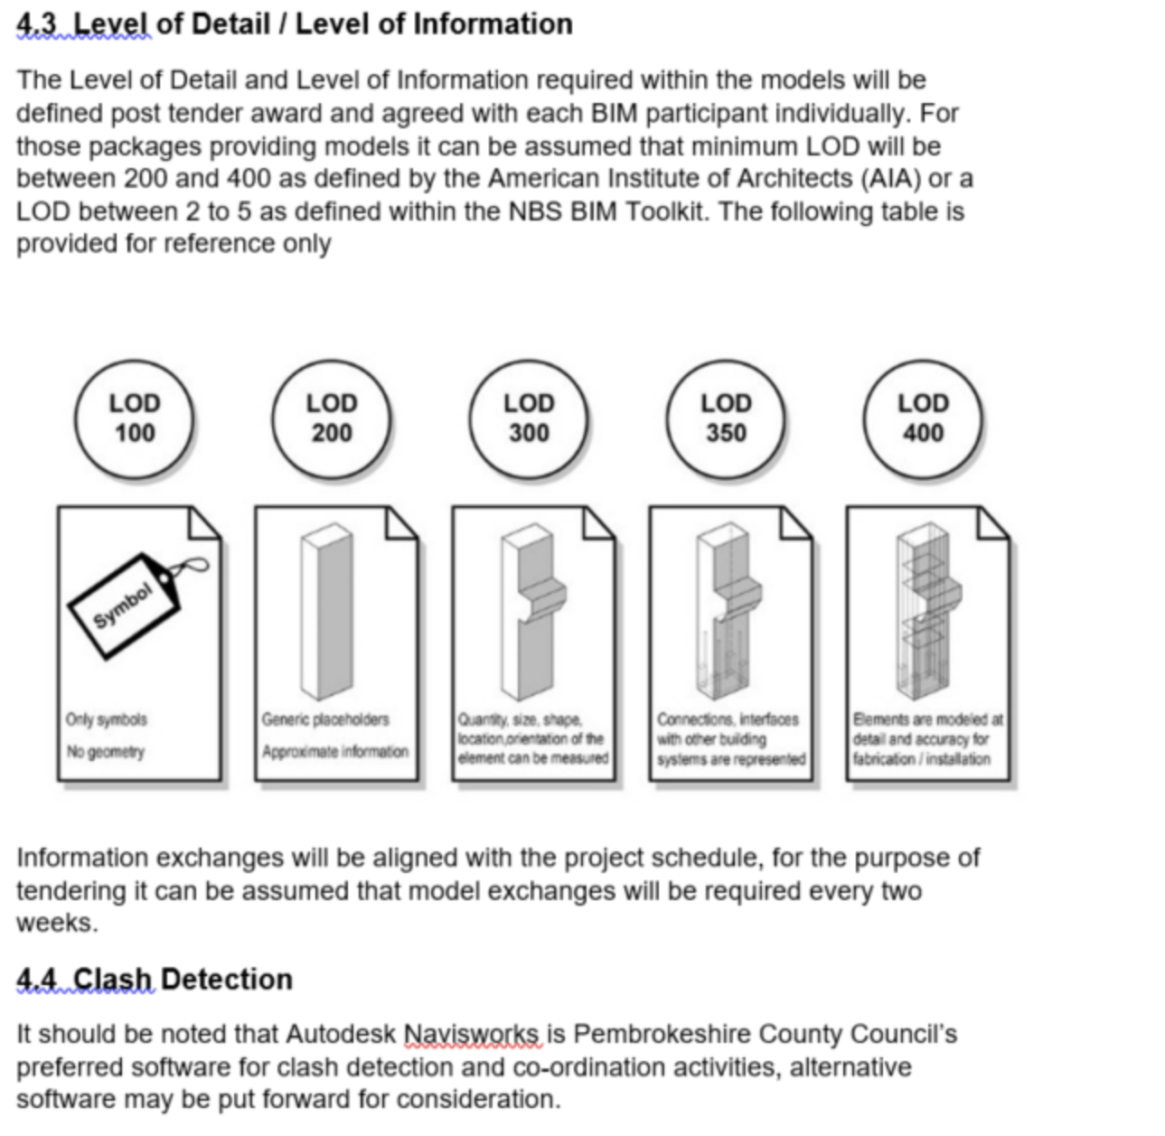
The EIR document provided by the client on this scheme (Pembrokeshire County Council) was a detailed document which enabled the contractor to produce their BIM execution plan to the clients standard. The EIR document informed the required level of detail / level of information listed below:

Level of Detail / Level of Information section Pembrokeshire County Councils EIR document issued as part of the tender documents for HHVC (Council, 2021)

The section lists that the LOD will be between 200-400, dependent upon the RIBA stage and information submitted, this varied. Below lists a table detailing RIBA stages 0-3 & the level of information / level of detail submitted at each stage to the clients satisfactory:

RIBA Stage | Level of Detail / Information
RIBA Stage 0-1 | Within RIBA Stage 0-1, the level of detail provided was LOMD1 / LOMD2 in reference to the NBS LOD table provided within the letter. The information provided at this stage was aspects such as site analysis, the clients brief, proposed schedule of accommodation areas & site massing. The LOD at this level doesn’t require to be any more than LOMD2, below lists some example pieces of information to determine the LOD utilised.

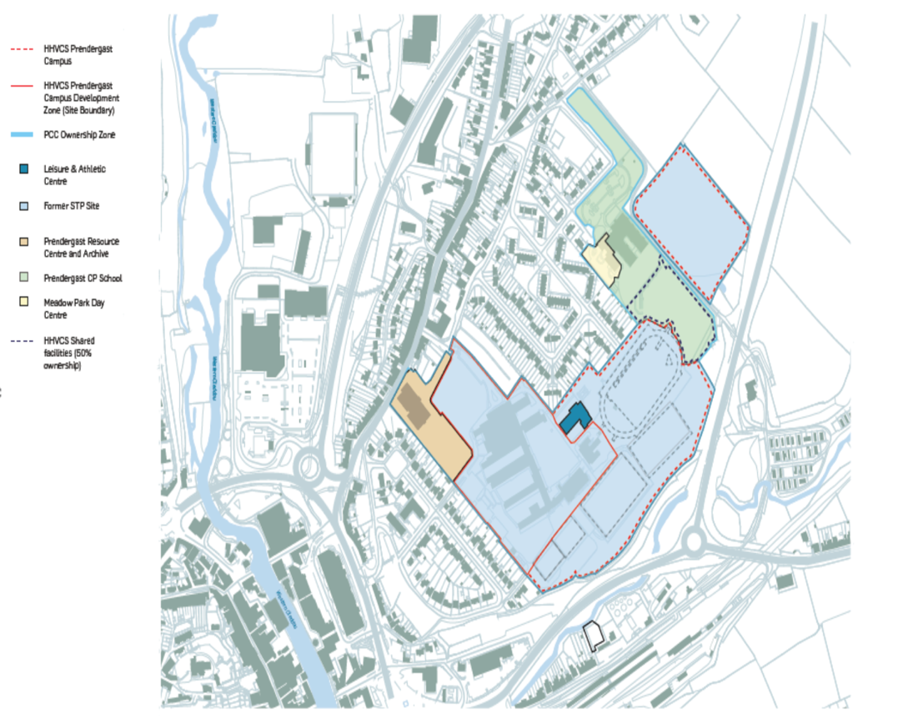

Site Analysis Drawing (Council, 2021)
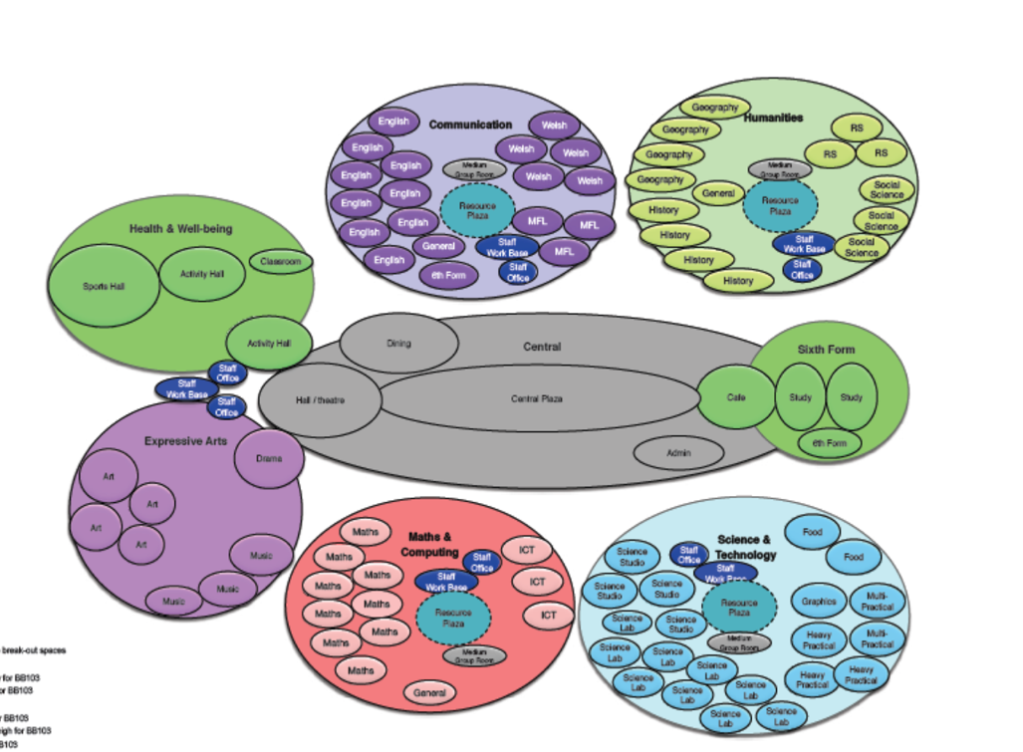

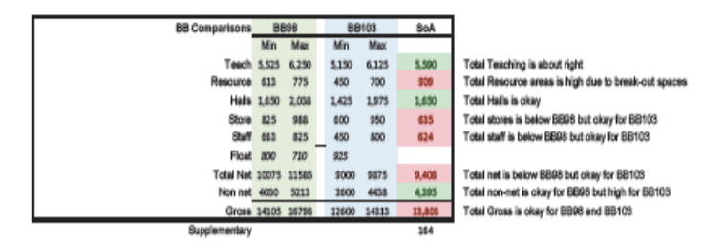

Proposed Schedule of Accommodation – Gross Areas (Council, 2021)

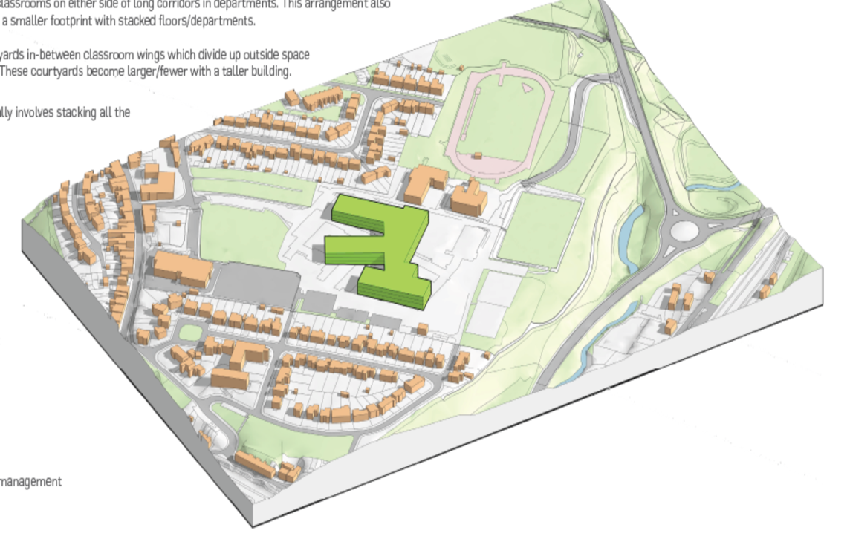

Site Massing (Council, 2021)
RIBA Stage | Level of Detail / Information
RIBA Stage 2 | Within RIBA Stage 2, the level of detail provided moved into LOMD 3 & partly 4 with reference to the NBS LOD table. This included drawings from various disciplines such as acoustic engineers, flood engineers and a range of utility drawings were provided. The architectural model was informed by the schedule of accommodation in more detail and general arrangement plans were produced. Elevational drawings were also produced, increasing the detail significantly. Below lists some example pieces of information which details the LOD / information need provided at this stage:
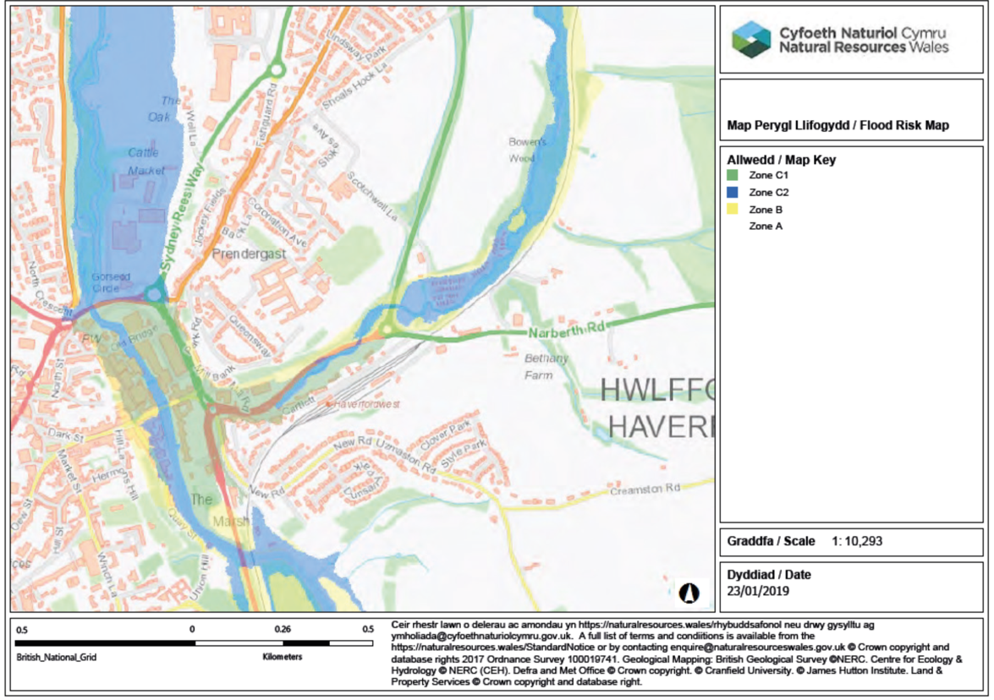

Flood Risk Map (Council, 2021)
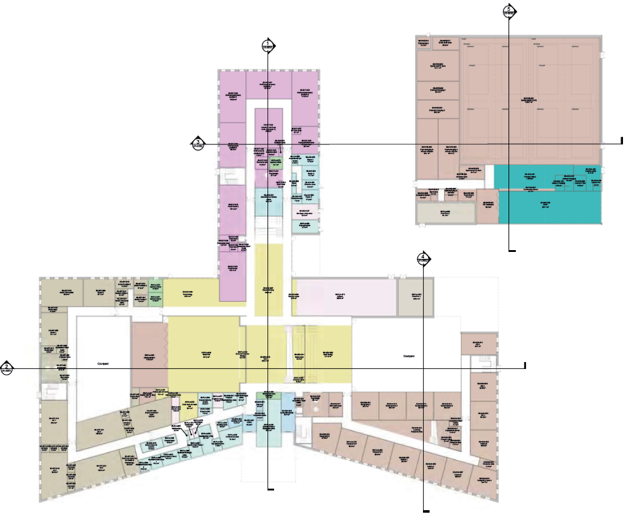

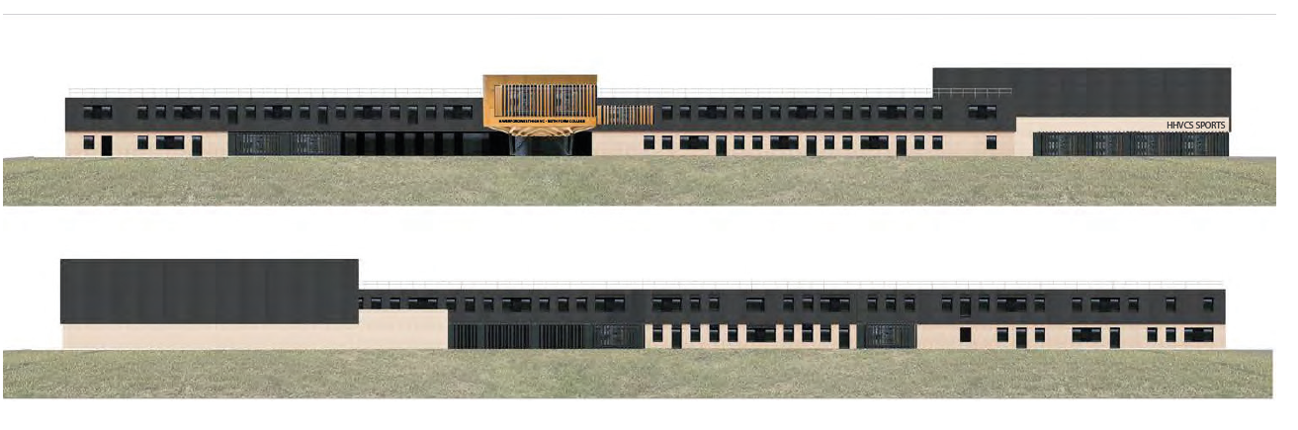
General Arrangement Drawing (Council, 2021)

Elevational Drawing (Council, 2021)
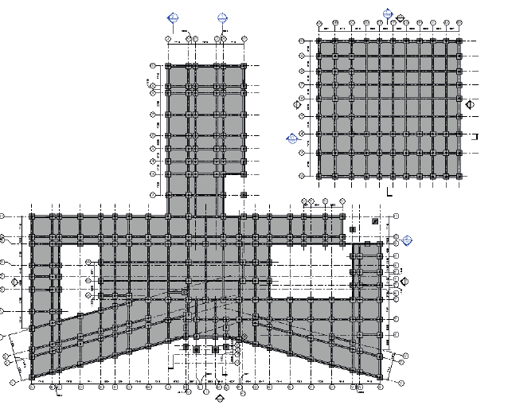

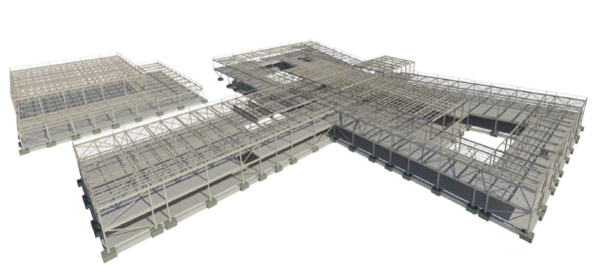

Structural Drawing with Elevation (Council, 2021)
RIBA Stage | Level of Detail / Information
RIBA Stage 3 | Within RIBA Stage 3, the level of detail provided was predominately LOMD 4 with reference to the NBS LOD table. This included an architectural package with detailed spatial coordinated drawings, with detailed elevations & renders. The other disciplines packages were also designed in further detail. Below lists some example pieces of information which details the LOD / information need provided at this stage:
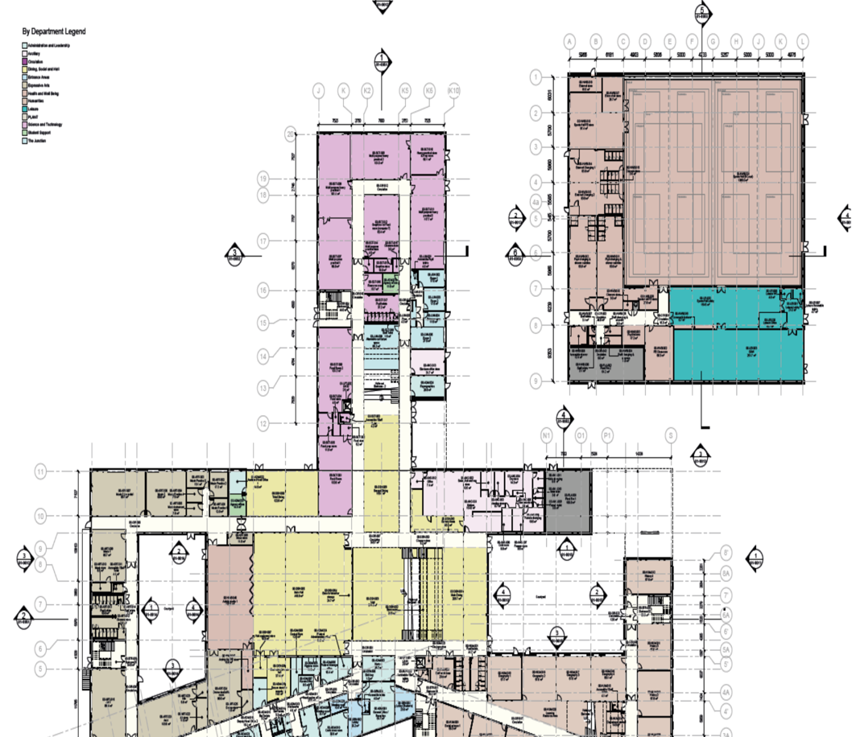

General Arrangement Plan (Council, 2021)
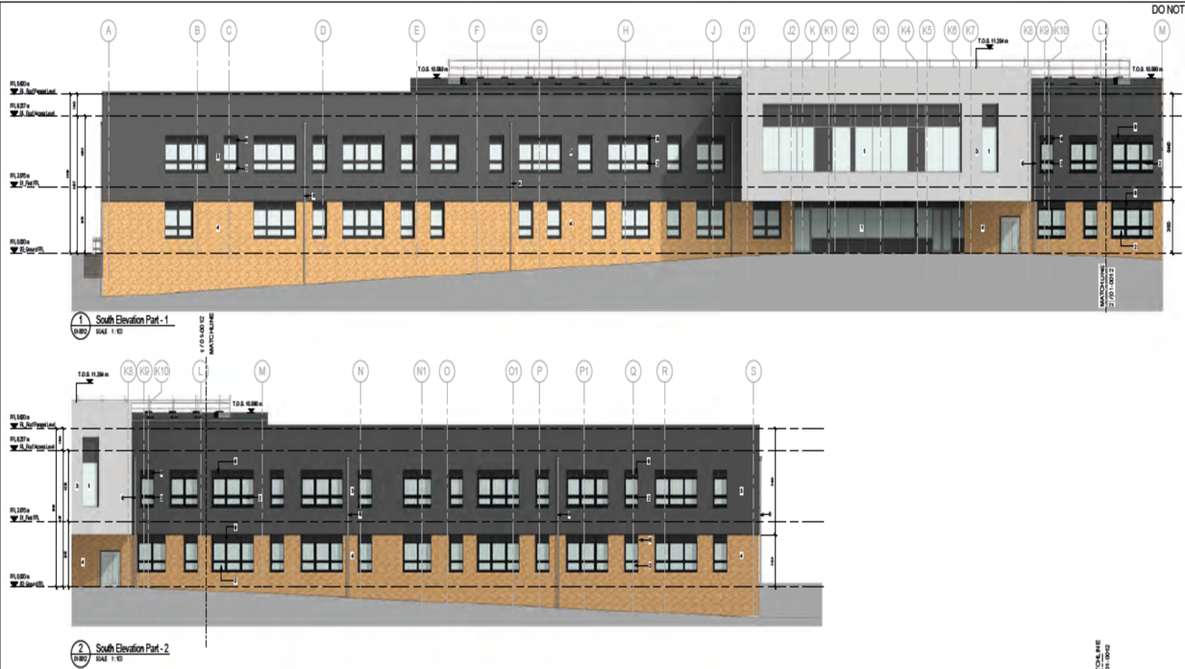

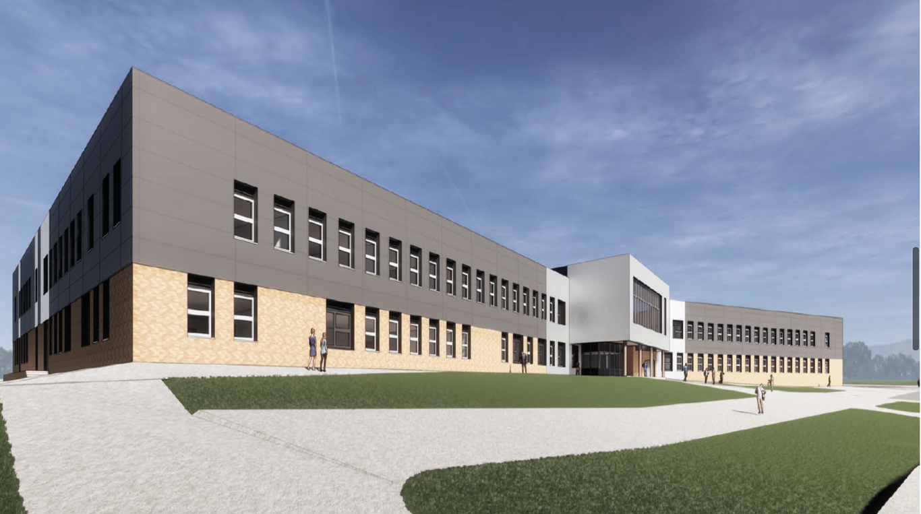
Elevation Drawings (Council, 2021)

Elevation Render (Council, 2021)

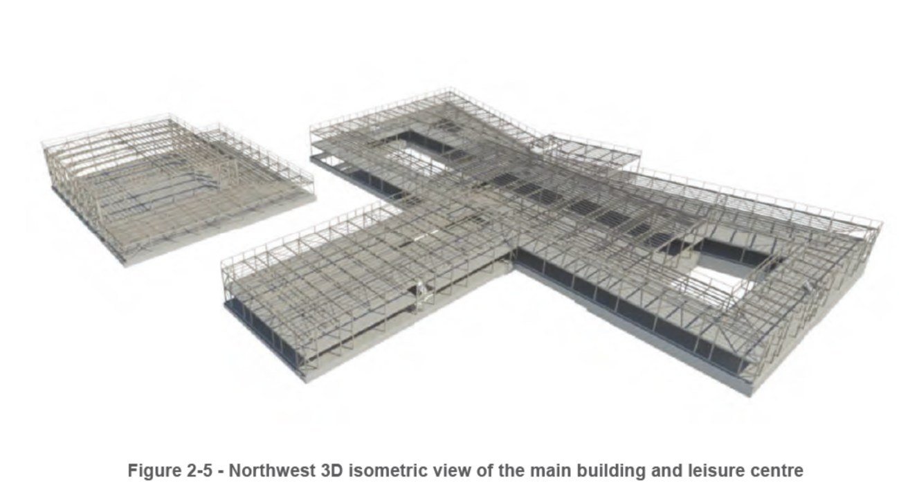

Structural Elevation (Council, 2021)

As portrayed within the examples, the LOD / Level of Information need varies at each stage. Utilising a project example such as the above can help Carmarthenshire produce their EIR document. It is vital that the LOD / Level of Information need is only what the stage requires.

4.2 Ysgol Caer Elen
Ysgol Caer Elen is a Welsh Medium school which formed part of the 21st Century school’s campaign. The school is split into two elements & houses both primary and secondary pupils therefore the design incorporated both BB98 & BB99. The school EIR document was similar to the previous example, therefore the LOD / Level of Information need was the same. Due to the timescales of this build, the project would have adhered to the PAS BIM Standards as these were the current standards at the time frame of the build.
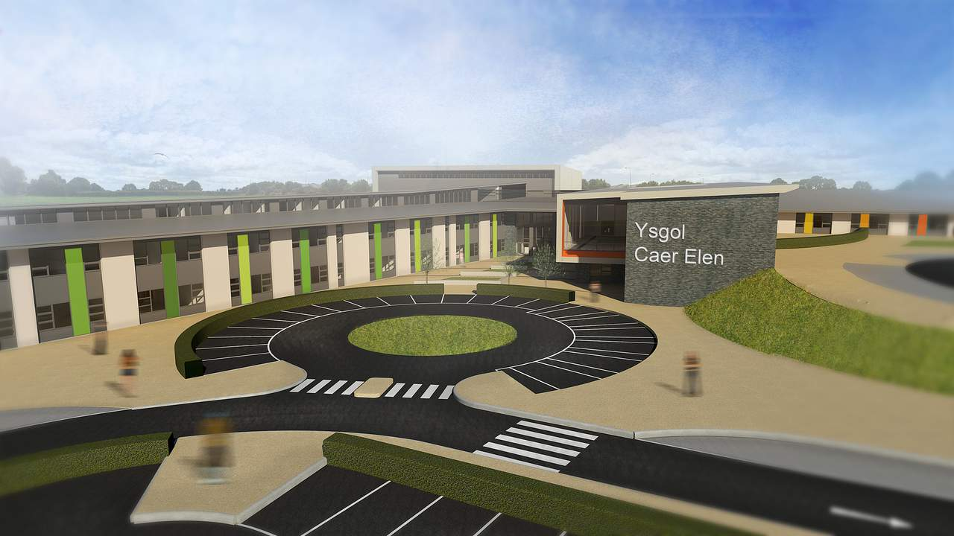

Ysgol Caer Elen Concept Design (Treglown, 2019)
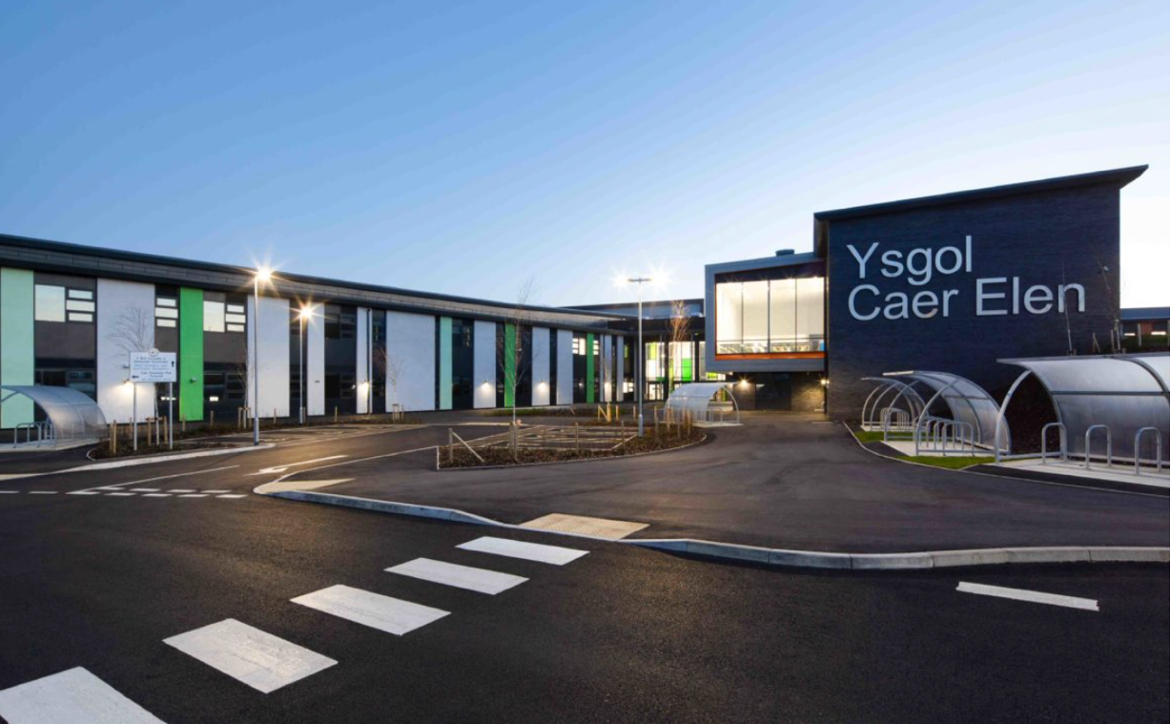

Ysgol Caer Elen Complete Construction (Treglown, 2019)
As the previous scheme details the LOD / Level of Information need at RIBA Stages 0-3, below details the LOD / Level of Information need produced for this scheme at RIBA 4 (Technical Design) & RIBA 5 (Construction):
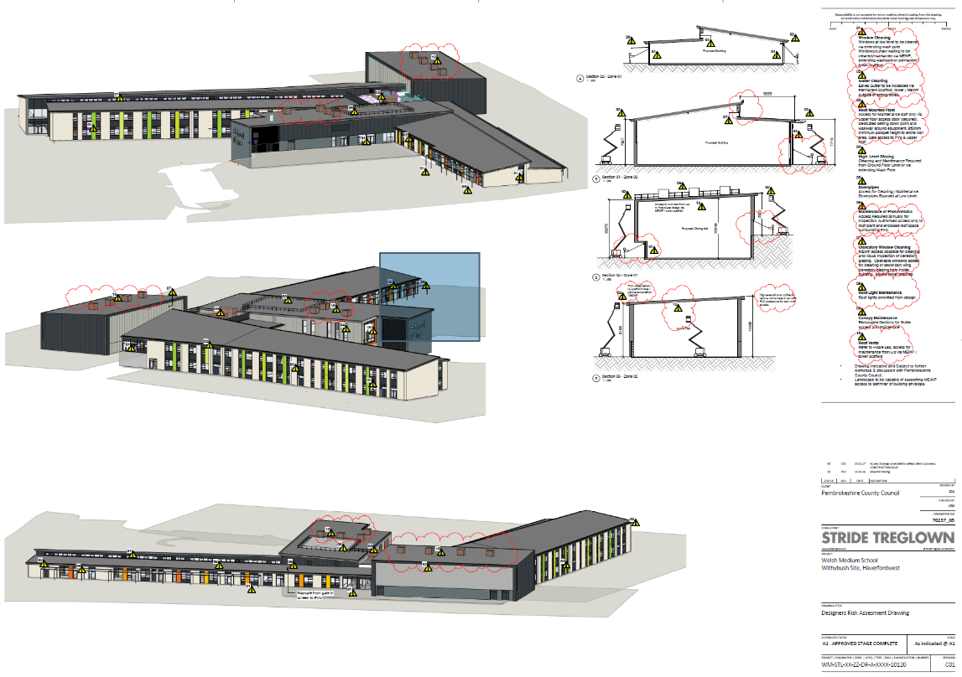

Elevation Drawing (Risk Assessment)
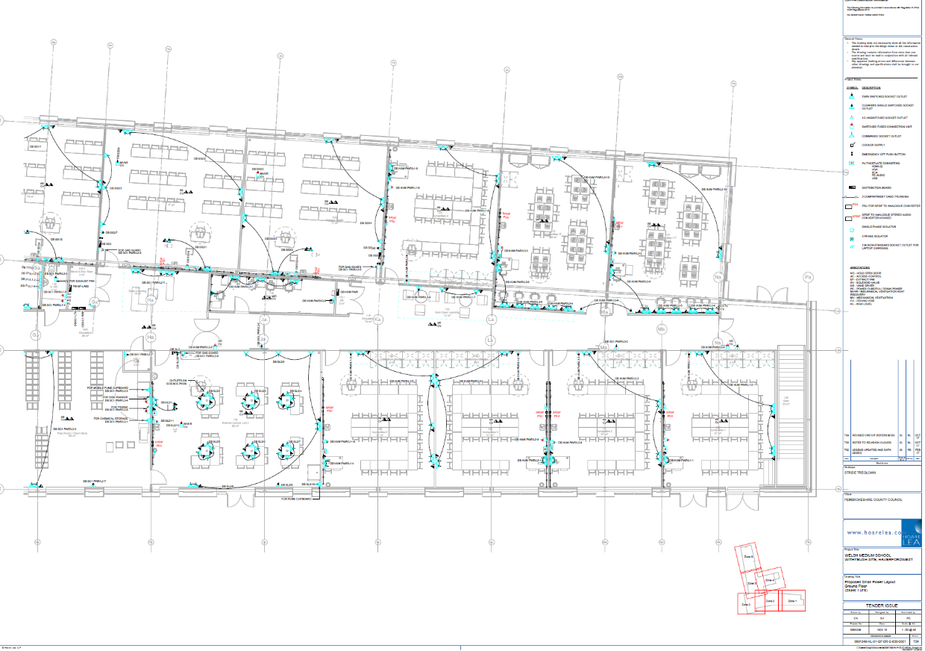

Electrical – Small Power & Data Layout

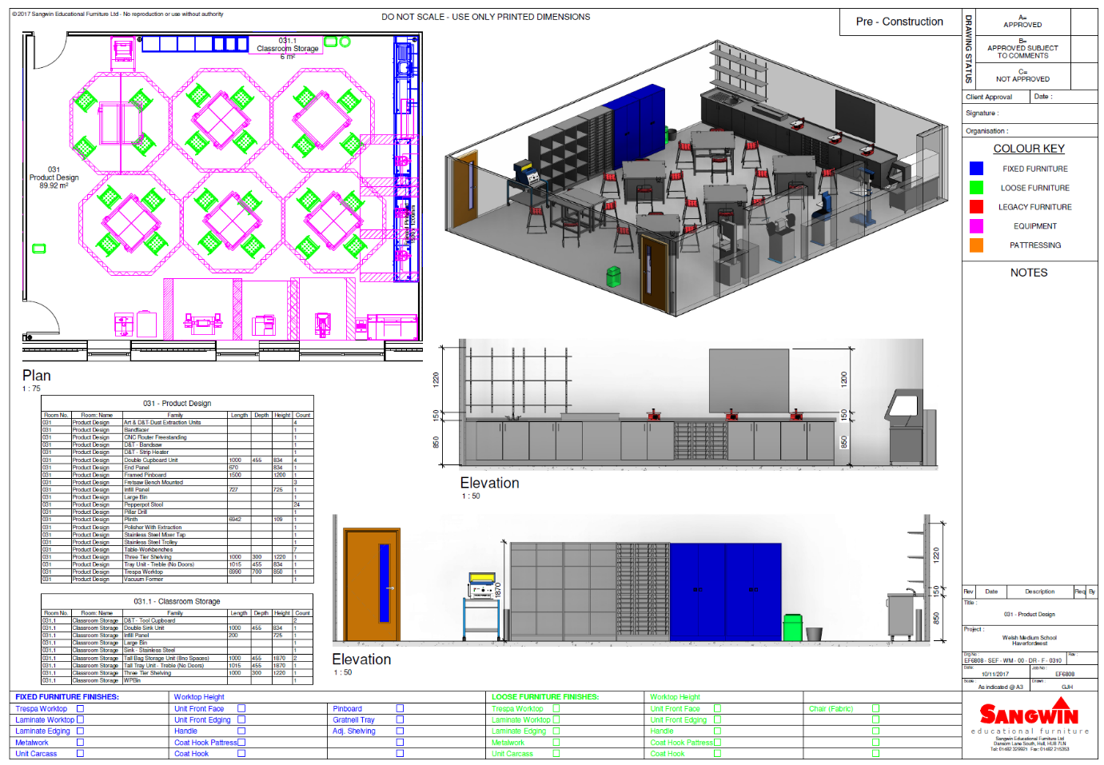
Furniture Detail / Layouts

4.4 Summary of BIM Examples
The examples of projects above are both projects which formed part of the 21st Century school campaign. These two projects all achieved BIM Level 2 maturity and therefore the information provided within the EIR’s would have been similar. Due to the time frame of the projects, the standards adhered to in relation to BIM would have varied due to previous PAS standards being now withdrawn. There are various publications in which detail the level of detail required within the EIR document, one of which was produced by the University of Cambridge (Britain, 2022). Below details a BIM maturity wedge which details the requirements required in order to comply; it is vital that this information is listed within the clients EIR, which then forms the BIM Execution Plan.
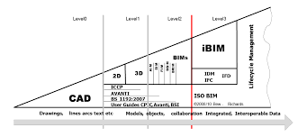

BIM Maturity Wedge (Space, 2022)

4.41 Level of Detail / Level of Information need
As identified in the worked examples above, the LOD / Level of Information need varies at each RIBA Stage of the project. At the early RIBA stages, it is not necessary to incorporate the level of detail which may be done at later RIBA stages; it is vital the client is aware of this as the LOD / Level of Information need will form part of the EIR. Carmarthenshire County Council should utilise the worked examples to attain a stance on the required LOD at each RIBA stage. The NBS toolkit can be utilised by the client to inform their EIR’s, as the lead consultants we will then produce the design elements / provide the level of information in accordance with the section specified within the EIR.

5.0 CONCLUSION
As a conclusion, the letter details our responsibility as the lead consultant and the standards in which will be adhered to in order to comply with the relevant legislations. This details how the information will be shared with yourselves as the client; further to this section 3.0 & 4.0 comprises of the level of information required by yourselves as clients, with section 4.0 listing example projects in which were designed to the same standard.

REFERENCE LIST

BIM, U., 2022. BIM Maturity Levels Explained- Level 0, Level 1, Level 2, Level 3. [Online]
Available at: https://www.united-bim.com/bim-maturity-levels-explained-level-0-1-2-3/
[Accessed 31st December 2022].

BSI, 2014. BS 1192-2:2014. [Online]
Available at: https://knowledge.bsigroup.com/products/collaborative-production-of-information-fulfilling-employer-s-information-exchange-requirements-using-cobie-code-of-practice/standard
[Accessed 2022 December 2022].

BSI, 2014. BSI. [Online]
Available at: https://knowledge.bsigroup.com/products/collaborative-production-of-information-fulfilling-employer-s-information-exchange-requirements-using-cobie-code-of-practice/standard
[Accessed 28th December 2022].

BSI, 2014. PAS 1192-2: 2013. [Online]
Available at: https://knowledge.bsigroup.com/products/specification-for-information-management-for-the-capital-delivery-phase-of-construction-projects-using-building-information-modelling/standard
[Accessed 13th December 2022].

BSI, 2018. PAS 1192-6:2018. [Online]
Available at: https://knowledge.bsigroup.com/products/specification-for-collaborative-sharing-and-use-of-structured-health-and-safety-information-using-bim/standard
[Accessed 2022 December 22nd].

BSI, 2019. British Standards. [Online]
Available at: https://www.bsigroup.com/en-GB/iso-19650-BIM/
[Accessed 26th November 2022].

BSI, 2020. BS EN 17412-1: 2020. [Online]
Available at: https://www.thenbs.com/PublicationIndex/documents/details?Pub=BSI&DocID=330918
[Accessed 29th December 2022].

BSI, 2021. BSI. [Online]
Available at: https://knowledge.bsigroup.com/products/organization-and-digitization-of-information-about-buildings-and-civil-engineering-works-including-building-information-modelling-bim-information-management-using-building-information-modelling-delivery-phase-of-the
[Accessed 22nd December 2022].

BSI, 2022. BS EN ISO 19650-4:2022. [Online]
Available at: https://www.thenbs.com/PublicationIndex/documents/details?Pub=BSI&DocID=337690
[Accessed 28th December 2022].

Council, M., 2022. Caldicot Comprehensive. [Online]
Available at: https://www.monmouthshire.gov.uk/project-details/
[Accessed 1st January 2023].

Council, P. C., 2021. EIR BIM, s.l.: s.n.
David, U. o. W. T. S., 2021. BIM Naming Conventions. s.l.:Gavin Traylor.
Govermenent, W., 2022. BIM Protocol. [Online]
Available at: https://gov.wales/sites/default/files/publications/2022-07/template-education-project-agreement-building-information-management-protocol.pdf
[Accessed 25th November 2022].

Goverment, W., 2020. 21st Centurty Schools and Colleges Programme business case guidance. [Online]
Available at: https://www.gov.wales/sites/default/files/publications/2020-09/business-case-guidance.pdf
[Accessed 3rd January 2023].

Goverment, W., 2022. Sustainable Communities for Learning: building bulletins. [Online]
Available at: https://www.gov.wales/sustainable-communities-learning-building-bulletins
[Accessed 31st December 2022].

ISO, 2021. ISO 55001:2014. [Online]
Available at: https://www.iso.org/standard/55089.html
[Accessed 6th December 2022].

NBS, 2022. BIM Level Explained. [Online]
Available at: https://www.thenbs.com/knowledge/bim-levels-explained
[Accessed 13th December 2022].

NBS, 2022. NBS LOD. [Online]
Available at: https://www.thenbs.com/knowledge/level-of-detail-lod-and-digital-plans-of-work
[Accessed 29th December 2022].

Online, W., 2018. Caldicot Comprehensive School. [Online]
Available at: https://www.walesonline.co.uk/news/wales-news/what-new-365m-school-looks-13604668
[Accessed 2nd January 2023].

Online, W., 2020. Haverfordwest High School. [Online]
Available at: https://walesnewsonline.com/haverfordwest-high-school-new-build-approved/
[Accessed 29th December 2022].

Parliament, W., 2020. Senedd Wales. [Online]
Available at: https://senedd.wales/visit/our-estate/senedd-at-15/senedd-building-design-concept/
[Accessed 18th November 2022].

RIBA, 2020. RIBA Plan of Work. [Online]
Available at: https://www.ribaj.com/intelligence/updates-to-the-riba-plan-of-work-2019-dale-sinclair-gary-clark
[Accessed 22nd December 2022].

Treglown, S., 2019. Ysgol Caer Elen. [Online]
Available at: https://stridetreglown.com/projects/ysgol-caer-elen/
[Accessed 3rd January 2023].

