Level of processing and the effect on memory recall.

Abstract

The current study is a partial replication of Craik & Lockhart (1975) experiments to determine whether levels of processing effects memory recall. A small study group of 21 students took part in a recall task with an incidental learning task carried out beforehand. The results supported previous theories that deep level processing will have a better recall result than shallow processing. The findings in this study showed significant differences between groups supporting the theories of Craik & Lockhart (1972). Pairwise differences were present between groups and showed significant differences between structural & semantic and Phonological & semantic processing. There are no significant differences between Structural & phonological processing. Further analysis and limitations are discussed.

Introduction.

Human memory models have been conceptualised as stores which information is transferred between, the classification of memory that is widely accepted is that there are three storage levels, Sensory stores, short-term memory and long -term memory, one critique of the distinction between stores has been the characteristics of their differences in retention of information (Craik & Lockhart, 1972).

Craik & Lockhart (1972) suggests an alternative framework, ‘Depth of Processing’ where it is implied that this depth results from a greater degree of semantic analysis; after recognition of the stimulus further elaborative processing may take place. Analysis of a word passes through different sensory stages to levels that have associative recognition patterns and then to the semantic stages of stimulus reinforcement. Meaningful stimuli have more rapidity in being deeply processed than stimuli that has less meaning, it will also be better retained; this means that analytic speed does not necessarily predict that the word will be retained. Determining the depth of retention, therefore, is dependent on how much attention has been given to the stimulus, the processing time that is available and how compatible it is with the analysing structures, thus, determining depth of processing. The current study replicates in part Craik & Lockhart (1975) study to confirm the findings that a deeper level of processing does aid in better recall.

Craik & Tulving (1975) questioned this theory of how stimuli is processed from the structural to the semantic and that processing of the stimulus stops once the relevant analysis is completed, they also state their belief that judgement time serves as an indicator of the depth to which it reached, thus it’s memorability. Craik and Tulving (1975) offered a conclusion that deeper processing will give better retention, it is also an argument that recognition at a higher level of processing may simply be attributable to longer study times. Another way to study memory is through incidental learning, where the subject is unprepared for the recall task (Hyde & Jenkins, 1973). Extensive recall has been recorded when subjects are required to consider the word meaning and is comparable to learning the words without an orienting task (Johnston & Jenkins, 1971).

There is an argument that sensory processing can be remembered just as well as semantic processing, provided conditions for this type of processing are appropriate (Morris, Bransford & Franks, 1977). Further critique of Craik & Lockhart (1972) suggestion that deep levels of processing, being elaborative of existing knowledge, is that it fails to consider retrieval strategies or the decision making that is involved in the recall (Eysenck, 1978).

The current study is a partial replication of Craik and Tulving (1975) Depth of processing and word retention experiments. The aim of this study is to investigate the effects of varying levels of processing on the recognition of words. It is predicted that stimuli presented at a semantic level of processing will yield higher recall results than stimuli presented at a structural level.

Methodology.

Design.
A one-way Anova related design was used to measure the three conditions, structural, (shallow), phonological (intermediate) and semantic processing (deep). The IV (independent variable) is the depth of processing and the DV (dependent variable) is the number of words recognised. To prevent participants memorising the words and compromising the recognition task results, an incidental learning technique was preformed first. Participants were shown 45 words via PowerPoint. There were 15 questions in each condition, presented in a random order. Participants took part in all conditions.

Participants.
Twenty-one undergraduate students from West Wales aged between 20yrs and 53yrs of age took part in the classroom experiment, 18 females and 4 males. The students were not aware that the experiment was a recall task.

Materials.
45 words were presented on PowerPoint slides with a blue background and black writing. (See appendix 2.) Font size 36, Helvetica Neve. A4 sheet of paper printed with tick boxes yes & no, with 3 practice rows at the top. (See appendix 3). On a separate white A4 paper, 105 words were printed in black ink. (See appendix 4.)

Procedure.
See appendix 1.

Results

The following section presents the results of the three conditions: structural, phonological and semantic processing. The following table shows the mean and SD for the three conditions.

Table 1.
Means and SD for the structural, phonological and semantic conditions.

Condition | Mean | SD
Structural  Phonological  Semantic | 2.8  4.1  11 | 2.7  2.3  2.2

Table 1 shows that condition 3 deeply processed (semantic) words showed the largest mean compared to the shallow processing (structural) in condition 1, indicating that a deeper level of processing resulted in the strongest memory trace.

A one-way ANOVA repeated measures was carried out to test whether there were significant differences between the 3 conditions (N=21). The results of the ANOVA indicated a significant effect of processing F(2,40)=129.057, p=.000 showing there was significant evidence to support the hypothesis. Follow up comparisons indicated that pairwise differences were present between conditions. There was significant pairwise difference between conditions 1 & 3 (p=.000) and conditions 2 & 3 (p=.000) with a mean score of 2.8 & 11 for conditions 1 & 3, and a mean score of 4.1 & 11 for conditions 2 & 3. However, there was no significant difference between conditions 1 & 2 (p=.08) with a mean score of 2.8 & 4.8. These results indicate there is effect of levels of processing on the recognition of words.

Discussion.

The aim of this study was to investigate if there are significant differences between shallow and deep levels of processing on recall, the prediction being that semantic processing would yield a higher result than structural processing. The hypothesis was supported, thus supporting Craik & Lockhart (1972) theory. The current study shows significant differences between structural and semantic processing, clearly suggesting that deeper level processing does indeed have an effect on recall. It can be argued that the level of attention given to the stimuli is dependent on the depth of analysis given, as the results clearly show that little analysis resulted in poor recall. However, the higher result of recall at the semantic level can also be resultant of longer study times (Craik & Tulving, 1975). It is clear that deeper levels of processing do lead to better recall, however, there is an argument as to whether the depth to which the stimuli has been processed or the processing effort of the stimuli is the greater influence on the outcome of the recall task. Craik & Tulving (1975) study confirmed the earlier theory of Craik & Lockhart (1972) that rehearsal is not enough, and more attention is needed to process at a deeper level, thus, the information that is encoded is influenced by the type of processing. Structural processing required the participant to merely look at the visual structure of a word, as opposed to semantic processing that required the participant to study the word for meaning before placing it into a sentence.

Hyde & Jenkins (1973) study suggests that a subject may anticipate the task and, in turn, learn the material being presented, the use of an incidental learning task beforehand may dispel this theory. The findings in the current study did indicate that having an incidental learning task beforehand to prevent memorising words still produced significant differences and that deeper level processing yielded the best results, supporting Hyde & Jenkins (1973) theory. Johnston & Jenkins (1971) found the same extensive recall at a semantic level, when required to consider the word meaning, as there would be when memorising the list of words. A critique of these theories is that there is no consideration of the retrieval strategies or any consideration of the decision-making process that is involved in the recall process (Eysenck, 1978). Also, it is suggested that an interest in the subject, focussed attention, as well as deep processing can result in higher functionality (Mahdavian & Kormi-Nouri, 2008).

The current study does have some limitations. The study group was very small, and participants were students studying psychology and had taken part in other studies prior to this one. This may imply that an interest in the task and knowledge of cognitive psychology alerted students to the type of task being presented and, in turn, students were more aware that there would be a follow-on task compromising the experiment; however, the results did support previous theories. The way the depth of processing was measured could also be of concern in that there is no definitive way to assess the depth of processing that took place and it is assumptive that, if recall was good, semantic processing had to have taken place. Further studies of levels of processing to gain a better understanding of how we process, retrieve and recall information would be advantageous. Education is one area to which a better understanding would be beneficial. By revising on a semantic processing level, more information is remembered when recall is necessary and this can result in higher achievements in exam results and greater retention of information in everyday life and working environment.

The depth of processing theory has been refined since Craik & Lockhart (1972) theory, however, repetition of the experiments has yielded similar results despite change and development. A successful research framework has encouraged a database that has in turn served as a foundation in constructing future theories (Lockhart & Craik, 1990).

References.

Craik, F. I., & Lockhart, R. S. (1972). Levels of processing: A framework for memory research. Journal of verbal learning and verbal behavior, 11(6), 671-684.

Craik, F. I., & Tulving, E. (1975). Depth of processing and the retention of words in episodic memory. Journal of experimental Psychology: general, 104(3), 268.

Eysenck, M. W. (1978). Levels of processing: A critique. British Journal of Psychology, 69(2), 157-169.

Hyde, T. S., & Jenkins, J. J. (1973). Recall for words as a function of semantic, graphic, and syntactic orienting tasks. Journal of Verbal Learning and Verbal Behavior, 12(5), 471-480.

Johnston, C. D., & Jenkins, J. J. (1971). Two more incidental tasks that differentially affect associative clustering in recall. Journal of Experimental Psychology, 89(1), 92.

Lockhart, R. S., & Craik, F. I. (1990). Levels of processing: A retrospective commentary on a framework for memory research. Canadian Journal of Psychology/Revue canadienne de psychologie, 44(1), 87.

Mahdavian, A., & Kormi-Nouri, R. (2008). Effects of attention and levels of processing on explicit and implicit memory function with interesting and unteresting tasks in university students. Journal of Applied Sciences, 8(6), 1055-1060.

Morris, C. D., Bransford, J. D., & Franks, J. J. (1977). Levels of processing versus transfer appropriate processing. Journal of Memory and Language, 16(5), 519.
Appendix 1. Procedure.

Participants were briefed that they were taking part in a classroom experiment. They were handed a sheet of A4 paper with 3 columns, the first numbered 1-45 and the other two with a tick box with either yes or no corresponding to the numbered rows 1-45, and 3 practice trials (See appendix 3). The experimenter explained there were 45 trials/slides each with a question that is answered YES or NO by simply putting a cross or tick in the appropriate box, the numbered rows 1-45 correlated with the slide that was being shown and the question being asked. There were three sets of questions, 15 in each category.

Category 1 asks - Is the word in capital letters? This sentence is shown for 2 seconds before the word is shown for 4 seconds, in total each slide in this section is shown for 6 seconds. For example, FINGER or finger. The participant would then tick the YES or NO box.

Category 2 asks - Does the word shown on the slide rhyme with…? A second word then appears on the screen, for example, does the word CAT rhyme with HAT? Or, does the word CAT rhyme with DOG? The first word appears for 2 seconds before the rhyming word appears for 4 seconds, in total each slide in this category is shown for 6 seconds before the next question. The participant would then tick the YES or NO box.

Category 3 asks - Does the word fit into a sentence? The sentence is shown for 2 seconds with the word missing, the missing word is then shown underneath the sentence for 4 seconds, in total each slide in this category is shown for 6 seconds. For example - Does a dog bark? or Does a dog meow? The participant would tick the YES or NO box.

The PowerPoint slide was presented with the 3 practice trials shown first. The three categories each with 15 questions were presented in a randomised order (See appendix 2). Participants were unaware that this section of the experiment was an incidental learning task, this was intentional, so the random words shown on the screen would not be memorized by the participants.

The recognition test followed and was presented to the participants, a total of 105 words printed in black ink on white A4 paper were printed in 3 columns, 45 of which were the words used in the incidental task (See appendix 4), they were asked to put a cross next to the words they recognised from the previous PowerPoint slides. The words were randomly listed with words that had not been presented in the slides.

The experiment was part of a classroom experiment so there was no informed consent, consent was presumptive. Participants had the right to withdraw at any time during the experiment and no personal information was collected from the participants. Participants were fully debriefed at the end of the experiment and were made aware that details of the first task were withheld intentionally to prevent any manipulation of shallow, intermediate and deep processing by memorising the words and compromising the results of the recognition task. See appendix 5 & 6 for debrief and consent form.
Appendix 2. PowerPoint Slides.

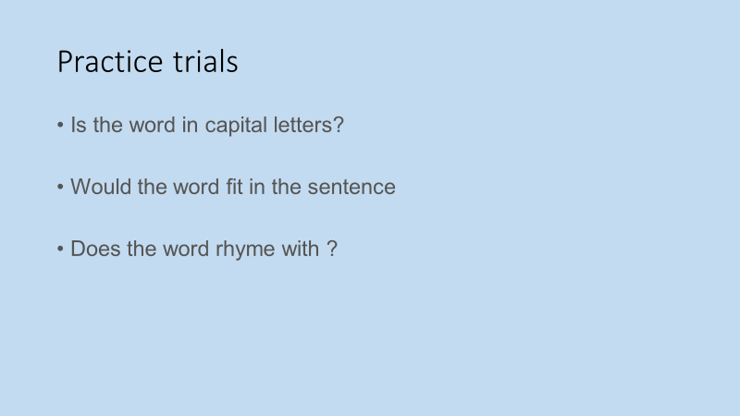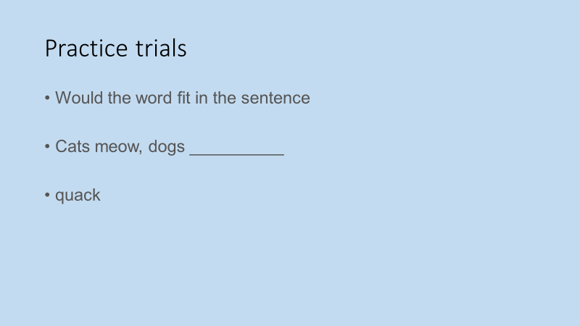
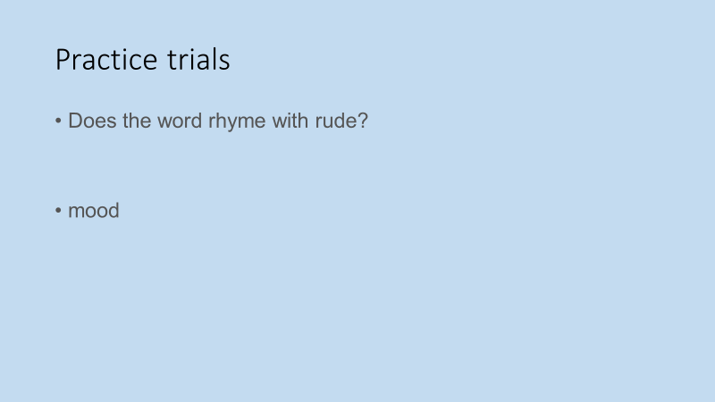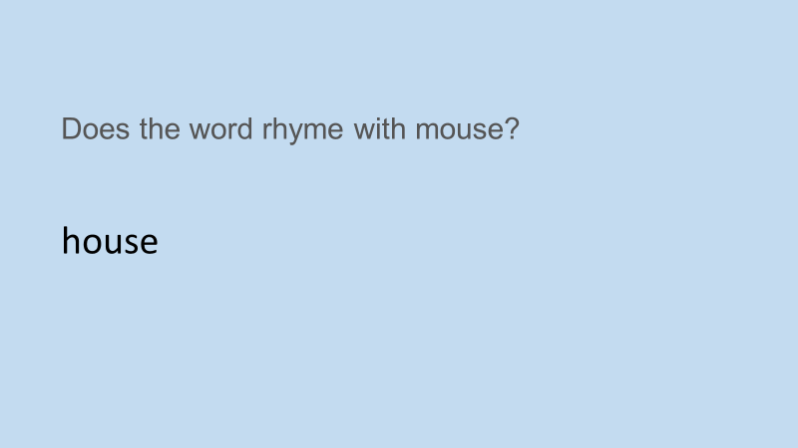
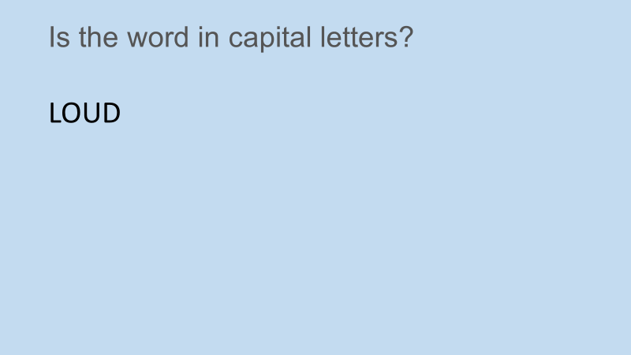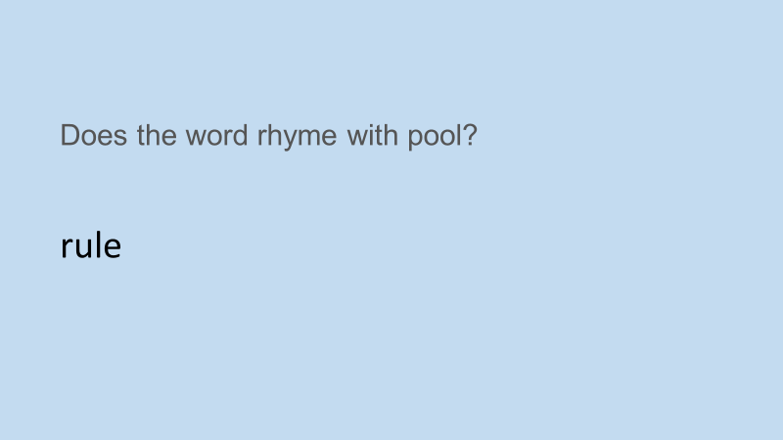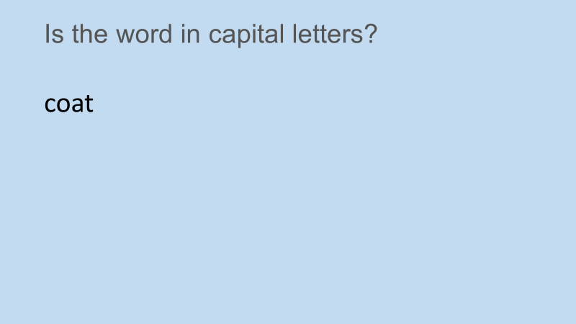
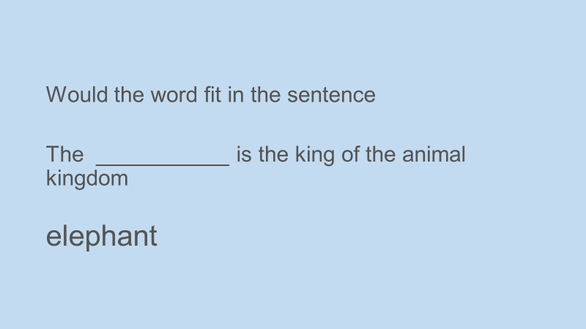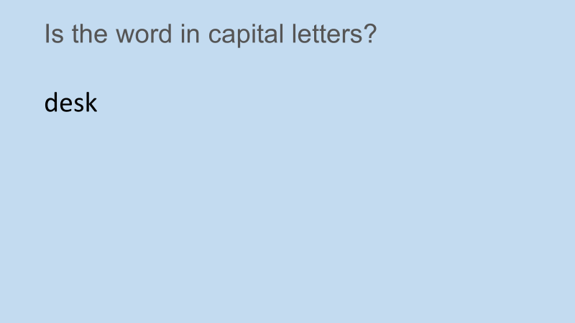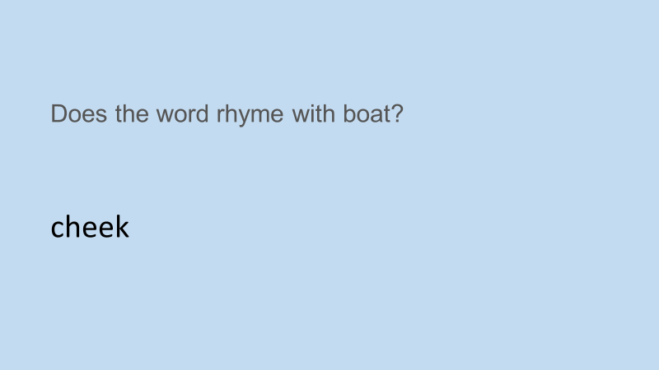
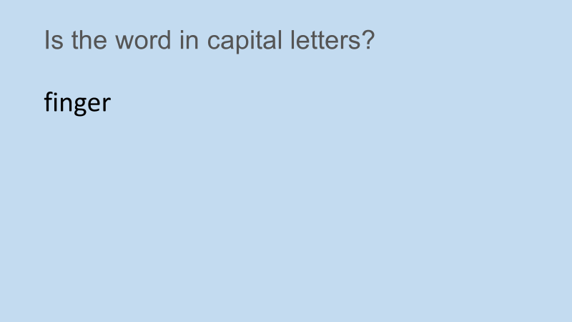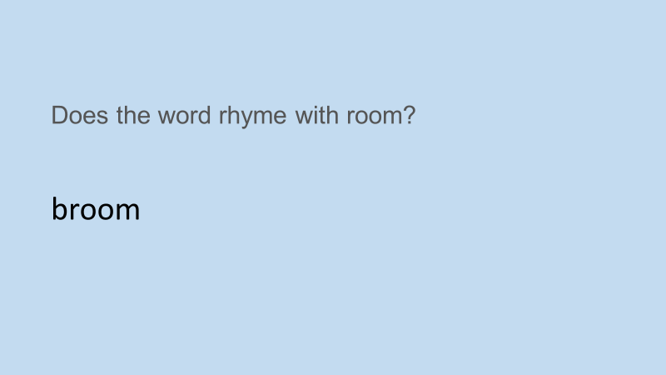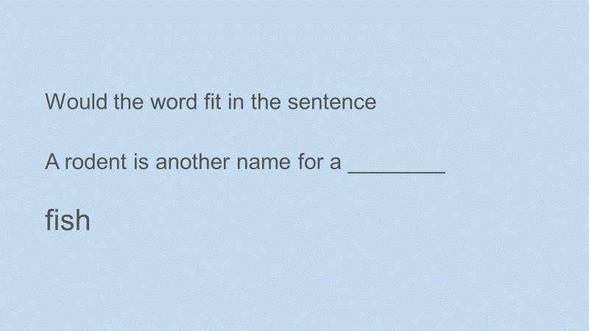
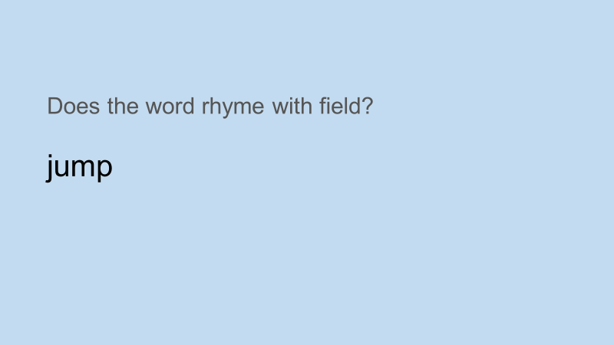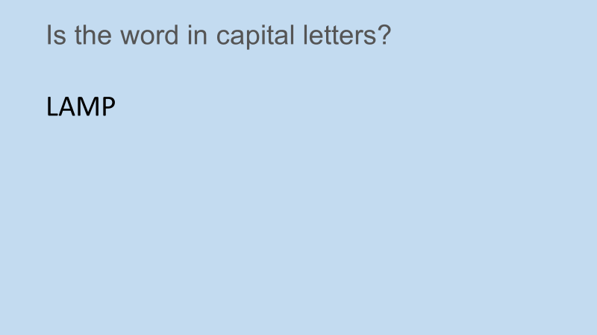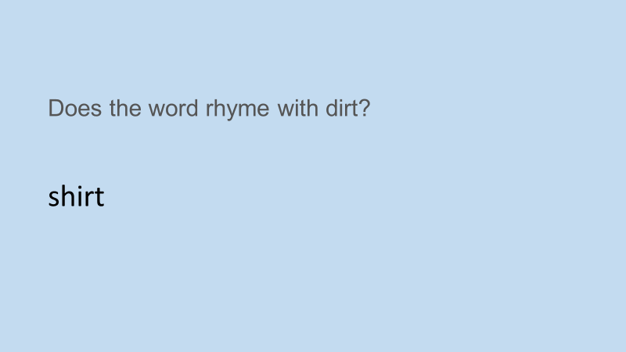
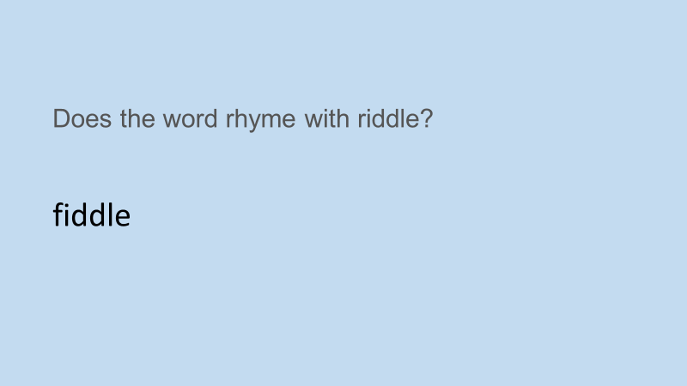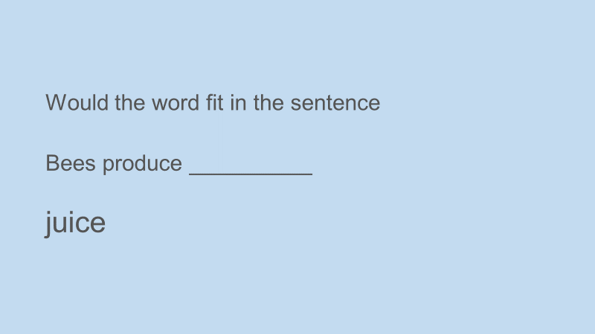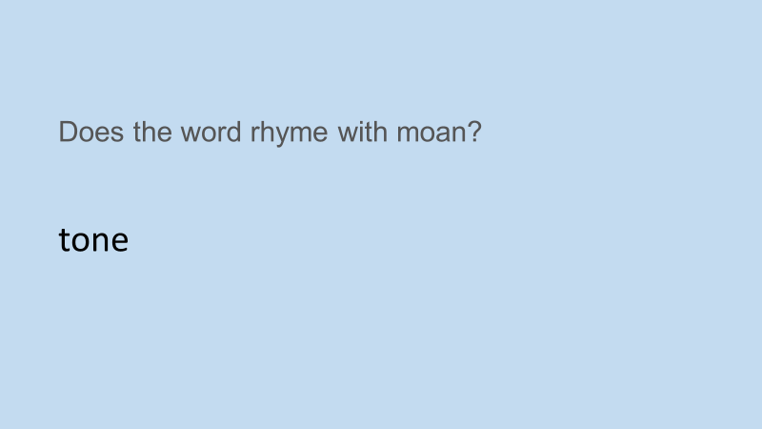
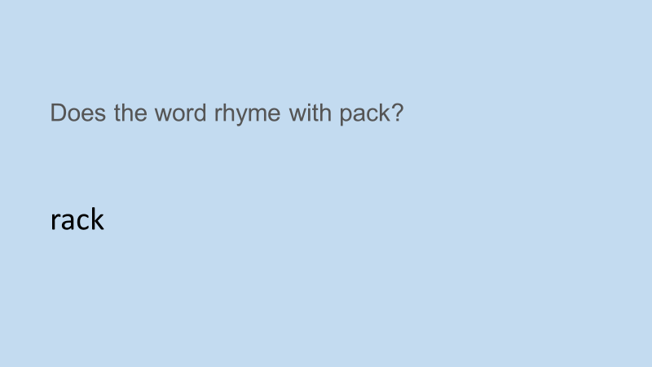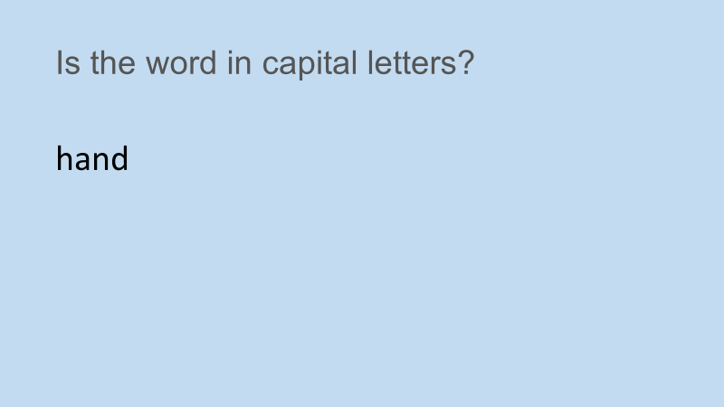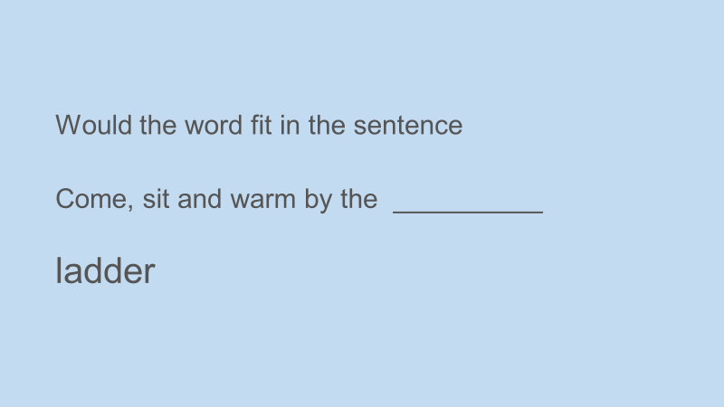
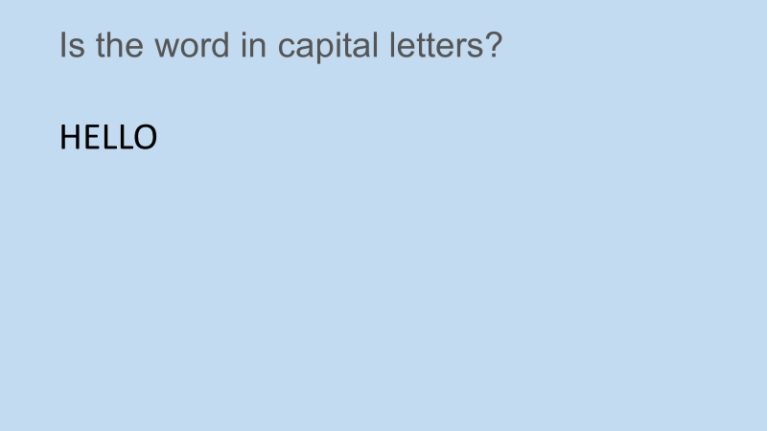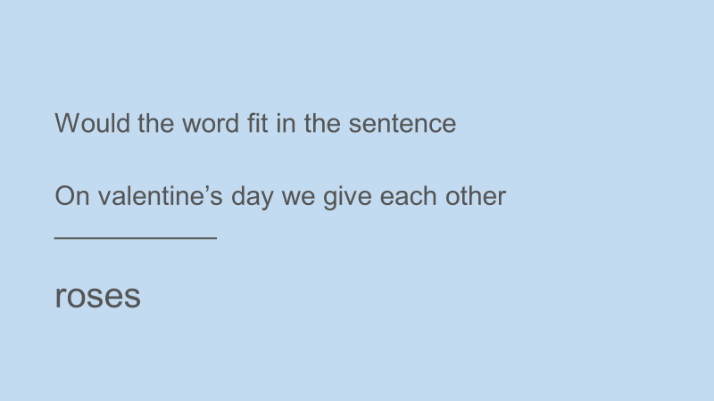
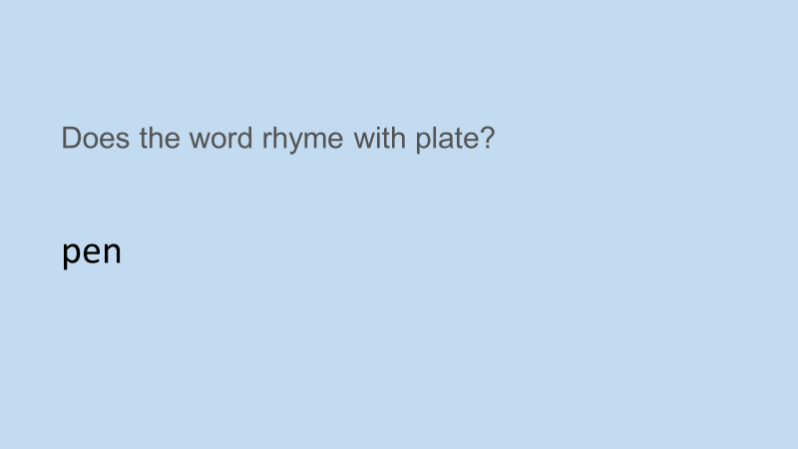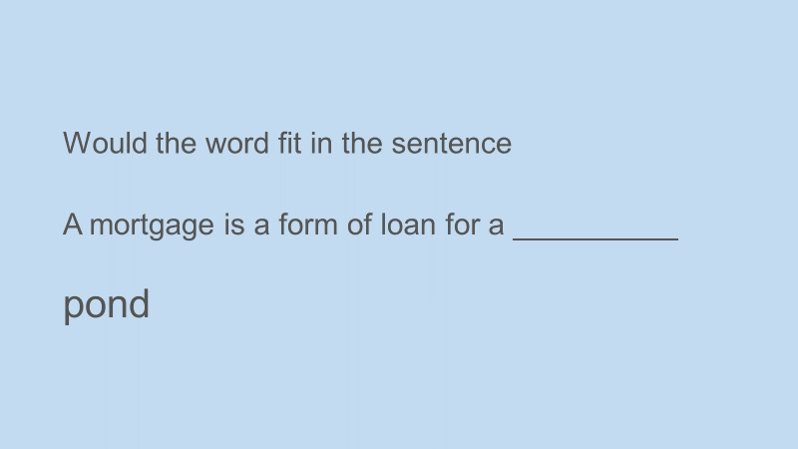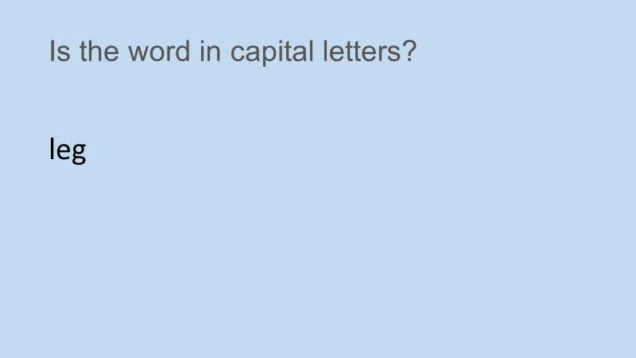
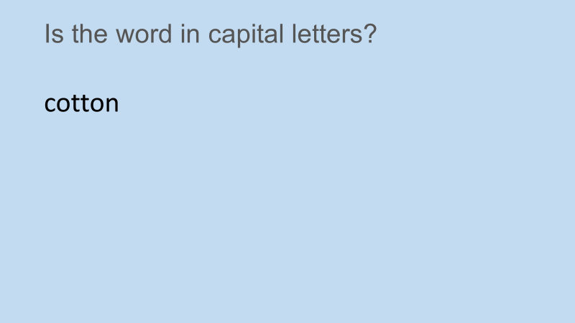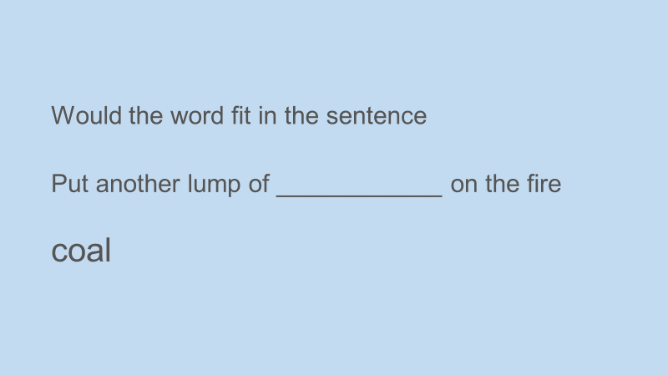
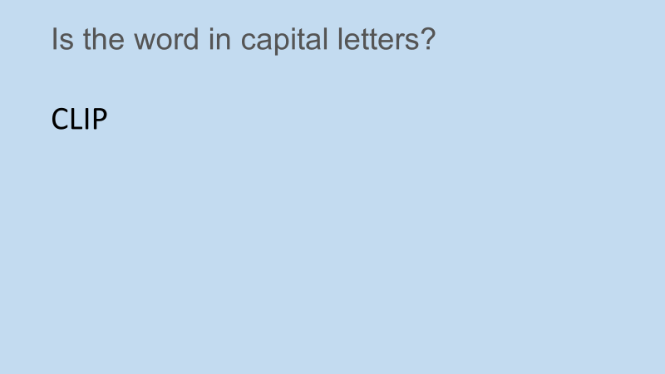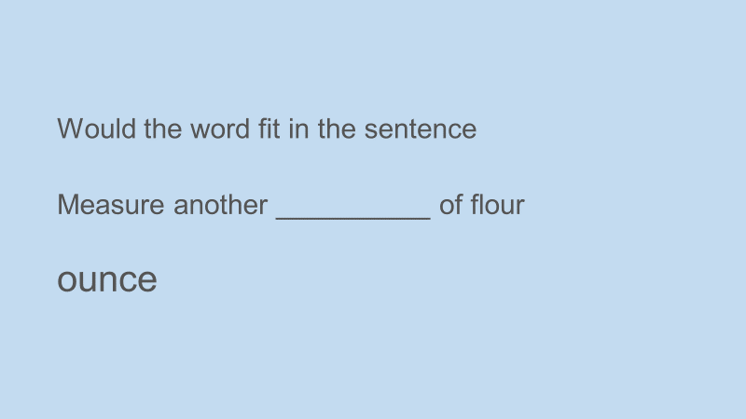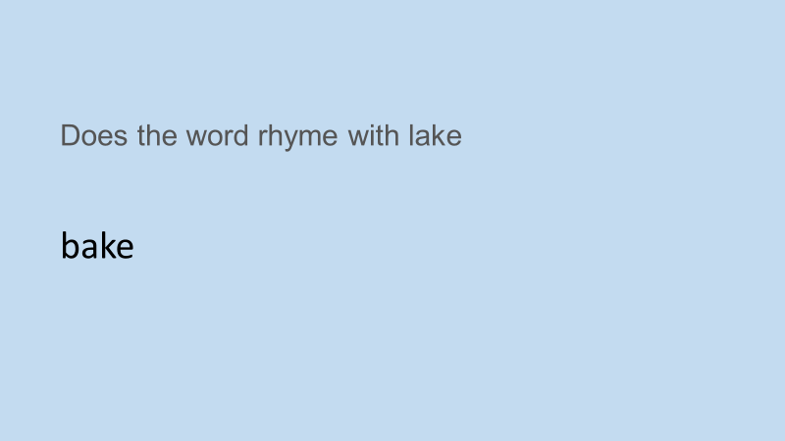
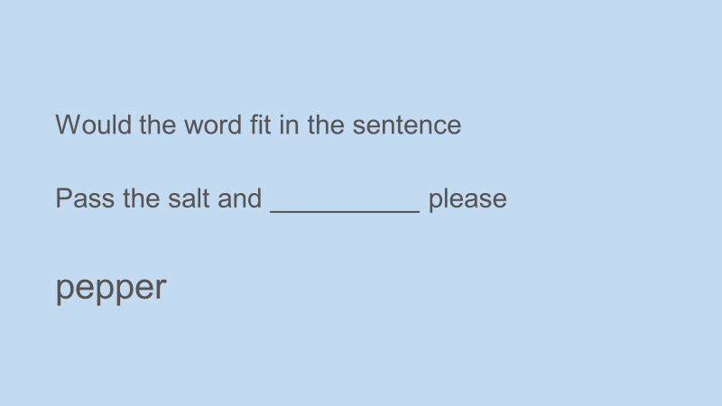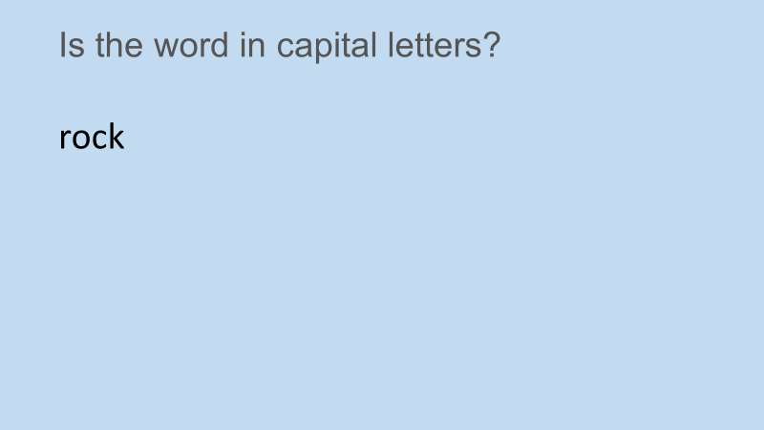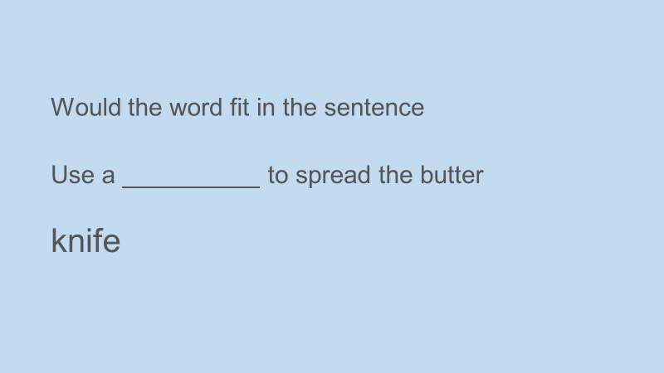
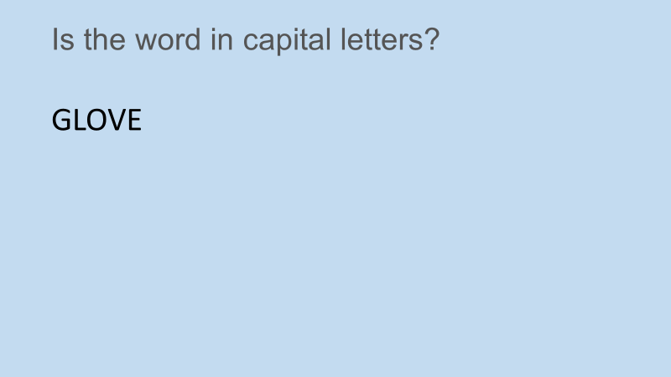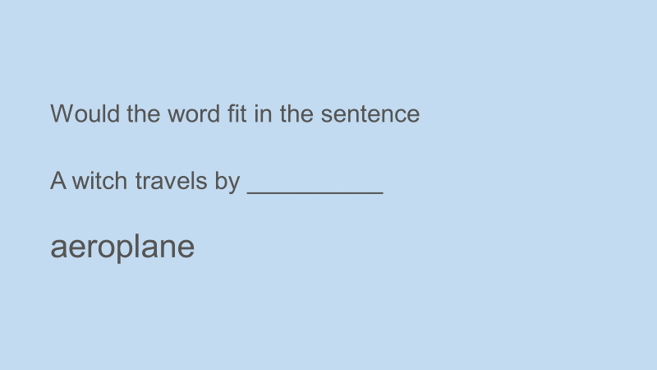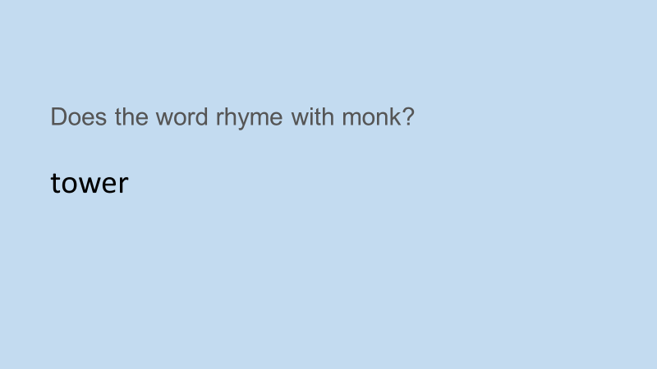
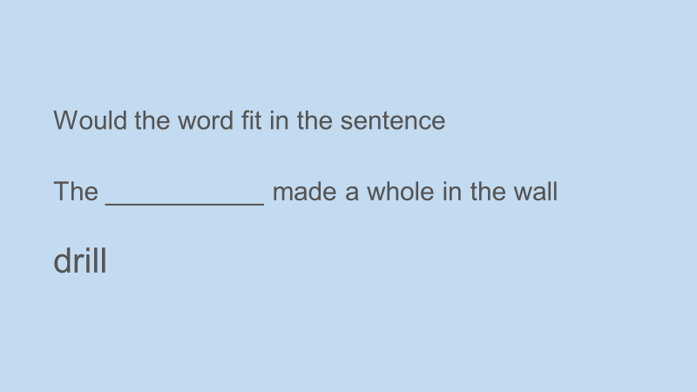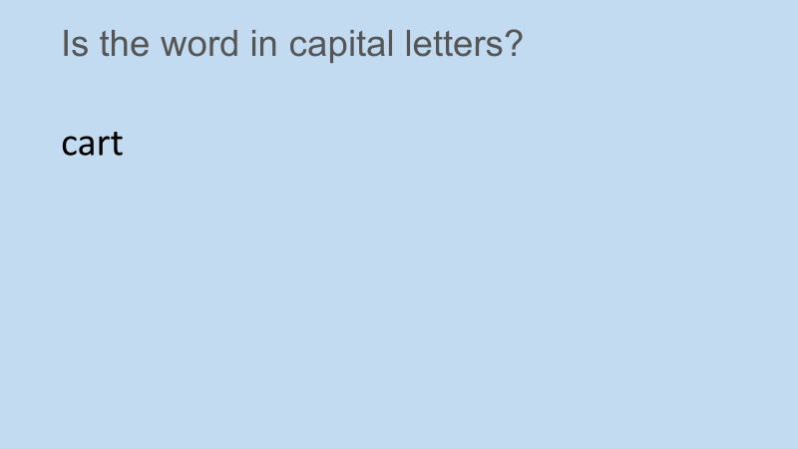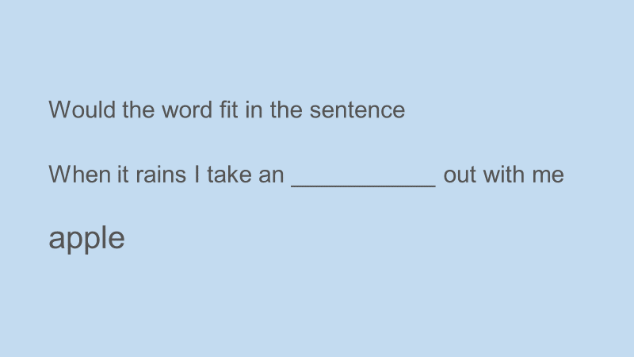
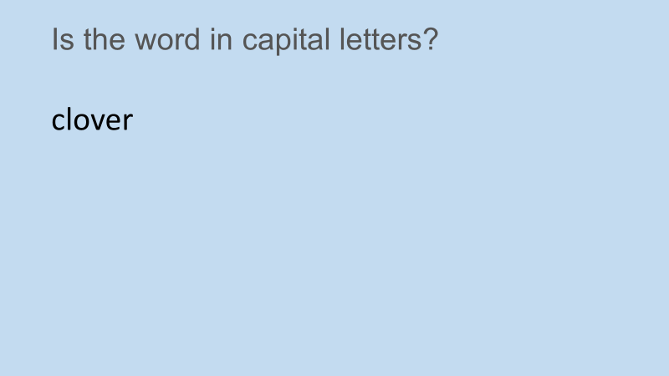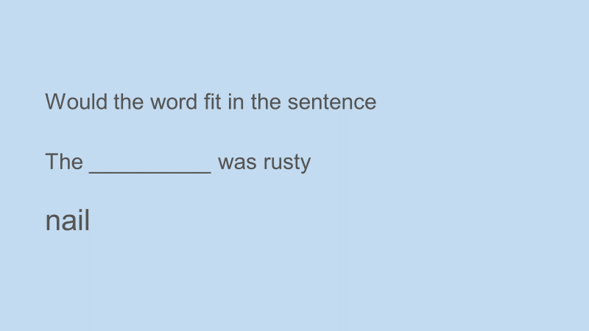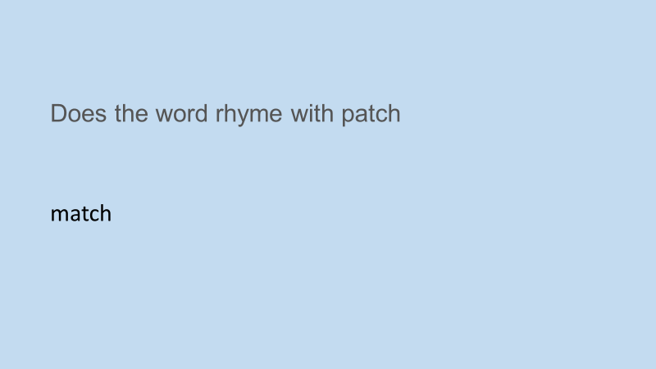
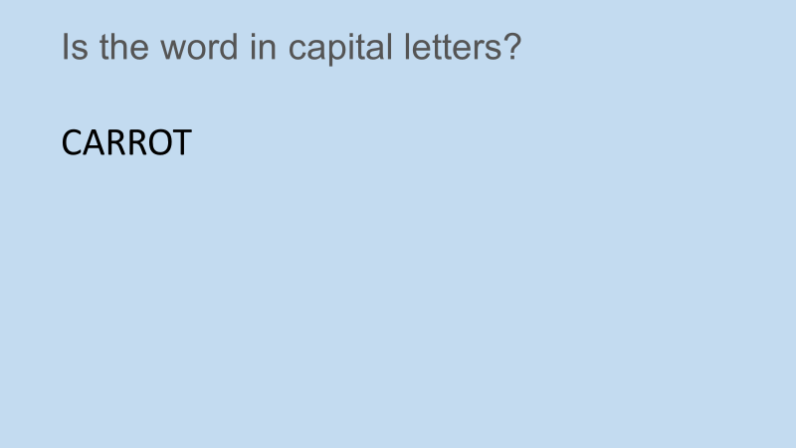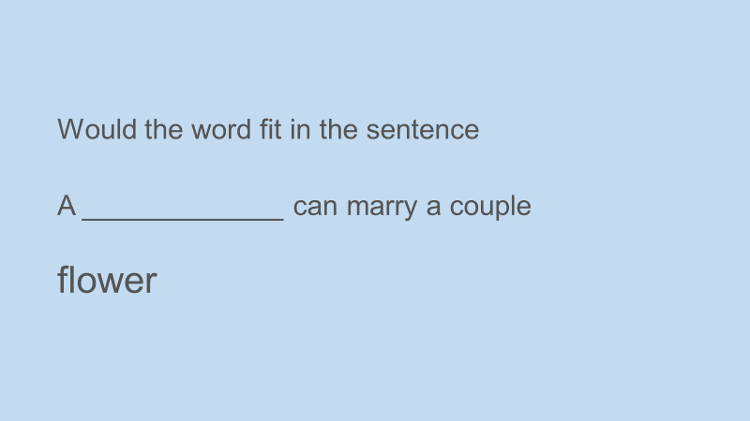
Appendix 3. Yes/No answer sheet.

Put a cross on YES or NO in response to what you see on the screen
 | YES | NO
 | YES | NO
 | YES | NO
 | YES | NO
 | YES | NO
 | YES | NO
 | YES | NO
 | YES | NO
 | YES | NO
 | YES | NO
 | YES | NO
 | YES | NO
 | YES | NO
 | YES | NO
 | YES | NO
 | YES | NO
 | YES | NO
 | YES | NO
 | YES | NO
 | YES | NO
 | YES | NO
 | YES | NO
 | YES | NO
 | YES | NO
 | YES | NO

 | YES | NO
 | YES | NO
 | YES | NO
 | YES | NO
 | YES | NO
 | YES | NO
 | YES | NO
 | YES | NO
 | YES | NO
 | YES | NO
 | YES | NO
 | YES | NO
 | YES | NO
 | YES | NO
 | YES | NO
 | YES | NO
 | YES | NO
 | YES | NO
 | YES | NO
 | YES | NO

Appendix 4. Word List.

Put a cross by all the original words that you saw when answering the questions
house | LOUD | rule
coat | lost | Fiddle
snail | elephant | muddle
desk | cheek | carrot
phone | tiger | mince
finger | fish | cream
lose | trowel | flower
rubber | juice | hose
throw | crowd | jumper
broom | match | grass
lion | skirt | last
shirt | frame | LAMP
text | rail | tank
glove | jump | sketch
knife | rope | coal
rest | tram | sweater
rice | rack | rock
tone | tack | towel
chair | HELLO | cotton
arm | rake | aeroplane
paint | hand | roses
time | mower | maze
leg | ladder | bake
train | chest | tower
book | rest | glass
clip | pen | play
pepper | pond | line
pear | motor | ounce
neck | foot | hat
paper | Cart | apple
drill | lazer | priest
light | nail | farm
case | harm | clover
tablet | list | razor
knee | ice | race

Appendix 5. Consent Form.


School of Psychology
Carmarthen Campus

Study Consent Form

I understand that this research study is being carried out by a 2nd year Psychology Student for their dissertation, and that taking part in this study will involve watching a PowerPoint presentation related to a level of processing task and that I will be answering questions from the slides.
This task will take approximately 10 minutes to complete.
I understand that participation in this study is entirely voluntary and I am free to withdraw participation at any time without giving a reason. I am aware that if I have concerns about the study I can discuss these concerns with the researcher or academic supervisor at any time during or after the study.
I understand that the information provided by me will be held confidentially, with a code assigned in place of my name. These data will be stored indefinitely in accordance with the Data Protection Act.
I also understand that at the end of the study I will be provided with a debrief form and the opportunity to discuss any issues with the researchers.

I, ___________________________________( NAME) consent to participate in the study conducted by Michaela Paterson, School of Psychology, University of Wales Trinity Saint David, Swansea under the supervision of [ supervisor]

Participant Signature:________________________________________________
Date:___________________
Name and signature of researcher taking consent.

Appendix 6. Debrief Form.

School of Psychology
Carmarthen Campus

Study Debrief Sheet

Level of Processing and the effect on memory recall.

Thank you for taking part in the study.

The aim of this study was to explore whether the depth of processing has an effect on memory recall.

If you wish to withdraw your data from the study you must tell the researcher now. After this point, all of your data will remain confidential/anonymous and we will not trace it back to you.

If taking part in this study has raised any questions please speak to the researchers on Michaela Paterson, 1704051@student.uwtsd.ac.uk or contact the academic supervisor Dr Charlotte Greenway c.greenway@uwtsd.ac.uk

Thank you once again for taking time to participate in this study.

Michaela Paterson

BSc Honours Applied Psychology

University of Wales Trinity Saint David, Carmarthen

Appendix 7. SPSS Data.


