Harriet Doek 1800795 – Module ECAD4002 – Reading a story to children with rationale and reflection
Task 1: Lesson Rationale
Age | 5-6
Personal Training Target (WG, 2009) | S3.1.1
The Learning Intension | Introduce the Welsh language patterns for Clothes.
Learning Objective | - Learn Welsh vocabulary for various pieces of clothing and how to describe what people are wearing.
Success Criteria | - Demonstrate knowledge/understanding of Welsh language patterns themed around clothing.
Previous Learning | Welsh language patterns for colours and weather.
Resources | ‘Dillad Tedi Twt’
Curriculum Coverage (WG, 2015)  (Welsh Development - Reading) | Range:  - hear lively readings from a variety of sources  - appreciate books, stories and words around them  - read and respond to imaginative material, as appropriate, which should include:  - stories, poems and chants containing patterned and predictable language  Skills:  - follow stories read to them and respond as appropriate  - listen to others reading appropriate imaginative material  - listen to a story being read by following the print  - use context to perceive the meaning of familiar words and decode new words by means of clues in pictures, letter sounds and word forms
YCC  (WAG, 2003) | - Recognising that there are many different levels of fluency in Welsh.  - Teaching through the medium of Welsh and using incidental Welsh in the life of the school.
Thinking  (WAG, unknown) | Activating prior skills, knowledge and understanding.
Welsh Patterns (Examples) | - Cot Law  - Welis  - Cap  - Sbectol haul  - Crys T  - Siorts  - Sandalau  - Jins  - Treinyrs  - Sgarff  - Siwmper  - Esgidiau  - Cot  - Menig  - Het  - Beth wyt ti’n wisgo? / Dw i’n gwisgo_____  - Beth yw tedi yn wisgo? / Mae Tedi Twt yn gwisgo______  - Beth wyt ti’n wisgo, Tedi Twt? / Dw i’n gwisgo____

Task 2: Welsh Reading Recording (05:29)
URL: https://youtu.be/ENjz_Ebih8A

Task 3: Written Reflection on Task 2
On the 12th of March 2019 I performed a reading of ‘Dillad Tedi Twt’: a book designed to help Foundation Phase children learn and practice basic Welsh language patterns. I used this book in order to introduce the Welsh language patterns surrounding the theme of Clothes for the first time. This was somewhat a daunting task and leading up to the reading I was a bit nervous. However, I am happy with my performance and, despite my concerns, the children demonstrated good understanding of the story by interacting with my questions and demonstrating good listening skills.
Following the reading I set several tasks in the theme of the Welsh patterns I had just presented. This mainly encouraged them to use their new knowledge within different contexts, while developing their Welsh listening, oracy and literacy skills. As the book had only just introduced the relevant language patterns, differentiation was only needed in the main activities [Appendix 1, Appendix 2].
I’m very glad I read ‘Dillad Tedi Twt’ as part of an overall lesson as it allowed me a better opportunity to observe what the children had absorbed and whether they understood me clearly. I could tell by their main pieces of work that if I had made the book reading a singular activity, students may not have absorbed the information properly.
Although I did not get to implement or observe it myself, I would have liked to see the new sentence patterns being added to the morning routine, or at least used on days of non-school uniform i.e. World Book Day. At Mount Street Infants School, Powys, children are given opportunities to rehearse their learning in different contexts such as rehearsing their welsh sentence structures and word patterns in the school dining hall at lunchtimes (Estyn, 2nd March 2015). This was very beneficial as it got them to practice their Welsh in everyday environments.
I’m pleased with how well I managed to combine the familiar with the unknown. As you can see throughout my reading, I made sure to pause on each page and test students on their knowledge of Welsh language patterns. Additionally, I made sure to keep within the theme of Tedi Twt as he had already helped them learn welsh before such as their colours. These aspects are simple in practice but contributed greatly in how the children took interest in both the story and activities to follow. David Ausubel suggested that learning only takes place by relating new events or items to already existing concepts (Brown. D. H, 2002, p.83). In other words: “the more other facts a fact is associated with in the mind, the better possession of it our memory retains (Brown. D. H, 2002, p.85)”.
In terms of my overall reading performance I think I demonstrated that I could confidently read Welsh texts at Foundation Phase level. When reading the Welsh text, I gave accurate pronunciations and made sure my voice had a clear and lively tone. I decided early on that I wouldn’t try to give the characters different voices, but that doesn’t mean I didn’t try to portray myself as being interested and enthusiastic about what I was reading to the children. While reading I also pointed to the relevant pictures so that the students could start making connections between the object and the word.
I attempted to get as many students as I could to contribute to the discussions by keeping track of who I had picked previously, as well as asking a variety of questions ranging from translating the weather to asking what they would wear on a windy day. This was part of an effort to link prior learning to the current language patterns being taught while also making the new language patterns seem simpler and easier to use in everyday conversations i.e. you know how to say what you are wearing in English but today we are going to learn how to say it in Welsh. Additionally, this related to the theme of ‘Dillad Tedi Twt’ where he would change clothes depending on the weather.
As you can see in the video, I often repeated my questions several times in order to make sure children had heard me correctly while allowing children more thinking time. On a few occasions I think I did accidentally give to much prompting sometimes but overall, I think the questions added a lot to a seemingly simple activity.
I was really happy about how I performed these aspects of the reading activity and I hope to continue developing them in the future. Unfortunately, there were some aspects of the reading activity that I could improve on or just think twice about next time.
Smaller disappointments included struggling to hold the book open. This book was designed for the Foundation Phase book and its large size allowed the pictures and text to be clear and understandable for my pupils. However, combine this with the fact that I have short arms means that I did sometimes struggle to make sure my pupils could see the book. This was especially evident when looking back at the video where I noticed one of my students hiding behind the computer desk. In turn she couldn’t see the book properly and often looked at the floor. I didn’t even notice where she was sat until the end of the recording where I attempted to get her to join in with discussions. Next time I will have to make a quick visual survey/review of any blind spots within my chosen seating area and make sure that I can see students next time I lead similar activities in the future.
I did have some larger disappointments in terms of my own use of the Welsh language patterns that were already used within the classroom. Most notably, although I made sure to read and pronounce clearly and precisely, I did have to read from the book itself. This may have contributed to the struggle of handling it. Next time I would attempt to learn the text off by heart, or at least familiarise myself to the point where I would only need prompts. On a more frustrating note, when looking back, I realised that I gave myself several opportunities to demonstrate incidental welsh i.e. instead of saying ‘Well Done’ I could easily have said ‘Da Iawn’, or ‘Ardderchog’. Good incidental Welsh has allowed schools like Ysgol Plascrug to use Welsh as a natural medium for communication and informal conversations between staff and pupils (Estyn, 4th March 2015). I can sometimes become so focused on a task that I forget the small things. This is something I will have to work on in the future.
Overall, this was a great learning experience and I found the recording especially useful in my reflections. I need to continue developing and maintaining my strengths through practice and reflection. However, my points for improvement will require both a better look at both incidental Welsh patterns and general Welsh language patterns. Other aspects will improve through better preparation and thought into how I, and the pupils, are positioned within the learning space. In future readings I would like to include a closer look at the relevant and familiar Welsh phonics within the book.

Bibliography
References:
- Brown, D, H (2002) Principles of Language, Learning and Teaching: 4th Edition
- Estyn (2nd March 2015) Whole-school approach to raising standards in welsh. Available at: https://www.estyn.gov.wales/effective-practice/whole-school-approach-raising-standards-welsh (Accessed: 5th May 2019)
- Estyn (4th March 2015) Welsh Second Language Comes First. Available at: https://www.estyn.gov.wales/effective-practice/welsh-second-language-comes-first (Accessed: 5th May 2019)
- Welsh Assembly Government (2003) Developing the Curriculum Cymreig. Qualifications, Curriculum and Assessment Authority for Wales (ACCAC)
- Welsh Assembly Government (Unknown) Skills framework for 3 to 19-year-olds in Wales. Department for Children, Education, Lifelong Learning and Skills
- Welsh Government (2009) The Qualified Teacher Status Standards Wales
- Welsh Government (2015) Curriculum for Wales: Foundation Phase Framework
Appendix:
- Middle/Higher ability Worksheet
- Lower Ability Worksheet

Appendix 1:
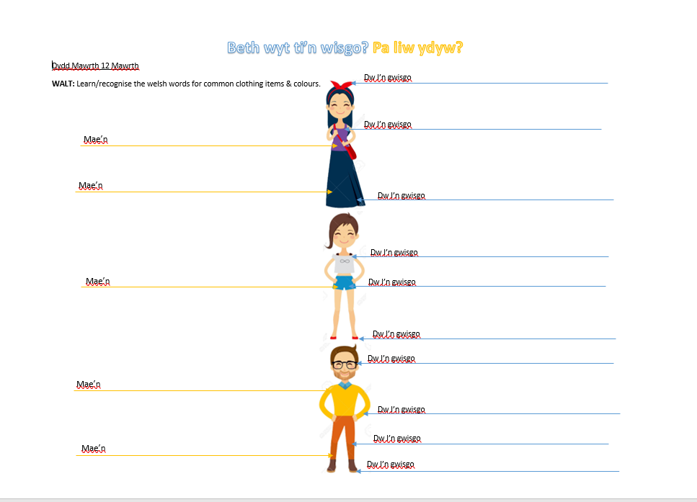

Appendix 2:


