Creating Confident Kids
‘An investigation into the use of drama in primary schools, its benefits to a child’s learning and why drama should be an integral part of a child’s education’

A child’s education is such an essential part of their life. It allows them to gain fundamental skills that will help them as they get older. As a child they often find themselves learning the curriculum through more table-based work and reading books whereas theatre is an inclusive and extremely advantageous type of work which covers important and relevant topics in education in a more creative way. This is the reason why I am investigating into the use of drama in primary schools and if it does have a benefit on a child’s education and can teach them more valuable skills that classroom work could not.
As a child we often find ourselves emersed in the educational system of going to school and knowing that you will most likely be sat a table all day and not really engaging in any of the lessons physically or creatively. Children are mor likely to find themselves learning through a textbook than learning this knowledge through more imaginative exercise. Despite the Educational system in the UK focusing on teaching children valuable information they are overlooking the benefits a child will gain by learning in a much more immersive way. Curriculum learning is so important, but I believe they brush over other important topics such as inclusion, bullying etc when they are just as important. I am going to conduct both Primary and Secondary research into drama and its involvement in the educational system and determine how but also why it benefits children in primary schools especially as I believe this is the place where they learn their core learning and steppingstones are put in place ready to learn more in depth the older, they get. To be able to engage in learning but also be allowed to be creative and have fun is something I believe every child should have the opportunity to do and it’s so important in their development.
Throughout the educational system, drama is not seen as a valuable lesson to teach. According to the Department of Education they state that they ‘do not consider drama to be core knowledge’ (D.F.E. 2012.). After they stated this, it made me beg to differ whether they have statistics to support this like talking to drama teachers or if they just came to this conclusion themselves. Drama has many qualities that allows children to grow and allows them to gain valuable skills that they can take froward in not only their education but lives. The government not being able to see these qualities and benefits that drama has makes me question whether they just overlook this and focus on the more ‘academic’ subjects. When researching why drama isn’t as important, I came across an article that stated that schools are experiencing a ‘creative crisis’ (Sally Weale. (2021). The article stating this makes me believe that they have noticed a lack in this subject being taught and investment towards the arts from the government isn’t as it should be. This leads me to believe that it may be because of funding issues. Schools across England and Wales are in a constant battle of getting enough funding to educate their students. School leaders have stated that they are in a ‘funding crisis’ and are ‘struggling to make ends meet’ (Nick Morrison. (2019). The government aren’t supporting schools with enough money to ensure children get the correct education therefore there only going to be focusing on the more ‘academic’ subjects instead of the arts that can supply a child with more skills that will help them in the future.

I looked at the Welsh Government and what their current legislation is for the inclusion of drama. When researching into this they stated that they believe by adding drama into the curriculum children can ‘gain an understanding and an appreciation of the diverse communities of wales as well as the wider world’ (Curriculum for Wales, 2022) From previous research the Department of Education stated that they don’t consider to drama to be ‘core knowledge’ whereas now they believe that it allows children to gain different understandings that they wouldn’t have from just table based work in classrooms. After finding this information I researched into what may have changed for the government to have a different insight on encouraging imaginative play. When researching what may have changed the governments perspective of imaginative play it drew me back to the topic of funding. (THIS NEEDS WORK)
Skills that are learnt throughout drama lessons are extremely transferable throughout other subjects as they all tie in together. By using imaginative play in primary schools, it ‘plays a huge part in development and is often where the children can explore freely allowing us to observe the children in a way that shows their best skills’ (Jancett Childcare. 2021.) I found this to be a useful insight to comment on as it highlights that drama does indeed play a huge part in a child’s development and that it is beneficial because it enables teachers to see what the children are excelling at and what areas of work may need a little help. For example, they may be doing well with confidence but need more encouragement with communicating with other classmates. There were many different aspects of information regarding what exactly drama helps with regarding a child’s social, emotional and cognitive development. As you develop as a person you find yourself gaining different traits you have and ways to strengthen your development. As child we learn from a young age core skills that allow us to continue evolving throughout our lives. Drama allows to learn these skills in a much more in-depth way and through the medium of physical activity. It allows students to be part of the action instead of sitting back and reading about it instead. Wilhelm wrote an article which was Called ‘The Age for Drama’ and stated that he believes through drama, students ‘became a part of the learning process rather than mere observers’ (Jeffrey D. Wilhelm. (2006)). I felt as though this was an interesting point to reflect upon as it highlights that drama is a ‘learning process’ and that children can learn during imaginative play instead of just sitting back and listening or watching which is what they would be doing in a classroom.
I would argue that drama should be taught as its own subject but also as a medium for other subjects to. When reading ‘The Teaching of Drama in the Primary School’ I came across a note that stated that the National Curriculum council had published a poster which highlighted how drama can help other subject areas. The poster stated that ‘drama is primarily a service tool’ (Brian Woodland. (Unavailable) which indicates that they now see it as useful device for learning and that it can enhance a child’s verbal and nonverbal expression of ideas. Drama can allow you to improve your vocal projection and articulation. As a child one of the main things, you learn at a young age is to read, write and spell. Drama is a great way of teaching these skills without even realign that you’re being taught. Something I found important to comment on was ‘drama can reach students who are not reached through traditional methods’ (Manon can de Water. (2021).). This was a valuable insight because it highlights how drama can help educate a child in ways that normal traditional teaching methods can’t.
From personal experience, I struggled to engage in subjects in school especially English and any literacy- based topics. I found my mind wandering and not fully paying attention to what is being taught. It was only when I took part in a TIE based workshop designed to engage children in literacy that I found myself learning so much more and absorbing more information than I would’ve. Lily Small who is the artistic director of Great Big Theatre Company highlighted the benefits of drama education. Two of the things that was highlighted was how drama can help with self-confidence and communication skills. I found these two extremely important to comment on because these two skills are extremely valuable in growing as a person. Without having frequent drama lessons in school, I feel as though I wouldn’t have had much confidence as I aged and that I wouldn’t be able to voice my opinions with fluency and projection. These are core skills to have and as Lily Small states ‘confidence gained in drama applies to school, career and life’ (Great Big Theatre Company. (2014)).
I decided upon messaging Sarah Evans who works at a Primary School as I wanted to conduct some of my own research into the use of drama in an educational setting and to get a first-hand account of what it’s like as a member of staff in a school with the idea of drama involved. I asked her multiple different questions regarding this (See Appendix 1). We discussed multiple different areas of imaginative play. One of the questions I asked her was Question 1 ‘Do you believe drama is a useful tool in helping a child grow in their education and self?” I felt like this was a question I wanted answering the most as I was interested in what the answer would be from a professional’s perspective. She stated that she believes that drama is a “useful tool” and that it can ‘help children develop critical thinking skills. To hear that come from a professional point of view it enables me to infer that she has seen first-hand how a child or multiple children may have grown from the use of drama and that she believes having drama implemented into the curriculum is a good thing. She also stated that by using drama in a primary school, children are embraced into a ‘supportive environment’. I found it interested that she commented on this because when researching I found that David Farmer who founded Tiebreak Theatre Company stated that drama allows children to ‘express their emotions in a supportive environment’ (David Farmer. (Unknown)). I found this to highlight how both staff and professionals can see how drama can support children and by it taking place in an educational setting it allows the children to feel safe and protected.
Another question that I thought was important to highlight was Question 3 (Appendix 2). I found it informative and useful hearing why drama may be taking a back seat in the curriculum especially from a qualified teacher. Sarah stated that there is ‘time restraints’ on teachers and that there is contently different topics being added to the curriculum that need to be covered. I found this insight to be fascinating as I didn’t realise that the curriculum is constantly changing and that teachers are pressured into making sure that the children are learning what they should be in a certain time period. Although I understand that teachers are under this pressure, I still believe if we looked into the benefits of drama more and the different techniques that can be used, we would be able to teach certain aspects of the curriculum through imaginative play.
After speaking to Sarah, I wanted to investigate into how drama can benefit a child a bit more. I was fascinated with how incorporating aspects of the curriculum through drama can help a child not just with their knowledge but with their development. Drama allows a child to experience new things and understand the world a lot more. Both Toye and Prendiville both stated, ‘the combination of imagination and pretending in play is what makes it important in both child development and child learning’ (Nigel Toye and Francis Prendiville. (2000)). I decided to comment on this as it highlights that that imaginative play or in better terms drama can help develop a child and that it enhances their learning. There is a list of many benefits that I found on the website (Pyjama Drama ((Unknown)) which highlighted for me the different ways in which a child can develop and what skills help them do so.
Problem Solving
During drama we encounter imaginary worlds and imaginary tasks which face us with problems. While dealing with this we learnt to problem solve therefore allowing us to gain this skill and take it forward into the wider world
Critical Thinking
By solving the problems, we are faced with, children will need access how to solve these problems which will allow them to gain critical thinking skills. This skill is an important skill as it allows us to work efficiently and as a child allows us to quickly process information which is needed throughout education.
Communication
By using drama, we come across multiple different characters who will be using a range of different vocabulary. Listening is an important part of communicating and can be developed through pretend play. Children are given the opportunity to work with their peers, share thoughts, feelings and idea’s also which helps build their communication skills.
Self-Awareness
An understanding of their own feelings and others feelings as well as their behaviour towards other people is built through drama and is being built is a safe environment where they won’t feel judged and be able to analyse that everyone has similarities and differences but to embrace them.
Empathy
By getting into the role of characters it allows children to understand how they’re feeling, what may be happening at present and how that may make them feel. By doing this it allows them to gain a valuable life skill of empathy which it a very core skill to have as it allows us to understand and relate to people from all different paths and different backgrounds.
Creative Thinking
By using drama, they enable a child to think creatively and to think on their feet. They are able to view things from different perspectives and think of new ways to communicate with others. They can generate new ideas and develop creativity. Drama is a great tool in helping children respond imaginatively to multiple situations.

I conducted my own questionnaire which discussed Drama in primary schools. I wanted to question people’s own experience in school and whether they were encouraged to partake in drama-based activities. I wanted to see if people thought drama was a positive or negative thing to get a child involved in and their personal experiences. I wanted to do this because I believe knowing how imaginative play in a primary school setting has evolved or declined helps me in my research of whether drama has a positive of negative impact based on its encouragement and its involvement in schools. I feel as though this questionnaire ties in nicely to this section of my project as I start to talk about the primary research, I conducted myself and the findings that I discovered.
I made sure to share the questionnaire around to different groups of people. For example, I have answers from people who are currently still in school but at an older key stage level, People who are a lot older and went to school a while back, and teachers. Knowing I shared the questionnaire to a large audience I thought it would be quite successful, which it turned out to be and I manged to get 23 responses and a variety of different opinions to work with.
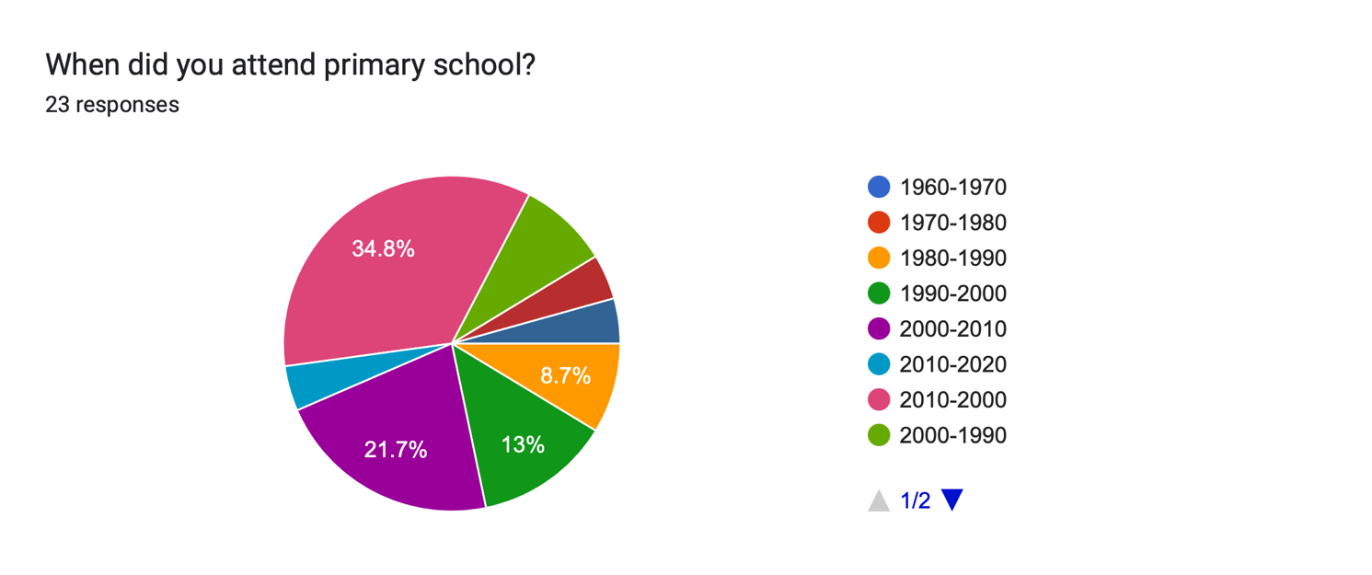
I wanted to ask this question before delving into the nitty gritty because I wanted to see what different age groups I was working with. As you can see from the results, I had a range of different ages to work with. I asked the question in a way that didn’t out right ask their age as some people might not want to comment how old they were. I also made sure to incorporate ‘Primary school’ into the question because it makes it more personal to what my project is about and lets the targeted audience know that they have to prepare to talk about their primary school experience as it is referred to in this question. A large amount of people went to primary school from 2000-2010 which is around the same age bracket of when I was in school so I can only imagine that their school experience may have been quite similar to my own. Something that interested me was the 1960-1970 age bracket as I am Intrigued as to what drama was like in education back then and to hear from a first-hand experience which is what this questionnaire will do for me. During my own research, I found a website that highlighted what education was like in the 60-70’s. I learnt that in the 1960’s it was known as ‘talk and chalk education’ (Ellen Castelow (2015)) in which means that children would be sitting at their desks with a paper and pen while the teacher stood at the front teaching. This actively demonstrates that children were not really pushed to be physical with their work and would often find themselves just sat at their desks facing the board learning.
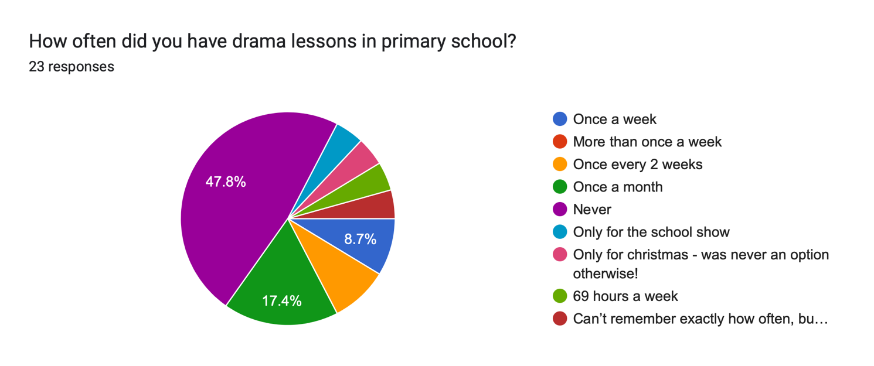
When asking this question, I knew that there would be an array of different answers as different people would have had different experiences of drama lessons in school. What shocked me the most about this question was the amount of people that answered “Never”. This allows me to infer that they wouldn’t have been exposed to the possible benefits of imaginative play, therefore making me question how many others in the country have not experienced what drama can do to a child and how it can encourage different skills that they can use in the future. The Great Big Theatre Company state that drama has a” positive impact on physical, emotional, social and cognitive development” (Great Big Theatre Company. (Unknown)) which helps support my statement that people who wouldn’t have had the opportunity to partake in drama activities may not have the same number of skills for example, social skills that someone who was exposed to imaginative play would have. As someone who was encouraged to participate in drama outside of school as it wasn’t offered to me in an academic environment, I can understand that many people wouldn’t have had the option but saying this I have gained valuable skills participating in drama that these people may not of had the chance to gain.
Why do you think drama wasn’t or still might not be offered in Primary Schools? (Optional)
I wanted people to express their feelings when answering this question. I wanted to know what exactly people opinions were and why they believe drama might not be encouraged in educational settings. There was a lot of different answers for this question. There was one answer that I felt was vital to comment on (Appendix 4). I chose to comment of this answer because I believe this person is being very open and sharing exactly how they feel in regard to drama in schools and that is exactly what I wanted when people were answering this question. I wanted them to be able to be honest with their answers which is what I believe this person did. It was interesting that they decided to comment on the stigma that children ‘misbehave’ and ‘play up’ when drama is introduced in a classroom. Most people see drama as an opportunity for a child to mess around and not get any work done as they see it as free time but what they don’t realise is that drama has so many benefits that helps correct a child’s behaviour if it was poor beforehand. Imaginative play can help a child’s physical attitude in the classroom and how they are with their peers. The website (Little Sunshine’s Playhouse and Preschool (2020)) states that drama allows “monitored physical play” and that it “helps children earn the importance of self- regulation and respecting other people’s boundaries”. This supports that drama can allow a child to express themselves in a safe environment but also teach them that even though it’s having creative freedom, it’s not misbehaving it’s getting excited at a new way of learning and how to manage that excitement in everyday life.

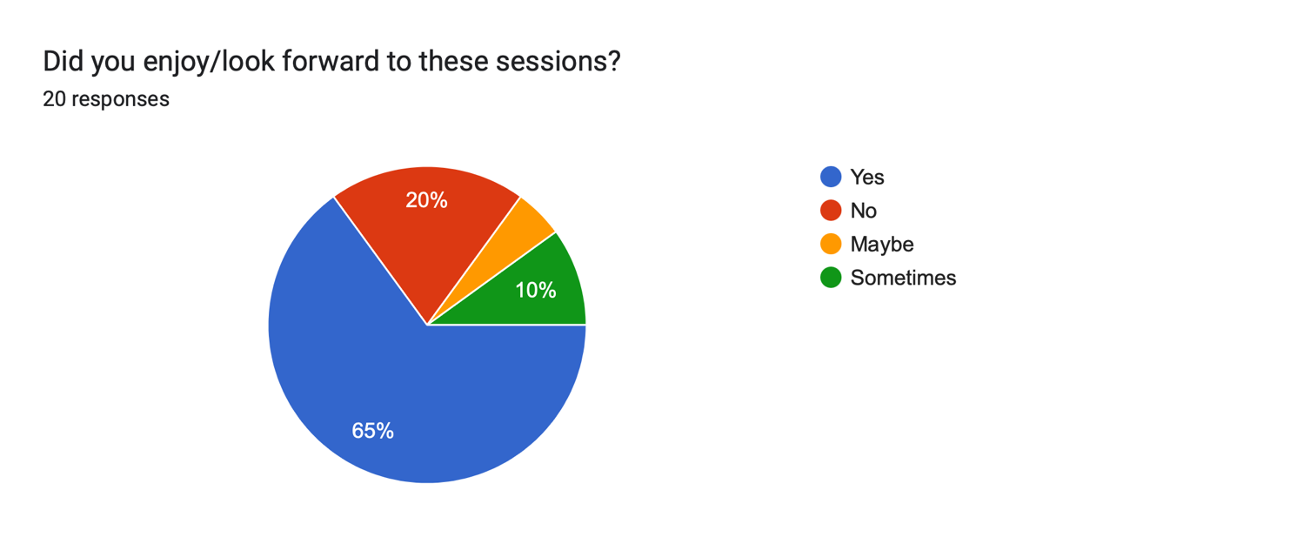
I asked this question because I wanted to see how many people actually enjoyed taking part in drama. As much as studies and opinions can show how drama can benefit a child, I wanted to truly see if these people actually enjoyed taking part and found themselves having fun while taking part in these activities. As you can see majority of people said yes but there was still quite a high number of people who said ‘no’. This led me to believe that drama isn’t something that catches the liking of all children. Yes, as studies and my own research has shown, drama can help a child develop many skills but if we look at the overall happiness of a child taking part in imaginative play then we are left with some children who aren’t open to that area of study. It led me to think if certain people said ‘no’ because the way the lessons was delivered in their school wasn’t to proper standard and that staff weren’t trained to teach the proper dynamics of drama techniques therefore there people may have been forced to performing or get up in front of people when they didn’t want to which has then made them not enjoy drama full stop.
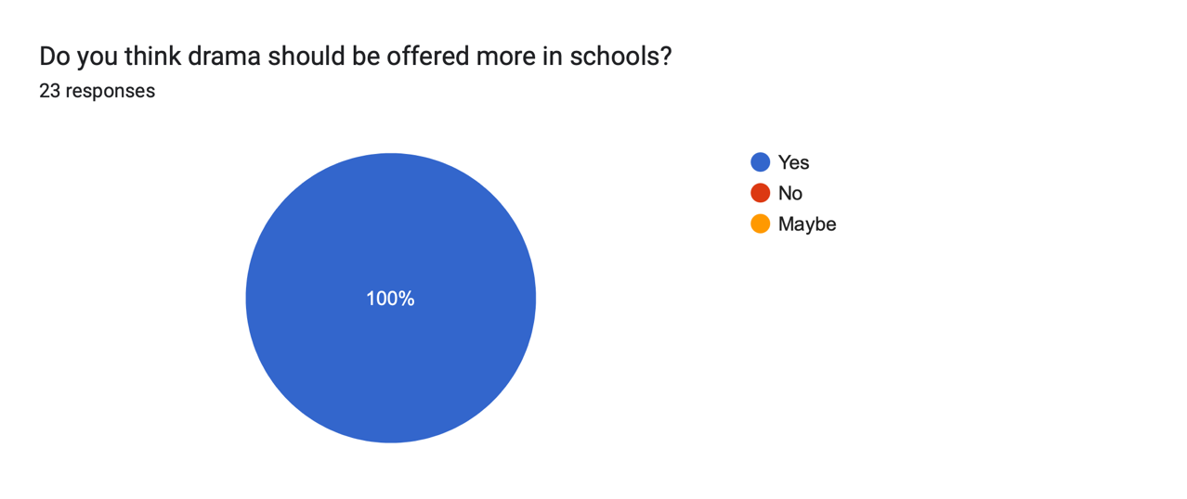
I asked this question because I wanted to see if people thought drama should be encouraged more in educational settings. As you can see out of all 23 responses, all of which has responded with ‘yes’ and that they believe based of what they know already of drama, and it’s benefits that all children should have the chance to take part in imaginative play. After this question I wanted to know why people think this and if they would be willing to share their reasoning behind their answer. One answer that I found important to highlight was someone stating that they believe drama allows neurodivergent children to learn in a less academic environment (See Appendix 5). I found these persons answer to be incredibly helpful in finding out how people see drama in primary schools and whether they believe that it should be an essential part of learning. When this person commented on the idea of neurodivergent children being given the opportunity to learn in a less academic way it made me questions whether children with disabilities struggling learning in a classroom and would benefit more with being physical with their learning. This answer led me on to researching into the use of drama and it effects of a child who may have learning difficulties.
I found some interesting results that highlights just how helpful imaginative play can truly be not only for all children but for children who have disabilities. This led me into looking at Autism how it effects a child’s learning. Looking into how many people are actually diagnosed with autism made realise that its more than I thought. The BMA company stated that there is an estimate of ‘700,000’ people diagnosed with autism in the UK alone. I was shocked with how high this statistic is as I didn’t realise how many people are affected by this disorder and how hidden this disability is. Most people find themselves not realising they have autism until they come across difficulties in everyday life. ‘Autistic people have difficulties in interpreting both verbal and non-verbal language like gestures or tone of voice’ (National Autistic Society (Unknown)) this was a valuable insight because it therefore highlights that people who are diagnosed with Autism can face difficulties in everyday life and it therefore effects the way they sometimes communicate with others. I found that children who have autism have three key characteristics. These being difficulty interacting and communicating, narrow interests and repetitive behaviour. These 3 characteristics are what all autistic children may experience. I found this interesting as I was able to distinguish how autism effect people and the way it can make someone change especially children. Tying this in with my hypothesis, I explored next into how drama can help children with this disability and some ways cases in which a child may have benefited from the use of imaginative play. ‘Improvisation exercises are useful because so many autistic kids rely on ‘scripts’ to navigate social situations’ (Laura McKenna (2016)) This quote which was said by writer Laura McKenna actively demonstrates that children with autism struggle with social interactions with their peers and being able to engage in conversation which my previous research outlines but by McKenna saying this, it highlights how drama tools such as improv can really help expose a child to the possibilities of engaging with people and not having to rely on words that are already printed out for them but their own thoughts and feelings.
Many children are encouraged to get involved within drama if they have autism as it can help develop important skills that may not be able to develop in mainstream school. Drama can offer a range of different tools and techniques to help a child have new experiences and to embrace themselves and more skills that would be very effective for them in the future. Drama games especially are successful in helping autistic children. Lucy Quick who is the co-founder of ‘Perform’ which is a drama school suggests that she has seen ‘first-hand’ how drama games can be supportive and advantageous. She lists multiple skills that have been developed through drama games and techniques for example she states that they ‘improve self-confidence, recognise emotions in others, work as a part of a group…’ (Lucy Quick (2011)) all things considered she seems pretty confident in her own research and first had encounters with children with Autism that drama does have multiple different benefits for them, and it will help them develop as an individual and learn more skills that they will be able to take forward in the future.
Children with autism can be classed as ‘vulnerable’ at different points in their life states Professor Simon Baron-Cohen. As a professor direct to the Autism Research Centre, he specialises in working with all ages of people who have autism and together with his research teamwork out the potential vulnerabilities they are in order to work with them to make sure they are supported in any way they can be. One thing that stood out to me was the idea of drama therapy. I wanted to touch on this as it highlighted how it was established to enable people of the spectrum to get the help they need when it comes to things we have to do in drama and the industry. As a child we often find ourselves scared to embrace change, to meet new people and to communicate. If we put ourselves in the mind of a child with autism imagine how scary those tasks may be as they can become overwhelmed quite quickly. The website Drama for Autism stated that ‘it’s extremely important to create a positive environment for communication for children with Autism’. (Drama for Autism (Unknown)). This was an interesting statement to comment on as I found that it highlights just exactly what is needed in order for not only children who may have disabilities but all what all children need which is a safe, secure and well managed environment. If a child does not feel safe their current environment, then they will not be willing to co-operate in any activities and will distance themselves from any communication with staff or with peers which again will not help them in the long run with their social skills. Whereas with drama therapy, we are able to use drama tools such as role-play, storytelling, improvisation and theatre games as a therapeutic way of helping the children to engage a lot more and to feel comfortable doing so in the confinements of a stable and safe environment that drama offers. Allowing a child to build on their ‘cognitive, emotional. And social development’ (Drama for Autism (Unknown)) through drama therapy is a huge achievement and would make all the difference for children who are on the spectrum. I found this website to be insightful and allow me to understand how important drama really is to be on the curriculum as it helps children who struggle with table-based work and would prefer to find themselves being active while learning and engaging in imaginative play.
At the start of my project, I was already looking into people to interview who has been involved within the drama scene from a young age but also people who may or may not of had access to drama during primary school. After thinking about this I got in touch with Blaze Roper. Blaze is a student at UWTSD who is currently studying Applied drama and is looking to become a drama practitioner. I wanted to understand a bit more of her background when it came to the performing arts and how she found her education to be. She was very open in her answers to questions I had and I established with her before the interview began that I wanted to hear from her own experience and her own thoughts towards drama. Before I commenced with the interview, I had a list of different questions I wanted her to answer (See Appendix 3) she gave me full in-depth answers which helped me with my process and allowed me to engage upon some new information that i didn’t know before. She stated at the beginning of the interview that her experience with drama in primary schools was only when it came to the annual school play. Between this there would be no sight of any drama taking place. The phrase she used which I thought was something interesting to comment on was ‘if you did drama outside of school you were likely to get a main role’. This around the board is something I’ve heard and seen myself. Especially in my own school. It appears this may be a common theme throughout all schools. I found it fascinating that this was the case in her school. It leads me to believe that because drama isn’t encouraged in schools, staff have no grounds to cast children as main parts in the school plays because they’ve not seen what their capability is. I feel like this is an unfair trait that schools are using and that if we used drama more in schools then children would have an equal chance at school productions. She highlighted that she took part in drama lessons outside of school and when I asked whether she believes that it’s helped her develop to who she is today she agreed and stated that it has “helped my confidence” and that she was able to “trail out situations and conversations”. By her saying this she implies that she was able to gain valuable skills such as her confidence and communication skills that she is now able to take forward in practices and to use in everyday life by socialising with people and working out problems in situations and how to approach different ones.
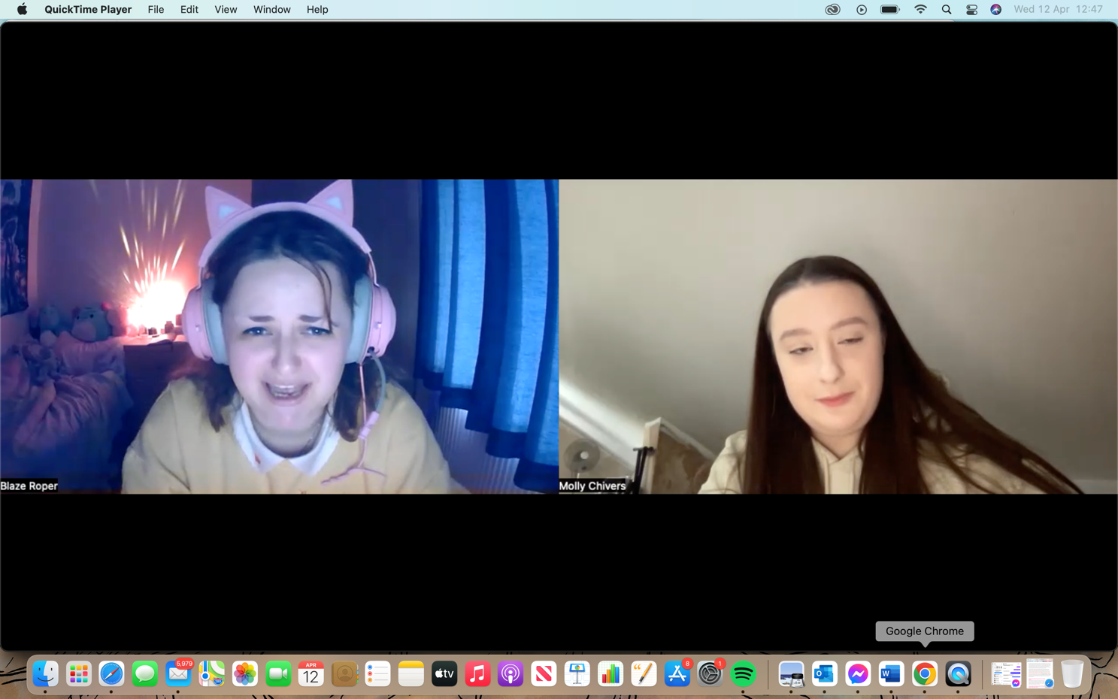
As the interview progressed. I asked her a range of different questions but one that stuck out to me was when I asked “How do you think taking part in drama has affected you in today’s age? Her answer to this was one that really helped solidify how important drama really is to a child and backs up my previous research I did in regards to Autism and the role drama plays with that. She stated that she didn’t know growing up that she was autistic. Throughout her time in drama school, she was able to adapt more in situations than she could in mainstream school just purely based off tools that drama brings to the table. She believes that drama helped her discover that she has autism and that it explained a lot to her. By her saying this it outlined for me how someone had a first hand of experience of benefitting from drama and how by them being involved within specialised techniques it allowed them to figure out more about themselves that they didn’t know before. In other words, it allowed her to find the missing piece to the puzzle. This helps me back up the research I did previous to meeting with Blaze as I found that Sarah was saying similar things as she also believes drama enables a child to really find themselves. One thing I did want to highlight was the fact that Blaze describes drama as a “godsend”. She believes that if she didn’t have drama in her life all those years ago, she doesn’t know where she would be now and in what state she would be in. Drama allowed her to discover all these new things about herself and to gain more valuable skills that makes her who she is. She comments on the fact that she now understands herself a lot more and she also said that “a lot of my life has made sense because of drama”. To be able to understand yourself is something we all take for granted. Imagine not being able to really know who you are and having no way of knowing but then finding something that allows you to be yourself and find yourself and such a supportive environment to have drama described as a ‘godsend’ highlight just how important of a factor it has played in this woman’s life and how it has helped her flourish into who she is today. I believe it has helped a lot of other people in the world and that there are a lot of currently who are experiencing the same thing.
After meeting with Blaze, I investigated into the different types of ways drama can help a child and different tools and techniques. I researched into Theatre in Education and the way it can help educate a child. I started by researching into what Theatre in Education actually is. Theatre in Education or what is also known as TIE is a practice in which is interactive. The purpose of TIE is to ‘help aid the educational process’ (Sarah Robson (2018)) states Robson who works alongside other practisioners who work with the Theatre in Education process. The TIE movement was first established in 1965 by the Belgrade who were a a company who specialised in touring schools teaching children through this medium. They believed that it allowed practioners to create a ‘range of learning opportunities’ (Bootman Violet (2020))) for both children and young adults. As an actor in training myself I have done previous workshops where I facilitated using this process. I found the children to engage a lot more and feel as though they were apart of the learning in a much more intimate way as they were able to decide different situations and solve problems for themselves while watching a live piece of theatre. There are 4 predominant learning styles. These are; visual, auditory, red/write and kinaesthetic. All these different tyles are contrasting and mean different things for each person. For example, the Wilfred Laurier University stated that all these styles are ‘methods of learning or understanding new information’ (Wilfried Laurier University (2008). The team broke down the meanings of these different types of learners.
Visual Learners
Visual learners learn through seeing and being able to process something by looking at it. For example diagrams, pictures, symbols etc.
Auditroy Learners
Auditory learners learn by listening to wha is being taught. For example watching videos, attending lectures or tutorials and discussing with peers or staff.
Read/Write Learning
Read/Write learning is learning through reading and writing. They struggle to learn new things through listening or looking therefore the best way for them to take in information is to study books or write notes.
Kinaesthetic Learning
Kinaesthetic learning is learning while using your senses and doing. For example, while learning this way you will be using all your senses at one to utilize learning.
All this actively demonstrates that there are multiple different learners and people who have different way in taking in information. If we put these types on learners into a drama class, I believe the first three types of learners would maybe find it challenging because they work with more class-based learning whereas kinaesthetic learners work more based on engaging within the material and getting hands on learning. The process of Theatre in Education would help with all 4 of these learning types because it allows the children to watch the theatre, engage within the piece, read and make notes throughout the show but also listen to what is taking place in order to learn. This is where I believe TIE is a useful tool that should be used more in schools as it reaches out to all different types of learners instead of just one and enables ALL the children to learn instead of just some. Furthermore, aside from TIE there is another process in which facilitators use quite frequently which is a process called Mantle of the Expert. Mantle of the Expert was founded by teacher, Dorothy Heathcote. She had a huge impact on the world of drama and its approaches towards teaching. She believed that using ‘in role’ in a classroom allows the children to ‘explore imaginary contexts (Burt’s Drama (Unknown)). This implies that the children will take on a role in the classroom and then throughout the session they would stay in the ‘profession’ they have been given and complete the workshop along this basis. Heathecote’s aim was to help and support staff that would enable them to use drama in and around the classroom.
I spent my time reading the book ‘Key concepts in Theatre/Drama Education’ which was written by Shifra Schonmann. This book outlined for me how a pupil’s learning can be developed through Mantle of the Expert. Schonmann stated that the ‘in role’ concept ‘provides the necessary tensions to bring about effective learning’ (Shifra Schonmann (2011)). This statement demonstrates how using Mantle of the Expert can bring out useful and effective learning for children and it helps them learn more knowledge in a well-established way. After learning about the way Mantle of the expert can be delivered and how it enables a child to learn in a much more involved and dramatic way, I wanted to test out this theory myself and build my own workshop in a Mantle based way.
(YOUTUBE VIDEO Start talking about wanting to do a workshop, collaborating with people in my class who wanted to create a workshop to, age rating, primary school, looking at the different workshop types, emailing schools, challenges, planning workshop, different techniques and activities, time limit, putting the workshop on, different ages and less group number, photos, videos, how workshop went, different activities that worked and didn’t, Luke being autistic and the hieroglyphics task and his involvement but the actual task on it’s own as well, collaboration and how it worked, overall if we were to do it again and doing it with the proper age group it’s meant to be for and adding different activities like teacher in role, collaboration)
At the start of my project, I knew I wanted to create a workshop that was aimed at primary school children.

(5008 words)

- Different types of learners (Mantle of the Expert)
This means- that actively demonstrates that

Appendix
“I think the system doesn’t count drama as an “important” subject. There’s such a toxic reasoning behind this, schools think drama is a waste of time as they think it won’t lead to a career or success. Firstly, yes it definitely can! Secondly, so what? Are kids not allowed to simply be creative, be social and have fun? Some schools think that drama is a chance for children to play up, be silly or misbehave. If this does happen, I think it’s usually because children are sat at a desk with their heads down so much, that when they have the opportunity to be creative and express themselves in a drama lesson, they get overexcited as drama is a rare occurrence. Whereas if drama was compulsory, there would be more of a healthy balance.’” (Appendix 4)

Bibliography
Department of Education, D.F.E. 2012. Letter to Birmingham Repertory Theatre. November 2012. (Accessed: 3rd January 2023)

Sally Weale. (2021). Boy playing saxophone Arts in schools This article is more than 1 year old ‘Creativity crisis’ looms for English s. [Online]. The Guardian. Last Updated: 15th July 2021. Available at: https://www.theguardian.com/education/2021/jul/15/creativity-crisis-looms-for-english-schools-due-to [Accessed 6th January 2023].

Nick Morrison. (2019). Education’s funding crisis. What happens when the money runs out?. 12TH April 2019, P.g.Null.

Jancett Childcare. (2021). The Benefits of Drama for Children. [Online]. Jancett.co.uk. Available at: https://jancett.co.uk/the-benefits-of-drama-for-children/ [Accessed 21 October 2022].

Curriculum For Wales. (2022) Guidance area of Learning and Experience- Expressive Arts. Avaialble at: https://s3-eu-west-1.amazonaws.com/hwb-live-storage/a2/59/d2/72/a63544998390b2fb11b8828a/draft-statutory-guidance-expressive-arts.pdf (Accessed 3rd January 2023)

Brian Woolland. ((Unavailable)). The National Curriculum/ Introduction. In: Elizabeth Perrott. (Ed). The Teaching of Drama in the Primary School. New York: Longman Publishing. p.Pg.6. (Accessed 4th January 2023)

Jeffrey D. Wilhelm. "The Age for Drama" Educational Leadership (2006)
Available at: http://works.bepress.com/jeffrey_wilhelm/1/

Manon van de Water. (2021). Drama in education: why drama is necessary. [Online]. EDP Sciences. Available at: https://www.researchgate.net/publication/349922126_Drama_in_education_why_drama_is_necessary [Accessed 21 October 2021].

Great Big Theatre Company. (2014). The Benefits of Drama. [Online]. gbtc.com. Last Updated: 2014. Available at: https://www.gbtc.com/benefitsofdrama.php [Accessed 20th February 2023].

David Farmer. ((Unknown)). Why Teach Drama to Primary School Children?. [Online]. dramaresource.com. Last Updated: (Unknown). Available at: https://dramaresource.com/why-teach-drama-to-primary-school-children/#:~:text=Drama%20gives%20childr [Accessed 8th Febuary 2023].

Nigel Toye and Francis Prendiville. (2000). Drama and traditional story for the early years. London: RoutledgeFalmer. pp. Pg 8-9.

Pyjama Drama. ((Unknown)). How drama develops life skills. [Online]. pyjamadrama.com. Last Updated: (Unknown). Available at: https://www.pyjamadrama.com/drama-play-life-skills [Accessed 11th March 2023].

National Autistic Society. ((Unknown)). What is Autism?. [Online]. autism.org.uk. Last Updated: (Unknown). Available at: https://www.autism.org.uk/advice-and-guidance/what-is-autism [Accessed 20th February 2023].

BMA. (2020). Autism Spectrum Disorder. [Online]. bma.org.uk. Last Updated: 7th September 2020. Available at: https://www.bma.org.uk/what-we-do/population-health/improving-the-health-of-specific-groups/autism-s [Accessed 20th February 2023].

Laura McKenna. (2016). Boosting Social Skills in Autistic Kids With Drama. [Online]. theatlantic.com. Last Updated: 2016. Available at: https://www.theatlantic.com/education/archive/2016/06/boosting-social-skills-in-autistic-kids-with-d [Accessed 14th February 2023].

Lucy Quick. (2011). Drama and Autistic Children. [Online]. perform.org.uk. Last Updated: 2nd August 2011. Available at: https://www.perform.org.uk/blog/2011/08/drama-autistic-children [Accessed 14th February 2023].

Drama for Autism. ((Unknown)). How does drama effect social communication?. [Online]. dramaforautism.weebly.com. Last Updated: (Unknown). Available at: https://dramaforautism.weebly.com/why-drama.html [Accessed 7th March 2023].

Ellen Castelow. (2015). Schooldays in the 1950s and 1960s. [Online]. historic-uk.com. Last Updated: 16th August 2015. Available at: https://www.historic-uk.com/CultureUK/Schooldays-in-the-1950s-1960s/ [Accessed 28th February 2023].

Great Big Theatre Company. ((Unknown)). The Benefits of Drama. [Online]. gbtc.com. Last Updated: (Unknown). Available at: https://www.gbtc.com/benefitsofdrama.php [Accessed 27th February 2023].

Little Sunshine's Playhouse and Preschool. (2020). The Surprising Benefits of Imaginative Play. [Online]. littlesunshine.com. Last Updated: 27th January 2020. Available at: https://littlesunshine.com/the-surprising-benefits-of-imaginative-play/ [Accessed 15 March 2023].

Sarah Robson. (2018). What is Theatre in Education and five reasons how it supports organisations to inspire positive change.. [Online]. wearegibber.com. Last Updated: 8th January 2018. Available at: https://www.wearegibber.com/blog/what-is-theatre-in-education/ [Accessed 13 March 2023].

Bootman, Violet. (2020) ‘What are the benefits of Theatre in Education’, solomontheatre.co.uk, 22nd October 2020. Available at: https://www.solomontheatre.co.uk/benefits-of-theatre-in-education/ (Accessed 6th March 2023)

Wilfrid Laurier University. (2008). Understanding your Learning Style. [Online]. web.wlu.ca. Last Updated: (Unknown). Available at: https://web.wlu.ca/learning_resources/pdfs/Learning_Styles.pdf [Accessed 28th Februrary 2023].

Burt's Drama. ((Unknown)). History of Drama in Education Part 4: Mantle of the Expert and the National Curriculum. [Online]. burtsdrama.com. Last Updated: (Unknown). Available at: https://burtsdrama.com/2020/05/27/history-of-drama-in-education-part-4-mantle-of-the-expert-and-the- [Accessed 6th March 2023].

Shifra Schonmann. (2011). Key Concepts in Theatre/Drama Education. The Netherlands: Sense Publishers. pp.35-38.

.

