
HTML & CSS Web development
ACCA4023

select the date you will be submitting
Ivan Ivanov 2434440
LECTURER: Sadhana Jha
Ivan Ivanov (2434440)

Contents
Introduction 2
Requirements 3
Purpose: 3
Subject matter 3
Intended audience 3
Implementation 4
Screenshots of the Webpages 4
Validation 5
HTML Validation 5
CSS Validation 5
Evaluation 6
Part A 6
Website usability- 6
Website accessibility: 6
Search engine optimisation 6
Part B 6
Usefulness (Usability and Utility) 6
Search Engine Optimisation (SEO) 6
Accessibility: 6
Part C 6
References: 7
Appendix 8

Introduction

This report explains the design and development of a multi-page website called Gaming World. The website was created using HTML and CSS as part of the HTML & CSS Web Development module. The aim of the website is to provide information about some of the most popular video games and gaming consoles in a simple and organized way. The website includes several pages such as a homepage, a games page, a consoles page, and a contact page. Each page focuses on a different topic related to gaming and presents information with images and text.
The report describes the purpose of the website and the main requirements used during its development. It also explains how the webpages were implemented and how the HTML and CSS code were validated using online validation tools. In addition, the report evaluates the website by discussing usability, accessibility, and search engine optimization (SEO). A comparison between two existing websites is also included to analyze how these websites apply usability, accessibility, and SEO principles.

Requirements

Purpose:

The purpose of the Gaming World website is to provide information about some of the most popular video games and gaming consoles. The website was created as part of the HTML & CSS Web Development module to demonstrate the use of HTML and CSS to build a simple multi-page website. It also aims to present gaming content in a clear and organised way so that users can easily read about different games and consoles.

Subject matter

The main topic of the website is video games and gaming consoles. The website includes information about several popular games such as Minecraft, Fortnite, Grand Theft Auto V and Call of Duty. Each game includes a short description explaining what the game is about. The website also includes a page that introduces modern gaming consoles including the PlayStation 5, Xbox Series X and Nintendo Switch. Images and short explanations are used to make the information more interesting and easier for users to understand.

Intended audience
The website is mainly intended for people who are interested in video games and gaming technology. This could include gamers, students, or anyone who wants to learn more about popular games and consoles. The website is designed to be simple and easy to navigate so that users can quickly move between pages and find the information they need.

Implementation

Screenshots of the Webpages
I created the webpages using HTML for the structure and CSS for the styling. The website was developed using Notepad++ and tested in a web browser to make sure all pages were working correctly.
Home Page

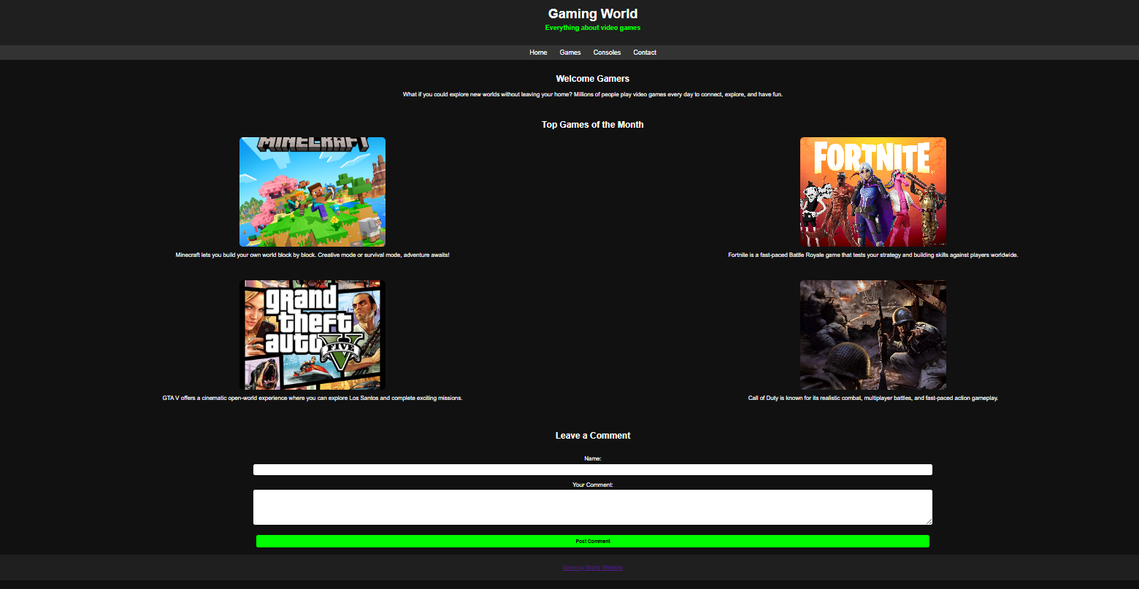
The homepage introduces visitors to the Gaming World website. It includes a welcome message and a section that displays some of the most popular games of the month. Each game is presented with an image and a short description. The images also include a hover effect that slightly enlarges the image when the mouse is placed over it. A comment section is also included where users can type a message.
Games Page
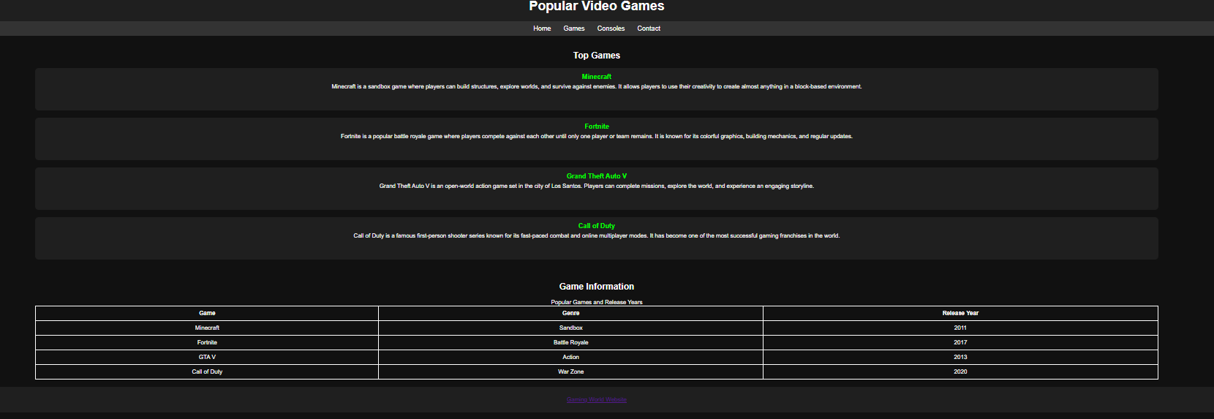
The games page provides more information about some popular video games. Each game includes a short description explaining the gameplay and what makes the game popular. The page also includes a table that shows additional information such as the genre and release year of each game. This helps present the information in a clear and structured format.
Consoles Page
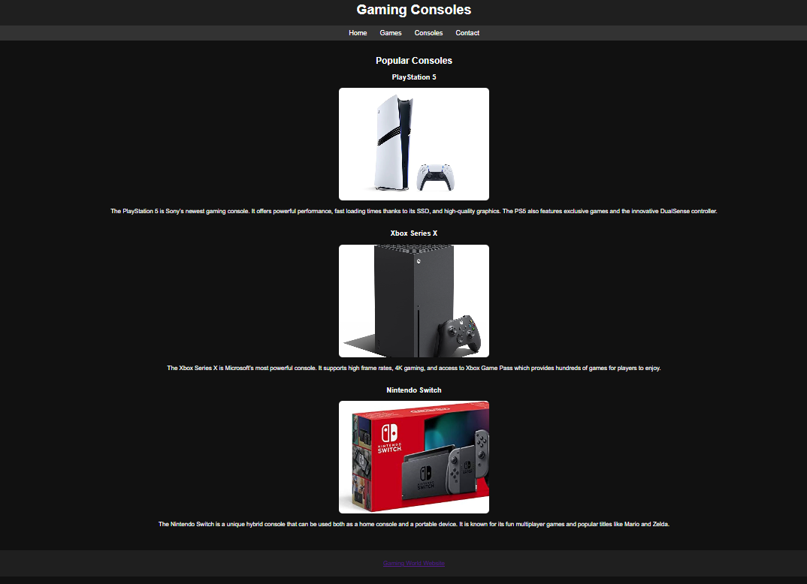
The consoles page introduces three popular gaming consoles: PlayStation 5, Xbox Series X and Nintendo Switch. Each console includes an image and a short description explaining its features and gaming capabilities. This page allows users to learn about the different gaming platforms available.
Contact Page
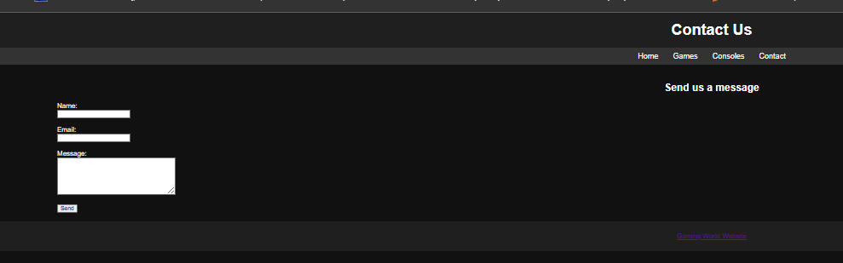
The contact page includes a simple form that allows users to enter their name, email address and message. This demonstrates the use of HTML form elements for collecting user input. The layout of the page follows the same style as the other pages to keep the design consistent across the website.

Validation

HTML Validation
The HTML code of the homepage was checked using the W3C HTML Validator. When I first validated the page, a few small errors appeared. These were mostly related to minor mistakes in the HTML structure, such as missing closing tags. After checking the code carefully, I corrected these issues by fixing the structure of the HTML elements. Once the changes were made, I validated the homepage again. The second validation showed that there were no errors or warnings, which means the HTML code follows the correct web standards.
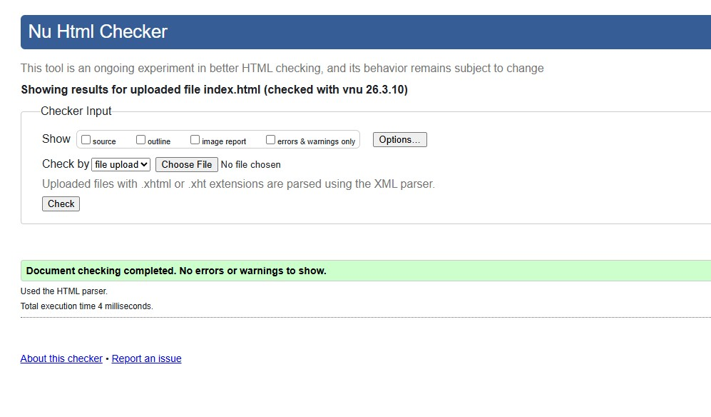

CSS Validation
I validated my CSS file using the W3C CSS Validator. After running the validation, the result showed that there were no errors in the stylesheet. This means that the CSS code I wrote follows the correct CSS Level 3 standards and is structured properly. Validating the CSS helped me confirm that the styling of the website should work correctly across different web browsers.
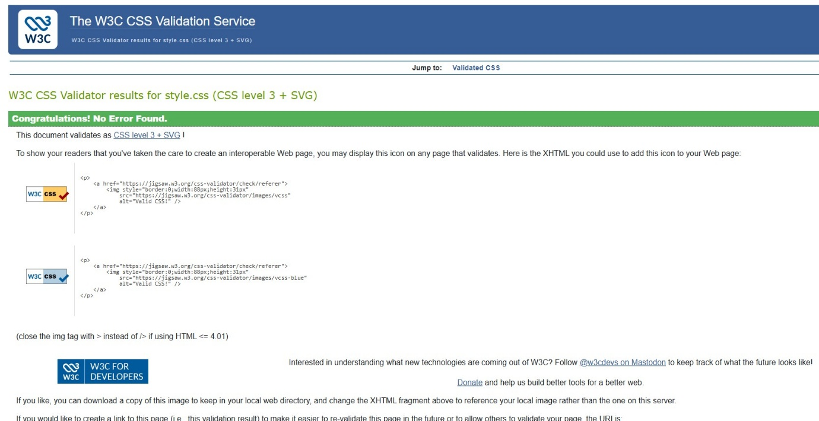

Evaluation

Part A (In this section explain your research on the following topics)

Website usability-
Website usability means how easy a website is to use. A website with good usability should allow users to move between pages easily and find the information they need without getting confused. Things like a clear navigation menu, simple layout and readable text help make a website easier to use.
While researching this topic, I found that usability is very important for keeping users on a website. According to Nielsen (2012), users usually leave a website if they cannot quickly find what they are looking for. Because of this, websites should be designed in a simple and organized way so that users can easily understand how to use them.

Website accessibility:
Website accessibility means making sure that a website can be used by everyone, including people with disabilities. Some users may have visual problems, hearing difficulties or problems using a mouse. Because of this, websites should be designed in a way that allows all users to access the content.
For example, images should include alternative text, websites should use clear headings, and the text should be easy to read. Lazar et al. (2015) explain that many websites still have accessibility problems that make it harder for some users to access online information. Because of this, developers are encouraged to follow accessibility guidelines such as WCAG to improve website accessibility.

Search engine optimisation
Search Engine Optimisation, or SEO, is the process of improving a website so that it can appear higher in search engine results. This helps more people find the website when they search for related information online.
Some common SEO techniques include using clear page titles, meta descriptions, headings and alternative text for images. According to Beel et al. (2010), websites that follow SEO practices are more likely to appear in search engine results, which can increase the number of visitors to the website.

Part B (In this section explain the evaluation of your website)

Usefulness (Usability and Utility)
The Gaming World website was designed to be simple and easy to use. The navigation menu at the top of each page allows users to move easily between the homepage, games page, consoles page and contact page. This helps users find information quickly without getting confused. The layout of the website is also consistent across all pages, which makes it easier for users to understand how the site works.
The content of the website is focused on popular video games and gaming consoles. Each page provides clear information with images and short descriptions to make the content more interesting and easier to read. For example, the homepage shows some popular games with images and short explanations, while the games page includes descriptions of each game and a table with additional information such as genre and release year.
In the future, the website could be improved by adding more games, more detailed descriptions and possibly interactive features. This could make the website more informative and engaging for users.

Search Engine Optimisation (SEO)
Several basic SEO techniques were used when developing the website. For example, the homepage includes a meta description that briefly explains the content of the website. This helps search engines understand what the page is about.
Headings such as <h1> and <h2> are also used to organise the content and make it easier for search engines to understand the structure of the page. In addition, images include alternative text (alt attributes), which helps search engines understand the images and also improves accessibility.
These techniques help improve the visibility of the website and make it easier for search engines to index the content.

Accessibility:
Accessibility was also considered during the development of the website. The website uses clear headings and simple navigation so users can easily understand the structure of the content. Images include alternative text descriptions so that screen readers can describe the images to visually impaired users.
The text is also readable and the layout is simple, which helps users navigate the website more easily. According to the WCAG guidelines, accessible websites should be perceivable, operable, understandable and robust. While this website follows some of these principles, accessibility could be improved further in the future by adding more accessibility features such as keyboard navigation support or additional accessibility testing tools.

Part C (Provide the comparison of two Live Websites)

Area | Website 1 | Website 2
Weblink of the Website | https://www.bbc.co.uk | https://www.gov.uk
Usability | Has a modern layout with many sections such as news, sport and entertainment. The navigation menu helps users move between categories easily, but the page can sometimes feel crowded because there is a lot of content. | Uses a very simple and clean layout. Information is presented clearly and the navigation is straightforward, making it easy for users to quickly find services and guidance.
Accessibility | Includes features such as alternative text for images, subtitles for videos and clear headings, which help users access the content. | Designed with strong accessibility principles. It uses clear text, good colour contrast and simple page structure to make the information easy to read for all users.
SEO | Uses descriptive page titles, headings and structured content which help search engines understand the pages. Because it publishes news frequently, the pages often appear high in search results. | Uses clear headings, structured content and descriptive titles, which helps search engines index the information correctly.
Mobile Friendliness | Responsive design adapts to smaller screens and the layout adjusts well on mobile devices. | The simple design works very well on mobile devices because the pages are mainly text-based and easy to navigate.
Conclusion | Provides rich multimedia content and a wide variety of information, but the large amount of content can make it feel busy. | Simpler and easier to use due to its clear structure and focus on accessibility and usability.

References:
[1] J. Nielsen, “Usability 101: Introduction to Usability,” Nielsen Norman Group, Jan. 2012. [Online]. Available:
Usability 101: Introduction to Usability
[2] J. Lazar, J. H. Feng and H. Hochheiser, Research Methods in Human-Computer Interaction, 2nd ed. Cambridge, MA: Morgan Kaufmann, 2017. [Online]. Available:
https://www.sciencedirect.com/book/9780128053904/research-methods-in-human-computer-interaction
[3] M. Speicher, “What is Usability?,” arXiv, 2015. [Online]. Available:
https://arxiv.org/pdf/1502.06792
[4] BBC, “BBC Homepage,” 2024. [Online]. Available:
https://www.bbc.co.uk
[5] GOV.UK, “GOV.UK Homepage,” 2024. [Online]. Available:
https://www.gov.uk

Appendix
Appendix A – index.html
<!DOCTYPE html>
<html lang="en">
<head>
<meta charset="UTF-8">
<meta name="viewport" content="width=device-width, initial-scale=1.0">
<meta name="description" content="Gaming World website showcasing popular video games and consoles. Explore Minecraft, Fortnite, GTA V, Call of Duty, and gaming consoles.">
<title>Gaming World</title>
<link rel="stylesheet" href="style.css">
</head>

<body>

<header>
<h1>Gaming World</h1>
<p class="highlight">Everything about video games</p>
</header>

<nav>
<a href="index.html">Home</a>
<a href="games.html">Games</a>
<a href="consoles.html">Consoles</a>
<a href="contact.html">Contact</a>
</nav>

<div class="container">

<h2>Welcome Gamers</h2>

<p>
What if you could explore new worlds without leaving your home? Millions of people play video games every day to connect, explore, and have fun.
</p>

<h2>Top Games of the Month</h2>

<div class="featured-games">
<div class="featured-game">
<img src="Minecraft.png" alt="Minecraft game screenshot" class="game-img">
<p>Minecraft lets you build your own world block by block. Creative mode or survival mode, adventure awaits!</p>
</div>

<div class="featured-game">
<img src="fortnite.png" alt="Fortnite game screenshot" class="game-img">
<p>Fortnite is a fast-paced Battle Royale game that tests your strategy and building skills against players worldwide.</p>
</div>

<div class="featured-game">
<img src="GTAV.png" alt="GTA V game screenshot" class="game-img">
<p>GTA V offers a cinematic open-world experience where you can explore Los Santos and complete exciting missions.</p>
</div>

<div class="featured-game">
<img src="call_of_duty.png" alt="Call of Duty game screenshot" class="game-img">
<p>Call of Duty is known for its realistic combat, multiplayer battles, and fast-paced action gameplay.</p>
</div>

</div>

<h2>Leave a Comment</h2>

<form class="comment-form">

<label for="username">Name:</label><br>
<input type="text" id="username" name="username"><br><br>

<label for="comment">Your Comment:</label><br>
<textarea id="comment" name="comment" rows="5" cols="40"></textarea><br><br>

<input type="submit" value="Post Comment">

</form>

</div>

<footer>
<p><a href="https://store.steampowered.com/" target="_blank">Gaming World Website</a></p>
</footer>

</body>
</html>

Appendix B – games.html
<!DOCTYPE html>
<html lang="en">
<head>
<meta charset="UTF-8">
<meta name="viewport" content="width=device-width, initial-scale=1.0">
<title>Popular Games</title>
<link rel="stylesheet" href="style.css">
</head>

<body>

<header>
<h1>Popular Video Games</h1>
</header>

<nav>
<a href="index.html">Home</a>
<a href="games.html">Games</a>
<a href="consoles.html">Consoles</a>
<a href="contact.html">Contact</a>
</nav>

<div class="container">

<h2>Top Games</h2>

<ul class="game-list">

<li>
<strong>Minecraft</strong>
<p>
Minecraft is a sandbox game where players can build structures, explore worlds, and survive against enemies.
It allows players to use their creativity to create almost anything in a block-based environment.
</p>
</li>

<li>
<strong>Fortnite</strong>
<p>
Fortnite is a popular battle royale game where players compete against each other until only one player or team remains.
It is known for its colorful graphics, building mechanics, and regular updates.
</p>
</li>

<li>
<strong>Grand Theft Auto V</strong>
<p>
Grand Theft Auto V is an open-world action game set in the city of Los Santos.
Players can complete missions, explore the world, and experience an engaging storyline.
</p>
</li>

<li>
<strong>Call of Duty</strong>
<p>
Call of Duty is a famous first-person shooter series known for its fast-paced combat and online multiplayer modes.
It has become one of the most successful gaming franchises in the world.
</p>
</li>

</ul>

<h2>Game Information</h2>

<table>
<caption>Popular Games and Release Years</caption>

<tr>
<th scope="col">Game</th>
<th scope="col">Genre</th>
<th scope="col">Release Year</th>
</tr>

<tr>
<td>Minecraft</td>
<td>Sandbox</td>
<td>2011</td>
</tr>

<tr>
<td>Fortnite</td>
<td>Battle Royale</td>
<td>2017</td>
</tr>

<tr>
<td>GTA V</td>
<td>Action</td>
<td>2013</td>
</tr>

<tr>
<td>Call of Duty</td>
<td>War Zone</td>
<td>2020</td>
</tr>

</table>

</div>

<footer>
<p><a href="https://store.steampowered.com/" target="_blank">Gaming World Website</a></p>
</footer>

</body>
</html>

Appendix C – consoles.html
<!DOCTYPE html>
<html lang="en">

<head>
<meta charset="UTF-8">
<meta name="viewport" content="width=device-width, initial-scale=1.0">
<title>Gaming Consoles</title>
<link rel="stylesheet" href="style.css">
</head>

<body>

<header>
<h1>Gaming Consoles</h1>
</header>

<nav>
<a href="index.html">Home</a>
<a href="games.html">Games</a>
<a href="consoles.html">Consoles</a>
<a href="contact.html">Contact</a>
</nav>

<div class="container">

<h2>Popular Consoles</h2>

<div class="console">

<h3>PlayStation 5</h3>
<img src="ps5.png" alt="PlayStation 5 console" class="game-img">

<p>
The PlayStation 5 is Sony’s newest gaming console. It offers powerful performance, fast loading times thanks to its SSD, and high-quality graphics. The PS5 also features exclusive games and the innovative DualSense controller.
</p>

</div>

<div class="console">

<h3>Xbox Series X</h3>
<img src="xbox.png" alt="Xbox Series X console" class="game-img">

<p>
The Xbox Series X is Microsoft’s most powerful console. It supports high frame rates, 4K gaming, and access to Xbox Game Pass which provides hundreds of games for players to enjoy.
</p>

</div>

<div class="console">

<h3>Nintendo Switch</h3>
<img src="switch.png" alt="Nintendo Switch console" class="game-img">

<p>
The Nintendo Switch is a unique hybrid console that can be used both as a home console and a portable device. It is known for its fun multiplayer games and popular titles like Mario and Zelda.
</p>

</div>

</div>

<footer>
<p><a href="https://store.steampowered.com/" target="_blank">Gaming World Website</a></p>
</footer>

</body>
</html>

Appendix D – contact.html
<!DOCTYPE html>
<html lang="en">

<head>
<meta charset="UTF-8">
<meta name="viewport" content="width=device-width, initial-scale=1.0">
<title>Contact</title>
<link rel="stylesheet" href="style.css">
</head>

<body>

<header>
<h1>Contact Us</h1>
</header>

<nav>
<a href="index.html">Home</a>
<a href="games.html">Games</a>
<a href="consoles.html">Consoles</a>
<a href="contact.html">Contact</a>
</nav>

<div class="container">

<h2>Send us a message</h2>

<form>

<label for="name">Name:</label><br>
<input type="text" id="name" name="name"><br><br>

<label for="email">Email:</label><br>
<input type="email" id="email" name="email"><br><br>

<label for="message">Message:</label><br>
<textarea id="message" name="message" rows="5" cols="30"></textarea><br><br>

<input type="submit" value="Send">

</form>

</div>

<footer>
<p><a href="https://store.steampowered.com/" target="_blank">Gaming World Website</a></p>
</footer>

</body>
</html>

Appendix E – style.css
body{
font-family: Arial;
background-color:#111;
color:white;
margin:0;
}

header {
background-color: #1f1f1f;
text-align: center;
padding: 20px;
}

header h1 {
margin: 0;
font-size: 36px;
color: white;
}

header .highlight {
color: lime;
font-weight: bold;
font-size: 18px;
margin-top: 5px;
}

nav{
background:#333;
padding:10px;
text-align:center;
}

nav a{
color:white;
text-decoration:none;
margin:15px;
font-size:18px;
}

nav a:hover{
color:lime;
}

.container {
width: 80%;
margin: auto;
padding: 20px;
}

.container h2 {
text-align: center;
margin-bottom: 20px;
}

.container h2:nth-of-type(2) {
margin-top: 60px;
text-align: center;
}

.container p {
text-align: center;
margin-bottom: 40px;
}

.game-img {
width: 400px;
height: 300px;
border-radius: 10px;
object-fit: cover;
transition: transform 0.3s ease;
}

.game-img:hover {
transform: scale(1.1);
cursor: pointer;
}
table{
width:100%;
border-collapse:collapse;
}

table, th, td{
border:1px solid white;
}

th, td{
padding:10px;
text-align:center;
}

footer{
background:#1f1f1f;
text-align:center;
padding:10px;
}

.console {
text-align: center;
margin-bottom: 40px;
}
.featured-games {
display: flex;
flex-wrap: wrap;
justify-content: space-around;
margin-top: 20px;
}

.featured-game {
width: 45%;
text-align: center;
margin-bottom: 20px;
}

.featured-game img {
width: 400px;
height: 300px;
border-radius: 10px;
object-fit: cover;
transition: transform 0.3s ease;
}

.featured-game img:hover {
transform: scale(1.15);
cursor: pointer;
}

.featured-game p {
margin-top: 10px;
font-size: 16px;
}

.comment-form{
margin-top:40px;
text-align:center;
}

.comment-form input,
.comment-form textarea{
width:60%;
padding:8px;
border-radius:5px;
border:none;
margin-top:5px;
}

.comment-form input[type="submit"]{
background-color:lime;
color:black;
font-weight:bold;
cursor:pointer;
padding:10px 20px;
}

.game-list {
list-style-type: none;
padding: 0;
}

.game-list li {
background: #1f1f1f;
margin-bottom: 20px;
padding: 15px;
border-radius: 10px;
}

.game-list strong {
color: lime;
font-size: 18px;
display: block;
text-align: center;
margin-bottom: 8px;
}

.game-list p {
margin-top: 8px;
text-align: center;
}

