UNIVERSITY OF WALES
Trinity Saint David

Level 4
DIGITAL SKILLS AND RESEARCH METHODS
Module Code/BMSK4003

TASK: write a report of 2000 words, on a relevant and appropriate workplace topic showing evidence of a use of a range of research methodologies and an understanding of effective and ethical data collection and interpretation

Lecturer: Dr Kazeem Oseni

Student: Silvia Postu
Student Number: 1812545

A report on market study for business development relevant to research methodologies and ethical data collection

Table of Contents

Introduction
……………………………………………………………………………………..3
Literature Review………………………………………………………………….3
Research Methodology…………………………………………………………….4
Qualitative data methods…………………………………………………………..4
Quantitative data methods………………………………………………………....4
Population………………………………………………………………………….5
Findings, Analysis and Discussion…………………………………………………5
Conclusion…………………………………………………………………………7
References…………………………………………………………………………8
Appendix 1 ……………………………………………………………………….9.
Appendix 2 ……………………………………………………………………….10

Introduction
The aim of this report is to show how can a Beauty Business Company start its activity in a specific new area as well as how profitable it is to open its branch in that area. It will also be focused on market place research of that area to find out how well known it is among the inhabitants of that area and how it can increase the Company’s customer database and their loyalty as well.
It will describe the research methods used in collecting data and what type of data where used. In this report will be discussed the importance of collecting data relating to market place study and to business development as well as organising and presenting them.

Literature Review

The value of data collection and data analytics represents the key core of a successful business. According to Abbi (2017) thinks it has become a decisive business strong point which provides an important competitive edge and influences the business growth. Collecting data means gathering information from different spheres that lead to understand exactly how a business is running, what makes it to decrease its profits, what improvements and changes can be made to increase revenue or profits, what additional functions can be added inside the company and outside it on the territory. In fact, in order to understand various sides of a business and customer behaviour a business Company should store and record every customer transaction and data. In order to benefit from data collection, business companies must process and analyse them.
The fact that you manage the information you hold, reflects not only on your business but also on the client and his needs. Each business has its own particularities and appropriate specifics therefore a ‘one-size fits all’ business model will not work every time. Data collection and data analysis are the main tools of a business that help to have a personalized, modern and sharp view of each of the key components of your organization and can give more solutions at the right time, which are resulting from real information collected over a period of time. These instruments support strategic actions that can foresee or predict future development of the organization.
Data analysis within an organization can lead to a truly deep and valuable understanding of running your own activity, as well as to identify a wide range of solutions for your own business:
“ - Gaining an overarching view of the entire business
- Understanding strengths
- Identifying trends and patterns
- Identifying inefficiencies and areas for development
- Using insight to help streamline the business
- Ascertaining how to improve sales and performance
- Predicting and anticipating future trends or outcomes” (Abbi, 2017)

Research Methodology
The meaning of research methodology offers a wide series of definitions: it can be understood like searching much more information about unknown specific topics; like finding solutions to one or more problems; like studying a particular information, generalising it and making a conclusion; like investigating a case of study and give an opinion, as (Dspace.utamu.ac.ug, 2019) points out.
“All progress is born of inquiry. Doubt is often better than overconfidence, for it leads to inquiry, and inquiry leads to invention” (manumelwin, 2019).
Research methodology varies from research methods. The first one is more used for academic research purposes usually narrowly focused on a specific scientific and academic branch or sphere, meanwhile research methods are the most used for government purposes, in economics and businesses. Businesses involves much more disciplines into their activities like: economy, psychology, history, mathematics, accountancy, politics, sociology, human resources, etc and they are based on research methods which can find out and sort out significant issues to make them run appropriately. The common research methods used in businesses are primary and secondary data. Primary data are surveys or questionnaires, direct observation, interviews, (Gent.uab.cat, 2019). Secondary data represents information from research sources such as articles, journals, newspapers. (Maund, n.d.)
Qualitative data
Data can be divided into two groups: qualitative and quantitative data. These data are descriptive and are obtained through observation. (Cleverism, 2019). To learn out a specific issue or subject are usually used surveys as a research method. Qualitative data refer to people behaviour, to their likes or dislikes, to colour, texture, etc otherwise said it may refer to human being needs, to human opinions on a particular subject, (Anon, 2019). “Qualitative research is empirical research where the data are not in the form of numbers.” (Coursehero.com, 2019).

Quantitative data
Quantitative data expresses measurements like quantities, values or numbers. This type of data can be counted… They are usually expressed in numerical form, such as length, size, amount, price and even duration. Using statistics to generate and analyse, this type of data adds credibility and business sustainability, so it is considered to be more reliable and objective, (Cleverism, 2019). Quantitative data are exact, concrete, limited numbers.
Usually qualitative and quantitative data are represented in charts, diagrams or graphs which generate a better understanding of them. Usually in collecting data are involved the population. An explanation and a suggestion at the same time of how to better organise and visualise the data in order to understand and read them easily is given by Eduard R. Tufte in his book “Visual display of quantitative information”.

“Five takeaways
- Less is more. “Above all else show the data” (p. 92). Erase everything you don’t need.
- “Graphical excellence consists of complex ideas communicated with clarity, precision, and efficiency.” (p. 51)
- Keep it proportional! “Lie Factor = size of effect shown in graphic divided by size of effect in data” (p.57). Keep it close to 1.
- You don’t have to use a graphic when there isn’t much data — a table is often better.
- Pie charts are useless. The dude hates pie charts.” (Edwardtufte.com, 2019)

Population
The definition of this term is quite widely explained. In this context it expresses a distinctive group of people or of things which participate in a survey (Abs.gov.au, 2019). A sample is a number of people who makes the survey, but enhance the feedback of a much bigger number of people.

Findings, Analysis and Discussion
I might have shown in here my past experience, when I moved to the south of my country and started my own small business as a self-employed cooperating in partner-ship with an American Cosmetic Company. Before opening my own office there I need to answer the questions: “Who I will sell my cosmetic products to?”; “How and where I will find my customers?”; “How many people are likely to buy my products?”. Thus, I created my own questionnaire and asked people to complete it, (Appendix 1). The population I chose for my questionnaire were women because the statistic exposure said in that area women are more likely to use cosmetic products rather than men. During a month I went from shop to shop, from boutique to boutique and the whole marketplace and proposed women to participate in a lottery with a guaranteed win by completing the questionnaire. The guaranteed win, for every woman who didn’t win a cosmetic product prize, was a free one-on-one beauty test class. I made the face-to-face questionnaire for 500 women.
The method used is: Quantitative data questionnaire of how likely are women to beauty.
Population = 500
Sample size = 500
Margin error = 0,1%
Confidence level = 95%

Diagram 1

Diagram 3

Diagram 3
Conclusion
Diagram 1, 2 and 3 communicate a strong point to be taken in account when planning a business strategy in a specific area. Red bar in diagram 1 shows that many people don’t have a personal beauty consultant which makes me feel free to offer them my services as a personal beauty consultant, thus I am respecting the ethical behaviour towards my colleagues and my clients. Face to face questionnaire highlights that women are quite open to beauty culture (diagram 1). Diagram 2, illustrate clearly what women request, so, that is an important factor to considerate when making investments in products deposit. This help to manage exactly and correctly money. Women require much more skin care products rather than other company’s products. (diagram 2). Skin care products are sold in kit, so their price is higher which leads to higher sellings. Chart 3 also shows encouraging results. 60% of the population interviewed are likely to start their own activity and 50% are open to try a new part-time flexible activity.
Additionally, appendix 2, shows an individual, particular questionnaire customer profile, which is focused on identifying the particularities and individual needs of each customer thus making the customer being highly satisfied about the services offered and about the products. The former leads to customer loyalty and the business thrive.
The market research using primary data method in a business, aims mainly to give an insight of increasing the customer data base, increasing sales and income, how high the investments should be, expand of business team and how profitable is to extend a business in a particular area.

References
Abbi, R. and Abbi, R. (2019). The Importance of Data Analytics and Business Development | MyDataAnalyst.com. [online] My Data Analyst. Available at: https://www.mydataanalyst.com/importance-of-data-analytics-and-business-development/ [Accessed 28 Aug. 2019].
Edwardtufte.com. (2019). Edward Tufte: Books - The Visual Display of Quantitative Information. [online] Available at: https://www.edwardtufte.com/tufte/books_vdqi [Accessed 30 Aug. 2019].
Maund, A., Schriek, M., Tinkler, P. (2017). Certificate in Higher Education: Skills for the workplace. Sage: London
Morgan, P. (2017). The Business Student`s guide to study and Employability. Sage: London
Abs.gov.au. (2019). Statistical Language - What are Data?. [online] Available at: https://www.abs.gov.au/websitedbs/a3121120.nsf/home/statistical+language+-+what+are+data [Accessed 30 Aug. 2019].
Coursehero.com. (2019). Punch KF 1998 Introduction to Social Research Quantitative and Qualitative. [online] Available at: https://www.coursehero.com/file/p70bjm8/Punch-KF-1998-Introduction-to-Social-Research-Quantitative-and-Qualitative/ [Accessed 30 Aug. 2019].
Cleverism. (2019). Overview of Qualitative And Quantitative Data Collection Methods. [online] Available at: https://www.cleverism.com/qualitative-and-quantitative-data-collection-methods/ [Accessed 29 Aug. 2019].
Dspace.utamu.ac.ug. (2019). [online] Available at: http://dspace.utamu.ac.ug:8080/xmlui/bitstream/handle/123456789/181/Research%20Methodology%20-%20Methods%20and%20Techniques%202004.pdf?sequence=1 [Accessed 29 Aug. 2019].
Gent.uab.cat. (2019). [online] Available at: http://gent.uab.cat/diego_prior/sites/gent.uab.cat.diego_prior/files/02_e_01_introduction-to-research-methods.pdf [Accessed 29 Aug. 2019].
manumelwin (2019). Significance of research - Research Methodology - Manu Melwin Joy. [online] Slideshare.net. Available at: https://www.slideshare.net/manumelwin/significance-of-research-research-methodology-manu-melwin-joy [Accessed 29 Aug. 2019].

APPPENDIX 1. Method: quantitative data survey of how known and required is a beauty Company among women in the south of Republic of Moldova.


Complete the questionnaire and participate in the lottery with guaranteed winnings!
How well known is Company X among women in your area!?
We are opening soon!

Q1. Have you learnt out about Company X and its beauty
products?
Yes No

Q2. Have you ever been to free Company X beauty tests
(one-on-one, party, on-line)?
Yes No I would like to

Q3. Do you have your personal Company X Beauty
Advisor?
Yes No I would like to have my personal Company X beauty Advisor

Q4. I am interested in beauty products:
Face skin care products Make-up

Body skin care Fragrances

Q5. I would also be interested in:
how to be a party hostess an additional earning
Your details:
Full name_______________________________
Date of birth____________________________
Phone number__________________________
e-mail address__________________________
address_______________________________

a high income career

Q6. How would you like to contact you?
text call

e-mail by post

APPENDIX 2. Method: qualitative data collection in order to meet customer needs.

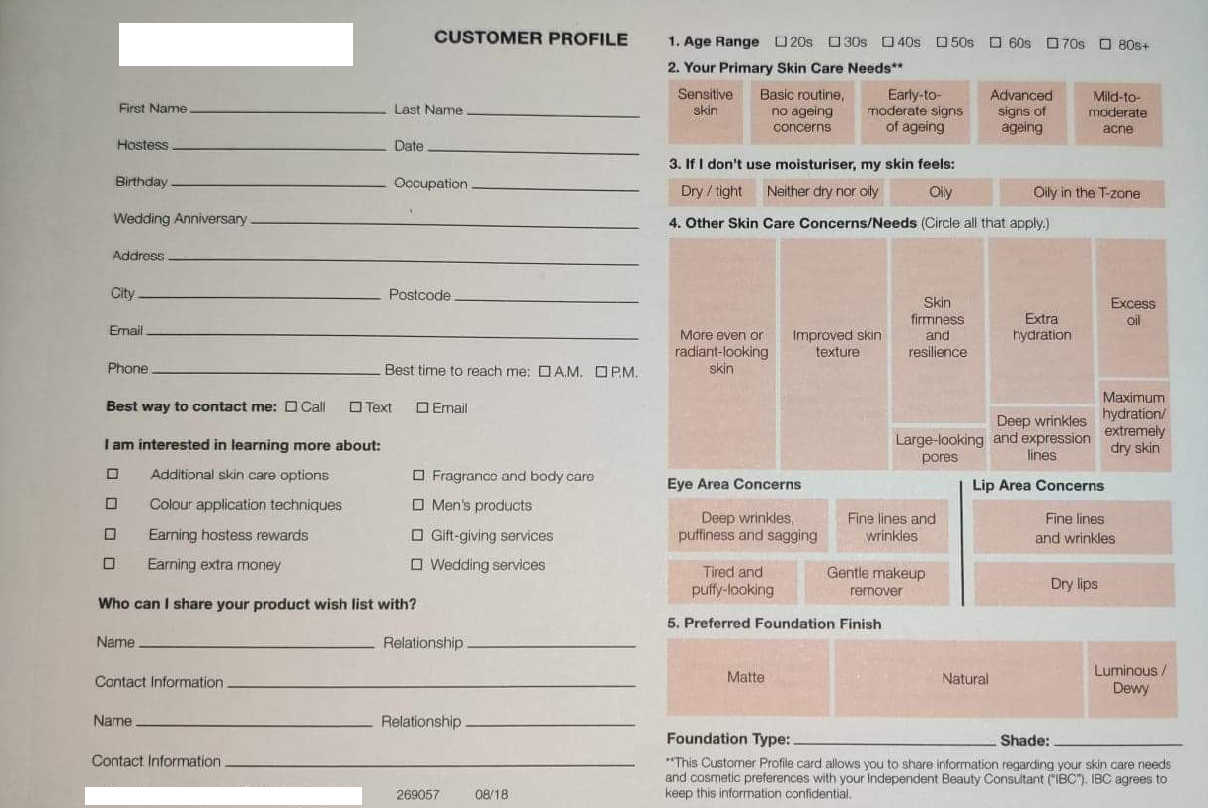
Beauty X Company

Beauty X Company

