

Name: Harrison Davies

Student Number: 2114726

Course: BSc Quantity Surveying

Module: Advanced Construction Technology

Assignment Title: Case study report with drawings

Lecturer: Rhodri Thomas

Word Count: 2500 words

Executive Summary
This report provides a critical review of the Dylan Thomas Centre, examining the difficulties of managing and maintaining and upgrading a historic building to satisfy modern performance expectations and sustainability standards. As a Grade II listed building in a coastal area, this report will investigate the constraints the centre is exposed to. Including heritage preservation, material aging and environmental effects. The report will identify possible integrations and solutions for future management of the facility.

Table of Contents
Executive Summary 2
Introduction 4
The Dylan Thomas Centre 4
Maintaining the Building 5
The Use of BIM in a Building’s Life Cycle 6
Risk Mitigation 6
Planning & Coordination 7
Maintenance & Asset Management 8
Digital Twins 8
Retrofit, Repair & Refurbishment 8
Modern Technology in Building Management 9
Smart Building Technologies 9
Artificial Intelligence (AI) 9
Retrofitting the Dylan Thomas Centre 9
Benefits for Facilities and Asset Management 10
Conclusion 11
Bibliography 12

Introduction
In the UK, there is estimated to have around 400,000 historic buildings, including listed properties and those located in our local areas (British Listed Buildings, 2024). In recognition of their historical significance, these buildings require careful preservation, which presents considerable challenges when attempting to maintain them or adapt them to meet modern requirements.
This report focuses on the Dylan Thomas Centre (DTC) in Swansea as a case study to explore these challenges in practice. The study investigates the issues associated with managing and retrofitting the building.
The aim of this report is to discuss the benefits of using BIM and other technologies to effectively plan, maintain and refurbish the building whilst mitigating risk. Given the heritage behind the building, there are precautions in place to preserve its architectural identity. With that being said, there are many innovative technologies that can be retrofitted into the DTC to assist with the day-to-day maintenance. This report will assess how smart technology such as smart buildings, scanning, AI and digital twins can be efficient in a listed building, evaluate whole life performance and improve facility and asset management.
Finally, an evaluation on the technology improvements and which are best suited to the Dylan Thomas Centre to ensure long term sustainability and modern facility management.

The Dylan Thomas Centre
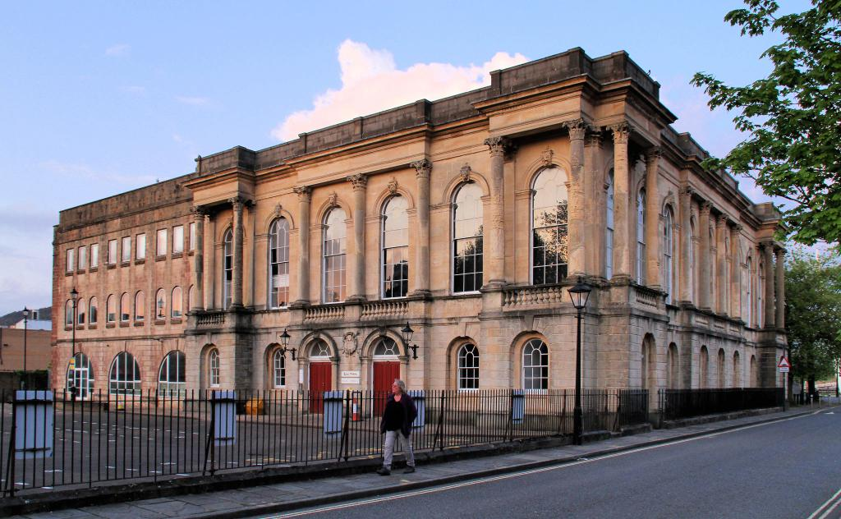
The Dylan Thomas Centre, located in the Maritime Quarter in Swansea, is a cultural landmark dedicated to the famous poet Dylan Thomas of the early 20th century. The building itself is of the former Old Guildhall and is a grade II listed building (British Listed Buildings, 2025). Built between 1825-1829, it has undertaken alterations throughout the years to accommodate its function today which serves as an educational facility open to the public with various exhibition spaces.

(GPS My City, 2025)

Although the building has undertaken adaptions, there still poses challenges to keep up with modern comfort criteria. There are legal limitations on retrofitting the building due to it being a grade II listed building.

Maintaining the Building
A building of this age often has its own set of challenges when it comes to management and maintenance. Due to its heritage and continuous use of the public, the aim of maintenance in the DTC is to ensure the buildings longevity, whilst retaining its character.
One of the biggest maintenance defects is age related decay to the building, such as the external face, primarily stonework, has corroded over the years. As shown in the image below taken in 2026, this is an ongoing issue.
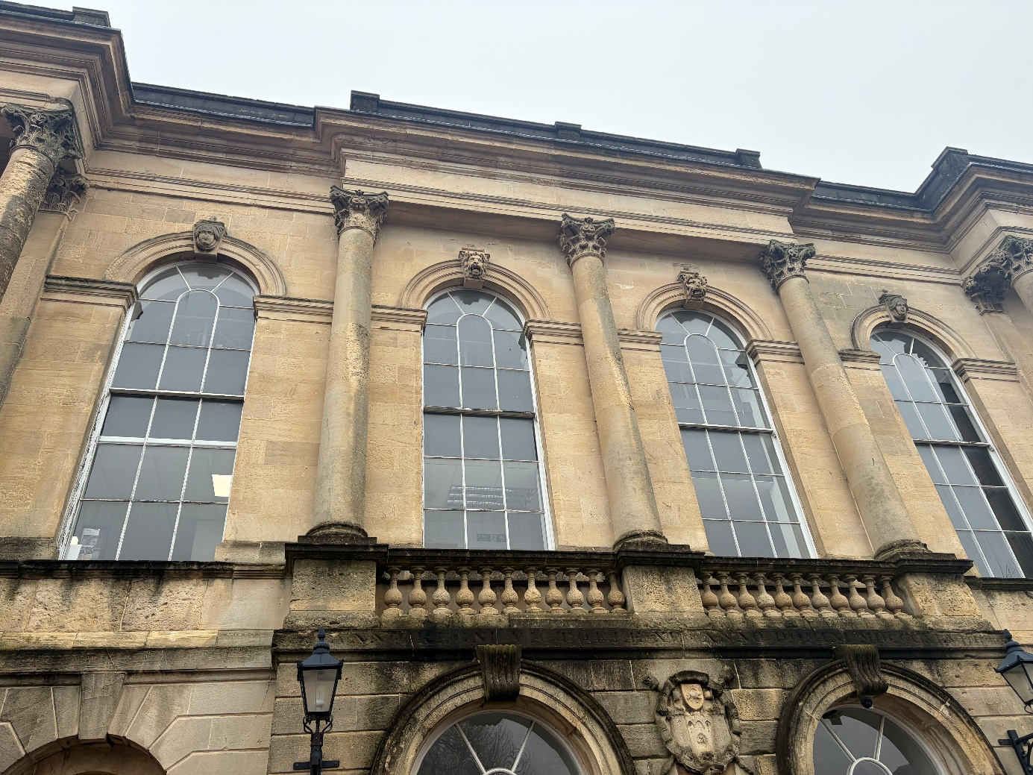
(Harrison Davies, 2026)
There is significant deterioration to this façade of the building, signs of material aging particularly near the ledges and pillars. A key factor contributing to this deterioration is the building’s coastal location, which significantly accelerates weathering processes. Salt carried in the air from seawater acts as a corrosive agent, gradually affecting the building materials and causing external finishes to bear the brunt of this exposure over time (Poma, 2018). In addition to this moisture ingression is more problematic in older buildings, often resulting in damp, mould build up and internal damage. Regular inspections are required by the maintenance team to identify early signs of serious damage.
Another maintenance difficulty with the Dylan Thomas Centre is its single glazed sash windows, which are also visible in the image above. The windows are a unique feature of the building’s historic aesthetic. However, from a performance and maintenance perspective, they present a plethora of challenges. Single glazed windows provide very poor thermal insulation compared to modern double or triple glazing. This is because they have no sealed air gaps, no gas fill, and no secondary layer to slow heat transfer (Double Glazing Window Installer, 2025). Further to this, the sash windows feature a timber window frame, this is requiring regular maintenance to preserve their condition. This includes re decorating and sealing the frame to prevent rot and warping. (Glazing Hub, 2025)
From a comfort perspective, the building heating system operates on gas radiators, specifically double iron radiators. These are generally a lot less efficient than more modern alternatives such as aluminium radiators (Buying Guides, 2025).
The Centre often relies on a reactive maintenance system, which addresses problems only after they arise. Reactive maintenance typically costs more than other systems such as pre planned maintenance (PPM), this is due to the urgency of the issues require immediate response and repair. (UKFSL, 2025)

The Use of BIM in a Building’s Life Cycle
Building Information Modelling (BIM) is widely recognised as a key digital tool for effective planning and risk mitigation. It has also become increasingly important in the management of listed buildings, with assets such as the Dylan Thomas Centre standing to benefit significantly from its application.

Risk Mitigation
One advantage of BIM is that it is able to identify and reduce risks before work begins. This is imperative in a historical building like the DTC as unforeseen defects can be disruptive and costly. Clash detection is used in BIM to identify these issues before they occur. It is a process that addresses conflict between 2 construction systems in a virtual environment, these conflicts arise when modern structural elements such as HVAC systems or electrical conduits interfere with another object. This relates to the DTC as they have integrated modern ventilation systems in the building.

The image below taken on a visit to the centre shows the ventilation system. This is not a heat recovery system but is a modern style of ventilation used in facilities.
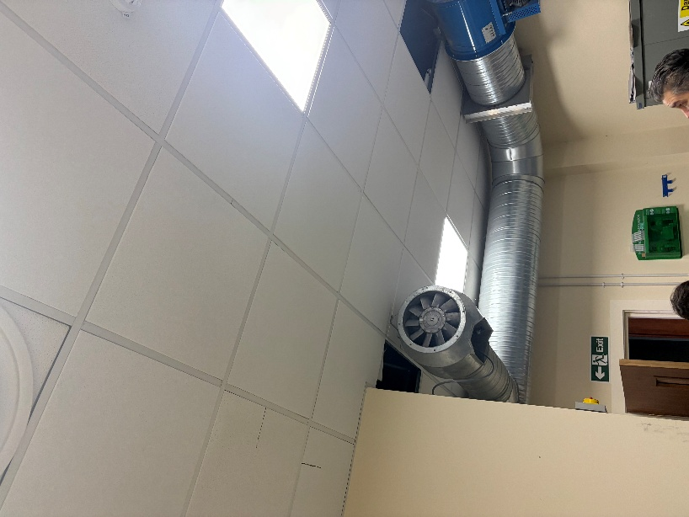

Planning & Coordination
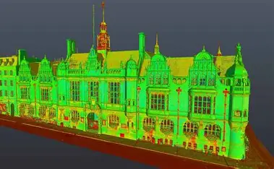
BIM can also be used to improve planning and coordination the Dylan Thomas Centre. A digital 3D model of the building can be created using laser scanning (Geo Scan Technical Team, 2025). These 3D models are integrated with the building’s architectural, structural and building services and are stored in one place. Given the fact that the DTC was built in the 1800s (British Listed Buildings, 2025) this would be particularly beneficial as there could be outdated or incomplete records of the building. These scans can identify defects early to save the building from potential decay.

Full external Laser scan of a Grade II historical Building (Lecia Geo Systems, 2025)

Maintenance & Asset Management
Modern BIM is not only a design tool. BIM supports enhanced maintenance and asset management. Every wall, column and beam in the building can have embedded data such as age, material and maintenance history. Maintenance schedules can be automated from this (Siewczyński, 2025), shifting the responsive maintenance to a pre-planned strategy. As discussed earlier, this would decrease the cost and will help reduce any disruption to the live public facility.

Digital Twins
A BIM model can be linked with sensors to pick up temperature, humidity and structural movement. This is called a digital twin. (Siewczyński, 2025)
For a historical building this enables early detection of damp or a build-up of moist, critically in heritage buildings. It can monitor the building’s settlement to protect against movement and ensures stability. It also can detect deterioration of materials early before visible damage even occurs, effectively setting replacements timelines. (Siewczyński, 2025)
2 researchers took a case study of the Rame Tower, located in Spain, to demonstrate how BIM applied to assets is useful for management and future refurbishment. (García-León, 2023)
Their findings include that the model can be used for ongoing management and monitoring. Digital Twins supports real-time, collaborative environments for stakeholders. In addition to this, It enables transition from static documentation to dynamic lifecycle management (García-León, 2023)

Retrofit, Repair & Refurbishment
BIM can be implemented into historical buildings to provide a platform for retrofit projects. Multiple types of data can be produced such as 3D design models, energy performance simulations and cost estimates and schedules (Maggie Khaddaj, 2020)
Projects can be planned and controlled more efficiently to retrofit the DTC using BIM. It allows stakeholders to simulate different options to see how they would potentially work without the need for physically constructing the works. This can reduce any uncertainty in decision making (Maggie Khaddaj, 2020)
BIM plays a key role in energy driven refurbishment. This is by enabling energy modelling and performance analysis to see how energy efficient the building will be with its energy upgrades, helping achieve strategies to reduce energy consumption. It makes it a very smart decision from both a commercial and operational standpoint. (Maggie Khaddaj, 2020)

Modern Technology in Building Management

Smart Building Technologies
Smart buildings use a network of sensors, IoT devices and analytics to manage the building in real time. These include the components of heating, cooling, lighting and security (Science Insights, 2024)
Smart building technologies include automated lighting, HVAC systems and environmental monitoring which can prevent humidity and sustain good air quality. The building can effectively sense what is going on inside and outside the building to adjust in real time to be as efficient as possible. Although the upfront cost, this can save future energy expenditure, reducing costs and ensuring human comfort. (Science Insights, 2024)

Artificial Intelligence (AI)
With the astronomical growth of artificial intelligence, it is transforming the way buildings can now be managed and maintained. As AI continues to advance, its role in smart buildings will shift from simple automation toward predictive and generative capabilities, enabling buildings to adapt intelligently to changing environmental conditions. (Open Asset, 2025)
AI can be integrated into the modern systems such as Air source heat pumps, HVAC and lighting, AI will optimise the use of these systems whilst reducing waste and carbon footprint. (Open Asset, 2025) AI can identify potential system failures before the occur, reducing costly downtime. Also, AI can be used in buildings to enhance security and safety by AI powered surveillance. (Sekhavat, 2025)

Retrofitting the Dylan Thomas Centre
To implement these technologies into the Dylan Thomas Centre. There must be a precautious strategy which preserves the heritage of the building but improves the performance and comfortability.
Firstly, the building should undertake laser scanning for a 3D BIM model to be accurately produced. This allows the retrofit team to plan and see how the alterations improve the building work before any construction. (Scan To BIM, 2025)
Due to the centre’s inefficient ventilation and heating from the single glazed sash windows and double iron radiators, Smart building technologies can be installed into the building. Integrated sensors and IoT devices can monitor the environmental conditions, these can be very effective due to the costal location of the centre. HVAC and controlled lighting systems can also be used to improve the human comfort whilst being energy efficient. (Science Insights, 2024)
AI can be implemented into the building for security and surveillance, AI can also be used within the smart building technology to optimise performance and efficiency of its energy systems by automatically controlling them, reducing the need for human interaction. Ai can interpret patterns and forecasts problems (Open Asset, 2025)
A creation of a digital twin is a vital technology that would help sustain the Dylan Thomas Centre. It enables continuous monitoring of the building with real time data. (García-León, 2023)
Other retrofit options could be upgrading the single glazed windows to double glazed to provide more thermal insulation. Also, installing solar panels as they provide a good renewable energy source, however due to the building being grade II listed, this may have some planning constraints. (Historic England, 2026)

Benefits for Facilities and Asset Management
After upgrading the centre, it offers benefits to future management and maintenance. The DTC currently relies on reactive maintenance, with the integration of modern technology this will no longer be required. This is because any issues will be identified at an early stage which gives the centre valuable time to be proactive and plan to carry out the repairs necessary. (Davies, 2026)
Smart systems offer a substantial improvement on energy efficiency. Studies found that smart building technologies can reduce energy consumption by up to 30% through improved operational efficiency and demand response strategies (ISCEM, 2025). Automated controls lower the energy consumption, reducing carbon emissions and support renewable energy. This is critical for the Dylan Thomas Centre, which must adapt to modern sustainability goals and performance targets. (Science Insights, 2024)
On the back of being more efficient comes with increased cost savings (Sekhavat, 2025). With the use of AI and smart technology, it reduces the operational and maintenance costs over the buildings life cycle because it will schedule the repairs in time instead of unexpected breakdowns which require costly repairs. (Open Asset, 2025)
Using BIM provides digital records of all the buildings components, maintenance history and lifecycle data all stored centrally. (Historic England, 2026)

Conclusion
The Dylan Thomas Centre embodies Swansea’s cultural heritage and holds significant historical identity (Dylan Thomas Centre, 2026). Careful preservation must be considered when carrying out any refurbishment to the centre. However, with the growth of Building Information Modelling (BIM) and smart technology in the industry, it is now more possible than ever to revitalise these landmarks, ensuring human comfort and optimising energy use. (Geo Scan Technical Team, 2025)
The adoption of BIM offers an innovative approach to managing the asset. BIM enables more accurate planning, controlled coordination while minimising risk through laser scanning to produce digital 3D models of the building (Lecia Geo Systems, 2025). This allows smart technologies to be implemented much easier and allows for strategies to be simulated before construction, which supports data driven decision making and proactive management. (Maggie Khaddaj, 2020)
Retrofitting the Dylan Thomas Centre would greatly improve the functionality of the building whilst keeping its core historical aesthetic. Smart sensors and IoT devices can pick up weathering to the façade of the building before any visible damage (Science Insights, 2024), thus allowing AI and digital twins to automate future maintenance schedules ahead of time. (ISCEM, 2025)This supports the long-term asset management throughout the building’s life cycle.
There are initial challenges associated with retrofitting the Dylan Thomas Centre, particularly the high upfront costs and the need to carry out refurbishment works while preserving the building’s heritage (Vale, 2022) . However, these challenges can be offset over time by shifting from a reactive maintenance approach to a planned and preventative strategy. By adopting this approach, defects, breakdowns, and signs of weathering can be identified at an early stage, reducing the likelihood of major repairs and helping to control long-term maintenance costs (Siewczyński, 2025). Overall its advantages far outweigh the drawbacks.

Bibliography
British Listed Buildings. (2024, 12 1). What Are Listed Buildings? Retrieved from British Listed Buildings: https://britishlistedbuildings.co.uk/site/about-listed-buildings/
British Listed Buildings. (2025). The Old Guildhall (Former Annexe to Dynevor Comprehensive School). Retrieved from British Listed Buildings: https://britishlistedbuildings.co.uk/300011643-the-old-guildhall-former-annexe-to-dynevor-comprehensive-school-waterfront-y-glannau
Buying Guides. (2025). 6 Reasons Why You Shouldn’t Buy Cast Iron Radiators. Retrieved from Buying Guides: https://ukradiators.com/blogs/buying-guides/why-you-shouldnt-buy-cast-iron-radiators
Davies, L. (2026, 02 12). 5 Concrete Examples of Predictive Maintenance for Smart Buildings. Retrieved from Watt Sense: https://www.wattsense.com/blog/building-management/examples-of-predictive-maintenance/
Double Glazing Window Installer. (2025, 12 17). Understanding Single Glazed Windows: A Simple Guide. Retrieved from Double Glazing Window Installer: https://www.doubleglazingwindowsinstaller.co.uk/blogs/single-glazed-glass/
Dylan Thomas Centre. (2026). ‘Love the Words’ Exhibition. Retrieved from Dylan Thomas Centre: http://www.dylanthomas.com/exhibition/
Future SIPs. (2025, 11 14). Future SIPs. Retrieved from Future SIPs: https://www.futuresips.co.uk/sips-south-wales/
García-León, J. M.-E. (2023). HBIM AS A TOOL FOR THE ANALYSIS AND CONSERVATION OF ARCHITECTURAL HERITAGE. CASE STUDY: THE RAME TOWER'S DIGITAL TWIN. Retrieved from Int. Arch. Photogramm. Remote Sens. Spatial Inf. Sci: https://isprs-archives.copernicus.org/articles/XLVIII-M-2-2023/637/2023/isprs-archives-XLVIII-M-2-2023-637-2023.html
Geo Scan Technical Team. (2025). Scan to BIM for Listed and Historic Buildings. Retrieved from Geo Scan : https://geo-scan.uk/insights/scan-to-bim-for-listed-historic-buildings/
Glazing Hub. (2025, 10 02). What Is the Disadvantage of a Sash Window? Retrieved from Glazing Hub: https://glazinghub.co.uk/blog/what-is-the-disadvantage-of-a-sash-window
GPS My City. (2025). Dylan Thomas Centre, Swansea. Retrieved from GPS My City: https://www.gpsmycity.com/attractions/dylan-thomas-centre-41324.html
Historic England. (2026, 02 24). Retrieved from Historic England: https://historicengland.org.uk/advice/technical-advice/retrofit-and-energy-efficiency-in-historic-buildings/improving-energy-efficiency-through-mitigation/
ISCEM. (2025, 08 05). Smart Building Technologies for Enhanced Energy Efficiency. Retrieved from ISCEM: https://icsecm.org/smart-building-technologies-for-enhanced-energy-efficiency/
Lecia Geo Systems. (2025). The full laser scan survey of a Grade II* Listed historic building. Retrieved from Lecia Geo Systems: https://leica-geosystems.com/case-studies/reality-capture/the_full_laser_scan_survey_of_a_grade_ii_listed_historic_building
Maggie Khaddaj, I. S. (2020, 07 11). Using BIM to Retrofit Existing Buildings. Retrieved from Science Direct: https://www.sciencedirect.com/science/article/pii/S1877705816301990
Open Asset. (2025). How AI Is Revolutionizing Smart Buildings: 10 Use Cases + 5 Examples. Retrieved from Open Asset: https://openasset.com/resources/ai-smart-buildings/
Poma, J. (2018, 07 9). Studies show salt air affects metals more than 50 miles inland. Retrieved from Poma Metals: https://pomametals.com/salt-air-inland-distance-for-metal/
Scan To BIM. (2025). Scan to BIM Services for Historical Buildings Projects. Retrieved from Scan To BIM: https://scantobimsolutions.com/sectors/historical-buildings/
Science Insights. (2024, 03 24). What Are Smart Buildings and How Do They Work? Retrieved from Science Insights: https://scienceinsights.org/what-are-smart-buildings-and-how-do-they-work/
Sekhavat, A. (2025). Navigating the AI Revolution in Smart Buildings: Opportunities, Roadblocks, and Strategies. Retrieved from TIA: https://tiaonline.org/navigating-the-ai-revolution-in-smart-buildings-opportunities-roadblocks-and-strategies/
Siewczyński, B. (2025, 04 05). BIM goals and uses in the management, maintenance, and preservation of historic buildings: an open access perspective. Implementation characteristics of HBIM for improved documentation and lifecycle management. Retrieved from Nature: https://www.nature.com/articles/s40494-025-01588-z
SIPs Technical Data. (2025, 11 14). Retrieved from Clays: https://www.clays.com/sips-technical-data
Stokes, A. (24, 11 2020). Homes of the future in Bridgend. Retrieved from Wales & West Housing: https://www.wwha.co.uk/en/news/homes-of-the-future-near-completion-in-bridgend/
UKFSL. (2025). Planned Maintenance vs Reactive Maintenance: Which Saves Your Business More? Retrieved from UKFSL: https://www.ukfsl.co.uk/industry-news/planned-maintenance-vs-reactive-maintenance-which-saves-your-business-more
Vale, G. (2022, 10 30). The Surprising Disadvantages of Smart Buildings Revealed. Retrieved from Builder Space: https://www.builderspace.com/the-surprising-disadvantages-of-smart-buildings-revealed

