E-Portfolio Link: https://2518099.wixstudio.com/e-portfolio

Module Name: Learning In the Digital Era
Module Code: ACCA 4025

Student Name: Liliana Stryzhakovska
Student ID: 2518099
Group: 1

Lecturer’s Name: Koushik Modak

Introduction…………………………………………………………………………………………....2

Main Body…………………………………………………………………………………………......2

Task 1: Essential Academic and Employment Skills for the future career Path……2

Task 1 (a): Report on Essential Academic and Employment Skills………....3

Task 1 (b): Evaluation of Task 1 (a) based on Similarity report……………..3

Task 2: Collaborative Mind Map and Individual Poster……………………………….4

Mind Map (Collaborative)………………………………………………………...4

Poster (Individual)…………………………………………………………….…..5

Task 3: Virtual Collaboration and RefWorks……………………………………………6

Report on Virtual Collaboration Forming……………………………………….6

Step-by-step process of using RefWorks with visuals………………………..7

Task 4: E-Portfolio Creation and Evaluation………………………………………….10

Task 4 (a): E-Portfolio Creation………………………………………………..10

Task 4 (b): Illustrative Review of E-Portfolio tool Selection…………………10

Conclusion………………………………………………………………………………………...11

References………………………………………………………………………………………..11

Task 1 References:………………………………………………………………………11
Task 3 References:………………………………………………………………………11

Introduction
In today’s academic and professional world, having the right skills and tools is very important for success. This portfolio presents my academic achievements, personal strengths, and career goals, while also showing how I can organize and present information effectively. It includes my reflections on essential academic and employment skills, my experience creating a digital portfolio using Wix, and my step-by-step process of managing references with RefWorks. The purpose of this portfolio is to demonstrate my learning journey, highlight my abilities with digital tools, and show how I am preparing for future academic and professional opportunities.

Main body
Task 1 (a): Essential Academic and Employment Skills for the future career Path
Academic and employment skills are crucial for career development and success. These skills help individuals perform effectively in their studies and future professions. Developing both academic and employability skills enables students to adapt to change, work efficiently, and progress in their chosen career paths [1].

Essential Academic Skills:

a) Communication Skills. Strong written and verbal communication helps individuals express ideas clearly, present information effectively.
b) Critical Thinking and Problem-Solving. The ability to think critically, analyse information, and find logical solutions is essential
c) Research and Information Literacy.
d) Digital Literacy. Proficiency in using technology and digital tools is essential for online learning, and research.
e) Time Management and Organization. Managing time effectively helps students meet deadlines.
Essential Employment Skills
a) Teamwork and Collaboration. Working well with others, respecting diverse opinions, and contributing to group goals are key skills.
b) Adaptability and Flexibility. The modern workplace is constantly evolving.
c) Leadership and Initiative. Employers value individuals who can lead projects, take initiative, and motivate others.
d) Professionalism and Work Ethic. Being reliable, punctual, honest, and respectful demonstrates professionalism and builds a positive reputation in the workplace [2].
e) Interpersonal and Communication Skills. Effective communication and positive relationships with colleagues, clients, and supervisors enhance teamwork.

In conclusion, essential academic and employment skills form the foundation for future career success. Continuous learning and personal growth will remain vital in navigating the changing global workforce [3].
In the modern world, having strong academic and employment skills is essential for both personal development and future career success. Education today is not only about gaining knowledge but also about developing the abilities that help individuals work effectively, think critically, and adapt to change. This report reflects on the importance of these skills and how they support my own future career goals.
For my own career path, I see both academic and employment skills as equally important. Academic learning helps me think critically and solve problems logically, while employment skills allow me to apply that knowledge effectively in practical situations.
In conclusion, essential academic and employment skills are key to achieving long-term success. They support lifelong learning, personal growth, and career development. By continuing to improve my communication, critical thinking, teamwork, and digital skills, I can prepare myself for the challenges of the future workplace and become a more capable and confident professional.
I used Turnitin to check the originality of my work. The similarity report showed a 31% match, which mainly consisted of properly referenced sources and common academic phrases.
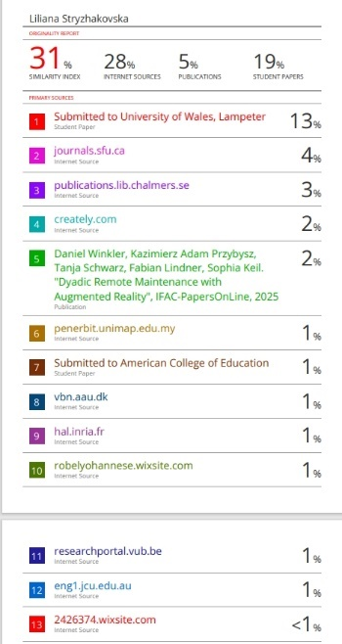

Task 1 (b): Evaluation of Task 1 (a) based on Similarity report

After reviewing the similarity report for my previous submission titled “Report on Essential Academic and Employment Skills,” I found that the overall similarity percentage was within an acceptable academic range. Most of the matched content came from common academic phrases or definitions that are widely used when discussing skills such as communication, teamwork, and critical thinking. These similarities are understandable, as such terms are commonly applied in educational writing.
However, I also noticed a few sentences that were closely similar to online sources or examples provided in study materials. Although these were not directly copied, they reflected similar structures or wording. To improve the originality of my work, I plan to rephrase sentences more effectively in my own style, use synonyms where possible, and ensure that any referenced ideas are properly cited using the required referencing style.
Overall, the similarity report helped me understand how to maintain academic integrity and produce more original work. I learned the importance of paraphrasing, referencing, and developing my own voice in writing. In the future, I will continue to review my work carefully before submission to ensure it meets academic honesty standards and reflects my personal understanding.

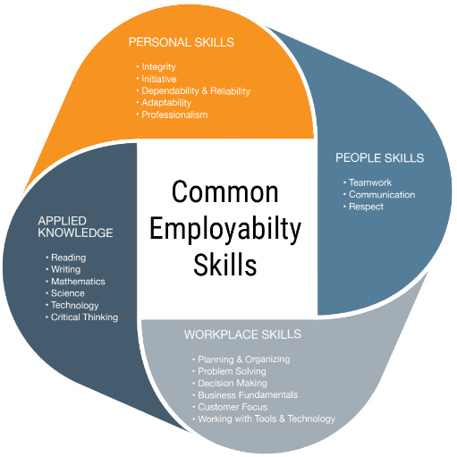

Task 2: Collaborative Mind Map and Individual Poster
Mind Map (Collaborative)
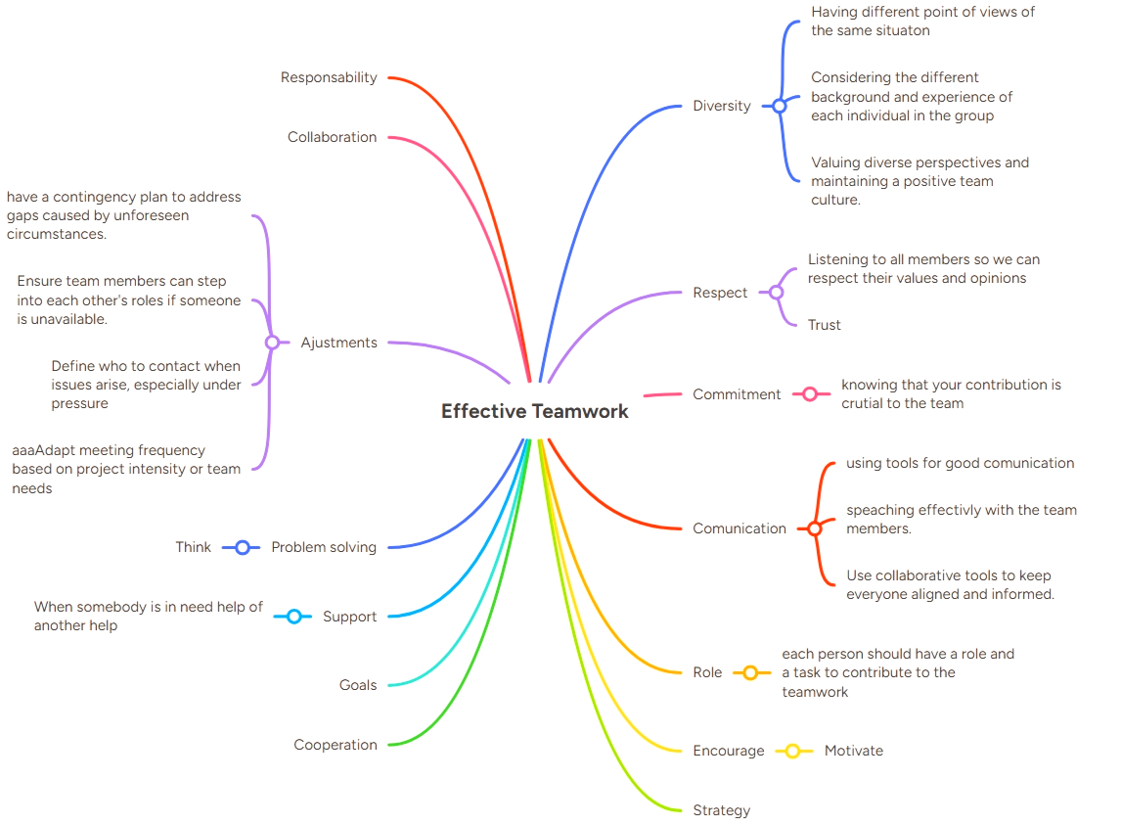

Poster (Individual)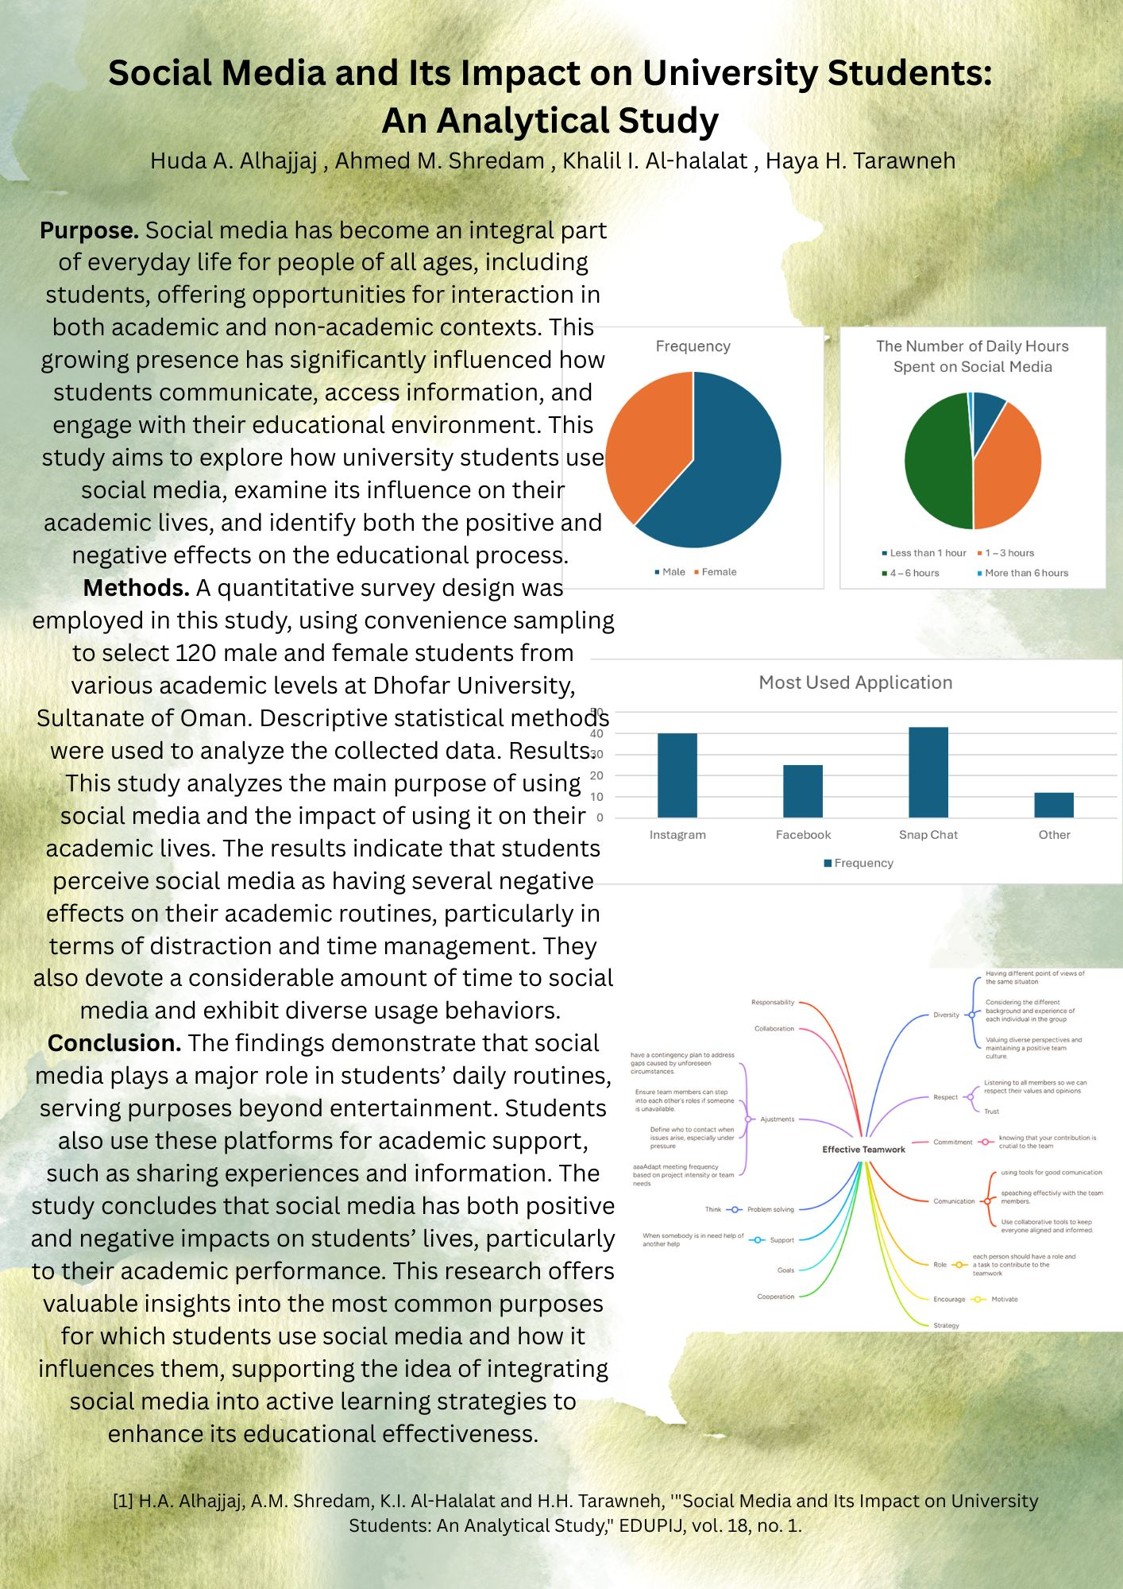

Task 3: Virtual Collaboration and RefWorks
Report on Virtual Collaboration
Forming
Advanced technology adoption promises to transform manufacturing, supporting greater flexibility, agility, and efficiencies through digitally connected processes. Research on technologies is rapidly expanding, along with interest in industry adoption, with far-reaching consequences for re-imagining human work. Consistent with the focus of ergonomics and human factor, people remain central in the work of the future and with technology used to augment their capabilities to achieve consistent quality and enhanced safety in product and service delivery. Usability remains a central focus beginning with the human-technology interface which is entrenched within the broader sociotechnical system linking organisation, human, and technology, with critical implications for sustainable adoption. Realising this potential requires testing new applications of new technologies and using systematic approaches built on usability and human-centric principles. The application of ergonomics and human factor principles supports the development of design guidelines for interfaces, products, processes, and jobs, improves technology performance, and enhances human skill acquisition, providing a competitive advantage for business [1].
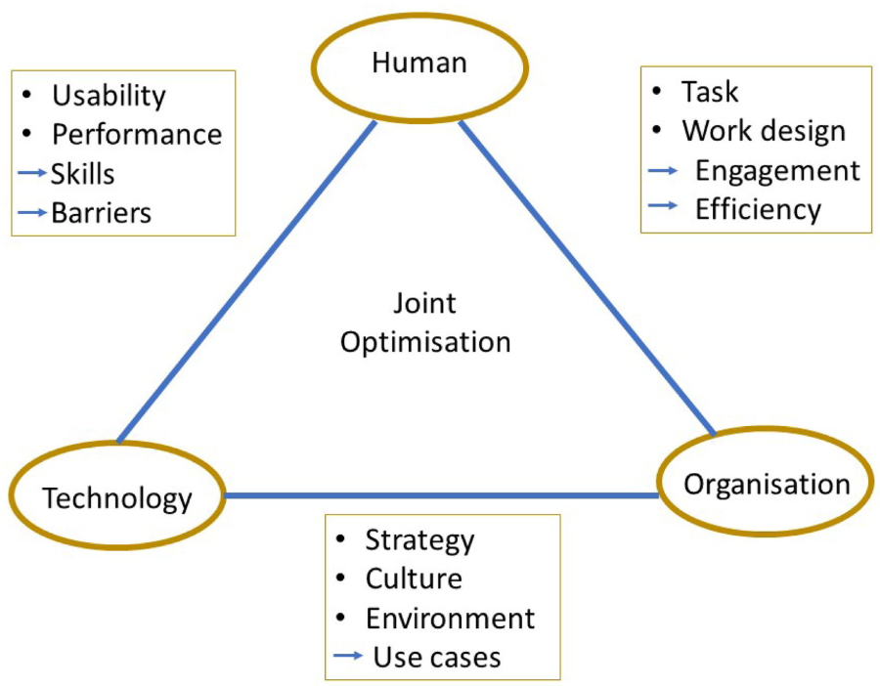
Figure 1.
Empirical evidence suggests that Visual Planning can be instrumental in the success of multi-site (geographically dispersed) teams. Nevertheless, this technique should not be viewed as an automatic, all-encompassing solution for ensuring team triumph. Visual Planning offers crucial assistance to both single-site and multi-site groups, particularly when there is a significant requirement for structured coordination and close collaborative effort ([2]).



 Figure 2.

The deliberate choice of a visual methodology for conducting research launched a process of intensive exploration, exposing us to the artistic expressions and lived experiences of others. Furthermore, it initiated cycles of reflection, intellectual debate, and mutual dialogue. Ultimately, the visual medium served as both a catalyst for involving participants deeply within the research framework and a powerful mechanism for self-development and performative expression ([3]).
Visual Collaboration represents a cutting-edge strategy that leverages graphic instruments to enhance the efficacy of communication, deepen understanding, and fortify synergy in contemporary workplaces. By facilitating the visual representation of intricate concepts, this collaborative approach markedly improves information exchange and optimizes the decision-making trajectory ([4]).
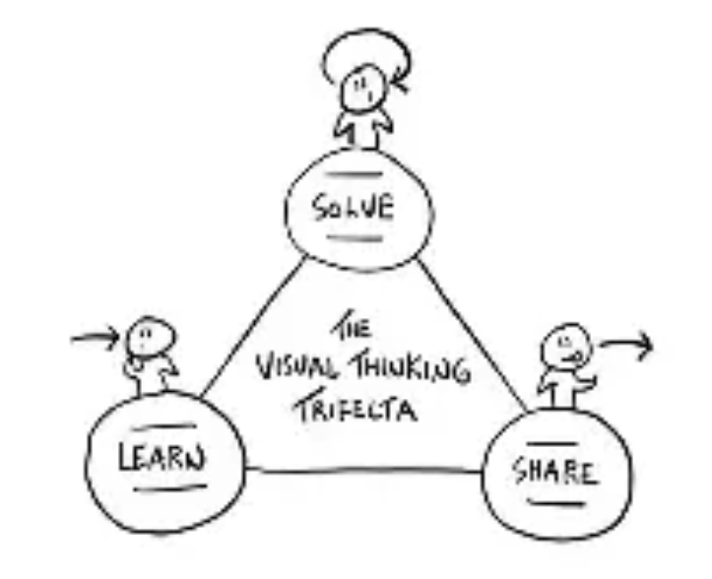
Figure 3.

Step-by-step process of using RefWorks with visuals
First, go to the RefWorks website https://www.refworks.com If you are a first-time user, click “Sign Up” to create a new account using your email. If you already have an account, click “Login” and enter your details.
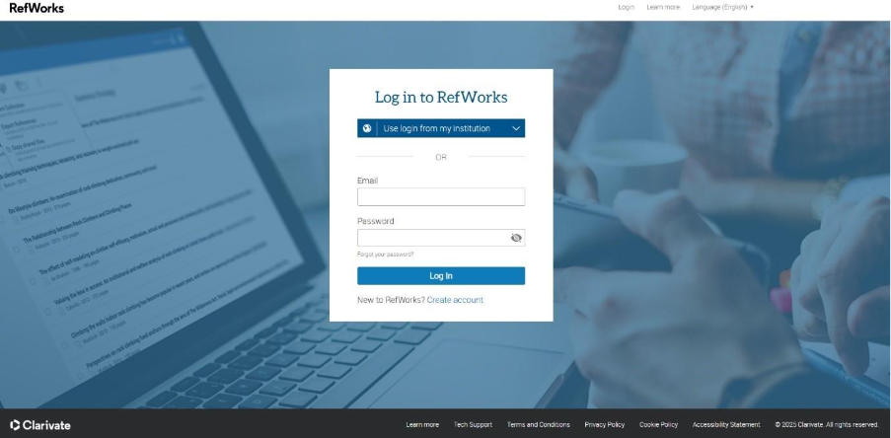

Once logged in, you can organize your references by creating folders. Click “Create New Folder” and give it a descriptive name.
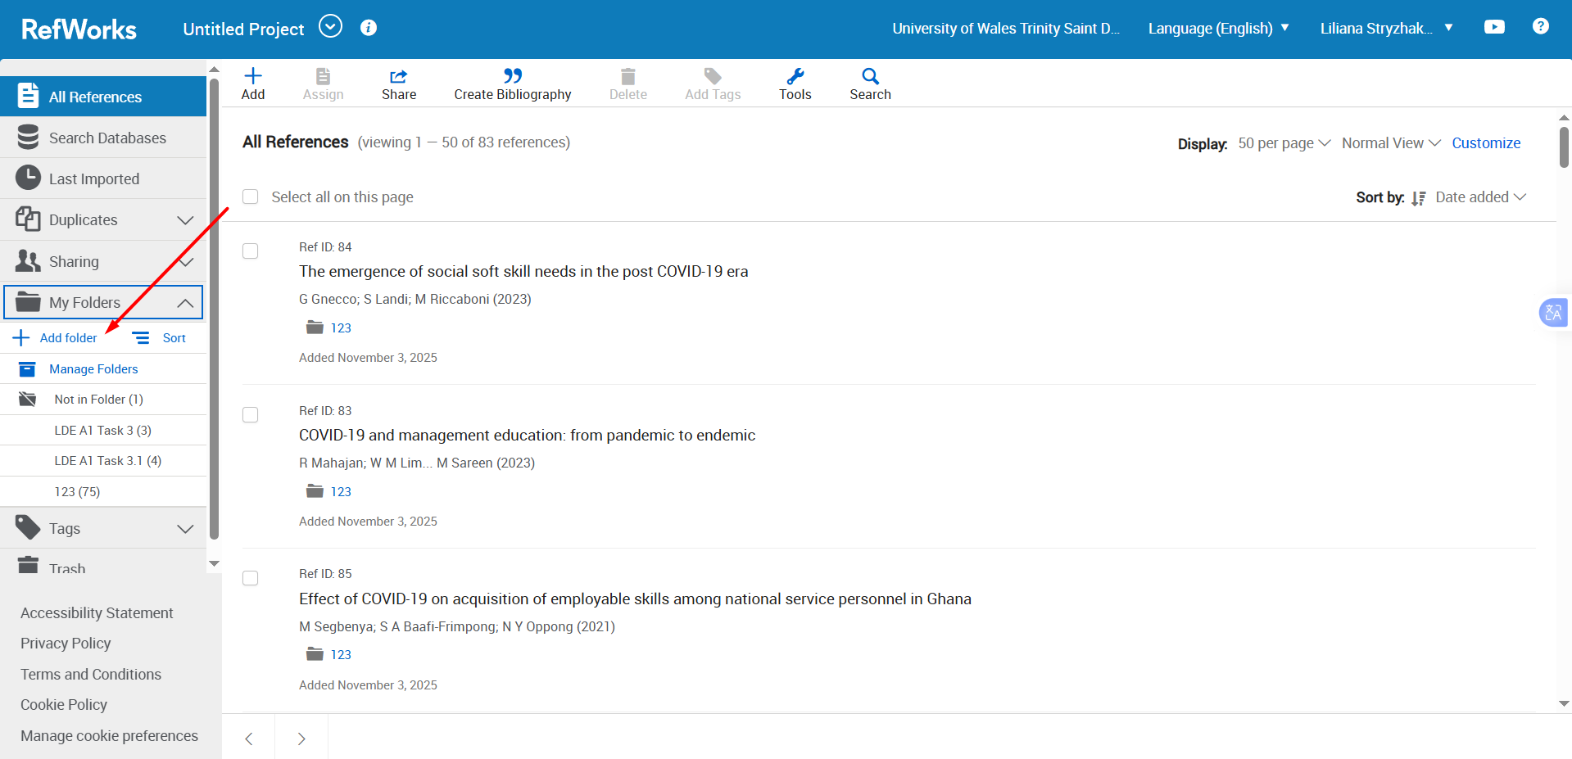

You can to add references in different ways.
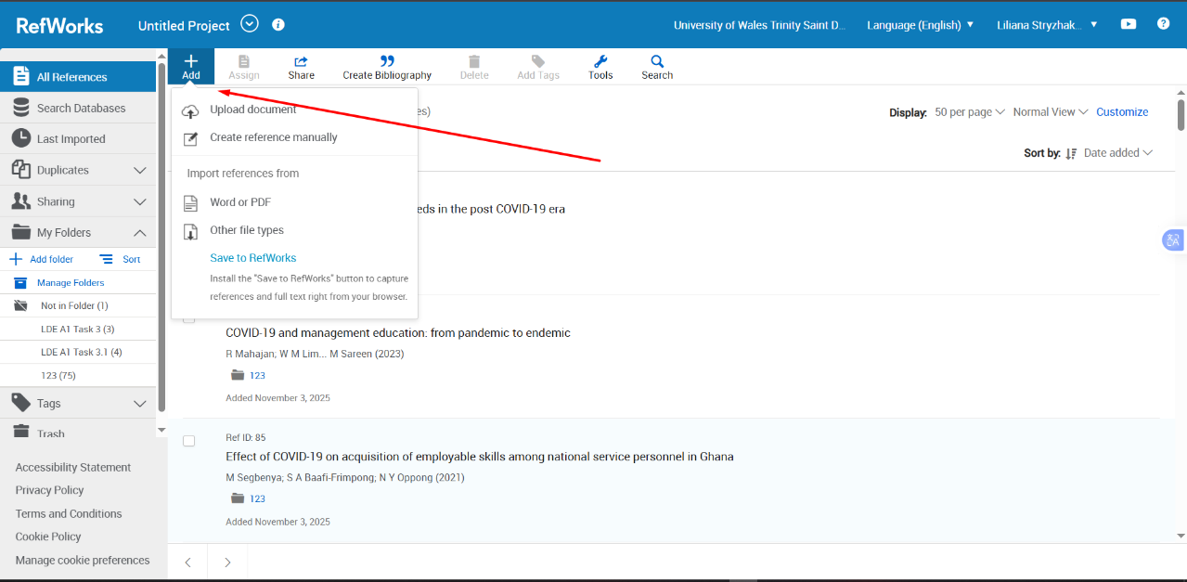
Move references into the appropriate folders by selecting them and clicking “Assign”.
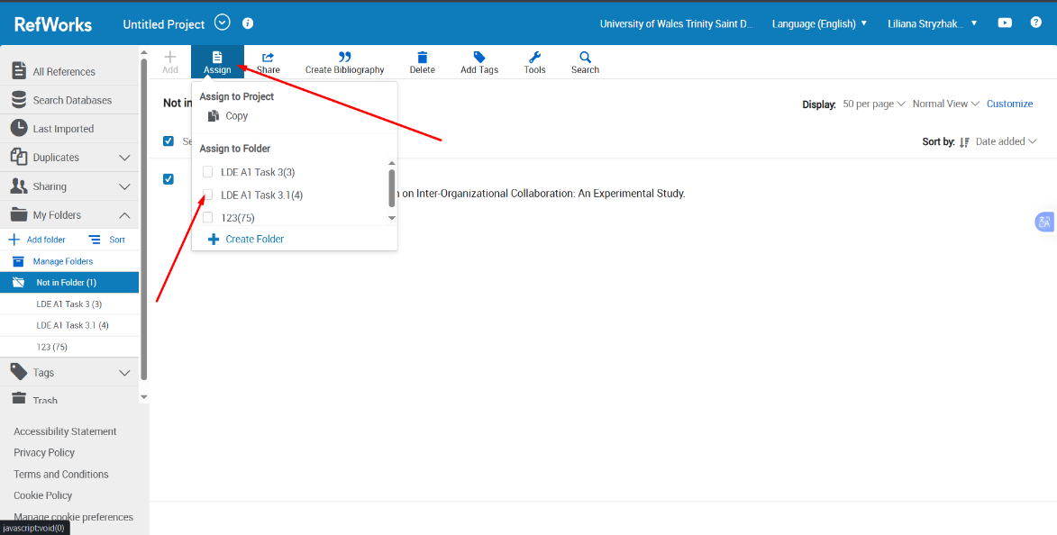

Insert References in Word. Install RefWorks Citation Manager (RCM) for Word. Open your document. Open RefWorks. Sign in to your RefWorks account.
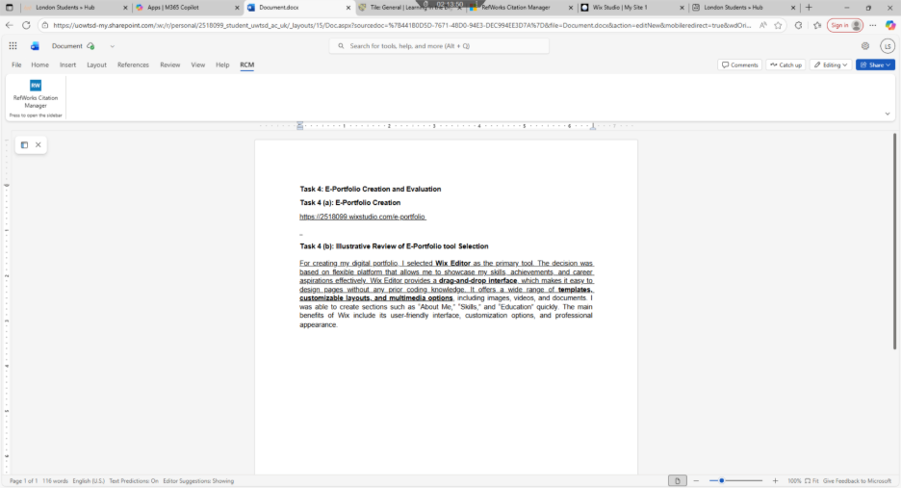

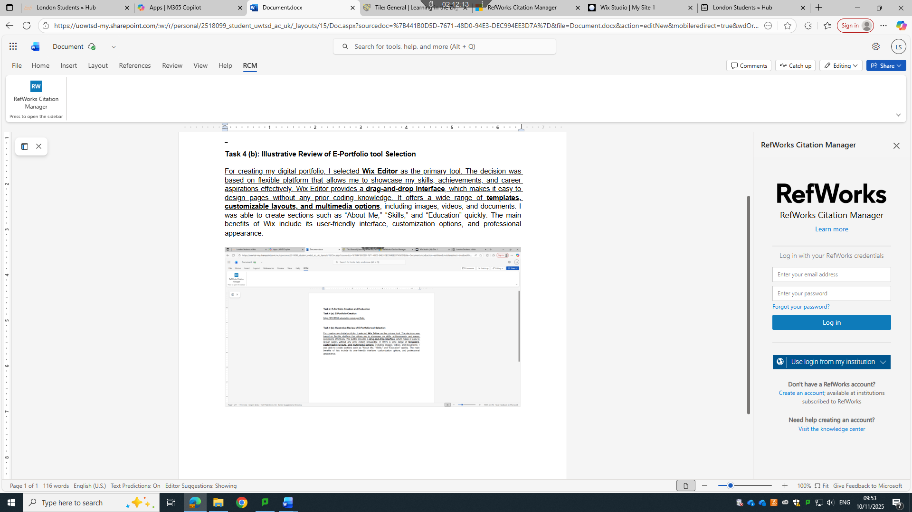

Find the reference you want in your RefWorks library (select a folder). Click “Insert Bibliography” to automatically create a reference list in your chosen style.
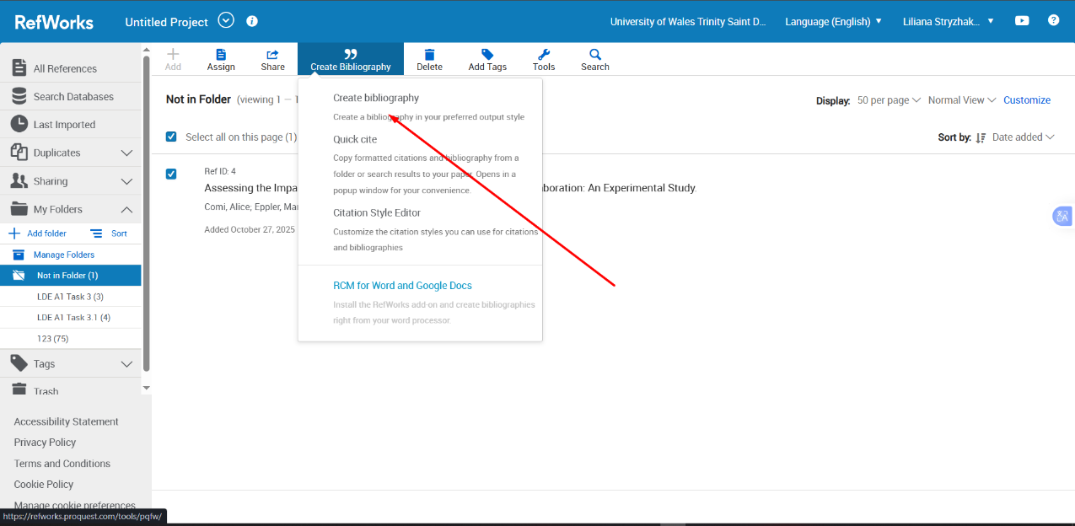

Click to “Copy to Clipboard” into your document.
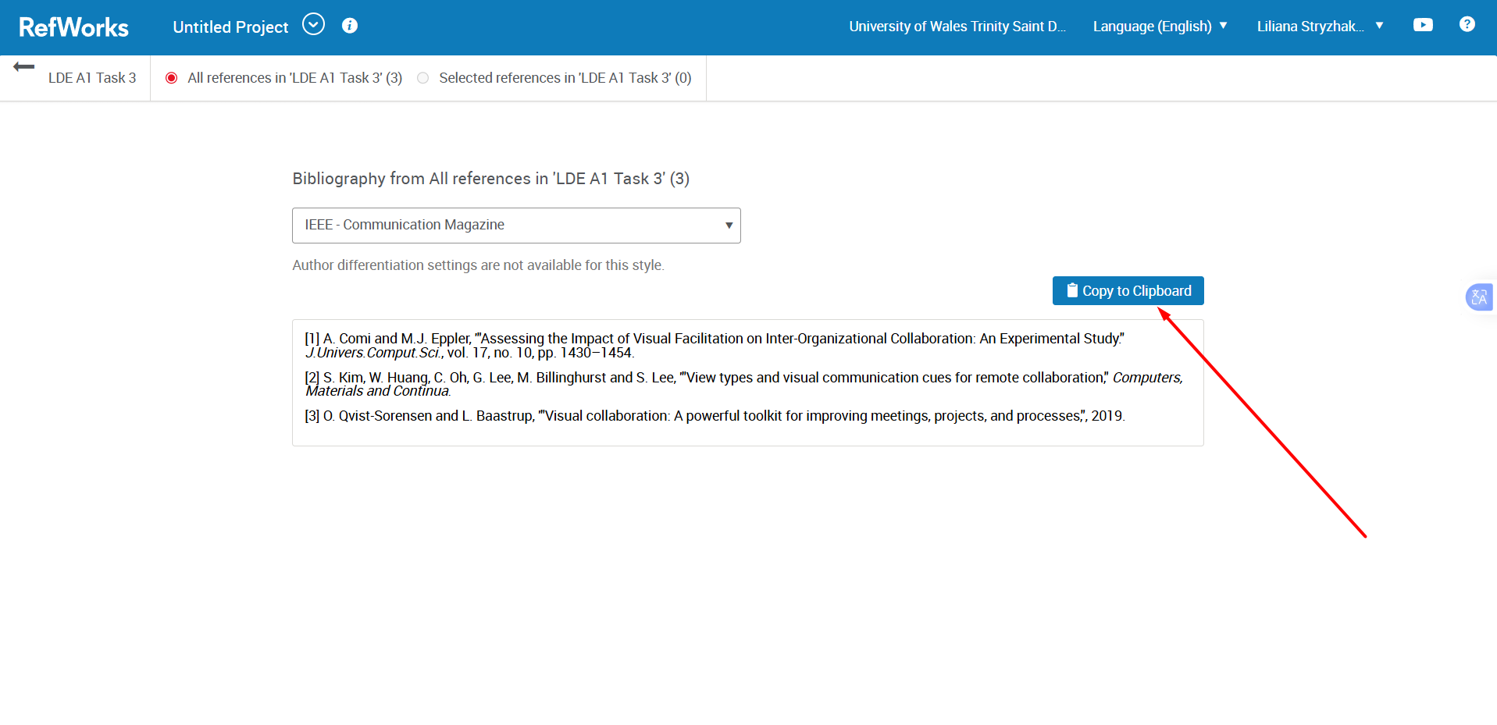
Task 4: E-Portfolio Creation and Evaluation
Task 4 (a): E-Portfolio Creation
https://2518099.wixstudio.com/e-portfolio

Task 4 (b): Illustrative Review of E-Portfolio tool Selection
Creating this portfolio allowed me to bring together all the tasks completed throughout the module and reflect on the skills I developed. Task 1 helped me identify essential academic and employment skills and emphasised the importance of academic integrity through the similarity report. Task 2 strengthened both my teamwork and independent skills through the collaborative mind map and individual poster. Task 3 improved my virtual collaboration abilities and taught me how to use RefWorks for accurate referencing. Task 4 involved organising all my work into an e-portfolio, which I created using Wix for its simple, flexible design.
Overall, compiling these tasks into one portfolio showed my progress in communication, digital literacy, teamwork, organisation, and academic writing. Using Wix helped me present my work clearly and professionally, demonstrating my development and readiness for future academic and professional challenges.

Conclusion
In conclusion, creating a portfolio and using tools like RefWorks has helped me understand the importance of organizing, presenting, and citing information professionally. Developing both academic and employment skills, such as communication, critical thinking, teamwork, and digital literacy, is essential for my future career. Through this process, I have learned how to plan and structure my portfolio, select the right e-portfolio tool, and manage references efficiently. These experiences have not only improved my technical and organizational abilities but also increased my confidence in showcasing my achievements career goals. Overall, these skills and tools will support my ongoing learning and prepare me for success in the professional world.

References
Task 1 References:
[1] (M.A. Haron M. M.)
[2] (Anonymous)
[3] (S. Rosenberg)

Task 3 References:
[1] V. O’Keeffe, R. Jang, K. Manning, R. Trott, S. Howard, A. Hordacre and J. Spoehr, '"Forming a view: a human factors case study of augmented reality collaboration in assembly," Ergonomics, vol. 67, no. 12, pp. 1828–1844.
[2] J. Bertilsson and G. Wentzel, '"Visual planning: Coordination and collaboration of multi-site teams in product development organisations," Chalmers University of Technology.
[3] S. Dawani and G. Loots, '"Doing research together: creating spaces of collaboration with young people using visual methods," Visual Methodologies.
[4] O. Qvist-Sorensen and L. Baastrup, '"Visual collaboration: A powerful toolkit for improving meetings, projects, and processes,", 2019.

