Sustainable Business Revenue Generation Plan

Student name: Andreea Dumitru
Student number: 1705539
Module title: Financial Management for the Hotel Industry. BMIH 5007
Lecturer: Dale Clarke

Table of content

Sustainable Business Revenue Generation Plan 0
Table of content 1
Executive summary 2
1. Introduction 2
2. Findings 3
2.1 Advantages of outsourcing 3
2.2Advantages of Insourcing 5
3. Ethical Responsibility 6
4. Conclusion and Recommendations 9
5. Reference List 10
6. Appendices 13

Executive summary

The purpose of this research is to investigate Accor Hotels' long-term revenue production in light of the possibility of outsourcing the housekeeping department. Following a thorough investigation, this paper will explain the benefits of both outsourcing and insourcing. Lastly, will investigate how the ethical considerations and responsibilities for its employees might affect the housekeeping department, followed by a conclusion and recommendations.

Introduction

It is well-known that the housekeeping department is the second most important in any hotel of any size, having the important role of providing comfort to guests maintaining cleanliness and hygiene, maintaining the privacy of guests, providing safety and security, and having a pleasant décor by creating a pleasant and classy ambience (OverstayTonight,2022).
Finding reliable housekeepers might be tough, and hiring new employees requires a sophisticated hiring procedure and a full HR department to address their demands, which embraces the opportunity of outsourcing this department. The last thing any hotel needs is a shortage of staff in the busiest time, and Accor Hotel is one of the busiest operating in 100 countries throughout the world, with over 5,100 hotels (Accor 2019).
Accor (2019) the largest hospitality company in Europe, is a French global hospitality corporation that owns, operates, and franchises hotels, resorts, and vacation homes having a footprint in other parts of the world, with over 230.000 employees. Accor was founded by Paul Dubrule and Gérard Pélisson on April 22, 1960, and is headquartered in Paris, France (Forbes, 2023).
It is well-known for its superior sustainability, reputation, brand image, guest experience, profits, and customer loyalty, and has fostered innovation, boosted competitiveness and helped solve global issues simply by being engaged in Planet 21 Initiative, eliminating the use of all plastic straws, stirrers and cotton buds (Marketing,2013).
For decades, Accor has pushed limits. Planet 21 shows the Group's ambitious 2020 targets, based on four strategic priorities: engage with workers, involve consumers, innovate with partners, and collaborate with local communities (Accor, 2019).

2. Findings

2.1 Advantages of outsourcing

Large hotels and businesses are increasingly outsourcing professional housekeeping services (Tyagi et al,2015).
A study made in 2015 (Tyagi et al,2015), identified which types of hotels would adopt outsourcing, and it was observed that most starred category hotels outsource housekeeping functions (Tyagi et al, 2015, p. 4328). See Appendix A
Without a doubt, outsourcing helps companies of all sizes cut expenses, boost efficiency, and improve offerings. Figure 1 provides accurate numbers of the main benefits (Tyagi et al, 2015, p 4329).
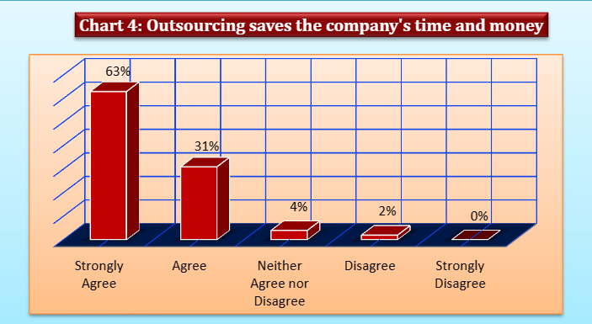
Figure 1 (DocPlayer,2015)

The most important advantage that Accor would benefit from would be saving direct costs on salaries, equipment and supplies, and indirect costs like general administration and internal services. When Accor’s management outsources a department like housekeeping, they can focus on improving things like customer service and expanding marketing. There are many other benefits for Accor to investigate when outsourcing such as enabling the hotel's management cut pay, keep things simple and keep staff flexible. Because of this, Accor can increase profit and run their businesses more efficiently. Outsourcing means that they don't have to go through the trouble of hiring, deal with absenteeism, and make sure they have enough supplies. Many hotels find it easier to manage housekeeping services when they are outsourced, but many also choose to train their staff. (Dixit, 2021).

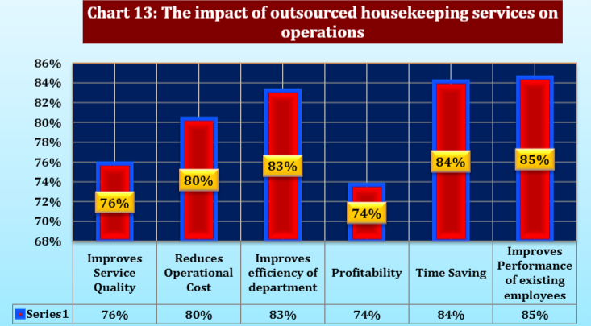
Figure 2 (DocPlayer,2015)

Figure 2 is revealing that outsourcing housekeeping services have a positive impact on operations. A striking fact is although COVID-19 has had a significant negative impact on the hospitality industry, there is still a significant demand for hotel occupancy,
Hospitality Net (2021, p 4) pointed out that over 80% of travellers in the coming year will check hotel health and safety before booking. 93% want hotels to list their safety precautions (Hospitality Net,2021, p.4). See Appendix B
Housekeeping is rarely outsourced since they directly affect the hotel's image and income, however, it is not a written rule, as a result of not having to worry about hiring and training people for housekeeping, outsourcing reduces expenses by at least 25 per cent (Priya,2019).

Advantages of Insourcing

For Accor Hotel, the department of housekeeping is, without a shadow of a doubt, the one that comes in second place behind the front desk in terms of how important it is. Its contribution is huge to the overall reputation of Accor. Strict cleanliness is a requirement that must be fulfilled. Since the rooms account for the majority of a hotel's earnings, housekeeping is a significant priority (Burdo,2018)
Some important advantages of insourcing are:
- help in building talent internally
- internal employees can be promoted, and vacancies can be filled
- the hotel’s procedures and operations can be tailored directly to the business
- higher quality control
- efficient communication between departments
- brand building
- higher task delivery (Janse, 2019).
The role and responsibility of the housekeeping department decide the reputation of the hotel. Accor’s employees are responsible for various jobs and the functioning of the hotel. It's simple to believe that housekeeping merely entails someone arriving to deliver new towels and change the bedding (Burdo,2018). A housekeeper's responsibilities go beyond that. It includes:
- maintaining appliances
- delivering supplies as needed
- maintaining primary communication between the guest and the front desk department
- updating the room status regularly
- coordinating closely with the maintenance and the engineering department
- identifying the maintenance issues that may arise
- Services like laundry and food delivery
- rectification and replacement of any type of issue that the guests encounter
- making sure guests’ stay is comfortable (HOSPITALITY Keynote Speakers,2021).
It is without a doubt that Accor’s guest’s comfort comes first, and the housekeeping department represents its backbone. Accor acquired a competitive edge by paying attention to every element of a good stay. In addition to a clean shower and fresh linen and towels, giving visitors plump, comfy pillows and duvets, functional contemporary equipment, and luxury guest amenities may enhance their experience and distinguish one hotel from another (BUNZL,2018).
Accor (2020) has prioritised guest safety for over fifty years. To safeguard the safety of their guests and workers, they launched a unique cleaning and prevention mark, ALLSAFE (Accor,2020). Bureau Veritas, a global testing, inspection, and certification company, established the ALLSAFE global cleaning and preventive standards. To earn this designation, all Group hotels must follow certain requirements and be audited by Accor operational specialists or Bureau Veritas (Accor, 2020).

Ethical Responsibility

The cornerstone of corporate social responsibility (CSR) is ethical responsibility which is based on doing things in a just and moral way and treating everyone equally in the workplace. although external factors or customer needs may influence ethical goals, businesses frequently set their standards (Fernando,2022).
Although Accor must prioritise employee wellbeing over profit, a less professional aspect is impacting housekeeping workers’ wellbeing, as recent reviews on Indeed (2023), indicate that they are dissatisfied and would not advise this employment at this hotel, criticising the management for being ineffective and the training and software for being outdated. (Indeed,2023) See Figure 3
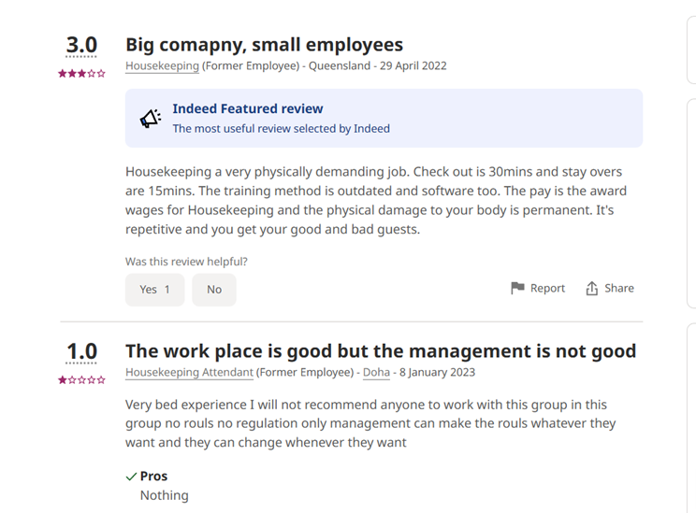
Figure 3 (Indeed,2023)

Many others reported that they were forced to spend only 20 minutes in each room on extra tasks, such as moving heavy bed mattresses, and that they would not be paid if the tasks were not finished within the allotted time. Other employees reported they felt they were given easy jobs while others were given difficult ones, and they were not treated equally (Indeed,2022).
It is undeniable that this has a significant impact on the life cycle of the employee and that it highlights the primary reason for Accor's outsourcing of housekeeping because when employees are inspired, motivated, and encouraged at work, they are more productive, and their employment is much less stressful on their overall health and well-being, which sadly, is not applicable for Accor (Wygert, 2020).
Accor is one of the busiest hotels and with urgent business demands, employees with high workloads often fret about the task being delivered on time. They sacrifice quality for time and worry about their results. Helplessness, uncertainty, and burnout rule out such situations. If Accor were more concerned with its workers' mental health on the job, it might reduce workplace stress by improving task clarity and creating a more encouraging atmosphere (Marinaki, 2023).
The table below clearly demonstrated that overwork itself might induce professional burnout. Burnout is usually treated by working less, taking a break or using a sick day to survive (Wygert, 2020). It is not only the number of hours spent, but it is also how they are handled, and the experience gained.
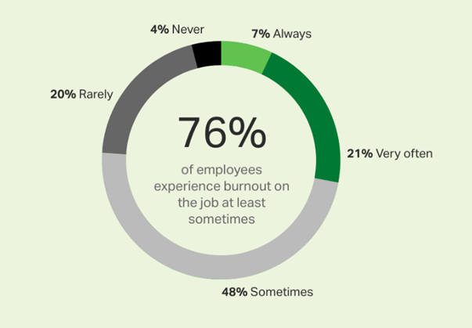
Figure 4(Gallup,2020)
CIPD (2022), argues that investing in employee well-being may improve resilience, engagement, productivity, and illness absence (CIPD,2022). Well-being programmes fail because they are disconnected from a daily business providing a great opportunity for Accor to outsource.
Accor will be dependent on its CSR since it has the potential to increase long-term profits; as a result, the company's standards will most likely be extended to significant outsourced providers (Gentinetta, 2023).
Choosing the correct vendor should not be difficult for Accor because all it must do is concentrate on a few qualities like reputation, experience, competence, and cost-effectiveness to make the responsible decision. Certainly, reputation matter and Accor need to choose a vendor with a good reputation in the market which can be done easily through referrals (Goswami, 2022).
The longer a company has been in business, the more it can be trusted, however, Accor needs to focus on making sure that the vendor chosen has both experience and a good reputation, and a high level of expertise. This will make sure that all the hotel’s needs are met, such as the timeline, payment, and legal steps (Goswami,2022).

Conclusion and Recommendations

Although there is no evidence that Accor is outsourcing the housekeeping department, this research, highlighted with certainty that the approach of outsourcing is a useful tool for Accor, as offers the management and department a multitude of advantages like reducing the recruitment time, enhancing qualitative profit and boosting the hotel’s efficiency. Companies like Accor, that help customers are more likely to be valued than those that produce great items (Fernando,2022).
It would be highly recommended for Accor to use WGC, which is the UK's premier multi-service business, offering outsourced facilities and workplace management, hotel housekeeping, and contract cleaning to the world's finest hotels, brands, and employers since 1974, and it meets all the requirements. Hiring WGC to do the housework could be the start of a new partnership. It Is a big decision for Accor but also could be the right one (WGC, 2023).
Because the hotel is open around the clock, departments must collaborate to deliver excellent guest service for this operation to succeed. Hotel guests should not see what happens behind the scenes to ensure a nice stay and return. Outsourcing is all about saving Accor’s hard-earned money, so it needs to focus on that it gets what is paying for, and that its quotes fit its budget (Goswami, 2022).
In a globally competitive environment, Accor must always cut costs and improve processes to make the profit and returns that shareholders expect. In the end, Accor’s success depends on placing heads in beds and giving a pleasurable experience and it can be done without the guests having to acknowledge or approve (Phillis, 2017).

Reference List

Accor. (2019) Discover our brands. Available at: https://all.accor.com/brands/index.en.shtml (Accessed:7 March 2023).
Accor. (2019) WITH PLANET 21, ACCOR AIMS TO PROVIDE A POSITIVE HOSPITALITY EXPERIENCE. Available at: https://all.accor.com/gb/sustainable-development/index.shtml (Accessed: 21 February 2023).
Accor. (2020) Ethics and Corporate Social Responsibility Charter. Available at: file:///C:/Users/ANDREE~1/AppData/Local/Temp/MicrosoftEdgeDownloads/abf45b7a-13f5-434e-bab7-261895269e39/ACCOR_Ethics_and_Corporate_Social_Responsibility_Charter_20_ENG.pdf (Accessed: 21 February 2023).
Accor. (2020) Some of the most stringent cleaning standards & operational protocols in the world of hospitality. Available at: https://group.accor.com/en/Actualites/2020/05/allsafe-cleanliness-prevention-label (Accessed: 13 February 2023).
Accor. (2022) Commitment. Available at: https://group.accor.com/en/commitment (Accessed: 21 February 2023).
BUNZL. (2018) Hotel hospitality: The importance of excellent housekeeping. Available at: https://www.bunzlcatering.co.uk/hotel-hospitality-the-importance-of-excellent-housekeeping/ (Accessed: 13 February 2023).
Burdo, H. (2018) Importance of Housekeeping in the Hotel Industry. Available at: https://bizfluent.com/about-5553465-importance-housekeeping-hotel-industry.html (Accessed: 13 February 2023).
Burt, V. (2012) ‘Hotel Management Pros, and cons of outsourcing housekeeping’. HospitalityEducators.com. Available at: http://www.hospitalityeducators.com/articles/20121015_10#.Y-ujbcfP0eM (Accessed: 14 February 2023).
Calbone, A. (2019) ‘The pros and cons of outsourcing housekeeping positions’, Hospitality Lawyer. Available at: https://hospitalitylawyer.com/wp-content/uploads/2019/01/Whether-to-outsource-housekeeping-positions.pdf (Accessed: 21 February 2023).
CIPD. (2022) Wellbeing at work. Available at: https://www.cipd.co.uk/knowledge/culture/well-being/factsheet#19510 (Accessed: 22 February 2023).
Dixit, A. (2021) ‘Rare Hospitality’, What are Benefits of Outsourcing Housekeeping Services in The Hotel And Hospitality Industries. Available at: https://www.raregrp.com/what-are-benefits-of-outsourcing-housekeeping-services-in-the-hotel-and-hospitality-industries/#:~:text=What%20are%20Benefits%20Of%20Outsourcing%20Housekeeping%20Services%20In,3%20Advantages%20of%20Hotels%20Outsourcing%20Housekeeping%20Services%3A%20 (Accessed: 13 February 2023).
Fernando, J. (2022) Corporate Social Responsibility (CSR) Explained with Examples. Available at: https://www.investopedia.com/terms/c/corp-social-responsibility.asp (Accessed: 9 March).
Forbes. (2023) Accor. Available at: https://www.forbes.com/companies/accor/?sh=2f4c868a5f47 (Accessed: 21 February 2023).
Gentinetta, J. (2023) 11 Examples of CSR practices in the hospitality industry. Available at: https://hospitalityinsights.ehl.edu/csr-practices-hospitality-industry (Accessed: 21 February 2023).
Goswami, S. (2022) Outsourcing Your Hotel Housekeeping: The Ultimate Guide for Hoteliers. Available at: https://www.ezeeabsolute.com/blog/outsourcing-hotel-housekeeping/ (Accessed: 21 February 2023).
Hospitality Net. (2021) The New Landscape of Housekeeping and Hygiene: Communications and Protocols are Key to Gain Travellers’ Confidence. Available at: https://www.hospitalitynet.org/file/152008969.pdf?v=2. Pdf (Accessed: 13 February 2023).
HOSPITALITY Keynote Speakers. (2021) WHAT IS THE HOUSEKEEPING DEPARTMENT - What are the main roles in this unique support department? [video]. Available at: https://www.youtube.com/watch?v=USBgspRmaWs (Accessed;9 March 2023).
Indeed. (2023) Accor Employee Reviews for Housekeeper. Available at: https://au.indeed.com/cmp/Accor/reviews?fcountry=ALL&fjobtitle=Housekeeper (Accessed 22 February 2023).
Janse, B. (2019) What is Insourcing? Definition, Benefits & Advantages and More. Available at https://www.toolshero.com/management/insourcing/ (Accessed: 10 March 2023).
Marinaki, A. (2023) ‘Employee wellbeing: Caring for your people’, Workable. Available at: https://resources.workable.com/stories-and-insights/employee-wellbeing-caring-for-your-people#obstacles-to-sustaining-wellbeing-at-work (Accessed: 22 February 2023).
Marketing. (2013) CSR INITIATIVES OF ACCOR GROUP OF HOTELS. Available at: https://myassignmenthelp.info/assignments/csr-initiatives-accor-group-hotels/ (Accessed: 21 February 2023).
Openkey. (2018) ‘Openkey’, Outsourcing Hotel Operations, Advantages and Disadvantages, 22 February. Available at: https://www.openkey.co/2018/02/22/outsourcing-hotel-operations-advantages-and-disadvantages/ (Accessed: 14 February 2023).
OverstayTonight. (2022) Hotel Housekeeping: Importance, Functions, Types of Rooms. Available at: https://www.overstaytonight.com/hotel-housekeeping/ (Accessed: 21 February 2023).
Phillis, C. (2017) The Operation of Hotels. Available at: https://bizfluent.com/info-7853853-operation-hotels.html (Accessed: 13 February 2023).
Priya, P. (2019)’ Pros and Cons of Outsourcing Hotel Operations!’, cyfuture. Available at: https://cyfuture.com/blog/pros-and-cons-of-outsourcing-hotel-operations/ (Accessed:7 March 2023).
Tyagi et al. (2015) ‘Outsourcing: A study on Benefits to Housekeeping Department in Hotels’, DocPlayer, 2(11), pp. 4325-4335. Available at: https://docplayer.net/19237789-Outsourcing-a-study-on-benefits-to-housekeeping-department-in-hotels.html (Accessed: 21 February 2023).
WGC. (2023) Outsourced Housekeeping. Available at: https://www.wgc.ltd.uk/welcome/services_housekeeping.php (Accessed: 21 February 2023).
Wygert, B. (2020) ‘Employee Burnout: The Biggest Myth’, Gallup. Available at: https://www.gallup.com/workplace/288539/employee-burnout-biggest-myth.aspx (Accessed: 22 February 2023).

Appendices

Appendix A
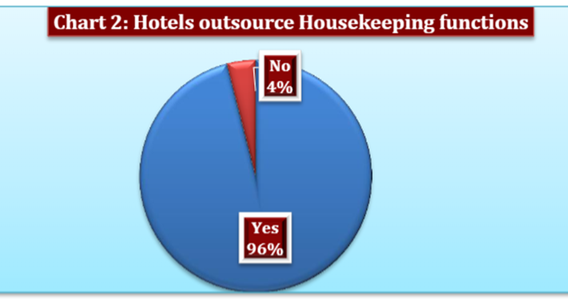

Appendix B


