BENG-Manufacturing Systems Engineering
Optimising throughput on a machining line through discrete event simulation
Ford Cooper (P148308)
Fcooper.148308@student.awtsdac.uk
Abstract
This dissertation reviews the ongoing concern regarding low throughput scores being achieved on AJ-Block machining line which is resulting in targets not being met. In order to improve end of line jobs per hour, a simulation study on the line has been proposed. This study will look to identify the top three constraints then propose various altercations which can be made to the system in order to break these bottleneck areas. In order to carry out a simulation study, base data is collected either manually or from POSmon, and analysed to be imported into the created base model used to represent AJ-Block line. This dissertation is presented using a DMAIC approach. Within the Define phase, it can be seen how big of scale the line underachieving as well is as the customers of which who are effected. The measurement stage compiles all the collected base data which is collected in order to be inputted into a created simulation model. The analysis stage shows the creation of the base model used to represent AJ-Block line along with the top three cyclic and operational constraints which are being encountered. The improvement phase details various experiments which have been run in order to improve JPH scores within the top three constraints, then providing a suggestion into what should be implemented in order to achieve a greater throughput. In the control phase key areas of which need to be kept constant are recognised in order to maintain an improved EoL JPH score.

DECLARATION OF AUTHENTICITY
This thesis is the result of the authors’ original research. It has been composed by the author and has not been previously submitted for examination which has led to the award of a degree.
Print: F.L.Cooper
Signed:
Student Number: P148308
Date:

Acknowledgements
This dissertation is being submitted in order to achieve a Bachelor’s Degree in Manufacturing Systems Engineering. I wish to acknowledge input of various individuals who helped in the completion of this project.
I begin by thanking Ford Bridgend Engine Plant for providing me with the resources necessary in order for this study to be achieved. I would like to thank the Industrial Engineering department within Bridgend (Dai Canfield, Dan Doherty and Garry Lewis) who supported data collection and analysis.
A sincere thanks must be given to the Ford Simulation department located in Dunton (Michael Higgins, Garg Ankush and John Ladbrook), who trained me to use the tool and also gave constant aid in the development of the project.
Finally, I wish to thank the lecturers and supporting staff (Richard Morgan) at the University of Wales Trinity St David for tutorials and continued support.

Table of Contents
1 DECLARATION OF AUTHENTICITY 1
2 Acknowledgements 2
4 Table of Figures 5
5 Acronyms and Abbreviations 7
6 Timescale and Revised Work plan 8
7 Model and Methodology 9
8 Ford Motor Company Background 10
8.1 Ford – UK – Bridgend 10
9 General Introduction 11
10 Research/ Literature Survey 12
10.1 Introduction to Simulation 12
10.1.1 Definition of Simulation 12
10.1.2 Discrete Event Simulation 12
10.1.3 DES Example 12
10.1.4 Benefits of Discrete Event Simulation 13
10.2 Simulation within Automotive Industry 13
10.2.1 Simulation Packages 14
10.3 Current Application of Simulation within Ford Bridgend Engine Plant 15
10.3.1 Ford Alternative Simulation Tool (FAST) 15
10.3.2 Command Generator 15
10.3.3 Machine Breakdown Analysis Tool 16
10.3.4 Verification 17
10.3.5 Validation 18
10.4 Automotive Machining Line 21
10.4.1 Terminology 21
10.4.2 AJ-Block Machining Line 22
10.5 Theory of Constraints 23
11 Define 24
11.1 Problem Statement 24
11.1.1 Current Trend 24
11.2 SIPOC (Supplier, Input, Process, Output, Customer) 25
11.2.1 Process Map 26
11.3 Goal Statement 28
11.4 Objectives 28
11.5 VOC – Voice of Customer 29
11.5.1 AJ-Block Machining Line Flow Chart 29
11.5.2 Internal Customers 29
11.5.3 External Customers 29
11.5.4 Voice of Customer (VOC) Statement 30
11.5.5 Critical To Quality (CTQ) 30
11.6 Cause and Effect Diagram 31
11.6.1 5 Whys 32
11.7 Project Charter 33
12 Measure 34
12.1 Data Collection Plan 34
12.2 Data Type 35
12.3 Base Data 36
12.4 Collection of Base Data 37
12.4.1 Machine Cycle Time 37
12.4.2 Equipment Fault Detail 40
12.4.3 Actual Job per Hour Score 43
12.4.4 Tooling 44
12.4.5 Scrap 45
13 Analyse 47
13.1 Creation of the Base Model 47
13.1.1 Assumptions 49
13.2 Simulation Results 50
13.2.1 H-Chart 50
13.2.2 Summary 51
13.2.3 Simulation Cyclic Bottleneck Analysis 52
13.2.4 Simulation Operational Bottleneck Analysis 53
13.2.5 Statistical analysis 54
14 Improve 55
14.1 Base Tests 55
14.1.1 Cyclic Without Gantry Losses 55
14.1.2 Target Time 55
14.2 Constraint Tests 56
14.3 Braking First Constraint (Operation 140 Honer Fully Flexible) 56
14.3.1 Result 57
14.4 Breaking Second Constraint (Operation 70 Machine Front & Rear End Faces Gantry Reinstatement) 58
14.4.1 Result 60
14.5 Test Three (Operation 160 Wash Cycle Time) 60
14.5.1 Result 60
14.6 Test Four (Multiple Test Simulation) 61
14.6.1 Result 61
14.6.2 Cost Saving 62
14.6.3 H-Chart 63
14.7 Improvement Validation 64
15 Control 65
15.1 Strategy 65
15.1.1 Scheduled Simulation 65
15.1.2 Automatic Data Collection 65
16 Conclusion 66
16.1 Future Experiments 67
17 References 69
18 Appendices 71

Table of Figures
[Table 1: Set out work plan for dissertation]
[Table 2: Former and Current Products Manufactured in BEP] Ford UK (2019)
[Table 3: Benefits of Simulation in industry] Made Smarter (2017)
[Table 4: The JPH score recorded for AJ-Block machining in 2017]
[Table 5: Operations carried out on an engine block on AJ machining line]
[Table 6: Historic POSmon cycle time of operations]
[Table 7: The distributions created and used within the simulation model]
[Table 8: The JPH score lifted from shift reports for AJ-Block machining]
[Table 9: Raw scrappage values of AJ-Block line]
[Table 10: The results summary of the simulation on AJ-Block line]
[Table 11: The cyclic JPH results from the simulation]
[Table 12: Operational JPH results from the simulation]
[Table 13: Cyclic simulation model results without gantry losses]
[Table 14: Operational simulation model results for fully flex Op140]
[Table 15: Operational simulation model results with target cycle times]
[Table 16: A summary of basic simulation tests for Op140]
[Table 17: Operational simulation model results for fully flex Op140]
[Table 18: A summary of basic simulation tests for Op70]
[Table 19: Operational simulation model results for fully flex Op140]
[Table 20: Operational simulation model results for fully flex Op140]
[Table 21: Operational simulation model results for fully flex Op140]
[Table 22: A summary of basic simulation tests for Op160]
[Table 23: Operational simulation model results for fully flex Op140]
[Table 24: Operational simulation model results for fully flex Op140]
[Table 25: The tooling life for AJ-Block machining]
[Figure 1: Set out work plan for dissertation]
[Figure 2: An example of discrete event simulation of an airport arrival and departure]
[Figure 3: The popularity of various simulation packages]
[Figure 4: The FAST interface home screen]
[Figure 5: The command generator interface]
[Figure 6: The machine breakdown analysis tool interface]
[Figure 7: Sequence of steps proposed for simulation] Leal (2011)
[Figure 8: An example of a Ford H-Chart]
[Figure 9: Layout of AJ-Block Machining line]
[Figure 10: Current process which is undertaken by an engine block on AJ machining line]
[Figure 11: AJ-Block machining line flow chart]
[Figure 12: Cause and Effect of not hitting target on AJ-Block machining]
[Figure 13: Flowchart of input data for a simulation model]
[Figure 14: Example of the cycle time report which is produced by POSmon]
[Figure 15: An example of an equipment fault detail report]
[Figure 16: A snapshot of the model used to represent AJ-Block Line]
[Figure 17: The statistical analysis of AJ-Block line generated by Witness]
[Figure 18: A pie chart for the statistical analysis of Op160 Wash]
[Figure 19: Derivative constraints surrounding Operation 140 Honers]
[Figure 20: An I-Gantry (Single Mast)]
[Figure 21: An H-Gantry (Double Mast)]
[Graph 1: Illustration of the JPH score recorded for AJ-Block machining in 2017]
[Graph 2: Showing the actual daily JPH score recorded from shift reports]
[Graph 3: The H-chart comparison of simulation to actual data sets]
[Graph 4: The cyclic bottleneck analysis of AJ-Block line]
[Graph 5: The operational bottleneck analysis of AJ-Block line]
[Graph 6: The H-chart comparison of simulation to actual data sets]
[Graph 7: The JPH score recorded for AJ-Block machining in 2018]

Acronyms and Abbreviations
BEP - Bridgend Engine Plant
CNC - Computer Numeric Control
DES - Discrete Event Simulation
EoL - End of Line
FAST - Ford Alternative Simulation Tool
FIS - Factory Information System
FTT - First Time Through
IDT - Industrial Digital Technology
JLR - Jaguar Land Rover
JPH - Jobs per Hour
MCT - Machine Cycle Time
MODAPTs - MODular Arrangement of Predetermined Time Standards
MP&L - Material Planning & Logistics
MTBF - Mean Time between Failures
MTTR - Mean Time to Repair
OEE - Overall Equipment Efficiency
PAG - Premier Automotive Group
PFS - Plant Floor Systems
PLC - Programmable Logic Controller
POSmon - Position Operating System
WCL - Witness Command Language

Timescale and Revised Work plan
The authors final work plan is represented in [Figure 1]. It can be seen that the structure of the project was identified in order to ensure all tasks were to be carried out within an allotted timescale. An original work plan was created in order to divide the project into smaller manageable tasks, then throughout the work process regular amendments were made in order to improve forecasted completion dates.
Week Number | Task Description
1 | Problem Formulation
2 | Set Objectives
5 | Plan
N/A | Model
N/A | Collection of Data
6 | Create Simulation Model
9 | Verification
10 | Validation
11 | Experimental Design
14 | Production Run & Analysis
15 | Documentation
16 | Update
[Table 1: Set out work plan for dissertation]
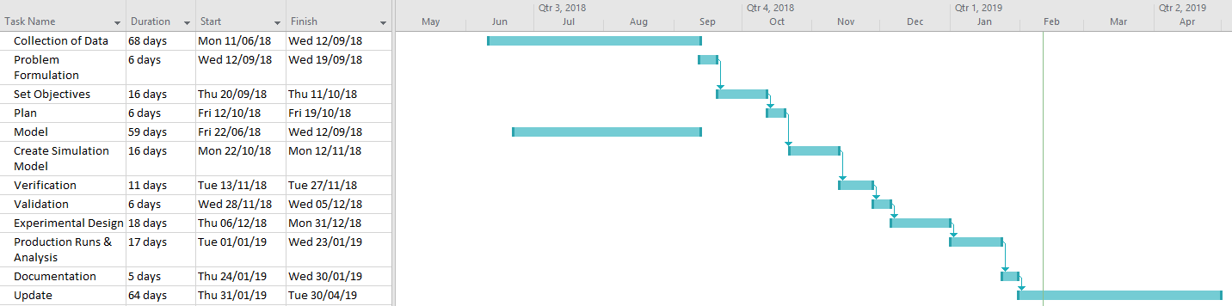
[Figure 1: Set out work plan for dissertation]

Model and Methodology
This dissertation looks at improving the current machining process adopted by AJ-Block machining to increase throughput by adopting a Six Sigma DMAIC approach.
Six sigma is a systematic, highly disciplined, customer-centric and profit driven organization-wide strategic business initiative, which is based on process-focused and measurement driven methodology, Tang (2007). According to Markarian (2004), Six Sigma is a methodology/philosophy used to better improve quality by analysis data with statistics in order to find the root cause of quality problems and to implement controls. The method used on a Six Sigma project is a DMAIC (define, measure, analyse, improve and control) process.
DMAIC is a problem solving process which drives the lean Six Sigma methodology. DMAIC consists of five phases, according to Ford Motor Company (2002) these include:
- Define – The purpose of the define phase is to refine the project teams understanding of the problem to be addressed. The define phase sets the foundation for the success of the Six-Sigma project. Within the define phase customers are recognised as well as their needs and expectations. In this phase the team is organised with roles and responsibilities being decided.
- Measure – The purpose of the measure phase is to establish techniques for collecting data about current performance that highlights project opportunities, and provides a structure for monitoring subsequent improvements. Within this stage various forms of data will be gathered which include cycle times, defect types and frequency of defects.
Upon completion of the measure phase, project teams will have:
  - Plan for collecting data that specifies the data type and collection technique
  - Validated measurement system that ensures accuracy and consistency
  - Sufficient sample of data for analysis
  - Set of preliminary analysis results that provides project direction
  - Baseline measurement of current performance
- Analyse – As an outcome of the measure phase, the project team will narrow the focus to a distinct group of project issues and opportunities. The purpose of the stage is to allow the team to further target improvement opportunities.
Upon completion of the analysis phase, certain questions should be answered:
  - Approach to analysing data
  - What is the improvement opportunity
  - What was the root causes contributing to the improvement opportunity
  - Did analysis result in any changes to the problem statement/scope
- Improve – As an outcome of the analysis phase, the project team should have a strong understanding of the factors impacting the project. The purpose of the improve phase is to:
  - Generate ideas regarding ways to improve the process
  - Design and pilot improvements
  - Validate improvements
  - Implement improvements
- Control phase – The purpose of the control phase is to institutionalise process improvements. At the completion of the control phase the process owner will understand:
  - Customer process/product performance expectations
  - How to measure and monitor Xs to ensure the performance of Y
  - The corrective actions that should be taken if the process is no longer in control.

Ford Motor Company Background
Ford Motor Company began operation on July, 9, 1919. It is a global automotive and mobility company. Fords main business include designing, manufacturing, marketing and servicing a line of Ford vehicles which include cars, trucks and sport utility vehicles (SUV) as well as Lincoln Motors. The company was founded by Henry Ford on June, 16, 1903. The company manufactures and distributes vehicles across six continents with roughly 166,000 employees and 65 plants worldwide, Ford (2019).

Ford – UK – Bridgend
BEP is an important part of Ford Motor Company with an output which exceeds 1.5 million engines when combined with Dagenham Engine Plant (DEP) in 2013, Wales Online (2013). According to Ford UK (2019), BEP was opened in 1980 with a plant size of 1,525,320 square feet. The plant currently employs approximately 2,130 staff or hourly paid personnel. Within BEP there are various machining and assembly lines present. The current lines located in BEP do not only build engines for Ford but also for Jaguar & Land Rover and previously, Volvo. BEP has built a variety of engines which include:
[Table 2: Former and Current Products Manufactured in BEP] Ford UK (2019)
Engine | Model
1.25 L 4-cyl. | Fiesta
1.4 L 4-Cyl. | Fiesta, B-Max
1.6 L Ti-VCT | Fiesta, B-Max, Focus, C-Max, Grand C-Max, Mondeo
1.6 L Ecoboost | C-Max, Grand C-Max, Mondeo, S-Max, Galaxy
1.5 L Ecoboost | Fiesta ST
PAG 3.2L SI6 | Volvo
AJ133 5.0L V8 | Jaguar & Land Rover
AJ126 3.2L V6 | Jaguar & Land Rover

General Introduction
Computer based Discrete Event Simulation is one of the most commonly used aids for the design of automotive manufacturing systems. The use of discrete event simulation differs in each industry, the purpose of this dissertation is to illustrate the benefits of applying DES to an automotive industry in the context of locating bottlenecks and suggesting/ proving methods of improving throughput. The significance of throughput within a manufacturing business cannot be understated. This dissertation will explore methods of refining operations in order to maximise jobs per hour (JPH) to hit target scores. The benefits of using simulation within industry will be explored in conjunction to benefits Ford will also obtain from utilising the tool.
This dissertation puts detailed focus on the AJ machining block line within BEP which is currently underachieving and not hitting target JPH scores. There are currently two AJ machining lines producing both the AJ133 and AJ126 head and block.
In order to identify these bottleneck areas, a large amount of data must first be collected and analysed. This data will be used within a DES model created by the author, which will replicate the current production line found on the shop floor. The model will be used to produce sets of results which can be studied in order to locate bottlenecks and suggest improvement. These improvements can be costed with potential cost savings derived from their implementation.
A DMAIC approach will be used by the author in this dissertation in order to show a structured view of how to achieve the main goal, using this problem solving method.

Research/ Literature Survey

Introduction to Simulation

Definition of Simulation
Before conversing on how Discrete Event Simulation (DES) is used with Ford BEP, it is vital to first understand what is meant by the term simulation. Simulation is a tool used to aid decision making within a manufacturing industry. According to Arsham (1996), simulation can be defined as ‘a tool which is used to better understand performance or reliability of systems but also used to verify correctness of designs’. Simulation models are a concept design of a real-world or projected real world system. The models can contain every aspect of the system under analysis or just enough data to satisfy the scope of the suggested project. Robinson (2010), supports this by explaining, simulation models in a manufacturing industry may include every partner present in the supply chain but only contain minimal detail on each person, and this may be due to insufficient data available or because the scope of the project is being fulfilled without this data present.

Discrete Event Simulation
Discrete Event Simulation is a form of simulation used within manufacturing industries, it can be described as the process of coding the specific behaviour of a complex system as an ordered sequence of defined events, which include specific changes such as, a systems’ change in state, that occur over time. DES can be described as the ability to create a representation of reality in the form of a computer based model, in order to understand how a system functions and establish the effect inputting a change has on the system, Ladbrook (2004). Within DES, objects are inputted in to the simulation as independent entities with each object having its own set of associated data. Within manufacturing the parameters of this data could represent breakdowns or cycle times of machinery. DES is not an emulation of the system, meaning it is not an exact reproduction of the system with its inherent functions and logic, as this would create too much detail which would hinder the models run speed. Instead, DES involves the generation of an artificial history of the system and the observation of that artificial history to draw inferences concerning the characteristics of the real system being represented, Higgins (2014).

DES Example
A common example used to illustrate discrete event simulation can be seen in the form of a plane arriving, landing and departing from an airport.
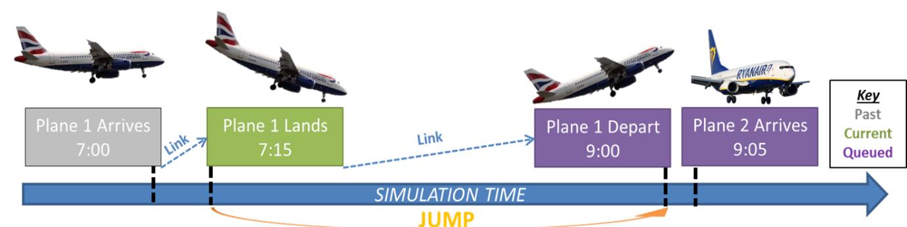
[Figure 2: An example of discrete event simulation of an airport arrival and departure]
It can be seen that the events which have been modelled are, plane one arriving, plane one landing, plane one departing and plane two arriving. Each of these events has been stamped on a simulated time line, with the simulation jumping from event to event, it being noted that DES assumes no change in the system between events. The current task being plane one landing, then the simulation will jump to the future task of plane one departing.

Benefits of Discrete Event Simulation
Within the manufacturing industry there have been many applications of Industrial Digital Technologies (IDTs) such as simulation in not only the improvement of current systems but also forward planning for future changes. According to a Made Smarter review, ‘there is an overwhelming evidence-based consensus that industrial digital technologies can provide a step-change in industrial productivity’. In general, simulation is used as a tool to assist decision making within BEP but can aid tasks such as quantifying system throughput (JPH), identifying system bottlenecks and also understanding the flow of the line prior to committing funds to a project. The uses of simulation in business are varied and it is often utilized when conducting experiments on a real system is impossible or impractical, often because of cost or time. The ability to analyse the model as it dynamically progresses, sets simulation modelling apart from other methods, such as those using Excel forecasting or linear programming. The benefits of IDTs such as simulation can summarised below:
[Table 3: Benefits of Simulation in industry] Made Smarter (2017)
Direct Benefits | Indirect Benefits
- Improved forecast of future business performance  - Avoids disturbance to real system  - Reduced risk of failure on implementation | - Increased labour and resource productivity  - Increased asset utilisation due to reduced machine downtime  - Encourages data collection  - Increase of communication between departments

These findings are also backed up by Cisco, a specialist in digital manufacturing, who believe IDTs can improve overall equipment effectiveness (availability, performance and quality), with studies showing 60% of adopters of IDTs, akin to simulation, received a boost in productivity.

Simulation within Automotive Industry
Large global automotive manufacturers such as Ford, Nissan, Volvo and Toyota are utilising DES as a simulation tool within their business. According to Camillo (2017), Managers at Nissan Motor Iberica, have reported to have benefited from DES in the design process of an assembly line. Project Managers at Nissan Europe optimised NV200 van production at plant level by simulation, to determine the most efficient layout of each assembly line. Discrete event is now a standard tool used in the design and implementation of many automotive manufacturing systems such as machining or assembly lines. According to Faget (2005), Volvo has utilised DES in the decision making process in their distribution and processing facilities, as well as manufacturing facilities. Objectives for using discrete event simulation can vary, according to Jayaraman (1997), include:
- System throughput determination
- Bottleneck detection
- Manpower allocation and optimization
- Comparing operating philosophies
- Logistics system design and analysis
- Optimising shift patterns
- Material handing designs

Simulation Packages
Ford utilises the Witness software package supplied by Lanner to construct simulations of assembly and machining lines. According to Lanner (2018), ‘Witness can provide a simulation of your business model providing certainty and foresight into your operational plans to ensure smart decisions are made.’ There are a variety of other simulation packages available to companies across the manufacturing sector. Other discrete event simulation package providers include companies such as Siemens, Rockwell or Simul8. These companies provide a DES software product which can be used to simulate experiments and carry out throughput optimization. A study carried out by Dias (2016), compared a variety of different simulation packages on the popularity from different sources and sectors shown in [Figure 3].
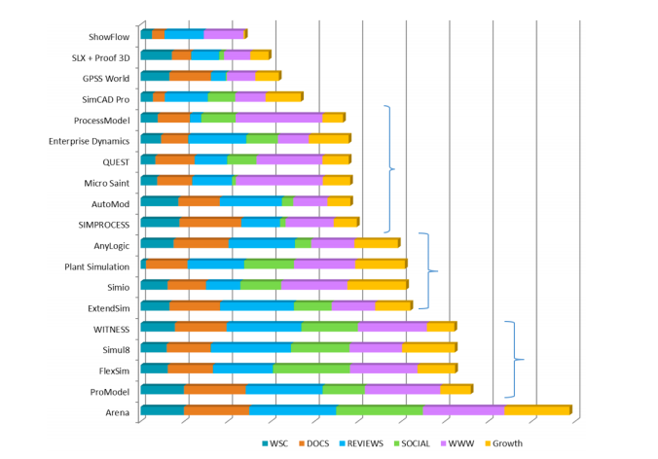
[Figure 3: The popularity of various simulation packages]
It can be seen that there are various versions of simulation packages available to the manufacturing sector with some software being more popular than certain companies to others, suggesting that certain packages have advantages.

Current Application of Simulation within Ford Bridgend Engine Plant
There are a variety of simulation packages available to companies across the manufacturing sector. Ford utilises the Witness software package, supplied by Lanner, to produce simulations of assembly and machining lines. According to Lanner (2018), ‘Witness can provide a simulation of your business model providing certainty and foresight into your operational plans to ensure smart decisions are made.’

Ford Alternative Simulation Tool (FAST)
It was highlighted by Ford’s European Simulation team that problems would arise due to Witness being specialized software, requiring intense training for engineers within engine and assembly plants, which would not be a feasible option due to cost and length of training time. It was proposed by the simulation team and a Lanner senior consultant, that there would be advantages from creating an interface know as FAST (Ford Engine Assembly Line Simulation Tool). FAST is a Microsoft Office Excel Macro Enabled Workbook which is deliberately designed to give engineers a simpler method to model production lines by presenting a more user friendly interface.
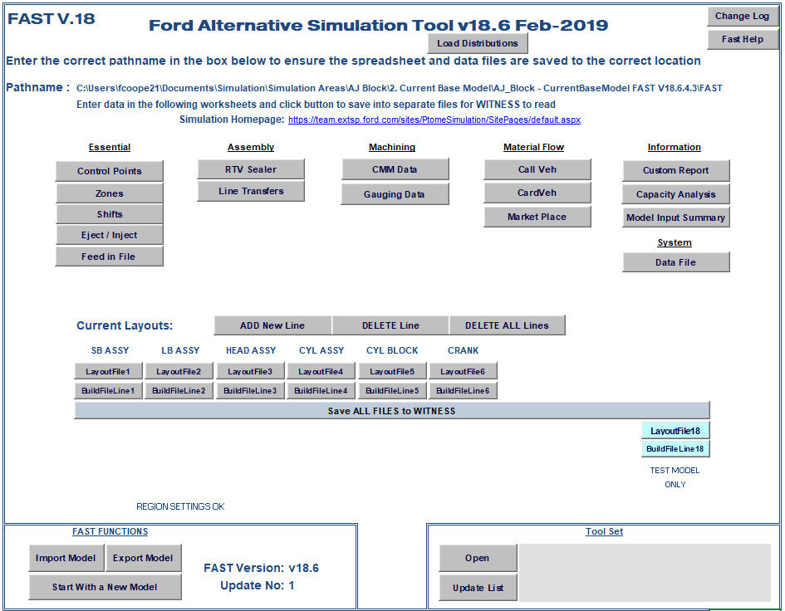

[Figure 4: The FAST interface home screen]
The purpose for the introduction of FAST was simply, to reduce the build time of models, in order for results to be obtained within a timescale which would not affect or disrupt the manufacturing or assembly lines. Once all relevant data is inserted into an excel interface file, a macro is run to transfer the data directly into Witness software for the model to proceed.

Command Generator
This toolset is another Excel based spreadsheet which is operated when planning various experimental runs. This spreadsheet makes it easy for users to enter certain limits which the model will be tested for. These limits can include production run length time and whether parameters such as breakdowns or labour are to be included in the model analysis. Within this tool it is possible to turn on/off conditions such as cycle times, TBF, TTR, FTT, over cycle, changeover, tool change, gantry cycle times, gantry breakdowns, frequency gauge, bench gauge or labour. The tool also gives the user authority to control which section of the model is to be analysed by selecting various zones, of which to run.
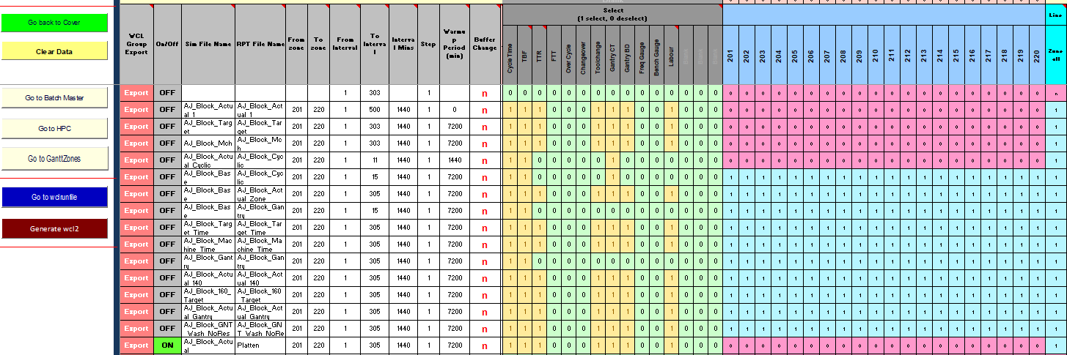
[Figure 5: The command generator interface]
Information which has been inserted into the Command generator tool is converted into a Witness Command Language (WCL) file. This file is actioned within Witness, for the purpose of activating, or deactivating, certain conditions which were previously defined. The test can either be run locally on a PC or sent via the command generator tool to the high power computers (HPC) located in North America. The latter option being the most proficient when available.

Machine Breakdown Analysis Tool
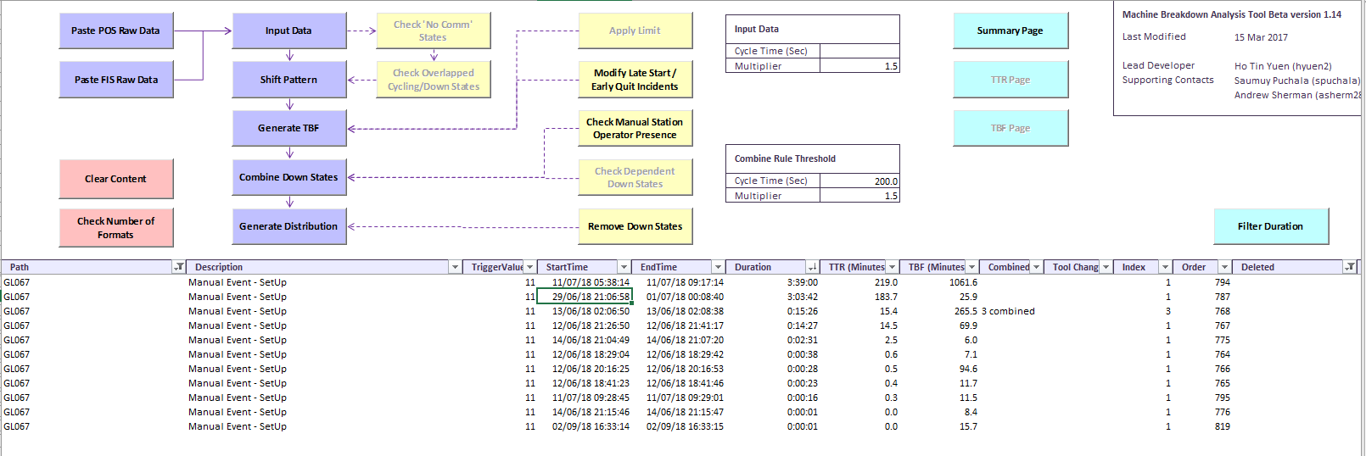
To gather data for import into Witness, the machine breakdown analysis tool is utilised. This tool gives the user the ability to extract data from the position operating system (POSmon) and transfer to Witness.
[Figure 6: The machine breakdown analysis tool interface]
With this tool, raw data is inserted into the interface, then, using the toolset provided, it is possible to create distributions for each machine which has been analysed. The toolset has the ability to group certain machines and give an output for its MTTR (Mean Time to Repair) and MTBF (Mean Time between Failures).

Mean Time to Repair
‘Mean Time to Repair refers to the amount of time required to repair a system and restore it to full functionality’, Christiansen (2018). This metric measures the time taken from when the repair on the machine starts until all repairs are finished and machinery is back to running state. It can be calculated via:
Mean time to repair = Total maintenance time / Total number of repairs

Mean Time between Failures
This is a metric refers to the duration of time that elapses between one failure to the next. This metric is a sum of both the mean time to fail and the mean time to repair. This metric can be calculated via the equation:
Mean time between failures = Total uptime / Number of breakdown
MTBF is incorporated into the project to give the simulation model the same characteristics which is being seen within the real world system.

Verification
In order to gain trust in the base model, it is important for the base model to be verified before use. According to Oreskes (1994), validation is the process of determining that a model which is to be implemented is an accurate representation of the real world system. Verification is a vital step within the base model building process as errors can be identified and corrected. In order to ensure a model is verified, necessary steps must be taken and as a minimum it should be ensured:
- FAST has stored the correct components and features into the Witness model with the correct logic in place.
- Witness runs the model, with all parts being routed to the correct place as coded in FAST.
- The correct data in terms of cycle times have been inputted from FAST into Witness, also that each station is processing the part at this cycle time.
- Other data such as quality, breakdowns and stock handling has been inserted correctly.

There is no standard for verification of base models within Ford Motor Company. One method adopted by the author was conventional inspection. Inspection can be described as a static analysis technique which was first proposed in IBM by Fagan (1976) and has been commonly used in industry since. According to Fagan (1976), this method looks at distributing the programme to various members of a team who have different perspectives and are asked to identify any faults within the programme. The Witness file is distributed to various members of the industrial engineering department and also the simulation team for inspection to take place. Within FAST there are verification tools which can be utilised as another form of static analysis to aid verification. The FAST toolset has a series of set mathematical calculations which have the ability to forecast the cyclic JPH of a machine by analysing cycle times without having to run the model in Witness. This can be used as a set of data which can be cross referenced to results produced from Witness to ensure the Witness model and FAST model both run as expected. When analysing results obtained it is up to the modellers’ discretion to decide whether the statistical analysis is close enough to model output. According to Higgins (2014), when comparing data sets a five percent difference between cells JPH is acceptable and will allow progression within the verification process. Animation verification is another method adopted by Simulation engineers during verification processes. Animation dynamically presents the operational behaviours defined in the specification to give engineers a chance to interact with the model and observe functionality, this form of verification is given by the Witness software. According to Miller (2003), animation can provide an intuitive way to give the user the ability to monitor states and behaviour of a system to ensure it reflects the original expectation.

Validation
Validation is a demonstration that a model within its domain of applicability possesses a satisfactory range of accuracy consistent with the intended application of the model, Sargent (1984). In simple terms, validation can be considered as the term used to determine whether the conceptual simulation model is and accurate representation of the system which is being studied. Validation demonstrates that a simulation model meets a specified performance standard. Validation is a vital part of the model building within Ford Motor Company as most models are built off site at the Dunton facility. Validation can be split into various forms which include; operational or conceptual.
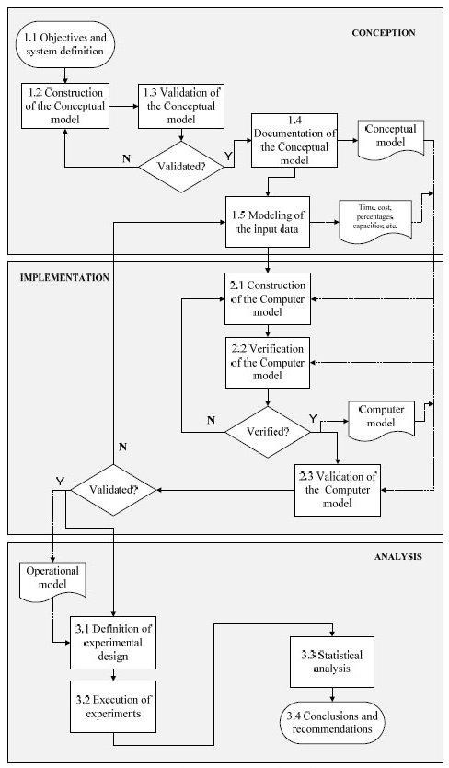

[Figure 7: Sequence of steps proposed for simulation] Leal (2011)
[Figure 7] emphasises the existence of three models that characterise their respective stages in simulation modelling. It can be seen that the conceptual model has to be validated in order to be implemented into a computational model, this computational model must then be validated to be recognised as operational.
Conceptual validation – This form of validity is determined by understanding whether theories and assumptions which have been adopted within the simulation model are correct. According to Anderson (1974), conceptual validities’ purpose is to determine whether the created model represents the real system within the necessary scope. To begin to build a reliable base model we must first have sufficient data on the system to develop theories, which can be used to aid construction of logical relationships identified between events, thereby representing the system at hand. Within Ford, the FAST toolset can limit validity of experiments as there are many assumptions already made from using the tool. FAST creates various assumptions which an engineer has no control over. When modelling, engineers are expected to list any further assumptions which are being made, these can include assumptions such as machines not running fully flexible or various operations within a cell being down for repair. These assumptions will be listed in a final document given with the report presented to the plant. To build a conceptual model we must have sufficient data on the problem entity to develop theories that can be used to build the model, plus data to develop mathematical and logical relationships for use in the model, which will allow the model to adequately represent the problem entity for its intended purpose and to test the model’s underlying assumptions.
Operational validation – Operational validation can be understood as the validation of the computational model for how suitable it is for carrying out experiments, within the limits set in the simulation projects objectives, Leal (2011). There are various methods of operational validation which have been identified such as face to face validation. Another method being the comparison of simulation data to real system results using average and standard deviation of results or alternatively statistical tests, such as building confidence levels. According to Leal (2011), techniques for operation validation involve:
- Animation – The operational performance of the model being graphically shown as the model evolves over time.
- Validation by events – The events of the simulation study being compared to those of the real system, in order to determine similarities.
- Face to face validation – This technique looks at asking individuals with a background of the system for their opinion on if the behaviour of the model is reasonable.
- Internal validity – A variety of replicas being run on the model to determine the level of variability of the model, with a large variability leading to the questioning of simulation results.
- Sensitivity analysis – This technique consists of changing values of inputs and internal parameters of a model to determine the effect on the behaviour and output of the model, the same outputs should happen in the real world.
- Turing test: This technique looks at presenting the data generated by the real and simulated model randomly to individuals who understand the process. These individuals are then asked to distinguish between the outputs of the real system and simulation.
- Validation by historic data – If the historic data of the system match inferences made by the simulation data.
Within Ford, the most common method of simulation validation is the comparison of historical data against simulation output data. This method looks at comparing EoL JPH in both the simulated model and the JPH which is obtained from shift reports. The process adopted by Ford, is the collection of data over a three month period of production compared against the simulated output, which has been run for the same time period. Both data sets are then compared via a Ford H-Chart, as show in [Figure 8], using the Ford Result Collection Tool.
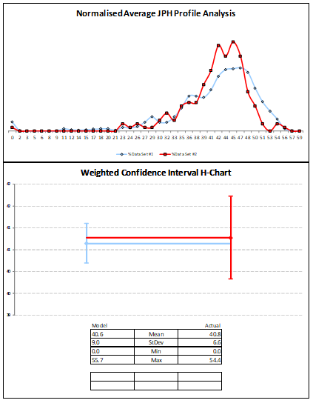
Lower Confidence Level
Mean
Upper Confidence Level
[Figure 8: An example of a Ford H-Chart]
This Ford H-Chart is a graphical view used to compare both actual and simulated data sets. This graph shows data set one in blue and data set two in red. The top graph looks at the normal average JPH profile, with the X-axis being the JPH score and the Y-axis the weighting (number of occurrences).
The bottom graph shows a visual output of the confidence interval and mean values plotted for each set of data. For the model to be considered valid operationally, both graphs must be produced. For a model to be considered valid, the top graph should show both sets of data overlapping, illustrating both data set having a common average JPH score. The bottom graph should show the mean JPH score of both data sets overlapping, slight deviation is allowed, if the mean values fall within the confidence levels of each data set, the model can be believed to be operationally valid.

Automotive Machining Line

Terminology
There are various different terminologies used to describe and model a machining line, these include:
Operation: This is described as any process which is carried out on an engine. Each operation is given an ‘Op number’, for example, ‘Op 70 - Machine front & rear end faces’.
Station: An operation can contain multiple stations which carry out the exact same operation but increase capacity of the area. An example, Op 70 could contain four cells, which include, Op 70.1, Op70.2, Op70.3 and Op 70.4. Each cell will carry out operation 70.
Manual Operation: A station which has a human operator to complete a task is considered a manual station. An example, ‘Op 167 – Manually assemble 2 cup plugs’.
Automatic Operation: An automatic operation is undertaken when a task is completed without the use of any manual labour. An example, common automatic operations include stations which require running down several bolts to a specified torque.
Semi-Automatic Operation: An operation which is both manual and automatic. Commonly a human will start the process of the operation and is completed automatically.
Conveyors: These are used to transport parts through the line between various operations automatically, using friction to pull parts along the line.
Gantry: A gantry is an overhead structure used to transport parts between stations of the same operation or move parts from one conveyor to the next. Within Ford, Gantries can either be an H-Gantry or an I-Gantry. A H-Gantry has two masts in use to load and unload parts from stations. An I-Gantry only utilises one mast.
Operator: A phrase given to personnel who are utilised on manual or semi-automatic machines. These operators work within a team and are rotated through various operations.
Platen: A platen is a platform used to hold a part for transport throughout the line on the conveyor system. Platens are designed specifically to hold a select derivative type.

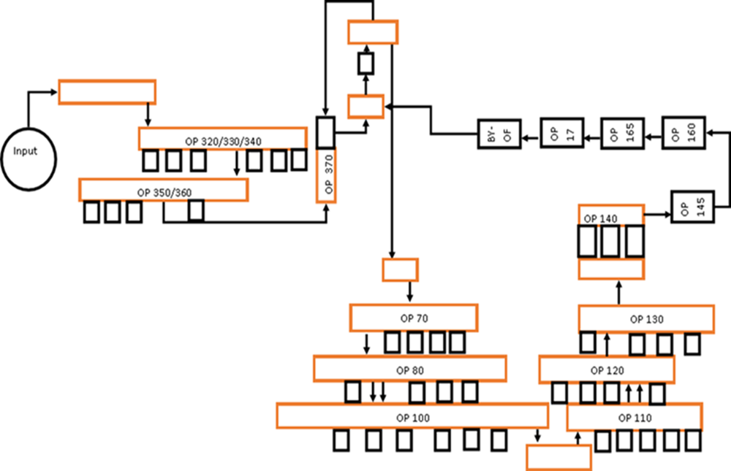
AJ-Block Machining Line
[Figure 9: Layout of AJ-Block Machining line]
Key
- Arrows represent conveyor systems along with the flow of the line.
- Orange represents gantry systems used to move parts from stations to necessary conveyor systems.
- Boxes represent stations within an operation.
- Input represents the manual task which loads blocks either AJ-133/V8 or AJ-126/V6.

Theory of Constraints
The bottleneck area (constraint) in a process describes the operation which takes the longest time period to produce a part. According to Pande (2002), a bottleneck has a direct effect on the throughput of a process. Throughput is a term used to identify how much product a process is providing during a specified time frame. As mentioned, a constraint can be described as the slowest process within a system. In order to improve throughput of the process, Goldratt (1990), suggests five steps:
- Identifying the systems constraints – According to Saboe (2016), every system has a constraint that will determine the throughput of the entire system. This constraint can be in the form of a person, a team, a machine, an organization rule or an object which is limited to the speed it can work at. As a system objective, the ‘Theory of Constraints’ looks at finding this bottleneck area and taking action to improve overall throughput. In order to help identify these areas, tools such as flow charts, root-cause analysis or pareto charts can be used. In this dissertation, DES can be used as a tool for identifying constraints and suggesting potential improvements to aid the overall goal, which in this case, is the end of line (EoL) jobs per hour (JPH) produced by AJ-Block machining.
- Decide how to exploit the systems constraints – Bottlenecks can be exploited by ensuring work is done in order to overcome them. It is important that if a bottleneck area has been identified, all resources are directed at this area. If an area is moving slower that the rest of the system, a method to improve throughput would be to address this slower area with highest priority emphasis. In this simulation three bottleneck areas will be identified, these will highlight operations for management to target to improve EoL JPH. Simulation tests will be run on each bottleneck area separately, followed by a combinational experiment.
- Subordinate everything else to the above decision – Ensure people support this bottleneck area. If the bottleneck area is working to a specified time, it would be detrimental to have others work a lot faster, as EoL JPH is solely impacted by this bottleneck area. According to Saboe (2016), it is a better strategy to have everyone work at the pace of the bottleneck area.
- Evaluate the systems constraints – This stage analyses what can be done in order to improve performance of this bottleneck area, steps include:
    - Get more personnel to do the bottleneck work
    - Invest in faster machinery
    - Better training for personnel
    - Improving workspace
    - Change organizational policies
- If in the previous steps a constraint has been broken, resort back to step one. Each time a potential improvement is implemented, it should be measured and repeated if found non-beneficial.


Define

Problem Statement
A drop in throughput of the Machining AJ-Block line is causing a strain on AJ-Assembly line due to insufficient blocks being supplied within target time, as a result, overtime is given to ensure target is met, thereby, not hindering Assembly. During the period of January to December 2017, on average AJ-Block machining produced parts at a rate of 20.1 JPH (Jobs per hour). The programme cycle target of the line cyclically is given to be 36.54 JPH, due to the cyclic bottleneck having a cycle time of 1.642 minutes. Given that the ‘run at rate’ for cylinder block is 70%, the operational target is set to 25.58 JPH. This means that AJ-Block machining is under achieving the target JPH by 5.47 JPH. Throughput must be improved on AJ-Block machining in order not to put stress on AJ-Assembly and to reduce waste, such as, additional cost due to overtime payment.

Current Trend
Jan | Feb | Mar | Apr | May | Jun | Jul | Aug | Sep | Oct | Nov | Dec
21.01 | 20.99 | 20.79 | 20.80 | 20.74 | 19.74 | 20.27 | 18.85 | 19.63 | 19.08 | 19.58 | 19.83

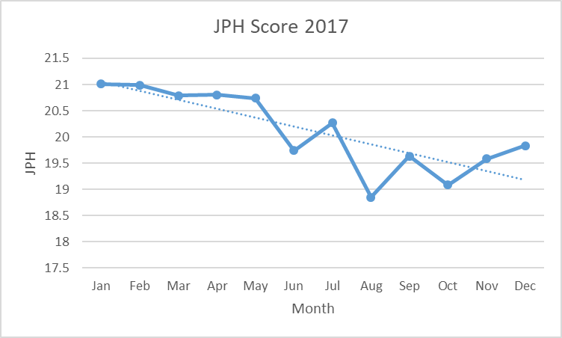
[Table 4: The JPH score recorded for AJ-Block machining in 2017]
[Graph 1: Illustration of the JPH score recorded for AJ-Block machining in 2017]

SIPOC (Supplier, Input, Process, Output, Customer)
According to Pande (2002), ‘The SIPOC diagram is used to show major activities, or sub-processes, in a business process, along with the framework of the process, represented by the Suppliers, Inputs, Outputs, and Customers’. This tool can be utilised to highlight activities found on the AJ-Block line.
Supplier | Input | Process | Output | Customer
Schedulers.  Material Planning & Logistics Department.  Manual labour at input. | Rough engine block either AJ-133 or AJ-126 (V8, V6). | Various operations.  (Can be seen below). | A finished block which has passed all quality checks. | AJ-Assembly line.  Jaguar Land Rover vehicle assembly plant.  Jaguar Land Rover dealership.

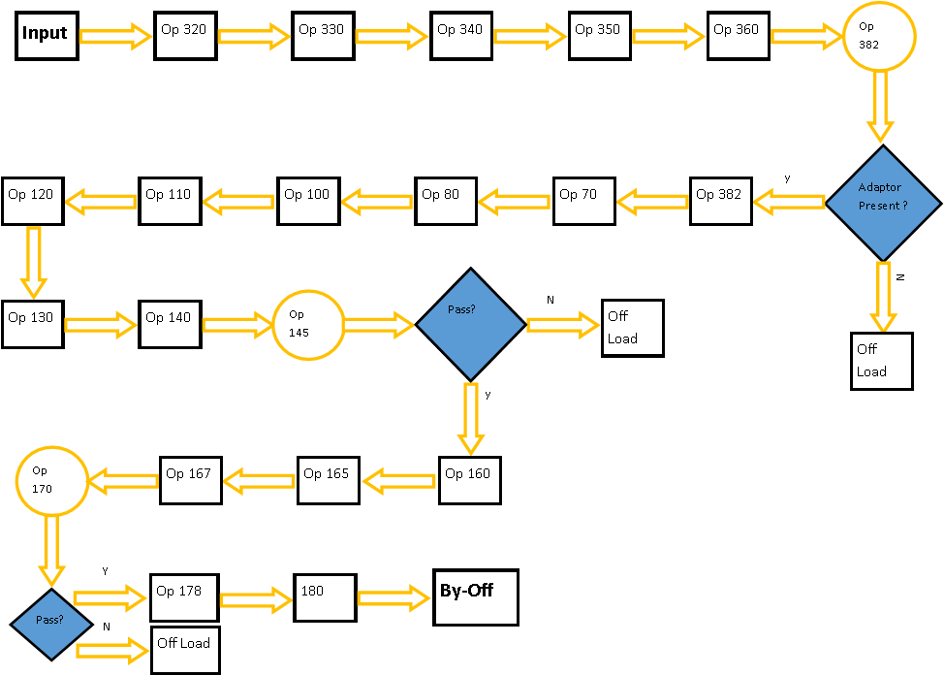
Process Map
[Figure 10: Current process which is undertaken by an engine block on AJ machining line]
Operation | Description
320 | S/F Pan & MBC Faces, Mill Thrust Faces
330 | Wash
340 | Assemble MBC & Secure
350 | Mill Thrust faces
360 | Wash
382 | V adapter automation - camera
30 | SI6 - Machine joint face
40 | SI6 - Mill bulk heads, liner notches, crank half bore, Fin mill joint face
50 | SI6 - Wash
60 | SI6 - Leak test oil gallery (V8 tested)
61 | SI6 - Load SI6 Bedplates
63 | SI6 - Assemble bedplate to block
64 | SI6 - Assembly bolts to I6 (Four Stations Manual)
65 | SI6 - Rundown bedplate bolts
70 | SI6 & AJ133 - Assy adaptor plate #2 & dis assy adaptor plate #1
74 | Machine front & rear end faces
75 | SI6 - Manually Assemble Mid Drive gear Hsg.
80 | Machine bank faces, spotface liners
100 | SI6 - Machine chest face & bank faces
100 | Machine chest face & bank faces
110 | Machine under bank bosses
120 | Machine cylinder bores
130 | Finish mill head deck faces
140 | Hone cyl bores
145 | Hone crank bore, gauge cyl bores & crank bore
160 | Wash
165 | Assemble (4) Screw Plugs
167 | Manually assembly # 2 cup plugs
170 | Leak Test Water Jacket & Engrave
177 | Disassemble adaptor plate # 2
178 | Remove block from adapter plate & load on to pallet/conveyor
180 | SI6 Bedplate Dis-Assembly/Assembly
190 | Buy-off Inspection & manually unload block from automation into racks
195 | Adaptor Storage System
[Table 5: Operations carried out on an engine block on AJ machining line]
A process map is a planning and management tool which can visually represent the flow of work, in this case, the process of operation for an AJ-Block machining line. According to Jacka (2009), process mapping is a tool which allows reviewers the opportunity to get a better understanding of the process and effectively find ways for that process to be improved.

Goal Statement
Deep dive into current issues which are being encountered on the AJ-Block machining line, these issues include cycle times and breakdowns of machinery. Data for these issues will be captured and analysed then, imported into a simulation model of the line. From this model, results will be analysed in order to formulate recommendations and suggestions of what can be implemented to improve end of line (EoL) JPH, achieving target and avoid assembly stoppages due to block shortage.

Objectives
- Collect data on AJ-Block machining (Cyclic, Gantry, Tooling, Breakdown, Gauging, FTT, Scrap and Manning).
- Analyse data, ensuring data is not skewed. Create distributions for breakdowns on machinery, including availability, mean time between failure (MTTF) and mean time to repair (MTTR).
- Create a simulation model of the current process.
- Import data into a simulation model of the current AJ-Block line, to validate and verify the model is working correctly.
- Identify system constraints/ bottlenecks
- Suggest improvements which could be implemented in order to improve end of line JPH by breaking bottleneck areas.

VOC – Voice of Customer

AJ-Block Machining Line Flow Chart
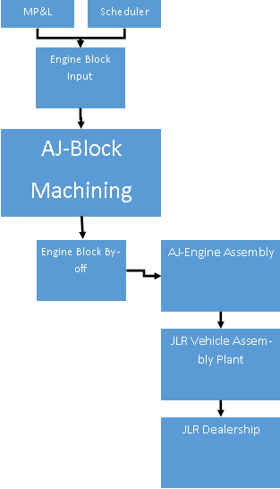

[Figure 11: AJ-Block machining line flow chart]
According to Griffin (1993), the voice of the customer tool can help when identifying customers’ need, structuring customers’ needs and providing priorities for customers. It is also said that VOC is the process used in order to obtain customers’ expectations and preferences.

Internal Customers
Internal customers can be described as customers who utilise the output of the same process to complete their own process. From the above flow chart it can be seen that AJ-Block has one internal customer. When the engine has passed through all necessary operations, ‘Buy-off’ is reached. From here, the finished block will be transported to the AJ-Engine assembly line via MP&L.

External Customers
External customers can be identified as individuals or groups who pay money for the product which is being manufactured at Bridgend Engine Plant (BEP), they are impacted by the product output. Direct external customers of BEP can be identified as the vehicle assembly plants which are supplied, JLR vehicle assembly plant being a typical example. In this context, an indirect customer is represented by the JLR Dealerships which sell the complete vehicles.

Voice of Customer (VOC) Statement
The current throughput of AJ-Block machining is having a detrimental effect on AJ-Assembly line due to insufficient blocks being available. If there is insufficient stock present of cylinder blocks, assembly is halted. For every ninety-seven seconds of assembly on stop, one engine is lost from buy-off.

Critical To Quality (CTQ)
According to Goh (2002), that critical to quality (CTQs) are the very significant measurable characteristics of a product or process whose performance or specification parameters must be achieved so that the customer will be satisfied.
Feedback from management on AJ area, states there is a shortage of blocks being delivered to assembly which is causing stoppages. To reduce these stoppages overtime has been authorised, which in itself, is an added burden in terms of cost.
Must Be:
- Pass through all necessary machining operations.
- Meet quality expectation passing all quality related operations.
- Correct derivative which has been ordered (V6/V8).
- Delivered to assembly on time to avoid stoppages.

Cause and Effect Diagram

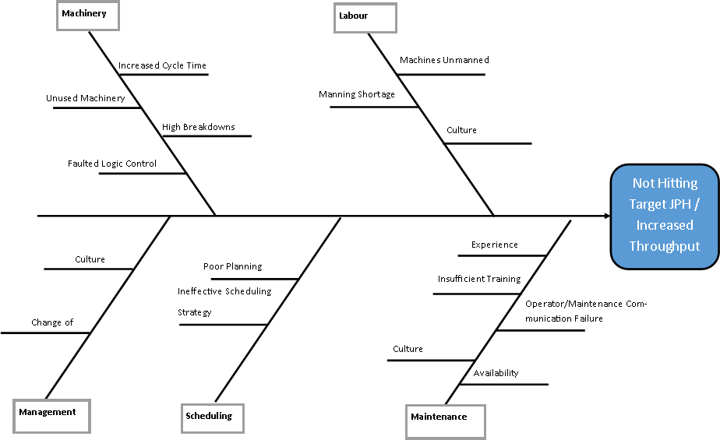

[Figure 12: Cause and Effect of not hitting target on AJ-Block machining]
When attempting to problem solve tasks, a helpful DMAIC tool is the fishbone diagram. According to Simon (2017), ‘a fishbone will help to visually display the many potential causes for a specific problem or defect’. This diagram can show all the possible causes which could be restricting the throughput of AJ Block line. In order to fully understand the reasoning behind AJ-Block machining not hitting target JPH, a cause and effect diagram can be constructed in order to serve as a visual tool to identify, and therefore explore, all possible causes related to the problem of target not being met. The main categories being considered for not hitting target JPH are identified as machinery, labour, maintenance, scheduling and management.

5 Whys
To better understand reasoning behind the causes effecting AJ-Block line not reaching potential JPH targets, the 5 Why tool can be used. This is a tool which will aid in identifying the root cause of a problem and can be used in conjunction with the cause and effect diagram found in [Figure 12]. From the cause and effect, it can be seen that there are five main groups found, which include, management, machinery, scheduling, labour and maintenance. The 5 Why tool will specifically look at the root cause of machinery.

Although one root cause has been identified here, there can be many other root causes for target throughput not being met. This is where simulation can be utilised to identify these constraints and bottlenecks, which are the current causes of low end of line (EoL) jobs per hour (JPH).

Project Charter
Business Case:
The stoppages encountered at engine assembly cost the company one engine every ninety seven seconds the line is stopped, due to shortage of blocks. To ensure this does not occur, overtime payments must be made in order to hit target figures, this payment is an added cost and waste to the company. Improving EoL JPH is essential to hit targets and reduce any unnecessary added cost. If this project is not implemented, overtime payments will continue, resulting in a loss of profit from the product which is manufactured.
Problem Statement:
A drop in throughput of the Machining AJ-Block line is causing a strain on AJ-Assembly line due to insufficient blocks being supplied within target time, as a result, overtime is authorised to ensure target is met, thereby not hampering Assembly. During the period of January to December 2017, on average, AJ-Block machining produced parts at a rate of 20.1 JPH (Jobs per hour). The programme cycle target of the line cyclically is given to be 36.54 JPH, due to the cyclic bottleneck having a cycle time of 1.642 minutes, meaning that the slowest machine on the line produces one part every 1.642 minutes. Given that the ‘run at rate’ for cylinder block is 70%, the operational target is set to 25.58 JPH. This means that AJ-Block machining is under achieving the target JPH by 5.47 JPH. Throughput must be improved on AJ-Block machining in order to not put stress on AJ-Assembly and to reduce waste such as additional overtime payment.
Goal Statement:
Deep dive into current issues which are being encountered on the AJ-Block machining line, these issues include cycle times and breakdowns of machinery. Data for these issues will be captured and analysed, then imported into a simulation model of the line. From this model, results will be analysed in order to formulate recommendations and suggestions of what can be implemented to improve end of line (EoL) JPH, achieving target and avoid assembly stoppages due to block shortage.
Scope Statement:
The project scope looks at optimising buy-off JPH on AJ-Block line by use of simulation. This project looks at producing a validated and verified simulation model which can be utilised in order to suggest improvements to increase throughput.
Timeline:
This project is anticipated to be 22 weeks, the time is allocated as per the project Gantt chart.
Team Members:
Project leader – Ford Cooper
Simulation team – Mike Higgins
Industrial engineers – Dai Canfield, Garry Lewis and Dan Doherty.

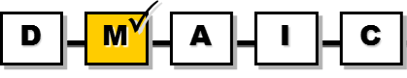
Measure

Data Collection Plan
Waddick (2001), believes that a data collection plan will help organize data collection activities and is a vital step in gathering data in the measurement stage. The data collection plan is made up of six separate areas seen below:
- What?
- Machine Cycle Times
- Gantry Cycle Times
- Tooling
- First time through (FTT)
- Breakdown
- Manning
- Why?
  - To locate the bottleneck are of the line, in order to suggest improvements to increase throughput
- Who?
  - To produce this base data various teams are consulted. Examples of teams which are required to produce data for simulation are:
    - Gauging
    - Tooling
    - Quality
    - Process
    - Productivity
    - MOS (Reliability and Maintainability)
    - Layout
- How?
  - All data gathered has been sourced via the Position Monitoring System (POSmon)
  - Manual timing, for cycle time checks of stations/ gantries
- When?
  - POSmon breakdown analysis is based on period of 11/06/18 – 20/07/18 & 13/08/18 – 12/09/18. Excluded dates – 16/06/18, 23/06/18, 30/06/18, 07/07/18, 14/07/18, 13/08/18, 18/08/18, 24/08/18, 25/08/18, 27/08/18, 28/08/18, 01/09/18, and 08/09/18. (Non-productive, mini-shift, down days).
- Where?
  - Data will be collected from AJ-Block machining line located within Bridgend Engine Plant (BEP)

Data Type
All data gathered has been sourced via the Position Monitoring System (POSmon), this is an internally developed monitoring system originally deployed in 1997 and utilised on the AJ-Block machining line. According to Stiles (2011), this system was developed by a joint North American and European team to be suitable for every engine and assembly plant to summarise data quickly and effectively. The basic system architecture consists of equipment reporting data back to a programmable logic controller (PLC) which feeds back to a data exchange device via the VLAN network. This data is then sent to Plant floor systems (PFS) shared web server, PFS shared historical server, dedicated POSmon real-time server and a global client PC.
Data which is recorded includes exclusive states such as:
- Cycling – The equipment has started to cycle in automatic mode and is currently cycling without operation.
- Starved – The equipment has stopped, with the cycle timed out, in a position where it is waiting for a new part to be processed.
- Blocked – The equipment has stopped cycling, the cycle has timed out, in a position where a processed part cannot be transferred out because the last processed part is still to be removed from the output station.
- Waiting Auxiliary Part – The equipment has stopped cycling, the cycle has timed out, in a position where an auxiliary part is required and not available. For example, the core plug bowl feeder is empty.
- Bypass – The equipment is not required to process parts as it is switched to bypass mode.
- Tool Change – The equipment has been requested to place one or more of its tools carrying slides into tool change position.
- Waiting Attention – The equipment has stopped in a detectable or timed out fault condition that is none of the above defined cycle stop conditions.
- Repair in Progress – The equipment has been switched into manual mode or a guard door is open.
This data can be accessed either from the real time system (RTS) or the historic reports (PMHR). RTS provides real data at a fifteen second delay view of the plant status. It can also provide data at an area, line or station level. Historical reports show a history of data over a three month period, grouped into thirty different report type files.

Base Data
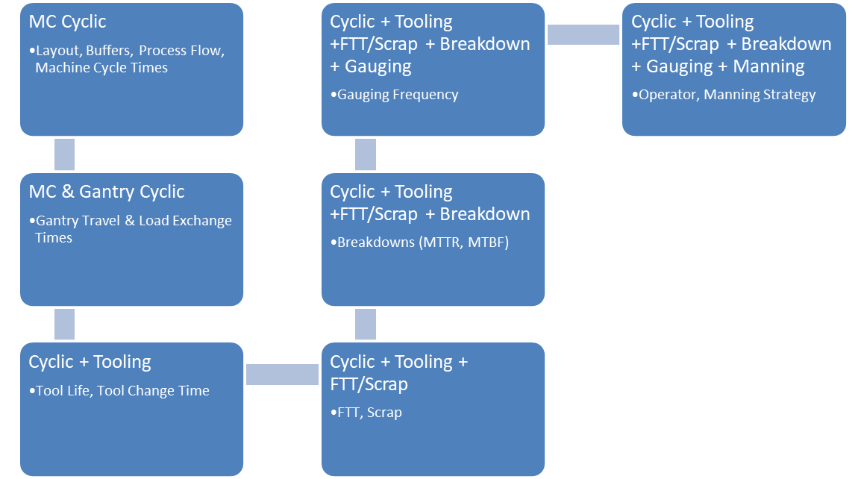
In order to create a simulation model which actually represents the real world system under analysis, certain areas must be measured and inputted into the base model. A flowchart of input collection strategy can be seen below:

[Figure 13: Flowchart of input data for a simulation model]

Collection of Base Data

Machine Cycle Time
From POSmon historic reporting, it is possible to access cycle time data for each machine/ operation within a cell, this is done via the cycle time report file.
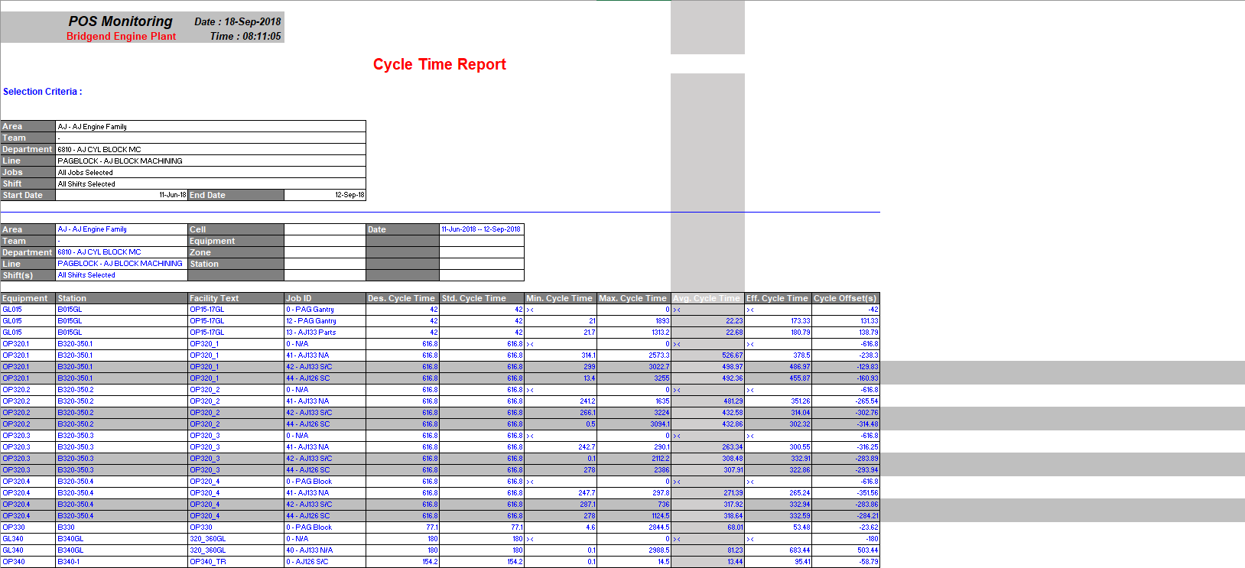
[Figure 14: Example of the cycle time report which is produced by POSmon]
Data which is recorded via POSmon needs to be filtered to discard skewed data which has the ability to damage simulation findings. All operations are given a target cycle time which is addressed during installation. In order to filter out any outliers, a max/min filter is applied. If the cycle time being reported can be seen to be greater or less than 50% of the design cycle time then, this machine will be put under further study. A manual time will be taken in order to produce a cycle time which is more reflective. The study period of the POSmon report is 11/06/18 – 12/09/18 with non-productive days being discarded (summer shutdown). The following summary shows cycle times of operations against the derivative being processed, either AJ133 or AJ 126. Skewed data is discarded from the summary below and represented by (N/A). In order to get a reliable cycle time for the machine it was necessary to take an average cycle time of the cell instead. This average will replace the skewed data within the model and will be listed as an assumption made in order to gain a reliable model. Skewed cycle times can arise from PLC recording data wrongly due to wiring faults or configuration faults. Another method used to discard skewed data, was to manually time machines cycling state and use this recorded time in the model.
The following summary shows cycle times of operations against the derivative being processed either AJ133 or AJ 126.
 | POS database
 | Cycle time/seconds |  | Cycle time/min |  | Average cycle time/min
Operation | AJ133 | AJ126 | AJ133 | AJ126 | AJ133 | AJ126
320.1 | 498.97 | 492.36 | 8.32 | 8.21 | 6.49 | 6.47
320.2 | 432.58 | 432.86 | 7.21 | 7.21 | 6.49 | 6.47
320.3 | 308.48 | 307.91 | 5.14 | 5.13 | 6.49 | 6.47
320.4 | 317.92 | 318.64 | 5.30 | 5.31 | 6.49 | 6.47
330.0 | 77.10 | 77.10 | 1.29 | 1.29 | 1.29 | 1.29
340.1 | 86.36 | 86.49 | 1.44 | 1.44 | 1.54 | 1.60
340.2 | 92.26 | 96.50 | 1.54 | 1.61 | 1.54 | 1.60
340.4 | 104.17 | 88.40 | 1.74 | 1.47 | 1.54 | 1.60
340.3 | 92.49 | 95.72 | 1.54 | 1.60 | 1.54 | 1.60
350.1 | 272.95 | 288.77 | 4.55 | 4.81 | 4.58 | 4.81
350.2 | N/A | N/A | 4.32 | 4.56 | 4.58 | 4.81
350.3 | 276.83 | 288.82 | 4.61 | 4.81 | 4.58 | 4.81
360.0 | 97.80 | 92.26 | 1.63 | 1.54 | 1.63 | 1.54
67.0 | 130.52 | 124.75 | 2.18 | 2.08 | 2.18 | 2.08
70.1 | 479.71 | N/A | 8.00 | 5.72 | 6.49 | 5.72
70.2 | 354.37 | 340.49 | 5.91 | 5.67 | 6.49 | 5.72
70.3 | 292.98 | 277.67 | 4.88 | 4.63 | 6.49 | 5.72
70.5 | 431.08 | 410.88 | 7.18 | 6.85 | 6.49 | 5.72
80.1 | N/A | 371.20 | 4.64 | 6.19 | 4.64 | 5.86
80.2 | 296.21 | 384.43 | 4.94 | 6.41
80.3 | 260.99 | 320.82 | 4.35 | 5.35
80.5 | N/A | 331.04 | 4.64 | 5.52
100.1 | 350.33 | 388.88 | 5.84 | 6.48 | 6.00 | 6.62
100.2 | N/A | 394.89 | 6.00 | 6.58 | 6.00 | 6.62
100.3 | 367.05 | 414.01 | 6.12 | 6.90 | 6.00 | 6.62
100.4 | N/A | N/A | N/A | N/A | 6.00 | 6.62
100.5 | 363.42 | 390.52 | 6.06 | 6.51 | 6.00 | 6.62
100.6 | 360.05 | 398.43 | 6.00 | 6.64 | 6.00 | 6.62
110.1 | N/A | 315.68 | 5.39 | 5.26 | 5.39 | 5.15
110.2 | 298.26 | 299.08 | 4.97 | 4.98 | 5.39 | 5.15
110.3 | 308.25 | 313.00 | 5.14 | 5.22 | 5.39 | 5.15
110.5 | 363.08 | N/A | 6.05 | 5.15 | 5.39 | 5.15
120.1 | 334.76 | 268.48 | 5.58 | 4.47 | 5.60 | 4.58
120.2 | 335.62 | 265.50 | 5.59 | 4.43 | 5.60 | 4.58
120.3 | 335.51 | 291.77 | 5.59 | 4.86 | 5.60 | 4.58
120.5 | 339.30 | 273.16 | 5.66 | 4.55 | 5.60 | 4.58
130.1 | 151.80 | 134.17 | 2.53 | 2.24 | 2.61 | 2.43
130.2 | 160.49 | 148.12 | 2.67 | 2.47 | 2.61 | 2.43
130.4 | 158.20 | 155.24 | 2.64 | 2.59 | 2.61 | 2.43
140.1 | 287.07 | N/A | 4.78 | 3.74 | 4.78 | 4.05
140.2 | N/A | 252.22 | 3.99 | 4.20 | 4.78 | 4.05
140.4 | N/A | 233.51 | 3.99 | 3.89 | 4.78 | 4.05
145.0 | 48.03 | 49.73 | 0.80 | 0.83 | 0.80 | 0.83
160.0 | 122.21 | 104.31 | 2.04 | 1.74 | 2.04 | 1.74
165.0 | 41.63 | 40.52 | 0.69 | 0.68 | 0.69 | 0.68
167.0 | N/A | N/A | N/A | N/A | N/A | N/A
170Trans | 18.74 | 18.31 | 0.31 | 0.31 | 0.31 | 0.31
170Av | 105.36 | 99.97 | 1.76 | 1.67 | 1.76 | 1.67
170.1 | 71.91 | 60.62 | 1.20 | 1.01 | 1.20 | 1.01
170.2 | 79.00 | 57.26 | 1.32 | 0.95 | 1.32 | 0.95
170Mark | 60.00 | 60.00 | 1.00 | 1.00 | 1.00 | 1.00
[Table 6: Historic POSmon cycle time of operations]

Equipment Fault Detail
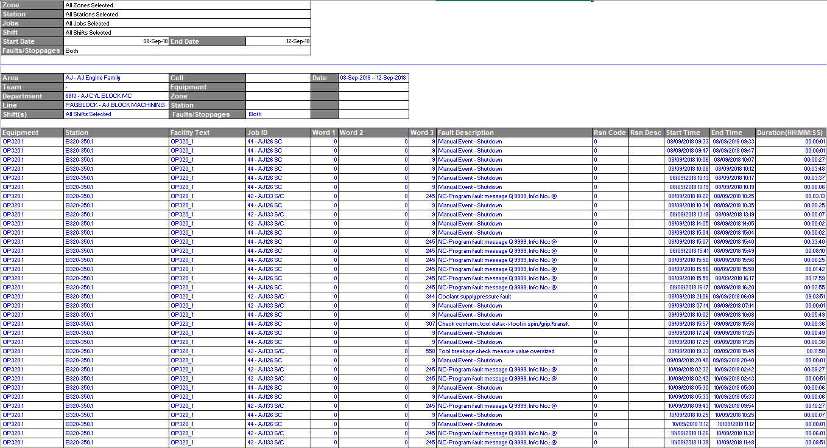
From POSmon historic reporting, it is possible to access machine equipment fault detail data for each machine/ operation within a cell. This data shows all reported machine faults along with the duration of the breakdown. An example of a report obtained from POSmon can be seen below:
[Figure 15: An example of an equipment fault detail report]

In order to obtain reliable working data from POSmon, all data must be filtered to discard spurious data. This data must then be formatted in a pre-defined layout allowing Witness to readily consume data. The steps taken to produce the data necessary for use in Witness is as follows:
- Input - All raw POS data is inputted into the FAST analysis breakdown tool which will ignore all states except the parent states of ‘Cycling’ and ‘Down’. The data being pulled from POSmon is the equipment fault detail report for all cells and operations during the study period of 11/06/18 – 12/09/18 with major non-productive days being discarded (summer shutdown).
- No Comm - This data is then checked for ‘No Comm’ which is, no incoming communications. The ‘No Comm’ logic states that any ‘no comm’ next to a down, will be converted to a down, ‘no comm’ between two cycling states will be removed and any false ‘no comm’ will be removed. A ‘no communication’ is where the machine has lost communication with the system and the reason for this has not been identified, for example, the communication cable accidentally being unplugged. It is possible to identify if these ‘no comm’ states are true or false, if for example a machine is running between a certain time period but at the same time reports ‘No Comm’, this data can be discarded from the study. A machine can only be in one state at any given time.
- Overlap - Overlapping data is discarded from the distributions. This step is put in place in order to double check the reliability of data being pulled from POSmon, by checking whether there are any cycling states which are overlapping with down states. This step is put in place to ensure the first assumption is met, which is, all states are mutually exclusive.
- Shift pattern – Shift pattern is added in order to discard any data which is taken during non-productive hours. Regular non-productive hours are taken out of the study such as weekends, lunch and tea breaks, followed by irregular non-productive hours, such as non-production days or mini-shifts. Data will only be taken for stations which have broken down within production time and not during down days. During the study period, AJ-Block will run a 4-shift pattern, which means 12 hour shift period. This line also runs a tag break system which means the line never stops for break times. The line runs a mini shift on a Sunday, so all data is discarded from this particular data set, as is perceived to be non-productive.
- Time between failures (TBF) - TBFs are generated. This stage now discards all ‘cycling’ states from the data stream therefore only ‘down’ states will remain within the data, along with their appropriate fault description.
- Combining Down States – This stage will combine down states which occur within a certain time threshold. In this study the current assumption looks at combining down states using the threshold of five minutes. This function is implemented in order to combine breakdowns which occur back to back with one and other. An example being when a machine breaks down, an operator resets the fault but during the next cycle the machine breaks down again. In order to obtain more accurate distributions, these two failures will be combined as one.
- Comparison – The final data set is compared to actual data which has been manually recorded by maintenance personal on the line. Shift reports from the data period under study are analysed and crossed referenced to the filtered POSmon data. Any data which has been recorded on POSmon and not logged in shift reports is flagged and brought to supervisor level. This data will either be manually discarded if the data is corrupt and reported falsely or retained if agreed by management.
- Generating Distributions – A distribution is created for both the mean time to repair (MTTR) and the mean time between failures (MTBF).

Distribution Summary
Number | Availability | Down % | Name | MTTR /min | MTBF /min
1 | 99.10% | 0.90% | DCN148 | 20.1 | 2156.7
2 | 99.50% | 0.50% | DCN192 | 15.8 | 2933.7
3 | 99.90% | 0.10% | DCN202 | 2.3 | 1976
4 | 99.30% | 0.70% | DCN204 | 8.4 | 1118.2
5 | 98.60% | 1.40% | DGL015 | 24.2 | 1721
6 | 79.50% | 20.50% | DGL067 | 40.4 | 156.3
7 | 98.30% | 1.70% | DGL068 | 14.2 | 799.5
8 | 81.70% | 18.30% | DGL070 | 66.2 | 294.9
9 | 91.90% | 8.10% | DGL080 | 53.2 | 606.7
10 | 81.80% | 18.20% | DGL100 | 107 | 479.5
11 | 99.60% | 0.40% | DGL105 | 22.2 | 5689.1
12 | 96.50% | 3.50% | DGL110 | 38.7 | 1075.3
13 | 84.10% | 15.90% | DGL120 | 80.8 | 426.1
14 | 91.10% | 8.90% | DGL130 | 41.7 | 428.2
15 | 99.60% | 0.40% | DGL140 | 11.1 | 2467
16 | 98.70% | 1.30% | DGL140B | 8.3 | 629.6
17 | 93.00% | 7.00% | DGL195 | 367 | 4856.6
18 | 94.10% | 5.90% | DGL340 | 22.8 | 365.4
19 | 92.60% | 7.40% | DGL350360 | 19.1 | 240.8
20 | 97.90% | 2.10% | DOP067 | 25.9 | 1205.8
21 | 94.20% | 5.80% | DOP0701 | 29.1 | 472.2
22 | 91.70% | 8.30% | DOP0702 | 39.5 | 435.1
23 | 87.80% | 12.20% | DOP0703 | 44.5 | 320
24 | 86.60% | 13.40% | DOP0705 | 41.5 | 268.6
25 | 85.40% | 14.60% | DOP0801 | 69.6 | 406
26 | 85.60% | 14.40% | DOP0802 | 81.8 | 487.9
27 | 92.80% | 7.20% | DOP0803 | 51.5 | 664.1
28 | 93.70% | 6.30% | DOP0805 | 39.7 | 594
29 | 76.60% | 23.40% | DOP1001 | 46 | 150.2
30 | 85.00% | 15.00% | DOP1002 | 56.3 | 320.1
31 | 82.40% | 17.60% | DOP1003 | 68.6 | 321
32 | 78.30% | 21.70% | DOP1005 | 61 | 220.1
33 | 91.70% | 8.30% | DOP1006 | 37.5 | 412.5
34 | 89.70% | 10.30% | DOP1101 | 66.3 | 576.8
35 | 90.00% | 10.00% | DOP1102 | 49.9 | 447.4
36 | 93.80% | 6.20% | DOP1103 | 49.6 | 750.5
37 | 90.30% | 9.70% | DOP1105 | 70.4 | 658.6
38 | 85.80% | 14.20% | DOP1201 | 29.2 | 176.9
39 | 82.70% | 17.30% | DOP1202 | 39.7 | 190.4
40 | 85.50% | 14.50% | DOP1203 | 76.3 | 448.9
41 | 82.80% | 17.20% | DOP1205 | 33.2 | 159.4
42 | 89.10% | 10.90% | DOP1301 | 33.4 | 272.7
43 | 91.80% | 8.20% | DOP1302 | 80 | 898.1
44 | 87.60% | 12.40% | DOP1304 | 61.7 | 436.8
45 | 87.50% | 12.50% | DOP1401 | 17.8 | 124.7
46 | 88.60% | 11.40% | DOP1402 | 37.1 | 289.2
47 | 88.60% | 11.40% | DOP1404 | 30.5 | 237
48 | 94.50% | 5.50% | DOP145 | 8.2 | 141
49 | 93.40% | 6.60% | DOP160 | 25.5 | 357.6
50 | 98.90% | 1.10% | DOP165 | 5.7 | 501.8
51 | 91.10% | 8.90% | DOP165A | 14.6 | 149.8
52 | 75.60% | 24.40% | DOP1701BLK | 23.6 | 73
53 | 85.00% | 15.00% | DOP1702BLK | 10.6 | 60.4
54 | 92.90% | 7.10% | DOP170AV | 24.3 | 316.2
55 | 96.70% | 3.30% | DOP170MARK | 12.7 | 369.2
56 | 92.30% | 7.70% | DOP170TRANS | 26.7 | 319
57 | 99.20% | 0.80% | DOP177 | 10 | 1230.9
58 | 87.90% | 12.10% | DOP3201 | 42.7 | 311.2
59 | 91.20% | 8.80% | DOP3202 | 23.7 | 244
60 | 90.60% | 9.40% | DOP3203 | 25.3 | 244.3
61 | 92.70% | 7.30% | DOP3204 | 17.6 | 224.7
62 | 94.20% | 5.80% | DOP330 | 36.1 | 587.2
63 | 88.10% | 11.90% | DOP340 | 7.6 | 55.9
64 | 89.30% | 10.70% | DOP3501 | 42.1 | 352.8
65 | 92.90% | 7.10% | DOP3502 | 32.9 | 430.8
66 | 91.90% | 8.10% | DOP3503 | 32.6 | 371.1
67 | 93.20% | 6.80% | DOP360WASH | 17.9 | 244.9
68 | 99.00% | 1.00% | DOP382 | 9 | 925.6
[Table 7: The distributions created and used within the simulation model]
Key
•MTTR (mins) – Mean time to repair.
•MTBF (mins) – Mean time between failures.
•Availability % - Amount of uptime
•Down % - Amount of downtime

Actual Job per Hour Score
As mentioned previously, in order to operationally validate the simulation model, it is vital that the output of the model compares similarly with the actual data output of the system. In order to do this a Ford H-Chart is produced, comparing output simulation JPH with actual JPH at EoL of the system. Actual EoL JPH is recorded daily per shift in the shift reports created from supervisors. In order to create a reliable model, the JPH data period must match the data period used for all other base data (Breakdown, Cycle time, FTT) which is the 11/06/18 – 12/09/18.

Date | JPH (Shift report) | Date | JPH (Shift report) | Date | JPH (Shift report)
11/06/2018 | 15.07 | 07/07/2018 | 17.47 | 25/08/2018 | 3.90
12/06/2018 | 18.13 | 08/07/2018 | 15.60 | 26/08/2018 | 20.30
13/06/2018 | 14.00 | 09/07/2018 | 17.87 | 27/08/2018
14/06/2018 | 19.29 | 10/07/2018 | 19.78 | 28/08/2018 | 13.80
15/06/2018 | 21.82 | 11/07/2018 | 19.82 | 29/08/2018 | 14.90
16/06/2018 | 20.71 | 12/07/2018 | 6.89 | 30/08/2018 | 18.10
17/06/2018 | 23.29 | 13/07/2018 | 20.62 | 31/08/2018 | 19.20
18/06/2018 | 23.91 | 14/07/2018 | 18.53 | 01/09/2018 | 9.60
19/06/2018 | 18.93 | 15/07/2018 | 23.60 | 02/09/2018 | 19.80
20/06/2018 | 18.27 | 16/07/2018 | 18.67 | 03/09/2018 | 25.00
21/06/2018 | 17.38 | 17/07/2018 | 18.36 | 04/09/2018 | 16.30
22/06/2018 | 14.27 | 18/07/2018 | 21.64 | 05/09/2018 | 15.10
23/06/2018 | 21.47 | 19/07/2018 | 21.20 | 06/09/2018 | 16.10
24/06/2018 | 20.31 | 20/07/2018 | 13.64 | 07/09/2018 | 16.30
25/06/2018 | 20.80 | 13/08/2018 | 14.70 | 08/09/2018 | 11.10
26/06/2018 | 18.76 | 14/08/2018 | 0.00 | 09/09/2018 | 24.90
27/06/2018 | 22.00 | 15/08/2018 | 16.10 | 10/09/2018 | 20.50
28/06/2018 | 13.87 | 16/08/2018 | 22.70 | 11/09/2018 | 21.10
29/06/2018 | 16.22 | 17/08/2018 | 19.60 | 12/09/2018 | 19.90
30/06/2018 | 13.91 | 18/08/2018 | 12.10
01/07/2018 | 21.82 | 19/08/2018 | 18.40
02/07/2018 | 19.82 | 20/08/2018 | 18.50
03/07/2018 | 18.40 | 21/08/2018 | 19.10
04/07/2018 | 11.78 | 22/08/2018 | 24.10
05/07/2018 | 19.73 | 23/08/2018 | 17.90
06/07/2018 | 19.29 | 24/08/2018 | 4.70
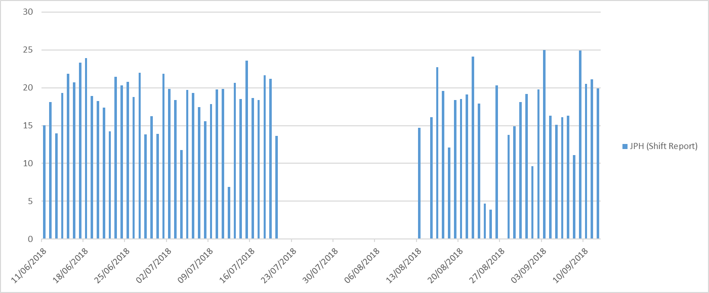
[Table 8: The JPH score lifted from shift reports for AJ-Block machining]
[Graph 2: Showing the actual daily JPH score recorded from shift reports]
During the study period only data which is recorded during productive hours is considered. This means that any shift which is a non-productive shift is discarded from the data set, these include shifts such as down-days, mini-shift or maintenance-shifts.
It can be seen that, other non-productive days which have not been recorded in the data lay between 20/07/2018 – 13/08/2018, this represents the summer vacation period, where production did not take place.

Tooling
The line under analysis is a machining line which utilises various CNC machines to carry out operations on an engine block. Each CNC machine has a designated tooling system and magazine, which hold various tools such as drills, boring bars, tabs or reamers. Each tool has a tool life, the tool needs replacing once this life has expired so that the operation being carried out remains within specification. The data collected on tooling can be seen in [Table 25].

Scrap
In order to account for scrappage total within the model, raw data collected from the finance department must be analysed. In [Table 9], the raw scrappage figures for each operation found on AJ-Block line can be seen. The data shows raw scrappage values for that date period of June through until August, which matches the POSmon reporting period of 11/06/18 – 20/07/18 & 13/08/18 – 12/09/18 which is used for the simulation study period.
Operation | Jun | Jul | Aug
10 | 0 | 0 | 0
40 | 0 | 0 | 0
50 | 0 | 0 | 0
60 | 1 | 0 | 0
65 | 0 | 0 | 0
67 | 1 | 2 | 4
70 | 21 | 11 | 16
80 | 3 | 0 | 1
100 | 26 | 28 | 28
110 | 2 | 6 | 2
120 | 14 | 19 | 14
130 | 2 | 4 | 0
140 | 59 | 43 | 47
145 | 0 | 11 | 2
150 | 0 | 0 | 0
160 | 1 | 0 | 3
165 | 5 | 8 | 5
170 | 9 | 3 | 2
177 | 0 | 4 | 0
180 | 15 | 1 | 3
210 | 0 | 0 | 0
250 | 0 | 0 | 0
320 | 9 | 25 | 8
340 | 9621 | 5505 | 3219
350 | 3 | 5 | 11
AAA | 0 | 6 | 0
AAB | 0 | 1 | 0
AAG | 0 | 0 | 0
AAI | 0 | 0 | 0
ANC | 0 | 0 | 0
ART | 0 | 15 | 1
BOL | 0 | 0 | 0
BRD | 0 | 2 | 0
BRT | 0 | 1 | 0
CPP | 0 | 0 | 0
CRB | 0 | 0 | 0
CYB | 0 | 0 | 0
DAM | 20 | 3 | 0
DES | 0 | 0 | 0
ENG | 0 | 0 | 1
ETD | 0 | 0 | 0
LEK | 0 | 0 | 0
MCH | 0 | 16 | 0
OBS | 14 | 1 | 2
POR | 0 | 0 | 0
RUS | 0 | 0 | 0
SCR | 0 | 0 | 0
SUP | 0 | 0 | 0
SUS | 0 | 0 | 0
USD | 0 | 2003 | 0
XTH | 0 | 5 | 0
Total | 9826 | 7723 | 3369
Blocks Scrapped | 262 | 266 | 190
Prod'n | 12048 | 8,794 | 6,842
Scrap Pct | 2.2% | 3.0% | 2.8%
[Table 9: Raw scrappage values of AJ-Block line]
From the above table, the mean value for scrap, in percentage terms, was 2.6%, during the period. This value was used to account for scrappage in the model. The simulation model will calculate that during the simulation run length, 2.6% of all parts produced, will be discarded from the study and JPH score.

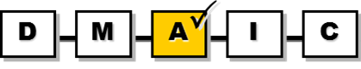
Analyse

Creation of the Base Model
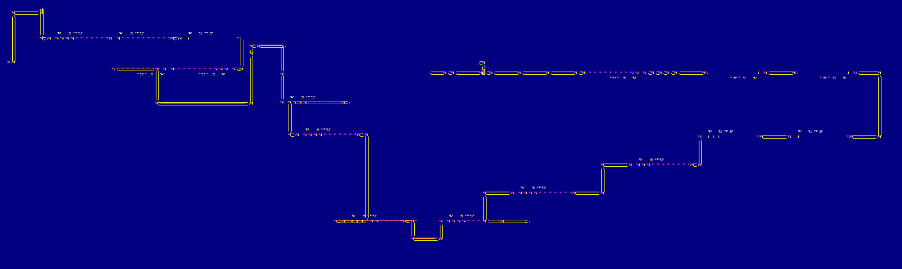
In order to analyse the data which is collected, a simulation base model must first be formed to represent AJ-Block line with all its coherent logic, this model was built by the author:
Gantry
Operation
Conveyor
Input
By off

[Figure 16: A snapshot of the model used to represent AJ-Block Line]

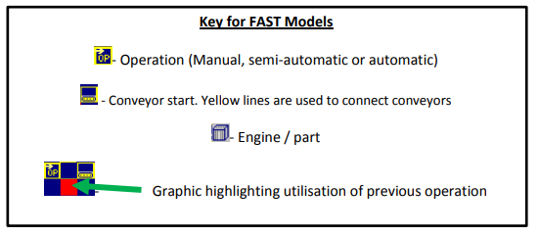
For simulation purposes each operation has been split into a separate zone in order to analyse and recommend improvements, the zone set up is as follows:
Operation | Zone
Op 15 - Manual Load | 201
GNT 15 | 201
Op 320 - S/F Pan & MBC Faces, Mil Thrust Faces | 202
Op 330 - Wash | 203
Op 340 - Assemble MBC & Secure | 204
Op 350 - Mill Thrust Faces | 205
Op 360 - Wash | 206
GNT 67A | 206
Op 67 - Assemble Adaptor | 206
GNT 68A | 206
Op 70 - Machine Front & Rear End Faces | 207
Op 80 - Machine Bank Faces, Spotface Liners | 208
Op 100 - Machine Chest Face & Bank Faces | 209
GNT 100 | 209
Op 110 - Machine Under Bank Bosses | 210
Op 120 - Machine Cylinder Bores | 211
Op 130 - Finish Mill Head Deck Faces | 212
Op 140 - Hone Cyl Bores | 213
Op 145 - Hone Crank Bore, Gauge Cyl Bores & Crank Bore | 214
Op 160 - Wash | 215
Op 165 - Assemble Screw Plugs | 216
Op 167 - Manually Assembly Cup Plugs | 216
Op 170 -Transfer | 216
Op 170 - Adv Seal | 216
Op 170 - Leak Test Water Jacket & Engine | 216
Op 170 - Mark | 216
Op 177 - Disassemble Adaptor Plate | 217
Op 178 - Remove From Adaptor | 218
Op 195A - Adaptor Storage System | 219
Op 195 - Manual Buy-off | 219

Assumptions
In order to mimic the actual machining line and produce a reliable model, certain assumptions had to be made, these included:
- POSmon breakdown analysis is based on period of 11/06/18 – 20/07/18 & 13/08/18 – 12/09/18. Excluded dates – 16/06/18, 23/06/18, 30/06/18, 07/07/18, 14/07/18, 13/08/18, 18/08/18, 24/08/18, 25/08/18, 27/08/18, 28/08/18, 01/09/18, and 08/09/18. (Non-productive, mini-shift, down days). This assumption is based on information gathered by shift reports cross referenced with relevant supervisors who ensure that the data being used is valid.
- Feed in file uses a 58:10 batch feed for AJ126 to AJ133. This represents input of 58 AJ126 blocks loaded onto the line, followed by 10 AJ133 blocks. This assumption is produced on information given via the scheduling team for the AJ-Machining line.
- Based on a 233 pallet Feed. This means that on the machining line there are 233 pallets circling online. This assumption is based on a manual count of online platens taken by the industrial engineering department.
- Op 100.4 has been removed due to inactivity. During the three month period of study Op 100.4 has been faulted and not in use, this means that Op100s now run four machines instead of five resulting in a decrease in capacity. This assumption is based off information gathered by supervisors.
- Input and Buy-off are always manned. This assumption addresses the fact that there is always an operator available to input and buy-off engines on the line, so there will be zero operator blockage at the beginning or end of the line.
- When gantry DGL 340 faults, machines Op320, Op330 and Op 340 are down. This means that when gantry, addressed DGL 340, fails, all operations which is controlled via this gantry also fail. This is due to DGL feeding multiple operations.
- Op 70 & 130 Gantry running on one mast during this data period, both gantries will have an increased cycle time. This assumption is based on information from shift reports and maintenance teams.
- Certain machines in different operations are not fully flexible to run both parts through the machine. Although machines should run fully flexible, due to reasons unknown at present, derivatives have been de-selected and will need to be accounted for in the model.
Restraints:
Op 80.1 (AJ126 Only), Op 110.5 (AJ126 Only), Op120.5 (AJ126 Only), Op130.4 (AJ126 Only), Op140.1 (AJ133 Only), Op140.2 (AJ126 Only), Op140.3 (AJ126 Only).

Simulation Results

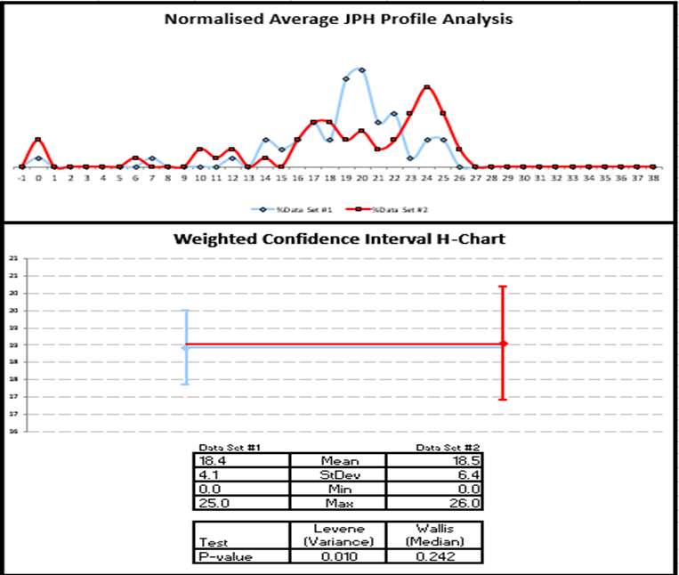
H-Chart
[Graph 3: The H-chart comparison of simulation to actual data sets]
Data sets for both periods are compared to produce an H-chart, actual data set being shown in blue and simulation data being shown in red. The simulation model reflects the production on the AJ-Block machining line for 11/06/18 – 20/07/18 & 13/08/18 – 12/09/18. Simulation mean JPH is based on one replication of the model for 53 shifts to match actual data from study period (11/06/18 – 20/07/18 & 13/08/18 – 12/09/18). From the H-chart, it can be seen that mean JPH of data set one and two overlap into each other’s confidence level, with a mean JPH of 16.4 and 16.5 respectively. From the average JPH profile analysis, it can be seen that both data sets lie between the five to twenty-seven JPH mark and show areas of overlapping. This simulation model can be said to be statistically equivalent to plant production, resulting in this model being fit for experimental simulation. This concludes that the model created with all the relevant input data is verified and validated and now available to draw inferences from, in accordance with throughput optimisation improvements.

Summary
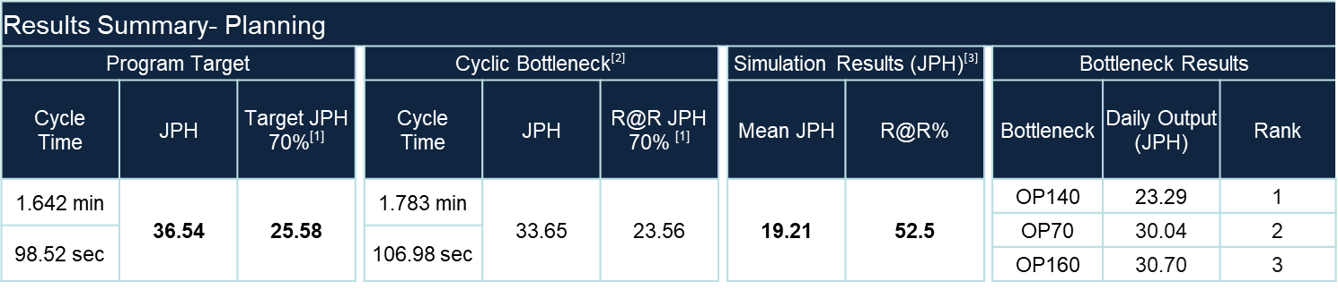
The base model experiment is run over a 500 day period, this will give enough data to draw accurate conclusions, to decide on whether the data produced matches the actual data set gathered off the line. The results below show a summary of the data set gathered from the simulation over the time period:
[Table 10: The results summary of the simulation on AJ-Block line]
The programme target which was set out when the line was installed within BEP looked at the machining line having a cyclic JPH of 36.54 meaning, every hour, if no breakdowns or failures occurred, 36.54 engines would leave buy-off. This is due to the cyclic bottleneck of the line having a cycle time of 1.642 mins. Realistically, various breakdowns and faults naturally occur on the line, so a line target JPH of 25.58 is given. This represents 70% of the cyclic target in order to account for all these stoppages.
When analysis of the line was carried out, it was seen that the current cyclic bottleneck had changed from what was expected, and due to machines being slowed down the cyclic bottleneck now was seen to be the Op160 wash. This machine now had a cycle time of 1.783 mins and was able to produce at 33.65 JPH cyclically, with a ‘run at rate’ of 70% it could only produce 23.56 JPH.
From simulation analysis, it was recorded that the operational mean JPH of the line was 19.21 which is a 52.2% ‘run at rate’ compared to the cyclic bottleneck. In summary, the simulation JPH mean, under achieved target JPH by 6.37. Simulation results show that operational bottleneck areas are:
- Operation 140 – 23.29 JPH
- Operation 70 – 30.04 JPH
- Operation 160 – 30.70 JPH

Simulation Cyclic Bottleneck Analysis
 | Op15 | Op320 | Op330 | Op340 | Op350 | Op360 | Op70 | Op80 | Op100 | Op110
Mean JPH | 90.73 | 36.18 | 51.77 | 37.22 | 36.56 | 37.60 | 36.30 | 38.38 | 42.87 | 43.18
 | Op120 | Op130 | Op140 | Op145 | Op160 | Op170 | Op177 | Op178 | Op195 | EoL
Mean JPH | 46.64 | 65.58 | 25.97 | 70.58 | 32.69 | 58.24 | 85.27 | 83.20 | 85.50 | 25.94
[Table 11: The cyclic JPH results from the simulation]
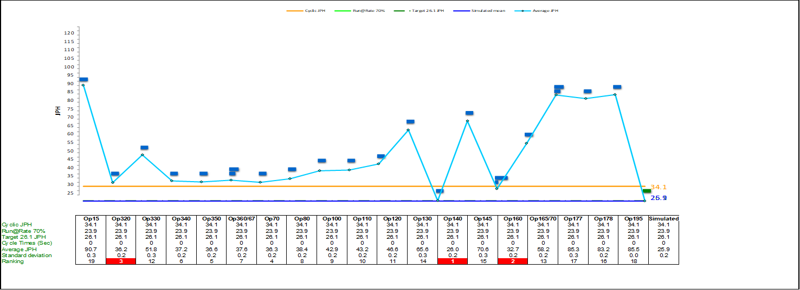
The cyclic bottleneck analysis shows that if the system was to run with zero breakdowns, and only cycle times which have been dedicated to each machine and gantry, the 100% potential is 25.94 JPH. This is a reduction of 10.6 JPH from programme target. From the results obtained it can be seen that the lowest three JPH zones correlate to Op 140 Honers, Op 160 Wash and Op 320 - S/F Pan & MBC Faces, Mil Thrust Faces giving a JPH of 25.97, 32.69 and 36.18 respectively.
[Graph 4: The cyclic bottleneck analysis of AJ-Block line]

Simulation Operational Bottleneck Analysis
 | Op15 | Op320 | Op330 | Op340 | Op350 | Op360 | Op70 | Op80 | Op100 | Op110
Mean JPH | 90.52 | 32.40 | 48.67 | 32.32 | 32.61 | 34.61 | 30.04 | 33.29 | 31.41 | 39.16
Min | 68.17 | 13.58 | 9.63 | 12.00 | 15.54 | 17.29 | 0.00 | 0.00 | 0.00 | 22.25
Max | 91.83 | 36.29 | 52.50 | 37.83 | 36.92 | 38.17 | 36.54 | 39.08 | 43.04 | 43.67
St.Dev | 1.61 | 3.19 | 5.92 | 3.89 | 3.28 | 3.74 | 6.87 | 5.91 | 10.42 | 3.56
 | Op120 | Op130 | Op140 | Op145 | Op160 | Op170 | Op177 | Op178 | Op195 | EoL
Mean JPH | 36.91 | 56.63 | 23.29 | 66.78 | 30.70 | 53.25 | 85.28 | 83.21 | 83.60 | 19.21
Min | 0.75 | 0.00 | 7.17 | 9.96 | 10.71 | 0.00 | 84.33 | 82.17 | 1.00 | 0.00
Max | 46.58 | 66.46 | 26.42 | 71.33 | 33.25 | 58.75 | 86.54 | 84.33 | 85.63 | 28.08
St.Dev | 6.47 | 10.87 | 2.34 | 6.22 | 3.24 | 5.26 | 0.32 | 0.31 | 9.59 | 6.61
[Table 12: Operational JPH results from the simulation]
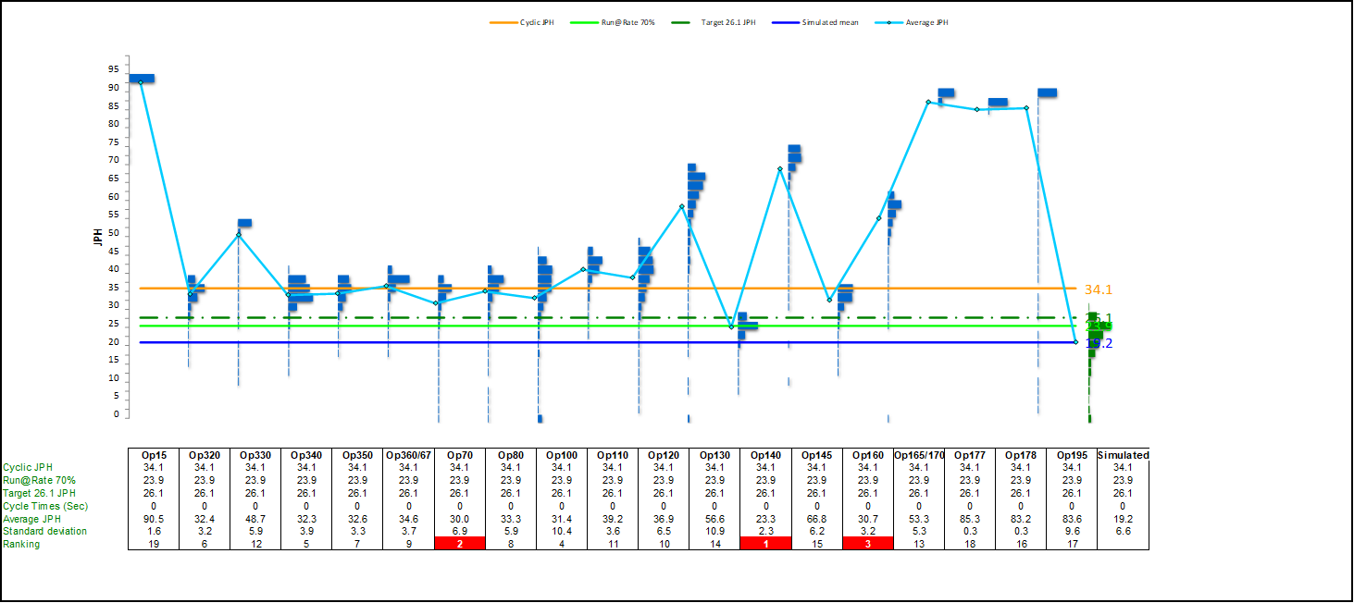
The operational bottleneck analysis shows that if the system was to run with all inputs being accounted for, which include, breakdowns, FTT, tooling and cycle times, data shown in [Table 12] is produced. From this data set, it can be seen that the mean EoL JPH is simulated to be 19.21 over a 500 day period. From the results obtained, it can also be seen that the lowest three JPH zones correlate to Op 140 Honers, Op 70 Machine Front & Rear End Faces and Op 160 Wash, which give a mean JPH score of 23.29, 30.04 and 30.70 respectively.
[Graph 5: The operational bottleneck analysis of AJ-Block line]

From comparison of cyclic simulation model to operational simulation model, it can be seen that there is a loss of 6.73 JPH due to breakdowns and availability of machinery. One improvement which can be suggested is that the MTTF & MTTR of machinery be improved whether from better maintenance strategies or preventative maintenance, in order to increase the availability of the machinery.

Statistical analysis
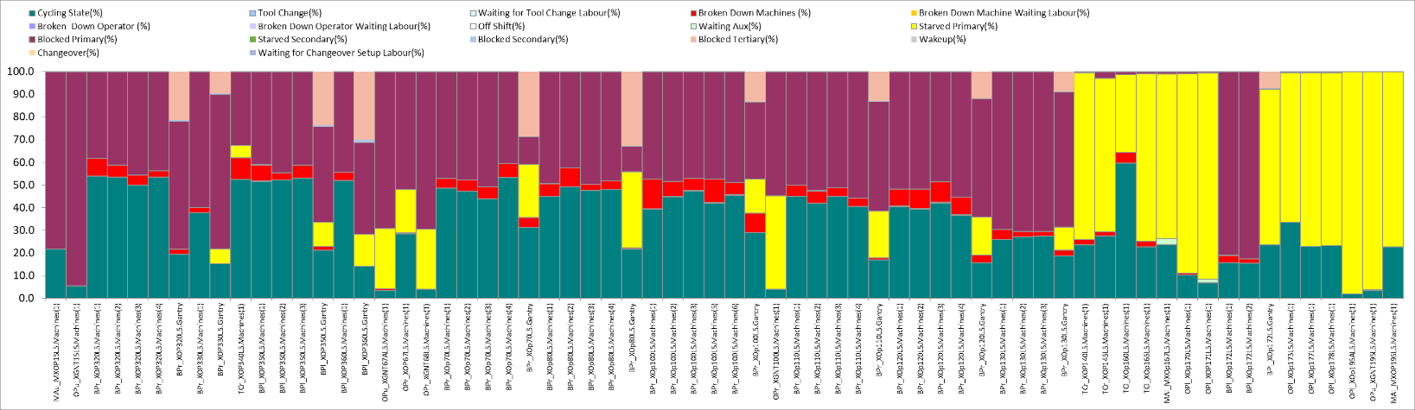
From bottleneck operational analysis areas which need to be targeted, in order to improve through put, include Op 140, Op 70 and Op 160.
[Figure 17: The statistical analysis of AJ-Block line generated by Witness]
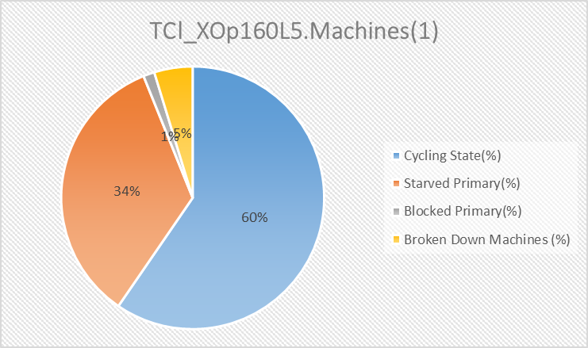
In order to determine further bottleneck areas of the line, all operations are examined, with the output statistics being collected in a stacked column chart. The model generated via Witness creates its own states from the input data given, and report on areas such as utilisation, broken down, blocked or starved. There are numerous methods available in order to determine bottleneck areas using simulation. One method which can be adopted is the utilisation method. This method highlights the operation which is found to have the greatest active time. From [Figure 17], it can be seen that the operation with the greatest active time (Cycling state) is Op 160 Wash.

[Figure 18: A pie chart for the statistical analysis of Op160 Wash]

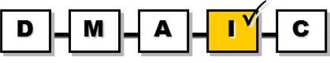
Improve

Base Tests

Cyclic Without Gantry Losses
As an initial test, a simulation can be run in order to determine whether losses are being encountered due to gantry cycle times. In a perfect world, a gantry should not hinder the JPH of an operation. In this simulation the line is set to a cyclic level so that no losses are encountered due to breakdowns. In this simulation study the gantry speed is taken out of the equation, this is making the case that a cells will never be starved due to a wait on a gantry.

Results
 | Op15 | Op320 | Op330 | Op340 | Op350 | Op360 | Op70 | Op80 | Op100 | Op110
Mean JPH | 90.73 | 37.23 | 51.77 | 37.22 | 37.30 | 37.60 | 40.75 | 39.85 | 44.53 | 44.30
 | Op120 | Op130 | Op140 | Op145 | Op160 | Op170 | Op177 | Op178 | Op195 | EoL
Mean JPH | 48.45 | 71.40 | 26.01 | 70.71 | 32.73 | 58.24 | 85.27 | 83.20 | 85.50 | 26.18
[Table 13: Cyclic simulation model results without gantry losses]
Comparing the results obtained from the cyclic experiment without gantry losses, to the cyclic base model results, it can be seen that there are large variations in results between Operations 70 and 130.
 | Operation 70 | Operation 130
Cyclic Base Model | 36.30 | 65.58
Cyclic No Gantry Losses | 40.75 | 71.40
Difference | 4.45 | 5.82
[Table 14: Operational simulation model results for fully flex Op140]
From this simulation test it can be concluded that the gantry travel time is affecting these two operations, which is resulting in loses of 4.45 and 5.82 JPH respectively. As a result of these findings, it can be recommended that to improve throughput of AJ-Block line, Operations 70 & 130 gantries must be improved in terms of their cycle time to load and unload cells.

Target Time
As an initial basic test, a simulation can be run in order to determine whether losses are being encountered due to machine cycle times. From the measurement and analysis stages it can be seen that many machines are currently over cycling, when compared to their original times at initial installation. To determine whether this has a detrimental effect, an operational simulation can be run returning all machines back to their original target time.

Results
 | Op15 | Op320 | Op330 | Op340 | Op350 | Op360 | Op70 | Op80 | Op100 | Op110
Mean JPH | 90.52 | 47.57 | 43.36 | 30.85 | 37.56 | 42.30 | 42.48 | 39.78 | 38.36 | 40.81
 | Op120 | Op130 | Op140 | Op145 | Op160 | Op170 | Op177 | Op178 | Op195 | EoL
Mean JPH | 52.22 | 60.35 | 41.96 | 69.89 | 70.90 | 51.39 | 85.28 | 83.21 | 83.60 | 22.97
[Table 15: Operational simulation model results with target cycle times]
From the results obtained it can be seen that the over cycles encountered by the operations on the line are have a large effect on the EoL JPH. It can be seen that the simulation experiment has an EoL JPH of 22.97 compared to the base model 19.21. This indicates that over cycles in operations are costing the line 3.76 JPH. As a result of these findings, it can be recommended that to improve throughput, efforts must be directed at the cycle time of machinery, restoring machines back to target cycle times.

Constraint Tests
From Bottleneck analysis shown in [Table 12], by using theory of constrain methodology, simulation experiments can be run in order to determine how to break a bottleneck area in order to improve throughput. According to Goldrat (1990), the process capacity is determined via the slowest machine in the system. With this in mind, simulation tests will be implemented in order of ranking, for the main three constraints, which were found to be:
- Operation 140 - Honer - 23.29 JPH
- Operation 70 - Machine front & rear end faces – 30.04 JPH
- Operation 160 - Wash – 30.70 JPH

Braking First Constraint (Operation 140 Honer Fully Flexible)
 | Operation JPH
Base Model | 23.29
Cyclic | 25.97 (+2.68)
Cyclic Without Gantry Losses | 26.01 (+2.72)
Target Time | 41.96 (+18.67)
[Table 16: A summary of basic simulation tests for Op140]
It can be seen from tests which have been undertaken that various improvements can be made to increase the throughput of OP 140. These include:
- Improved availability (Reduced breakdown)
- Improved cycle time of operation
A further study can be simulated surrounding the derivative restraints of Op 140 Honers. In the simulation base model, from assumptions made due to real world restrictions, Operation 140 has certain derivative constraints which include Op140.1 (AJ133 Only), Op140.2 (AJ126 Only) and Op140.3 (AJ126 Only). These derivative constraints can have an impact on EoL JPH, therefore a study can be conducted to determine whether the line will have an increase throughput, as a result of making these three cells fully flexible so that each cell has capability to run both AJ-133 and AJ-126 parts.
When Operation 140 was inputted into the line, three cells were brought in, each with the ability to run V6 and V8 derivatives. Over its working time period, derivative restraints have now been implemented for reasons unknown whether it be tooling, maintenance or by mistake. The current set up of derivative specifications can be seen below:

Actual Experiment
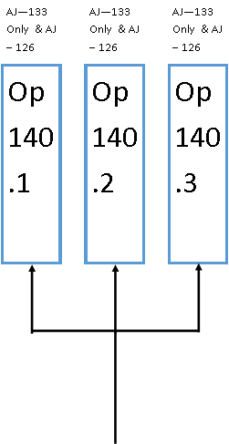
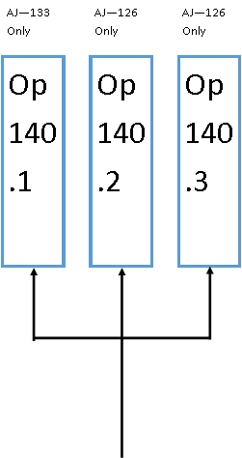

[Figure 19: Derivative constraints surrounding Operation 140 Honers]

Result
 | Op15 | Op320 | Op330 | Op340 | Op350 | Op360 | Op70 | Op80 | Op100 | Op110
Mean JPH | 90.52 | 32.40 | 48.67 | 32.32 | 32.61 | 34.61 | 30.04 | 33.29 | 31.41 | 39.16
 | Op120 | Op130 | Op140 | Op145 | Op160 | Op170 | Op177 | Op178 | Op195 | EoL
Mean JPH | 36.91 | 56.63 | 37.54 | 66.78 | 30.70 | 53.28 | 85.28 | 83.21 | 83.60 | 21.34
[Table 17: Operational simulation model results for fully flex Op140]
Results show that from returning Op 140.1/2/3, back to running fully flexible instead of derivative specific, a simulated EoL JPH can be seen of 21.34 which is a +2.13 improvement on the base model EoL JPH of 19.21. This would result in Op140 dropping out of the top three constraints, giving Op 70, Op 160 and Op 100 as the remaining top constraints.

Breaking Second Constraint (Operation 70 Machine Front & Rear End Faces Gantry Reinstatement)
 | Operation JPH
Base Model | 30.04
Cyclic | 36.30 (+6.26)
Cyclic Without Gantry Losses | 40.75 (+10.71)
Target Time | 42.48 (+12.44)
[Table 18: A summary of basic simulation tests for Op70]
It can be seen from tests which have been undertaken that various improvements can be made to improve the throughput of OP 70. These include:
- Improved availability (Reduced breakdown)
- Reduced gantry cycle time
- Improved cycle time of operation
Gantry Reinstatement
The gantry reinstatement is a suggested improvement, which could be implemented as a measure to identify if EoL JPH increases if efforts were made on maintenance to repair the fallen masts. During the study period for the creation of the base model, it was assumed that the double mast gantries, which supply operations 70 and 130, were running on a single mast. As a result, these gantries have an increased cycle time as they undertake more movements in order to load and unload blocks.
Actual
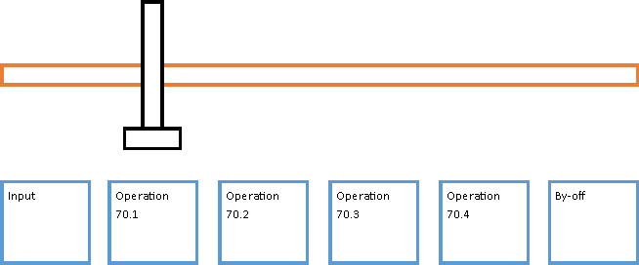
[Figure 20: An I-Gantry (Single Mast)]
The actual gantry on operation 70 and 130 runs on a single mast due to a breakdown on the second mast. The process of a load/unload should be as follows:
- Gantry left picks part from input
- Gantry moves over starved operaption
- Gantry right unloads operation
- Gantry left loads operation
- Gantry moves to buy-off
- Gantry right places part on buy-off
Due to the breakdown which has been encountered, gantry right, is ofline in both operation. This effects the process as only the gantry left is carrying out the jobs, which means this H-Gantry is now working as an I-gantry. As a result, the gantry cycle time for exchange will increase.
Gantry cycle time (I-Gantry)
Operation | 70.1 | 70.3 | 70.5 | 70.2
Load /s | 2.59 | 4.52 | 6.54 | 4
Unload /s | 6.4 | 14.88 | 23.36 | 11.08

Operation | 130.1 | 130.2 | 130.3 | 130.4
Load /s | 2.56 | 5.52 | 6.78 | 4.25
Unload /s | 7.20 | 14.90 | 26.45 | 11.27
[Table 19: Operational simulation model results for fully flex Op140]
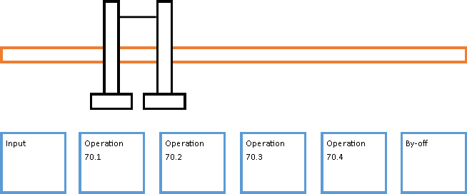
Experiment
[Figure 21: An H-Gantry (Double Mast)]
For the simulation experiment, to replicate the implementation of reinstatement of gantry right, the cycle times for a known working H-Gantry were inserted.
In order to run this experiment, gantry load and unload times are altered to replicate that of a known fully functional H-Gantry, in this case Op 120.
Gantry cycle time (H-Gantry)
Operation | 120.1 | 120.3 | 120.5 | 120.2
Load /s | 3.12 | 3.24 | 9.36 | 2.52
Unload /s | 3.54 | 4.8 | 6.06 | 4.02
[Table 20: Operational simulation model results for fully flex Op140]

Result
 | Op15 | Op320 | Op330 | Op340 | Op350 | Op360 | Op70 | Op80 | Op100 | Op110
Mean JPH | 90.52 | 32.40 | 48.67 | 32.32 | 32.61 | 34.61 | 33.29 | 33.29 | 31.41 | 39.16
 | Op120 | Op130 | Op140 | Op145 | Op160 | Op170 | Op177 | Op178 | Op195 | EoL
Mean JPH | 36.91 | 56.97 | 23.29 | 66.78 | 30.70 | 53.25 | 85.28 | 83.21 | 83.60 | 19.73
[Table 21: Operational simulation model results for fully flex Op140]
Results show that from the reinstatement of the second mast on both Op 70 & 130, a simulated EoL JPH can be seen of 19.73 which is a +0.52 improvement on the base model EoL JPH of 19.21. The top three constraints now correlate to Op 140, Op 160 and Op 100.

Test Three (Operation 160 Wash Cycle Time)
 | Operation JPH
Base Model | 30.70
Cyclic | 32.69 (+1.99)
Cyclic Without Gantry Losses | N/A
Target Time | 70.90 (+40.2)
[Table 22: A summary of basic simulation tests for Op160]
It can be seen from tests which have been undertaken that various improvements can be made to improve the throughput of OP 160. These include:
- Improved availability (Reduced breakdown)
- Improved cycle time of operation
As can be seen in [Table 10], Op 160 Wash is now the cyclic bottleneck machine, this means that if zero breakdowns occur on the line, op 160 would have the lowest net potential JPH due to the cycle time assigned to it. The target cycle time of the machine which was given and signed off by industrial engineering gave a cycle time of 0.772 minutes, since installation the machine now has a cycle time of 1.783 minutes which is an increase of 1.011 minutes. [Table 22] shows that the test with the highest gain is the target time test, this gives a +40.2 JPH in throughput through this operation, indicating that the issue which is restricting JPH is cycle time based, as opposed to breakdown. The increase of cycle time was reported as a necessity due to quality measures. In order to ensure the quality of parts leaving the wash, an increased cycle time is incurred. This is due to the wash not functioning to the standard to which it was installed. A simulation experiment can be run in order to determine the effect of repairing the wash, so that cycle time is reduced. In this experiment Op160 Wash will cycle back to the programme target time of 0.772 minutes.

Result
 | Op15 | Op320 | Op330 | Op340 | Op350 | Op360 | Op70 | Op80 | Op100 | Op110
Mean JPH | 90.52 | 32.40 | 48.67 | 32.32 | 32.61 | 34.61 | 33.29 | 33.29 | 31.41 | 39.16
 | Op120 | Op130 | Op140 | Op145 | Op160 | Op170 | Op177 | Op178 | Op195 | EoL
Mean JPH | 36.91 | 56.97 | 23.29 | 66.78 | 70.90 | 53.25 | 85.28 | 83.21 | 83.60 | 19.72
[Table 23: Operational simulation model results for fully flex Op140]
Results show that from the improved cycle time of Op160 Wash, a simulated EoL JPH can be seen of 19.72, which is a +0.51 improvement on the base model EoL JPH of 19.21. This leads to the top three constraints becoming Op 140, Op 100 and Op 340.

Test Four (Multiple Test Simulation)
In order to break the top three constraints, simultaneous experiments can be run containing all previous constraint experiments, these include:
- Breaking constraint one – Operation 140 Honer – Make all cells fully flexible, removing all current derivative constraints which include Op140.1 (AJ133 Only), Op140.2 (AJ126 Only) and Op140.3 (AJ126 Only).
- Breaking constraint two – Operation 70 Machine Front & Rear End Faces – Reinstate both gantry masts, thus reducing the cycle time of the operation by minimising load and unload times.
- Breaking constraint three – Operation 160 Wash – Improve cycle time of wash by altering back to its programme target time.
In order to improve throughput of the line a study can be undertaken, combining all of the experiments into one simulation to improve throughput.

Result
 | Op15 | Op320 | Op330 | Op340 | Op350 | Op360 | Op70 | Op80 | Op100 | Op110
Mean JPH | 90.52 | 32.40 | 48.67 | 32.32 | 32.61 | 34.61 | 33.29 | 33.29 | 31.41 | 39.16
 | Op120 | Op130 | Op140 | Op145 | Op160 | Op170 | Op177 | Op178 | Op195 | EoL
Mean JPH | 36.91 | 57.46 | 37.54 | 66.78 | 70.90 | 53.28 | 85.28 | 83.21 | 83.60 | 22.45
[Table 24: Operational simulation model results for fully flex Op140]
Results show that combining all three previous constraint experiments, into one final experiment, produces an EoL JPH of 22.45. This is an increase of 3.24 JPH on the original base model of 19.21 JPH. The top three constraints, therefore become, Op 100, Op 340 and Op 320.

Cost Saving
In order to justify the implementation of the experimental findings, cost analysis is undertaken:
Current JPH = 19.21
Improved JPH = 22.45
JPH Increase = +3.2
(Information taken from simulation findings)
Productive Hours/Week = 132
Productive Weeks/Year = 46.4
Increases Jobs/Year = 19844.352
(Information taken from Industrial Engineering department)
Hours Saved = 1033
People on Line = 18
Labour Rate = £43.81
(Information taken from Finance department)
Cost to Produce Improved JPH
Base = £814,620.46 (The basic cost of providing overtime to cover)
Premium = £407,310.23 (The cost of shift allowance)
Fringe = £1,099,737.63 (Additional extras such as health insurance, pension, etc.)
Total Cost = £2,321,668.32

Investment
Capital Investment Requires (£) = £ (To be assessed)
(The investment required will need to be costed via management)

Exchange Rate ($) = 1.27

Net Saving (£) = 2,321,668.32
Net Saving ($) = 2,948,518.77
This cost saving summary illustrates that implementation of the suggested improvements leads to a saving of £2,321,668.32. This saving will be realised from the cost of funding reduced overtime. From making cost savings such as shown it will make BEP a more profitable company, which could play a major role in attracting further manufacturing business.

H-Chart
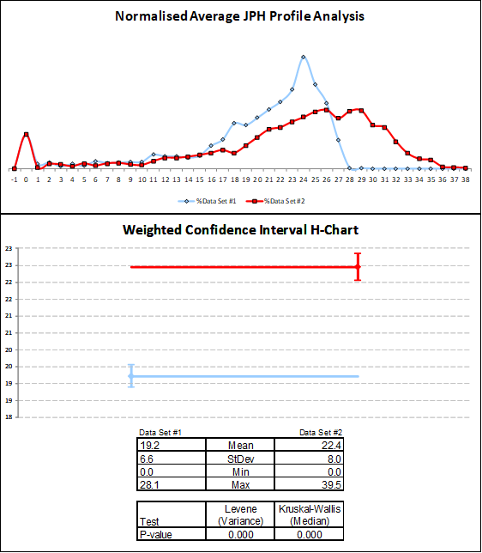
In order to visually represent the improvement which can be obtained from breaking the top three operational constraints, an H-chart can be constructed. Data set one shows the base model which mimics the line as it stands during the study period. Data set two represents the forecasted results from making necessary adjustments to break top three bottleneck areas which include:
- Gantry reinstated to run both mast (Op70, 130)
- Wash to target CT
- Op140 fully flexible

[Graph 6: The H-chart comparison of simulation to actual data sets]
The H-chart illustrates the mean value of JPH increasing from 19.2 to 22.4. The normalised average JPH profile shows how the JPH has now shifted to the right, indicating that there will be a larger volume of higher JPH values obtained from implementation.

Improvement Validation
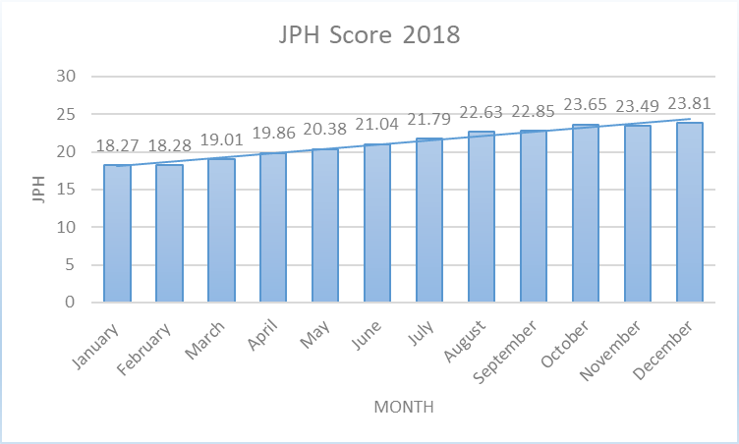
In order to prove whether the improvement actions suggested have had a benefit on throughput of AJ-Block line, JPH score of the line for 2018 can be analysed.
[Graph 7: The JPH score recorded for AJ-Block machining in 2018]
The data displayed shows a positive trend in recorded JPH score. This shows that throughout the year of 2018, throughput has increased from a minimum of 18.27 to a maximum of 23.81. Data analysis and simulation studies started in May of 2018. From the commencement of the simulation studies, it can be seen that JPH scores has rose from 20.38 to 23.81, to the end of December. This is a 14.4% increase in throughput. A steady increase can be seen from January to the beginning of May with an increase EoL JPH of 1.59. Simulation was proposed due to conventional approaches for improving throughput being exhausted, resulting in a further EoL JPH increase.


Control
To ensure the continued positive impact which the implemented improvements have influenced, and the benefits obtained from use of throughput optimization DES, it is imperative that a control strategy is put in place in order for AJ-Block line not to resort back to lower JPH scores.

Strategy

Scheduled Simulation
It can be seen from [Graph 7] that there is a correlation between the use of simulation on AJ-Block line and improved EoL JPH scores. In order to ensure these improved scores remain and increase even further, a strategy must be implemented. The proposed simulation strategy suggests that experiments are re-run on a three month period schedule. With these suggested implementations taking place, it is possible to collect another batch of input data every three months’ and re-run the simulation model.
These scheduled simulation run will entail a simulation engineer revisiting the AJ-Block line with a new three month period of base data such as cycle times, breakdowns and scrap, which can then be added to the model. From re-running the experiment it will be possible to identify a fresh set of top three constraints, where new experiments can be run to overcome them and further improve EoL JPH. This proposed strategy of further throughput optimization experiments, will seek to prevent this block line from under achieving, by detecting the main constraints/bottlenecks of the line every three months with a new data input set.
Weekly meetings have been arranged in order to discuss any simulation findings or further experiments which are to be run. This ensures that simulation stays as an adopted constraint finding tool, used to improve throughput and suggest possible improvements.

Automatic Data Collection
In order to ensure that input data is always being updated for AJ-Block line, it could prove beneficial to automatically update the data set instead of manually. This would mean that all data such as breakdown data and cycle times could be automatically updated with the past three months’ worth of data instantly. In order to do this, an updated tool set is in the process of being built named ‘Faster’. This new tool would replace FAST for future simulation projects. FASTER will be a modelling tool which utilises the data analysis tool ‘Alteryx’ instead of the current excel tasks. Alteryx provides the ability to automate manual data tasks into repeatable analytical workflows, such as, data pulling for breakdowns and cycle times. This will ensure that data is constantly being pulled keeping models up to date and simulation models being readily available to management. The proposed idea is to link ‘Alteryx’ workflows to current data capturing software such as POSmon and FIS. This would mean models could be updated on a daily basis. These models being constantly validated by simulation engineers in the same methods, ensuring models are correct and ready for use. By achieving this, models will provide a more accurate representation of the current system under analysis.

Conclusion
The overall goal of the project was to deep dive into current issues which are being encountered on the AJ-Block machining line, these issues included cycle times and breakdowns of machinery. This data being first captured, analysed and then, imported into a simulation model of the line. From utilising the simulation model, identification of the line production constraints being encountered, were forthcoming. Analysis of these constraints was undertaken to formulate important recommendations and suggestions for increased EoL JPH. Key to the recommendations and suggestions was achievement of target and avoidance of assembly stoppages due to block shortages.
This main aim of improving EoL JPH would be achieved via the set objectives:
- Collect data on AJ-Block machining (Cyclic, Gantry, Tooling, Breakdown, Gauging, FTT, Scrap and Manning).
- Analyse data, ensuring data is not skewed. Create distributions for breakdowns on machinery, including availability, mean time between failure (MTTF) and mean time to repair (MTTR).
- Create a simulation model of the current process.
- Import data into a simulation model of the current AJ-Block line, to validate and verify the model is working correctly.
- Identify system constraints/ bottlenecks
- Suggest improvements which could be implemented in order to improve end of line JPH by breaking bottleneck areas.
The initial steps looked at the collection of data from sources to obtain the information necessary to create a reliable simulation model. This objective can be considered complete with three months’ worth of data being collected for cycle times, gantry times, tooling, breakdowns, gauging, FTT, scrap and manning.
The next step looked at using the collected breakdown data to create distributions in order to represent the availability, MTTF and MTTR of each cell currently found within the operations. This can be considered complete from the creation of the distribution summary located in [Table 7].
Subsequent to data collection and analysis stages being complete, the project looked at inputting the data into a newly created simulation model representing AJ-Block line. It can be seen that a model has been created with verification and validation being carried out. From validation of the model it can be seen that both data sets, one being actual data pulled from shift reports and the other the output of simulation matched, with a mean JPH of 16.4 and 16.5 respectively. It was then agreed that the base model created was statistically equivalent to plant production, resulting in the model being fit for experimentation simulation. From this validated base model it could be understood that the top three constraints encountered within the systems were:
- Operation 140 – 23.29 JPH
- Operation 70 – 30.04 JPH
- Operation 160 – 30.70 JPH

From these findings it was possible to create experimental simulations to overcome these bottleneck areas and improve overall throughput. The recommended actions looked at breaking the necessary bottleneck areas by making the improvements of:
- Breaking constraint one – Operation 140 Honer – Make all cells fully flexible, removing all current derivative constraints which include Op140.1 (AJ133 Only), Op140.2 (AJ126 Only) and Op140.3 (AJ126 Only).
- Breaking constraint two – Operation 70 Machine Front & Rear End Faces – Reinstate both gantry masts, thus reducing the cycle time of the operation by minimising load and unload times.
- Breaking constraint three – Operation 160 Wash – Improve cycle time of wash by altering back to its programme target time.
From breaking these top three bottleneck areas with the suggested improvements, it can be quantified that EoL JPH will be increased to 22.45 which is +3.2 improvement on the current JPH score of 19.21. These findings conclude that the main aim of increasing throughput of AJ-Block has been achieved additionally, by achieving this main aim a cost reduction has been identified, being a saving of £2,321,668.32 which would now be realised from not funding overtime in pursuit of current JPH target levels. Moreover, this saving is made with increased productivity predicted by the simulation.
In conclusion, discrete event simulation has proved a beneficial tool in constraint identification and throughput optimisation. Due to positive projects such as this, the use of simulation is now becoming a Ford worldwide tool with more industrial engineers being trained in simulation in order to carry out similar tasks in various plants. It is the ideal that discrete event simulation will be used in every plant day in day out in order to make the business more profitable and efficient. The use of simulation is supported by the director of manufacturing powertrain operations who stated, ‘I have witnessed the evolution of the simulation tool and successful application within PTME and some of our plants over the past few years. I am more convinced than ever that there is no better tool for us to use to undertake our engineering work upfront and validate spend prior to commitment. This is the future and we should adopt it within our current roles, as substitutional not additional workload’, Kieran Cahill, (2018).

Future Experiments
Although the main aim of improving throughput has been achieved, it is still possible to elevate EoL JPH by running further experiments to achieve the 70% programme target of 25.58. In order to achieve this 70% programme target, it would be beneficial to run further experiments aimed at breaking more deeply the main constaints.
- Test the effect of changing the feed ratio of the line, deducing the best input ratio of AJ133 to AJ126. Currently a feed in file uses a 58:10 batch feed for AJ126 to AJ133, experiments can be run to identify the optimal feed ratio.
- Making line fully flexible, then analyse the effect on output JPH. This test would look at removing all derivative restraints which have been imposed for various reasons and determine if it is hindering production.
- Making line fully flexible and bringing all machines back in to target cycle times, to quantify the best JPH increase possible with the breakdowns distributions which are currently being found.
- Running a platen optimization experiment. As previously mentioned, when a block in inputted onto a line it is attached to a platen which is used to transport the block on conveyor systems. It may be found that there are not enough platens being found online which is causing starvation or too many causing blockages. A platen optimization experiment will find the precise number of platens needed online to give the optimal EoL JPH.
As simulation has proven a valuable tool in improving throughput and reducing cost it has been recommended for use within other areas of BEP. These areas include:
- MOD 1 - A machining line which produces the AJ-Head for the AJ 126 & 133 (V6/V8) engine.
- Dragon – This is split into three machining lines and an assembly line. In order to carry out simulation on these lines, models will be either be created or updated with a new accurate three month period of base data.

References
Anderson, H. (1974). An Investigation into Scheduling for an Interactive Computer System. IBM Journal of Research and Development. 18(2), 125-137.
Arsham, H. (1996). Performance Extrapolation in Discrete-event Systems Simulation. Journal of Systems Science. 27(9), 863-869.
Baines, T. Mason, S. Siebers, P.O. and Ladbrook, J. (2004). Humans: the missing link in manufacturing simulation? Simulation Modelling Practice and Theory. 12(7-8), pp.515-526.
Camillo, J (2017). Simulation Software Helps Nissan Design, Manage Assembly Lines. Available at: https://www.assemblymag.com/articles/94038-simulation-software-helps-nissan-design-manage-assembly-lines. [Accessed: 14/02/19].
Christiansen, B (2018). MTTR, MTBF or MTTF – A simple guide to failure metrics. Available at: https://limblecmms.com/blog/mttr-mtbf-mttf-guide-to-failure-metrics/. [Accessed: 21/01/19].
Cisco. (2018). Digital manufacturing. Available at: https://www.cisco.com/c/en/us/solutions/industries/manufacturing.html. [Accessed 11/12/18]
Dias, L., Vieira, A.A., Pereira, G.A. and Oliveira, J.A. (2016). December. Discrete simulation software ranking: a top list of the worldwide most popular and used tools. In Proceedings of the 2016 Winter Simulation Conference (pp. 1060-1071). IEEE Press.
Fagan, M. (1976). Design and code inspections to reduce errors in programme development. IBM Systems Journal. 15(3), pp. 182-211.
Faget, P., Eriksson, U. and Herrmann, F. (2005). December. Applying discrete event simulation and an automated bottleneck analysis as an aid to detect running production constraints. In Proceedings of the 37th conference on Winter simulation (pp. 1401-1407).
Ford UK, (2019). Bridgend Engine Plant. Available at: https://corporate.ford.com/company/plant-detail-pages/bridgend-engine-plant.html. [Accessed 04/02/19].
Goh, T. (2002). A strategic assessment of Six Sigma. Quality and Reliability Engineering International, 18(5), pp.403-410.
Goldratt, E. (1990). What is this thing called Theory of Constraints and how should it be implemented? pp. 65-98.
Griffin, A. (1993). ‘The voice of the customer’. Marketing science, 12(1), pp.1-27.
Higgins, H. (2014). Fitness of Simulation. Available at: http://orca.cf.ac.uk/61450/. [Accessed: 20/01/19]
Jacka, J. (2009). Business process mapping: improving customer satisfaction. John Wiley & Sons. pp. 13 – 24.
Jayaraman, A. and Gunal, A.K. (1997), January. Applications of discrete event simulation in the design of automotive powertrain manufacturing systems. In Winter Simulation Conference, 1(1). pp. 758-764.
Kleijnen, J.P. (1995). Statistical validation of simulation models. European journal of operational research. 87(1). pp.21-34.
Leal, F., Costa, R.F.D.S., Montevechi, J.A.B., Almeida, D.A.D. and Marins, F.A.S. (2011). A practical guide for operational validation of discrete simulation models. Pesquisa Operacional. 31(1). pp. 57-77.
Made Smarter. (2017). Available at: https://www.gov.uk/government/publications/made-smarter-review. [Accessed 11/12/18].
Markarian, J. (2004). What is Six Sigma? Reinforced Plastics. 48(7). pp. 46-49
T. Miller and P. Strooper. (2003). A Framework and Tool Support for the Systematic Testing of Model-Based SpeciÖcations. ACM Transactions on Software Engineering and Methodology. 12(4). pp. 409-439.
Oreskes, N., Shrader-Frechette, K. and Belitz, K. (1994). Verification, validation, and confirmation of numerical models in the earth sciences. Science. 263(5147). pp. 641-646.
Pande, P,S. (2002). What is six sigma? (Vol. 1). New York: McGraw-Hill.
Robinson, S., Brooks, R., Kotiadis, K. and Van Der Zee, D.J. eds. (2010). Conceptual modelling for discrete-event simulation. CRC Press.
Robinson, S., Arbez, G., Birta, L.G., Tolk, A. and Wagner, G. (2015). December. Conceptual modelling: definition, purpose and benefits. In Proceedings of the 2015 winter simulation conference. pp. 2812-2826. IEEE Press.
Saboe, D. (2016). Addressing Bottlenecks with Theory of Constraints. Available at: http://masteringbusinessanalysis.com/mba082-addressing-bottlenecks-theory-constraints/. [Accessed: 02/03/19].
Simon,k. (2017). The cause and effect. Available at: https://www.isixsigma.com/tools-templates/cause-effect/cause-and-effect-aka-fishbone-diagram/. [Accessed: 28/09/17].
Stiles, J. (2011). POSMon. Available at: https://mfg.spt.ford.com/sites/VOMOS/Shared Documents/POSMon overview.ppt. [Accessed 12/02/19].
Tang, L.C., Goh, T.N., Lam, S.W. and Zhang, C.W. (2007). Fortification of Six Sigma: expanding the DMAIC toolset. Quality and Reliability Engineering International. 23(1). pp. 3-18.
U.S. Department of Defence. (2009). DOD Modelling and Simulation (M&S) Verification, Validation, and Accreditation.
WalesOnline, (2014). Car giant Ford appoint a new plant manager at Bridgend. Available at: https://www.walesonline.co.uk/business/business-news/car-giant-ford-appoint-new-7072972. [Accessed 04/02/19].

Appendices
Tool ID Number | Description | Hole/Feature Machined | Variant | Tool Life Minutes
AB-320-01 | Probe | Temp Comp | AJ133/AJ126
AB-320-02 | Milling Cutter | Op320 Bearing Cap fixing Faces - Op350 Faces F800, F900 B & C | AJ133/AJ126 | 3125
AB-320-03 | Step Drill | Bearing Cap fixings Outer Holes #331 - #340 | AJ133/AJ126 | 470
AB-320-04 | Step Drill | Bearing Cap fixings Inner Holes #341 - #350 | AJ133/AJ126 | 509.8333333
AB-320-05 | Tap M8 x 1.25 | Op320 Bearing Cap fixings Outer Holes #331 - #340 - Op350 Holes #300, #304, #306, #308, #311, #315 | AJ133/AJ126 | 1548
AB-320-06 | Tap M10 x 1.5 | Bearing Cap fixings Inner Holes #341 - #350 | AJ133/AJ126 | 2373.333333
AB-320-07 | Boring Bar | Bearing Cap fixings Outer Holes #331 -#340 | AJ133/AJ126 | 960
AB-320-08 | Milling Cutter | Piston Jet Faces F355 - F358 | AJ133 SC/AJ126 | 3483.333333
AB-320-09 | Step Drill | Drill #355 - #358 | AJ133/AJ126 | 190
AB-320-10 | Milling Cutter | Mill Bearing Fixing Semi Finish | AJ133/AJ126 | 4500
AB-320-11 | Milling Cutter | Mill Bearing Fixing Finish | AJ133/AJ126 | 9000
AB-320-12 | Reamer | Ream #355 - #358 | AJ133 SC/AJ126 | 1000
AB-320-13 | Drill | Drill #351 - #354 + Part Marking Holes | AJ133 SC/AJ126 | 414
AB-350-14 | Milling Cutter | Mill face F900 faces A C E F G H J K M N | AJ133/AJ126 | 2720
AB-350-15 | Step Drill | Drill #941, #823 | AJ133/AJ126 | 470
AB-350-16 | Step Drill | Drill #316, #317 | AJ133/AJ126 | 167.5
AB-350-17 | Step Drill | Drill #300, #304, #306, #308, #311, #315 Drill Marking points #372, #373, #374, #374, #375 | AJ133/AJ126 | 328.1060606
AB-350-18 | Step Drill | Drill #301 - #303, #305, #307, #309, #310, #312 - #314, #320,  #321 - #325, #327, #328 | AJ133/AJ126 | 342.9824561
AB-350-19 | Step Drill | Drill #371 | AJ133/AJ126 | 180
AB-350-20 | Drill | Drill #318, #322, #917 | AJ133/AJ126 | 160
AB-350-21 | Boring Bar | Holes #316, #317 | AJ133/AJ126 | 1750
AB-350-22 | Milling Cutter | Mill # Face F300 (S face) | AJ133/AJ126 | 927.5
AB-350-23 | Boring Bar | Holes #318, #322 | AJ133/AJ126 | 1400
AB-350-24 | Boring Bar | Holes #329, #330 | AJ133/AJ126 | 2158.333333
AB-350-25 | Step Drill | Hole #940 | AJ133/AJ126 | 455
AB-350-26 | Tap | Holes #941, #823 | AJ133/AJ126 | 136.1666667
AB-350-27 | Step Drill | Holes #912 + Part Mark | AJ133/AJ126 | 186.6666667
AB-350-28 | Carbide Step Drill | Drill Counterbore Hole #304 | AJ126 | 110
AB-350-29 | Milling Cutter | Mill Inner Boss | AJ126 | 1024
AB-070-17 | Milling Cutter | Interpolate Mill Hone Clearance Bores #C1 - #C6 | AJ133/AJ126 | 1400
AB-070-18 | Milling Cutter | Interpolate Mill Hone Clearance Bores #C1 - #C8 | AJ133/AJ126 | 1400
AB-070-19 | Step Drill | Drill #415, #512 | AJ133/AJ126 | 250
AB-070-20 | Step Drill | Drill #500, #501 & #400, #401 | AJ133/AJ126 | 175
AB-070-21 | Milling Cutter | 2 x Part Marking Pads | AJ133/AJ126 | 6000
AB-070-24 | PCD - Monoblock | Holes #624, #625 | AJ133/AJ126 | 4000
AB-070-25 | Drill | Hole #627 | AJ133/AJ126 | 750
AB-070-27 | PCD - Monoblock | Hole #627 | AJ133/AJ126 | 3250
BL 070 34 | Mono End Mill | Mill F600, 622 and 623 | AJ126 and AJ133 | 833
BL 070 36 | Gauge | Gauge Thrust Face | AJ133/AJ126
SB-080-08 | Tap M10 x 1.5 | Holes #917, #912, #802 - #810 | Si6 AJ133/AJ126 | 1596
BL-080-11 | Gauge | Temp Comp | AJ133/AJ126
AB-080-12 | Drill | Drill C'Bore Holes #913 - #916 | AJ133/AJ126 | 460.4166667
SB-080-14 | Tap M8 x 1.25 | Tap Holes #913 - #916 | Si6 AJ133/AJ126 | 1012.7
AB-080-18 | Step Drill | Holes #917, #802 - #810 | AJ133/AJ126 | 355
AB-080-20 | Boring Bar | Hole #824 | AJ133/AJ126 | 2166.666667
AB-080-20 | Step Drill | Holes #800, #801, #824 | AJ133/AJ126 | 166.6666667
AB-080-21 | Step Drill | Holes #812 - #819, #900 - | AJ133/AJ126 | 511.2121212
AB-080-22 | End Mill | Mill Pad #944 | AJ126 | 740
AB-080-23 | Carbide Step Drill | Drill Counterbore Hole #943 | AJ126 | 316.6666667
AB-080-24 | Cut Tap M8 X 1.25m | Tap Hole #943 M8 x 1.25mm | AJ126 | 128.975
AB-080-25 | Thread Mill M14 x 1.5mm | Thread Mill Holes #820 M18 x 1.5mm, #821, #931 & #932 M24 x 1.5mm | AJ133/AJ126 | 990
AB-080-26 | End Mill | Spot Face #944 & #945 | AJ126 | 1178.333333
AB-080-33 | PCD End Mill | Mill Sensor Face | AJ126 | 5437.5
AB-080-34 | Carbide Drill | Spot Face #121 | AJ126 | 312.5
AB-080-35 | Carbide Drill | Drill #121 | AJ126 | 125
AB-100-01 | PCD Bore | Dowel Holes #800, #801 | AJ133/AJ126 | 1192
AB-100-01 | Bi Metal Bore | Semi Finish 1st Bearing #800 | AJ133/AJ126 | 34.79166667
AB-100-01 | Bi Metal Bore | Finish 1st Bearing #800 | AJ133/AJ126 | 139.1666667
AB-100-02 | End Mill | Holes #936, #937 | AJ133/AJ126 | 155.8333333
AB-100-03 | Boring Bar | Rough Crank Bore | AJ133/AJ126 | 83.33333333
AB-100-04 | Brush | Brush Crankbore | AJ133/AJ126 | 166.6666667
AB-100-05 | Milling Cutter | Faces # F900 & F800 | AJ133/AJ126 | 5885
BL-100-06 | Gauge | Temp Comp | Si6 AJ133/AJ126
BL-100-09 | Milling Cutter | Face # F800 | Si6 AJ133/AJ126 | 185.9
AB-100-10 | Step Drill | Drill Counter Bore Holes #944 & #945 | AJ126 | 153.3333333
AB-100-11 | Carbide Reamer | Ream Holes #944 & #945 | AJ126 | 183.3333333
AB-100-12 | Back Chamfer Cutter | Chamfer Holes #943 - #945 | AJ126 | 245
AB-100-13 | Boring Bar | Fine Bore Crankbore | AJ133/AJ126 | 288.9033333
BL-110-23 | Milling Cutter | Mill Pads F100, F101, F103, F104, F105, F106, F708, F718, F705, F706, F700, F704, F600, F622, F623 | AJ133/AJ126 | 33600
AB-110-13 | Drill | Holes # 622, #623 | AJ133/AJ126 | 186.6666667
AB-110-14 | Step Drill | Holes # 700 - #704 & #100, #101, #103, #104 | AJ133/AJ126 | 300.9259259
AB-110-15 | Step Drill | Holes # 705, #706 & #105, #106 | AJ133/AJ126 | 472.5
AB-110-16 | PCD - Monoblock | Holes #705, #706 & #105, #106 | AJ133/AJ126 | 1100
AB-110-17 | Step Drill | Holes # 708, 718, 514-516, 604-621, 601-602, 412-414 | AJ133/AJ126 | 439.7435897
AB-110-18 | PCD - Monoblock | Holes # 400, 401 & 500, 501 | AJ133/AJ126 | 825
BL-110-21 | Gauge | Temp Comp | Si6 AJ133/AJ126
AB-110-25 | Step Drill | Drill Counter Bore Holes #118 & #119 | AJ133/AJ126 | 249.1666667
AB-110-27 | Tap M8 x 1.25 | Hole # 122 | AJ126
AB-110-28 | Drill | Hole #120 | AJ126 | 1075
AB-110-29 | Back Chamfer Cutter | Hole # 120 | AJ126 | 875
AB-110-30 | PCD - Monoblock | Hole #120 | AJ126 | 4203.333333
AB-110-31 | Step Drill | Hole #122 | AJ126 | 735
AB-110-32 | Tap M10 x 1.5 | Tap Holes #700 - #704 & #100, #101, #103, #104 | AJ133/AJ126 | 1613.333333
AB-110-34 | Tap M8 x 1.25 | Tap Holes #705, #706 & #105, #106 | AJ133/AJ126 | 2420
AB-120-03 | M042 Boring Bar | Semi Finish Bore Cylinder Bores #C1 - #C6 AJ126 | AJ126 | 89
AB-120-03 | M042 Boring Bar | Finish Bore Cylinder Bores #C1 - #C6 AJ126 | AJ126 | 492
AB-120-03 | M042 Boring Bar | Chamfer Cylinder Bores #C1 - #C6 AJ126 | AJ126 | 50
AB-120-05 | M042 Boring Bar | Semi Finish Bore Cylinder Bores #C1 - #C8 AJ133 | AJ133 | 84
AB-120-05 | M042 Boring Bar | Finish Bore Cylinder Bores #C1 - #C8 AJ133 | AJ133 | 392
AB-120-05 | M042 Boring Bar | Chamfer Cylinder Bores #C1 - #C8 AJ133 | AJ133 | 50
AB-120-07 | Mapal Boring Bar (Fixed Tooling) | Semi-Finish & Chamfer Cylinder Bores #C1 - #C6 AJ126 | AJ126 | 600
AB-120-08 | Mapal Boring Bar (Fixed Tooling) | Finish Cylinder Bores #C1 - #C6 AJ126 | AJ126 | 825
AB-120-11 | Mapal Boring Bar (Fixed Tooling) | Semi-Finish & Chamfer Cylinder Bores #C1 - #C6 AJ126 | AJ126 | 600
AB-120-12 | Mapal Boring Bar (Fixed Tooling) | Finish Cylinder Bores #C1 - #C6 AJ126 | AJ126 | 750
BL-130-01 | Gauge | Temp Comp
AB-130-04 | Milling Cutter | Finish Mill F400 & F500 | AJ133/AJ126 | 3472.221
AB-130-07 | Tap M10 | Tap Holes #402-#411 & #502-#511 | AJ133/AJ126 | 3252
AB-130-08 | PCD - Monoblock | Holes # 622, #623 | AJ133/AJ126 | 1200
[Table 25: The tooling life for AJ-Block machining]

