Community Care and Development

Formal Paper

Submited by Oana Chirila
University Of Wales Trinity Saint David

Student Number 1706160
Submission date 04-01-2022

Content list

- Introduction
- Main body
- Conclusion
- Appendix
- Reference list

- Introduction

This formal paper focuses on domestic abuse and all forms of violence directed at women in Wales who are experiencing or at risk of domestic and sexual abuse, as well analyse the community’s efforts to raise awareness and educate the community in a beneficial way.
Most people today join a community because they feel safe sharing their values and getting involved in supporting others (Clarabut, 2020). When it comes to complex challenges such as domestic violence directed at women a community is built to meet the needs of its members to provide protection and to overcome. In this scenario, the objective of a community is to bring people together to campaign for and support each other in the effort to overcome any challenges. Individuals and communities can work together to build a culture in which victims of domestic abuse are informed about their legal rights and local resources available to them, raising awareness of the problem and challenging attitudes and behaviours.
Domestic abuse is a pattern of behaviour intended to gain or retain power and control over a partner in a relationship (Welsh Women’s Aid, 2021). It might take the form of physical, sexual, emotional, financial, psychic acts or threats against another individual. Any behaviour that frightens, intimidates, terrorises, manipulates, injures or humiliates somebody falls into this category. Domestic abuse affects people of all races, ethnicities, ages, sexual orientations, religions, and genders from all aspects of everyday life and at all levels of education (Welsh Government, 2021). It is reassuring to know that there are organisations that can help those who have been victims of violence. Women and children seeking safety can find emergency and temporary shelter, as well as assistance, information, and a variety of other services. The services are completely free and anonymous. (Citizens Advise, 2022).

- Main body
According to the Crime Survey for England and Wales in 2020, an estimated 2,3 million adults in England and Wales were victims of domestic violence in the last year with 1,6 million women compared with 757,000 men. (Stripe, 2020). Experts researching this topic agree that violence is a widespread problem in Wales, as estimates indicate about 11% of women and 5% of men are affected by domestic abuse each year, despite the fact that is significantly lower compared with 15 years ago (Robinson et al., 2012). Domestic violence instances continue to exist due to a limited of funding for non-governmental organisations to develop these services, set strategies, support victims and improve health and related services (Welsh Government, 2010).
The indicators of violence are not always evident, but they are linked to a variety of situations including tiredness, loss of interest and, in the case of victims a strong sense of guilt (Buddy, 2020). Domestic violence manifests itself in the family, which becomes less transparent and accessible to the immediate social environment such as extended family, neighbours, friends, and co-workers. These families are clearly socially isolated. They develop a stigma in the eyes of others, as well as a sense of shame and regret that causes them to withdraw (National Health Service, 2019).
According to the National Coalition Against Domestic Violence the impact of domestic violence will cause physical and mental trauma to women where in severe cases death, and will affect the majority of people at some point in their lives (Brown, 2021). The National Health Service play an important role in identifying and assessing people who are victims of domestic violence since they can be the initial point of contact with experts who could provide the support they need (The National Assembly for Wales, 2001).
The criminal justice system deals with the majority of domestic abuse cases, which sometimes are difficult to prosecute because they necessitate the consideration of any measure or support services to guarantee that the victim's safety and support requirements are adequately understood and addressed. The Domestic Abuse Act of 2021 intends to ensure that the legal system is successful in protecting victims of domestic violence and to create knowledge about the effects of domestic abuse on victims and their families in this respect (The Crown Prosecution Service, 2020).
In accordance with international obligations, the Violence Against Women, Domestic Abuse and Sexual Violence (Wales) Act 2015 aims to combat and reduce all forms of violence against women who have experienced or are at risk of domestic and sexual abuse, as well as all forms of gender-based violence, which are all considered violations of human rights (Welsh Government, 2021). In this way, the government has been quite effective in providing clear, logical, and compelling messages through all forms of media and communication campaigns in conjunction with the sector. More campaigns will be conducted, according to the government, to promote public awareness and give victims and potential victims confidence that they will be supported.
There are various organisations in Wales that can give direct services to women and children who have experienced or are at risk of domestic abuse (United Welsh, 2021), as well as act as regulators and enforce the letter of the law. Non-governmental organisations that carry out specialised operations in this dominium must work together with their stakeholders, local authorities, the National Health Service, General Practices, the Criminal Justice System, the police and anybody in the community to deliver efficient social services.
A well-known domestic abuse prevention organisation is Welsh Women Aid, a national charity organisation that was founded 1978 with the aim of ending domestic abuse and other forms of violence against women (Welsh Women’s Aid, 2022). Since its inception, the organisation has worked as part of a United Kingdom of services supported by the Welsh Government, campaigning for change and providing advice, support, consultation and training to all women, children and families who have been victims of violence and abuse. To optimise their ability, the organisation will collaborate with other services and systems to focus on preventing abuse from occurring in the first place and challenging perpetrators while they are still abusing others. The goal of the organization's approach is to ensure that women and girls in Wales attain independence, freedom and emancipation from discrimination, disadvantages and oppression so that they can fully participate in society.
A significant part of spreading awareness is by making campaigns that send a message that reaches people and either informs them of important aspects through existing media such as television, radio and newspapers (Wakefield, Loken and Hornik, 2014). Campaigns for change aim to change public perception, legislation or just simply raise awareness to an issue in order to persuade people to change their thoughts about certain topic by educating them (Neighbourhood Watch, 2020). The use of social media in campaigns for change is essential since it is the most effective technique of capturing people's attention and generating awareness about the issue. Social media allows to reach people of any age and gender, and it is also well known for easily sharing posts with friends which means that will encourage get more people sharing posts about the campaign without having to put in more effort or money (see appendix, fig. 3).
Welsh Women’s Aid performs an excellent job in this area, having launched several social media campaigns aimed at keeping women safe from all different types of abuse. Welsh Women’s Aid campaigns to improve practice and services for survivors of domestic violence and abuse, as well as to influence laws and policy in Wales or the United Kingdom as a whole (Welsh Women’s Aid, 2021).
The Ask Me project aims to change the way communities respond to domestic violence and abuse towards women. They provide free training and ongoing support that helps community members start conversations about abuse and help out survivors in their area (Welsh Women’s Aid, 2021).
Stand With Survivors is their response to COVID-19 and the rise in domestic abuse cases in isolation (Welsh Women’s Aid, 2021). They have created flyers to help members of the community recognise the signs of domestic abuse. Their most prominent way of bringing attention to the issues is through social media platforms such as Twitter or Facebook where they encourage their followers to share certain postings with friends and help spread the message or donating on the Welsh Women’s Aid website.
The No Grey Area campaign, which was launched on International Women’s Day, aims to end sexual harassment in the workplace and shows shocking data such four out of every five women having experienced sexual harassment at work (Welsh Women’s Aid, 2021). They also taken the opportunity to sell merchandise such as t-shirts in collaboration with feminist fashion brand Black & Beech, and for every t-shirt bought a 5£ will be donated (Welsh Women’s Aid, 2021) but also indirectly help others in being aware of the campaign by seeing the t-shirts worn by people.

In order for an awareness campaign to be effective, the target audience must be able to relate to the message and know clearly the problems and solutions. It is also necessary to provide people with services and resources which can only be done if the target audience is considered. Public awareness campaigns are more effective when the target audience is aware that they are the target audience. This can be done in subtle ways such as colour schemes and specific language, or it can be done explicitly by stating that the campaign is aimed at a specific demographic. It is simpler to relate to an audience when the objective is a specific group, but it is more difficult to transmit a message that includes everyone when the target is the entire population. If the goal of raising awareness and changing community views is to be achieved, everyone must listen (Jones, 2015).
Campaigns against domestic violence have been around for a long time, but as technology improves the methods of campaigning have shifted as well. According to a recent awareness campaign, domestic violence campaigns are becoming more powerful as technology improves. (Bowler, 2021). However, a message about domestic abuse can occasionally be so persuasive that the number of domestic abuses cases increases rather than decreasing. In this scenario it is recommended that the audience is aware of a clear message not to instigate the audience (see appendix, fig. 2).
According to statistics and evidence collected from police reports, surveys, the Crown Prosecution Service and other sources, serve to demonstrate that domestic violence, in all of its forms, is on the rise/decrease (Gouk and Hayward, 2020). In order to determine the metrics of success in the effort of organisations fighting domestic violence, data is used to contrast some types of violence that have grown/decrease in intensity with those that are neglected or accepted as representations of normalcy (see appendix, fig. 1).

- Conclusion
Domestic violence against women is a severe problem in Wales, as evidenced by this formal paper, and can take the form of physical, emotional, or sexual violence. The community's duty is to bring people together to campaign for and support one another in order to overcome obstacles and change people's attitudes and behaviours. Women and children who have suffered or are at risk of domestic violence can access free and anonymous temporary refuge, as well as support, information, and a range of other resources. Symptoms of violence are not always obvious, but they are linked to a wide range of situations and can result in physical and mental damage for the majority of people at some point in their lives. The role of community, local authority or health services are to identify and assess people who have been victims of domestic violence as they can be the first point of contact for experts who can provide the support they need. Organisations like Welsh Woman’s Aid, give direct services to women and children who have experienced or are at risk of domestic abuse with the aim of ending domestic abuse and other forms of violence against women. They campaign to keep women safe from all different types of abuse, to influence laws and policy and to work together with other services and systems to focus on preventing abuse in the first place, as well as challenging perpetrators when they are still abusing others.

- Appendix

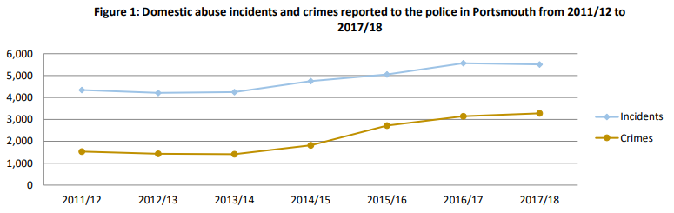
(2019), Portsmouth Domestic Violence and Abuse Strategy 2020-2023.

Fig. 2 Image from Welsh Women’s Aid campaigns
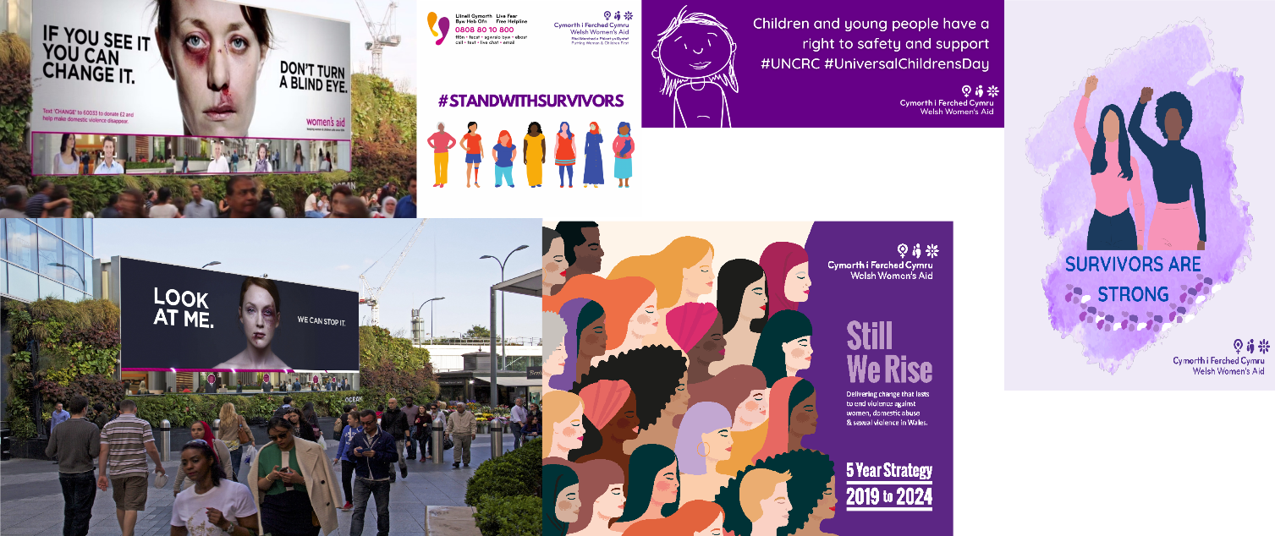

Fig. 3 These resources despleyed below, which were created by the author of this paper, are an example of how individuals may contribute to campaigns to end domestic violence against women.

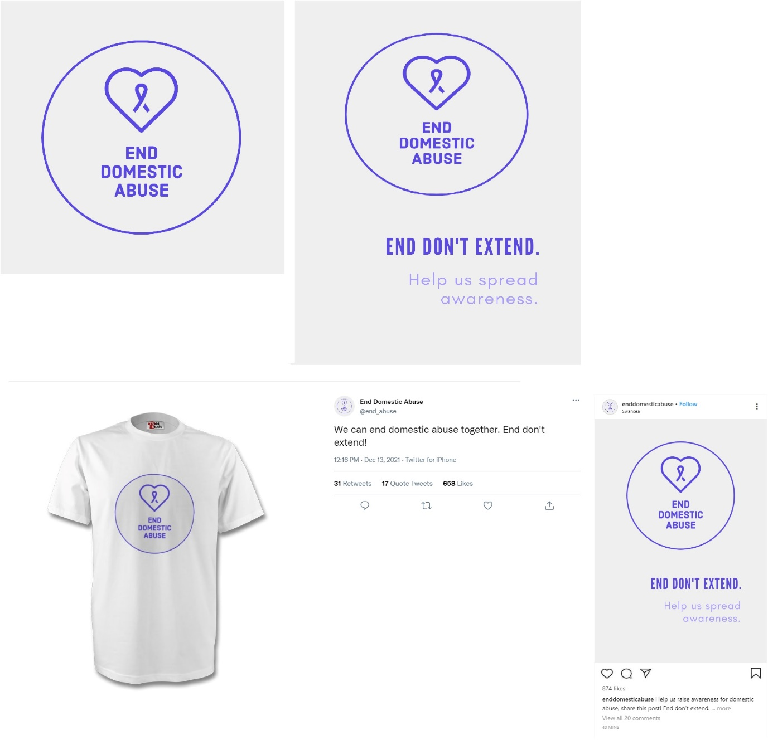

- Reference list

(2019), Portsmouth Domestic Violence and Abuse Strategy 2020-2023. Available at: https://democracy.portsmouth.gov.uk/documents/s25200/Domestic%20Violence%20and%20Abuse%20Strategy%20Appendix%20A%20draft%20for%20approval.pdf (Accessed December 2021).

Bowler, H. (2020), Refuge Fake Phone Ad Raises Awareness of Tech Domestic Abuse. Available at: https://www.thedrum.com/news/2021/11/16/refuge-fake-phone-ad-raises-awareness-tech-domestic-abuse?utm_source=Bibblio-Related&utm_campaign=editorial-content (Accessed December 2021).

Brown, J. J. (2021), 8 Recourses That Offer Help for Domestic Violence, Available at: https://www.everydayhealth.com/news/ways-to-get-help-for-domestic-violence/(Accessed December 2021).

Buddy, T. (2020), 9 Ways to Help a Victim of Domestic Violence. Available at: https://www.verywellmind.com/how-to-help-a-victim-of-domestic-violence-66533 (Accessed December 2021).

Citizens Advise (2022), Domestic Violence and Abuse-Getting Help. Available at: https://www.citizensadvice.org.uk/family/gender-violence/domestic-violence-and-abuse-getting-help (Accessed January 2022).

Clarabut, J. (2020), The Importance of Community. Available at: https://www.wellbeingpeople.com/2020/07/23/the-importance-of-an-engaging-community/ (Accessed December 2021).

Gouk, A. and Hayward, W. (2020), More than 35,000 Reports of Domestic Violence in Wales Never Got to Court Last Year. Available at: https://www.walesonline.co.uk/news/wales-news/domestic-violence-crime-women-wales-17540509 (Accessed December 2021).

Jones, S. (2015), Not Just a Slick TV Ad: What Makes a Good Domestic Violence Awareness Campaign? Available at: https://theconversation.com/not-just-a-slick-tv-ad-what-makes-a-good-domestic-violence-awareness-campaign-45041 (Accessed December 2021).

National Health Service (2019), Domestic Violence and Abuse, Health Body. Available at: https://www.nhs.uk/live-well/healthy-body/getting-help-for-domestic-violence/ (Accessed December 2021).

Neighbourhood Watch (2020), Domestic Abuse Campaign Toolkit. Available at: https://www.ourwatch.org.uk/crime-prevention/crime-prevention-toolkits/domestic-abuse/domestic-abuse-campaign-toolkit (Accessed December 2021).

Robinson, A., Brisbane, J., Farrar, J., Hardy, P., Jones, B., Pickles, J. and Shepherd, J. (2012), The Welsh Government's proposed ‘Ending Violence Against Women and Domestic Abuse (Wales) Bill’: Recommendations from the Task and Finish Group, Final Report.

Stripe, N. (2020), Domestic Abuse in England and Wales Overview: November 2020. Available at: https://www.ons.gov.uk/peoplepopulationandcommunity/crimeandjustice/bulletins/domesticabuseinenglandandwalesoverview/november2020 (Accessed December 2021).

The Crown Prosecution Service (2020), Domestic Abuse. Available at: https://www.cps.gov.uk/legal-guidance/domestic-abuse (Accessed December 2021).

The National Assembly for Wales (2001), Domestic Violence: A Resource Manual for Health care Professionals in Wales. Available at: http://www.wales.nhs.uk/publications/domviolence-e.pdf(Accessed December 2021).

United Welsh (2021), Organisations That Can Help. Available at: https://www.unitedwelsh.com/organisations-that-can-help/(Accessed December 2021).

Wakefield, M. A., Loken, B. and Hornik, R. C. (2014), Use of Mass Media Campaigns to Change Health Behaviour. Lancet 2010. Volume 376(9748), pp. 1261-1271.

Welsh Government (2010), Right to be Safe Strategy, Welsh Government. Available at: http://www.injuryobservatory.net/wp-content/uploads/2012/09/Violence-Strategy-2010-New-Strategy.pdf (Accessed December 2021).

Welsh Government (2021), Domestic Abuse. Available at: https://gov.wales/live-fear-free/domestic-abuse-wales (Accessed December 2021).

Welsh Government (2021), Violence Against Women, Domestic Abuse and Sexual Violence: National Advisers Annual Plan 2021 to 2022. What We Are Doing to Prevent Violence and to Support and Protect People Who Have Experienced Violence. Policy and Strategy.

Welsh Women’s Aid (2019), 5 Year Strategy 2019-2024. Available at: https://www.welshwomensaid.org.uk/about/annual-reports/(Accessed December 2021).

Welsh Women’s Aid (2021), Ask Me Project. Available at: https://www.welshwomensaid.org.uk/what-we-do/change-that-lasts/ask-me-project/ (Accessed December 2021).

Welsh Women’s Aid (2021), Campaigning and Influencing. Available at: https://www.welshwomensaid.org.uk/what-we-do/campaigning-and-influencing/ (Accessed December 2021).

Welsh Women’s Aid (2021), COVID 19 Bystander Toolkit. Available at: https://www.welshwomensaid.org.uk/campaigning/covid-19-bystander-toolkit/ (Accessed December 2021).

Welsh Women’s Aid (2021), Welsh Women’s Aid Campaign to End Workplace Sexual Harassment. Available at: https://www.welshwomensaid.org.uk/2021/03/welsh-womens-aid-campaign-to-end-workplace-sexual-harassment/ (Accessed December 2021).

Welsh Women’s Aid (2021), Welsh Women’s Aid Partners with Black & Beech to Launch T-Shirt Collaboration. Available at: https://www.welshwomensaid.org.uk/2021/12/welsh-womens-aid-partners-with-black-beech-to-launch-t-shirt-collaboration/ (Accessed December 2021).

Welsh Women’s Aid (2021), What is Domestic Abuse? Available at: https://www.welshwomensaid.org.uk/information-and-support/what-is-domestic-abuse/(Accessed December 2021).

Welsh Women’s Aid (2022), About. Available at: https://www.welshwomensaid.org.uk/about/ (Accessed January 2022).

