
Safa Ahmed | [Date] | [Course title]

Name: Safa Ahmed
ID Number: 2124319
Changemakers: Creativity & Value Creation (BMHP5014-LON)
E-portfolio: Recycling food for petter environment
Lecturer: Diola Bijlhout

1. Introduction
My project is about food recycling and recycling is the action or process of converting waste into reusable material(Britannica, 2023). The name of my charity is Food recycling for better environment which supports a charity in the UK that recycles food. I will use Mind map and Blog to interduce my Charity.

Task 1. Mind map

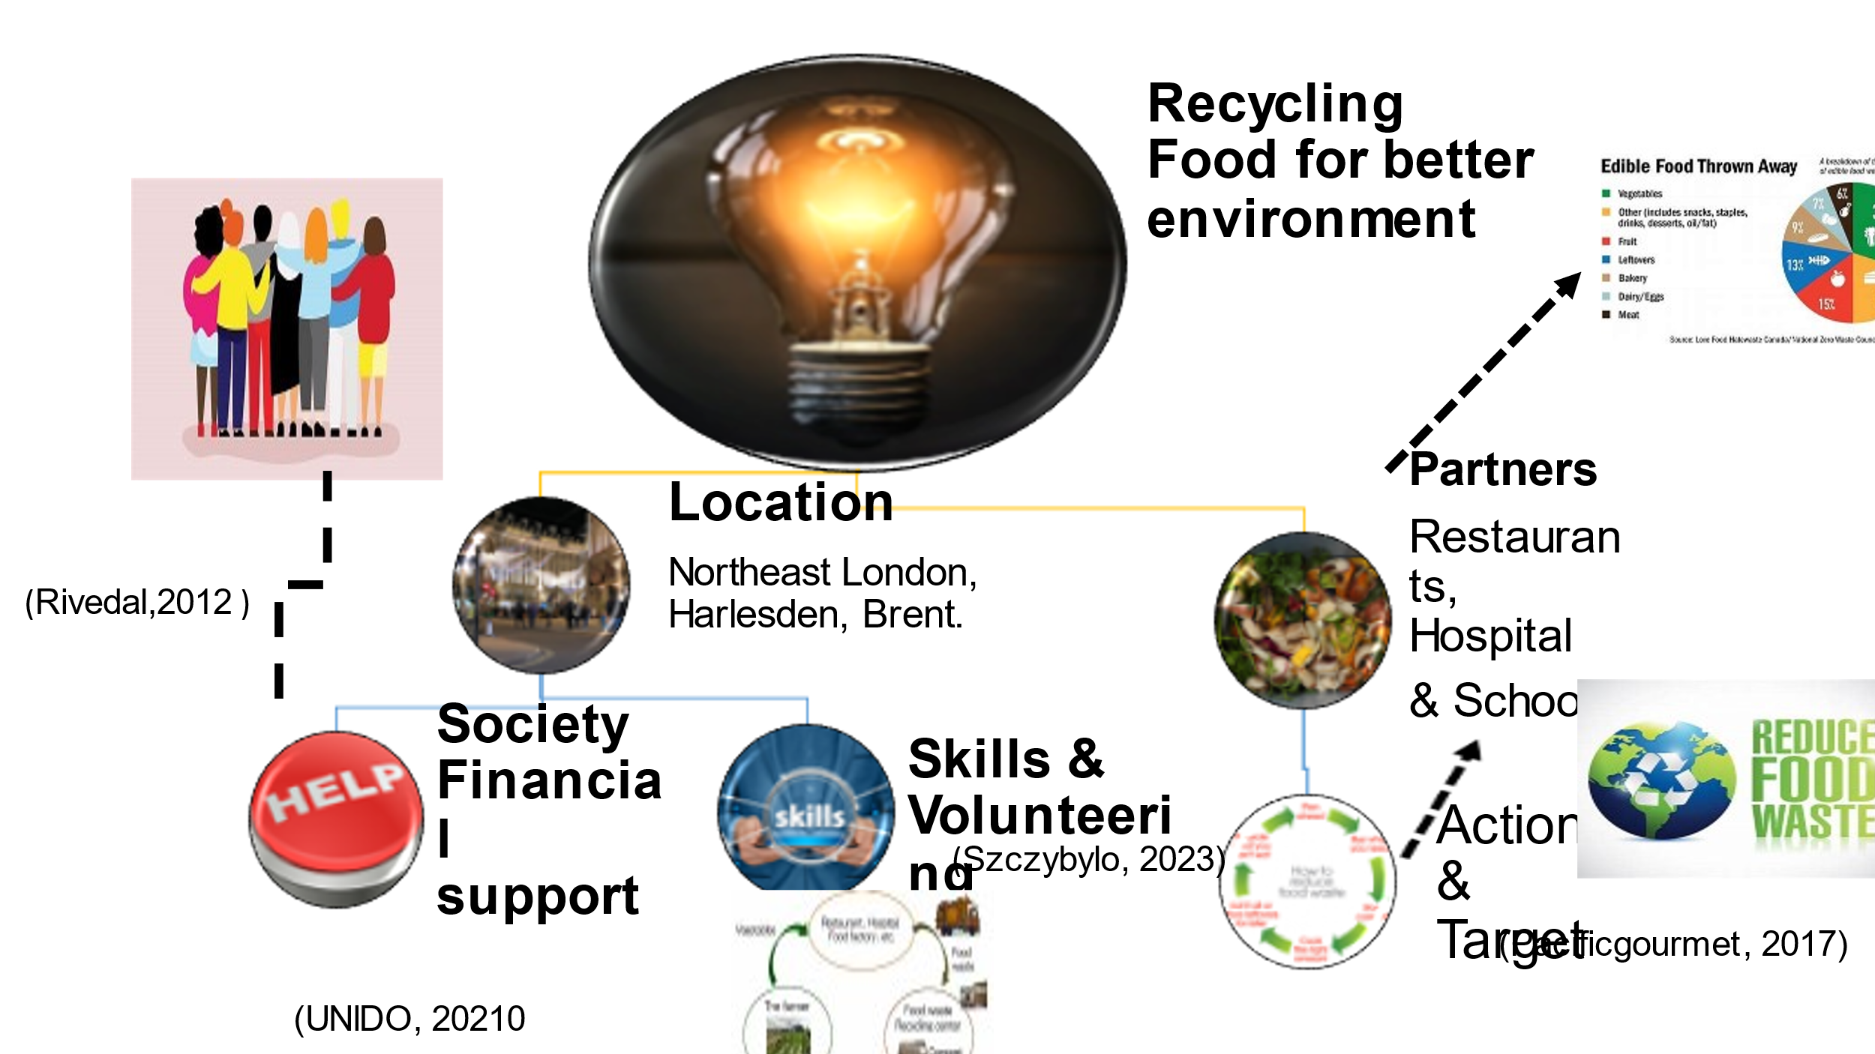

Recycling food for better enviroment
A key goal of the Food Recycling for better Environment Charity is to redistributing surplus food (that would otherwise go to waste) to those who can use it is a great way to conserve resources and to motivate more people to recycle more of the right things for the sake of health, life, and safety. In our charity, we aim to make a difference for the most vulnerable people in the community, for instance the homeless, single mothers, low-income families, the elderly, and people with disabilities.
2. Location
Our RFFBE charity plans to open a centre where people in the area can come together to enjoy a meal and takeaway for the elderly. Our RFFBE charity is in Northeast London, Harlesden, Brent. We chose this location because it is the best option for our community, and we want to support each other. Also, this location was chosen because it is in the poorest part of Brent Borough.
3. Partners
Restaurants, hospitals, shops, and supermarkets across the borough of Brent will be WFRFBE's main partners. Moreover, I intend to track the young generation to become part of my project through the Volunteer program as I believe that working together with locals can create a healthy and better society within their locality and enable citizens to reduce the huge impact of food waste on climate change. Simple changes can make a huge difference in this area.
The relationship between food, health, and climate change is clear. Fertiliser use, livestock production, and food waste contribute to about a quarter of the UK's carbon footprint. Each year, food and catering services in the NHS produce 1,543 ktCO2e, which accounts for about 6% of total emissions. Health benefits can be achieved by reducing food waste and promoting low carbon diets, rich in seasonal fruits and vegetables, beans, pulses, and other low carbon protein sources. (NHS, 2022)

4. support
Consumers can solve the UK's food waste problem. In collaboration with local councils and statutory authorities, develop a programme to implement recycling and build public trust. Around 9.5 million tonnes (Mt) of food are wasted each year by households and businesses, of which 70% were intended for human consumption (30% were inedible). As a result of this process, there are over 25 million tons of greenhouse gases that are emitted annually, which is worth over £19 billion. For the entire UK population to eat three meals per day for 11 weeks, it would have cost over 15 billion meals (6.4 Mt). There is no comparable estimate for UK pre-farm gates but WRAP estimate 1.6 Mt of food waste from primary production. My main source of financial support will be donations from the community and local councils. (House of Lords Library, 2021)
5. Skills & Volunteering
Poor recycling quality due to lack of knowledge, so improve consumer confidence on freezing and defrosting, especially of bread and meat. Help consumers understand how to store their food in the right way, particularly the storage of potatoes, fruit and vegetables and the correct fridge temperature. Additionally, our Centre offers skills development opportunities, assisting volunteers in their training and development. Professionals can also contribute their time and skills to communities through this program. There are a variety of volunteers, including job seekers. (Recycling, 2020)
6. Action
There are several things that need to be done to change people's behaviours to become healthier, and food needs to be recycled. People in the community should act rather than waiting for the government to act or focusing on other important issues, rather than waiting for them to do so. As part of my effort to collect food that is still good from restaurants, hospitals, shops, and supermarkets, the food will be recycled and turned into meals for the most vulnerable in our centre or as takeaway food. Together with three volunteers from my community, we will be cooking the food and serving. From my own budget, and with support of my community we will purchase a second-hand van to collect food. Also, reason why my charity is different the unique aspect of my charity is that food from Brent will be recycled within Brent to help those who are in need.

Task 2. Blog
THE BEST WAY TO RECYCLING FOOD IN THE UK
Are you interested in reducing food waste as effectively as possible?
I believe it is very important to know how to be more recyclable and how to help each other in our society in achieving a healthy environment and reducing the amount of food that is lost about one-third of the world's food is thrown away. I stopped and thought about what I could do to reduce this problem. I came up with my project idea because I see how much food goes to waste, so why don't we use it properly? The main objective of Recycling Food for Better Environment is to help people and the environment by recycling food.
In our charity we can help our members provide food, training, advocacy, and other support to their communities. Identifying people in need of additional assistance is just the beginning for our members.

- Charities such as http://www.fareshare.org.uk/ take excess food which is still good (and would otherwise go to waste) and redistribute it to those who can benefit from it.
- Also, there are a lot of Supporting charities Tackling food poverty such as https://www.recyclinglives.org/our-programmes/tackling-food-poverty/ They redistribute surplus stock from supermarkets and suppliers to charities and community groups. By providing quality food they help groups reduce their running costs and feed vulnerable communities while also reducing food waste. (Recycling,2020)
Avoid Food Waste
Also, there are another way to avoid this problem Anaerobic Digestion (AD) is a method that can turn food waste into energy and soil conditioners if it cannot be avoided, distributed to the poor, or turned into alternative foods. As a result, the waste is managed higher up the waste hierarchy instead of simply being disposed of. As a result, the material can recover additional value. Biogas and biofertilizer are produced through anaerobic digestion of organic matter such as animal or food waste. Anaerobic digesters are sealed, oxygen-free tanks that perform this process without oxygen. (Recycle, 2022)
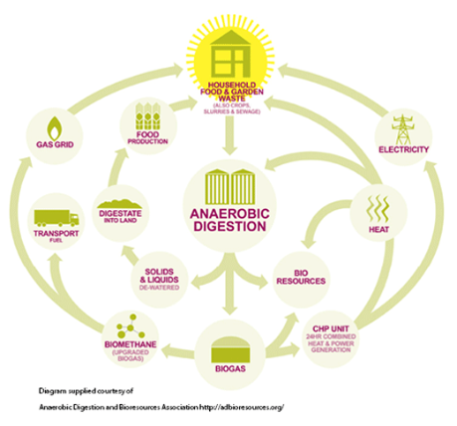
(Recycle, 2022)

conclusion

References
House of Lords Library (2021) Food waste in the UK [Online] Available at: https://lordslibrary.parliament.uk/food-waste-in-the-uk/#:~:text=According%20to%20the%20most%20recent%20report%20by%20the,by%20people%2C%20with%2030%25%20classified%20as%20%E2%80%9Cinedible%20parts%E2%80%9D ( Accessed: 2 April 2023).
NHS (2022) The impact of our food systems [Online] Available at: https://www.england.nhs.uk/ahp/greener-ahp-hub/specific-areas-for-consideration/food-and-nutrition/ (Accessed: 27 March 2023).
Recycle-more (2022) Avoid food waste [Online] Available at: https://www.recycle-more.co.uk/what-can-i-recycle/food (Accessed:7 April 2023).
Recycling Lives (2020) Feeding communities. [Online] Available at: https://www.recyclinglives.org/our-programmes/tackling-food-poverty/ (Accessed: 28 March 2023).

