Professional Career Development

Name: Leanne Lawrence
Module Code: BMSK4005
Topic: Professional Career Development
Instructor: Sylvia Hoffmann

Table of Contents
Introduction 3
Self-evaluation review 4
Self-motivation quiz 5
Johari window 7
Research and learning 8
SWOT: 20
Review of my understanding and expectations from the world of employment: 21
A review of own potential in suitable roles: 23
The effectiveness of my personal contributions when working with others in workplaces: 24
Suitability for employee and employer 26
Short term, medium term and long term goals: 27
Personal and professional career development: 28
Personal Development plan 28
Assessing the effectiveness of PDP for my suitable role: 30
Conclusion: 31
References 32

Introduction
The importance of self-assessment can’t be described in words. This assessment has helps me to be aware of my strengths, interests, values, drivers, influencers and weaknesses. By using the lifeline exercise, I depicted within significant events that has happened within my life. My personal career development plan in this overall assessment led me to achieve the desired goal and made me realize the aim of my life. Moreover, by using the analysis of the personal development plan, I became optimistic of my future plan and aware of my strengths and weaknesses that need to be overcome by planning and making strategy (Mackevic, V., 2014). I used different psychological models to analyze my characteristics and improved my goal thoughts.
This lifeline exercise will shows my momentous incidents that have happened within my life and how I have come to be in my current position and career now. Like others my life has ups and downs. This is shown within my life line below:⬇️
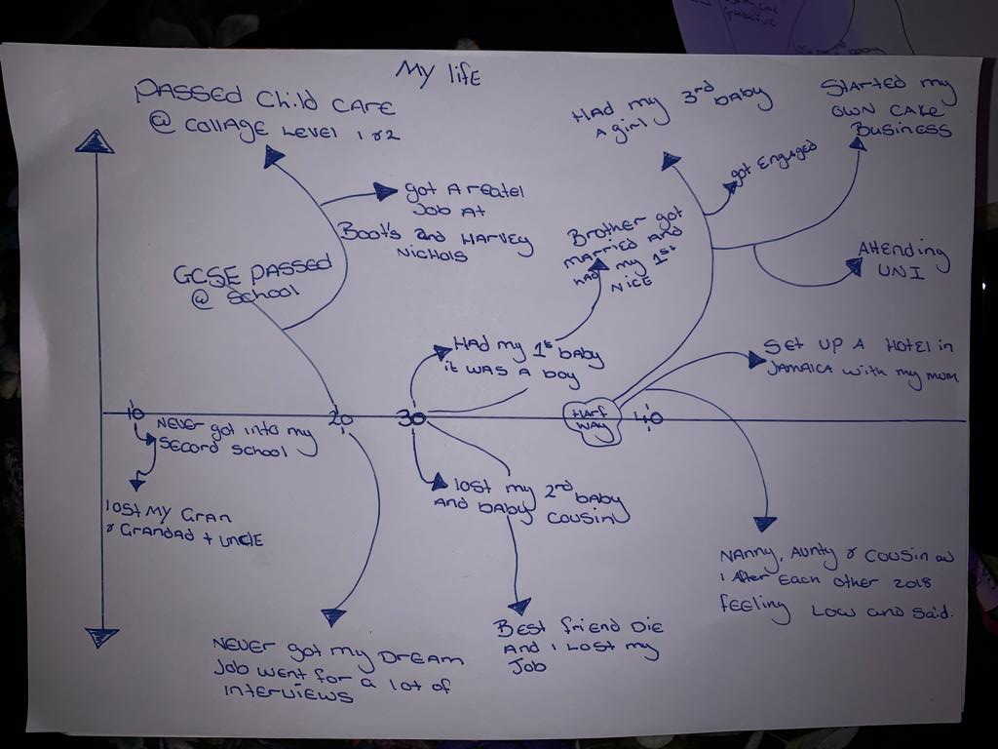
Figure: Life Graph of Leanne

Self-evaluation review

Within the first stage of my career, I need to identify my area of interest and abilities so that I would be able to know what I could and couldn’t do. This self-assessment has enabled me to identify factors for my personal development and it has helped me to achieve my desired goal.
I have always been a hard-working woman who enjoys doing things at my own paste. I generally prefer doing things independently that’s why I’ve choose a service oriented and self-employment business. While taking the decision I focused on what I could do and what I enjoy doing.
My personal values reveal desires, needs and ambitions within my life. These values can be helpful in decision making as it help me to attach to my true desires. Personal values work as a reminder sometimes in particular situation we get detract from our goal.
However, the personal principles reveal the basic rules, regulations, norms and laws to be followed and differentiate between right and wrong things. We all need to have a set of personal principles as we move along in our careers.
Personal values that I have acquired:
Passion: before taking on any task I prefer to assess whether I have a strong passion for it or not. If I’m not being passionate enough, I get bored very quickly and the task then becomes lengthy which leads to failure.
Challenge: I like tackling challenges. These provide an internal motivation for me to do the task.
Autonomy: I always seek for autonomy within my work to be enthusiastic and confident in doing tasks. When I don’t feel autonomous I get the task somewhat coercive which restrict myelf to practice my creativity.
Leadership: I have the ability to direct people in a right way. I share my vision and positive aspects of the tasks which enhance their acceptance of my direction and vision.
Some additional values that I have included are problem solving, optimism, innovative and openness to experience.
There are some influencers like angels which have enhanced my personal values. Within the people surrounding me like my colleagues, friends and subordinates who have helped me to identify my inner leadership strength. My religion, culture and my dignity has also helped me to develop my values like honesty, openness that has allowed me to experience different friendships etc. The most important influencers within my life are god and my family this is where I’ve inherited my core values from.

Self-motivation quiz
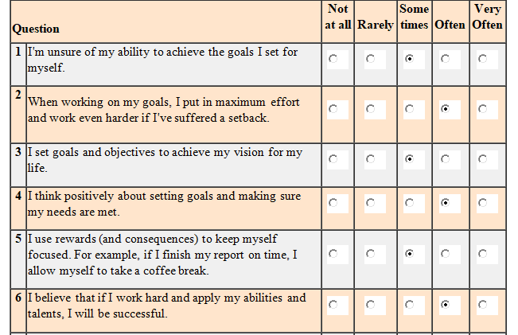
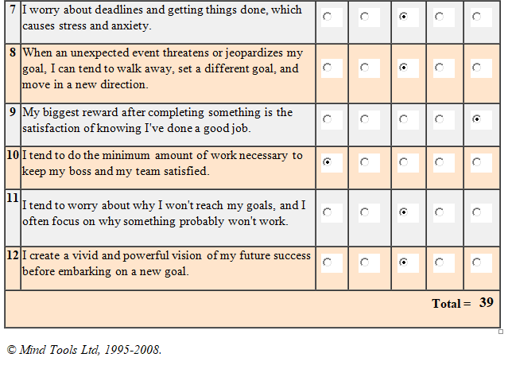 (Mindtools.com, 2018)

Johari window
Johari window is a useful tool for mapping personal awareness. It helps me to improve my self-awareness and increase relationship between groups. The Johari Window model was invented by American psychologists Joseph Luft and Harrington Ingham in 1955, while researching group dynamics at the University of California Los Angeles (flixabout.com, Sep 12, 2016). This model is practiced to build understanding of personal development, interpersonal relationships and improve communication.
It started by describing one from of a fixed list of adjectives, then it collects confirmation from groups or colleagues on the same list. So it increases mutual understanding within groups.
Johari window model that perfectly describes me is depicted below:

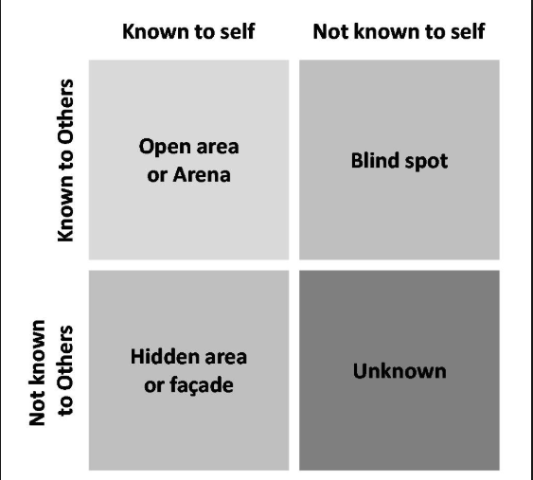
The model has four quadrants (flixabout.com, Sep 12, 2016). The first quadrant is the Open Area or Arena which reveals the behavior and motivation part for me, which is known to me and also known to others. It perfectly describes me as a social being.
The second segment is the blind spot area which includes the behaviors and motivation known to others but not known to myself. This section triggers the need to identifying my strength and weaknesses and to improve awareness. The constructive feedback is needed to solve the limitations (flixabout.com, Sep 12, 2016).
The third quadrant describes the behaviors and motivation known to me, but not known to others. So it’s important to disclose one’s strength and abilities to build cooperation with others (flixabout.com, Sep 12, 2016).
The fourth quadrant is the unknown area which describes the information (flixabout.com, Sep 12, 2016). That is not known to others or to me. This is the difficult information to find out. Observation by others and self-discovery can be helpful to identify that information about me.

Research and learning

Learning refers to acquiring or modifying current behaviors, knowledge, personal values and skills. Learning can be facilitated by several events which increase skills and knowledge. The individual learning can be selective and optional where team learning is somewhat political and dogmatic. The techniques to learning may be different from person to person (Cottrell, 2010).
There are several tools and frameworks of learning styles such as Honey and Mumford, Kolb’s, VARK and Dantec learning styles etc. Each of the learning style has its own features and framework. These learning styles enable me to learn new things and enrich my knowledge.
How the learning styles affected my learning is shown below:
Honey and Mumford learning style:
In this model the learners are divided into four segments based on their characteristics of learning style. These segments include activist, theorist, pragmatist and reflector.
Activists: activists are the people who learn by actually engaging in the task without any hesitance. Their learning style resembles the open-minded approach of learning which requires brainstorming, solving puzzles and participating competitions etc. (Mumford and Honey, 1992)
Theorists: theorists like to learn from the theories, statistics, stories, background and books etc. their learning process include academic theories, models and concepts. Learners tend to learn from the facts and underlying theory (Student Success Space, 2017).
Pragmatists: the pragmatist learners prefer to examine their knowledge by applying it on real life events. When they transfer their ideas into real action, they form concepts and knowledge. Their learning process includes case studies, discussion, solving problems and thinking.
Reflectors: These types of learners learn from the experience. They think about the theories that provided solutions of the problem are being implemented properly or have been malfunctioned.

Applying Honey and Mumford learning style:
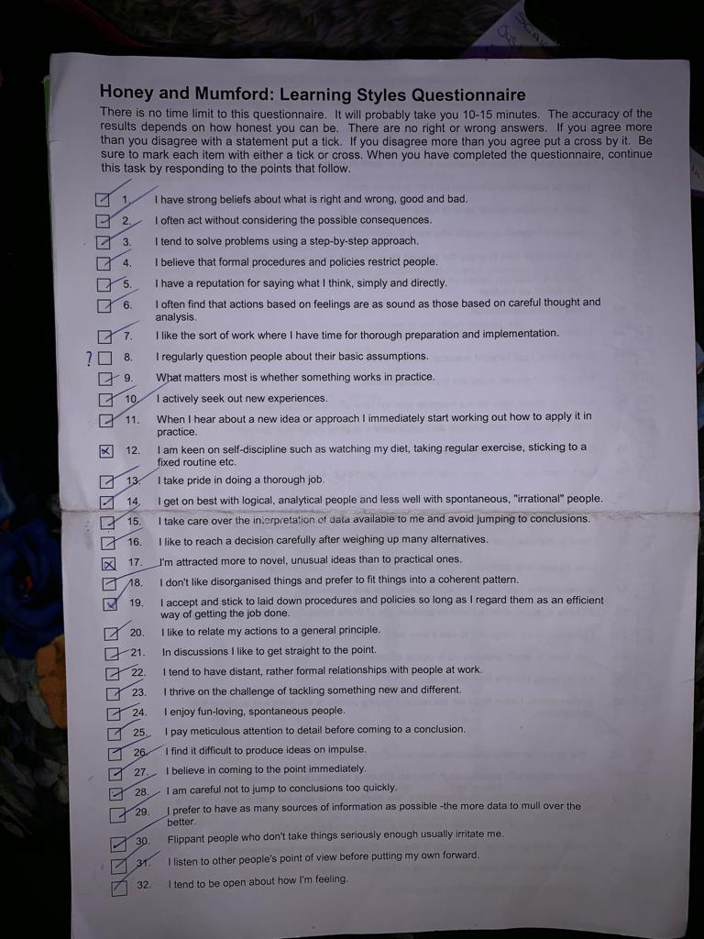
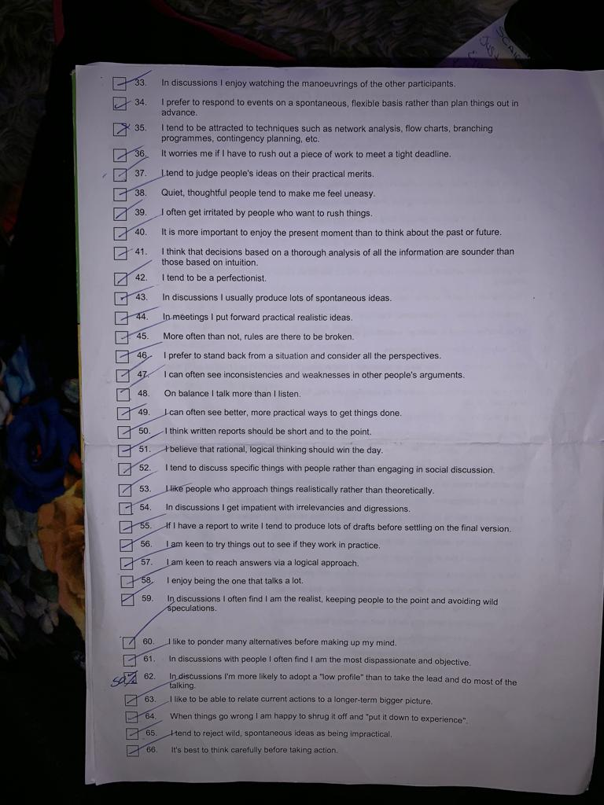
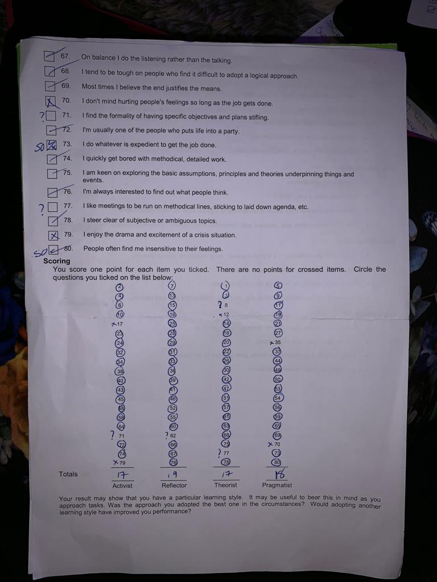
According to the questionnaire I am a reflector as I have always wanted to learn through the real experiences.
VARK learning model: in the term VARK, ‘V’ stands for visuals, ‘A’ stands for auditory learning, ‘R’ for reading and ‘K’ for kinesthetic learning (Moayyeri, 2015).
The visual learning style refers to learning from visual display of information, notes, spatial arrangements, diagrams, charts, graphs and pictures.
Auditory learning style refers to learning through listening lectures, group discussions and directions.
In Reading learning style, learners learn through reading material, textbooks and notes.
In Kinesthetic learning style, learners learn through actually doing and performing activities using senses of sight, smelling and touching.

VAK learning style to discuss my own learning style is depicted below:

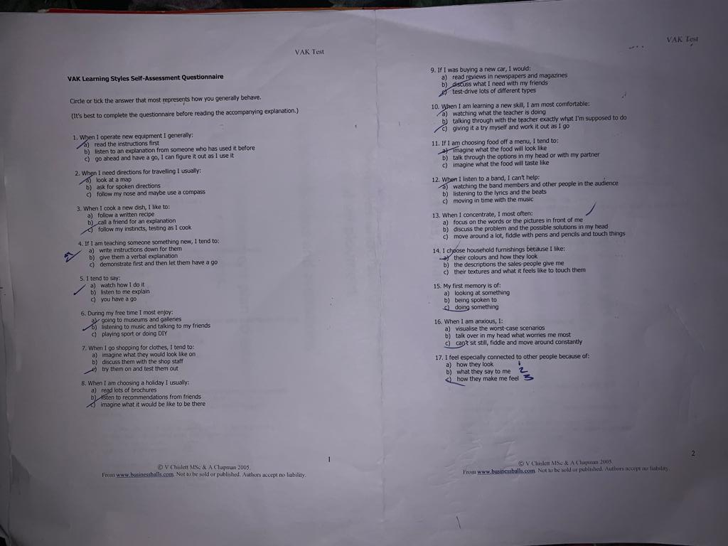
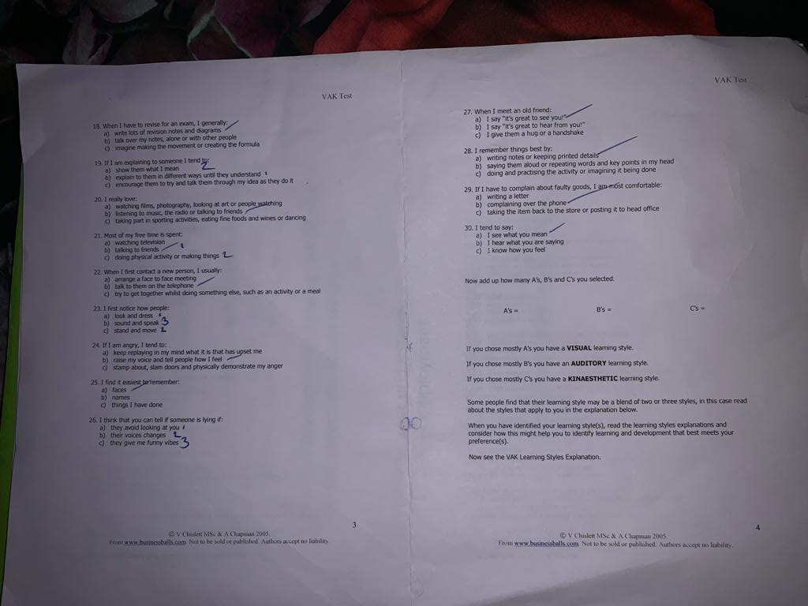

A’s=10
B’s=9
C’s=11
According to the questionnaire I am a kinesthetic learner as I always prefer to learn from actually doing things and being hands on.

Reflecting own learning style:
I am going to use Kolb’s learning cycle for reflecting own learning style:
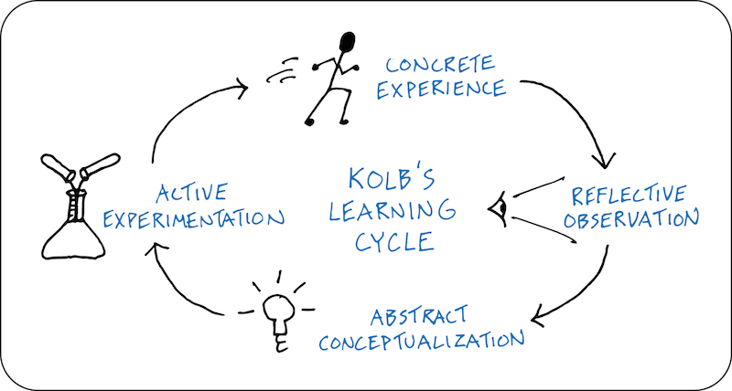
Figure: Kolb’s learning style
Concrete experience: I have experienced time management, leadership, writing essays, team management, conflict resolving, negotiating etc. I have also experienced different skills within my academic life with my team, communicating with my teacher one to one and fellow class mates.
Reflective observations: That I learned in my academic life has made me feel that I can observe and lead my within my surroundings with leadership skill, writing my essay/topic with full concentration with using suitable wordings. The skills I have now reflect within my daily behavior and attitudes. But I still feel that I’m lacking in motivating others and communicating with others. I often feel that I’m failing within time management too.
Abstract conceptualization: The learning and following up of my skills has enabled me in doing my school work; this has led me to feel the need of improvement. Which I found out through my weaknesses and I should communicate with others more, studying the contemporary motivational tools and techniques that I’ve applied in my everyday life with my friends and my subordinates to get things done.
Active experiment: To actively perform the learning style and improving on my weaknesses the comment from I started communicating with my friends, teachers on different topics to improve on my fluency; I focused on my day to day time management and I was able to figured out how to motivate others and negotiate conflicts to be resolved.
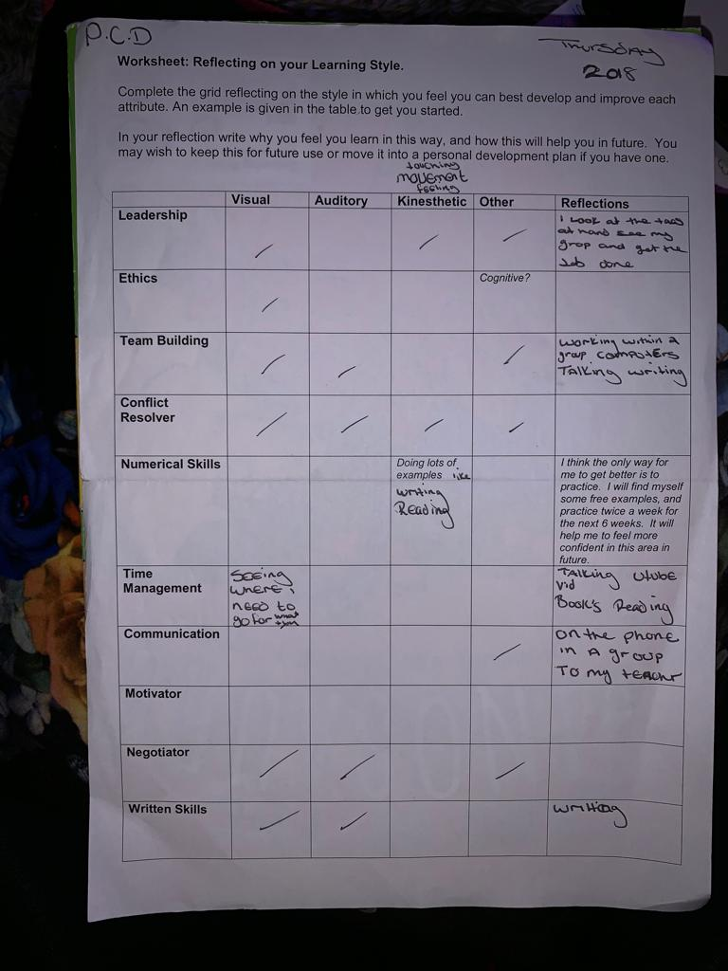

SWOT:
SWOT analysis is useful for assessing my strength, weakness, opportunities and threats. Strength and weakness is considered to be internal analysis (Morgan, 2016). By identifying my strength, I’m to use them to get maximum benefit. Assessing my weakness has enables me to know areas of further improvement and modification. Assessing opportunities has helps me to avail the benefit of those facilities efficiently and knowing threats has enable me to be strong enough to overcome the problems. Analysis of threat and opportunity is considered as external analysis. A person cannot control the external factors.
Strength: strengths are a skills and abilities that I currently have. The skills of communicating and interacting with others are an important skill that I consider I have. The ability to manage and direct a person with my leadership skills. I also like to take on challenging jobs. In which I have a strong passion for.
Weakness: weaknesses are the skills and abilities that I don’t have. I need to improve on those skills. I lack in technological skills and time management skills which are considered as a very important skills to have.
Opportunities: opportunities are the potential benefits that are open to me and can be advantageous if I utilize them. I can see one opportunity that is ahead of me for myself and my hotel that I currently own. It will be profitable if I add more food items or more cuisine in the menu.
Threats: threat is the risk or uncertainty that I can face I future for which I need to be prepared. Threats from a competitor can lose my competitive advantage if I don’t fully prepare myself beforehand by inventing new things and updating my knowledge. This analysis often helps us to be awakened and updated to new trends and fads.

Review of my understanding and expectations from the world of employment:
Employment is an important function of an organisation. The employers follow a set of framework to recruit employees. Employers care about the mission, objectives and culture of the organisation to recruit the right employee for the right position. The methods employers follow in recruiting is discussed below:
The organisational policy fit: the employers follow a set of policy and principles in recruitment process. The policies include the mission, vision and code of conduct of the organisation. The person who fit with these organisational policies will be selected for the job.
Job fit: in this type of recruiting method where the employer seeks whether the person’s skills and abilities match with the job description or not. As in my case I am an owner of a hotel and I have the skills of managing a restaurant. If I get a job in a restaurant as a manager I can surely do the job but I won’t be that much efficient in a large manufacturing or textile company.

Organisation culture fit: this is one of the right organisational requirements from the employees. Employees must be culturally fit with the organisation. If the employee does a job perfectly but notwithstanding the organisational culture, then there is no organisation culture fit.
Skills and abilities: the employer investigates about whether the skills and abilities that the employees possess match with the needed skills and abilities to perform the job.
What the recruiters are doing:
Within the real world, the recruiters follow a set of recruiting methods for recruiting the best employee for their organisation (Morgan, P., 2016). The best method of them is assessing the compliance with organisational policies which enables to achieve the organisational objectives. Some recruiters prefer to follow job fit where others prefer to use organisational culture fit. Sometimes employer prefer to assess the required skills of the applicants where others prefer applicants with technologically skilled to get the benefit of innovating new things.

The purpose for a job description:
Job description is the statement of the duties and responsibilities of the job. A well written and structured job description works as an effective communication tools by which both the employers and the applicants can know what the job entails.
Job description helps to confirm that right employees are selected for the right position. An effective job description is one which clearly reflects the goals and objectives of the organization. It increases job commitment and helps to achieve organisation’s missions and objectives.
A job description is very helpful for the candidates applying for the job. They can know what sort of tasks they are going to do if they get the job, what sort of skills, duties and responsibilities are needed to attach to the job.
The purpose of person specification:
Person specification is an important part of the employer’s toolbox. Person specification is the specification of the skills that a person must have to perform the job. It outlines educational requirement, personal abilities and experiences needed. It ensures the unbiased and subjective evaluation of candidates.
It helps to advertise the roles and duties with specific and accurate information about the job. It is considered same as important as job description. It facilitates the communication of the traits useful in the candidate’s resume. This allows the organisation to identify the traits they think to be useful from the candidates. By this way the can easily find the right person for the job.

How employers make selection:
The recruiter starts with screening out the candidates using a protocol. Every organisation set some arduous process of recruitment. They make selection decisions based on the performance obtained through the tests. They take several tests such as job knowledge tests, aptitude tests, personality tests and other relevant work sampling tests. During all the stages the recruiter tries to find out whether the applicants skills match with the job requirements or not. Applicants who have the required and relevant job skills are selected for the post.

A review of own potential in suitable roles:

Potential in suitable roles refers to the opportunities and worthwhile options ahead of me. I have my own cake business and a hotel. After working for a good time, I understand the potential opportunities that I can take to be successful in my career. The possible roles that can be taken and the required skills are discussed below:
Restaurant manager: from the working experience in my cake shop and hotel I learned how to manage people and direct them. I can foresight the possible opportunities in this field. If I take this role, this will be an ideal job for me.
Hotel manager: as I have mentioned that I already own a hotel, so hotel management is a better option for me. I have the relevant leadership skills and can easily manage people. It will be best for me if I get back to this job from my business.

Owning a food chain:
I currently own a cake shop and I want to expand this line in a new food chain. That has been my cherished dream. I have the experience of customer taste preference, a good knowledge of food menu and excel at promoting and delivering foods etc.

The effectiveness of my personal contributions when working with others in workplaces:

Behind every successful product there is a contribution of teamwork. Teamwork enables to work toward objectives and soothes the movement toward target. In a team people attempt to combine their individual skills, knowledge and expertise to achieve a target (Maund, A., 2017). Teamwork must provide constructive feedback.
Some examples of how I contribute to teamwork at workplace:
Skills and abilities: I use my leadership skills to direct workers in preparing the food items, arranging events, designing food menu and serving foods to customers. I use negotiation skills while collecting ingredients from the suppliers.

Knowledge: working in the food chain I gained a good knowledge within every phases of food industry such as the customer demand, taste preference, competitor’s strategies and the market. The important part of them is the knowledge about food. If the food item is not good, customers will be dissatisfied and will lose customers. I have a good knowledge of food like which foods are tasty, hygienic and which foods are detrimental for health.
Communication skill: I have developed my communication skill to effectively handle dealing with customer and directing employees. I’ve always try to listen to everyone’s problem and respect their ideas. I share my knowledge with my subordinates to align (Cottrell, S., 2010).
Experience: working in the food industry I experienced lots of things about how things are done in a food industry. This enabled me to create a specialization in my work. I use my experience while working and dealing with employees, suppliers and customers.
Responsibilities: I remain always responsible for the payroll systems of the employees and suppliers. I take responsibility in properly serving the agitated customers, managing conflict between the employees and maintaining the food quality.
Adherence to the policies and procedures: I always strictly comply with the policies and procedures such as employability act, refund policy and dismissal procedures etc.
So, this is how I contribute to as an owner or as a manager. I always prefer to interact with others and work in a team. Without my team it will be difficult for me to operate my business for a single day. The impact of my contribution to the team starts from the ordering of food to the delivering and refunding customers when they complain for bad quality foods.
Some areas of my contribution to the teamwork is needed to be developed. I lack the skills of time management as I often forgot to instruct workers to make before the deadline. Moreover, slow process of preparing and delivering foods often make customers dissatisfied. So timeliness is an important part to deliver foods timely and increasing customer delight.

Suitability for employee and employer
Businesses have to follow different regulations and legislation imposed by the government such as Data Protection act. This act requires the organisations to keep the privacy about the personal information of the employees and its customers. The act protects the right of the employees and customers.
Why staffs leave their jobs?
There are several reasons why staffs leave jobs. Some of them are discussed below:
- Conflicting relationship between staffs and the boss: this is one of the most common reasons for which staffs leave job. When the relationship between the boss and the employees is not good, employees leave the job (Cottrell, S., 2010).
- Lack of motivation: Motivation can be financial and non-financial. When staffs don’t get right motivation they may leave the job.
- Bad relationship with coworkers: this factor also creates conflict in the workplace and employees may want to leave the job.
- Lack of independence: it also can demotivate the staffs and they can leave the job.
- There may be other reasons for leaving such as financial instability of the firm and low growth and bad reputation of the organization (Cottrell, S., 2010).
Most recent regulations and legislations and its impact on my work:
The employment law requires the maintenance of minimum wage and proper dismissal procedure. Distance selling regulations requires the honest and detailed description of the goods and services, delivery time, costs of transection, cancellation and refund rights of the customers.
Personal value and ethics:
Everybody has their own barriers and we all need a suitable career to progress in our professional life. One of the ethical dilemmas that I face is when I try to check the effectiveness of employee’s performance; it becomes obvious to check their personal space and their activities in the social media. This activity hinges the privacy concern of the employees about their persona life. So I have made a rule to check only their activities related to work instead of their personal space. The personal values usually remain stable over time. But it is not obvious that values will not change. Sometimes I face different opinions of particular functions. Then some opinions are added to my values or modified my personal values. Sometimes I prefer to stay on my opinion. For example some wants to just provide different types of food items but I prefer to deliver various food items with better quality.

Short term, medium term and long term goals:

Short term goals:
Getting my web page up and running effectively
Passing my 1st year at university
Trying to cut costs
Learning a new skill
Trying to increase sales
Hiring more staffs
Medium term goals:
Passing my driving test
Trying to increase speed and productivity within my cake business
Long term goals
Opening new hotel in Jamaica
Graduating from university
Living abroad
Extending my cupcake business
Becoming a successful business woman

Personal and professional career development:

Personal development plan is an ongoing process of developing one’s career by utilizing the strength and overcoming the weaknesses (McMillan, K., 2006) Personal development plan enables to assess own potentials, find out opportunities, set goals, reflect own values and develop expertise. It involves an action plan to improve the strength of a person by creating self-awareness. PDP provides the understanding of using their skills, knowledge and experiences. No matter in what stage one belongs – planning new career, looking for a job or leaving a job; it provides a direction to the improvement.
Personal career development helps to assess the weak areas that should be improved and mitigated. Professional career development includes the ongoing process of improving and modifying the skills and knowledge with the career planning. As it helps to set plan, it’s get easier to achieve desired goal (Cottrell, 2010).

Personal Development plan

NAME: | Leanne Lawrence | Student NUMBER:
COVERING THE PERIOD FROM: | 01/01/’19 | TO: | 01/01/’23

What do I want/need to learn? | What will I do to achieve this? | What resources or support will I need? | What will my success criteria be? | Target dates for review and completion
Web page development | Learning programming language  Creating and updating web page | Free courses from codecademy and udacity | Promoting my business  Attracting more customers | 26 Dec, 2018 to 30 Feb,2019
Working with an expert | Learning restaurant management | Communication skill  Coordination  Interpersonal skills | Get a degree on restaurant management | 25 Jan 2019 to 20 Dec, 2022
Opening a new hotel in Jamaica | Serving more customers  Providing quality foods | Financial capabilities  Labor training  Management capability  Labor | Increased sales  Getting More customers  Getting more employees | 15 Jan, 2023

Assessing the effectiveness of PDP for my suitable role:

PDP has been one of the major determinants in my success of career. Through the PDP I had made the SWOT analysis which helps to identify my strength, weakness, opportunities and threats. This allows me to set a clear goal and move onto it. However, only setting goals and objectives will not be enough, regular monitoring of the improvement must be done. Monitoring allows us to assess whether the functions are going right as planned.
The characteristics of effective personal development plan:
- Evaluating present skills and knowledge
- Having vision of the desired goals
- Factors driving the goals
- Setting goals based on time frame (short, medium and long term)
- Setting functions to be done
- Collecting resources
- Monitoring activities

What I have achieved through my personal development plan:
Personal development plan empowers me to identify how I can use my skills with measurable results which is beneficial for my chosen roles. The regular monitoring helps me to identify where the problem lies and how to overcome those problems. I have achieved the best way to get better opportunities around me and achieve my targets.
As the future is uncertain, I don’t know what will happen and my mind can change. So it is important to set a target and have a clear vision and mission. This is the best benefits the tools provide that I got so far. The tools permit me to stick on the goal and work until achieved.
I will not be able to get the true benefits of the opportunities and my skills also. I will not be strong enough to overcome the threats to better understand the situation.
I need to improve my current skills and the skills that I lack. In future I will be willing to set more challenging goals to achieve.

Conclusion:
Personal development plan is the key part of the report. It enables me to realize how I can use my strength to develop my career. In designing personal development plan some analysis must be done such as SWOT analysis, skills audit, self-motivation quiz, learning styles and self-assessment analysis. To support these analyses there should be added some other parts such as the personal values, personal objectives, drivers, influences, ethical dilemma and the recruitment process used by the employers etc.

References
Maund, A. Schriek, M. and Tinkler, P. (2017). Certificate in Higher Education: Skills for the Workplace Student Yearbook. Sage Publications
Morgan, P. (2016). The Business Student’s Guide to Study and Employability. Sage Publications
Mindtools.com. (2018). How Self-Motivated Are You?. [online] Available at: https://www.mindtools.com/pages/article/newLDR_57.htm.
Cottrell, S. (2010). Skills for Success: Personal Development and Employability.
Adair, J. and Allen, M. (1999). Time Management and Personal Development. 3rd ed. London: Thorogood.
Cottrell, S. (2010). Skills for Success: The Personal Development Planning Handbook (2nd edition). Hampshire: Palgrave MacMillan
Ctb.ku.edu. (2018). Chapter 3. Assessing Community Needs and Resources | Section 14. SWOT Analysis: Strengths, Weaknesses, Opportunities, and Threats | Main Section | Community Tool Box. [online] Available at: https://ctb.ku.edu/en/table-of-contents/assessment/assessing-community-needs-and-resources/swot-analysis/main
flixabout.com. (Sep 12, 2016). Johari Window. [online] Available at: https://www.youtube.com/watch?v=KdYo5jn29w4&feature=youtu.be.
Mumford, A. and Honey, P. (1992). QUESTIONS AND ANSWERS ON LEARNING STYLES QUESTIONNAIRE. Industrial and Commercial Training, 24(7).
Student Success Space. (2017). Honey and Mumford learning style. [online] Available at: https://www.youtube.com/watch?v=izMEy-UiRKM
McMillan, K. and Weyers, J. (2006) The smarter student: Skills and strategies for success at university, London.
Mackevic, V. (2014) From confusion to conclusion. How to write a First-Class essay..2nd edition. Edited by Tom Wild. United States: Createspace.
Moayyeri, H. (2015). The Impact of Undergraduate Students’ Learning Preferences (VARK Model) on Their Language Achievement. Journal of Language Teaching and Research, 6(1), p.132.

