https://contemporarychallenges32.wordpress.com
Password for all posts: 2213359

Blog 1

What do I consider to be the biggest threat to human kind and why?
I consider the largest threat to human kind to be climate change; it's effects and repercussions.
Checked or unchecked, climate change poses a threat to every facet of human life (BBC, 2023). We are already seeing it's effects, with rising and more volatile global temperatures that have seen an increase in droughts and flooding. The longer nothing is done the more these problems will cumulate and evolve, with many countries in Africa and the Middle East suffering extreme heatwaves, widespread drought and food shortages. Additionally, the rising sea levels will leave many islands, specifically nations in the Pacific region, submerged underwater. The resulting mass migration from these newly uninhabitable areas, will lead to increased overcrowding and an incredible strain on the infrastructure of the remaining habitable areas.
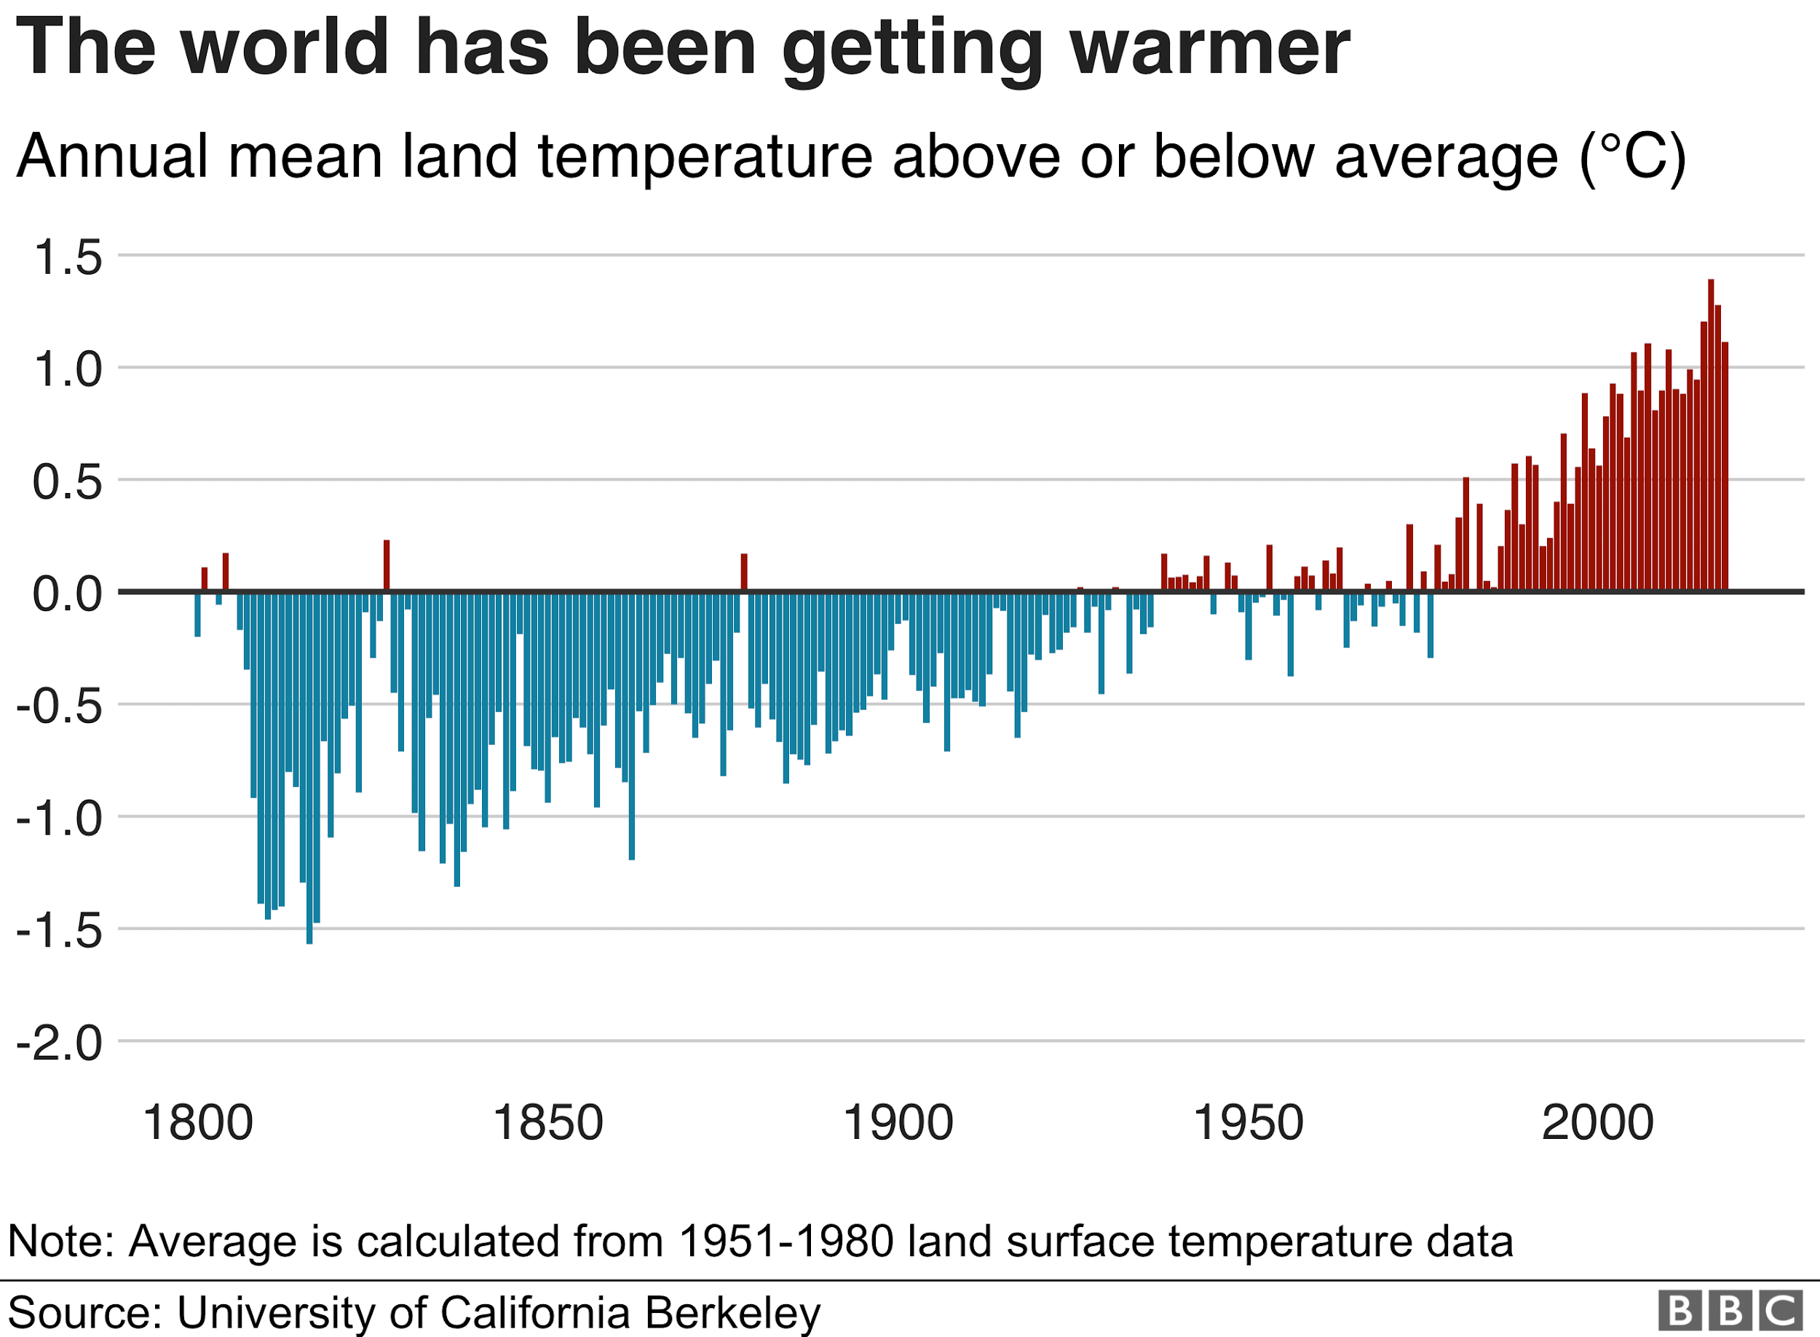
The graph shows the sharp increase in Annual mean land temperature over the past 50 years (University of California Berkeley, 2020).
On top of this, there are other effects caused by the droughts and water shortages climate change will cause. Drought increasing the risk of wildfires, as seen already in Australia, but more directly when people can't get enough water for sanitation, respiratory and gastrointestinal illnesses tend to spread far easier (Garthwaite, 2019).
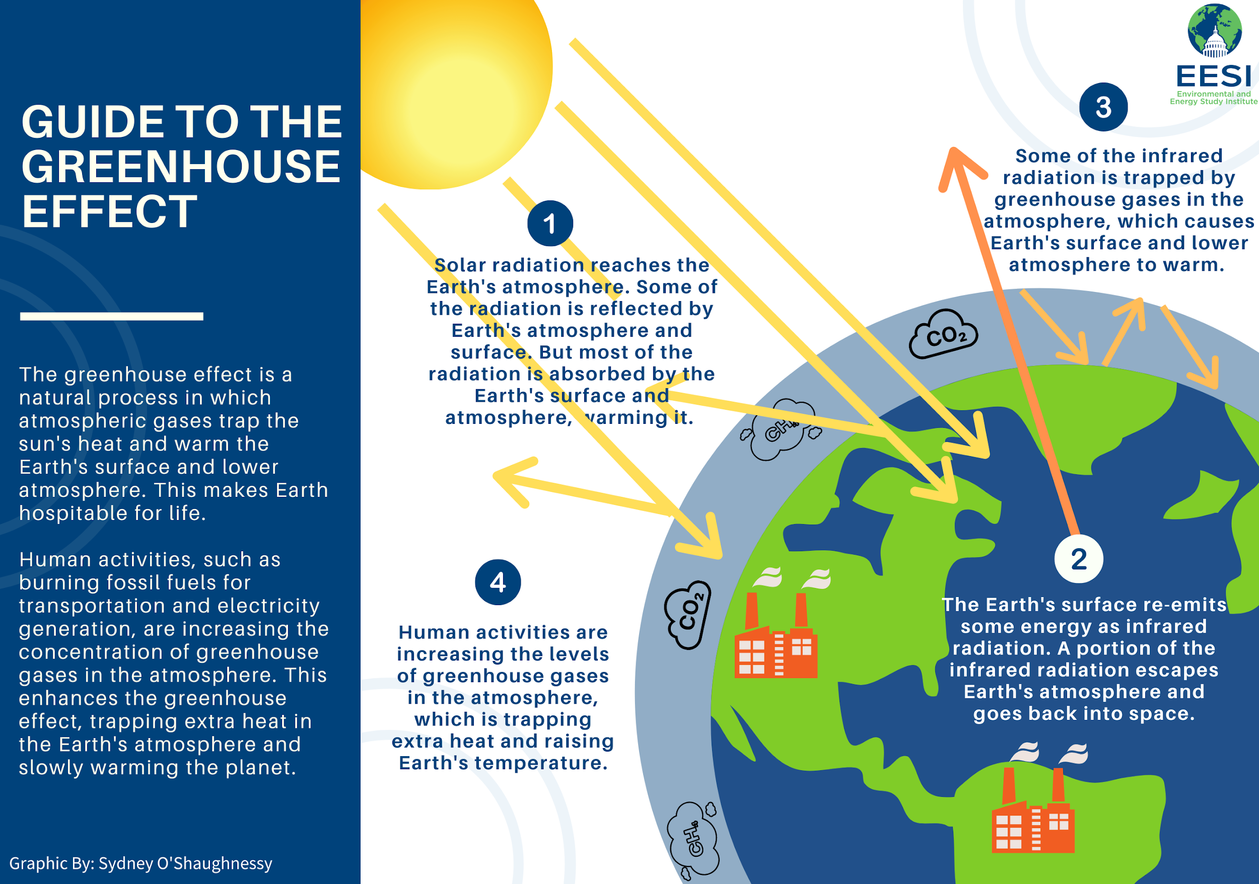
The above image displays the science behind global warming and begins to explain how human action affects it (O' Shaughnessy, 2018).
There are of course other threats to human kind, like the rise of AI and automation. The threat of automation is the replacement of (initially) low skilled workers with AI and robotics, pushing more and more people into unemployment. However AI also has the potential, with sufficient risk assessment and mitigation, to transform our society positively and improve the human condition (World Economic Forum, 2018).

References:
BBC (2023) What is climate change? A really simple guide.
Available at: https://www.bbc.co.uk/news/science-environment-24021772
(Accessed 13 April 2023)

O’ Shaughnessy, S. (2018) Guide To The Greenhouse Effect. Available at https://www.eesi.org/climate-change-FAQ (Accessed: 13 April 2023)

World Economic Forum (2018) How to manage AI’s risks and rewards. Available at https://www.weforum.org/agenda/2018/01/how-to-manage-ais-risks-and-benefits/ (Accessed: 13 April 2023)

Garthwaite, J. (2018) The effects of climate change on water shortages Available at: https://earth.stanford.edu/news/effects-climate-change-water-shortages (Accessed: 13 April 2023)

University Of California Berkeley (2020) The world has been getting warmer
Available at: https://ichef.bbci.co.uk/news/2048/cpsprodpb/C7C4/production/_110504115_global_temperature_v2-nc.png (Accessed 13 April 2023)

Blog 2

Unit 2: What skills will I need to be successful in the Acting field?
If I wish to be successful in the Acting field, a key skill I will need to attain is the ability to think and analyze critically (Bradford, 2020). This key skill will be required of me when mining scripts for details about my character and their backstory, as well as when making creative choices about characters and how to approach scenes.
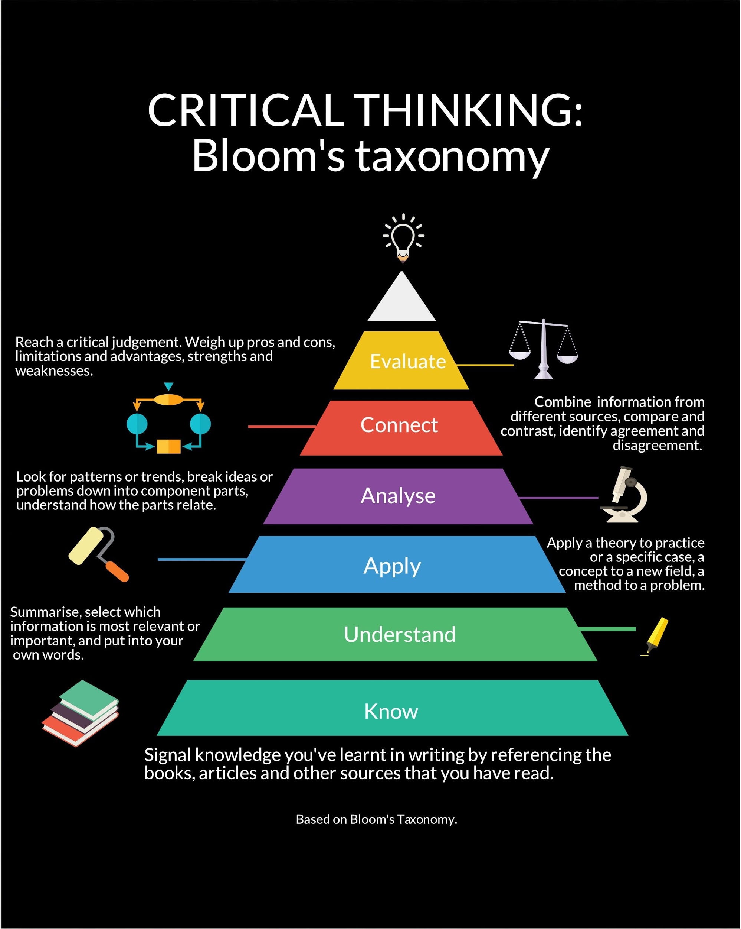
This image from The University of Northampton (2019), displays the steps involved in Bloom's Taxonomy. Bloom's Taxonomy is a structured method used to develop someone's critical thinking skills. It displays a useful template for the type of skills I will need to acquire to be successful in the acting field.
Conflict management is a hugely important skill for any actor to have. As put forward by Lee (2015), conflict can often have a positive impact on a group's creativity as it forces them to think and work harder to find solutions. Therefore rehearsal spaces will often ask actors to embrace conflict, and so to be successful as an actor I will need to have the tools to cope with conflict.
To be successful in the Acting field I need to be open and accepting to other people's ideas and be careful not to get too attached to my own ideas. Acting is a collaborative process and the building of performances is often a melting pot of ideas from many contributors. Attaching myself to positions and ideas will block that collaboration from moving forward. When people negotiate over positions they often lock themselves to it, as they clarify and defend it the more stubborn they become as their egos take control (Patton, Fisher and Ury, 2011).
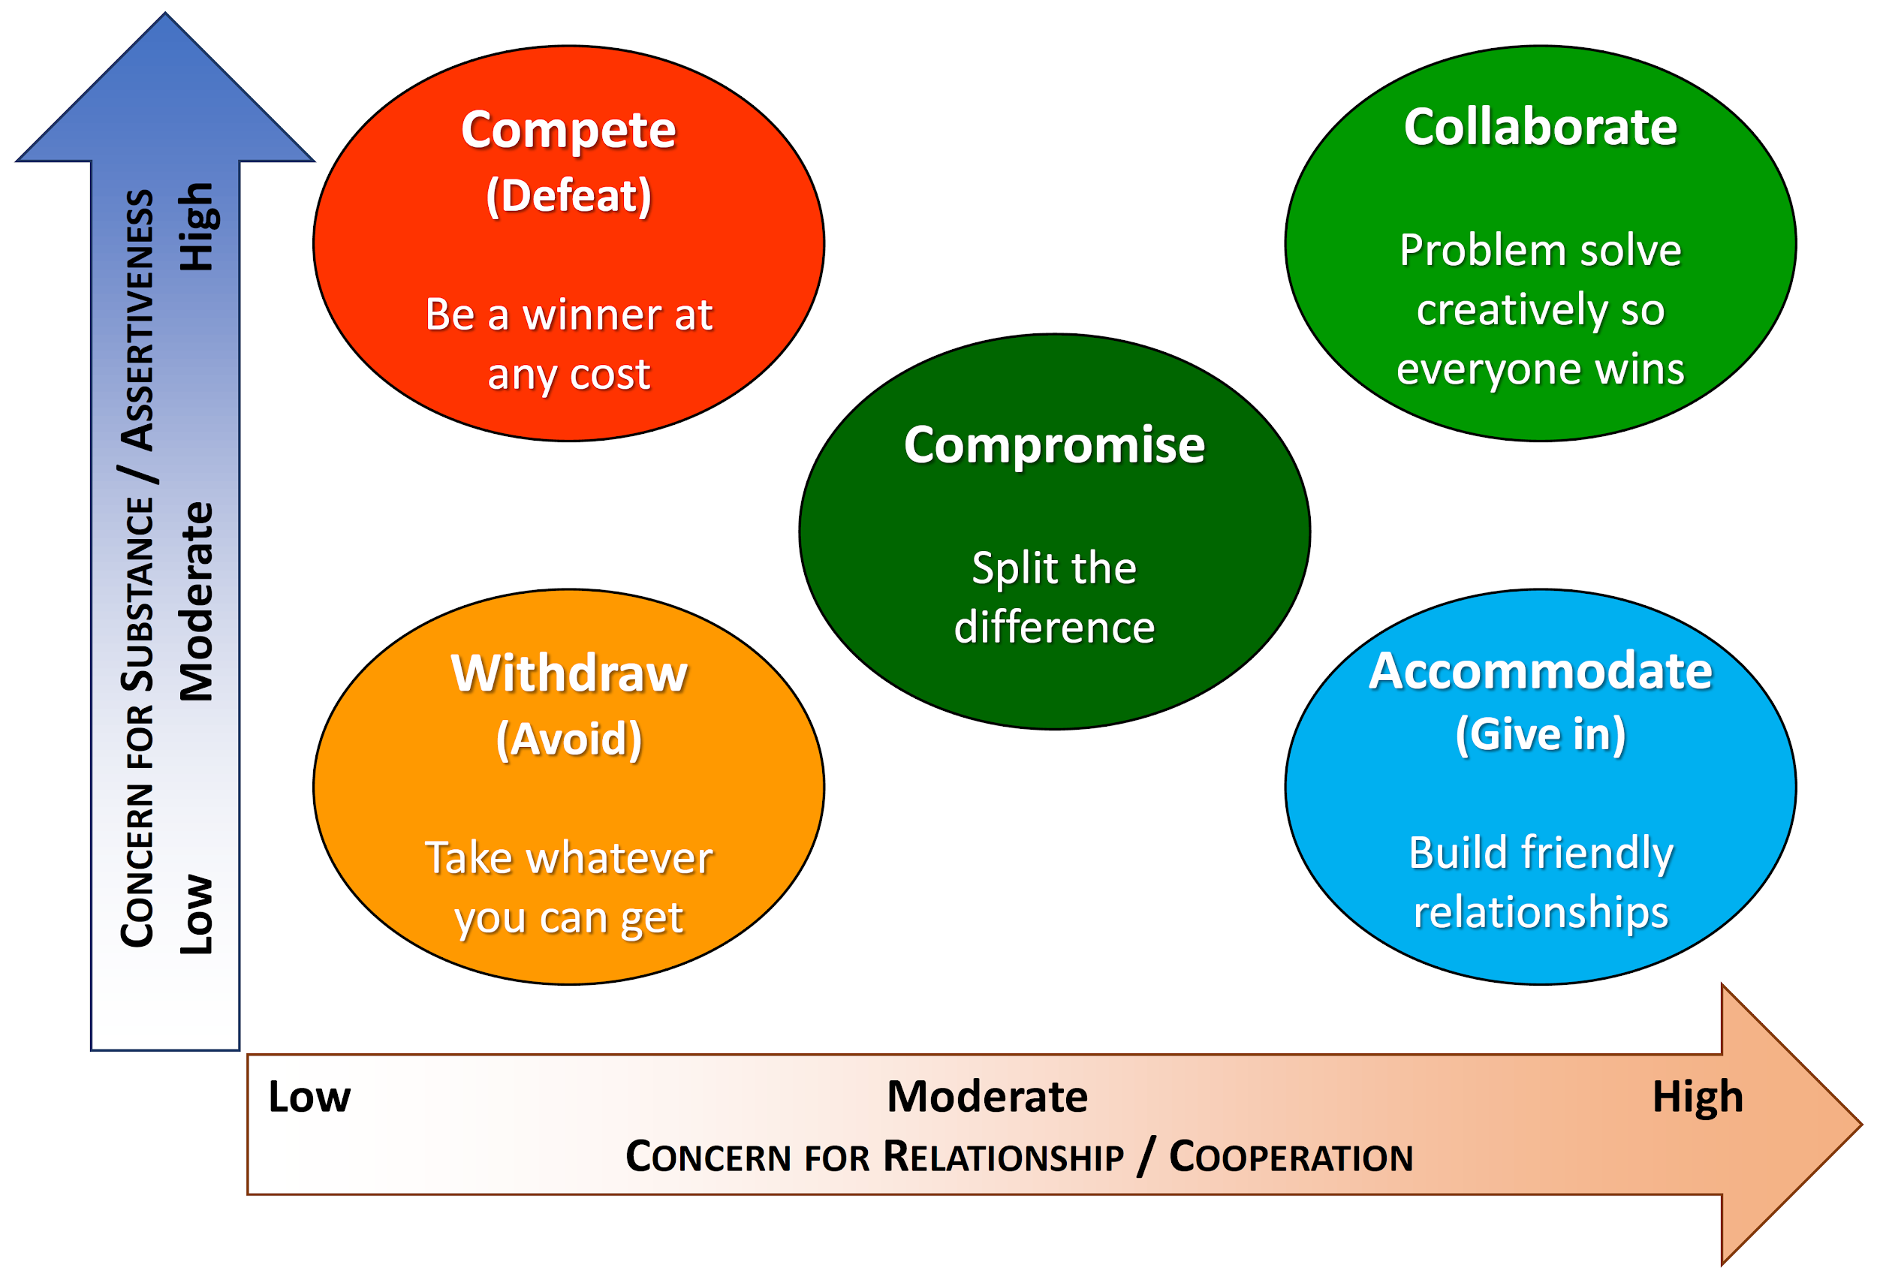
The chart above displays the typical reactions to conflict, the different approaches to overcoming that conflict and their resulting outcomes (Association of American Medical Colleges, 2018).
References:
Fisher, R., Ury, W. and Patton, B. (2011) Getting to yes; Negotiating agreement without giving in. New York: Random House

Lee, S. (2015) Conflict Is Good for Creativity. Available at: https://knowledge.insead.edu/leadership-organisations/conflict-good-creativity#:~:text=We%20found%20that%20relationship%20conflict%20has%20the%20positive,which%20we%20were%20able%20to%20replicate%20our%20findings. (Accessed: 16 April 2023)

The University of Northampton (2019) Critical Thinking: Bloom’s Taxonomy. Available at: https://bpb-eu-w2.wpmucdn.com/mypad.northampton.ac.uk/dist/d/6334/files/2018/09/Infographic-Critical-thinking-Blooms-1tsbgtw.jpg (Accessed: 16 April 2023)

Association of American Medical Colleges (2018) Teaching Conflict Resolution In Medicine. Available at: https://aamc-meded.global.ssl.fastly.net/production/media/filer_public/a9/cd/a9cda2a8-e1a0-445c-a96a-65d305d35fae/mep-14-10672-g1.png (Accessed: 16 April 2023)

Bradford, D. (2020) Why Actor’s Need Script Analysis. Available at: https://www.mindfulacting.co.uk/blog/why-actors-need-script-analysis/ (Accessed: 20 April 2023)

Blog 3

The merits and shortcomings of design thinking for studying acting
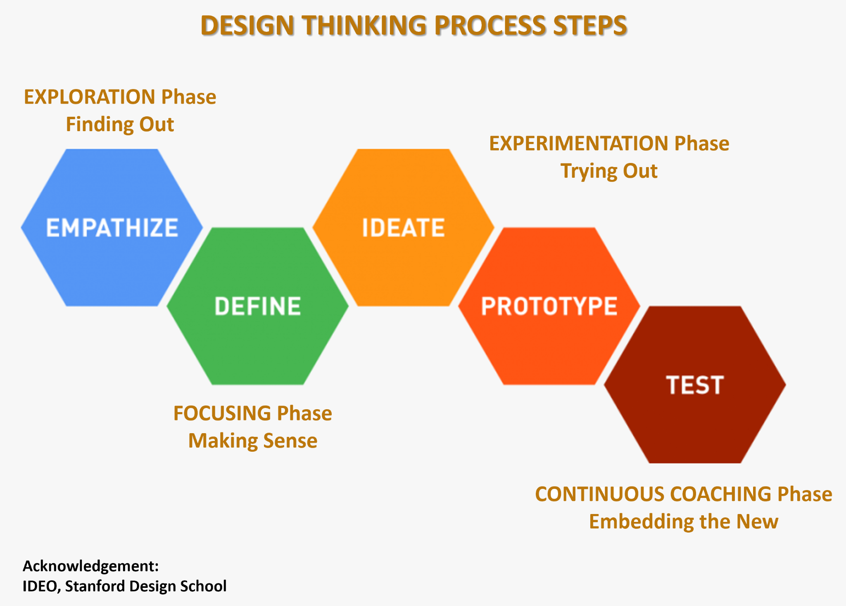
What is Design Thinking? This image (Level Seven, 2020) lays out the steps involved in the process of Design Thinking. Empathizing with your audience/consumer to understand their wants and needs. Define your aims and outcomes, ideate and prototype ways of achieving those goals and finally test them.
One of the merits of using the Design Thinking Process as an actor is that it's focus is squarely on the audience and their wants. Everything an actor does is for the audience, particularly in theatre, the communication between an actor and the audience is vital. The audience is never wrong, when receiving responses to your work what the audience discerned is all that matters (Deer and Dal Vera, 2016). What you as the actor meant to communicate isn't important, communication is what the other person understood or felt. If the response you received wasn't what you wanted, then you need to ideate, prototype and test other ideas until you get the response you're looking for. While, as an actor it is important to have maximum involvement and commitment to your role, you must do so while being receptive and aware of how it is landing with the audience. You never play to the audience but must trust your sixth sense (Hagen & Frankel, 2009).
Additionally, the Design Thinking process has merit for those studying actors as it encourages experimentation and a willingness to fail. The test phase in particular, acknowledges the reality that your ideas and prototypes are not necessarily going to solve the defined needs of the audience. This vulnerability that comes with the distinct possibility of failure is a huge positive of the Design thinking strategy as it requires bravery, and "all quality acting requires courage (Barber, Schreiber and Norton, 2012)".
However, the emphasis of the Design Thinking strategy being on the audience, and the actor shaping their work around the audience's expectations and wants could also be considered a shortcoming when utilizing it within the acting field. When actors play to the audience rather than to each other or to their truth, it threatens to compromise their work's artistic integrity and substance (Merlin, 2014). Meaning that by focusing squarely on the audience, the actor is reducing the impact their performance is having on the audience, despite their best intentions. This is a trap that any actor could easily fall into using the Design Thinking process.
References:
Level Seven (2020) Design Thinking Process Steps. Available at: https://www.level7live.com/wp-content/uploads/2020/05/stages-of-design-thinking-level-seven-cropped.png (Accessed: 20 April 2023)

Merlin, B. (2014) The Complete Stanislavsky Toolkit. 2nd edn. Great Britain: Nick Hern Books Limited

Deer, & Dal Vera, R. (2016). Acting in musical theatre : a comprehensive course (2nd ed.). Routledge. https://doi.org/10.4324/9781315850191

Hagen, & Frankel, H. (2009). Respect for acting (2nd ed.). John Wiley & Sons.

Schreiber, Barber, M. B., & Norton, E. (2012). Acting Advanced Techniques for the Actor, Director and Teacher. Constable & Robinson.

