Ways of Perceiving - Curation, Commentaries and Compositions

Jeonard John Veloso Cruz
Student Number - 1702794
BA Graphic Design
Contextual Practices Tutor - Ryan Moule

The theme of my exhibit is how things quickly escalate from peace to chaos and it is titled The Calm Before... I settled upon this idea when my group (Group 4) were discussing about what themes we can do for this project and after an extensive discussion, we came to the idea of chaos and how it affects us on a daily basis. I chose to work in the middle and look at how chaos begins. I did this by investigating riots in history that started out with peaceful protests, hence why I called the show The Calm Before… I wanted to do this as evidence that anyone can take advantage of a situation, and let it escalate and also wreak havoc.

Working with the theme of peace and chaos can be a vastly large subject. But with what is happening right now in our tiny planet, it is time to inform the public about how something that was initiated to be peaceful and magnanimous for a victim of violence, can be exploited for the favour of others with a far more dark and cruel intentions. But the exhibit is not just about the riots and criminals. The police officers that caused harm to the innocents are also a prime example of exploiting their power as a person of the law who swore to protect and serve the citizens that they inflicted pain towards.

Coons and Weber (2014) wrote “Manipulation is the steering or influencing of the choices of others by means that might be morally problematic (though not necessarily wrong in all cases). Three forms of manipulation are distinguished: deception, pressuring, and employing emotional vulnerability or character defects. Exploitation Involves making use of the vulnerabilities of others for your ends. All three concepts raise issues relating to the value of freedom, conceived as independence of one’s choices from the will of others.” in their book titled Manipulation: Theory and Practice. And they are correct, the truth gets lost within the chaos and it gives the people who launched the protests that did not want any more violence and just wanted to receive any answer.

Postema (2005) wrote “If we are to enable our students to understand law and practice it effectively, they argued, we must teach them to look at what courts do, not what the courts say— especially not what Langdell-inspired collections of leading cases say.” in his book titled A Treatise of Legal Philosophy and General Jurisprudence.

In fact the artists responded the only way they know how, and that is through art. Each piece has its own experience and atmosphere, they range from an aggressive point of view to a more informal and true depiction of the incidents. A diverse selection of works creates a new and fresh feel to the audience unlike the standard exhibits in every city.

When entering the exhibit for The Calm Before… You will encounter Nick Scott’s powerful typographic piece accompanied by the video clips by news reports from national news stations, interviews, videos from people who were involved in the riots and clips from witnesses of the violence.

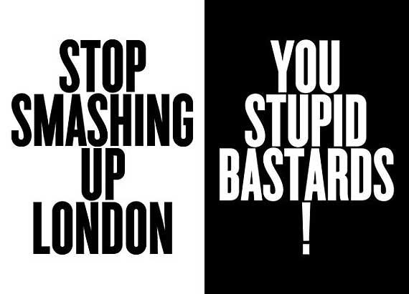

Nick Scott, 2011

This will be great to include in the exhibit to spark some nostalgia onto the audience and trigger some emotions from the people. This will be a great piece to start within the exhibit, for its powerful yet simple message is heavily relatable during the time of the riots. The words are basically what everyone was thinking and/or saying during those times of violence in England. Nostalgia has become a powerful tool in today's society as we like to repeat history with objects such as trends, fashion, movies and even food.

The second piece of work that will be featured in the exhibit is from Mark Vallen titled Lost Angeles. A highly powerful and striking piece that provides context without any scene of violence and ruins. This can and will make anyone who investigates it stop at their tracks and admire the destruction while experiencing a rush of mayhem.

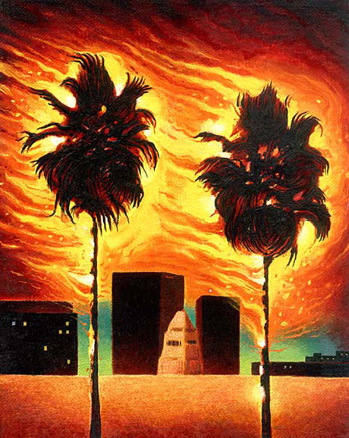

Mark Vallen, Lost Angeles, 1992

Vallen said “I created this small oil painting after witnessing the Rodney King riots of April 29th, 1992. The painting was an attempt to capture what I had witnessed; L.A.'s palm trees set ablaze during the mayhem”. What drew my attention about this piece of work is the name… “Lost Angeles”. And the fact that a symbol of California, summer and calmness is set on fire via violence. The colours link heavily to the imagery of destruction and bedlam.

The third artwork is from Sandow Birk titled The Apprehension of Rodney King. This is truly one of the best pieces of art that Sandow Birk has created about the L.A Riots, in my opinion as it is almost identical to religious imagery if looked at and can provide a great amount of context on how the riots began. It features Sgt. Stacey Koon of the L.A.P.D. The fact that Rodney King can be barely seen in the painting and the main focus is the police officers is a clear commentary on the events that happened soon after the brutality they have unleashed.

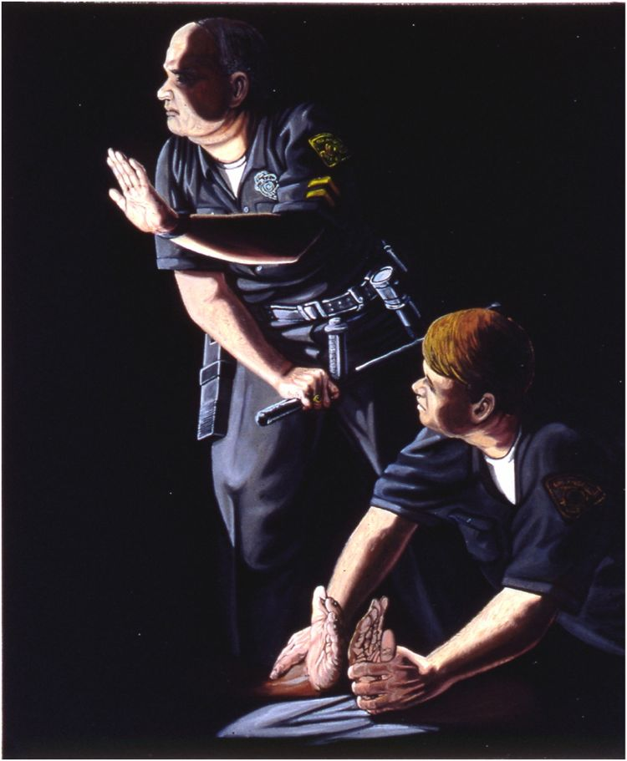

Sandow Birk, The Apprehension of Rodney King

The two pieces will be joined by the video clips by news reports from news stations, interviews, the Rodney King video and the full trial of Sgt. Stacey Koon. These clips will act as an explanation as to what happened during that time. The projection of the videos will be quite large.

And the final piece of artwork will be from Eric Drooker which he drew on scratchboard for The New Yorker during the Ferguson riots in St. Louis, Missouri. The piece is generally hefty and widely confusing in content which is exactly what was happening in the riots for there were other, evil interests at play. What started out to be a peaceful protest, sparked into pure pandemonium when gangs took advantage of the situation to loot and destroy family businesses and homes.

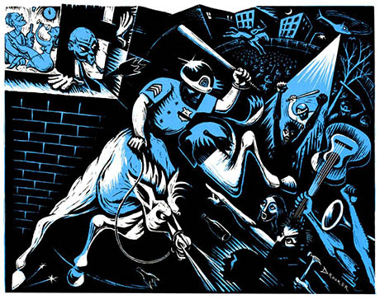

Eric Drooker, Police Riot, 2014

Mullin from Poynter.com wrote “Drooker didn't have the luxury of witnessing Ferguson's protests firsthand, so he had to rely on photographs from the scene. He began researching the piece on Monday after receiving an email from The New Yorker's art director: the magazine wanted to do a cover story on Ferguson and needed art as soon as possible. Drooker got to work. At one point, he got so frustrated with the quick turnaround that he nearly quit”. A separate video will be made for this space for it will focus on the families affected by the violence and what the peaceful protest turned sour was really about, this should highlight the truth about the events that occurred.

Last but not least, there will be a wrecked police cruiser in the middle of the space, just to set the atmosphere of the exhibit, the audience can interact with the police cruiser but it is not recommended. The show will rely purely on the noises coming from the videos of each space which will then create the same environment as a riot.

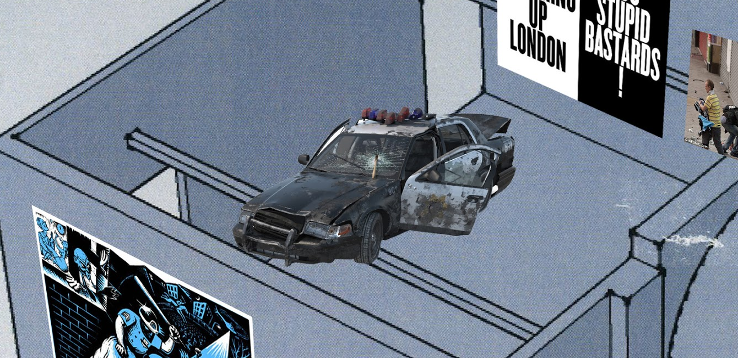

This is the full map for The Calm Before… It will be held in the famous Mission Gallery for the general public.

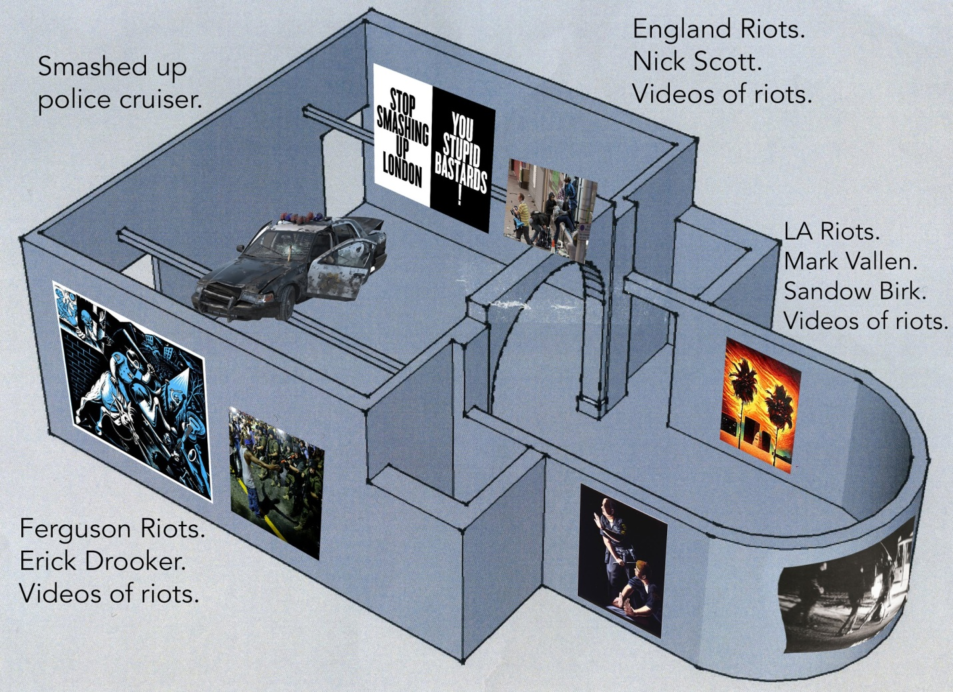

Bibliography

Coons, C and Weber, M. (2014) Manipulation: Theory and Practice. Oxford: Oxford Scholarship Online.

Postema, G.J. (2005) A Treatise of Legal Philosophy and General Jurisprudence. Springer Science & Business Media.

Vallen, M. (2018). ART FOR A CHANGE - "Lost Angeles." A Painting by Mark Vallen.

Mullin, B. (2018). New Yorker's Ferguson cover artist has been on the front lines of police protests.

