Name: Dolu Miah 1809541
Title: Digestive System
Module: Introduction to Physiology
Module Code: BMHP5003
Lecturer: Mumtaz Goolam

Small Intestine
Mouth
The first part of the digestive system is your mouth.
- The teeth break the food
- The tongue moves & mixes the pieces with saliva to form a Bolus (ball)
- The tongue pushes the bolus to the oesophagus to start the next journey

(Waugh, Grant and Ross, 2001)

Large Intestine
Digestive System
Mouth
Main Organs
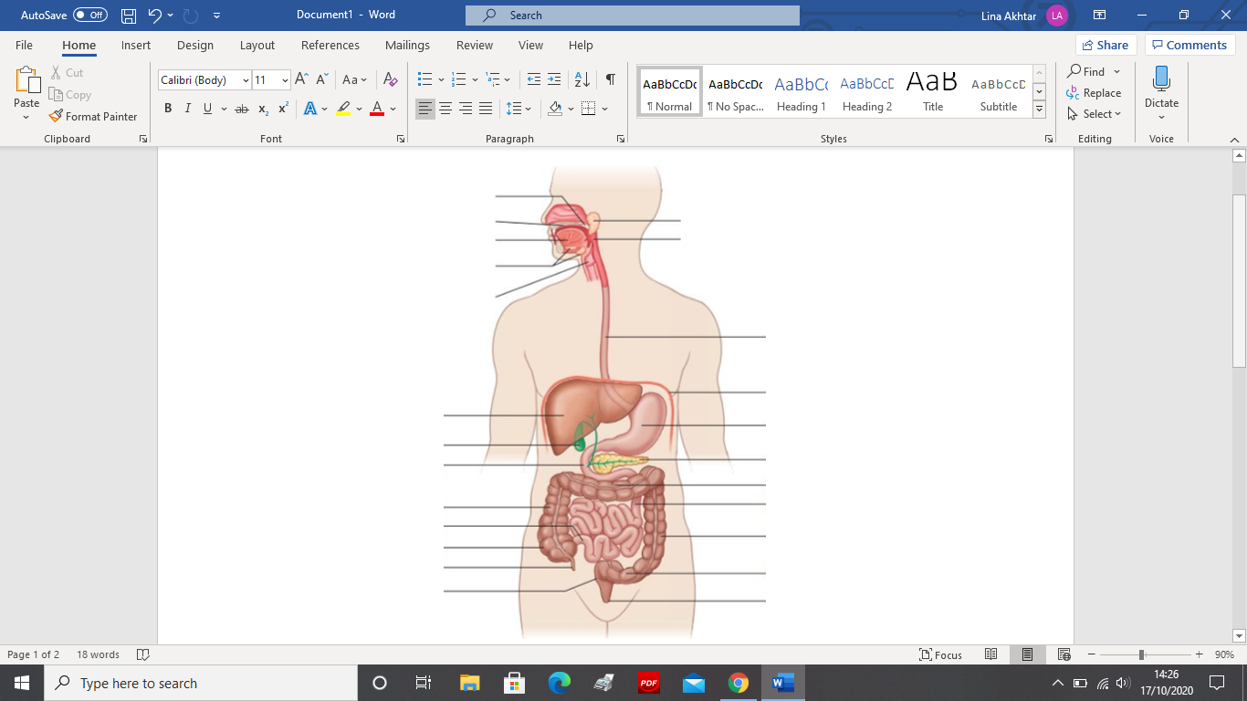
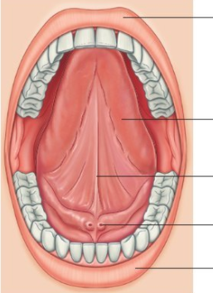
Upper Lip
Salivary gland
Soft palate
Esophagus
- Flexible tube that extends from the mouth to the stomach. It has two sphincters (one at the top/bottom) both open and close
- Bolus goes down the oesophagus and it moves by peristalsis.
- Peristalsis is the rhythmic muscular contractions of the digestive system to move food through.
- (LES) food has to go through here and if it loosens up too much people have gastric reflux.

(Odya and Norris, 2017, pp. 235-237)
Oropharynx
Hard palate
Tongue
Teeth

Salivary glands
Inferior surface of tongue
Larynx
Frenulum of tongue
Duct of salivary gland
Lower lip
Esophagus
Stomach
- It is a hollow muscular organ that stores food we eat and breaks it down into tiny pieces.
- It secretes digestive juice and mixes our food with these juices to form a mixture called chyme. Acid in the stomach also kills bacteria and dangerous microorganisms that enter the stomach with the food.
- Stomach is the size of a fist and can stretch and shrink. It consists of three parts, fundus, the body and pylorus.
- Fundus – is a structure that goes up above its original opening. The body – middle portion this is the largest region of the stomach. Pylorus – the gate – last portion of the stomach
Once this process has finished, the food is propelled into the duodenum.
(Tortora and Derrickson, 2017, p. 794)
(Waugh and Grant, 2018, p. 318)
Diaphragm
Stomach
Liver
Peristalsis in oesophagus
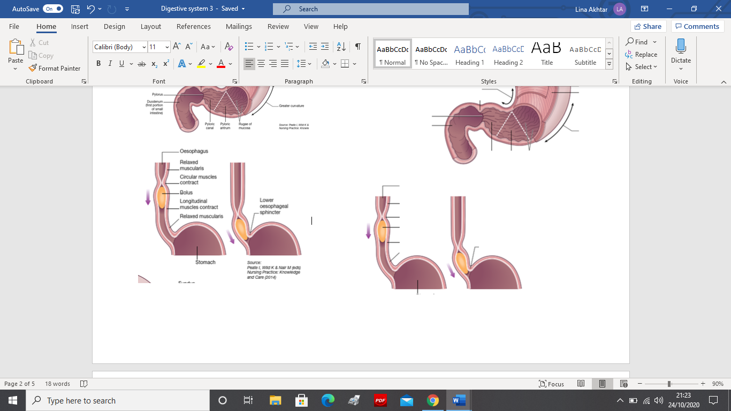
Pancreas
Duodenum
Gall Bladder
Oesophagus
Transverse colon
Relaxed muscularis
Jejunum
Ascending colon
Circular muscles contract
Stomach
Descending colon
Ileum
Bolus
Fundus
Esophagus
Appendix
Caecum
Logitudinal muscles contract
Serosa muscularis:
Cardia
Lower oesophageal sphincter
Sigmoid colon
Rectum
Lower oesophageal sphincter
Anus
Lesser curvature
Circular layer
Longitudinal layer
Body

The mouth
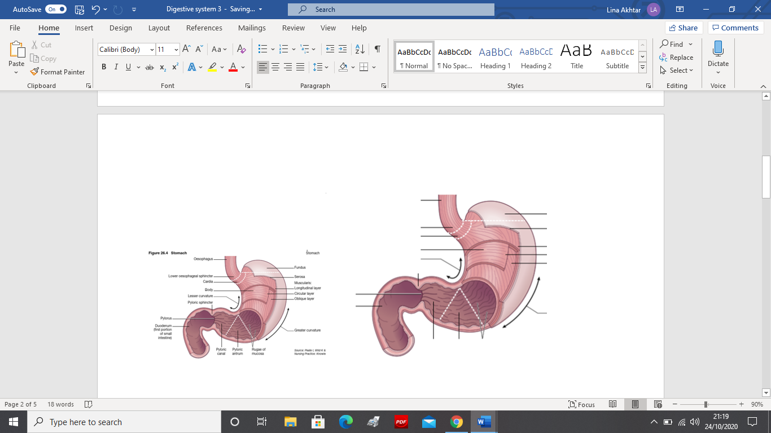
Oblique layer
Pyloric sphincter
Pylorus
(Waugh and Grant, 2018, pp. 313-367)
Greater curvature
Duodenum – first portion of small intestine
Stomach
Rugae of mucosa
Pyloric antrum
Pyloric canal
(Peate, 2015)
Relaxed muscularis
(Peate, 2015)
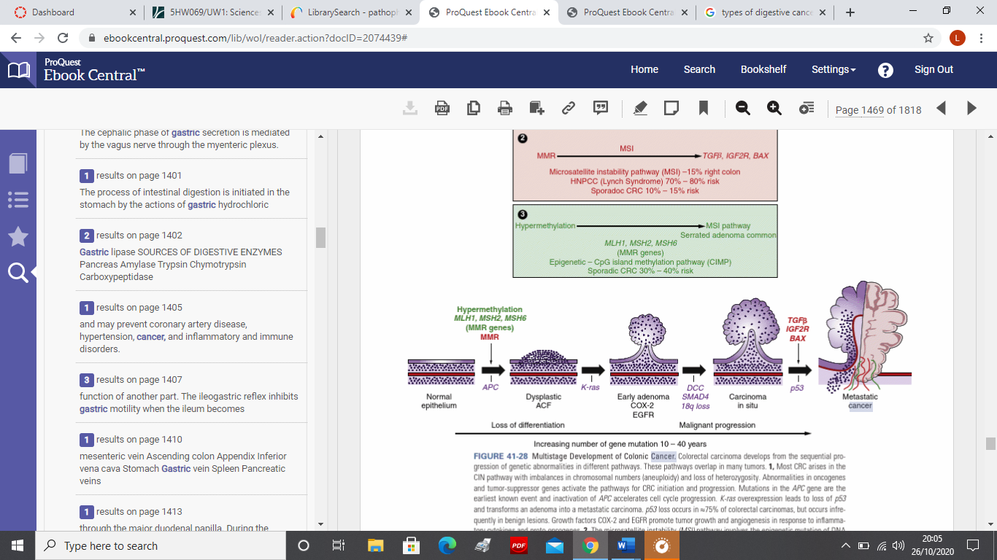
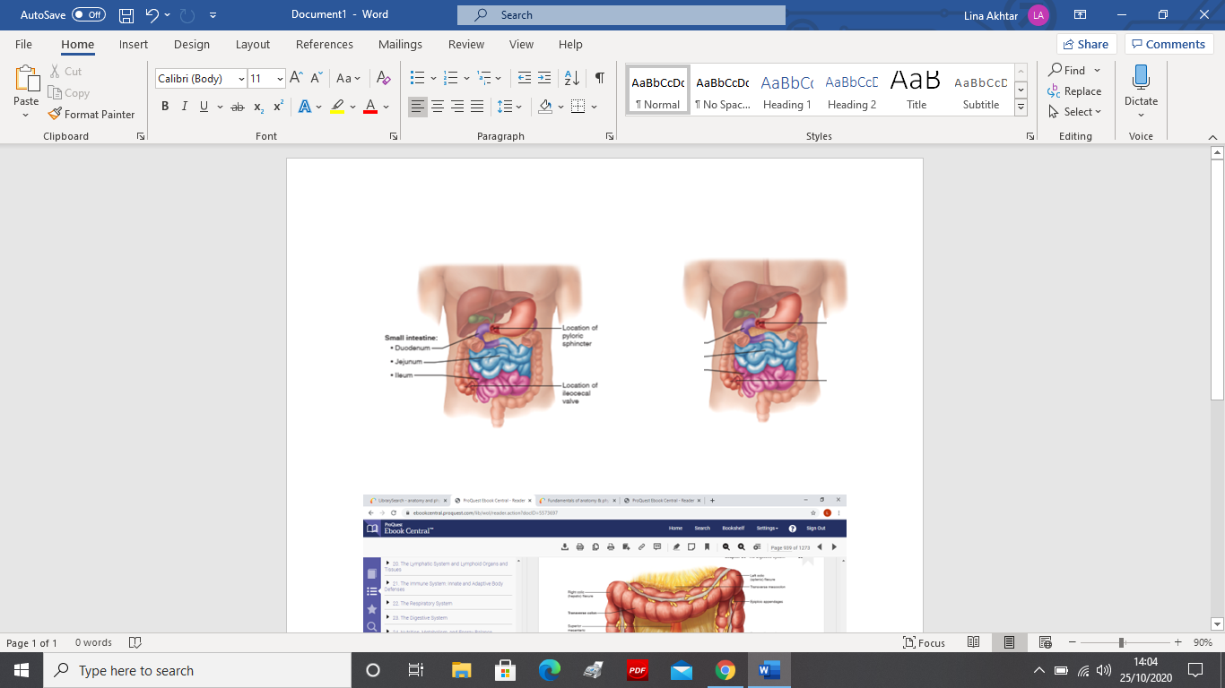
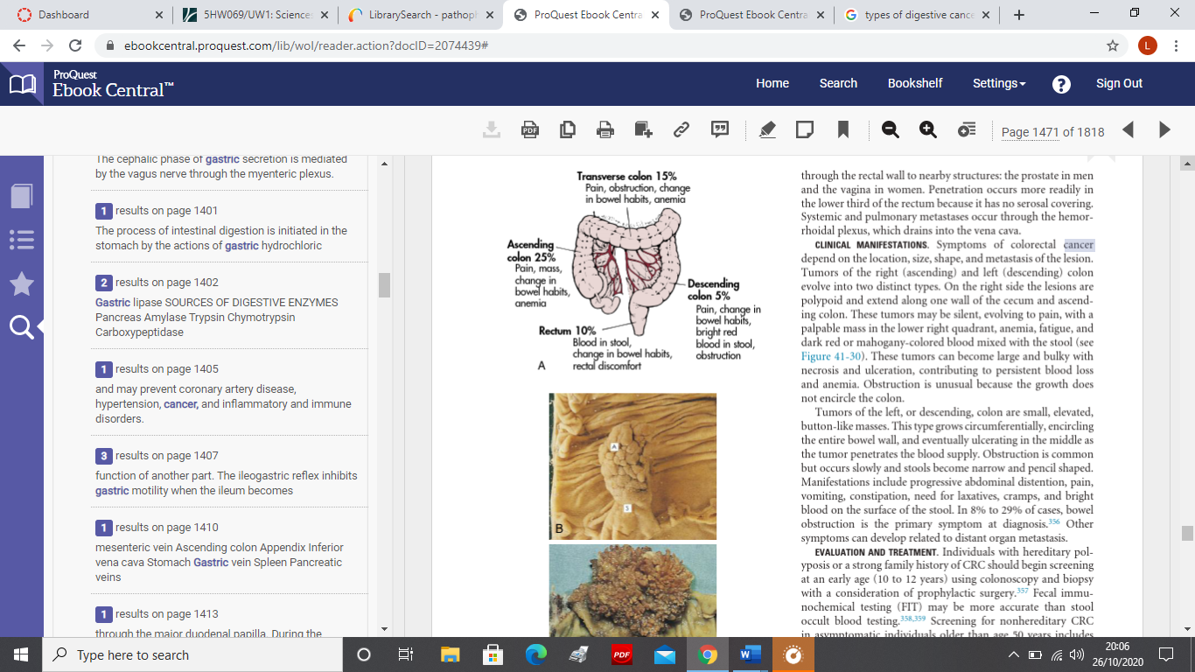
Metastatic Cancer
Normal epithelium
Colorectal Cancer
Small intestine & Large intestine
Transverse colon – pain, obstruction, change in bowel habits, anemia
Ascending colon – pain, mass, change in bowel habits, anemia
Transverse colon
Colorectal cancer: This is a cancer that starts in the colon or the rectum.
- Where people undergo colostomy to shorten or remove a damaged part and the cut end is diverted, the opening is called a stoma.
- A pouch is placed over the stoma to collect your stools
- A colostomy is needed to treat injury or problem with your digestive system
- Diagram above shows normal cells which slowly progresses to colorectal cancer. They tend to grow slowly and takes years for it to form
- Difficult to detect early
- Obstruction is common and occurs slowly and stool becomes narrow
- Other problems can be vomiting, cramps, constipation and blood in stool
Duodenum
Pyloric sphincter
Jejunum
Descending colon
Decending colon – pain, change in bowel habits, bright red blood in stool, obstruction
Ileocecal valve
Ileum
Rectum – blood in stool, change in bowel habts, rectal discomfort
Sigmoid colon
Ascending colon
(McCance and Huether, 2014, pp. 1468-1472)
Anal canal
Rectum
Appendix
Layers of alimentary canal: This is the passage in which food passes through the body from mouth to anus during digestion.
- Mucosa – known as mucous membrane, the membrane consists of epithelium which is in direct contact with ingested food. It has a thin, smooth muscle layer called the muscularis mucosa.
- Epithelium is the thin tissue in the outer layer and lining the alimentary canal
- Submucosa – connective tissue that supports the mucosa and joins it to the muscular layer and includes blood and lymphatic vessels and releases secretions.
- Muscalaris – smooth muscle in the small intestine promoting mechanical digestion
- Serosa – this is the outer layer present only in the alimentary canal. This holds the alimentary canal in place near the vertebral column.

(Hoehn and Marieb, 2019)
Visceral peritoneum
Intrinsic nerve plexuses
Accessory Organs
These are organs that don’t touch the food but they have to be secreting their product to help digestion occur.
Liver:
- one of the main functions are to make and secrete important substance called bile.
- Bile is important for the digestion of fats
- It processes blood coming from the small intestine containing nutrients and filters out toxins and waste
- You will not live without a liver but can live with only part of it
- It converts glycogen back into glucose and used to help blood sugar
Gall bladder:
- It receives and stores bile produced by the liver
- Delivers bile into the duodenum where it helps in the digestion of fats
- Excess fats or bile salts can cause gallstones to form
- You can survive without a gall bladder
Pancreas:
- It makes pancreatic juices called enzymes and helps break down sugars, fats/starches
- It neutralises stomach acid after a meal
- It maintains body’s blood glucose

(Tucker and Foulston, 2015, pp. 153-154)
Small Intestine:
There are three distinct regions to the small intestine,
- Duodenum – is the first part of the small intestine (shortest) where preparation and absorption begins. The next two parts are Jejunum and Ileum.
- This is roughly 22 feet long.
- It is part of the gastrointestinal tract between the stomach and the large intestine
- It has millions of tiny finger-like coatings called cilia or villi to increase surface area and makes digestion more efficient
- Nutrients are passed through the walls of the small intestine into the bloodstream. Whatever is left continues to the large intestine.
Large Intestine:
The main function is to absorb water and minerals from the remaining leftover and transmit the useless waste material from the body.
- Large intestine is about 5 feet long
- It accepts the leftover from the small intestine
- You may have a large part of this removed and still make a full recovery.

(Odya and Norris, 2017, pp. 238-240)
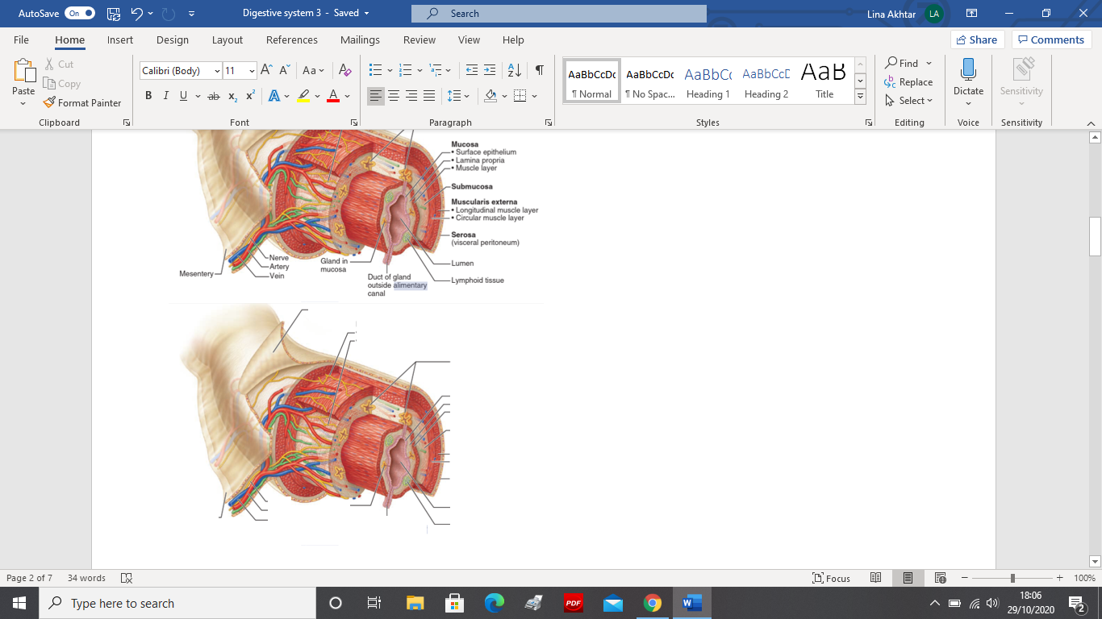
(Marieb, 2014)
Longitudinal muscle layer
Submucosal nerve plexus
Artery
Nerve
Vein
Gland in mucosa
Lymphoid tissue
Lumen
Serosa
(visceral peritoneum)
Circular muscle layer
Submucosa
Surface epithelium
Lamina propria
Muscle layer
Mucosa
Submucosal glands
Duct of gland outside alimentary canal
Mesentry
Mysentric nerve plexus
References

Hoehn, K. and Marieb, E. (2019) Human anatomy and physiology. 11th edn. England, Essex: Pearson Education Limited
Marieb, E. (2014) Essentials of Human Anatomy and Physiology. 11th edn. England, Essex: Pearson Education Limited
McCance, K. and Huether, S. (2014) Pathophysiology, The Biological Basis for Disease in Adults and Children. Saint Louise: Elsevier
Odya, E. and Norris, M. (2017) Anatomy and Physiology for dummies. 3rd Edn. Hoboken: John Wiley & Sons
Peate, I. and Mair, M. (2015) Anatomy and physiology for nurses at a glance. Chichester, West Sussex: John Wiley & Sons
Tortora, G.J. and Derrickson, B.H. (2017) Tortora’s principles of Anatomy & Physiology, Global Edition. Hoboken: John Wiley & Sons
Tucker, L. and Foulston, J. (2015) An Introductory Guide to Anatomy & Physiology. London: EMS Publishing
Waugh, A., Grant, A. and Ross, J. S. (2001) Ross and Wilson Anatomy and Physiology in Health and Illness. Edinburgh: Elsevier
Waugh, A. and Grant, A. (2018) Anatomy and physiology in Health and Illness. 13th Edn. Edinburgh: Elsevier

