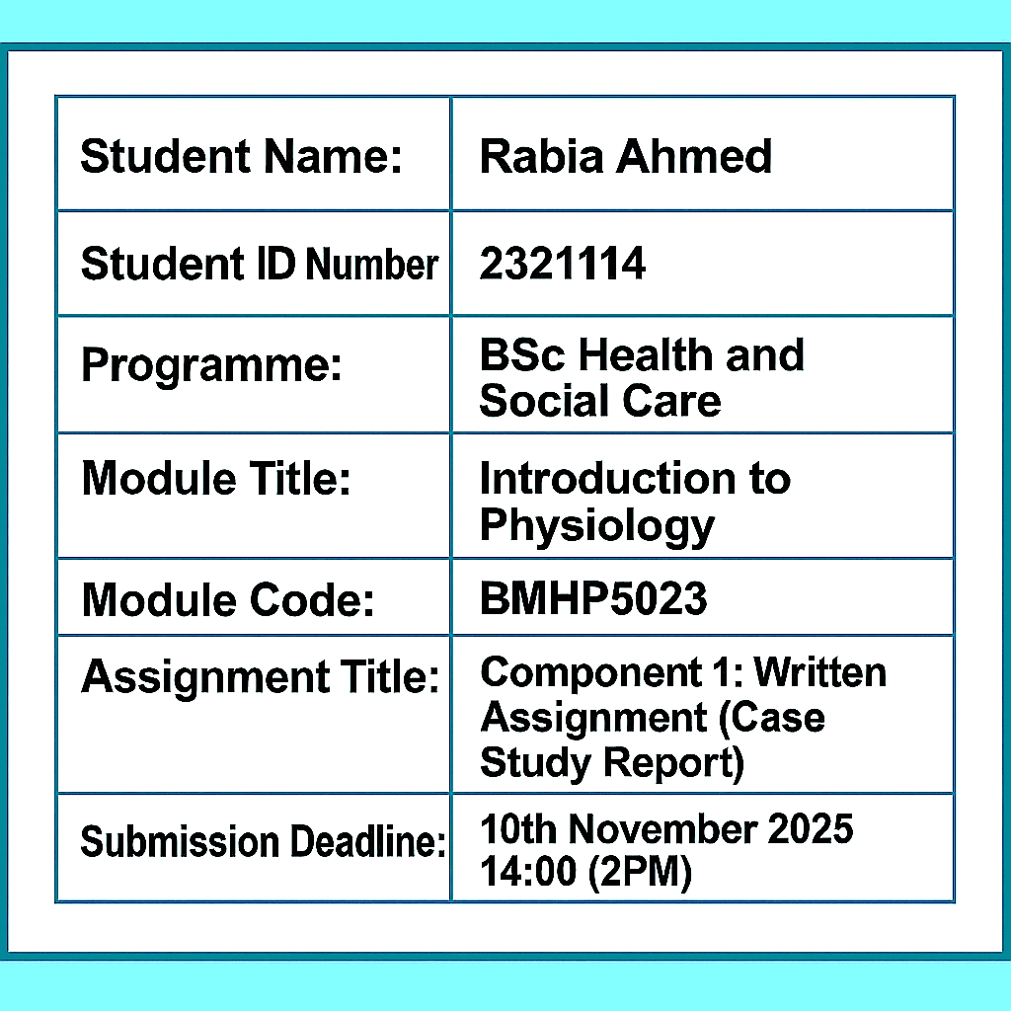


Table Of Contents
Introduction 2
2. Structure of the Respiratory System and Mechanical Respiration 3
3. Gas Exchange in the Lungs 5
4. Irritants, Airway Inflammation and Impact on Respiration 6
5. Monitoring and Tracking Respiratory Function 7
6. Evidence-Based Lifestyle Recommendations 8
7. Conclusion 10
References 11

Introduction
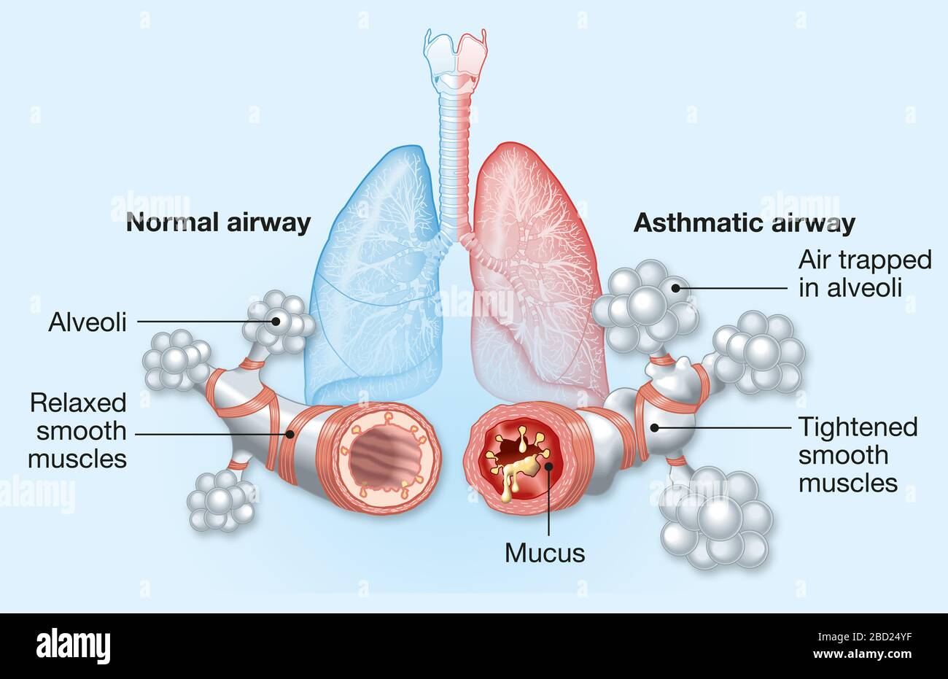
Asthma is a chronic inflammatory disease of the respiratory tract that leads to the airways being swollen, narrow, and excessive, and difficulty breathing (NHS, 2024). It is one of the most prevalent chronic conditions in young adult people, as its impact in the UK is approximately 1 in 11 cases (Asthma + Lung UK, 2023). In addition to coughing and wheezing, there is an actual weight to asthma, it interferes with the school attendance, the variety of daily activities and in serious cases even makes it life-threatening. It is not only a medical problem, but it is a significant public health problem that impacts both families, education, and health care systems.

The following report examines particular topic of interest, namely, "asthma in adolescents," paying attention to the functioning of the respiratory system and the reasons why, at times, there is no cooperation between the respiratory and other body systems. It starts by describing the anatomy and physiology of the lungs, routes by which air passes through the nose and mouth to the so-called alveoli, where oxygen and carbon dioxide take place. Then the discussion is on how the airways can be triggered to inflame and constrict by the environmental irritants such as pollen, pollution, and tobacco smoke to initiate the usual asthma symptoms.

Moreover, the report will describe how asthma is "clinically monitored" and how such devices as peak flow meters, spirometry, and symptom diaries will help to monitor lung functioning and earlier detect exacerbations. Lastly, it examines the significance of a regular exercise and a balanced diet, as well as adherence to medications, which are the aspects of lifestyle factors in self-management. All these factors contribute to the ability of young people with asthma to stay in control and independent with long-term respiratory wellness.

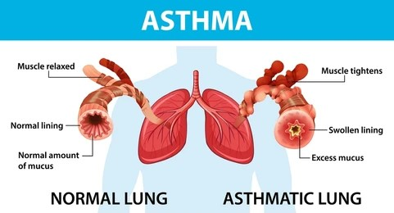
(NHS, 2024)

2. Structure of the Respiratory System and Mechanical Respiration
The respiratory system is a sequence of organs, which make it possible to exchange carbon dioxide and oxygen. The air gets in via the nose and it is filtered, warmed, and moistened then is directed via the pharynx and the larynx into the trachea. The trachea further branches into two bronchi, then each of them further divides into smaller bronchioles located in the lungs. These bronchioles end with tiny air sacs known as alveoli where gas exchange takes place. The dome-shaped muscle under the lungs plays a very important role in breathing as it ensures that it contracts and relaxes to alter the thoracic pressure.

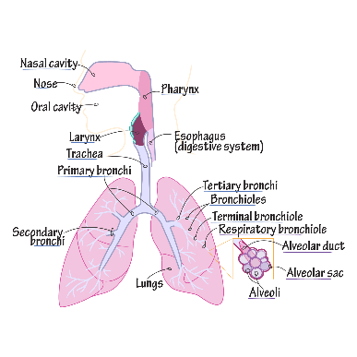
In the act of breathing in, the diaphragm will shorten as it passes downwards and the external intercostal muscles will raise the rib cage where the chest will be able to enlarge and the air will get pulled into the lungs. In the process of expiration the muscles contract, the cavity of the chest becomes smaller and air is forced through.

The lung design promotes effective exchange of gases: alveoli (millions) give an opportunity to have a large surface, thin walls easily favor diffusion, and expelling is supported by the process known as elastic recoil. There are a dust and pathogen-trapping mucus, and a table cleaning of dust in the airways, which is ensured by the movement of the cilia, ensuring lungs are healthy.

During asthma, the bronchiole smooth muscle systems constrict, and there is excess production of mucus, which constricts the airways, and the breathing becomes difficult. This structural alteration is the reason of the characteristic wheezing and dyspnea observed during attacks of asthma.
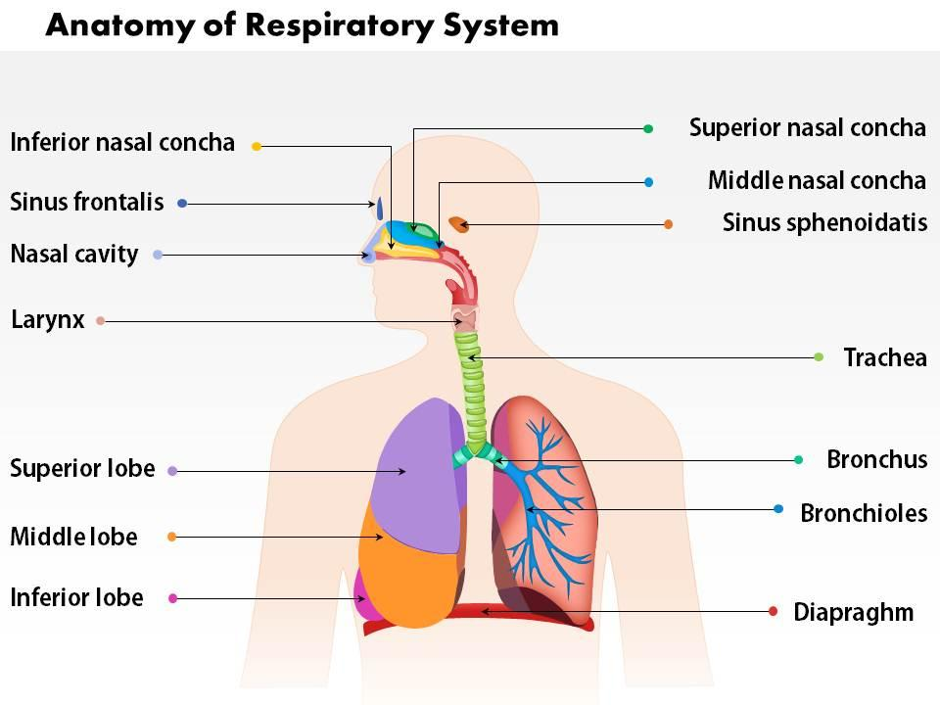
(Asthma+LungUK)

3. Gas Exchange in the Lungs
The process of gas exchange takes place in the alveoli which are small air sacs engulfed in a web of capillaries in the lungs. The oxygen exercises in the diffused air then crosses the thin membrane of the alveoli and into the blood, and the opposite happens to carbon dioxide (CO 2) which moves in the reverse direction out of the blood into the alveoli where it is expelled. The gradients of partial-pressure cause this exchange as explained in the law of Dalton, according to it the gases move in the direction where the partial-pressure is larger to where it is lesser until the point of equilibrium is reached.

The big surface area of the alveoli, their wet lining (gases could dissolve on it), and one-cell-thick membrane that minimizes the distance to diffusion improve the efficiency of the diffusion process. When in the blood, oxygen is attached to hemoglobin in red blood cells to create oxyhemoglobin and enables the quick transport of oxygen to the organs and tissues of the body.

Asthma also involves inflammation, narrowing of the bronchi, and secretion of mucus that blocks the number of breaths in some alveoli. This results in ventilation and perfusion (V/Q ratio) mismatch some of the blood flows through under-ventilated alveoli resulting in inadequate oxygen levels (hypoxia) and excessive CO 2 (hypercapnia) in more severe cases. As a result, the patients with asthma could feel breathless and exhausted because of the reduction of the efficiency of gaseous exchange.
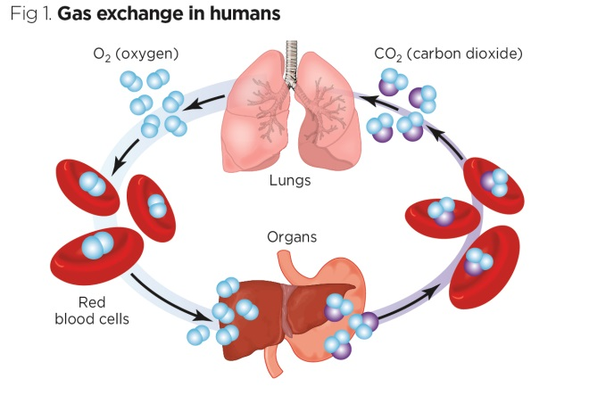
(Alveoli gas exchange – NHS)

4. Irritants, Airway Inflammation and Impact on Respiration
Examples of environmental irritants that may cause asthma symptoms include; pollen, dust mites, pet dander, air pollution, tobacco smoke, cold air, exercise and viral infections. Exposure of an asthmatic person to these triggers leads to an inflammatory process in the airways by the immune system. It starts by activating mast-cells that release such inflammatory mediators as histamine and leukotrienes. These are the chemicals that cause swelling of the air way lining (oedema), shortening of smooth-muscle (bronchospasm), and secretion of mucus, resulting in air obstruction.

The airways become narrow making airflow limited, which results in typical wheeze, cough, tightness of the chest and dyspnea (shortness of breath) diagnosis of asthma. Excessive production of mucus also obstructs smaller bronchioles, which reduces ventilation and gaseous exchange.

These changes would be reversible in acute asthma and treated properly with the help of bronchodilators and corticosteroids. Chronic or poorly controlled asthma however can result in airway remodeling, wherein long-term inflammation results in structural alterations in that airway, which include airway thickening, augmentation of smooth-muscle bulk, and fibrosis. Such long-term changes may decrease lung elasticity and the respiratory performance in the long run.

Reduction of exposure to triggers, such as allergens, minimization of pollution and prophylactic inhalers play important roles in the prevention of exacerbation and the achievement of the stable respiratory health of adolescents.
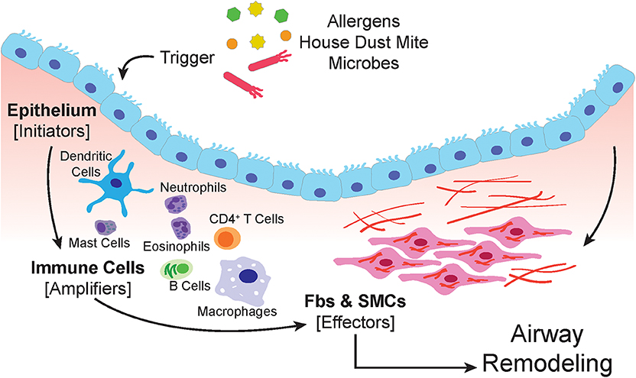
(Asthma + Lung UK)

5. Monitoring and Tracking Respiratory Function
Effective asthma management and early deterioration identification require monitoring respiratory functioning. Peak expiratory flow (PEF) is a test of the top rate at which air is expelled out of the lungs in a forced exhalation, determined by a peak-flow meter. Teenagers are advised to measure the daily airway PEFs to detect the changes in the airway functionality. In accordance with the article called NICE (2023) and NHS Asthma Action Plans, the outcomes are compared with individual best values and divided into green, amber, and red zones: green in control, amber in cautious and in need of medicine, red in restriction with a high severity and need of the immediate medical attention.

Nurses are at the forefront of informing the youth on the proper use of the devices, reading of results, and following their own action plan. Another type of assessment, including spirometry (to gauge the lung capacity and airflow) and pulse oximetry (to gauge the oxygen level), has more specific means of assessing the work of the respiratory system in clinical settings.

Awareness of deteriorated lung results early with precise recording and trending results can be used in preventing acute exacerbations. Nurses can encourage adolescents to gain self-monitoring power to be able to manage the situation, enhance symptom control, and sustain long-term respiratory health.
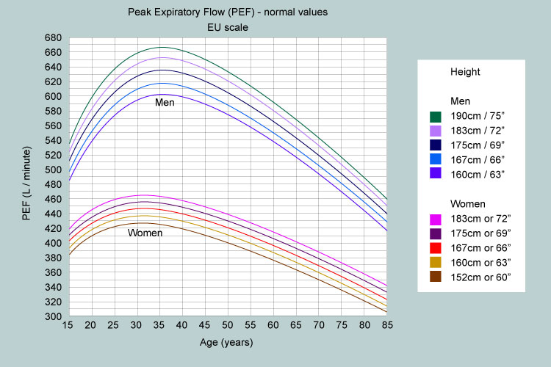

6. Evidence-Based Lifestyle Recommendations
Asthma self-management includes lifestyle adaptation as one of its vital components (NICE, 2023). It has been demonstrated that altering some lifestyle habits can usually significantly boost the management of asthma, diminish attacks and also improve the overall health of teenagers. Education, motivation, and collective care are some of the key ways in which nurses can facilitate these changes.

Lifestyle Change | Evidence or Rationale (Source) | Expected Benefit
Avoid smoking/vaping | NICE (2023); Department of Health and Social Care (DHSC, 2022) | Reduces airway inflammation and prevents further respiratory damage, improving long-term lung health.
Allergen control (e.g., washing bedding weekly, limiting pet contact, using dust-mite covers) | Asthma + Lung UK (2023) | Reduces allergen exposure, leading to fewer night-time symptoms and improved sleep quality.
Physical activity within individual limits | NHS (2024) | Strengthens respiratory muscles, enhances stamina, and supports emotional wellbeing, provided symptoms are well controlled.
Annual flu vaccination | Public Health England (PHE, 2023) | Protects against respiratory infections that can trigger severe asthma attacks and hospitalization.
Healthy BMI and balanced diet | BMJ Nutrition (2022) | Maintaining a healthy weight and eating nutrient-rich foods support immune function and optimize lung capacity.
Adherence to inhaler technique and medication plan | Nursing and Midwifery Council (NMC, 2023) | Ensures effective drug delivery, maximizing control and preventing exacerbations.
In combination with regular monitoring and the use of inhalers, these lifestyle measures will empower adolescents to manage their condition and will enhance the overall health outcomes in the long-term.
There is a key role that nurses can play through providing education, motivational interviewing to promote behavioral change and partnering with the youth to work with them and their families. This is an interactive strategy, which fosters trust, confidence, and makes lifestyle management a long-term commitment to holistic management of asthma.
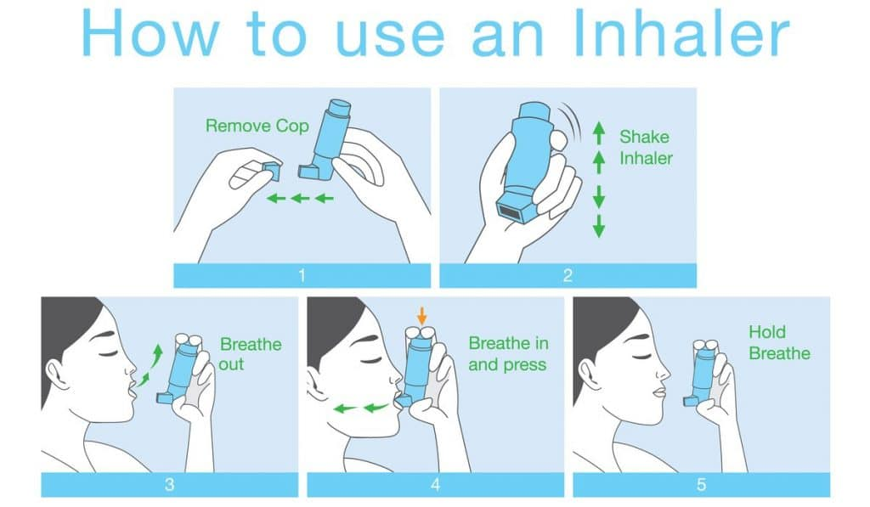
(NHS)

7. Conclusion
Asthma is a permanent yet reversible airways condition that is caused by an inflammation response by the airway’s walls, airways constriction, excess of mucous that obstructs normal movement of air into the lungs. Anatomical and physiologic changes are also helpful in understanding ways to balance the anatomy and physiology of the respiratory system facilitate a symptom of shortness of breath and wheezing.

The interplay between airway inflammation, environmental factors and changeable lifestyle risk factors (e.g. physical activity, diet, smoking cessation) plays a role towards the level of asthma control and general quality of life experienced by individuals with asthma.

Nurses are better placed to empower the adolescent asthmatics to take charge of their asthma through their education guided by current scientific evidence to encourage self-monitoring and facilitate the establishment of healthy behavioral patterns that will help them manage their asthma. To enhance the management of acute and chronic asthma, nurses can offer holistic, patient-centered care using clinical knowledge and promote compliance and collaborate with adolescents and their families.

References
- NHS (2024) Asthma. Available at: https://www.nhs.uk/conditions/asthma/
- NICE (2023) Asthma: diagnosis, monitoring and chronic asthma management (NG80). Available at: https://www.nice.org.uk/guidance/ng80
- Asthma + Lung UK (2023) Asthma information and resources. Available at: https://www.asthmaandlung.org.uk/
- Public Health England (2023) Seasonal influenza vaccination programme. Available at: https://www.gov.uk/
- DHSC (2022) Health and Care Act 2022: integration and innovation. Available at: https://www.gov.uk/
- NMC (2023) The Code: Professional standards of practice and behaviour for nurses, midwives and nursing associates. London: NMC. Available at: https://www.nmc.org.uk/
- CQC (2023) Fundamental standards. Available at: https://www.cqc.org.uk/
- The Health Foundation (2016) Person-centred care made simple. London: Health Foundation.
- BMJ Nutrition (2022) ‘Dietary patterns and respiratory health,’ BMJ Nutrition, Prevention & Health, 5(2).
- RCN (2023) Principles of nursing practice.
- British Thoracic Society (2023) BTS/SIGN Asthma Guideline. Available at: https://www.brit-thoracic.org.uk/
- World Health Organization (2023) Asthma key facts. Available at: https://www.who.int/
- DHSC (2014) Care Act 2014: statutory guidance. Available at: https://www.gov.uk/
- NHS Leadership Academy (2021) Healthcare Leadership Model: Leading with care. Available at: https://www.leadershipacademy.nhs.uk/
- Cochrane (2022) Interventions for improving inhaler technique in asthma. Available at: https://www.cochranelibrary.com/

