
romi begum
Professional career development

febuary 2018
University of Wales Trinity Saint David

Executive Summary
Main important topics been discussed in this report is swot, johari windows, smart goals,vark,honey and mumford,go mad and employment process . Here i have talked about the employability recruitment and interview skills and questions on what to say and what the company are looking at.

Table of Contents
Executive Summary 1
Introduction 2
Findings 3
Conclusion/Recommendations 6
References/Bibliography
7

Term of reference
On the 13 ^{h} of march 2018 (shelia khan) report from Romi begum to be submitted on the 27th of march.

Introduction

Whenever it’s short-term or long-term goals, The best way why I needed career development skills is..., career development helps you plan to take responsibility for your weaknesses, even if you’re bad at doing work we can always try and develop new ways and new skills .also it will boost your confidences in your work career developments by setting a goal plan and being organised. Career development can give you control in your aspects of your career. I will gradually to know your strengths and weaknesses by heart. You will decide and work on what are your targets and set tasks on your goals and meet them. Then you will seem to notice motivation in your career wise.

After I graduate you must need a career lifetime job the skills myself must needed is able to commenced awareness ,understanding how to run a business or working in a busy work environment that making the interviewer your interested and showing you are willing to understand of what the company achieved through products and how to run one alone .
(Peter Morgan) 2018

Findings
1.1 Basic communication covers verbal and written communication and having listening skills is very important.
Speaking clearly, able to stay focus and being reliable is the key skills to success.
I will have to work with in others to prove that I am a team player but also can manage and interact to others and take responsibility. It’s about building relationship with team players that helps everyone to achieve goals.
You may need your problem –solving skills by resolving issues and problems. It’s a main part to approach problems from perspective.
Leadership is one graduates must have while working in a team to show you have potential to lead a team and others workers .help them to motivate you and team players its about setting deadlines and leading a good example to others.
The ability working under pressure is remaining calm at all times in a situation able to work under stress and solve problems what May interviewers look upon on in the company.
Confidence in a work place you will need to strike the balance between respect and being arrogant and by having respect to others work colleagues helps you build good relationship with the co worker and you .
How I developed my career skills is by having personal skills it can be improved and developed quickly by doing actives like
- Team work –sports event, presentation meeting
- Lateral thinking – thinking ways to raise cash for charity
- Writing skills- writing down an essay

Also you can do projects courses by
Speaking communication - joining a kids camp, working as a receptionist
Numeracy – working in a bank, doing mathematics’, budgeting your money
Planning and organising – planning a wedding, trips, camps
Listening- lectures, working as a waiter, listening to a book reader

What I have learned in my lessons was learning my weaknesses and my strengths, by developing how to concur those by doing research and completing 2 styles questionnaires based on our personality.
Also learning to:
SWOT
This is a very useful technique for understanding your weaknesses and your strengths. In both ways this had improved my threats and made them to my strengths. I have struggled to do numeracy and by that I made them opportunity by planning on how to become better by doing online research and practising to overcome my fears.
https://www.mindtools.com/pages/article/newTMC_05.htm
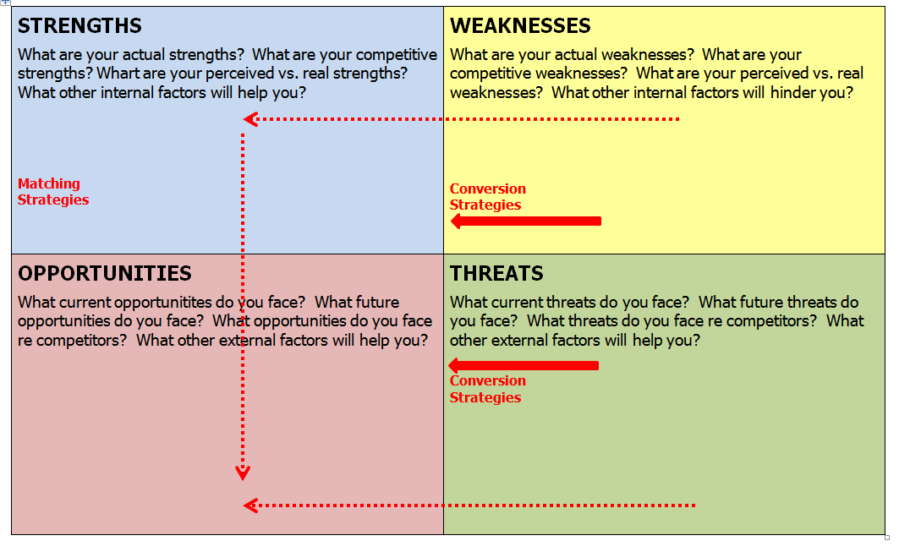
https://www.google.co.uk/search?q=swot&dcr=

JOHARI WINDOWS
This technique is meant to help you mentally and build connection with yourself and others also this has helped me in many ways by self- awareness, person development, improving communications,inter- person relationship ,group anaemic and team development .
Many one of the ‘soft skills’ that people use to develop self-development.
It has great model for me because of the simplicity and it has helped me upon my weakness such as confidence, working with others and team leadership skills.
http://www.selfawareness.org.uk/news/understanding-the-johari-window-model

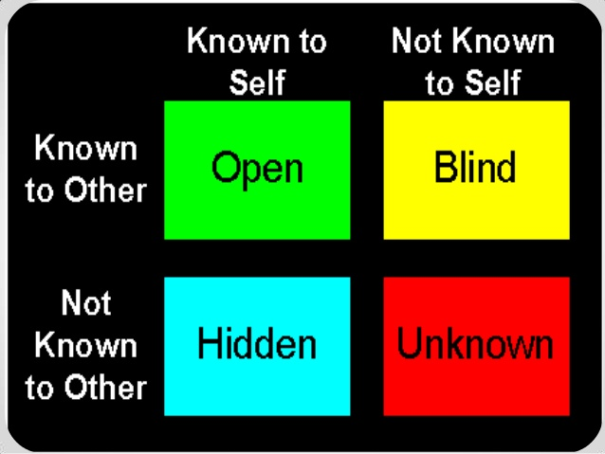
https://www.google.co.uk/image (5:38PM on 10 November 2013)

SMART GOALS
By using this system it has helped me in may ways by being organised and planning well and knowing what your goals are and acheiving them i have always wanted to be an supply teacher or ehalth support worker, it is very important to me because i hav emany skills with children and in the health section. The steps i will be taking is going to my classes and finishing my assighments on time , i will know when achived my goals is by when i have my degree and i want to achieve this by the next two years.
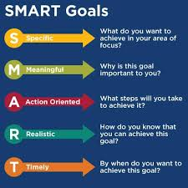

1.2
Here are the two learning styles was;
VARK QUESTIONAIRE
- V- VISUAL
- A-AURAL
- R-READ/WRITE
- K- KINESTHETIC

This questionnaire is self reflection used on teachers and students like me my personal experience were visual and by that meaning I learn by looking at books listening in classes .

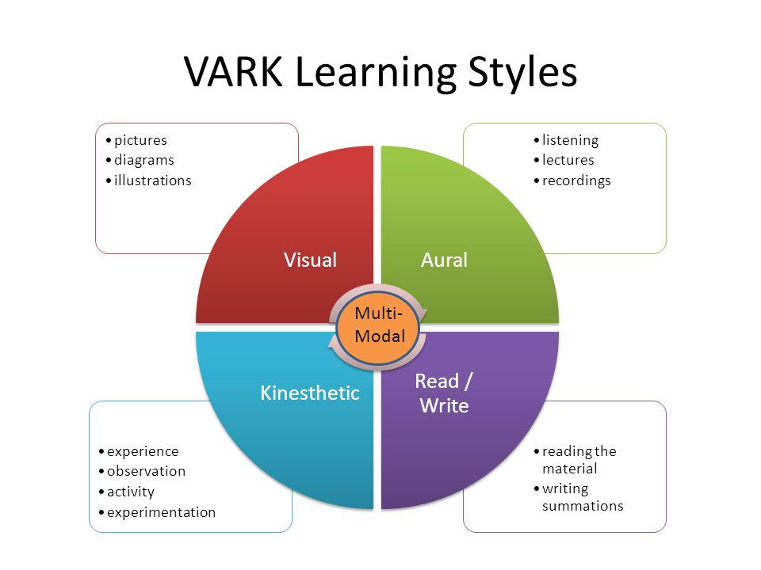
https://uk.images.search.yahoo.com/search/images

HONEY AND MUFORD (1992)
Here are the 4 types of learners
- Activist
- Reflector
- Theorist
- Pragmatist
By having experience I work for an call centre by that I had lack of confidence so for that I did a questionnaire based on my skills and personality and by that was reviewing myself by experiences by observing other people by reflecting on my weaknesses by that I took online course to help me boost my confidence by using this technique.
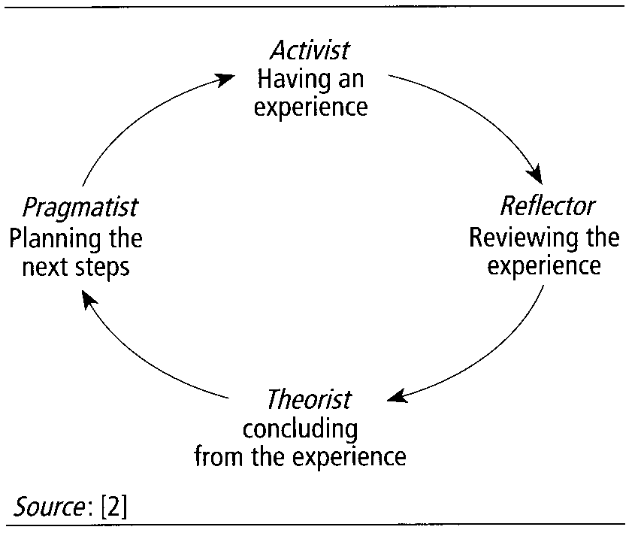
https://uk.images.search.yahoo.com/search/images

Here is my personal SWOT;
My weaknesses are not being confidence and how I reach to improve that I have done a presentation that boost up my confidence in front of people that helped me allot in the process and by that I can now managed to speak clearly in front of the audience.
My weaknesses is mathematics’ and I discovered you can do online courses to help you work towards numbers and that way when your in a interview u wil know exactly what to put in.

PDP STRATEGIES
Strength | PDP Opportunity | Strategy Required
Situation response | Health advisor | Finish my education
High empathy | Support worker | Get a degree

CONVERSION STRATEGIES
WEAKNESSES THREATS | CONVERSION STRATEGY | STRENGTH OR OPPORTUNITY CREATED OR WEAKNESS OR THREAT NEUTRALISED
ANALYTICAL SKILLS | CONFIDENCE | BUILDING UP MY CONFIDENCE
STICKABLILITY | MATHAMATICS | LEARNING MORE

SWOT ANALYSIS
- Strengths
- Weaknesses
- Threats
- Opportunities

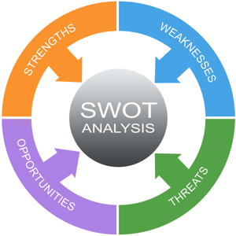

Here is my personal GO MAD:
Gilbert, A. and Chackrovaity, I. (2001) “Go Mad: about coaching”. Bath. Bath Pres

GO MAD
1. REASON/WHY? - To be a supply teacher or an health adviser
2. DEFINE/GOAL- Administration work
3. PLAN/PRIORITIEs- Go to lectures, have a time table
4. SELF BELIEF- Have will power and have motivation
5. INVOLE OTHERS- Have support from family, friends and work mates
6. PERSONAL RESPONSIBILITY –Doing research finishing assignments on time
7. TAKE ACTION AND MEASURE RESULTS - Feeling proud and finishing on time and celebrating with family

What types of support I will be supporting and overcoming them is by using the technique called SMART: (https://uk.images.search.yahoo.com/search/images)

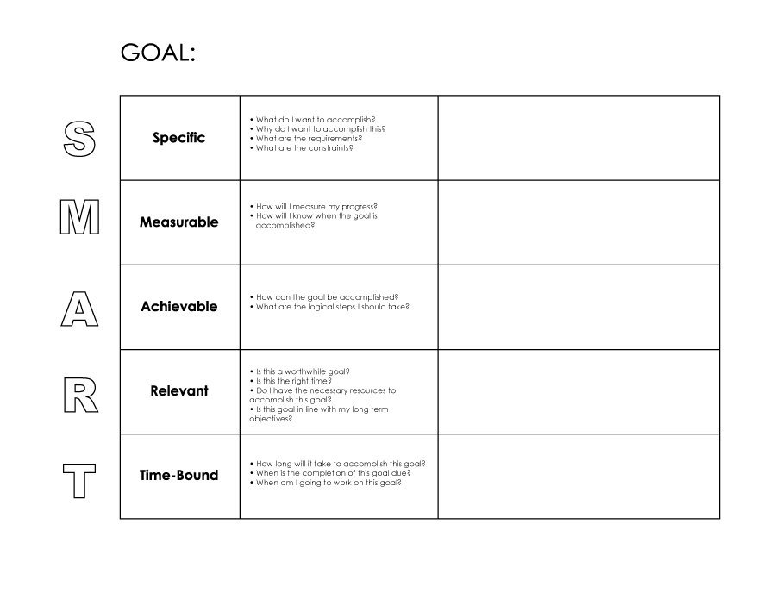
Next two years
To get a better career lifestyle
Yes by attending my lessons
By finishing my course
Degree
S – What exactly I want to achieve? I want to graduate and get my degree.
M-How will I know when I achieve it? By attending my lectures and getting feedback from my tutor.
A-Is it something you have control over? Yes I have and by building confidence and motivation.
R- Why is it applicable in your life? To have stability and have a better job .
T-when you want to achieve this? In the very next year

What support mechanisms are available to you?
Support from family and friends, doing online research for courses to help you learn more also asking feedback from your tutor and them improving your academic writing and then doing a presentation to boost yourself esteem and help you come over your threats.
https://link.springer.com/article/10.1007%2FBF00918174
Personal development plan
Here is shown my daily planned routine on how I spend my day.
12am | 1am | 3am | 4am | 5am | 6am | 7am
sleep | sleep | sleep | sleep | sleep | sleep | sleep
8am | 9am | 10am | 11am | 12pm | 1pm | 2pm
sleep | Wake up | breakfast | gym | gym | studying | Studying
3pm | 4pm | 5pm | 6pm | 7pm | 8pm | 9pm
resting | Netflix | Cooking | Going out | outside | Outside | Home
10pm  In bed | 11pm  sleep

Building a new career and better education for me, team work and confidence is needed and better knowledge, also developing new skills and better communication skills is what I want to achieve.
https://books.google.co.uk/books?

Part2
The learning process of hiring is that I learned:
- I Identify the person before a position can be filled, they must be available for part time or full time work.
- Planning and making sure your willing to agree for the position process steps, this involves interview, questions, instructions and taking notes.
- Create a job description doing research on the company to see what their based at and what products they do.
- Post and promotions advertising the job on website, adverts and leaflets.
- Recruiting seeking high standard qualified candidate for the job by linken, facebook or meeting events.
- Applicant screening job applications arrive by emails or by phoning up the company you must review cvs or cover letter during the interview.
- Screening interviews by then you will receive an email or a phone call with in the 48 hours from the company to invite you for an interview.
- Interviews you may have an early interview typically one to one or either by a phone call or Skype.
- Applicant talent assessment after the interview they might will to give you the job today, if not then within the next following week.
- Background checks one find steps is making an offer is doing background research on criminal recored,history and availability.
- Decision hiring staff based on the current interviews, knowledge, apperence, basic qualifications to see if your right for the job .
- Reference checks giving 3 types of reference an d they should be by someone you know for over 5 years, can be someone you know. And they should be contacted straight way.
- Job offer offering the job receiving a letter stating the salary and start date.
- Hiring the person once they start he or she need to fill in a permit contract .
- On board making the person feeling welcomed.
Our Employment Process
https://www.google.co.uk/search?q=job+process
- Online process- applying job on the website
- Hr review- background checkups on criminal records and credit check
- Manager interview- you will receive and email by the company or phone call
- Job offers- then after the interview, the company will decide if you got the job.
- Your first day- welcome to the company

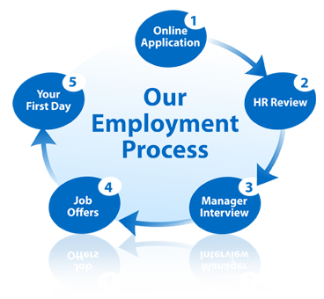
My suitable job?
https://www.4myschools.org/what-is-the-role-of-a-supply-teacher-or-teaching-assistant/
the role of being a supply teacher is being flexible and time for your students, also to apply cover for the school when the permit teacher absent.
You will need to be on time to classes being organised and well mannered and being a supply teacher offers you suitable times when to work by your flexibility both primary and secondary are very demanding .
We like to recommend for supply teachers to at least have cpd in particular.
This way you can management your behaviour, curriculum and teaching skills in the best way. It is important to let the school know on how your copying.
What is involved is teaching a subject in a school, your qualification skills, filling in assighments,one to one tutoring giving out home work and going to school events.
Recruitment process
Supply teacher that we looking for is someone who can travel, speaks clearly A qualified teacher with QTS or experience instructors. Someone who simple and flexible willing to take risks, very challenging job.
First thing we look for mostly is good bounding with your students and good and honest relationship most consultants is looking for in a person.
http://www.hays.co.uk/job/education-jobs/what-makes-a-good-supply-teacher-1371487
Do your research before your interview, take a looks at the websites, latest reports, pictures band location. If you work for the agency ask.
Firstly you will receive an Interview with the sub-n teacher chat to you about what job your interested, verify your qualifications, check your original documents, then you will fill in a DBS form.
After check your EWS registration and contacting the reference you gave. http://mps-education.com/substitute-teaching-jobs/

Remember what you see in your profile isn’t true, example of a question to ask during the interview
- Has work been set off?
- Any specific questions to ask about to my students?
- What is the school time table?
https://www.tes.com/jobs/careers-advice/supply-teaching/supply-teacher-guide-cracking-new-school?

In a cover letter based on your experiences the most fought skills for the jobs are:
Teaching skills
Classroom control
Presentation skills
Supervisory skills
Mathematics’
Manners
Dressed well

Example of cover letter
Dear Mr. Martin:
As a skilled and enthusiastic teacher with experience implementing lesson plans and communicating effectively with diverse middle school students, it is my pleasure to submit the enclosed resume for your review. My background and passion for education position me to significantly impact your school in the role of a Substitute Teacher at Cedar Lane Middle School.
Classroom management, cross-functional collaboration, and innovative educational techniques are just a few of the areas in which I excel. By teaching students across a range of subjects and capacities, I have honed my communication, creativity, and motivational skills. My inherent passion for fostering collaborative and exciting educational environments has successfully encouraged and developed productive, thoughtful, and accomplished young students.
Highlights of my qualifications include:
- Creating and implementing hands-on educational activities and programs to facilitate a fun, personalized approach to education while stimulating students’ enjoyment and appreciation for learning.
- Adhering to regular lesson plans and guidelines to maintain consistent classroom environments during normal teacher’s absence.
- Building and sustaining strong student relationships, encouraging student queries, comments, and concerns and laying the foundation for a dynamic and exciting classroom environment.
- Possessing a Bachelor’s degree in Education, as well as current North Dakota state teaching certification.
With experience and credentials, I am well prepared to dedicate myself to the highest standards of learning at your school and exceed your expectations in a Substitute Teacher role. I look forward to discussing my qualifications in further detail. Thank you for your consideration.
Sincerely,
Tammy Sanches
http://www.jobhero.com/substitute-teacher-cover-letter
What they look for in a c.v?
A strong c.v you will need to impress the school by start aiming about two pages no you c.v ,organise your personal information start with your name,email,address and phone number, then professional profile talk about your skills,education,grades and employment, take time to write it focus on the important information like yours skills, achievements .
Continuing writing your professional achievements, all teachers show they commitment of on level of teaching provide more evidence on your c.v then final check your grammar and spelling before you send off.

Conclusion/Recommendations
I have learned how to apply for a job, write a cover letter also talked about my strengths and weakness by swot plan and how to overcome them by using the vark technique and smart goal, by that I have now know what’s my career goals and why it is important because they will help you when you lose someone close and helps you move on, johari windows helped me allot by overcoming my fears and building strength and working on my targets and become successful there are two types of learning styles that I used for this report.

What types of methods that I have been using is Kolb’s learning styles questionnaire, this questionnaire is to find out more and learning techniques as an adult. This questionnaire won’t take you more than ten minute. https://www.google.co.uk/search?q=kolb+cycle

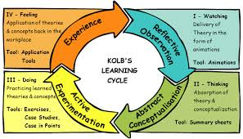

Reflective-watching
Abstract-thinking
Active-experimentation
Experience –experience

Vark
I have learned that it is important to use vark because it a reflection on ourselves and helps on which one your best out on, my results was visual and that’s what helped me allot for learning and it has many beneficial ways on my career wise also here below is a example on how it looks like this question helps you which part of learning strategies you take part in and what’s best for yourself the questions they would ask is
Visual learners- do you remember infr0mation in order
Aural- do you prefer lectures over books
Reading and writing learners- do you take notes during class
Is it difficult for you to sit in class for a long period of time
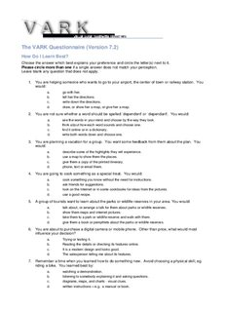

References/Bibliography
(Andrewmaund)Michaela schriek and paul tinkler(2018)
(Peter Morgan) 2018 business students guide
Gilbert, A. and Chackrovaity, I. (2001) “Go Mad: about coaching”. Bath. Bath Pres
http://mps-education.com/substitute-teaching-jobs/
http://www.bunbury.wa.gov.au/pdf/environment/u472/Appendix%2019%20U472%20Community%20Facilitator%20Kolb%20Questionnaire%20Final.pdf(http(s://uk.images.search.yahoo.com/search/images)
http://www.hays.co.uk/job/education-jobs/what-makes-a-good-supply-teacher-1371487
http://www.jobhero.com/substitute-teacher-cover-letter
http://www.selfawareness.org.uk/news/understanding-the-johari-window-model
https://link.springer.com/article/10.1007%2FBF00918174
https://targetjobs.co.uk/careers-advice/career-planning/273051-the-top-10-skills-thatll-get-you-a-job-when-you-graduate(2017) https://www.kent.ac.uk/careers/sk/skillsdevelop.htm(2017) http://info.smartrecruiters.com/content/hiring-process-steps
https://www.4myschools.org/what-is-the-role-of-a-supply-teacher-or-teaching-assistant/
https://www.google.co.uk/search?q=job+process https://books.google.co.uk/books?
https://www.google.co.uk/search?q=kolb+cycle
https://www.google.co.uk/search?q=swot&dcr=
https://www.linkedin.com/pulse/5-reasons-why-you-need-career-plan-now-joya-martin(2018)
https://www.mindtools.com/pages/article/newTMC_05.htm
https://www.verywellmind.com/vark-learning-styles-2795156

