

Project Management and Research Methods
PID
Shaun Holborow (1704229)
Course: Computer Networks and Cyber Security
Faculty name: SOAC
Date of Submission: 22nd November 2019

Introduction:

The purpose of this project is to create a fitness app that people desire to use for fitness that provides a unique trait of providing a competitive aspect not currently seen in the market for this type of application.

PID Item | Description
Objectives | - Achieve recognition as providing the best fitness app on the market  - Ensure usability is secured with customers using said app  - Motivate people to use the app for fitness.  - Provide a competitive factor to using said fitness app
Scope | Type of work:  Type of client:  - Exercise enthusiasts  Type of problem:  Geographic area covered:  Availability  Exclusions:  No areas are currently excluded
Constraints | Various constraints are considered particularly the following:  Severe weather  Power cuts  Changes in the interest of the market by customers  Not enough funding
Authority | Project Sponsor:  Scott Jones  Project Manager:  Scott Jones is the current Project Manager of this and is responsible for overseeing the project as a whole.  Project Organisation Chart/Structure:  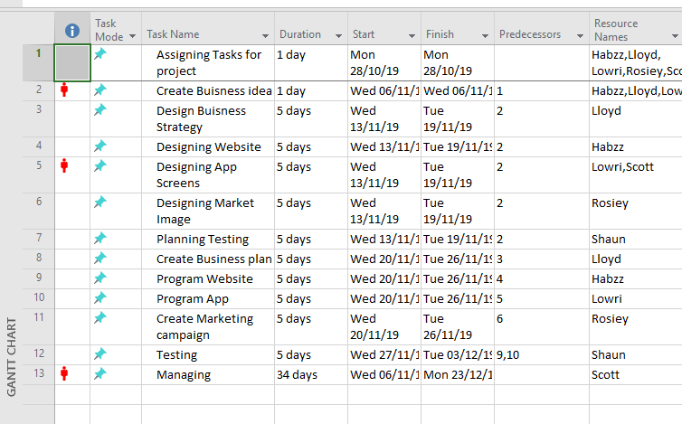  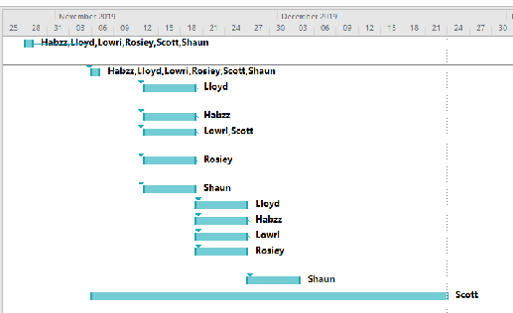
Resources | The current project stakeholders are the following:  - Scott Jones  - Lowri Jones  - Habib Muin  - Rosiey Aktar  - Lloyd Johnson  - Shaun Holborow  The key members of the project team are presented within the following table below:
Resources | Names | Roles |  | Job Description | Organisation
Resources | Scott Jones | Project Manager |  | Oversees the entire project and ensures that all goals are met and that efficiency is maximised. | J&J Fitness
Resources | Lowri Jones | Mobile Developer |  | In charge of developing applications for said mobile devices using various hardware and software. | J&J Fitness
Resources | Habib Muin | Website Developer |  | In charge of developing the website at which customers can access to view and download for usage of said application | J&J Fitness
Resources | Rosiey Aktar | Marketing |  | Oversees the marketing of said mobile app by creating connections/relationships with customers. | J&J Fitness
Resources | Lloyd Johnson | Business Developer |  | In charge of providing tasks/processes within the company to promote growth for the company. | J&J Fitness
Resources | Shaun Holborow | Business and Usability Analyst |  | Oversees the project or company by guiding them into implementing things such as improvements in efficiency of products. | J&J Fitness
Resources | Equipment:
Resources | Hardware |  | Software
Resources | - Computers  - Printers  - Test Kits |  | - Arduino IDE  - App Development Software
Resources | Finances:  Various finances would be organised for the team members of the project as well as for equipment used.

