  Component One:  What are the key skills required when working in the housekeeping team? 750 words (+/- 10%)  Contribution to Overall Module Assessment: 25% | Student No: | Livia Valentina Vladu  2127120
 | Module Title: | Operating Hotel Facilities
 | Module Code: | BMIH4006
 | Lecturer: | Lola Villard
Inside a hotel, the housekeeping department plays a variety of roles. In addition to assuring the cleanliness and visual appeal of the hotel's public areas and guest rooms, they report any maintenance difficulties. Typically, the executive housekeeper oversees maintenance report management. The person in command of the housekeeping department is an executive housekeeper. It is crucial to understand that the maintenance department is responsible for upkeep. The maintenance department is comprised of a group of individuals that repair furniture and fixtures.
Most hotels outsource their maintenance services. As a result, the housekeeping staff should keep track of any areas that require maintenance as they clean. It is essential to highlight that the cleaning staff performs several unique maintenance responsibilities. For instance, mending ripped uniforms or linens. To maintain the visual appeal of a hotel, it is necessary to swiftly solve maintenance issues in all public spaces and guest rooms.
The standards by which the housekeeping department functions are specified. Providing the expected level of cleanliness is one of the most essential criteria. Using visitor questionnaires to assess cleanliness, the hospitality industry maintains housekeeping standards. Guest satisfaction surveys measure visitors' levels of contentment and collect valuable data that may be used to enhance their level of contentment. Guest surveys can be conducted online via the hotel's website, using paper survey forms, or verbally during the checkout process (Study,2022).
At most hotels, housekeeping is one of the largest divisions. Despite its significance, this department's personnel are typically underpaid and overworked, resulting in a relatively high turnover rate. Often, this rate is ten to one hundred times that of other departments. This turnover rate costs the business tens of thousands of dollars in recruitment, training, missed productivity, and in certain states, overtime. Effectively administering such a department demands unique abilities and a unique individual. In most hotels, this is the Executive Housekeeper. This position is normal in many full-service hotels. Many limited-service establishments have followed suit by designating an Executive or Chief Housekeeper. Numerous hotels have promoted the job to the "Executive Staff level." It should also be noted that the Executive Housekeeper, along with the Executive Chef, is among the highest-paid roles in many hotels. This is done mostly to maintain and reward an employee who performs a crucial, challenging, and thankless job (Hoteltalk,2021).
Nothing delivers a stronger statement in the hospitality sector than cleanliness. No amount of service, friendliness, or glitz can match the feeling a guest feels upon entering an immaculate, well-organized room. Management and guests agree that a hotel must maintain a clean and orderly environment to fetch a fair fee and receive repeat business.
Good housekeeping is regarded as the backbone of the hospitality industry because its primary objective is to produce a clean, comfortable, safe, and aesthetically pleasing environment.
Hotel housekeeping is an operational department. It is accountable for the cleaning, maintenance, and aesthetic upkeep of rooms, public places, rear regions, and the surrounding area.
A hotel survives through the selling of rooms, food, beverages, and other minor services such as laundry, health clubs, health spas, sightseeing, and retail malls, among others. The selling of rooms comprises at least fifty percent of these sales.
Organization is a crucial skill for a housekeeper. You will need to keep track of multiple chores and tasks and manage your equipment and supplies. Good organisation will enable you to perform the highest quality work possible.
At a hotel, you always double your housekeeping trolley to ensure that it contains the necessary materials.
Always perform a complete 360-degree turn upon entering a room. This assists you in identifying and organising your top cleaning priorities for the area.
Try breaking down large projects into smaller, more attainable goals; this may be a helpful organisational tool on the job (Wikihow,2022).
Human resources are one of the most important aspects of efficient management for cleaning companies. Training and motivating the housekeeping staff is essential to achieving better results and enhancing the company's chances of success. The primary emphasis of orientation programs for the cleaning staff should be placed on customer safety and interpersonal communication. Andrews (2007) stated, "Regardless of their personal circumstances, housekeeping staff must always present a cheerful exterior and emotion" (p. 18).
Due to the nature of the field, housekeeping employees must work closely with customers, and the level of their communication skills has a significant impact on the efficiency of their work as well as their ability to meet customers' expectations, follow instructions, and fulfil requirements.
Despite the widespread misconception that cleaning is a form of physical labour that does not require special preparation or advanced skills, modern housekeeping companies evaluate the personal characteristics and learning capacity of prospective employees.
According to Morrow (2008), the primary requirements for becoming a professional housekeeper are "superior organisational skills, respect for client property, the ability to handle larger projects, and a comfort level working closely with clients for an extended period of time" (p. 57).

Word Count | 820

Component Two:
Contribution to Overall Module Assessment: 25%
In this scenario – You have just been promoted to the team leader for a floor within the hotel. A guest complains that on their arrival, their room had not been properly cleaned. Create an action plan and answer the following questions.

Problem | Why did it happen? | What are you going to do? | How will you prevent this from happening in the future? | What measures would you introduce to improve team effectiveness?
One of the guests has made a complaint regarding the clearance of his room. The guest was not happy with the room he is been allocated and said the room is not meeting the standards he paid for. | We received the complaint because the housekeeper didn’t clean the room properly because of the busy day at the hotel and the shortage of staff.  But also the supervisor who was meant to check the room didn’t do his job as he should do it. | For each new guest, hotel rooms are supposed to be immaculately clean, and a dirty room is the definition of a bad day for any hotelier. Guests typically have valid grounds for room cleaning complaints, including hair in the shower and sneakers left in the bottom drawer. These complaints account for roughly 10 percent of the total complaints received annually.  Generally, complaints with room cleanliness are resolved with profuse apologies and speedy corrections. Some guests will be happy with a short clean-up, while others will be disgusted or angry. Provide disgruntled visitors who will be relocating a new (just inspected) accommodation and a "fresh start" in terms of feeling opulent. If they refuse to leave, offer them a free lunch or spa treatment in the hotel's restaurant or spa while the cleaning team tries again to make the room spotless. | Throughout the time that the client is staying at the hotel, you should make sure that the housekeeping staff is on their toes and that they have a detailed set of instructions outlining all that is expected of them. The use of a schedule that details a time for each task and the cross-checking of that schedule by a supervisor goes a long way toward mitigating the likelihood of typical hotel complaints.  If a guest does complain about the housekeeping, you should apologise right away and then offer to make things right. Make an offer to the guest to promptly send a supervisor or member of the housekeeping staff to clean up the mess, and provide a complimentary amenity as recompense for the guest's discomfort. | As a part of this process, I would recommend having frequent mystery hotel visitor visits. These guests would be tasked with staying at the hotel for one night each month and sending a detailed report to the management. It is important for hotel managers and housekeepers to spend as much time as they can sleeping in their establishment so that they may better understand how guests feel. They should stay in all of the many types of rooms that are accessible; it is not necessary for them to have exclusive use of the deluxe suites.

Component Three:
Contribution to Overall Module Assessment: 50%
Your task is to create and prepare a presentation following the detailed scenario provided below.

As the floor housekeeping manager and given the recent guest complaints you need to put together a basic training presentation for your colleagues within the housekeeping team to get the best out of them, ensure that brand standard is being achieved and that Health and Safety procedures are also being followed.

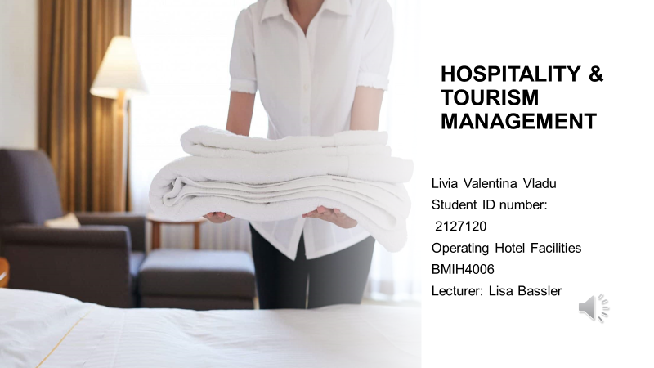

Training Notes:
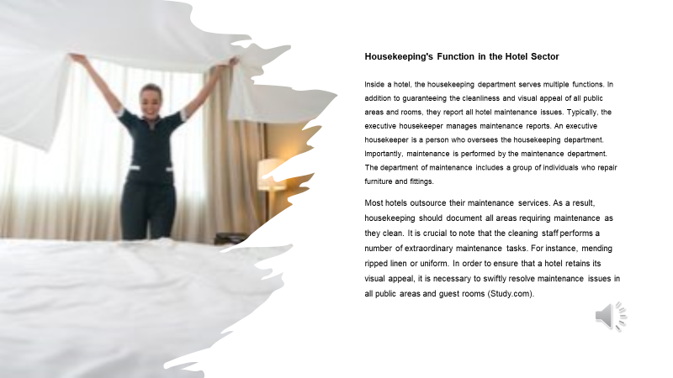

Training Notes:
For the good functioning of a hotel, the housekeeping department must do its job at a very good level and offer excellent services to customers.

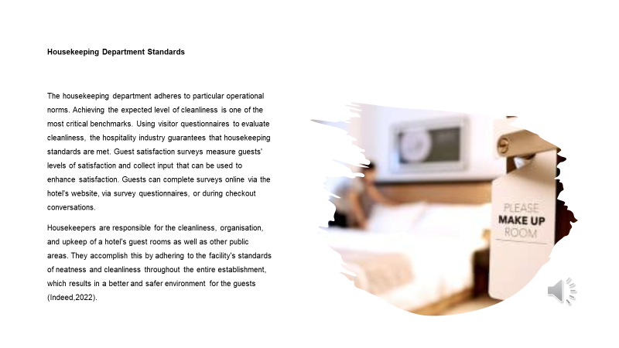

Training Notes: Offering a clean room to the guest is the most important, as this will be its first impression regarding the hotel’s services.

Training Notes:
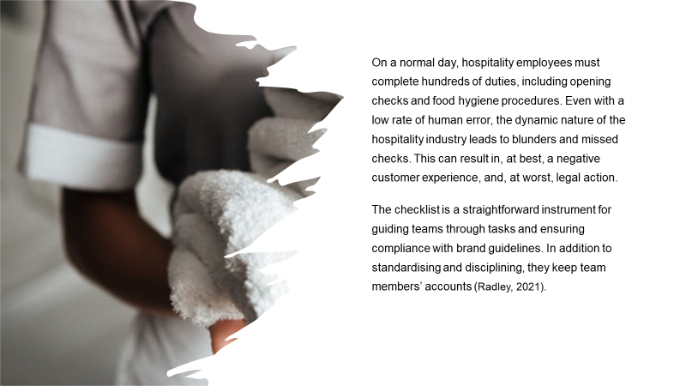

Training Notes: Housekeepers have a lot of duties during their shifts and sometimes they tend to forget to do the checks properly and this can lead to complaints from unhappy guest.

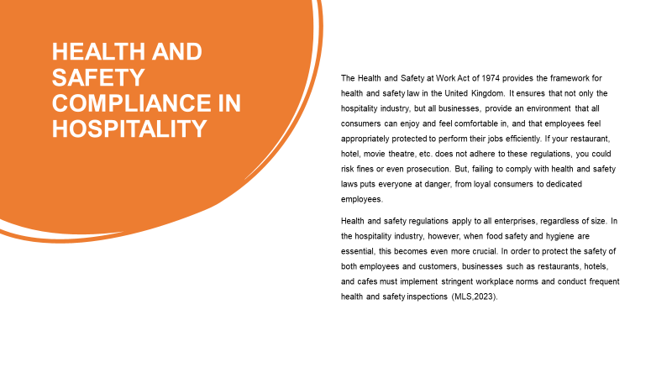

Training Notes: Health and Safety regulations definitely apply to the hotel industry as well as other the other organisations and it needs to be followed properly for the safety of employees and customers.
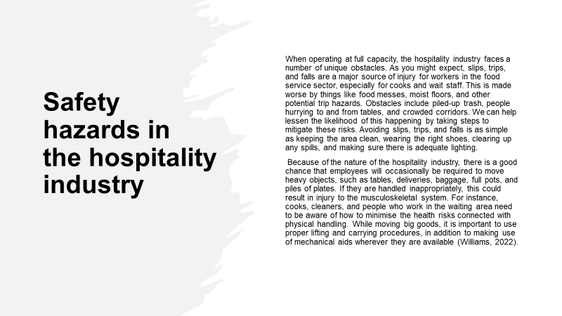

Training Notes:
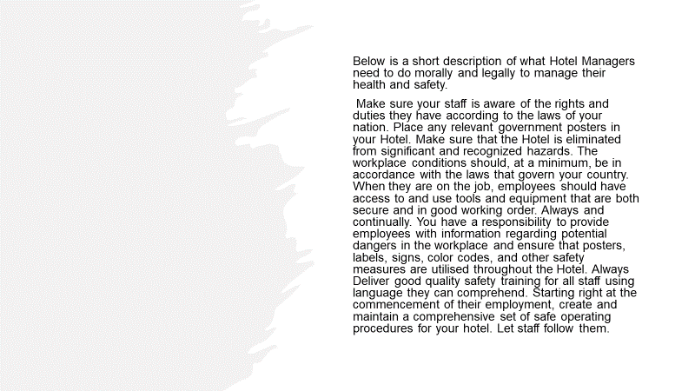

Training Notes: The Hotel Manages must follow the right procedures of Health and Safety for the well-being of the staff and the people staying at the hotel. Is their responsibility to do the right training and check if the staff is following the procedures.
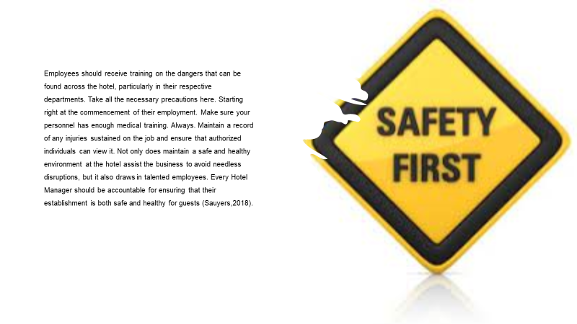

Training Notes: Training your staff is one of the most important things if you wish to succeed.
The hotel manager is the first person responsible for the safety of its staff.

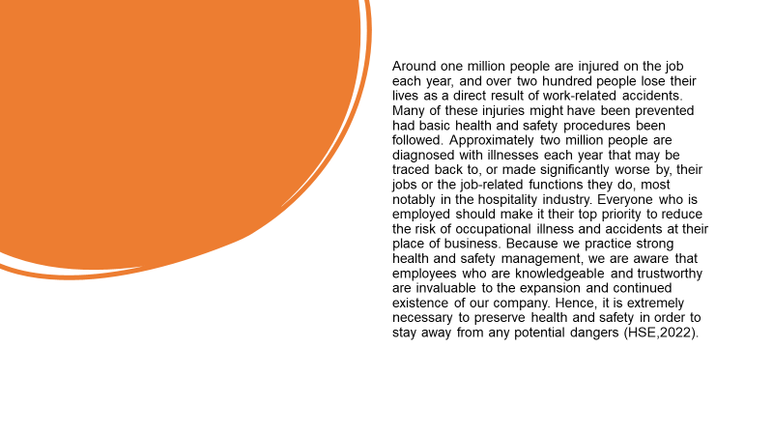
Training Notes: According to HSE, every year around 1 million people suffer injuries at work because Heart and Safety procedures are not followed properly.

References
Andrews, S. (2007) Textbook of hotel housekeeping management and operations. New DEhli, Tata McGraw-Hill.
Bunzl,2018. Hotel hospitality: The importance of excellent housekeeping. Available at: https://www.bunzlcatering.co.uk/hotel-hospitality-the-importance-of-excellent-housekeeping/ (Accessed:15.03.2023).

HotelTalk, 2022. https://hoteltalk.app/write-an-essay-about-housekeeping-department/ (Accessed:16.03.2023)
HSE, 2023. Catering and hospitality. Available at: https://www.hse.gov.uk/catering/ Accessed: 15.03.2023).
iHASCO,2023. 5 common safety hazards in the hospitality industry. Available at: https://www.ihasco.co.uk/blog/entry/2899/5-common-safety-hazards-in-the-hospitality-industry ( Accessed: 15.03.2023).
Indeed,2023. How to Become a Hotel Housekeeper (With Salary and Skills).Available at: https://au.indeed.com/career-advice/finding-a-job/how-to-become-hotel-housekeeper (Accessed: 15.03.2023).
Insights,2022. The top 5 hotel guest complaints and how staff can respond. Available at: https://insights.ehotelier.com/insights/2019/01/09/the-top-5-hotel-guest-complaints-and-how-staff-can-respond/ ( Accessed :17.03.2023).
LinkedIn, 2021. Six Common Safety Hazards in the Hospitality Industry. Available at: https://www.linkedin.com/pulse/six-common-hospitality-safety-hazards-ross-tims (Accessed: 15.03.2023).
LinkedIn, 2023. Health and Safety in Hotels: What Hotel Managers are Responsible for? Available at: https://www.linkedin.com/pulse/health-safety-hotels-what-hotel-managers-responsible-stephen-sawyers ( Accessed:15.03.2023).
Lim, 2018. Hotel Guests' Most Common Complaints and How to Prevent Them. Available at: https://www.hospitalitynet.org/opinion/4087001.html (Accessed: 17.03.2023).
Morrow, B. (2008) Cleaning service. Ocala, Atlantic Publishing Group.
MSL, 2023. The Importance of Health and Safety Compliance in Hospitality. Available at: https://msl-ltd.co.uk/health-and-safety-compliance-in-hospitality/
(Accessed: 15.03.2023).
Nexon, 2018. The importance of clean hotel rooms - Nexon Hygiene. Available at: https://www.nexonhygiene.co.uk/blog/2017/08/the-importance-of-clean-hotel-rooms/ (Accessed: 17.03.2023).
P&G Professional,2022. The Importance of Clean for Guest Satisfaction. Available at: https://pgpro.co.uk/en-gb/articles/the-importance-of-clean-for-guest-satisfaction/ (Accessed: 17.03.2023).
Preno HQ,2023. Common Guest Complaints in Hotels & How to Handle Them. Available at: https://prenohq.com/blog/common-hotel-guest-complaints-how-to-handle-them/ (Accessed: 17.03.2023).
Study,2023. https://study.com/learn/lesson/housekeeping-hospitality-industry-role-functions-standards.html (Accessed 15.03.2023).
Study,2023. Take Online Courses. Earn College Credit. Research Schools, Degrees & Careers. Available at: https://study.com/learn/lesson/housekeeping-hospitality-industry-role-functions-standards.html (Accessed: 16.03.2023).
Trail, 2023. How to maintain brand standards in hospitality. Available at: https://trailapp.com/blog/brand-standards-in-hospitality (Accessed: 15.03.2023).
UKEssays, 2023. Health And Safety In Hospitality Industry. Available at: https://www.ukessays.com/essays/management/health-and-safety-in-hospitality-industry-management-essay.php ( Accessed: 15.03.2023).
WikiHow,2023. 15 Basic Skills You Need to Be a Good Housekeeper. Available at: https://www.wikihow.com/What-Basic-Skills-Do-You-Need-to-Be-a-Good-Housekeeper (Accessed 17.03.2023).

