University of Wales Trinity Saint David

BA (Hons) Leadership and Management Skills for the Workplace
Term 2

Student Name: Iulian-Alexandru Dinu.

Student Id: 1909113.

Module Name: Developing Relationship and Workplace
Achievements.

Module Code: BMSW5102_LON.

Lecturer Name: Gregory Cowan.

Table of Contents
2 Introduction 2
3 Introduction of the chosen organization 2
3.1 Introduction of the Organization. Prezzo Restaurant 2
4 Organization plan 3
4.1 Identification plan for personal development needs and expectations of Employees. 3
4.1.1 Identification of personal Development needs. 3
4.1.2 Identification of employee’s personal needs. 7
5 Conclusion 9
6 References 10

Introduction
This report will show how to create a plan which will identify the personal development and needs of the Employees and the organization,
How an organization identify the needs of the employees how they can find what they want and how to develop them further in the organization which are the steps from the identification of the personal needs and how to develop them by creating plans which will work in the personal favour as well as the organization. And how this can make the organization grow by developing employees which are working for them, and for the employees to prove and become more productive which will create a space for their development in the organization.
What are the steps the organization will make and take and which tools and methods they will use to find and identify all the information about the personal needs and development of the employees will be discussed and shown in this report?

Introduction of the chosen organization

Introduction of the Organization. Prezzo Restaurant
The first restaurant that was opened in 2000 in New Oxford Street London back then was called Jonathan’s. Becoming the most well-known and most loved Italian restaurant on the high street.
The Prezzo name come when Jonathan's decision to sell to Prezzo Holding which is part-owned by TGP Capital which also operates Chimichanga, Caffe UNO, Mexico and Cleaver restaurants brands.
Which it's one of the biggest Italian-inspired British chains in the UK. Having competitors such as ASK, Prezzo Express and Strada. (PREZZO, 2021)
Since then, the business grows and expand fast owning in present 150 restaurants all over the UK with a team of more than 2.500 people which create amazing memories for our customers providing them delicious classic Italian food with a good range of Italian wines Gin and tonic were the people can come and relax with their children and family. For us, the customers matter and it's something that the organization will never change.
Keeping our customers, it's what makes us be above other Italian restaurants and allow us to grow so much and expand.

Organization plan

Identification plan for personal development needs and expectations of Employees.

Identification of personal Development needs.
Each organization needs to have a plan to identify the employee’s development and needs, every employee wants the organization to look and care about them to feel recognized, for the job that they are doing, the managers have to inform and introduce the employees with excellent productivity.
There are a few steps that can help identify the personal needs and development of the employee's, each employee has a personal life outside work which can affect the way they perform in the workplace it's very important to be flexible and to understand this.
Getting to know your employees will make a huge difference in the way the organization work and how will progress in the future, there are a few methods, tools and plan that can be used to find out and identify what are their personal and development needs.
- Training: In an organization such as Prezzo which is hospitality sector training it’s very important, all the employees will take and learn how the organization work and how they need to follow the company standards and to behave in the organization.
Each training plan it's developed for a specific job or role having different routes and strategies depending on the employee role in the organization. (Valamis, 2022)
- Tasks and jobs: Giving the specific task to each employee will make you understand better the knowledge and the skills of the employees, which will help you in your way to identify their development needs, and make you understand the future development plans of the employee in the organization are.

- Coaching: After identifying the skills and knowledge of the employees, providing coaching will help them expand the knowledge and polish their skills, giving them more confidence in themselves and the organization they are working for, making them more eager to learn and develop further in their career and organization.

- Working groups/ Committees: Allowing them to interact with other internal colleagues or external persons will expand the communication and team practice which will bring a bonus in their productivity as well and interacting with different persons from other organizations will give them insights and better communication practice.

- Simulation: providing role-play simulation will make them understand how to behave in a different situation with an angry, unhappy customer what he needs to do and what is the best way to do it.

- Career planning: When an employee show's great skills and knowledge in their role and great productivity the managers can suggest and point the specific employee to HR for a promotion. Or even the employee can raise the question with their managers about any further development in their career which will be passed to HR superiors. (Valamis, 2022)
Prezzo Company is using a few methods which they can supervise and see which employees are showing promise and great skills in their workplace.
Meetings and conferences call with the superiors which are held monthly with all the employees and nominations for the best employees, identified by the organization.
Face to face meeting/chat with the people nominated held by the OPS Director in charge of the restaurant in the specific area and discuss further plans and personal growth of the employees in the organization.
Prezzo has a unique application called Tutto Prezzo which is an application where the employees can post their performance or the restaurant performance that can be seen by all the Prezzo Company employees including CEO and Directors. A good point of the application is that can be accessed 24/7 all the content further them posting its restricted protecting personal details and can be accessed just by the HR or the CEO who constantly supervised the application.
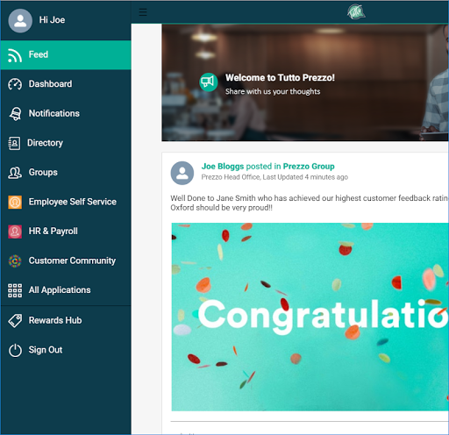 (Images, 2022)
This it’s the main page where all posts can be viewed by all the employees and superiors.

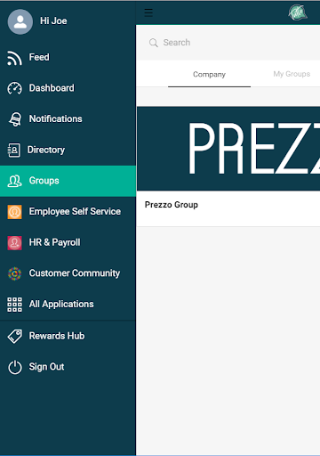 (Images, 2022)
The application allows creating groups with different employees from different brunches which can improve the communication and sharing of information, and experiences between Employee’s and restaurants, improving the quality of the service and productivity as well increasing the knowledge of the persons involved in the group.
Gives access to Employee Service where all the employees can check their employment details in the HR system. Payroll Information allows the verification of the past Wages allowing employees to compare the past and present wages and check any differences.
The main application gives access to different pages in the application which can help and offer support, such as Prezzo learning zone, Tutto Grazie, and Vacancies.
- Prezzo learning zone: It's a website created by the company where all the employees training is, on the website are located all the steps of training such as Health and Safety, Basic food safety, Advanced food safety and standards, Allergens, Fire safety, Alcohol Training, and few more other training that needs to be completed by all the employees so they can work in the organization.
- Tutto Grazie: one of the applications where all the managers can nominate employees with remarkable performance and reward them, this application it’s supervised by the Directors who can see which employees are having remarkable growth and are ready to develop further in the organization.
The reworded persons can win money in the application which is transformed into points and can be used to purchase different items from the application shop system.
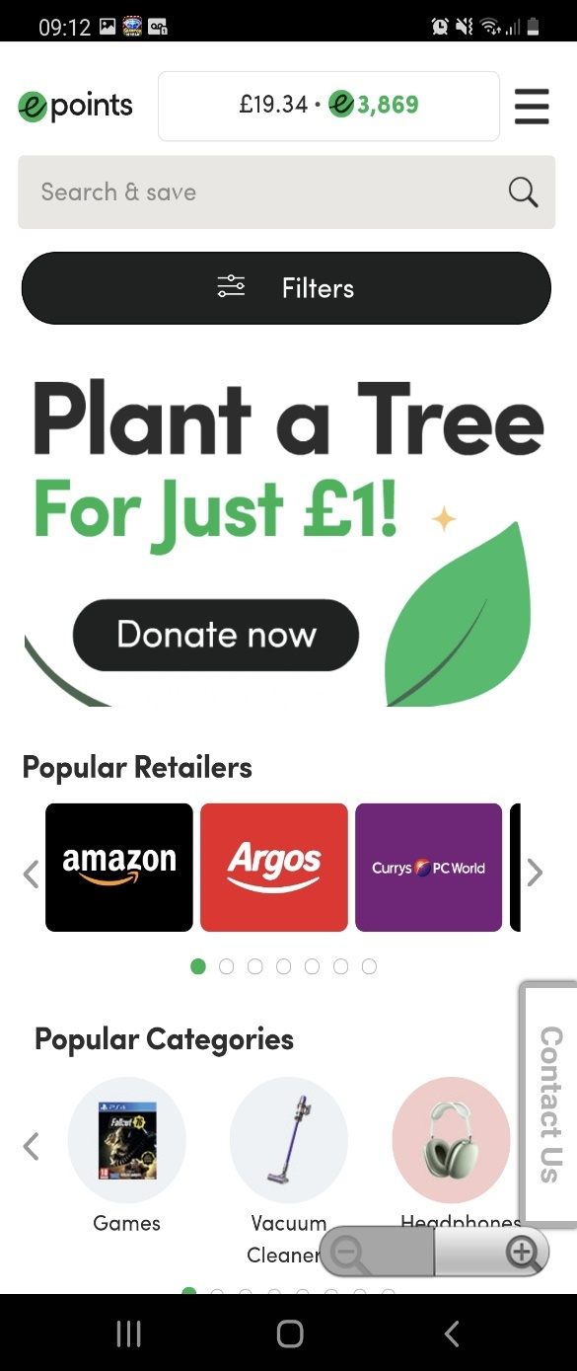
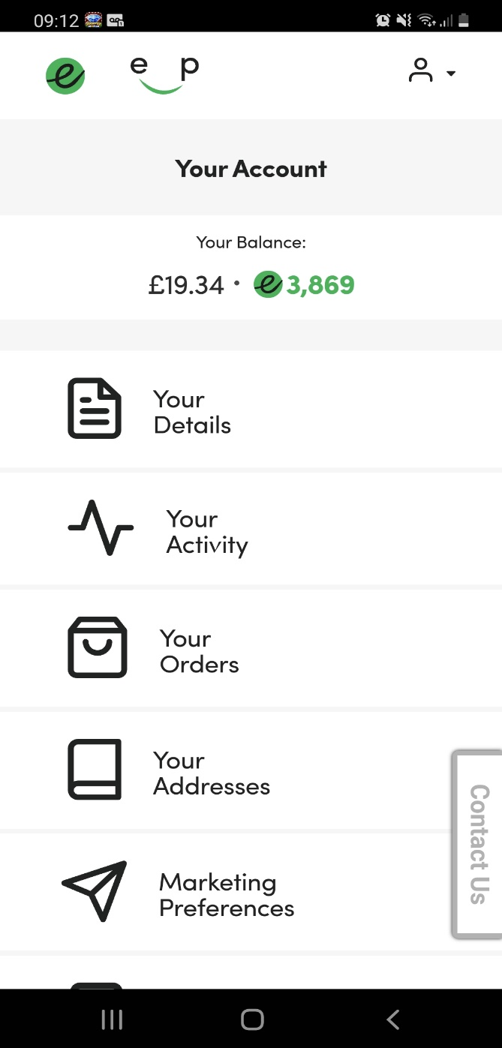
(Iulian-Alexandru Dinu Smartphone, 2022)
As well on the application, you can recognise employee's who are having a good performance at work without offering them money rewards allows the employee's name to be shared with all the Directors, Managers and CEO.
So much for the personal development of the employees, the next aspect of this report is to present how an organization can identify the employee's personal needs.

Identification of employees' personal needs.
All organizations need to identify and understand the personal needs of the employees most of the organization fails to understand what they want not just work-related, for example, an employee with a family who is overworking at some point the performance will slowly decrease creating a loss for the organization.
That's why it is very important to think from the other perspective as well not like a Boss but like a human person with needs.
It's easy to be a boss but it's harder to be a human being with a soul and heart which thinks about compassion, respect and well-being of the others who are working in the organization.
Prezzo it's the type of organization that discuss all the needs with the employees and listen to their words and comments, many people in the organization are with family, students, teenagers and grown-ups.
Each of them has different needs which they want to be respected, how an organization can identify those needs what are methods are they using.
For example, Prezzo Has Tutto application which was mentioned above page 7 where they can share, communicate their needs, as well all the managers hold meetings with the employee’s where everyone can say and communicate all their issues and what they want, and the organization can do all the possible to answer to their requests with solutions.
All the employees are looking to get something in exchange for their skills and knowledge that they put an offer to the organization, for example, all the Prezzo employees have 50% per cent discount on all Prezzo restaurants as well as a free meal at work when they are working, free soft, coffee, teas, family and friends discount, pension scheme, holidays and few more.
As well they can request the days when they want to stay home depending on their personal needs, the managers have the responsibility to keep the employees happy and offer them all these requests.
The HR duty it's to make the employee's feel safe, respected, recognise the work that they are doing, and any issues forwarded by the employee’s will be respected and the appropriate action regarding the issue to be taken.
Keeping the employees happy will benefit the organization in many ways, that's why Prezzo chose to make a small sacrifice for the better of the organization, many people don't understand that the employees are the ones keeping the organization on track to reach their goals and keeps the business running, if you don't have employee's, you can't function properly.
That’s why we can speak about employee empowerment on job satisfaction.
What is employee empowerment?
It’s closely related with the management techniques and instruments, giving empowerment to the employees will surely benefit the organization when the employees know how to use the instruments and techniques of the management team and they can use them in the workplace, such as:
- Motivating each other’s in the workplace will create better teamwork with better performance and productivity creating a nice environment where all they can work happily and with no stress.
- Job enrichment thanking the job to a further level by raising the organization standards and applying them to the workplace.
- Communication gives them the chance to communicate better with each other's creating a bond between employee's who will face all the hardships in the workplace.
- Trust building this connection between the employees gives them more confidence, helps them open, creating that friendship which can improve their behaviour and their performance.
- Training and feedback give them the power to train new employee's and teach them the organization goals and rules the way they need to work, and the steps required to prevail and step forward with the head up in the organization. Providing feedback of the new team members giving all the training details to the superiors the speed of learning and the progress of the new members. (Greasley, et al., 2008)

Each employee has the chance to grow in the organization all it's about proving and expanding the skills and what can be an offer to the organization if a progression happens how can they benefit from it.
For example, the OPS Director saw growth in one of the waiters working in Prezzo and he decide to promote the waiter to Duty Manager the question it's how this promotion can benefit the organization, and a list of pros and cons it's created which will lead to the decision of promoting, or it's to soon need more training and polishing the skills and knowledge.
After a face-to-face meeting, it's scheduled between the employee and the Ops Director to discuss the decision reached for the promotion.

Conclusion
After reading the report the plan for identifying the personal and development need of the employee’s is understandable, how an organization formulate a plan and what methods they are using to identify these aspects.
How much the organization needs to create all the proper ways to realize what the employees’ needs are the employee on his side needs to communicate what he needs and the organization to respect and meet those needs.
Each employee who will develop in the organization needs to be to their benefit what the employee can bring extra and how he can boost the performance and the productivity of the organization to reach the goals.
We have learnt what the organization offers the employees for the job they are doing and the performance and productivity they bring to the organization.
Why such a plan it's important for an organization that can increase productivity and the well-being of the employees by providing recognition, respect, and reward for the team members.

References
1928, M. A., 2015. Armstrong's handbook of performance management: an evidence-based guide to delivering high performance. 5th ed. s.l.:Kogan Page.
Beausaert, S., Segers, M. & Gijselaers, W., 2011. The Personal Development Plan Practice Questionnaire: the development and validation of an instrument to assess the employee's perception of personal development plan practice. International journal of training and development,, 15(4), pp. 249-270.
Elegido, J. M., 2013. Does It Make Sense to Be a Loyal Employee?. Journal of business ethics, 116(3), pp. 495-511.
Greasley, K. et al., 2008. Understanding empowerment from an employee perspective: What does it mean and do they want it?. Team performance management, 14((1/2)), pp. 39-55.
Images, G., 2022. Google Images. [Online]
Available at: https://www.google.com/search?q=tutto+application&tbm=isch&ved=2ahUKEwioy5LBwZ_1AhUaKxoKHXeYAQMQ2-cCegQIABAA&oq=tutto+application&gs_lcp=CgNpbWcQAzIHCCMQ7wMQJzoECAAQGDoLCAAQgAQQsQMQgwE6CAgAEIAEELEDOgUIABCABDoICAAQsQMQgwE6BAgAEEM6BAgAEB5QkwlY9ipg3i1oAHAAeA
[Accessed 02 01 2022].
Lejeune, C., Beausaert, S. & Raemdonck, I., 2021. The impact on employees' job performance of exercising self-directed learning within personal development plan practice. International journal of human resource management, 32(5), pp. 1086-1112.
PREZZO, 2021. PREZZO. [Online]
Available at: https://jobs.prezzorestaurants.co.uk/our-story
[Accessed 7 12 2021].
Valamis, 2022. Valamis. [Online]
Available at: https://www.valamis.com/hub/employee-development-methods
[Accessed 22 12 2021].

